120375 Formative Assessments

Formative Assessment 1: Interest

Individual activity
- There are 95500 people living in Mankwe. The annual growth rate is 6. % Every year. What will the population of Mankwe be after 10 years?
- You invest R678 for 12 years at a rate of 15.6%. What would your returns be at the end of year 12?
- Which of the following two investments are the most lucrative?
- R500 invested for 10 years at 14% compound interest per year, calculated by semester.
- R500 invested for 10 years at 13.8% compound interest per year, calculated quarterly.
Solution:
Here the interest is compounded twice a year thus q = 2

b. Quarterly means that the interest is compounded 4 times per year, q = 4

It is not necessary to calculate what the actual interest earned is here since the initial investment is the same in a and b.

- Which of the following investments would be the most lucrative?
R500 invested for 10 years at 14% per year, compounded each semester.
R500 invested for 10 years at 13,8% per year, compounded each quarter?
- An investor invests R500 for 5 year at 11, 5% per year, compounded yearly. At the end of year 5 he invests an extra R5000 running for 5 more years at 12% per year, compounded quarterly. Calculate:
the amount available after 5 years
the amount to be re-invested at the beginning of year 6
the final amount at the end of year 10.
- A father wants to have R16 000 available for his sons education on his 18th birthday. Calculate the amount he must invest on his son’s 10th birthday at 14% compounded interest?
- The Maluti Company bought equipment to the value of R43 200. The yearly depreciation is 12 %. After 12 year it is sold.
Calculate the value of the equipment after 12 years.
What is the amount that must have been invested 12 years ago at 12 % , to buy new equipment , valued R54 300. (Money generated from the sale of old equipment, calculated in a, is also used for the new equipment)

Formative assessment 2: cost estimate

Prepare a cost estimate for either the HIV/AIDS or the taxi service project. Use as many of the cost columns as apply. The Project Budget Schedule calculates the estimated cost of each activity or step in the project plan. Figures are divided over the applicable steps.

Sub-Unit
(Component or step)

Formative Assessment 3: - budget
Purpose: To understand the development of project budget
Time: 30 minutes learning team work
30 minutes learning team presentations and discussion
Task:
Break-away into learning teams
Develop a budget for your project
Learning teams will present their budgets to the rest of the class for comparison

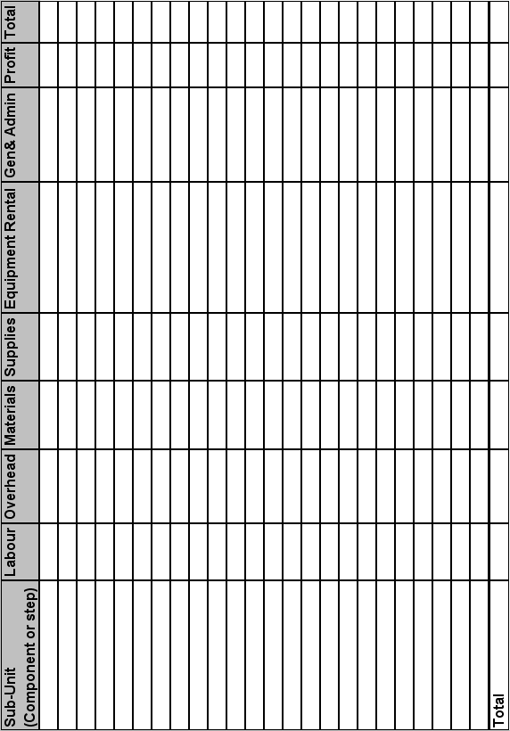

Formative assessment 4: assumptions

Group activity
In groups, compile a report to explain the assumptions that you made when preparing the budget.

Formative assessment 5: critical ratio

Do the following calculation.
128 hours had been allocated for labourers to level the site and dig the foundations.
R38 400 had been budgeted for labour costs.
The work was completed in 120 hours at a cost of R24 000.
- What is the Critical Ratio?
- What are your conclusions and how will it affect other aspects of the project?

Do the following calculations:
80 hours have been allocated for consultant engineers to design the process at a cost of R52 000. The consultants have billed you for 95 hours because of delays on your side. Their costs come to R61 750.
- What is the Critical Ratio?
- What are your conclusions and how will it affect other aspects of the project?

R200 000 had been allocated for civil engineers and their teams to be on site. The work was to be completed in 4 weeks. Due to heavy rains they had to redo some of the work and have been unable to complete the work and require another week at an additional cost of R50 000. The contractor says that you must pay them for the time they were on site as the delays were an act of God.
- What is the Critical Ratio?
- What are your conclusions and how will it affect other aspects of the project?

