LEARNER GUIDE

PROJECT MANAGEMENT
Module 3

Conduct project documentation management to support project processes
Unit Standard 120376 Level 4 Credits 6

TABLE OF CONTENTS
TABLE OF CONTENTS i
PERSONAL INFORMATION 2
INTRODUCTION 3
Programme methodology 3
What Learning Material you should have 4
Different types of activities you can expect 5
Learner Administration 6
Assessments 6
Learner Support 7
Learner Expectations 9
UNIT STANDARD 120376 10
FILING SYSTEM 13
Filing 14
Why Do We File? 14
Filing can be done: 14
Pending Tray 18
Borrowing files 18
Filing Equipment and Accessories 18
Electronic Filing 20
FILE MANAGEMENT 22
The Process Of Filing 23
DOCUMENT TEMPLATES 25
Project Administration 26
Correspondence 26
Meetings 26
Project control documents 27
Materials control documents 27
Financial documents 28
Templates may include the following: 28
HANDOVER DOCUMENTS 29
MANAGE PROJECT DOCUMENTS 31

PERSONAL INFORMATION
NAME
CONTACT ADDRESS
Code
Telephone (H)
Telephone (W)
Cellular
Learner Number
Identity Number
EMPLOYER
EMPLOYER CONTACT ADDRESS
Code
Supervisor Name
Supervisor Contact Address
Code
Telephone (H)
Telephone (W)
Cellular

INTRODUCTION

Welcome to the learning programme

Follow along in the guide as the training practitioner takes you through the material. Make notes and sketches that will help you to understand and remember what you have learnt. Take notes and share information with your colleagues. Important and relevant information and skills are transferred by sharing!

This learning programme is divided into sections. Each section is preceded by a description of the required outcomes and assessment criteria as contained in the unit standards specified by the South African Qualifications Authority. These descriptions will define what you have to know and be able to do in order to be awarded the credits attached to this learning programme. These credits are regarded as building blocks towards achieving a National Qualification upon successful assessment and can never be taken away from you!

Programme methodology


The programme methodology includes facilitator presentations, readings, individual activities, group discussions and skill application exercises.
Know what you want to get out of the programme from the beginning and start applying your new skills immediately. Participate as much as possible so that the learning will be interactive and stimulating.
The following principles were applied in designing the course:
- Because the course is designed to maximise interactive learning, you are encouraged and required to participate fully during the group exercises
- As a learner you will be presented with numerous problems and will be required to fully apply your mind to finding solutions to problems before being presented with the course presenter’s solutions to the problems
- Through participation and interaction the learners can learn as much from each other as they do from the course presenter
- Although learners attending the course may have varied degrees of experience in the subject matter, the course is designed to ensure that all delegates complete the course with the same level of understanding
- Because reflection forms an important component of adult learning, some learning resources will be followed by a self-assessment which is designed so that the learner will reflect on the material just completed.
This approach to course construction will ensure that learners first apply their minds to finding solutions to problems before the answers are provided, which will then maximise the learning process which is further strengthened by reflecting on the material covered by means of the self-assessments.

Different role players in delivery process
- Learner
- Facilitator
- Assessor
- Moderator

What Learning Material you should have
This learning material has also been designed to provide the learner with a comprehensive reference guide.
It is important that you take responsibility for your own learning process; this includes taking care of your learner material. You should at all times have the following material with you:
  Learner Guide | This learner guide is your valuable possession:  This is your textbook and reference material, which provides you with all the information you will require to meet the exit level outcomes.  During contact sessions, your facilitator will use this guide and will facilitate the learning process. During contact sessions a variety of activities will assist you to gain knowledge and skills.  Follow along in the guide as the training practitioner takes you through the material. Make notes and sketches that will help you to understand and remember what you have learnt. Take and share information with your colleagues. Important and relevant information and skills are transferred by sharing!  This learning programme is divided into sections. Each section is preceded by a description of the required outcomes and assessment criteria as contained in the unit standards specified by the South African Qualifications Authority. These descriptions will define what you have to know and be able to do in order to be awarded the credits attached to this learning programme. These credits are regarded as building blocks towards achieving a National Qualification upon successful assessment and can never be taken away from you!
  Formative Assessment Workbook | The Formative Assessment Workbook supports the Learner Guide and assists you in applying what you have learnt.  The formative assessment workbook contains classroom activities that you have to complete in the classroom, during contact sessions either in groups or individually.  You are required to complete all activities in the Formative Assessment Workbook.  The facilitator will assist, lead and coach you through the process.  These activities ensure that you understand the content of the material and that you get an opportunity to test your understanding.

Different types of activities you can expect
To accommodate your learning preferences, a variety of different types of activities are included in the formative and summative assessments. They will assist you to achieve the outcomes (correct results) and should guide you through the learning process, making learning a positive and pleasant experience.

The table below provides you with more information related to the types of activities.
Types of Activities | Description | Purpose
Knowledge Activities   | You are required to complete these activities on your own. | These activities normally test your understanding and ability to apply the information.
Skills Application Activities   | You need to complete these activities in the workplace | These activities require you to apply the knowledge and skills gained in the workplace
  Natural Occurring Evidence | You need to collect information and samples of documents from the workplace. | These activities ensure you get the opportunity to learn from experts in the industry.  Collecting examples demonstrates how to implement knowledge and skills in a practical way

Learner Administration


Attendance Register
You are required to sign the Attendance Register every day you attend training sessions facilitated by a facilitator.

Programme Evaluation Form
On completion you will be supplied with a “Learning programme Evaluation Form”. You are required to evaluate your experience in attending the programme.
Please complete the form at the end of the programme, as this will assist us in improving our service and programme material. Your assistance is highly appreciated.

Assessments
The only way to establish whether a learner is competent and has accomplished the specific outcomes is through the assessment process. Assessment involves collecting and interpreting evidence about the learners’ ability to perform a task.
To qualify and receive credits towards your qualification, a registered Assessor will conduct an evaluation and assessment of your portfolio of evidence and competency.
This programme has been aligned to registered unit standards. You will be assessed against the outcomes as stipulated in the unit standard by completing assessments and by compiling a portfolio of evidence that provides proof of your ability to apply the learning to your work situation.



How will Assessments commence?

Formative Assessments
The assessment process is easy to follow. You will be guided by the Facilitator. Your responsibility is to complete all the activities in the Formative Assessment Workbook and submit it to your facilitator.

Summative Assessments
You will be required to complete a series of summative assessments. The Summative Assessment Guide will assist you in identifying the evidence required for final assessment purposes. You will be required to complete these activities on your own time, using real life projects in your workplace or business environment in preparing evidence for your Portfolio of Evidence. Your Facilitator will provide more details in this regard.
To qualify and receive credits towards your qualification, a registered Assessor will conduct an evaluation and assessment of your portfolio of evidence and competency.

Learner Support
The responsibility of learning rests with you, so be proactive and ask questions and seek assistance and help from your facilitator, if required.


Please remember that this Skills Programme is based on outcomes based education principles which implies the following:
- You are responsible for your own learning – make sure you manage your study, research and workplace time effectively.
- Learning activities are learner driven – make sure you use the Learner Guide and Formative Assessment Workbook in the manner intended, and are familiar with the workplace requirements.
- The Facilitator is there to reasonably assist you during contact, practical and workplace time for this programme – make sure that you have his/her contact details.
- You are responsible for the safekeeping of your completed Formative Assessment Workbook and Workplace Guide
- If you need assistance please contact your facilitator who will gladly assist you.
- If you have any special needs please inform the facilitator

Learner Expectations
Please prepare the following information. You will then be asked to introduce yourself to the instructor as well as your fellow learners


Your name:
The organisation you represent:
Your position in organisation:
What do you hope to achieve by attending this course / what are your course expectations?

UNIT STANDARD 120376

Unit Standard Title
Conduct project documentation management to support project processes

NQF Level
4

Credits
6

Purpose
Learners accessing this standard will be working as a leader in the context of a small project / sub-project involving few resources and having a limited impact on stakeholders and the environment or working as a contributing team member on a medium to large project when not a leader. These projects may be technical projects, business projects or developmental projects and will cut across a range of economic sectors. This standard will also add value to learners who are running their own business and recognise that project management forms an integral component of any business

Learning assumed to be in place
Learners accessing this qualification will have demonstrated competence in computer literacy, numeracy, literacy and communications at NQF level 4 or equivalent
Learners accessing this qualification will have demonstrated competence in computer literacy and applicable software at NQF level 4 or equivalent
ID 120372 - Explain fundamentals of project management

Unit standard range
Project level will include but is not limited to working as a leader in the context of a small project/sub-project involving few resources and having a limited impact on stakeholders and the environment or working as a contributing team member on a medium to large project when not a leader
Projects may include but are not limited to all projects including technical, developmental and business related projects
Documentation management systems may include but are not limited to computer based document control systems, computer based document tracking systems, manually operated document control systems
Templates may include but are not limited to letters, memo`s, faxes, e-mail messages, minutes of meetings, document transmittal forms, various types of drawings, programme schedules, cost reports, equipment data sheets, specifications, procedures, standing orders, materials control documents (Orders, receiving, issued, inventory levels, stock counts), contracts, requisitions, budget authorisations, change notices, change orders, site instructions, rectification instructions, variation orders, petty cash vouchers, petty cash returns, timesheets, travel / expense claims, technical procedure related controls
Policies and procedures may be organisation specified systems, policies and procedures or where these do not exist, accepted industry best practice

Specific Outcomes and Assessment Criteria
Specific Outcome 1: Use a paper based and/or electronic filing system for a project
Assessment Criteria
A filing system exclusively for the project is developed and utilised according to project needs
Project files are clearly named and structured to enable easy filing or retrieval.
An inventory of the project documentation is prepared and maintained in accordance with agreed filling system
An audit trail for project documentation is maintained according to agreed filing system
All files and documentation are maintained to ensure they are current, up-to-date, neat and clean
Specific Outcome 2: Use standardised processes for identifying, securing and finding documents
Assessment Criteria
All documents are named and filed to agreed standards
Filing system is structured and indexed reflecting project, sub-project, phase and stage levels, management, quality and specialist (technical) products
Multiple versions of documents are correctly filed and annotated in accordance with agreed filing system
Back-up and archive processes are identified and utilised in accordance with agreed filing system
Sensitive and /or confidential documents are kept in safe custody
Specific Outcome 3: Provide project templates to team members
Assessment Criteria
Templates are prepared in accordance with requirements and accepted standards
Templates and their components are identified and explained in terms of how they should be used
Procedures for the usage of templates are explained and communicated to team members
Specific Outcome 4: Assist in preparing project documents for handover at the end of a project or a project phase/stage
Assessment Criteria
Handover project documents are prepared in correct format and within agreed time frame
Handover project documents are complete, concise and in the required location and are handed over to appropriate individuals
Specific Outcome 5: Describe and explain project documentation management processes
Assessment Criteria
The documentation system requirements are explained in relation to quality, access and trace ability
Document control requirements for a project are explained with reasons for the control
Storage and retrieval functions and processes are explained with examples of each.
Benefits of documentation management for a project are explained with examples

Unit Standard Essential Embedded Knowledge
Using a paper based filing and retrieval systems
Using electronic based filing and retrieval systems
Templates used in project management
Identifying, securing and finding documents on a project
The causes and effects of uncontrolled changes and access to documentation
Identification systems for documentation

Critical Cross-field Outcomes (CCFO)
Identify and solve problems related to the management of project related documentation
Collect, analyse, organise and critically evaluate information relating to the establishing, using and preparing project documentation
Communicate effectively, ensuring smooth administration of project documentation
Use science and technology effectively and critically in the management and administration of project documentation
Demonstrate the world as a set of related systems understanding the impact of project documentation management on the overall success of the project

FILING SYSTEM

Outcome
Use a paper based and/or electronic filing system for a project

Assessment criteria
A filing system exclusively for the project is developed and utilised according to project needs
Project files are clearly named and structured to enable easy filing or retrieval.
An inventory of the project documentation is prepared and maintained in accordance with agreed filling system
An audit trail for project documentation is maintained according to agreed filing system
All files and documentation are maintained to ensure they are current, up-to-date, neat and clean

Filing

Why Do We File?
To ensure that all records are maintained in a neat and clean environment.
To make information easily accessible: in other words, we file to find
It is very important to keep all incoming documents or copies of outgoing documents on file (sorted and secured in suitably marked folders and placed in convenient storage), for reference and verification (confirmation, certification) purposes. To enable their being found without delay, such documents must be files in a systematic way.

Filing can be done:
- Manually, by means of sorting and storing paper documents (hard copies) by hand.
- Electronically, by means of computers, microfilms, tapes or disks
A good filing system ensures that the project’s operations run smoothly as information can be accessed easily and timeously.
Although you may have a clerical person assisting you with filing, we have included some information about establishing a suitable filing system, which may be useful for you to discuss with them. This will ensure that you both agree on the type and format of the filing system to be used.
Some tips to remember when filing
Check all papers are completed and can be filed
Check attachments are firmly fixed to the correct document
Check that there are no extra papers attached to the document
Sort into order
File away carefully in the filing cabinet in the correct place
File regularly, preferably each day
Check for any missing files and locate these (use an out card system)
Make sure your files are clearly marked with tags, preferably typed tags
Make sure that the key people in the project understand how your filing system works
The requirements for an effective filing system
Simplicity
Appropriate classification
Accessibility
Suitable equipment
Safety (avoiding damage by water, fire, dust)
Security (maintaining confidentiality)
Compactness
Trained admin staff
Speed of retrieval
Economical in terms of time, cost of equipment and accessories
What type of filing system should you use?
Information can be filed in one of the following ways:
Alphabetical
Numerical
Geographical
Subject
Chronological
Electronic

Alphabetical

Alphabetical filing is perhaps the most popular filing method used, but although it sounds easy, there are certain rules which must be followed …

Examples
Alexander, Bennett, Christian etc

Document Subject | Rule | File Under …
Rebecca Langford | Always use first letter of surname | L
Sandra Smith  Norman Smith  Valerie Smith | If the same surname, use the first letter of the first name | Smith, Norman  Smith, Sandra  Smith, Valerie
Anne Rees-Jones | If hyphenated surname, use first letter | Rees-Jones
Woods  Woodside  Wood | Short names before long names | Wood  Woods  Woodside
Southern Cross Ltd | First letter of company name | S
McPherson  McAvoy  M’Clintock | File as if they all read as “mac” and use third letter as filling point | McAvoy  M’Clintock  McPherson
Dr Norman Gray  The Northern Star  A Small Shop | Ignore words “a”, “the”, title in front of words | Gray  Northern Star  Small Shop
7th Avenue Shop | Change numbers into words | S (seventh)

Numerical
When a numerical system is used, each new file is given the next number. Unfortunately, with every file having a number and no name, trying to find a document becomes a difficult task. Therefore, a numerical system will be accompanied by an alphabetical index. You look in the alphabetical index for the name and this will give you the number of the document.  Examples  Invoices, credit notes etc | 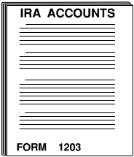  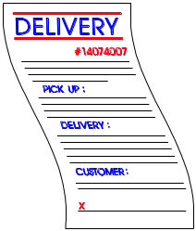  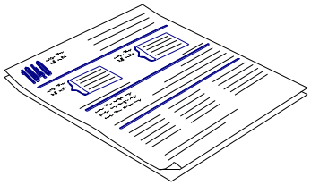  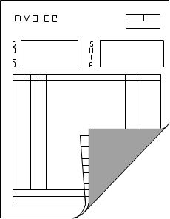


Geographical
Information is sometimes filed by area, road, village, town or country. Travel and estate agents are two types of organisations which may use this method. A firm that has several branches around the country may use this system. The place under which files are stored and sub-sections within them are usually arranged in alphabetical order.

Examples
Regional reports, branch info, international documents etc

Subject
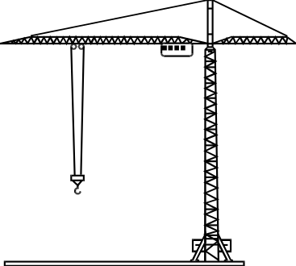

Information is filed according to the particular subject. For example, it is useful in colleges for filing information under subjects such as Business Studies, Marketing etc.

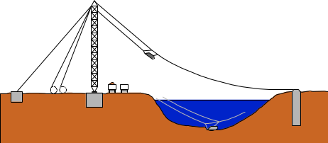
Examples
Projects, purchases, debtors etc

Chronological

This is where files are placed in date order. This is not a very common system as it is not very practical. If a company uses a chronological system, all the letters etc received bearing the same date would be filed away together using the date as the filing point.  It takes a great deal of time searching through bulky files, which contain daily correspondence. It would take even longer if the person looking for it did not know the date under which it was filed.  Examples  Letters, contracts etc | 

Electronic

This is where information is filed by means of creating files on a computer. The major advantage of an electronic system is that information is not stored in one particular order and therefore it can be sorted using any classification at the touch of a button. | 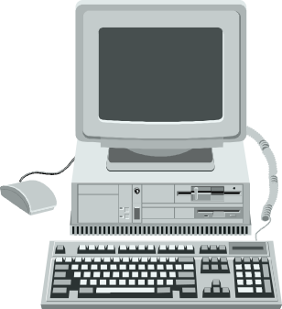

When to file
It is important to check that letters can be filed after they have been dealt with. Some projects use a “file” stamp or “file” may be written on the document.

Filing point
When filing a document, the filling point must be identified. This is the letter, number, subject or geographical area under which the document is to be filed.

E.g. File invoice no 10345 which has been sent to Mr B Craven

Numerical system 10345
Alphabetical Craven

Pending Tray
A pending tray is used for work that is awaiting attention.

Borrowing files
If someone wishes to take a file away, the must complete an “out card”. This is necessary in case someone else needs the file urgently. A note is left in place of the file stating the file has been removed. The “out card” gives details of who has borrowed the file, when it was borrowed and the intended date of return.

Out card

File Name | Borrower | Department | Date Out | Date Returned
Smith | Anne | Sales | 5/8 | 6/8

Filing Equipment and Accessories
A variety of filing equipment and accessories are available to assist you with the filing process. The type used will depend on the space available and type of information to be stored. There are four ways in which files can be stored:

  - Vertical | Filing Cabinet  Files behind each other
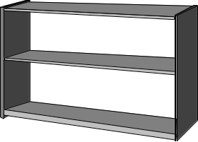  - Lateral | Cabinet with no drawers  Files side by side
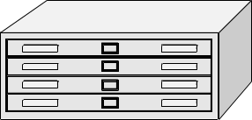  - Horizontal | Narrow Drawers  Files on top of each others
  - Circular | Carousel  Files placed in circular arrangement on layers of shelves which rotate

Some useful filing tips…
A file drawer or shelf should be filled to no more than 90% of it capacity. Tightly packed files slow filing and finding files down
Folders tabs should be visible immediately when opening the drawer
Folder tabs should be typed
Standard folders are scored to hold 25mm of material – no more than this should be placed in the folder
Always make a list of the files inside the cupboard or shelf. This way a person can immediately see when a file is missing or whether the file is in the cupboard. This list can be placed on the inside of the cupboard
Torn papers should be mended before they are filed
All documents should be placed with the tops to the left as you face the folder – this is easier as we read from left to right
Certain fax machines use the fax paper rolls. Any of these types of faxes to be filed must be photocopied first as the writing disappears after a while

Electronic Filing
Computers are the easiest way to file documents, depending on whether you have organised your computer’s directories. Information, received via e-mail or typed documents, can be filed in two ways:
Temporarily by using the “working space” memory of the computer
On disks or CD’s
For the purpose of filing, we will only look at how you would file on the computer. Most documents are created in a work processing programme such as Word, WordPerfect, Excel etc. You may also record information on a programme such as Microsoft Project. These programmes have specific directories (a route map of documents) where you must file your documents.
Remember: To always type the folder and file names in sentence case e.g. Letters, 13 May 2001, Computer Training.
Remember:
Use sentence case to save your file e.g. “Daily Reports”
Save files according to subject, date, etc.
Create folders for the various people you type for and file the document in these folders
Do not create too many sub folders within your main folders – this slows down the searching of documents
Keep a manual list of where you saved important documents
Never put passwords on your files as nobody can enter these files or folders when you are absent
Never save your file with a file name longer than two words e.g. Management Report for CT Branch 2001. Save as…
My Documents / Reports / Management / CT 2001
Or
My Documents / Report / Management CT 2001

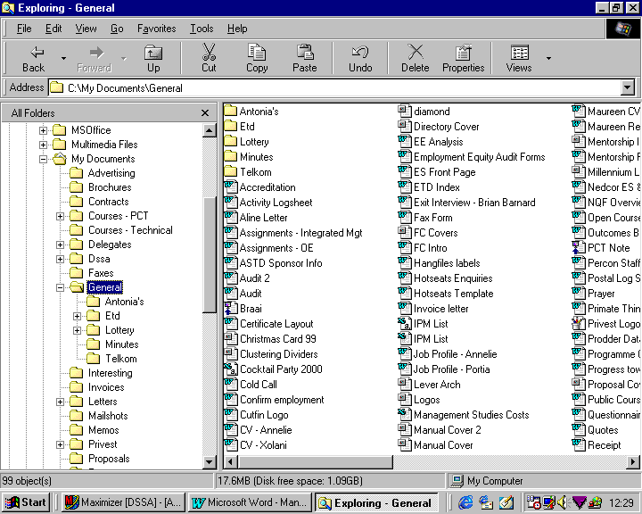

FILE MANAGEMENT

Outcome
Use standardised processes for identifying, securing and finding documents.

Assessment criteria
All documents are named and filed to agreed standards
Filing system is structured and indexed reflecting project, sub-project, phase and stage levels, management, quality and specialist (technical) products
Multiple versions of documents are correctly filed and annotated in accordance with agreed filing system
Back-up and archive processes are identified and utilised in accordance with agreed filing system
Sensitive and /or confidential documents are kept in safe custody

Assessment Criteria

The Process Of Filing

There are eight basic steps in a typical filing routine.

- Collecting the items to be filed.
If this is your responsibility, ensure that you collect the filing every day.
- Inspecting.
Make sure that the items are intended for filing.

Also ensure that confidential items do not lie around for everyone to see, they should preferably be placed in a separate folder and filed immediately.
- Indexing.
Which indexing system is used, where will the correspondence be placed?
Allocating a file reference number to the correspondence, according to the recognized filing system used by your organisation.
Make very sure that you allocate the correct reference to correspondence, as a document that was indexed incorrectly can be lost for a long period of time.
Certain files and correspondence will be confidential and only certain staff members will be allowed access to these files. Ensure that they are coded correctly and also that a notation is made on the outside of the file.
- Cross referencing.
If the correspondence refers to more than one file, use a cross-referencing system,
or, depending on the procedure in your company, add a copy of the correspondence to the other file as well.
- Sorting.
Sort the filing in the method of classification used by your organization – alphabetical, numerical, alpha-numerical.
Having the filing sorted in the correct order will speed up the filing process.
There are various types of sorters that can be used to help you sort the correspondence for filing:
- Concertina file: - it has 26 partitions, one for each letter of the alphabet. It is convenient for temporary sorting or storing as the file can expand when it becomes fuller.
- Pigeon hole: this is a shelf with 26 pigeon holes, one for each letter of the alphabet. It is mainly used in a mail room for sorting mail and is seldom used for general filing.
- Flap sorter, also known as an alphabetical sorter: this commonly called Long John Sorter. It is a thick cardboard strip with 26 flaps, one for each letter of the alphabet. Correspondence is sorted in the flaps before being placed in file folders.
- Filing.
File the correspondence, ensuring that you place the documents in the correct file.
Looking for correspondence that has been misfiled is a big waste of time for you and your co-workers looking for the information.
Ensure that you file confidential documents first
Documents must be filed chronologically, with the most recent date on top.
Ensure that you file the documents with their attachments and enclosures.
- Lending of files and file contents.
Ensure that the “out” cards are completed and signed for before handing over the files.
It will also be your responsibility to ensure that the file is returned. Follow up on outstanding files on a weekly or daily basis, depending on the procedure in your organization. This is especially important when confidential files are signed out.
When the file is returned, remember to sign it in again.
Make sure that confidential correspondence is not handed to unauthorized personnel.

OUT CARD
NAME OR SUBJECT | DATE | TAKEN BY | DATE RETURNED AND INITIALS
Smith James | 15/05/05 | NDP | 31/05/05 NDP
Tiger Brands | 15/05/05 | BJP | 26/05/05BJP
ABC Trading Co | 26/05/05 | ISN

DOCUMENT TEMPLATES

Outcome
Provide project templates to team members

Assessment criteria
Templates are prepared in accordance with requirements and accepted standards
Templates and their components are identified and explained in terms of how they should be used
Procedures for the usage of templates are explained and communicated to team members

Project Administration
As we have seen, a project is a complex initiative with many activities and involved parties. In a very large project, the company may insist that the project admin meets total quality management practice standards, such as those specified by the International Standards Organisation (ISO), or the South African Bureau of Standards (SABS). A large organisation which manages many large projects may have developed it’s own company ‘Special Preferred Practice / System’, which must be followed.
Whether the project is large or small it is essential to keep track of all operations. As such, it is essential that the project administration is efficiently recorded so that documents can be easily traced, accessed and retrieved when required.
In order to do this, a document management system has to be put into place. This may be computer based or may be a manual document control system.
The documents needed by a project are very similar to those needed in any business organisation.

Correspondence

Business letters
Business letters are sent to outside stakeholders such as the client, the community forum and so on. A business letter has a specific format

Memorandum
Memoranda are used to communicate internally: between the project manager and the project teams, between the project teams and so on. A memorandum remains within the project and is not sent to outside stakeholders.
The memorandum also contains details of the organisation in the form of a letterhead and will have a layout that has been defined by the organisation.
A memorandum is usually not signed by the writer

Faxes
A fax is a way of sending business correspondence via a facsimile machine. A covering page, called a facsimile transmittal sheet is sometimes used to send the letter or memorandum to the recipient. Or, the facsimile transmission sheet could be laid out so that it serves as the letter or memorandum as well.

Reports
A report will be used to give feedback to stakeholders about the progress of the project

Meetings

Agenda
a list of the topics to be discussed at the meeting. It must be sent to attendees before the meeting so that they can add topics if needed. The date, time and venue of the meeting must be quoted in the agenda. The final agenda will set out the topics that have to be discussed in the order that they will be discussed. The final item on the agenda is usually called General and anything that is not classified under the other topics will be discussed here. The final agenda must be available to attendees in the meeting

Distribution lists
to send the agenda and minutes of the meeting to everyone who has to receive them.

Attendance registers
for the people attending the meeting

Minutes
are very important documents. They are called minutes because they are a minute-by-minute record of procedures taking place at the meeting
In order to standardise documents it is useful to create templates that are easy to follow.

Project control documents
Several schedules will be developed.

Events Control Chart
The events control chart is used to control the completion of tasks and activities as they take place. It is also used to monitor the progress of a project by comparing the actual dates of completion with the planned completion dates.

Work breakdown structure
R

Budget Control Chart
This chart is used to compare the actual costs of the project against the budgeted costs. This chart is used to keep the costs of the project in line with what can be afforded. This chart will help the project manager to determine whether certain items are going to cost more or less than budgeted for

Resource chart
used to allocate resources

Preparation Control Chart
The preparation control chart is used to prepare for unplanned changes to a project. The project manager will list possibilities of things that can go wrong and then provide possible solutions and action plans to resolve these issues as they occur.

Materials control documents
Most large projects would use a lot of materials, such as cement, steel, sand, stones, etc. for building a stadium. These materials have to be controlled and the following documents are commonly used for this purpose:
Order forms
Inventory control sheets

Financial documents

Time sheets
This is a record of the hours an employee worked and is used to calculate salaries, wages and overtime.

Travel and expense claim
When employees have to travel or have to undertake expenses that have to do with the project, they have to be refunded. This has to be documented for financial control. If the employee purchased something, the proof of the purchase must be attached. This is usually a till slip or an invoice.

Petty cash voucher
Petty cash is used for small purchases, such as stamps or odd items of stationery. Petty cash transactions must also be administered correctly, as account must be given for all the money spent. When small purchases have to be made, a petty cash voucher is issued:

Templates may include the following:

Memo’s | E-mail messages | Document transmittal forms
Programme schedules | Equipment data sheets | Procedures
Contracts | Budget authorizations | Change orders
Rectification instructions | Petty cash vouchers | Faxes
Minutes of meetings | Various types of drawings | Cost reports
Specifications | Standing orders | Requisitions
Site instructions | Change notice | Variations orders
Petty cash returns
Materials control documents – Orders, receiving, issued, inventory levels, stock counts

HANDOVER DOCUMENTS

Outcome
Assist in preparing project documents for handover at the end of a project or a project phase/stage

Assessment criteria
Handover project documents are prepared in correct format and within agreed time frame
Handover project documents are complete, concise and in the required location and are handed over to appropriate individuals

At the completion of the project the handover procedures will be followed. This is discussed in a later unit standard.
Project administration will be responsible for completing the required handover documents, as laid down in the project procedures. Typical handover documents include:
- A declaration of a project's imminent completion: this declaration is sent to all stakeholders prior to the handover ceremony. The declaration should include the date, time and place of handover.
- Agreement of Satisfactory Completion and the Agreement Check-List: The hand-over agreement is used as a guide for use by the Project Manager and user to ensure that all relevant actions are attended to.
- Description of the overall progress of the project, resources used, costs incurred and the schedule followed
- The final report
- Any other documents as required by the project

These documents have to be prepared and handed over to the appropriate people involved in the project. Copies of all documents have to be filed with the project documentation.

MANAGE PROJECT DOCUMENTS

Outcome
Describe and explain project documentation management processes

Assessment criteria
Document control requirements for a project are explained with reasons for the control
Storage and retrieval functions and processes are explained with examples of each.
Benefits of documentation management for a project are explained with examples

