LEARNER
SUMMATIVE ASSESSMENT GUIDE
& PoE

Communication Level 3

Interpret and use information from texts.
Unit Standard 119457
Level 3 Credits 5

Write texts for a range of communicative contexts
Unit Standard 119465
Level 3 Credits 5

CONTENTS
CONTENTS i
Contact Details 1
Competence 2
Appeals & Disputes 3
Assessment Process Flow 4
PORTFOLIO OF EVIDENCE 5
Portfolio Building 5
Plan Your Portfolio 5
Gather The Evidence 5
Evaluate Your Evidence 5
Cross-Reference Your Evidence To The Unit Standards 5
Organise Your Information 6
Learner Documents 7
Learner Curriculum Vitae 7
Attendance Registers 8
ASSESSMENT STRATEGY 9
Assessment Preparation 10
Preparing The Candidate 10
Assessor’s declaration: 11
Agreed Assessment Plan 12
UNIT STANDARD 119457 15
UNIT STANDARD 119465 17
Formative Assessments 19
Summative Assessment Readiness Statement 20
Formative Assessments 21
Summative Assessment Readiness Statement 22
SUMMATIVE ASSESSMENTS 23
Knowledge Questionnaire 119457 & 119465 23

Contact Details

Assessor Details
Name
SETA |  |  |  | Registration No:
Contact Details | e mail:
 | Phone: |  |  | Fax:
Moderator Details
Name
SETA |  |  | Registration No:
Contact Details | e mail:
 | Phone: |  |  | Fax:
Candidate Details
Surname |  |  |  |  | Name
Employer |  |  |  |  | ID No
Branch
Contact Details | e mail:
 | Phone: |  |  |  | Fax:

Competence
Congratulations on completing the following programme. We sincerely hope you enjoyed the programme and that the learning experience was enriching.
The fact that you have attended training, however, is not sufficient evidence of your competence for us to award you a certificate and the credits attached to this programme. You are required to undergo assessment in order to prove your competence to achieve credits leading to a national qualification.

Being Declared Competent Entails:
Competence is the ability to perform whole work roles, to the standards expected in employment, in a real working environment.
There are three levels of competence:
- Foundational competence: an understanding of what you do and why
- Practical competence: the ability to perform a set of tasks in an authentic context
- Reflexive competence: the ability to adapt to changed circumstances appropriately and responsibly, and to explain the reason behind the action
To receive a certificate of competence and be awarded credits, you are required to provide evidence of your competence by compiling a portfolio of evidence, which will be assessed by a Services SETA accredited assessor.

You Have to Submit a Portfolio of Evidence
A portfolio of evidence is a structured collection of evidence that reflects your efforts, progress and achievement in a specific learning area, and demonstrates your competence.

The Assessment of Your Competence
Assessment of competence is a process of making judgments about an individual's competence through matching evidence collected to the appropriate national standards. The evidence in your portfolio should closely reflect the outcomes and assessment criteria of the unit standards of the learning programme for which you are being assessed. To determine a candidate’s knowledge and ability to apply the skills before and during the learning programme, formative assessments are done to determine the learner’s progress towards full competence. This normally guides the learner towards a successful summative (final) assessment to which the assessor and the candidate only agree when they both feel the candidate is ready.
Should it happen that a candidate is deemed not yet competent upon a summative assessment, that candidate will be allowed to be re-assessed. The candidate can, however, only be allowed two reassessments. When learners have to undergo re-assessment, the following conditions will apply:
- Specific feedback will be given so that candidates can concentrate on only those areas in which they were assessed as not yet competent
- Re-assessment will take place in the same situation or context and under the same conditions as the original assessment
- Only the specific outcomes that were not achieved will be re-assessed
Candidates who are repeatedly unsuccessful will be given guidance on other possible and more suitable learning avenues. In order for your assessor to assess your competence, your portfolio should provide evidence of both your knowledge and skills, and of how you applied your knowledge and skills in a variety of contexts. This Candidate’s Assessment Portfolio directs you in the activities that need to be completed so that your competence can be assessed and so that you can be awarded the credits attached to the programme.

Appeals & Disputes
The candidate has the right to appeal against assessment decision or practice they regard as unfair. An Appeals and Disputes procedure is in place and communicated to all assessment candidates in order for them to appeal on the basis of:
- Unfair assessment
- Invalid assessment
- Unreliable assessment
- Unethical practices
- Inadequate expertise and experience of the assessor
Appeals have to be lodged in writing (Candidate Appeal Form) & submitted to the Training Provider internal moderator within 48 hours, following the assessment in question. The moderator will consider the appeal & make a decision regarding the granting of a re-assessment. The learner will be informed about the appeal-outcome within 3 days of lodging the appeal. Should the learner not be satisfied with the internal appeal outcome, the learner will be advised of the rights to refer the matter to the SETA ETQA.

Abbreviations used in this guide:
C = Competent
NYC = Not Yet Competent

Assessment Process Flow

Assessment Activities conducted per the Assessment Plan
Assessment Plan agreed by candidate & completed by the assessors before the actual assessment
CANDIDATE

Detailed Assessor Report compiled & forwarded for Moderation
ASSESSMENT
Assessment Guide submitted to Training provider as per Assessment Plan

Feedback Report Completed by Assessor & individual feedback given to candidate
Appeal form completed by the candidate in event of dispute
Record of Learning Updated
Assessment Results Moderated

Action Plan completed by Assessor

All records & evidence filed
SETA
Completed Assessor report/Moderator report/Record of Learning forwarded to SETA
Approval and Certification obtained from SETA
SETA to register on National Learner Database

Certificate of Competencies issued to successful candidates

PORTFOLIO OF EVIDENCE

Portfolio Building
Your Portfolio of Evidence (PoE) contains the evidence needed to declare you competent and to award credits towards the award of this qualification to you. Evidence should be authentic and reflect both your knowledge of the subject and your ability to apply this knowledge in the workplace. Thus, evidence day to day activities supporting the specific outcomes addressed by this learning programme should complement the theoretical learning you attended and were assessed on.
There are FIVE key steps in creating a portfolio that will reflect your competence.

Plan Your Portfolio
Plan and document the sequence, graphics and layout of your portfolio. This will assist you in following a logical sequence, which makes the Portfolio also much more user friendly and understandable for the assessor. It will also reflect your professional approach and attitude towards the subject matter, your work and your life. Impact and appearance always contribute to or affect your chances of being taken seriously and declared competent!

Gather The Evidence
An evidence checklist has been provided (Section 4) to tell you what evidence needs to be gathered for assessment purposes. However, there are four broad categories of evidence that you should include:
- Knowledge evidence (your knowledge questionnaire)
- Direct performance evidence (actual samples of your work or records of activities captured on audio or video tape)
- Indirect performance evidence (documentary records of your performance e.g. appraisals, photographs, testimonials, self-assessments, customer ratings etc.)
- Supplementary evidence (to confirm the authenticity of your evidence)

Evaluate Your Evidence
Once you have collected your evidence, evaluate each piece by ensuring that it is:
- Valid (relevant to the unit standard/s being assessed)
- Authentic (clearly your own work)
- Current (not more than 2 years old)
- Sufficient (adequate to prove your competence against all of the assessment criteria and range statements in the unit standard/s)

Cross-Reference Your Evidence To The Unit Standards
Evidence for assessment against unit standards must be linked to the outcomes of the unit standard in question. An evidence locator grid is useful for this.

Organise Your Information

How you structure your portfolio is critical. Your design and layout must look professional and clearly articulate your achievements, and it should make sense to someone seeing it for the first time. Use the following structure as a guide:
- A title page indicating:
- The title of the programme
- The unit standard titles to which the programme is aligned
- The assessment centre (The training provider)
- Your name, position and organisation
- Your contact details
- The name of your assessor
- The name of your moderator
- The date
- An index
- Background information
- Curriculum Vitae
- Organisation profile
- Job profile
- Organisation/department structure
- A copy of the unit standard/s
- Your assessment plan
- Your completed Knowledge Questionnaire
- An evidence locator grid
- The evidence itself
- Supporting evidence e.g. witness testimonies, reflections and witness status list
- Assessment records

Learner Documents

Learner Curriculum Vitae

Please file your CV behind this page. Please remember to include a copy of your Identity Document (ID).

Attendance Registers

File your attendance registers behind this page.

ASSESSMENT STRATEGY
These assessment exercises will cover the assessment criteria for the unit standard in order to prove competence. The purpose of the assessment process is to gather enough evidence to prove that the assessment criteria were achieved.
Competency will be assessed through a knowledge questionnaire as well as workplace activities and assignments recorded in POE. Assessment evidence should be sufficient to prove that the candidate is capable in all required tasks set by the unit standards and a competency judgement will be made regarding the exit level outcome. Principles of fairness, validity, practicability, reliability and consistency will be adhered to throughout.

Unit standard | Communication Level 3 |  | Unit Standard Codes |  | 119457; 119465.
Level | 3 |  | Credits |  | 10
Purpose of Assessment | The purpose of this assessment is to achieve the first step into applying the acquired skills and knowledge in the workplace
Assessment Procedures | - An integrated assessment approach will be followed to allow for practical and theoretical components. The entails the assessment of a number of unit standards, outcomes and criteria together in one assessment activity  - Candidates are not only assessed against specific outcomes, but also on critical outcomes, attitudes and values  - A summative competence judgment will be made on the basis of all assessment evidence produced, that proves that the candidate can be consistently judged as competent against the outcomes of the unit standards and the qualification as a whole.  - Candidates take responsibility for their own assessment and should notify the assessor when they are ready for assessment  - Candidates will receive feedback after the summative assessment, which will be discussed after all assessments have been completed  - All assessments will be reviewed to ensure that assessment practices are valid, fair, transparent, consistent and current  - An Internal/External moderator will moderate assessment practices  - The SETA will also conduct external moderation
Context of Assessment | Assessment Method | Assessment Conditions |  | Who will conduct assessment | Assessment results and feedback
 | Questionnaires  Work sample  Observation | Input based assessments |  | Assessor | Immediate

Assessment Preparation

Preparing The Candidate
Name of Candidate |  |  | Date
 |  |  | Time
Name of Assessor |  |  | Venue
How to prepare the candidate |  | Document Requirements | Agree (tick) | Action Required
Explain to the candidate why your are meeting and the purpose of the assessment |  | NQF Framework Assessment process
Discuss the assessment plan in detail |  | Assessment strategy
Explain assessment process, show assessment instruments to candidate and describe assessment conditions |  | Assessment instruments
Identify the role-players during assessment |  | Assessors  Moderator
Describe the evidence required to be declared competent |  | Examples of evidence
Explain how evidence will be judged
Explain to the candidate how to prepare: Give candidate summative task description |  | Summative task description
Confirm with the candidate what he/she should bring to the assessment |  | Detailed briefing on exact requirements to be given to candidate
Ensure that candidate understands the procedures of all assessment practices |  | Appeals procedure  Moderation procedure  Assessment policy
Ask the candidate if he/she foresees any problems or identify any special needs |  | List needs
Check with candidate that he/she clearly understands the assessment procedure
Comments or questions:

Assessor’s declaration:
I hereby declare that I have prepared the candidate for assessment, the candidate was consulted and all stakeholders have been informed and the workplace is prepared to ensure valid and fair assessment.
Assessor Name | Signature

Agreed Assessment Plan
Candidate's Name:
Assessor's Name:
Unit Standard Title: | 119457 Interpret and use information from texts  119465 Write texts for a range of communicative contexts
Special Assessment Requirements
Event | Date, time and location | Resources required | Evidence to be generated
Attend Training |  | Training material, Facilitator | Attendance Register
Complete assessments |  | Assessments | Completed Assessments
Complete Portfolio of Evidence |  | Portfolio of Evidence guide | Completed Portfolio of Evidence
Submit Portfolio of Evidence to Training provider |  |  | Acknowledgement of receipt from Training provider
Assessor roles and responsibility
Roles | - Assessor  - Guide  - Feedback Agent  - Reviewer
Responsibilities | - Consult candidate re assessment, assessment process and plan  - Agree assessment process and plan with candidate  - Forward documentation to candidate: plan, guide and assessment instruments  - Assess candidate with the use of different instruments  - Provide feedback on assessment findings  - Support candidate through assessment process  - Source feedback from candidate on assessment process  - Review assessment process and outcome  - Use assessment process as opportunity to transform assessment activities and outcomes

Candidate roles and responsibility
Roles | - Candidate  - Feedback agent  - Reviewer
Responsibilities | - Be available for assessment  - Be actively involved in the consultative process  - Learn from the assessment process  - Provide feedback to the assessor in terms of the assessment as learning activity  - Provide feedback to the assessor on the efficacy of the assessment process  - Review own role and assessor role in the assessment process
Assessment Instruments | - Portfolio of evidence  - Work sample  - Observation
Assessment Process
Step |  | Date
- Evaluation of POE addressing Essential Embedded Knowledge in unit standards
- Evaluation of Research Projects and other evidence address specific unit standards
- Consultation: assessment plan and assessment activities and instruments. Pre-assessment moderation and interviews conducted at this stage
- Observation: feedback on assessment against specific outcomes, critical outcomes and constructs in unit standards
- Feedback: to candidate regarding sufficiency of evidence and possible interview to gain supplementary evidence
- Feedback to candidate regarding assessment findings as well as review process
Feedback | Written feedback to be given to all stakeholders at the end of the assessment process, as well as verbal feedback to the candidate during assessment activities
Recording Process | Process and findings to be recorded and submitted for record keeping purposes as well as moderation and verification
Review Process | The review process is the responsibility of the assessor and the candidate. Joint reviewing will take place after feedback has been given to the candidate
Right to appeal | The candidate must be advised of the right to appeal

Accessibility and safety of environment | Step |  | Date
- Site inspection conducted
- Pre-assessment moderation conducted
Resources Required | - Assignments  - POE  - Assessments
I confirm that:
- I have been consulted on and have agreed to the training and assessment process as detailed in the assessment guide
- I have been advised of my right to appeal against any assessment that is unfair, unreliable, invalid or impracticable
- I have read and understood the appeal procedure
- I know that assessments may be moderated or verified by an external party
- The purpose of the assessment has been clearly explained to me
- The criteria have been discussed with me, and I know I will be assessed against these criteria
- I know when and where I will be assessed, and I was given fair notice
- I know how the assessment will be done, and any other requirements related to the assessment
- I am ready to be assessed

Signed: Date: ______
Overall Assessment Decision | Competent | Not yet competent
Candidate’s Signature |  | Date
Assessor’s Signature |  | Date
Moderator’s Signature |  | Date

UNIT STANDARD 119457
Unit Standard Title:
Interpret and use information from texts
NQF Level:
3
Credits:
5
Specific Outcome 1:
Use a range of reading and viewing strategies to understand the literal meaning of specific texts
Assessment Criteria
- Unfamiliar words are identified. Their meanings are correctly determined by using knowledge of syntax, word-attack skills, and contextual clues: Borrowed words, complex terms, acronyms, neologisms, colloquialisms, slang, jargon, dialect
- Different options for the meanings of ambiguous words are tested, and selected meanings are correct in relation to the context
- Main ideas are separated from supporting evidence and paraphrased or summarised
- The purpose of visual and/or graphic representations in texts are recognised and explained: Photographs, aerial photographs, schema, bar graphs, pie charts, pictures, drawings, illustrations, cartoons, maps, mind-maps, diagrams
Specific Outcome 2:
Use strategies for extracting implicit messages in texts
Assessment Criteria
- Source of text is identified and discussed in terms of reliability and possible bias
- Author’s attitude, beliefs and intentions are explored in order to determine the point of view expressed either directly or indirectly
- Author’s techniques are explored and explained in terms of purpose and audience: Length of sentence, punctuation, diction/choice of words, use of figurative language/jargon/technical terms/slang/dialect/irony/humour/satire/sarcasm/legalisms, choice of visuals, choice of camera angle, type of shot, cinematographic techniques
- Promotion of, or support for, a particular line of thought/cause is identified and explained with reference to selection or omission of materials
Specific Outcome 3:
Respond to selected texts in a manner appropriate to the context
Assessment Criteria
- Instructions and requests are acted upon.
- Text-type, format and register used are on the correct level of formality
Specific outcome 4:
Explore and explain how language structures and features may influence a reader
Assessment criteria
The choice of words, language usage, symbols, pictures and tone is described in terms of how a point of view is shaped or supported: Bias (cultural, religious or peer preferences, misrepresentation, discrimination, racist, sexist, ageist), humour, irony, sarcasm, use of omission and silence, figurative expressions, repetition, hyperbole, generalisations, stereotyping, pictures and captions, typography and grammar

Critical Cross-field Outcomes (CCFO)
- Identify and solve problems: using context to decode and make meaning individually and in groups in oral, reading and written activities.
- Work effectively with others and in teams: using interactive speech in activities, discussion and research projects
- Organise and manage oneself and one’s activities responsibly and effectively through using language
- Collect, analyse, organise and critically evaluate information: fundamental to the process of developing language capability across language applications and fields of study
- Communicate effectively using visual, mathematical and/or language skills: in formal and informal communications
- Use science and technology effectively and critically: using technology to access and present texts
- Understand the world as a set of inter-related parts of a system: through using language to explore and express links, and exploring a global range of contexts and texts

UNIT STANDARD 119465
Unit Standard Title:
Write texts for a range of communicative contexts
NQF Level:
3
Credits:
5
Specific Outcome 1:
Write for a specified audience and purpose: Narrative, discursive, reflective, argumentative, descriptive, expository, transactional, business correspondence, electronic texts, multi-media presentations
Assessment Criteria
- The purpose for writing, the target audience and the context is clear, in relation to the learning task or activity
- The text-type, style, and register selected are appropriate to audience, purpose and context
- Language appropriate to socio-cultural sensitivities is selected and used in an appropriate manner without compromising own values or arguments
- Writing is well-structured and conveys its message clearly
- Critical thinking skills are used as strategies for planning: Brainstorming, mind-mapping, spider diagram, highlighting
- Arguments are supported with sound reasons and facts, and writing reflects a clear point of view, and shows logical development of a clearly articulated premise
- Research skills are evident in the way data and information relevant to the context is identified, located and selected for inclusion in the final text: Accessing information from different sources; sorting; categorising; classifying; sifting for relevance, validity and reliability; recording; reporting; formulating conclusions
Specific outcome 2:
Use language structures and features: Use language structures and features to produce coherent and cohesive texts for a wide range of contexts
Assessment criteria
- Meaning is clearly expressed through the use of a range of sentence lengths, types, and complexities
- The use of paragraph conventions, including links between paragraphs in texts, promotes coherence and cohesion in writing. Their use is explained with reference to logical progression, cause and effect, and contrast
- The overall structure of a piece of writing is controlled and the conclusion is clearly formulated
Specific outcome 3:
Draft own writing and edit to improve clarity and correctness
Assessment criteria
- Writing produced is appropriate to audience, purpose and context. Corrections are an improvement on the original
- Control of grammar, diction, sentence and paragraph structure is checked and adapted for consistency
- Logical sequencing of ideas and overall unity is achieved through redrafting
- There is clear evidence that major grammatical and linguistic errors are edited out in redrafts.
- Inappropriate or potentially offensive language is identified and adapted/removed: Obfuscation, excessive use of jargon, jargon used to exclude, insensitive choice of words, (gender, rank, hierarchies in familiar settings or organisations, family, sports, wealth) offensive or incorrect register
- Experimentation with different layout and options for presentation are appropriate to the nature and purpose of the task

Critical Cross-field Outcomes (CCFO)
- Identify and solve problems: using context to decode and make meaning individually and in groups in oral, reading and written activities
- Work effectively with others and in teams: using interactive speech in activities, discussion and research projects
- Organise and manage oneself and one’s activities responsibly and effectively through using language
- Collect, analyse, organise and critically evaluate information: fundamental to the process of developing language capability across language applications and fields of study
- Communicate effectively using visual, mathematical and/or language skills: in formal and informal communications
- Use science and technology effectively and critically: using technology to access and present texts
- Understand the world as a set of inter-related parts of a system: through using language to explore and express links, and exploring a global range of contexts and texts
- Contribute to the full development of self by engaging with texts that stimulate awareness and development of life skills and the learning process

Formative Assessments
During your training, you were required to complete a number of activities within each Lesson in your Learner Study Guide. You need to complete these activities and attach the evidence of each in this section of your PoE.

Summative Assessment Readiness Statement
Note: R = Ready for summative assessment. NYR = Not Yet Ready for summative assessment
Candidate's Name |  |  |  |  | ID No.
Assessor's Name |  |  |  |  | Reg. No.
Unit Standard Title | 119457 Interpret and use information from texts
ASSESSMENT DECISION
Specific Outcome |  | R | NYR | Comments
Use a range of reading and viewing strategies to understand the literal meaning of specific texts
Use strategies for extracting implicit messages in texts
Respond to selected texts in a manner appropriate to the context
Explore and explain how language structures and features may influence a reader

Assessor’s / Facilitator declaration:
I hereby declare that I have assessed the learner’s formative assessment and find the learner ready / not yet ready for the summative assessment
Assessor / Facilitator Name | Signature

Formative Assessments
During your training, you were required to complete a number of activities within each Lesson in your Learner Study Guide. You need to complete these activities and attach the evidence of each in this section of your PoE.

Summative Assessment Readiness Statement
Note: R = Ready for summative assessment. NYR = Not Yet Ready for summative assessment
Candidate's Name |  |  |  |  | ID No.
Assessor's Name |  |  |  |  | Reg. No.
Unit Standard Title | 119465 Write texts for a range of communicative contexts
ASSESSMENT DECISION
Specific Outcome |  | R | NYR | Comments
Write for a specified audience and purpose
Use language structures and features
Draft own writing and edit to improve clarity and correctness
Write for a specified audience and purpose

Assessor’s / Facilitator declaration:
I hereby declare that I have assessed the learner’s formative assessment and find the learner ready / not yet ready for the summative assessment
Assessor / Facilitator Name | Signature

SUMMATIVE ASSESSMENTS

Knowledge Questionnaire 119457 & 119465
Read through the article and then answer the questions that follow.
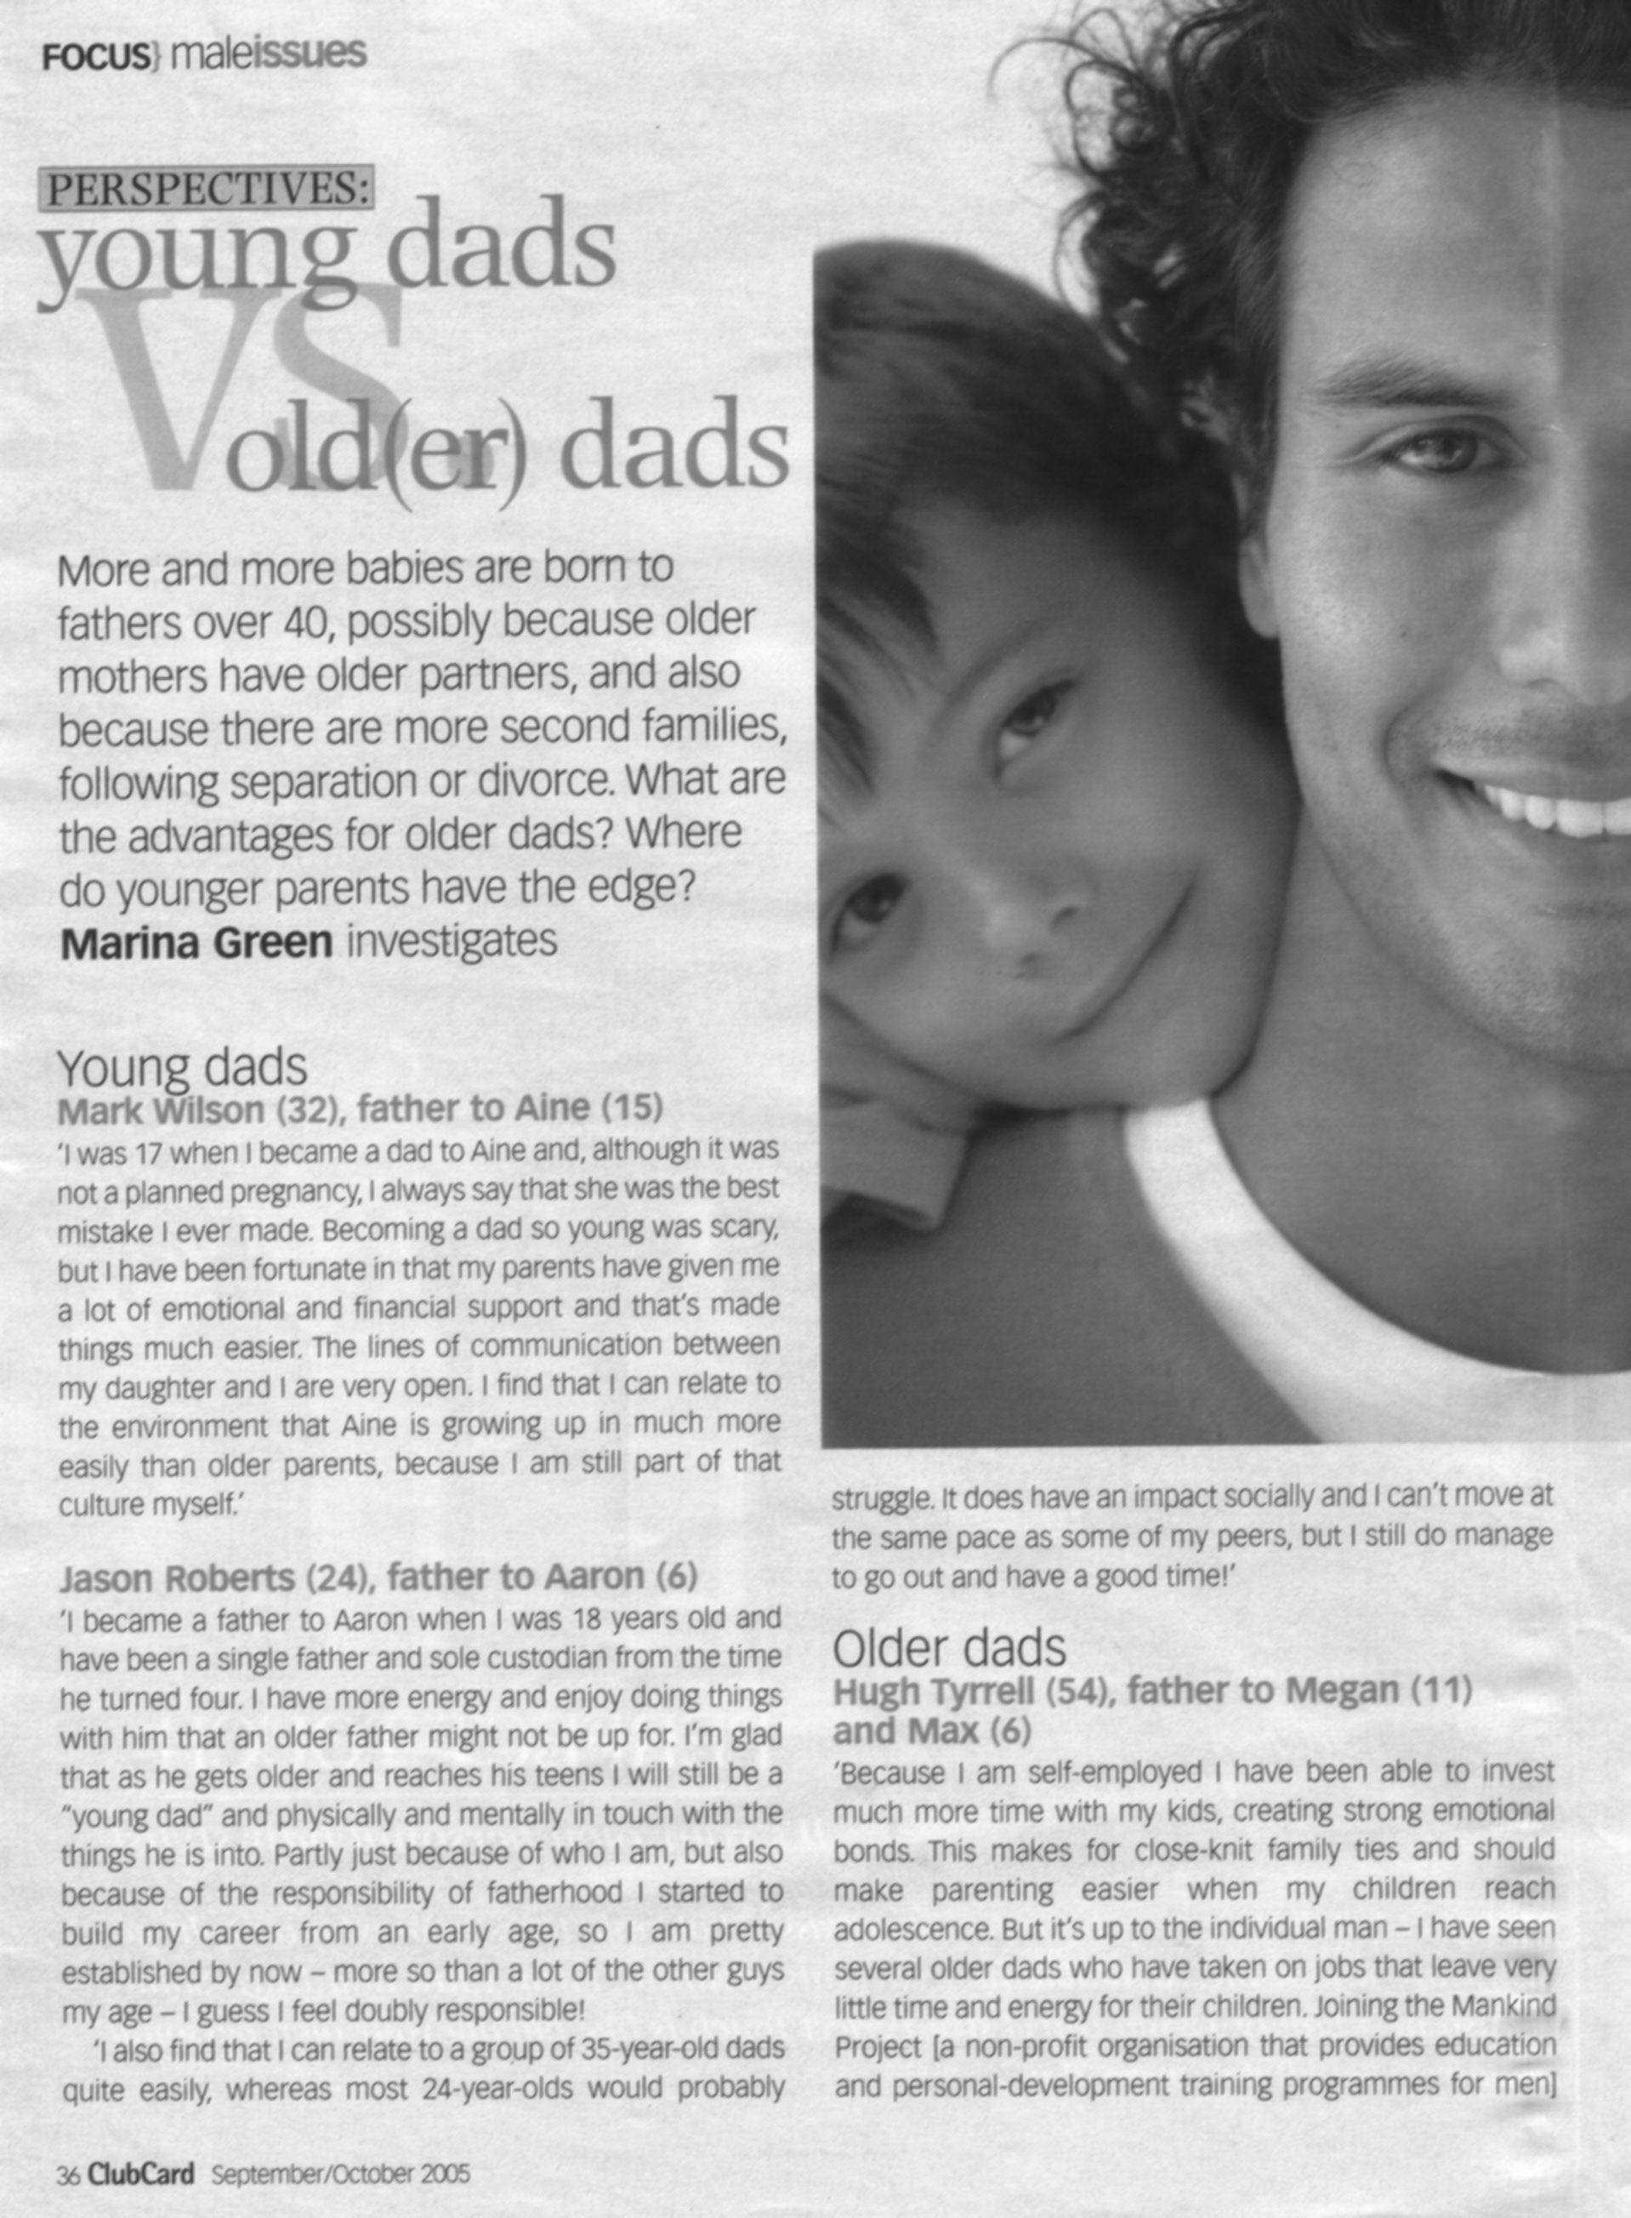

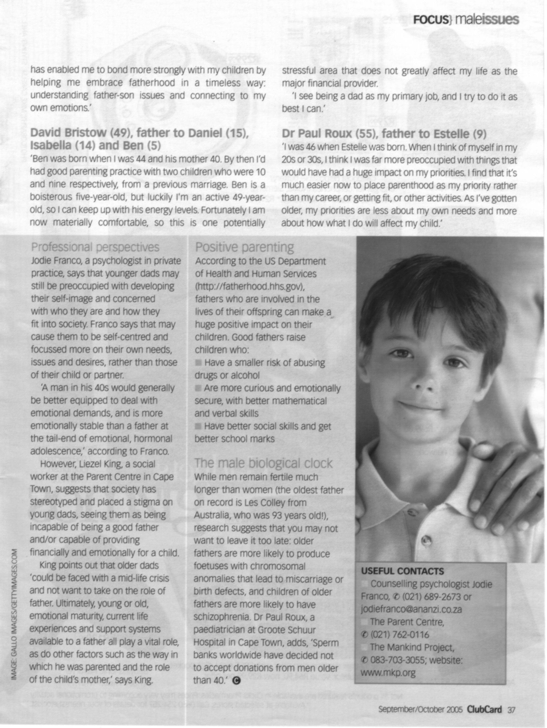

Unit Standard 119457 Specific Outcome 1: Use a range of reading and viewing strategies to understand the literal meaning of specific tests. Assessment criterion: Unfamiliar words are identified. Their meanings are correctly determined by using knowledge of syntax, word-attack skills and contextual clues.
- Underline at least three unfamiliar words. Explain the process you followed to determine their meanings.(6)
- List the words and their meanings. (3)

Assessment criterion: Different options for the meanings of ambiguous words are tested and selected meanings are correct in relation to the context.
- In the paragraph about Mark Wilson, father to Aine, Mark says: ‘she was the best mistake I ever made.” This is an ambiguous phrase, as mistakes are not usually good. What does he mean? Explain how you came to this conclusion. (3)
Assessment criterion: The purpose of visual and/or graphic representations in texts are recognised and explained.
- Why did they include photos of men and boys? (1)
- Do the photos explain the topic of the article? Motivate your answer. (2)
- Did the photos capture your attention? Motivate your answer. (2)
- Did the photos encourage you to read the article? Motivate your answer. (2)

Unit Standard 119457 Specific Outcome 2: Use strategies for extracting implicit messages in texts. Assessment criterion: Source of text is identified and discussed in terms of reliability and possible bias..
- Who is the author of the article? (1)
- Do you think the author is biased? Motivate your answer with at least three quotes from the article. (4)
Assessment criterion: Author’s attitude, beliefs and intentions are explored in order to determine the point of view expressed either directly or indirectly.
- Does the author have a point of view about older or younger fathers? Motivate your answer. (2)
- Is Jason Robert’s view expressed directly or indirectly? Motivate your answer. (2)
Assessment criteria: Author’s techniques are explored and explained in terms of purpose and audience; Promotion of, or support for, a particular line of thought/cause is identified and explained with reference to selection or omission of materials
- What is the purpose of the article? (1)
- Who is the article aimed at? Motivate your answer. (2)
- How does the author vary the length of the sentences? Motivate your answer by stating whether there are long and short sentences and whether there are more short sentences than long sentences. (2)
- Does the author’s diction make the article easy to read? Motivate your answer. (1)
- Identify jargon and technical words. Give at least two. (2)

Unit Standard 119457 Specific Outcome 4: Explore and explain how language structures and features may influence a reader. Assessment criterion: The choice of words, language usage, symbols and pictures and tone is described in terms of how a point of view is shaped or supported
- Does the author discriminate against older fathers? Motivate your answer. (2)
- Do you think the author is biased? Motivate your answer with at least three quotes from the article. (4)

Assessment criterion: Author’s attitude, beliefs and intentions are explored in order to determine the point of view expressed either directly or indirectly.
- Does the author use repetition in the article? Motivate your answer. (2)
- Is the author sarcastic? Motivate your answer. (2)

Unit Standard 119465 Specific Outcome 1: Write for a specified audience and purpose; Specific Outcome 3: Draft own writing and edit to improve clarity and correctness.
Unit Standard 119457 Specific Outcome 1: Use a range of reading and viewing strategies to understand the literal meaning of specific texts; Specific Outcome 3: Respond to selected texts in a manner appropriate to the context. Assessment criterion: Main ideas are separated from supporting evidence and paraphrased or summarised.
- Summarise the article. (1)
Assessment criterion: Critical thinking skills are used as strategies for planning.
- Start your first draft by drawing a mind-map. Attach the mind-map to your assessment. (1)

Assessment criteria: Corrections are an improvement on the original; Control of grammar, diction, sentence and paragraph structure is checked and adapted for consistency; There is clear evidence that major grammatical and linguistic errors are edited out in drafts; Inappropriate or potentially offensive language is identified and adapted / removed; Experimentation with different layout and options for presentation are appropriate to the nature and purpose of the task; Write the first draft of your summary. Attach the first draft to your assessment. (1)
- Rewrite the summary. Did you check and adapt your choice of words? Attach the second draft to your assessment. (1)
- Did you correct your grammar in the second draft? (1)
- Did you identify and remove inappropriate or potentially offensive language? (1)
- Did you experiment with the layout of your summary? (1)
Assessment criterion: Meaning is clearly expressed through the use of a range of sentence lengths, types and complexities.
- Write the final summary. Ensure that you make use of long and short sentences in your summary. (2)
- Make use of simple sentences. (1)
- Make use of compound sentences. (1)
- Make use of complex sentences. (1)
Assessment criterion: The use of paragraph conventions, including links between paragraphs in texts, promotes coherence and cohesion in writing.
- Does your summary have an introductory paragraph? (1)
- Does your introductory paragraph introduce the main topic? (2)
- Do your paragraphs follow each other logically? (1)
- Which method did you use to help you arrange your paragraphs in a logical way? (1)
- Does the first sentence of each paragraph introduce the topic of the paragraph? (1)
- Is your conclusion clearly formulated? (1)

Unit Standard 119465 Specific Outcome 3: Draft own writing and edit to improve clarity and correctness; Specific Outcome 2: Use language structures and features to produce coherent and cohesive texts for a wide range of contexts
Unit Standard 119457 Specific Outcome 3: Respond to selected texts in a manner appropriate to the context. Assessment criteria: Text type, format and register are on the correct level of formality; Writing produced is appropriate to audience, purpose and context
- Did you write your summary in the formal or informal register? (1)
Assessment criterion: Meaning is clearly expressed through the use of a range of sentence lengths, types and complexities.
- Rewrite your first draft. Ensure that you make use of long and short sentences in your summary. (2)
- Make use of simple sentences. (1)
- Make use of compound sentences. (1)
- Make use of complex sentences. (1)

Assessment criteria: The use of paragraph conventions, including links between paragraphs in texts, promotes coherence and cohesion in writing; Instructions and requests are acted upon; The overall structure of a piece of writing is controlled and the conclusion is clearly formulated; Arguments are supported with sound reasons and facts, and writing reflects a clear point of view, and shows logical development of a clearly articulated premise; Research skills are evident in the way data and information relevant to the context is identified, located and selected for inclusion in the final text
- Does your summary have an introductory paragraph? (1)
- Does your introductory paragraph introduce the main topic? (2
- Do your paragraphs follow each other logically? (1)
- Which method did you use to help you arrange your paragraphs in a logical way? (1)
- Does the first sentence of each paragraph introduce the topic of the paragraph? (1)
- Is your conclusion clearly formulated? (1)

TOTAL: (75)

