**LEARNER GUIDE**

**Communication Level 4**

**Read, Analyse And Respond To A Variety Of Texts**

Unit Standard 119469

Level 4 Credits 5

# TABLE OF CONTENTS

TABLE OF CONTENTS ii

PERSONAL INFORMATION 1

INTRODUCTION 2

Structure 3

Programme methodology 3

What Learning Material you should have 4

Different types of activities you can expect 5

Assessments 6

Learner Support 7

Learner Administration 7

Learner Expectations 8

UNIT STANDARD 119469 9

ANALYSE TEXTS 11

Introduction 11

Reading Skills 12

Reading Strategies 12

Skim 13

Scan 13

Sift 13

Prediction 13

Formative Assessment 1 14

Text Type 14

Genres 14

Formative assessment 2 14

Organisational Features Of Text 14

Titles, Chapters, Contents 15

Visual Clues 20

Visual And Graphic Representations 22

Diagram 22

Photographs 22

Arial Photography 23

Pie Chart 24

Bar Graph 25

Cartoons 26

Formative Assessment 3 26

ANALYSING WRITTEN MATERIALS 27

Explicit versus implicit 27

Omissions and Silence 28

Formative Assessment 5 28

CONTENT, LANGUAGE AND STYLE 29

Writing Techniques 29

Sentence Length 29

Diction 30

Punctutaion 31

Grammar 31

Language Structures And Features 32

Dealing With Bias 32

Humour 33

Sarcasm 33

Irony 33

Satire 33

Hyperbole 33

Generalisations 34

Stereotyping 34

Slang 34

Dialect 34

Jargon 34

Complex Terms 35

Ambiguous Words 35

Figurative Language 35

Idioms And Proverbs 36

Formative Assessment 7 36

Production Techniques In Visual Aids 36

Photographs And Slides 36

Transparencies 37

Posters 38

Videos And Films 38

# PERSONAL INFORMATION

|  |  |
| --- | --- |
| **NAME** |  |
| **CONTACT ADDRESS** |  |
|  |
| **Code** |  |
| **Telephone (H)** |  |
| **Telephone (W)** |  |
| **Cellular** |  |
| **Learner Number** |  |
| **Identity Number** |  |
| **EMPLOYER** |  |
| **EMPLOYER CONTACT ADDRESS** |  |
|  |
| **Code** |  |
| **Supervisor Name** |  |
| **Supervisor Contact Address** |  |
|  |
| **Code** |  |
| **Telephone (H)** |  |
| **Telephone (W)** |  |
| **Cellular** |  |

# **INTRODUCTION**

#### Welcome to the learning programme

Follow along in the guide as the training practitioner takes you through the material. Make notes and sketches that will help you to understand and remember what you have learnt. Take notes and share information with your colleagues. Important and relevant information and skills are transferred by sharing!



This learning programme is divided into sections. Each section is preceded by a description of the required outcomes and assessment criteria as contained in the unit standards specified by the South African Qualifications Authority. These descriptions will define what you have to know and be able to do in order to be awarded the credits attached to this learning programme. These credits are regarded as building blocks towards achieving a National Qualification upon successful assessment and can never be taken away from you!

## Structure

### Programme methodology

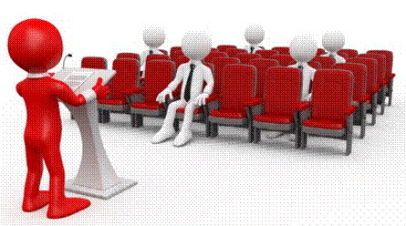

The programme methodology includes facilitator presentations, readings, individual activities, group discussions and skill application exercises.

**Know what you want to get out of the programme from the beginning and start applying your new skills immediately. Participate as much as possible so that the learning will be interactive and stimulating.**

The following principles were applied in designing the course:

* Because the course is designed to maximise interactive learning, you are encouraged and required to participate fully during the group exercises
* As a learner you will be presented with numerous problems and will be required to fully apply your mind to finding solutions to problems before being presented with the course presenter’s solutions to the problems
* Through participation and interaction the learners can learn as much from each other as they do from the course presenter
* Although learners attending the course may have varied degrees of experience in the subject matter, the course is designed to ensure that all delegates complete the course with the same level of understanding
* Because reflection forms an important component of adult learning, some learning resources will be followed by a self-assessment which is designed so that the learner will reflect on the material just completed.

This approach to course construction will ensure that learners first apply their minds to finding solutions to problems before the answers are provided, which will then maximise the learning process which is further strengthened by reflecting on the material covered by means of the self-assessments.

#### Different role players in delivery process

* Learner
* Facilitator
* Assessor
* Moderator

### What Learning Material you should have

This learning material has also been designed to provide the learner with a comprehensive reference guide. It is important that you take responsibility for your own learning process; this includes taking care of your learner material. You should at all times have the following material with you:

|  |  |
| --- | --- |
| **Learner Guide** | **This learner guide is your valuable possession:**  This is your textbook and reference material, which provides you with all the information you will require to meet the exit level outcomes. During contact sessions, your facilitator will use this guide and will facilitate the learning process. During contact sessions a variety of activities will assist you to gain knowledge and skills.  Follow along in the guide as the training practitioner takes you through the material. Make notes and sketches that will help you to understand and remember what you have learnt. Take and share information with your colleagues. Important and relevant information and skills are transferred by sharing!  This learning programme is divided into sections. Each section is preceded by a description of the required outcomes and assessment criteria as contained in the unit standards specified by the South African Qualifications Authority. These descriptions will define what you have to know and be able to do in order to be awarded the credits attached to this learning programme. These credits are regarded as building blocks towards achieving a National Qualification upon successful assessment and can never be taken away from you! |
| **Formative Assessment Workbook** | The Formative Assessment Workbook supports the Learner Guide and assists you in applying what you have learnt.  The formative assessment workbook contains classroom activities that you have to complete in the classroom, during contact sessions either in groups or individually.  You are required to complete all activities in the Formative Assessment Workbook. The facilitator will assist, lead and coach you through the process. These activities ensure that you understand the content of the material and that you get an opportunity to test your understanding. |

### Different types of activities you can expect

To accommodate your learning preferences, a variety of different types of activities are included in the formative and summative assessments. They will assist you to achieve the outcomes (correct results) and should guide you through the learning process, making learning a positive and pleasant experience.



The table below provides you with more information related to the types of activities.

| **Types of Activities** | **Description** | **Purpose** |
| --- | --- | --- |
| **Knowledge Activities** | You are required to complete these activities on your own. | These activities normally test your understanding and ability to apply the information. |
| **Skills Application Activities** | You need to complete these activities in the workplace | These activities require you to apply the knowledge and skills gained in the workplace |
| **Natural Occurring Evidence** | You need to collect information and samples of documents from the workplace. | These activities ensure you get the opportunity to learn from experts in the industry.  Collecting examples demonstrates how to implement knowledge and skills in a practical way |

### Assessments

The only way to establish whether a learner is competent and has accomplished the specific outcomes is through the assessment process. Assessment involves collecting and interpreting evidence about the learners’ ability to perform a task.

**To qualify and receive credits towards your qualification, a registered Assessor will conduct an evaluation and assessment of your portfolio of evidence and competency.**

**This programme has been aligned to registered unit standards. You will be assessed against the outcomes as stipulated in the unit standard by completing assessments and by compiling a portfolio of evidence that provides proof of your ability to apply the learning to your work situation.**



**How will Assessments commence?**

#### Formative Assessments

The assessment process is easy to follow. You will be guided by the Facilitator. Your responsibility is to complete all the activities in the Formative Assessment Workbook and submit it to your facilitator.

#### Summative Assessments

You will be required to complete a series of summative assessments. The Summative Assessment Guide will assist you in identifying the evidence required for final assessment purposes. You will be required to complete these activities on your own time, using real life projects in your workplace or business environment in preparing evidence for your Portfolio of Evidence. Your Facilitator will provide more details in this regard.

**To qualify and receive credits towards your qualification, a registered Assessor will conduct an evaluation and assessment of your portfolio of evidence and competency.**

### Learner Support

**The responsibility of learning rests with you, so be proactive and ask questions and seek assistance and help from your facilitator, if required.**

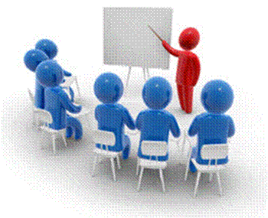

Please remember that this Skills Programme is based on outcomes based education principles which implies the following:

* You are responsible for your own learning – make sure you manage your study, research and workplace time effectively.
* Learning activities are learner driven – make sure you use the Learner Guide and Formative Assessment Workbook in the manner intended, and are familiar with the workplace requirements.
* The Facilitator is there to reasonably assist you during contact, practical and workplace time for this programme – make sure that you have his/her contact details.
* You are responsible for the safekeeping of your completed Formative Assessment Workbook and Workplace Guide
* If you need assistance please contact your facilitator who will gladly assist you.
* If you have any special needs please inform the facilitator

## Learner Administration

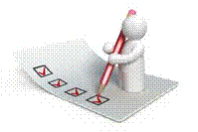

#### Attendance Register

You are required to sign the Attendance Register every day you attend training sessions facilitated by a facilitator.

#### Programme Evaluation Form

On completion you will be supplied with a “Learning programme Evaluation Form”. You are required to evaluate your experience in attending the programme.

Please complete the form at the end of the programme, as this will assist us in improving our service and programme material. Your assistance is highly appreciated.

### Learner Expectations

Please prepare the following information. You will then be asked to introduce yourself to the instructor as well as your fellow learners

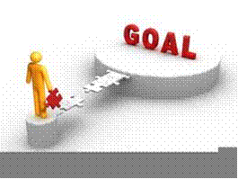

|  |
| --- |
| Your name: |
|  |
|  |
| The organisation you represent: |
|  |
|  |
| Your position in organisation: |
|  |
|  |
| What do you hope to achieve by attending this course / what are your course expectations? |
|  |
|  |
|  |
|  |
|  |
|  |
|  |
|  |

# UNIT STANDARD 119469

Unit Standard Title

Read/view, analyse and respond to a variety of texts

Credits

5

Purpose

Competence at this level will enable learners to use analytical skills to make sophisticated judgements about complex human and social issues. They are aware of both the functions of language and of its drama and power. Learners are critical, reflective and responsive readers and/or viewers of written/signed and visual texts. They are able to draw comparisons between texts, and to compare and contrast themes and issues in texts with those in the contexts in which they live and work. They identify and analyse style and tone/sign size and pace and account for their effectiveness in different texts. They are willing to challenge the assumptions and values expressed in texts. They are especially critical readers/viewers of both the written/signed and/or visual mass media. They can access, process and use information from a wide variety of texts.

Learners credited with this unit standard are able to: Critically analyse texts produced for a range of purposes, audiences and contexts; Identify and explain the values, attitudes and assumptions in texts; Evaluate the effects of content, language and style on readers`/viewers` responses in specific texts.

Specific Outcomes and Assessment Criteria

**Specific Outcome 1:** Critically analyse texts produced for a range of purposes, audiences and contexts.

Assessment Criteria

* Reading and/or viewing strategies appropriate to the purposes for reading/viewing are adopted: Skim, scan, prediction, knowledge of form and features of text types and different genre.
* Organisational features of texts are identified. The role of each of the features is explained in relation to usefulness in making meaning of readings and/or viewing: Role of titles, headings, introductions, paragraphs, conclusions, outcome statements, chapters, summaries, contents, diagrams, appendices or addenda, foreword, index, content lists glossary, hyper-links, layout, icons, tables, graphics, font size and/or type, photographs, captions, visuals, cinematographic technique
* Synthesis of information from texts, and generalisation of patterns and trends, result in appropriate conclusions about purpose, audience and context

**Specific Outcome 2:** Identify and explain the values, attitudes and assumptions in texts: Socio-cultural, learning and/or workplace contexts

Assessment Criteria

* An understanding of surface and embedded meaning in the text is reflected in presentations of viewpoints
* Values and views in selected texts are identified and explained in terms of the impact on meaning and target audience
* Evidence cited from texts in defence of a position is relevant

**Specific Outcome 3:** Evaluate the effects of content, language and style on readers`/viewers` responses in specific texts

Assessment Criteria

* Content is outlined and its possible effects on different readers/viewers are explored
* The impact of different writing/signing techniques on reader/viewer perspective are identified and explained in terms of the particular effect produced by each: Length of sentence, punctuation/non-manual features (NMFs), diction/choice of words, use of figurative language jargon / technical terms / slang / dialect / irony / humour / satire/ sarcasm / legalisms
* The influence of specific language structures and features is analysed: Bias (cultural, religious or peer preferences, misrepresentation, discrimination, racist, sexist, ageist), humour, irony, sarcasm, use of omission and silence, figurative expressions, repetition, hyperbole, generalisations, stereotyping, pictures and captions, typography and grammar
* The effect of selected production techniques in visuals is explained: Range of visuals: Photographs, transparencies, slides, posters, graphics, videos, films Range of techniques: Composition, layout, light, foregrounding, backgrounding, perspective, camera angle, frame, sequence, use of colour/black and white, font type, font size, headlines, captions, subtitles, borders, overlays, selection and/or omission, scale, size

Critical Cross-field Outcomes (CCFO)

* Identify and solve problems: using context to decode and make meaning individually and in groups in oral/signed, reading/viewing and written/signed activities
* Work effectively with others and in teams: using interactive speech/signing in activities, discussion and research projects
* Organise and manage oneself and one`s activities responsibly and effectively through using language.
* Collect, analyse, organise and critically evaluate information: fundamental to the process of growing language capability across language applications and fields of study
* Communicate effectively using visual, mathematical and/or language skills: in formal and informal communications.
* Use science and technology effectively and critically: using technology to access and present texts and exploring the ethics of science and technology through studying texts from and about these fields.
* Understand the world as a set of inter-related parts of a system: through using language to explore and express links, and exploring a global range of contexts and texts
* Contribute to the full development of oneself: by engaging with texts that stimulate awareness and development of life skills and the learning process

# ANALYSE TEXTS

Learning outcomes

* Critically analyse texts produced for a range of purposes, audiences and contexts.

Assessment criteria

* Reading and/or viewing strategies appropriate to the purposes for reading/viewing are adopted. Skim, scan, prediction, knowledge of form and features of text types and different genre
* Organisational features of texts are identified. The role of each of the features is explained in relation to usefulness in making meaning of readings and/or viewing. Role of titles, headings, introductions, paragraphs, conclusions, outcome statements, chapters, summaries, contents, diagrams, appendices or addenda, foreword, index, content lists glossary, hyper-links, layout, icons, tables, graphics, font size and/or type, photographs, captions, visuals, cinematographic techniques
* Synthesis of information from texts, and generalisation of patterns and trends, result in appropriate conclusions about purpose, audience and context

Introduction

**Reading is an essential part of communication.** When a writer (the communicator) wants to communicate with a recipient (the reader) and they are not in direct contact with each other, the writer will communicate his message in writing.

We see this every day in the form of advertisements, newspapers, magazines, CD covers, comic books, etc.

When you are reading something it is important to remember that the **writer wants to give a specific message**: when Game sends out flyers about special offers, they want you, the reader, to consider buying one or more of their products.

This is true of all forms of advertisement: the advertiser wants to introduce himself and his products to you in such a way that you are persuaded to buy from him, rather than from his competition.

A newspaper, on the other hand, contains articles that have at least two purposes: to inform you, the reader, and also to convince you, the reader, of the writer’s point of view. They use various methods to persuade you to buy the newspaper, so that you can read it: they have big advertisements about the headlines or main stories in the paper, they also print their headlines in big, bold letters in order to grab your attention.

You must always be aware that the writer’s purpose is to persuade you that their point of view is the right one. This is true of advertisements, magazines, newspapers, anything you read, even company policy.

What needs to be remembered is that in the case of company policy, you have to follow the rules as laid down. With almost everything you read, that is not directly work related, especially in newspapers and magazines, you have to remember that the writer wants to persuade you to believe his point of view.

Some writers are very good at this, so you must always analyse what you are reading in order to come to your own conclusions about the matter. One way of doing this is, of course, to read more than one writer’s point of view. You can do this by reading more than one newspaper or magazine that has articles of the same subject and you will be surprised by the differing points of view that are put forward.

An excellent example could be a newspaper headline that reads:

**ALL WHITE RUGBY TEAM**

This could mean that the Springbok rugby team was chosen with only white players. It could also mean that the coach, Jake White, has the right to put together the team without interference from the rugby administrators. It could also be a humorous play with words in order to grab your attention.

This means that whenever you read something, you have to be able to analyse what you are reading. You also have to be able to “read between the lines” – when things are not stated directly, but only hinted at.

If we look at the newspaper headline that was quoted as an example, we could take the headline to be a speculation that, if Jake White was able to choose players for the team, he would only choose white players.

So, how would you know what the headline means? By reading the article and then analysing it, taking into consideration

* What the writer states in the article,
* Who would probably read the article
* And very importantly, what the writer’s normal point of view is about the choice of rugby players for the Springbok rugby team.

Only then can you really determine what the writer is trying to tell you.

Reading Skills

Taking into account the various reading strategies that we employ, as well as the strategies that are used to capture our attention, how do we analyse written material to ensure that we understand what the writer is trying to say?

To start off, you would use more than one strategy when reading an article in a newspaper, for example.

You could **skim or scan**, in order to determine the main points, **read and then reread** in order to ensure that you are reading correctly and then you would **summarise** the main points:

* Who
* What
* When
* Where
* Why
* How

Reading Strategies

Whenever we read something, we employ a certain strategy:

* When you are in a hurry, you might skim over the reading material
* Sometimes we also predict what the writer is going to say, before we get to the section where he actually says it
* Scanning
* Sifting

BOOK033

Skim

A type of reading/viewing used to identify only the main idea or ideas or to pick out any words in capitals/ in italics/underlined, as well as any visuals or font indicators that would help a reader/viewer to understand a passage.

When you read through something very quickly, noting only the main points, you are skimming. We tend to do this when we are in a hurry, or when we are not interested enough in the writing to read the whole article. We skim, looking only for the main points, and do not take notice of the body of the writing.

Skimming allows you to go through a lot of reading material that might not be relevant to your need for information, in a very short time.

Scan

A type of reading/viewing used to locate a particular piece of information without necessarily attending to other parts of a text

This is different from skimming: when you skim, you look for the main points of the reading material, when you scan you look for information that is important to you. This information may not be included in the main points.

As an example let’s take a newspaper article about a crime that took place. Very often, I only read the basic details of the crime: what happened, where and when it happened, were the criminals caught. I do not read what witnesses and bystanders or even the victims of the crime had to say about it. I am only interested in certain aspects of the article and I therefore skim through it.

This morning I skimmed the newspaper article about the crime, now it’s evening and I want to know what one specific eye witness said. I’m not going to read the entire article, instead I scan only for the witness’s name in order to get to the part that I am interested in.

Sift

Selecting the most important ideas, words, facts or finding only those details relevant to a task or purpose

Prediction

When you anticipate what the writer is going to say next, or further on in the article or other piece, you are predicting. We often do this when we have read items from the same author a number of times and we more or less know what his views on the subject are.

This can happen often with sports writers and writers of political text, especially when they tend to put across their own points of view. If you read this person’s work often enough, you can predict what he is going to say about the match over the weekend or the political rally that took place.

Following is an extract from an article about slavery in Africa. Read the extract and then answer the following questions.

*At the first cracks of gunfire, the villagers of Nyamlell in southern Sudan dropped their hoes and scattered into the bush. Abuk Marou Keer also heard the guns. But the blind Dinka woman could only pull her seven-year-old son and twelve-year-old daughter close. Shaking with fear, they hid in their windowless hut and prayed.*

*Minutes later 300 men on foot, horseback and camels crashed through the fields of maize. Clad in turbans and the long, white robes of the desert, they brandished rifles, pangas and spears. Soon 80 village men lay dead.*

*The invaders were Muslim Arabs from northern Sudan; the victims darker-skinned Dinka tribes people who are Christians or practice native religions*

*Once the Arabs seized the cattle, they moved from hut to hut gathering grain, blankets, salt – and human booty. Deep in the shadows of one hut, they discovered Abuk. Grabbing the terrified woman by her bead necklace, a militiaman growled, “Now you belong to me!” in all, 282 Dinka, including Abuk’s mother, sister and niece were herded up and forced to march north.*

*Two days later Abuk and the rest of the prisoners reached a compound, which she was told would be her “home.” Like the other Dinka women and children, she was ordered to carry water, wash clothes and collect firewood for her Arab masters. Abuk had become a slave.*

Text Type

In the printed media, newspapers, magazines, brochures, text books, use is made of different techniques in order to

* get your attention,
* help the writer to get the message across,
* indicate a change of topic, a main point or sometimes both
* encourage you to read the written piece

They use:

Different font types and sizes

**Bold**, *italics* and underline

* Visual aids, such as cartoons, diagrams, and so on
* Titles and subtitles
* Captions: a title or brief explanation printed with a visual aid, which can be a photo, an illustration, a diagram or a cartoon
* Photos
* The layout of the page
* A summary of a piece of the article is quoted

**Advertisements** are very good examples of using text and visuals to get a message across, using as little words as possible.

Genres

Genre refers to the style of writing.

In literature, you get different genres such as poetry, prose, plays, fairy tales, fables, historiography, novels and then of course newspaper and magazine articles.

Organisational Features Of Text

Titles, Chapters, Contents

The title of textbooks and manuals, such as you used in school will contain information about the subject of the textbook.

Textbooks are then divided into **chapters**. Each chapter will contain information about a specific subject that relates to the title or main subject of the text book.

The chapters can then be further subdivided into **sections** and, if the manual is comprehensive, even **sub-sections**.

Contents Page

The writers who compile text books always try to make it easy for us to find specific information about a certain subject. Every textbook will have a contents page, which will give the main headings of the different chapters of the textbook.

You can then go to that page and look at the contents from that page on. Following is a contents page of a textbook about Reward Management.

Can you see that subjects are grouped together in a sensible manner? Can you see that it is easy to obtain information about a specific subject?

If you need information about market rates of pay, you will go to page 35, as indicated in the contents page. Here you will see that the **chapter** is further divided into **sections**.

Now you can page through the chapter, looking only at the **headings** of sections until you find the information you are looking for.

All this makes it easy for you to find the information in the first place and also to refer back to the information afterwards. You can therefore find information about motivation on pages 10 and 347.

Introductions

Most textbooks, chapters in textbooks and sometimes even sections in chapters will start with an introduction. The purpose of the introduction is exactly what the name implies: to introduce the subject to the reader. An example of an introduction is included in one of the pages for you.

Foreword

A foreword is found at the beginning of most books and is an introduction by the author of the book. It is different from the Introduction in that it is an explanation by the author of why the book was written.

An example of a foreword can be found on the next page.

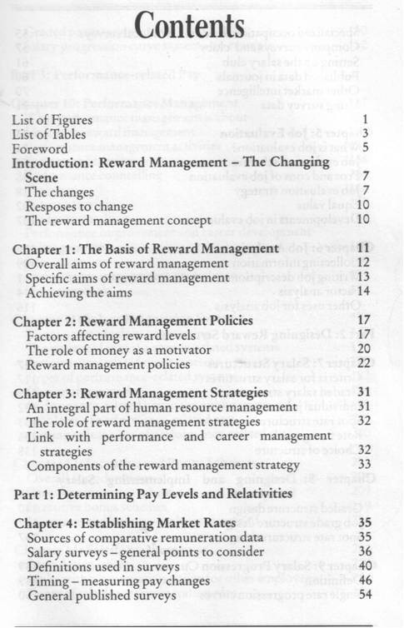

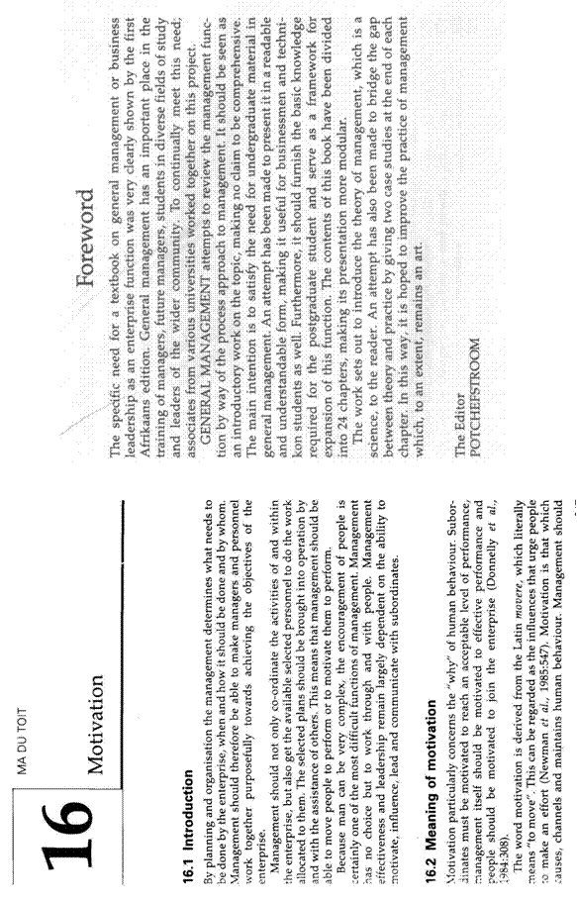

Outcome Statements

An outcome statement is found in training manuals, learner guides and assessment guides. It is a statement of the outcomes that must be achieved in order to be awarded the credits due for a specific unit standard.

Each section in your learner guide starts with an outcome statement.

Index

Most textbooks also contain an Index, situated at the back of the book. Using the Index, you can look up information by looking for a specific word. The Index is always sorted alphabetically, so if you want to look up the word motivation, you will have to go to M in the Index.

From the Index, under M, (shown on one of the following pages,) you can see that there are references to motivation on pages 10 as well as 347.

Appendices Or Addenda

Are added at the end of a book and they usually contain extra information or exercises that pertain to certain chapters and sections in the book.

Glossary

A glossary is usually found at the back of a text book. It is a list of words, usually unusual words, that are used in the manual, with an explanation of their meanings.

An example of a glossary can be found on the next page. When you find an unfamiliar word while working through the text book, you can refer to the glossary to find out the meaning of the word, if it is stated there.

| **Term** | **Definition** |
| --- | --- |
| Address Book | A list of names and email addresses. |
| Appointment | A reminder to do something on a particular date at a particular time (and optionally in a particular place). |
| Archiving | Removing old items from Outlook folders by either deleting them or storing them in a compressed file. |
| Attachment | A file sent by email. |
| AutoSignature | An Outlook tool for inserting text into a message. An AutoSignature can be a line or block of text and can be added to all new messages by default. |

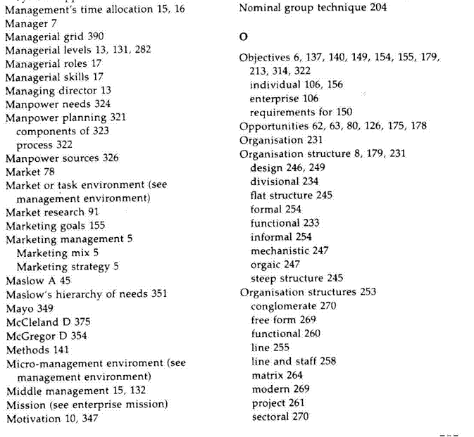

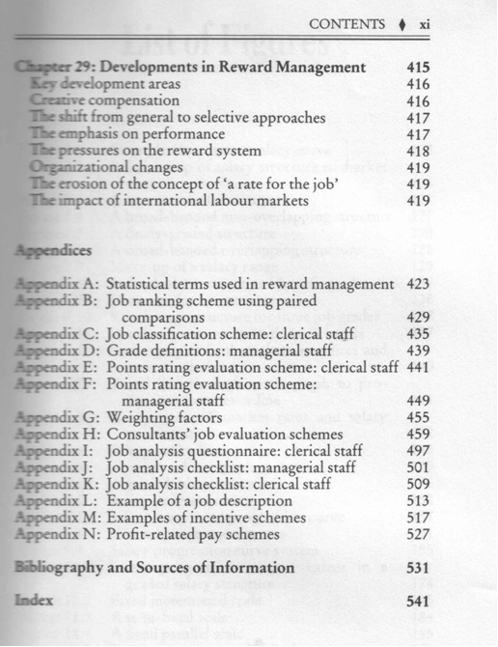

Conclusions And Summaries

Authors will many times include summaries at the end of sections or chapters.

A summary is a brief overview of the main points of the content that was discussed during the section or chapter.

At times the author will end the section or chapter with a conclusion in the place of a summary. The conclusion will be based on information discussed during the section or chapter.

The summary or conclusion should also give you a brief overview of the main points discussed in the section or paragraph.

Paragraphs, Layout, Font

In chapters and sections the written (or typed) contents will also be broken down into paragraphs. As seen in module 1, each paragraph should have its own subject, with the sentence of the previous paragraph leading into the subject of the second paragraph. The first sentence of the new paragraph should then introduce the new paragraph.

The layout of the page would usually also enable you to skim through the page if you quickly want to find out what the contents of the page are about. During a previous Formative Assessment you were requested to analyse two different magazines in terms of font type, headings, layout and copy breaks. Did you see how the layout of the page helped you to find out more about the subject without reading the entire article in depth? Many textbooks and other books will also be laid out in a way to make it easy for you to skim through the contents. At times the author will also highlight important words by using **bold**, *italics* or underline. Look out for these visual clues when reading through a text book.

All the above are techniques that enable you to find out quickly what the book, chapter or section is about. Once you have satisfied yourself that the contents are relevant to what you want to do, you can start reading the contents in depth. This will make it easier for you to understand what the subject of the content is and will save you the time of rereading the entire contents many times.

Hyper-Links And Icons

In web sites and web pages and some online manuals you will find hyperlinks. A hyperlink takes you to a specified place on the web site or web page. You will go to the hyperlink by clicking the mouse on the hyperlink.

Almost all web pages have hyperlinks. These links connect:

* One page to another part of the same page (useful if it is a really large page)
* One page to another page somewhere on the web
* A page to a file, such as a sound clip, video, a spreadsheet or a Word document

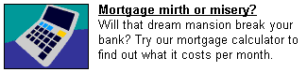These links to other pages can be links to things stored anywhere on the internet. **Hypertext** links are indicated by underlined text highlighted in blue (usually). Hyperlinks are also frequently in the form of buttons, graphics or pictures.

To find hyperlinks on a page move your mouse pointer over the page and where there is a hyperlink the pointer will turn into a hand with a pointing finger.

In the example shown, both the graphic and the underlined text link to the same page. You could click either to follow the link.

Icons are found in GUI- based software applications that you do your work in, such as Outlook, MS Word and MS Excel. The icon is usually a picture that you click on and it will execute a command, such as Save, Open, Print, etc. You will learn more about this in the End User Computing modules.

Visual Clues

Authors also use visual clues in order to emphasize, illustrate or explain certain points.

Diagrams

A simplified drawing showing the appearance or structure of something.

In school text books you would have found a lot of diagrams in biology and science. The diagram I remember best is the one of the grasshopper. Of course, a diagram is a sort of a mind map as well.

This diagram shows the outside of the ear.

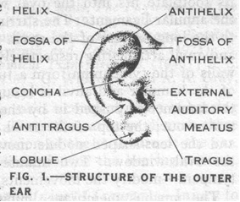

And this one shows the inside of the ear.

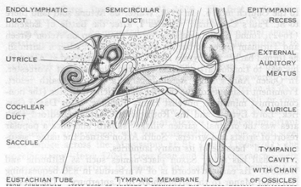

The diagram below shows the functions involved in the management process.

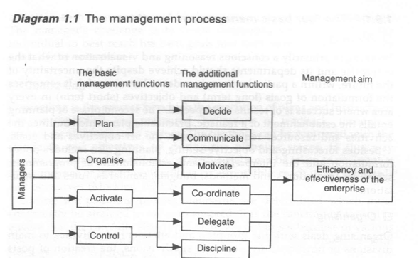

Captions

A caption is a title or brief explanation that is printed with a visual aid, which can be a photo, an illustration, a diagram or a cartoon.

The captions to the photos state:

Mandela casts his vote in April and President Mandela joins hands with ex-President de Klerk.

Can you see that you only have to look at the photos and the captions to find out what the article is about? If you want more information, you would have to read the article, but you already have an idea what the article is about.

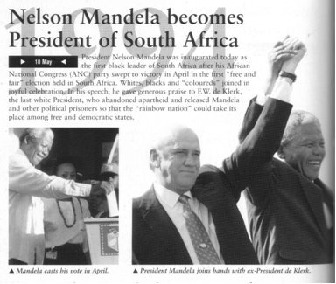

Visual And Graphic Representations

Visual and graphic representations are used to illustrate what the written piece is about. It is used to give more information about the subject, without writing long lines of text to explain the point the author is trying to make.

Diagram

A simplified drawing showing the appearance or structure of something.

This is a diagram of a human’s intestines. Can you see how easy it would be to explain the look, position and function of each separate organ in the human body by making use of a diagram.

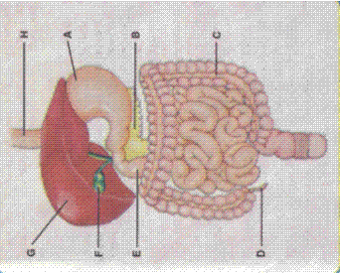

Photographs

When the manufacturer decided to advertise these shoes, they chose to use a photograph of the shoe to illustrate what it looks like, rather than saying to you, the reader:

“This is a lace-up shoe, with soles fit to walk or climb in, made from leather and suede, with added protection at the back for your heels, durable, long-lasting and comfortable. These shoes are made with your comfort in mind. Go out now and buy your Search and Enjoy Phaser Inferno climbing and hiking shoes.”

You can actually see all this from the photo.



Arial Photography

Aerial photography has been around for a long time. It was used as early as 1858 from hot air balloons. Aerial photography was used widely during the first World War. Photos taken from the air was used to gather information about the enemy’s position, moves and strength. At times, this was done daily. During the second World War and the Korean War aerial photography was also used a lot to gather information about the other side’s movements.

Today, aerial photography is used for the following purposes: to gather military information, to draw maps, to make survey photographs of natural resources such as forests, crops, rivers and so on.

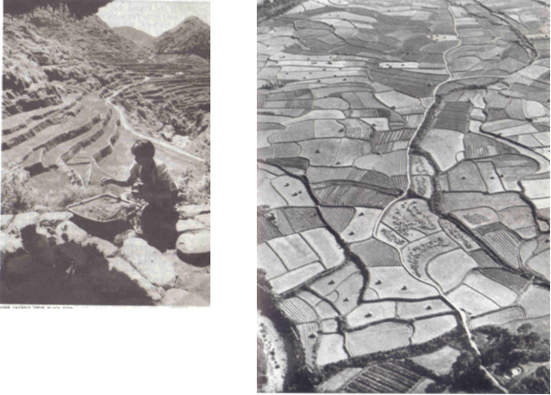

Photos taken from the air can be done from a hot air balloon, a helicopter, a parachute (although this will be difficult) and an aeroplane. The view from the air is vastly different from the view from the ground. Compare the following two photographs, both are of rice paddies. One was taken from the air and the other one was taken from a slightly higher viewpoint than the woman collecting rice seeds.

Of course, the height at which the photo is taken also affects what the photo looks like.

In an aerial photo all vertical lines, such as poles and tall buildings, tend to disappear at a “vanishing point” in the centre. In other words, it is difficult to judge the height of things from an aerial photo.

Pie Chart

A pie chart is used to show how a total breaks down. For example, you have R3000 per month to spend on rent, transport, food, etc. You can use a pie chart to give a visual demonstration of how you spend your R3000. Or you could write an explanation of a paragraph or two to prove to your parents that you are not spending money on unnecessary things.



|  |  |
| --- | --- |
| Rent | 900 |
| Transport | 300 |
| Food | 800 |
| Clothes | 500 |
| Spending | 500 |
| Total | 3000 |

Bar Graph

Is used to compare values at intervals, the bars run horizontally. For example, you can compare your marks for your matric subjects per school term.

You can compare the results on paper, which is lengthy, or you can use a bar graph.

This example shows only your mathematics results.



This example shows all your subjects



Cartoons

Cartoons in magazines and newspapers usually make a statement about something newsworthy that happens.

Cartoons are usually the author’s point of view about a subject and should be read with the enjoyment of the cartoon in mind and should not be taken literally, since it only conveys one person’s point of view.

One of my favourite cartoons is Madam and Eve, because it is so uniquely and typically South African. They usually make a statement about something that has happened in our own country and, while I do not always agree with them, I can really enjoy the cartoon. Incidentally, the cartoon was started by an American who was very amused by the way the word Madam is used in South Africa. In America, a madam is an owner and manager of a brothel ☺, so there is humour even in the name of the cartoon.

# ANALYSING WRITTEN MATERIALS

Learning outcome

* Identify and explain the values, attitudes and assumptions in texts: Socio-cultural, learning and/or workplace contexts

Assessment criteria

* An understanding of surface and embedded meaning in the text is reflected in presentations of viewpoints.
* Values and views in selected texts are identified and explained in terms of the impact on meaning and target audience.
* Evidence cited from texts in defence of a position is relevant

One of the reasons why we read written text is to determine the purpose of the text – why did the author write this specific article, textbook, instruction manual or whatever you are reading. Once we have determined what we think is the purpose of the text, we have to be able to justify what we think in terms of what is written in the article, textbook, etc.

In other words, we have to be able to understand what the author means, and we must be able to support out argument from what the author writes.

Explicit versus implicit

Whenever an author writes some text, certain facts will be stated clearly, while others are not stated clearly, only hinted at.

When facts are stated clearly, we call them explicit. **Explicit means clear and detailed**, with no room for confusion. In the article about slavery, the name of the blind woman is stated clearly, as well as the fact that she is blind. These are stated explicitly.

The opposite of explicit is implicit. **Implicit means suggested**, though not directly expressed. In other words, it is hinted at and you, the reader, should be able to identify what the author means. Referring back to the article about slavery, the writer states:

At the first cracks of gunfire, the villagers of Nyamlell in southern Sudan dropped their hoes and scattered into the bush.

The author does not say that it happened during the day, he also does not say that the villagers were working in their fields, yet we know this.

How do we know this? The author says the villagers dropped their hoes. A hoe is a long-handled gardening tool with a thin metal blade that is used to turn earth and cut through weeds. So, in one sentence the author tells us implicitly that it was daytime and that the villagers were working in their fields.

Omissions and Silence

Two of the tactics most used by journalists who write for newspapers and magazines are omissions and silence. Many people are misquoted in this way.

Omission is something that has been left out.

Below is a paragraph from the article about slavery. If I leave something out, it changes the entire meaning of the paragraph.

Once the Arabs seized the cattle, they moved from hut to hut gathering grain, blankets, salt – and human booty. Deep in the shadows of one hut, they discovered Abuk. Grabbing the terrified woman by her bead necklace, a militiaman growled, “Now you belong to me!” in all, 282 Dinka, including Abuk’s mother, sister and niece were herded up and forced to march north.

Now read the paragraph where human booty and the last sentence has been left out:

Once the Arabs seized the cattle, they moved from hut to hut gathering grain, blankets and salt. Deep in the shadows of one hut, they discovered Abuk. Grabbing the terrified woman by her bead necklace, a militiaman growled, “Now you belong to me!”

Do you see that the whole meaning of the paragraph has now changed and that there is now no reference to slavery?

Silence means not saying or writing anything.

If the author of the article about slavery did not write the article, we would never have known that it is going on. Silence can be just as dangerous as omission. If we don’t write and talk about what is going on in the world around us, we will never be able to identify problems. If problems are not identified, solutions cannot be found.

# CONTENT, LANGUAGE AND STYLE

Learning outcome

* Evaluate the effects of content, language and style on readers`/viewers` responses in specific texts

Assessment criteria

* Content is outlined and its possible effects on different readers/viewers are explored
* The impact of different writing/signing techniques on reader/viewer perspective are identified and explained in terms of the particular effect produced by each.
* Length of sentence, punctuation/non-manual features (NMFs), diction/choice of words, use of figurative language jargon/technical terms/slang/dialect/irony/humour/satire/sarcasm/legalisms
* The influence of specific language structures and features is analysed: Bias (cultural, religious or peer preferences, misrepresentation, discrimination, racist, sexist, ageist), humour, irony, sarcasm, use of omission and silence, figurative expressions, repetition, hyperbole, generalisations, stereotyping, pictures and captions, typography and grammar
* The effect of selected production techniques in visuals is explained. Photographs, transparencies, slides, posters, graphics, videos, film. Range of techniques: Composition, layout, light, foregrounding, backgrounding, perspective, camera angle, frame, sequence, use of colour/black and white, font type, font size, headlines, captions, subtitles, borders, overlays, selection and/or omission, scale, size

Writing Techniques

Authors make use of various writing techniques in order to persuade readers to their point of view. These techniques were discussed during module 1, but will be repeated here.

Sentence Length

The sentence may be regarded as the core of language communication, because a sentence is a complete thought that conveys (gives) a meaning. In other words, you use a sentence to explain yourself to other people, or to give your opinion about something. The end of a sentence is indicated by a full stop, called a period these days.

A sentence must make sense, therefore a sentence must express a complete thought. In order to do this a sentence must contain a verb (doing something) and a noun ( a subject) and the sentence must contain a thought that includes an idea that is relevant to the subject or the doing.

If you say: “The accident happened as I crossed the road.”, it makes sense to everyone who hears it and reads it. If you say: My dog was run over and Vin Diesel visited South Africa.”, it will not make much sense to other people. The two concepts have nothing to do with each other. In an instance like this, you will have to use two or more sentences or even two paragraphs.

A short sentence could be: Thabo takes the dog for a walk.

Authors use short sentences to heighten (increase) tension in a written piece. Longer sentences make a written piece more relaxed and not as filled with tension. If you are writing about strikes and unrest, your sentences would be shorter, while the sentence in a written piece about farming would be longer to create a more relaxed atmosphere.

Generally, we would try to vary the length of sentences in any written piece. A written piece that has only long or short sentences can be tiring to read.

There are **three** basic types of sentences.

Simple Sentences

These have one verb and one subject and object. “The boy is playing with the ball.”

Compound Sentences

A compound sentence is made up of two or more thoughts or sentences that are related to each other. The thoughts or sentences are then connected to each other to form one sentence by using the following words: **but, and, or**.

but, and, or

“The boy is playing with the ball, but his mother is calling him.”

“the boy is playing with the ball and some other children are watching.”

Sentences should have the same topic if you want to create a compound sentence. The following two sentences are not related to each other and should not be joined: “It is late.” and “I like reading.” “It is late and I like reading” does not make sense, since they do not share the same topic: lateness and reading do not have anything to do with each other.

*“It is late and I am going to bed.” is a better example.*

Complex Sentences

Consist of one independent sentence with one or more dependent clause that relates to it. The sentence and the clauses are **separated by a comma.**

“Although it is raining, the boy is playing outside.” Can you see that*: “Although it is raining”* is not a full sentence, it does not have a subject, so it is called a clause and has to be added to a sentence.

The clauses and the sentence must relate to the same topic if you want to create a complex sentence. “Although it is raining, I like reading.” Is a pointless sentence, since they do not share the same subject. “I have to go to the shop, even though it is raining,” is a better example of a complex sentence.

,

Remember:

**Too many short sentences will make your text appear choppy and curt.**

*Too many long sentences will have the opposite effect, your text will appear confusing.*

**Short sentences should be varied with longer sentences to give your text an even flow.**

Diction

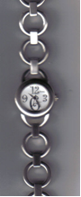Diction: The choice of words or phrases or signs in speech or writing or signing; the particular words or phrases or signs chosen to express an idea.

In most languages, but especially in English, words can have more that one meaning, depending on the context they are used in.

Watch can mean:

* To **watch** something, in other words to look at something attentively – watch TV or a soccer game or a movie
* It can also mean a **watch** that you wear on your arm and use to tell the time.
* When you **watch out** for something it can mean that you have to be careful. Watch out for that car/rock in the road, etc.
* A **watch** is also used to describe a fixed period of duty, usually four hours, on a ship, or in the Army. Firefighters also divide their **working shifts** into **watches**.

The actual meaning of the word will be determined by the context – the sentence and paragraph that it is used in.

Punctutaion

Punctuation is used to:

* Clarify meaning.
* Make material more readable.
* Help the reader understand what you are writing.

The most commonly used punctuation marks are:

**Comma** (,) is used to separate two independet clauses that are separated by a conjunction. I have given the matter much *thought, but decided* to cut my hair.

**Semicolon**: is a stronger punctuation mark than a comma, but not as strong as a full stop. Children begin by loving their parents: as they grow older they judge them, sometimes they forgive them.

**Colon**:replaces “for instance” or “as follows”. Be careful not to use a colon too often. *He did not understand several parts of the speech: market trends, market prices and the GDP*. Colon is also used to separate chapters and verses of the Bible: *Genesis 2:4*

**Full stop or period** is used to indicate the end of a sentence.

**Exclamation mark**: is used to indicate surprise or strong emotion. *You look beautiful today!*

**Question mark**: appears at the end of a direct question. *Where do you think you are going?*

Grammar

Grammar is the whole structure of a language, including the rules for the way words are formed and their relationship to each other in sentences.

This has to do with the words we use in sentences and also how we use them.

In the section about textbooks I quoted the following example:

If you say: “ My husband and I have been nearly married for two years.” it literally means that for two years you and your husband have been almost married, but have not gotten married yet. You probably mean that for two years you have been thinking about getting married, but cannot make up your minds to actually do it.

If you say: “My husband and I have been married for nearly two years” it means that you and your husband got married nearly two years ago and you are still together.

Below is a quote from the article about slavery, as written by the author.:

*Once the Arabs seized the cattle, they moved from hut to hut gathering grain, blankets, salt – and human booty. Deep in the shadows of one hut, they discovered Abuk. Grabbing the terrified woman by her bead necklace, a militiaman growled, “Now you belong to me!” In all, 282 Dinka, including Abuk’s mother, sister and niece were herded up and forced to march north.*

* If I substitute the word “booty” in the first sentence with “bodies”, it would mean that the slave traders gathered the remains of dead people to take with them.
* If I change the word order of the third sentence, I can change the meaning of the sentence as well:

*“Grabbing the woman by her bead necklace, a terrified militiaman growled ….”*

This, of course, means that the militiaman is terrified, and not the woman.

It is easy to change the meaning of a sentence or paragraph just by changing the order of the words in the sentence or paragraph.

You must always be aware of this and ensure that, when you are writing something (especially your summaries) you use grammar correctly. If you don’t you can be misunderstood and this could sometimes have serious consequences.

People can be misquoted simply by changing the word order of the sentences. When we read and write text, we have to be careful of our use of grammar.

Language Structures And Features

Writers use language structures and features all the time, in order to influence what you, the reader, thinks when you have read the written piece.

Languge structures and features include

* The choice of words.
* Use of language.
* Symbols.
* Pictures.
* Tone.

If we look at the article about slavery, we can see some examples in the first paragraph.

But the blind Dinka woman could only pull her seven-year-old son and twelve-year-old daughter close. Shaking with fear, they hid in their windowless hut and prayed.

If the author had not told us that they were shaking with fear, we would have felt differently about the paragraph.

Dealing With Bias

What Does Bias Mean?

An opinion or tendency to be strongly for or against a person or thing.

We are all biased in some way or other. We feel strongly about certain subjects, such as pornography, schooling in mother language, and many other subjects. Then there are subjects over which are biased, but do not necessarily feel too strongly about it, so we don’t get all worked up about it. This could be school uniforms, what to wear to the movies, and so on.

We all have opinions about everything, some opinions are stronger than others. Unfortunately, although we would like it to be so, our opinions and views are not always the right ones and, when we do not want to be convinced otherwise, we are biased.

I have a bias- I hate school uniforms and believe that it should be done away with totally. Children should be allowed to wear what they choose to school. I feel strongly about this and I refuse to be convinced otherwise. This is, of course based totally on my own dislike of uniforms and having to look like anyone else, so I am not necessarily right in my point of view, especially since most other people seem to like school uniforms. Luckily, this bias of mine is relatively harmless.

Unfortunately, not all biases are harmless. Bias can take many forms: it can be based on cultural or religious beliefs, it can show itself in a misrepresentation of facts, it can be discriminatory in terms of race, sex or age. It can also be due to peer preferences.

Most of us have suffered from other people’s biases in some way or other.

I have suffered from bias because I am a woman, it was thought that I cannot do what a man can do and, further, that I should not be allowed to prove that I can do administrative and managerial work as good as my male counterparts. To me, it was not a pleasant experience.

If I were biased against Muslims, I would interpret the article about slavery as meaning that all Muslim Arabs are kidnapping people to use and sell as slaves, even though the author of the article does not state this. My bias would then end in me disliking all Arabs and all Muslims, since, in my view they are all slave traders. Clearly, this is not true, since most races and nations have good and bad people and there are slave traders in South Africa as well, who are not Muslims or Arabs.

Whenever you read a written piece of text, you have to bear in mind that you yourself are biased and also that the author is also probably biased. You must always be able to determine the bias in yourself and the author.

Also, whenever you communicate in writing or verbally, bear in mind your own bias as well as the bias of your audience.

Lastly, remember your painful experience at the hands of some other person and his/her bias, before you treat people with disrespect because they disagree with you.

Whenever you read a written piece of text, you have to bear in mind that you yourself are biased and also that the author is also probably biased. You must always be able to determine the bias in yourself and the author.

Also, whenever you communicate in writing or verbally, bear in mind your own bias as well as the bias of your audience.

Lastly, remember your painful experience at the hands of some other person and his/her bias, before you treat people with disrespect because they disagree with you.

Humour

In the dictionary, humour is stated as being:” the quality of being amusing”. Jokes are humorous, so can text in an article be humorous or even a novel (long story) or parts of a novel.

Sarcasm

Is a way of using words that implies the opposite of what they mean, so as to upset or mock someone.

If you were talking to one of the team players that lost the game badly, and you say to him: “Well, you guys really played well” you are being sarcastic.

Irony

The expression of meaning through the use of language which normally means the opposite.

When an author uses irony, he states one thing, while meaning the opposite.

Your sport team lost a game badly over the weekend. On Monday morning you discuss the game with colleagues and you say: “Well, they played really well”, you are being ironic, since you mean the opposite

Satire

When an author uses satire, he portrays human weaknesses and shortcomings in a mocking way, usually in order to encourage people to improve their behaviour. The satirist uses his writing to show people how silly and ridiculous their behaviours and attitudes are. The cartoonist Zapiro is a satirist who uses cartoons to express his views of people in a mocking way in order to emphasize how silly we can be.

The Madam and Eve cartoon also uses satire, sometimes irony and also humour to portray South Africans in all their silly behaviours and beliefs.

Hyperbole

An exaggerated statement that is not meant to be taken in the strict sense of the words.

“I have told you a thousand times to clean your room.”

Generalisations

Make a general or broad statement based on specific cases.

**“Nobody from the Cape eats pap”.**

This is not true, most people from the Cape prefer to eat something else, but some of them do eat pap as much as we do.

When the soccer or rugby team loses two or three games in a row, we tend to say things like: “We can’t play soccer or rugby, we always lose”. This is also not true, since they do win games.

Beware of general statements when you read or write something. Writers should be careful of using general statements, as readers tend to believe what they read.

Stereotyping

An over-simplified idea of the typical characteristics of a person or thing.

All blondes are stupid. This is a stereotyping, since not all people with blonde hair are stupid. We just notice it, since blonde women are more noticeable to men, and when a blonde woman does something stupid, all blondes are called stupid.

Slang

Casual, very informal speech/signing, using expressive but informal words and expressions.

Slang is usually related to age or social group rather than to trade or profession (jargon). It is used to stress an identity for those in the know and to exclude those who do not know the terms, for example, words to describe money, grown-ups, police, and activities.

* My Bra
* Howzit Broe
* Whazzup

Dialect

A form of language used in a particular region or by a particular social group

The way we speak English and Afrikaans in Gauteng is different to how it is spoken in the Cape. The people in the Cape have their own unique way of speaking, which is legitimate even though not always grammatically correct. When this happens, it is called a dialect.

A dialect is usually mainly one language, but with a lot of borrowed words and neologisms, and a unique way of pronouncing the words.

Jargon

Words or expressions that are used by a specific trade, business or industry.

* A paper tiger: when a committee or other body is established to investigate an occurrence, and nothing much happens, it is called a paper tiger. It means that the committee is not doing what it is supposed to do, the members of the committee postpone actions and make up imaginary problems as to why they cannot do the work in time.
* In the training environment in South Africa we find a lot of jargon – words that are used in a context not previously used and existing words put together to mean something that is unique to the education and training environment. We talk about Unit Standards, which previously was called training courses, we talk about assessments rather than tests and we have standards generating bodies and standards governing bodies, and so on.

Complex Terms

Words or phrases that are complex and usually technical and related to a specific industry or sector.

* Electrocardiograph: monitors the heartbeat
* Government fiscal matters: to do with the governments budget and how they spend the money that we pay in taxes.
* The metallurgist in charge is Karis Allen, 35, a specialist in fractions and corrosion: a metallurgist is a person who specialises in studying metals, fractions and corrosion in this instance means how metal, such as steel, breaks and corrodes

Ambiguous Words

Ambiguous means **unclear or undecided**, having more than one meaning.

So an ambiguous word can have more than one meaning. When you come across a word like this, you have to refer to the context in which it is used in the sentence.

The boxer was boxed in.

* A boxer can be a person who boxes as a sport or a medium-sized breed of dog with a brown coat and pug-like face.
* Boxed: a box can be a container with a flat base and sides and a lid; it can also be an enclosed area for a group of people in a theatre, sports ground or law court, it can also be a service at a newspaper office for receiving replies to an advertisement, and so on.

*The boxer was boxed in a small area between the house and the gate and was barking his head off.*

*During the fight, the boxer in the red shorts was boxed into one corner of the boxing ring by the boxer in the blue shorts.*

If the sentence and the context the word is used in still does not make the meaning of the word clear, look up the word in a dictionary.

Figurative Language

Figurative language: Words or signs or phrases used in a non-literal way to create a desired effect (e.g. simile, personification, metaphor).

******This is done when we use a word or phrase in a non-literal sense (not to be taken literally) to add interest to speech or writing.

**Food for thought**. We cannot really eat our thoughts. The expression means that it is something to think about.

**He is as strong as an ox**. He is not really as strong as an ox, we only say this in order to illustrate how strong he is

When mothers say to their children “ I am so angry I could kill you…” they usually don’t mean this literally. Most mothers don’t kill their children. It is a figurative expression of how angry the mother is.

Idioms And Proverbs

According to the dictionary, an idiom is an expression that is natural to a specific language, while a proverb is a short saying stating a general truth or piece of advice. They are actually the same – **a saying that originates in a specific language and is usually applicable to that language, region or culture**.

Many proverbs and idioms can be translated into other languages, but many cannot, since what is applicable in Germany is not necessarily important in South Africa. Idioms and proverbs tend to be culturally based, as they originate as a saying that is popular with the people who speak the same language and undergo similar experiences.

* Beauty is in the eye of the beholder. This means that everybody has his own idea about beauty.
* Business is business. In business, there should be no other considerations.
* Easy come easy go. When you have not earned it, you tend to be wasteful.
* To be green with envy. To be very envious of what someone else has or has achieved. This is a good example of differences in language, since in Afrikaans envy and jealousy is yellow, not green. So, if you were making this statement in Afrikaans, you would say that someone is yellow with envy – the actual expression is to wear a yellow jacket. (die geel baadjie aanhê)
* To be as like as two peas. To be similar. In Afrikaans, we would say: soos twee druppels water op mekaar lyk (to look as similar as two drops of water)
* To cross the Rubicon. To commit oneself to an enterprise or a course of action.
* To live in grand style. To lead a life of wealth and luxury. In Afrikaans this is stated as: “op groot voet lewe”, which, when translated literally would state: “living in a big foot”.

Production Techniques In Visual Aids

Most of us use visual aids to enhance and explain our writing as well as oral presentations. Visual aids give important visual clues about the text or the presentation and can enhance and emphasize our points of view and also convince the audience of our point of view.

Photographs And Slides

Photographs

One of the most popular techniques used in written communication is photographs. As with any visual representation that is used to supplement written material, photos can have a big impact. The old saying: “A picture paints a thousand words” is very true of photos.

Newspaper photos of the weekend’s sport events illustrate what happened. Photos, of a big natural disaster, such as the tsunami around Christmas 2004, or a hurricane or earthquake, a plane crash or a train that has derailed, sells many newspapers, as people want to see what it looks like after the disaster.

Of course, photos are used in more positive ways than negative ways and it is important for you to consider using photos with your written work. The photo has to add to your writing, please don’t use photos that are not relevant to your written work.

Photos are very effective when you want to persuade readers to your point of view: If you want investors to buy a nice seaside or bushveld property, including a colourful, clear photo of the property will give the reader a positive visual stimulation.

If you want readers to contribute towards a hunger relief fund, showing photos of hungry children will encourage many people to contribute.

If you want voters to vote for you, show them photos of what you have achieved, for example, the houses that have been built, the roads that have been built, and so on.

Slides

Slides are photographs taken on positive film. The quality and colour that is given by slides cannot be equalled by any photograph. Unfortunately, slides usually have to be viewed through a slide projector. On the other hand the quality of the image makes up for this disadvantage.

Colour Or Black And White?

Printing colour photos in articles is very expensive. Magazines use a lot of colour photos, but they cost more than a newspaper. Newspapers make more use of black and white photos with the occasional colour photo.

If you are going to print your writing in black and white, use black and white photos. If you only have colour photos, change them to greyscale on your PC or ask your printer to change them. You will have a better image.

If you are going to give a presentation on the computer, you will use more colour images than black and white.

On the other hand, black and white photos and slides are more dramatic. Think about the photos of Sharpeville and the Soweto uprising. They will not have the same dramatic impact in colour as they have in black and white.

Transparencies

Transparencies are used with Overhead Projectors and can be in colour or black and white. The facilitator will make use of transparencies during the course of this training. The layout and style of the transparency should be considered carefully, since this is your visual aid.

* How much text are you going to include in the transparency?
* Are you using photos, slides, cartoons, tables, graphs or other pictures to enhance the visual impact of the slide?
* Where are you going to place the text and where are you going to place the picture?

Some general rules are:

* Use many pictures, cartoons, drawings, photos, etc to make the presentation interesting.
* Try to alternate text with pictures, as transparencies or any kind of presentation that is made up of text only can become very boring.
* You can even have a picture on the background with text over the picture in the foreground, or the other way around. Refer to the section about captions, where the article was printed over the numbers 1994. The text in the background is a light grey, with the article printed in black over it.
* If you have a coloured background, follow these rules: if the background is dark, the foreground must be light; if the background is light, the foreground must be dark. Dark on dark and light on light does not work.
* Adding borders to your text or visual aids helps to focus attention on the contents inside the borders. This is why paintings and photos are framed before we hang them on the wall. The frame creates boundaries that focus our attention on the content within the frame.
* Always ensure that your pictures relate to the subject. Do not use pictures of people swimming in the sea if you are writing about an earthquake – you will confuse and antagonise the reader.
* Do not use too many small pictures and photos. Enlarge them so that the readers and audience can see them clearly.
* You can also use overlays in transparencies: this is where you have two or more slides about the same subject and you place them on top of each other as you build up your presentation. A good example would be a comparison of pass rates of matriculants. Your first transparency would contain all the details necessary to introduce the subject, as well as the pass rate of matrics in, say 2000. the next transparency would contain the pass rate of matrics for 2001. This only becomes visible to the audience when you place the slide over the first one.

Posters

There are many examples of posters for us to view every day. Posters about violence against women, AIDS, soccer games, films, TV shows, advertisements, etc.

Videos And Films

There are many training videos available for use with live presentations, especially about meeting and telephone technique.

However, the best examples of the visual impact that videos and films have on an audience is advertisements. Nando’s are known for making controversial advertisements in order to advertise their products and, if there is some controversy about the ad, it gives them even more free exposure.

Some advertisements are aimed at the general public, such as the Nando’s, KFC and motor car ads. Others are aimed at serious people or people who have to make provision for their families if something happens to them, such as insurance advertisements.

Films (movies) are also used at times to make a statement, such as the film Tsotsi, which recently won an Oscar for the best foreign film.

In advertisements, films and even training videos, a lot of use is made of dialogue (spoken words), pictures and music to emphasize the point of view of the filmmaker and also to dramatise events.

What we all have to be careful of is that any advertisement, film or video usually gives only one side of the story. Expository TV shows such as Special Assignment and Third Degree have to show the point of view of both sides, especially if it is a controversial subject that people feel strongly about. If they don’t, they can be sued for libel.

This is not true of advertisements, films and documentaries. Be aware that, although it is pleasant to watch, it usually still only reflects one point of view. Also, you do not know what the author has left out, so always do some research of your own before you blindly believe what is stated in film and video.