**LEARNER GUIDE**

**Communication Level 3**

**Accommodate audience and context needs in oral communication**

Unit Standard 119472

Level 3 Credits 5

# TABLE OF CONTENTS

TABLE OF CONTENTS i

PERSONAL INFORMATION 1

INTRODUCTION 2

Programme methodology 2

What Learning Material you should have 3

Different types of activities you can expect 4

Learner Administration 4

Assessments 5

Learner Support 5

Learner Expectations 7

UNIT STANDARD 119472 8

INTERACT WITH THE AUDIENCE 11

Communication 11

Note : Communicate - ..according to the Oxford English Dictionary, it means the “share or exchange of information”. 11

Note: Communication is a two way street – information is shared with another party and the other party normally reacts in some way, even if they do absolutely nothing. 12

Note: Definition of communication “Human communication is the process whereby meaning is created between two or more people.” (Tubbs & Moss, 1994) 12

The Communication Process 12

Note: Communication is the interaction between at least two people, the communicator and the recipient. 13

What you do when you communicate: 14

Note : When participating in a conversation you are constantly interpreting the words you hear so that you can unpack or extract important information. This you do in order give an appropriate response. It is a process that you work through instinctively before you respond or give feedback or say something. 14

Note : Unpacking or extracting key ideas is like a brainstorm. Ideas are randomly thought of and not placed in a specific order. This is part of preparing a response starting with careful planning what you want to say. 14

Note : In order to repack or make an interpretation of these key ideas you have to make use of questions (what, when where, why who and how) to rearrange or restructure the brainstorm into a mind map or a flow diagram. This you do by means of grouping key concepts or related key ideas to show how they link or flow into each other in a logical sequence, to make sense. 15

Note: You do not have to make two diagrams. You can start with a brainstorm and then with the help of questions (What; When; Where; Why; Who; and How) you can develop the brainstorm into a flow diagram to map out your thoughts or your interpretation. 16

Various methods of communication 16

Tip : It is to the speaker’s advantage to be face to face with his audience as his nonverbal cues such as mannerisms, gestures and facial expressions help to project his personality and assist him to remain in contact with his audience. 17

Interact With The Audience 17

Contribute To Group Work 17

To achieve this you must plan what you want to say and who you want to address. 17

Interviews 18

Formal Meetings 19

A meeting may be defined as a gathering of persons to discuss matters of common interest and to make binding decisions. 19

Debates and negotiations 21

Differing Socio-Cultural Contexts 22

CAPTURE THE INTEREST OF THE AUDIENCE 23

Forms of communication 23

Note: The purpose of communicating is to get your message across to the audience. 23

Verbal Communication 23

Body Language 25

Nonverbal Communication 25

Nonverbal Messages 26

Barriers To Effective Communication 26

Always remember: you cannot listen while you are talking. In order for you to listen, you have to keep quiet and pay attention. 27

Capture And Retain The Interest Of The Audience 28

Reinforce The Message 28

Visual Aids 28

Handouts And Multimedia 28

Feedback From The Audience 29

Ask Questions 30

Active Listening 31

Continuity And Interaction 32

Pointers before you speak 32

55% of a message is conveyed by body language and facial signals 32

38% of a message is determined by your tone of voice 32

7% of a message is conveyed by the words you use 32

Guidelines for better explaining 33

Note : It is the duty of anyone involved in communication to make an all out effort to ensure that all communication is as successful as possible. 33

MANIPULATIVE USE OF LANGUAGE 35

Manipulative Use Of Language 35

Different Techniques To Manipulate Use Of Language 35

Note : To manipulate means to get someone to do or to feel something they might not necessarily want to. Are you aware of how often you are manipulated by the words around you – words that you hear on the radio, television, see on billboards and read in magazines and newspapers? 35

Fact And Opinion 36

Fact: a thing that is known to be true 36

Omission Of Necessary Information 36

Omission is something that has been left out. 36

Silence means not saying or writing anything. 36

Note : Often it is not what is said, but that what is NOT said that conveys a specific, and sometimes deliberate, message to the receiver. 36

Language Structures And Features 37

# PERSONAL INFORMATION

|  |  |
| --- | --- |
| ****NAME**** |  |
| ****CONTACT ADDRESS**** |  |
|  |
| ****Code**** |  |
| ****Telephone (H)**** |  |
| ****Telephone (W)**** |  |
| ****Cellular**** |  |
| ****Learner Number**** |  |
| ****Identity Number**** |  |
|  | |
| ****EMPLOYER**** |  |
| ****EMPLOYER CONTACT ADDRESS**** |  |
|  |
| ****Code**** |  |
| ****Supervisor Name**** |  |
| ****Supervisor Contact Address**** |  |
|  |
| ****Code**** |  |
| ****Telephone (H)**** |  |
| ****Telephone (W)**** |  |
| ****Cellular**** |  |

# **INTRODUCTION**

#### Welcome to the learning programme

Follow along in the guide as the training practitioner takes you through the material. Make notes and sketches that will help you to understand and remember what you have learnt. Take notes and share information with your colleagues. Important and relevant information and skills are transferred by sharing!



This learning programme is divided into sections. Each section is preceded by a description of the required outcomes and assessment criteria as contained in the unit standards specified by the South African Qualifications Authority. These descriptions will define what you have to know and be able to do in order to be awarded the credits attached to this learning programme. These credits are regarded as building blocks towards achieving a National Qualification upon successful assessment and can never be taken away from you!

### Programme methodology



The programme methodology includes facilitator presentations, readings, individual activities, group discussions and skill application exercises.

Know what you want to get out of the programme from the beginning and start applying your new skills immediately. Participate as much as possible so that the learning will be interactive and stimulating.

The following principles were applied in designing the course:

* Because the course is designed to maximise interactive learning, you are encouraged and required to participate fully during the group exercises
* As a learner you will be presented with numerous problems and will be required to fully apply your mind to finding solutions to problems before being presented with the course presenter’s solutions to the problems
* Through participation and interaction the learners can learn as much from each other as they do from the course presenter
* Although learners attending the course may have varied degrees of experience in the subject matter, the course is designed to ensure that all delegates complete the course with the same level of understanding
* Because reflection forms an important component of adult learning, some learning resources will be followed by a self-assessment which is designed so that the learner will reflect on the material just completed.

This approach to course construction will ensure that learners first apply their minds to finding solutions to problems before the answers are provided, which will then maximise the learning process which is further strengthened by reflecting on the material covered by means of the self-assessments.

#### Different role players in delivery process

* Learner
* Facilitator
* Assessor
* Moderator

### What Learning Material you should have

This learning material has also been designed to provide the learner with a comprehensive reference guide.

It is important that you take responsibility for your own learning process; this includes taking care of your learner material. You should at all times have the following material with you:

|  |  |
| --- | --- |
| **Learner Guide** | **This learner guide is your valuable possession:**  This is your textbook and reference material, which provides you with all the information you will require to meet the exit level outcomes.  During contact sessions, your facilitator will use this guide and will facilitate the learning process. During contact sessions a variety of activities will assist you to gain knowledge and skills.  Follow along in the guide as the training practitioner takes you through the material. Make notes and sketches that will help you to understand and remember what you have learnt. Take and share information with your colleagues. Important and relevant information and skills are transferred by sharing!  This learning programme is divided into sections. Each section is preceded by a description of the required outcomes and assessment criteria as contained in the unit standards specified by the South African Qualifications Authority. These descriptions will define what you have to know and be able to do in order to be awarded the credits attached to this learning programme. These credits are regarded as building blocks towards achieving a National Qualification upon successful assessment and can never be taken away from you! |
| **Formative Assessment Workbook** | The Formative Assessment Workbook supports the Learner Guide and assists you in applying what you have learnt.  The formative assessment workbook contains classroom activities that you have to complete in the classroom, during contact sessions either in groups or individually.  You are required to complete all activities in the Formative Assessment Workbook.  The facilitator will assist, lead and coach you through the process.  These activities ensure that you understand the content of the material and that you get an opportunity to test your understanding. |

### Different types of activities you can expect

To accommodate your learning preferences, a variety of different types of activities are included in the formative and summative assessments. They will assist you to achieve the outcomes (correct results) and should guide you through the learning process, making learning a positive and pleasant experience.



The table below provides you with more information related to the types of activities.

| **Types of Activities** | **Description** | **Purpose** |
| --- | --- | --- |
| **Knowledge Activities** | You are required to complete these activities on your own. | These activities normally test your understanding and ability to apply the information. |
| **Skills Application Activities** | You need to complete these activities in the workplace | These activities require you to apply the knowledge and skills gained in the workplace |
| **Natural Occurring Evidence** | You need to collect information and samples of documents from the workplace. | These activities ensure you get the opportunity to learn from experts in the industry.  Collecting examples demonstrates how to implement knowledge and skills in a practical way |

### Learner Administration



#### Attendance Register

You are required to sign the Attendance Register every day you attend training sessions facilitated by a facilitator.

#### Programme Evaluation Form

On completion you will be supplied with a “Learning programme Evaluation Form”. You are required to evaluate your experience in attending the programme.

Please complete the form at the end of the programme, as this will assist us in improving our service and programme material. Your assistance is highly appreciated.

### Assessments

The only way to establish whether a learner is competent and has accomplished the specific outcomes is through the assessment process. Assessment involves collecting and interpreting evidence about the learners’ ability to perform a task.

To qualify and receive credits towards your qualification, a registered Assessor will conduct an evaluation and assessment of your portfolio of evidence and competency.

This programme has been aligned to registered unit standards. You will be assessed against the outcomes as stipulated in the unit standard by completing assessments and by compiling a portfolio of evidence that provides proof of your ability to apply the learning to your work situation.



**How will Assessments commence?**

#### Formative Assessments

The assessment process is easy to follow. You will be guided by the Facilitator. Your responsibility is to complete all the activities in the Formative Assessment Workbook and submit it to your facilitator.

#### Summative Assessments

You will be required to complete a series of summative assessments. The Summative Assessment Guide will assist you in identifying the evidence required for final assessment purposes. You will be required to complete these activities on your own time, using real life projects in your workplace or business environment in preparing evidence for your Portfolio of Evidence. Your Facilitator will provide more details in this regard.

To qualify and receive credits towards your qualification, a registered Assessor will conduct an evaluation and assessment of your portfolio of evidence and competency.

### Learner Support

The responsibility of learning rests with you, so be proactive and ask questions and seek assistance and help from your facilitator, if required.



Please remember that this Skills Programme is based on outcomes based education principles which implies the following:

* You are responsible for your own learning – make sure you manage your study, research and workplace time effectively.
* Learning activities are learner driven – make sure you use the Learner Guide and Formative Assessment Workbook in the manner intended, and are familiar with the workplace requirements.
* The Facilitator is there to reasonably assist you during contact, practical and workplace time for this programme – make sure that you have his/her contact details.
* You are responsible for the safekeeping of your completed Formative Assessment Workbook and Workplace Guide
* If you need assistance please contact your facilitator who will gladly assist you.
* If you have any special needs please inform the facilitator

### Learner Expectations

Please prepare the following information. You will then be asked to introduce yourself to the instructor as well as your fellow learners



|  |
| --- |
| Your name: |
|  |
|  |
| The organisation you represent: |
|  |
|  |
| Your position in organisation: |
|  |
|  |
| What do you hope to achieve by attending this course / what are your course expectations? |
|  |
|  |
|  |
|  |
|  |
|  |
|  |
|  |
|  |
|  |

# UNIT STANDARD 119472

#### Unit Standard Title

Accommodate audience and context needs in oral communication

#### NQF Level

3

#### Credits

5

#### Purpose

Learners at this level are aware of their audiences and purposes for communication. They adapt their style and language register to the requirements of different situations. They are able to speak confidently in both formal and familiar settings. They can articulate their purposes and reasons for the adoption of a particular register and style in any situation. They can usually identify the assumptions and inferences implicit in what people say and how they say it.

Learners credited with this unit standard are able to

Interact successfully with audience in oral communication

Use strategies that capture and retain the interest of an audience

Identify and respond to manipulative use of language

#### Learning assumed to be in place

The credit calculation is based on the assumption that learners are already competent in terms of the following outcomes or areas of learning when starting to learn towards this unit standard: the NQF Level 2-unit standard. US: FET-C/01 - Maintain and adapt oral communication

#### Unit standard range

The learner can engage in oral interactions in a variety of formal and informal contexts in socio-cultural, learning and workplace situations. Specific range statements are provided in the body of the unit standard where they apply to particular specific outcomes or assessment criteria.

#### Specific Outcomes and Assessment Criteria

Specific Outcome 1: Interact successfully with audience during oral communication.

Assessment Criteria

Contributions to group work are appropriate to the task and nature of the group, and promote effective communication and teamwork. Range: Contributions include: Identifying purposes, agendas, procedures and schedules; monitoring developments and retaining focus; drawing conclusions; preparing and delivering feedback and ensuring group ownership of conclusions.

Interviews successfully to establish a relationship appropriate to the context, and provide a non-threatening opportunity for participants to share information: Range: Formal and informal; plans, background research; ordering of questions; flexibility in the situation when sequence or focus is disrupted; organisation of data elicited; and conclusions drawn

Participation in formal meetings is appropriate to the purpose and context of the meeting. Participation is consistent with meeting procedures and contributes to the achievement of meeting objectives. Range: Spectrum of formal meeting procedures.

Participation in debates or negotiations is appropriate to the purpose and topic. Participation is consistent with formal procedures and contributes to meaningful interaction between participants. Range: Spectrum of informal and formal debating procedures and procedures for negotiations and meetings.

Responses to the ways others express themselves are sensitive to differing socio-cultural contexts.

Specific Outcome 2: Use strategies that capture and retain the interest of an audience.

Assessment Criteria

Key words, pace and pause, stress, volume and intonation are used in appropriate ways to reinforce the message..

Body language is appropriate to context and topic, and reinforces main ideas and attitudes.

Formal communications are planned in writing, and plans are detailed, complete, and realistic with respect to time allocation and content.

Visual aids are appropriate to topic and context, and enhance the presentation and the transfer of information and understanding. Range: Cue cards; visual aids; handouts; multi-media.

Techniques are used to maintain continuity and interaction. Range : Responding to queries, repetition of information, rewording, asking questions to check understanding, referring to cue cards; timing techniques; responsiveness to audience cues that contact is being lost.

Specific Outcome 3: Identify and respond to manipulative use of language. Range: News clips, summaries, political speeches, marketing material, advertisements.

Assessment Criteria

Facts and opinion are identified and distinguished.

Omission of necessary information is noted and addressed.

The implications of how the choice of language structures and features, specifically tone, style and point of view affect audience’s interpretations of spoken texts are explained.

Distortion of a contributor’s position on a given issue is explored with specific reference to what has been selected and omitted.

#### Unit Standard Essential Embedded Knowledge

The following essential embedded knowledge will be assessed through assessment of the specific outcomes in terms of the stipulated assessment criteria:

Learners can understand and explain that language have certain features and conventions, which can be manipulated. Learners can apply this knowledge and adapt language to suit different contexts, audiences and purposes.

Candidates are unlikely to achieve all the specific outcomes, to the standards described in the assessment criteria, without knowledge of the stated embedded knowledge. This means that for the most part, the possession or lack of the knowledge can be directly inferred from the quality of the candidate’s performance. Where direct assessment of knowledge is required, assessment criteria have been included in the body of the unit standard.

#### Critical Cross-field Outcomes (CCFO)

Unit Standard CCFO Identifying: Identify and solve problems: using context to decode and make meaning individually and in groups in oral, reading and written activities.

Unit Standard CCFO Working: Work effectively with others and in teams: using interactive speech in activities, discussion and research projects.

Unit Standard CCFO Organizing: Organise and manage oneself and one’s activities responsibly and effectively through using language.

Unit Standard CCFO Collecting: Collect, analyse, organise and critically evaluate information: fundamental to the process of developing language capability across language applications and fields of study.

Unit Standard CCFO Communicating: Communicate effectively using visual, mathematical and/or language skills: in formal and informal communications.

Unit Standard CCFO Science: Use science and technology effectively and critically: using technology to access and present texts.

Unit Standard CCFO Demonstrating: Understand the world as a set of inter-related parts of a system: through using language to explore and express links, and exploring a global range of contexts and text.

Unit Standard CCFO Contributing: Contribute to the full development of self by engaging with texts that stimulate awareness and development of life skills and the learning process.

# INTERACT WITH THE AUDIENCE

#### Specific outcome

Interact successfully with audience during oral communication

#### Assessment criteria

Make contributions to group work that are appropriate to the task and nature of the group and promote effective communication and teamwork.

Interview successfully to establish a relationship appropriate to the context, and provide a non-threatening opportunity for participants to share information.

Ensure that your participation in formal meetings is appropriate to the purpose and context of the meeting. Your participation will be consistent with meeting procedures and contribute to the achievement of meeting objectives.

Ensure that your participation in debates or negotiations is appropriate to the purpose and topic. Your participation will be consistent with formal procedures and will contribute to meaningful interaction between participants.

Ensure that your responses to the ways others express themselves are sensitive to differing socio-cultural contexts.

## Communication

As human beings we communicate with each other every day and when we communicate it is with a specific purpose in mind.

To interact

To inform

To find out

To influence

To regulate

To entertain

To record

You communicate by means of a language that is understood by the person or persons you are communicating with:

You are communicating when you are speaking face-to-face, or speaking over the telephone or cell phone, or even the Internet.

You communicate when you read an article written by an author in a newspaper, in a magazine, in a letter; in a report; and in a book.

When you write you are communicating through written words rather than spoken words. You write the words in stead of speaking the words.

Note : Communicate - ..according to the Oxford English Dictionary, it means the “share or exchange of information”.

Since the beginning of time man has communicated with his fellow beings. This “sharing or exchange of information” may take on many forms and many instruments may be utilised to convey this information. The reaction to the transfer of information may also vary, depending on a number of factors, which will be discussed later.

Note: Communication is a two way street – information is shared with another party and the other party normally reacts in some way, even if they do absolutely nothing.

A bus driver communicates with other people all the time. It starts when he receives his instructions about his schedule and route. He receives information and reacts to this exchange of information by getting into his bus and driving according to schedule. Upon his return to the depot he communicates information about the route and schedule e.g. road conditions, number of passengers, etc., as well as the condition of his vehicle back to the appropriate authorities.

Along his route he communicates with passengers when they board the bus. He communicates with the controller and fellow drivers. In the event of a breakdown he will communicate with the workshop personnel to inform them about the problem.

The most important communication the driver engages in is with other road users. By using warning devices like brake lights, indicators, hazard lights, hand signals (not the one- or two finger kind), he communicates his intentions to his fellow road users. In the event of the driver NOT communicating his intentions he might cause an accident and have to communicate with the police and ultimately a magistrate. Avoid communication with these two at all cost!!

Note: Definition of communication “Human communication is the process whereby meaning is created between two or more people.” (Tubbs & Moss, 1994)

### The Communication Process

**Message**

*Recipient*

*Communicator*

**Feedback**

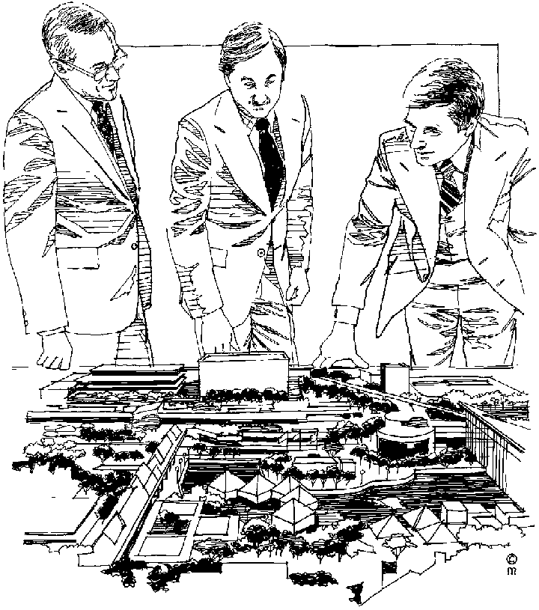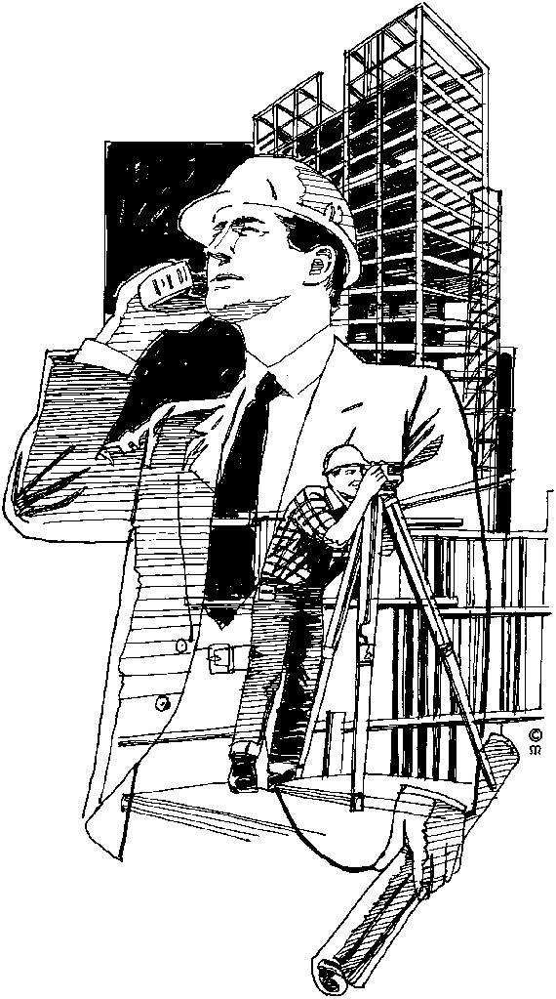

Note: Communication is the interaction between at least two people, the communicator and the recipient.

There can, however, be more than one recipient, like an audience listening to a speech or watching a movie.



#### The Communicator

The communicator starts the communication process by conveying a message about what he feels, thinks or believes about a matter that he wishes to share with others.

#### COMMU004The message

The message is that which the communicator wishes to convey to others by way of communication and can be used by the communicator to attempt to persuade someone to his way of thinking or it can be an idea, thought or feeling that the communicator wishes to share with others. This message needs to be communicated in some form, for while the message remains a thought in the communicator’s mind, it cannot be received or interpreted by a recipient.



#### The Recipient

The recipient receives the message, interprets it and reacts. This reaction is called feedback.

#### Feedback

COMMU008Feedback is not always verbal, but can also be conveyed by means of other reactions e.g. applause after a good performance

### What you do when you communicate:

You listen to what someone is saying – you think about what has been said - you respond;

You think about what you want to say- you speak your thoughts, opinions, etc. you wait for a response

You read the words written by an author- you think about what you have read - you respond

You think about what you want to say– you write the words you want to speak – you wait for a response.

Response refers to the feedback you give or get when communicating. It can either be oral or spoken, or it can be written. It can be in the form of a suggestion, advice, recommendation, statement, instruction, command, etc or it can be in the form of an assessment; a test, task, examination, demonstration, observation, etc.

Remember: It is not always what you say that is important. It is how you say it. You are continuously being assessed either directly or indirectly in all you say, or do, or write. Your knowledge, competency or your capabilities are measured when you respond or give feedback

Each type of feedback has different criteria or outcomes against which it is measured or assessed. These outcomes are in fact the skills you are required to demonstrate to prove that you are competent in what you are doing, saying, reading or writing.

Meaningful feedback requires purposeful preparation and presentation.

Note : When participating in a conversation you are constantly interpreting the words you hear so that you can unpack or extract important information. This you do in order give an appropriate response. It is a process that you work through instinctively before you respond or give feedback or say something.

You first have to interpret what you have heard, or read before you can respond or give meaningful feedback. Your, response or reaction demonstrates your interpretation, and your understanding of what you have heard, seen, felt, tasted, smelled, experienced or read.

When you interpret a message, whether it is a picture you look at; words someone is speaking; or the written word you are reading; your mind instinctively works through the following steps:

First you extract or unpack key words and key concepts so that you can speak about what is relevant. They can be extracted from your general knowledge bank or your experience, or from what you have heard and read about.

Note : Unpacking or extracting key ideas is like a brainstorm. Ideas are randomly thought of and not placed in a specific order. This is part of preparing a response starting with careful planning what you want to say.

Example: You are required to give feedback on the effect crime has on a community and how it can be minimised

A Brainstorm to unpack or collect information

Dissatisfaction Community poverty

gangs

unemployment fear

boredom anger

power recreation

aggression

security

emotions

job creation

violence control

Secondly you repack or rearrange and restructure these key ideas (keywords and key concepts) into sentences. Sentences are developed into paragraphs and organised into a logical sequence so that the information you share is meaningful.

Note : In order to repack or make an interpretation of these key ideas you have to make use of questions (what, when where, why who and how) to rearrange or restructure the brainstorm into a mind map or a flow diagram. This you do by means of grouping key concepts or related key ideas to show how they link or flow into each other in a logical sequence, to make sense.

Example: A mind map or flow diagram to restructure and organise the key ideas generated on crime in a logic way.

Because of- 🡪 dissatisfaction 🡪 involves🡪 community members

⮡unemployment ⮡ friends, family

⮡ boredom ⮡ youths

⮡ Poverty ⮡ children

emotions -🡪 anger 🡪 resulting in 🡪 violence

⮡ fear ⮡ power struggles ⮡ aggression ⮡ control

⮡ gangs

Prevented through -🡪 -community support.

⮡ Recreation opportunities

⮡ Job creation

⮡ security

Note: You do not have to make two diagrams. You can start with a brainstorm and then with the help of questions (What; When; Where; Why; Who; and How) you can develop the brainstorm into a flow diagram to map out your thoughts or your interpretation.

Then only do you respond by giving either verbal or written feedback. This is the final part of your preparation where you focus on how you are going to present your response or feedback. It is important to be familiar with the correct format in which you choose to give feedback or to respond.

#### Examples of oral feedback or verbal responses

1. Face to face conversations regarding a specific topic of interest or concern
2. Telephonic and electronic discussions
3. Presenting speeches, explaining and demonstrating procedures and schedules, discussing concerns and interests with groups of people.
4. Interviews both formal and informal
5. Giving instructions, guidelines, advice
6. Receiving instructions and requests.
7. Negotiations, debates,
8. Conversations, discussions
9. Practical demonstration
10. A verbal proposal
11. A coaching session
12. A presentation

### Various methods of communication

Written methods of communication make use of definite signs and symbols when presenting information in either a verbal context or in a written context.

|  |  |
| --- | --- |
| **Various methods of communication. Verbal Messages** | |
| **Signs and symbols** | **Method** |
| Facial expressions  Gestures  Tone of voice  Eye contact  Body language (way you dress, walk, stand, react, respond, move your body, etc),  Pace and pitch- tone of voice  Command of language  Choice of words  Pronunciation  Dialect  Accent  Sign language (for the deaf) | Telephone  Face to face  Conference  Meeting  Interview  Briefing  Informal discussions  Consultations  Bargaining  Mediation  Arbitration  Social groups  The grapevine  Gossip  Announcement  Intercom system  Presentation  Television  Debate  Panel discussion  Report  Films, DVD, CD  Training programmes  Video  Sign language |

Effective verbal communication is very important to all of us. To communicate effectively the whole personality should be adapted to the effort of arousing certain thoughts and feelings in the mind of the listener.

Tip : It is to the speaker’s advantage to be face to face with his audience as his nonverbal cues such as mannerisms, gestures and facial expressions help to project his personality and assist him to remain in contact with his audience.

## Interact With The Audience

### Contribute To Group Work

When communicating in the workplace you need to do it efficiently, in order to avoid wasting precious time on unnecessary communication.

To achieve this you must plan what you want to say and who you want to address.

In order to plan your communication, you need to know what the purpose of the communication is. If you need to remind someone of an appointment it is not necessary to schedule a meeting to do this. A simple memo will be adequate. Likewise, discussing the budget for the next year would require a committee- or a board meeting. If you are required to attend a meeting you need to know what the agenda is, to enable you to prepare yourself for the meeting.

It is also important to acquaint yourself with the procedures and schedules for meetings or other forms of communication within the company, as these may vary from company to company.

Once communication has taken place you must monitor developments thereafter, to ensure that decisions made are implemented or instructions carried out. In doing this you must take care to focus on the relevant matters and not get side-tracked.

From the monitoring process you can draw conclusions as to whether the outcome of the communication has been achieved or not. These conclusions have to be analysed, formulated and communicated back to the persons involved, ensuring that all involved are up to date on developments.

### Interviews

During an interview the interviewer (journalist, manager, principal, etc.) puts questions to the interviewee (person being interviewed).

Interviews can be formal or informal, depending on the purpose of the interview.

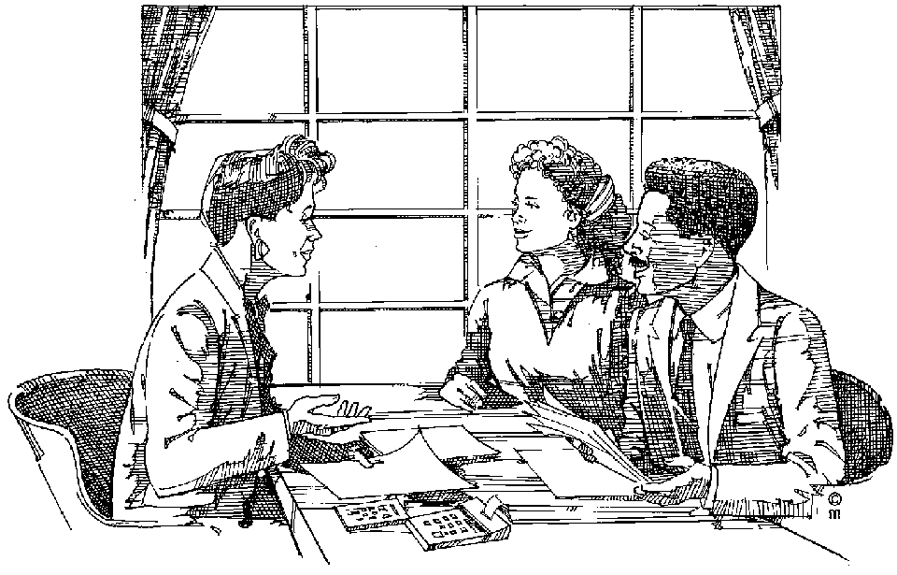Formal Interviews include

Job interviews,

Interviews for admission to a college or university,

Media interviews with politicians or celebrities, etc.

This form of interview is, as the name states, formal and structured. Before the interview the interviewer does background research and formulates questions he wants to put to the interviewee. The interviewer then carefully plans the structure of the interview to successfully elicit the intended information and use the allocated time effectively.

During such an interview it is important for the interviewer to be flexible when the sequence or focus of the interview is disrupted. He must have the skill to get the interview back on track by being assertive without offending the interviewee if possible, especially where time is limited e.g. television or radio interviews.

The interviewer must also have the skill to elicit the information he intends to get by asking the appropriate questions at the right time and then coming to the right conclusions in order to summarise what was said by the interviewee.

Informal interviews often occur at the spur of the moment and are not as structured as formal interviews e.g.

An interview with a sports star after a game,

An interview with an eye witness at the scene of an accident or

An interview with holidaymakers on the beach.

Due to the impromptu nature of this type of interview it is not always possible to plan and structure the interview and this is done while the interview is in progress.

The interviewer, in this case, must have the skill to think fast and react to information he elicited from the interviewee immediately. This makes the informal interview very challenging but also very exciting for the interviewer.

We will discuss job interviews but much of what is discussed also applies when you are conducting an interview.

#### Preparing for an interview

The key to a successful interview is good preparation. If you take time to prepare for the interview you will find that you will confidently be able to participate in the interview even if you are nervous. You will instinctively know how to respond to the questions put to you and you will have a good interview.

Do some research and find out as much as possible about the company and the advertised job.

It is a good idea to make a list of all the questions you want to ask.

Take time to analyse or unpack all your strong points and your weaknesses. Knowing these will contribute towards your confidence.

Make a list of questions you think you may be asked. How would you answer them?

Dress carefully for the interview. Always look neat and tidy. Remember the first impression you make when you enter the interview room is very important. Often more important than all the job skills and experience you have.

Take with a copy of your CV, the letter of application as well as the advertisement, the application form if you completed one and any job description you may have been given.

#### Being interviewed

The company interviews prospective employees to find out just how suitable they are for their purposes. These purposes have been summarised in the job description. Once they have read through the information you have sent them they will ask you two types of questions:

Questions that focus on finding out more about yourself, they give you an opportunity to sell yourself. Refer to your CV.

Questions that are directed towards your weaknesses, they tend to manipulate your confidence. Answer these questions one at a time.

Think carefully of what you have said in your CV; think of your weaknesses and answer as best you can:

Be friendly. Greet the interviewer and wait to be invited to sit down. You can shake hands if required. Sit up straight yet relaxed; don’t slouch in your chair.

Speak clearly, don’t speak too fast. Listen before you respond. Look at your interviewer don’t look at the desk or the floor.

Always be honest. If you are dishonest there is always a chance of being found out. Admit if you make a mistake or cannot answer the question. Being honest can be to your credit.

Be positive. For example if you left because you and you boss did not get on a negative response would be: “I had an argument with my boss.” “A positive response would be “There was a conflict of personalities between myself and a senior manager. We agreed it would be better if I left the company”

Make sure you answer the question. Don’t avoid questions that are difficult to answer. Think about them and then be honest. This type of question is gives an indication of how you will react to difficult situations in the workplace.

#### Problems during an interview

Sometimes things go wrong when you are in an interview. Being stressed doesn’t make it any easier. Your mind suddenly goes blank, your thoughts dry up and you do not know what to say.

Take a deep breath and pause a moment and relax. Don’t just start talking or rambling on speaking nonsense.

Ask the interviewer to repeat the question or if you cannot answer the question, admit that you don’t know.

Always be polite even if the interviewer is aggressive or irritating.

Stick to your answer if you believe in what you are saying.

#### Concluding an interview

Remember to thank the interviewer when the interview is brought to a close. If it is required shake hands before you walk towards the door. Don’t just walk out. Pause at the door to say once again thank the interviewer. Smile before you walk out. Last impressions are just as important as first impressions.

### Formal Meetings

A meeting may be defined as a gathering of persons to discuss matters of common interest and to make binding decisions.

For the purposes of this unit standard we are going to deal with the formal format of a meeting and some of the workings thereof.

Some types of formal meetings include

Annual general meetings,

Board meetings,

Executive meetings,

Briefing meetings,

Weekly production meetings

Monthly sales meetings

Meetings form a major part of communication within modern business and everyone should be familiar with the procedures involved.

The first consideration when planning a meeting should be whether or not a meeting is required. This should be determined by stating the objectives that need to be achieved and deciding from these formulated objectives whether a meeting is the best way to achieve these objectives.

#### Convening A Meeting

#### Notice of the Meeting

A valid notice stating the date, time and venue of the meeting should be forwarded to all parties entitled to attend at least seven days prior to the date of the meeting.

he agenda for the meeting should accompany the notice.

#### The Agenda

The agenda is the list of matters to be discussed at the meeting and is normally compiled by the secretary according to instructions from the chairman.

It can also include matters requested by members or matters arising from the minutes of the previous meeting.

A typical agenda could include:

Opening and welcome by the Chairman

Attendance register

Apologies for absence

Minutes of the previous meeting

Matters arising from previous minutes

Additions or alterations to the agenda

Matters on the agenda

General matters

Date of next meeting

Close

#### The Minutes

This is a record of discussions, decisions and voting during the meeting.

The minutes are normally recorded by the secretary and then signed by the Chairman.

These minutes should record proceedings accurately. Special attention should be given to recording essential items such as resolutions and amendments verbatim as well as the names of proposers and seconders. Proposers are people at the meeting who propose that a certain procedure should be followed or certain decisions should be made. Once a proposal has been made, someone else should agree with this proposal by seconding it – the seconders.

Where certain persons are given the responsibility to follow up on matters before the next meeting their names and details of their responsibility should be recorded accurately.

#### Legality

A properly elected Chairman as well as a quorum has to be present to convene a legal meeting.

A quorum is the minimum number of persons to be present to make binding decisions. The number of persons to constitute a quorum is laid down in the constitution and these persons have the right to vote and must be present for the duration of the meeting.

#### Duties of the Chairman

The Chairman must ensure that:

A quorum is present

And that the meeting is conducted fairly and in accordance with the rules and regulations as stipulated in the statutes, common law and the constitution.

He is also responsible for

Maintaining discipline throughout the meeting by ensuring that matters are handled according to their order on the agenda

And that all members get a fair chance to speak

He puts motions and amendments to the vote and pronounces the results.

The Chairman can adjourn the meeting if he thinks it necessary and he also declares the meeting closed at an appropriate time.

#### Duties of the secretary

The secretary is responsible for the administrative function at a meeting.

These responsibilities include:

Convening the meeting and preparing the necessary documents e.g. the agenda, minutes from the previous meeting, attendance register and membership list.

Taking notes during the meeting and compiling the minutes from these notes. (Ensure that important matters and motions are recorded verbatim.)

Handling all correspondence.

If you keep the abovementioned in mind when attending a meeting again you will be able to participate and make your own contribution towards achieving the objectives of the meeting.

### Debates and negotiations

Debates and negotiations can also be conducted in formal and informal formats.

A discussion of the weekend’s sports will be an informal debate where the debate is not structured and the outcome of the matter is not determined by putting it to a vote.

On the other hand a formal debate, such as during a meeting or session of parliament, is (supposedly) conducted in a structured manner with participants adhering to certain rules and procedures.

Debating should be conducted in an orderly manner. To achieve this goal participants and the Chairman should adhere to the following:

Matters must be discussed in the order in which they appear on the agenda.

Speakers supporting and opposing the motion should be allowed to speak alternately to maintain fairness and balance.

Members from a minority group should be granted sufficient opportunity to speak.

The debate may be interrupted at any time by raising a point of order when procedures aren’t adhered to.

All persons addressing members should do so through the Chairman.

The Chairman should ensure that procedures aren’t drawn out unnecessarily by repetitive arguments.

Every participant should have the right to speak once to the motion and once to any amendment. The proposer of a motion should have the right to reply.

The Chairman has the right to reply to the total debate by summing up or clarifying the issue.

#### Pointers for debating

Although people have different opinions and ideas it does not necessarily mean that one is right and the other wrong. There is often something of value in every opinion.

Allow everyone a turn to speak. Listen to what they have to say it could be of value to your argument.

Try not to interrupt someone when they are speaking. In a heated argument this will not always be easy, it will require a lot of self discipline!

Never get personal or insulting. The fact that you disagree with what someone is saying does not make them stupid.

Sometimes a debate or difference of opinion cannot be resolved. Then the reasonable thing to do is for all parties to ‘agree to disagree’, which is a result where no one wins - but no one loses either.

### Differing Socio-Cultural Contexts

While communicating with an audience you must always be aware of the socio- and cultural diversity of the audience and be sensitive to the manner in which people from different social- and cultural backgrounds express themselves.

To achieve this goal it is essential for the speaker

To be on the same level as those who he is addressing

And to use language that they can understand and identify with.

It may be helpful to interact with the audience prior to addressing them in order to find out more about their background and customs so as not to offend them by speaking above their level of comprehension.

#### Pointers for Intercultural communication

It is in the workplace that people from different cultural backgrounds come into contact with each other and unconsciously use different behaviour patterns that can lead to confusion and conflict. The following skills could help avoid unnecessary misinterpretations:

Show openness and respect towards the norms, values and behaviour patterns of people from a different culture.

Do not focus on the differences between people (race, colour, background, body language, accent, manners, behaviour) rather focus on what you have in common (self respect, integrity, the need to be accepted and to be recognised, working to be successful)

Learn to know more about the culture of people whom you work with, it will make communication more successful. Know that other cultures are interesting and that you do not come from a superior culture.

Choose your words carefully as they not only express your thoughts, they also impress the receiver and the impression your words make motivates the reaction you receive.

Use clear simple language. Select vocabulary, gestures and a body language that your audience will relate to and understand

Have empathy – put yourself in the other persons’ shoes and see the situation from their point of view.

Learn to be not only an active listener but also someone who can read the actions, gestures and body language.

Mind your manners, be polite acknowledge and respect the differences.

# CAPTURE THE INTEREST OF THE AUDIENCE

#### Specific outcome

Use strategies that capture and retain the interest of an audience.

#### Assessment criteria

Use key words, pace and pause, stress, volume and intonation in appropriate ways to reinforce the message.

Ensure that your body language is appropriate to context and topic, and reinforces main ideas and attitudes.

Plan your formal communications in writing, and your plans will be detailed, complete, and realistic with respect to time allocation and content.

Ensure that your visual aids are appropriate to topic and context, and enhance the presentation and the transfer of information and understanding. Range: Cue cards; visual aids; handouts; multi-media.

Use techniques to maintain continuity and interaction. Range: Responding to queries, repetition of information, rewording, asking questions to check understanding, referring to cue cards; timing techniques; responsiveness to audience cues that contact is being lost.

## Forms of communication

There are many forms of communication such as personal-, mass-, intercultural- and organisational communication.

Personal communication is when you communicate with yourself or with one or two other people.

Organisational communication takes place within an organisation.

Mass communication is when you are communicating with many people at the same time. Newspapers, radio and TV are examples of mass communication.

Intercultural communication can be personal, mass or organisational communication, but takes cultural differences into account.

Furthermore, communication can be verbal as well as non-verbal, both of which will be discussed.

Note: The purpose of communicating is to get your message across to the audience.

In order to do this, you will make use of certain techniques that are aimed at capturing and holding the attention of the audience.

### Verbal Communication

The way that you speak can reinforce your message and influence your audience. When you speak in the same tone, pitch, volume and pace all the time it becomes boring for the audience and they can fall asleep. If you listen to public speakers, TV and radio commentators, you will notice that they vary the tone, pitch, volume and pace when they speak, in order to capture and maintain the interest of the audience.

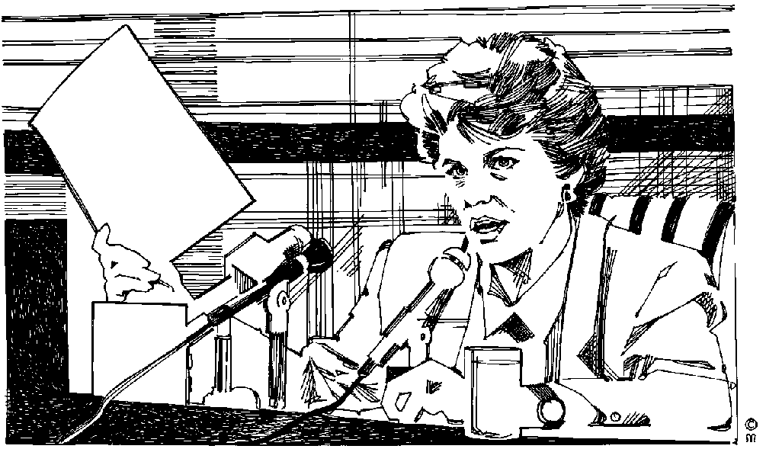

The tones, pitch, pace and volume of your voice can determine how a listener will interpret what you are saying. By controlling these vocal characteristics you can become a more effective speaker. The tone is the sound of your voice, e.g. bright or deep, and expresses your feeling or mood. A bright tone will indicate feelings of excitement, joy, etc. while a deep tone will indicate feelings of placidity or sorrow. So when you are addressing a serious subject, your will use a deeper tone of voice, while a lighter tone of voice is appropriate for a more light hearted subject.

Pitch is determined by the tension on your vocal cords, i.e. how high or low your voice sounds. Generally you will speak at a high pitch when excited and at a lower pitch when relaxed.

The paceor speed at which you speak can also influence your audience. When you are telling someone that you have won the Lotto you will talk much faster than when you are telling him that you cannot attend a major sporting event. You need to adapt the volume of your voice to the environment. Factors such as:

being indoors or outdoors,

number of listeners in a room,

the size of the room,

background noise and availability of amplification will determine the volume at which you speak.

The volume of your voice can also indicate whether you are excited or relaxed, angry or friendly. When you are saying something important, you will increase the volume of your voice in order to stress the importance of the point you are making. Pause is a useful technique to stress important points in your presentation. When you pause for a couple of seconds just after making an important point, the audience knows that what you have said is important.

Using keywords is another technique to stress important points. In every presentation, not everything you say will be equally important. Some points will be main points and others will be extra information to explain what you are saying. You will use the main points to identify keywords in your presentation. When you get to the keywords you will stress them by adjusting the tone, pitch, volume and pace of your voice. This will give the audience the cue that the keywords and the point you made are important.

Now that you know what it means to vary the tone, pitch, volume and pace of the way you speak, you can use these methods to:

Enhance the meaning of what you are saying to the audience

Respond appropriately to the audience, even in differing circumstances

## Body Language

### Nonverbal Communication

There are many different types of nonverbal communication but for the purpose of this unit standard we are going to deal with nonverbal communication that directly interacts with verbal communication.

When communicating verbally you can express different feelings without even noticing or voicing these feelings. It is important that you know what these signals are and to be aware that you are also communicating these signals to the people you are communicating with. Just as important is that you recognise these signals that others communicate to you.

Some of these signals are:

#### N0219Handshake

This normally conveys a first impression of the person you are dealing with. A firm handshake will illustrate confidence and gets the other person’s attention. Hold on to his hand a little longer than is necessary to keep his attention. A sloppy handshake will, in contrast, can be interpreted as a sign of insincerity and/or laziness.

#### Eye Contact

Much can be interpreted by eye contact or the lack thereof.

Direct eye contact and a friendly expression will indicate openness and honesty. Always look the other person in the eye and maintain eye contact to show the speaker that you are listening.

Lack of eye contact can mean that the listener is not paying attention, is bored with what you are saying or is uncomfortable with what you are talking about. Not making eye contact can also indicate dishonesty and distrust.

#### Gestures

It is normal to make hand gestures during conversation to emphasise a point, but there are other gestures that convey your inner feelings without you making them consciously.

These include hand-, foot- and leg activity. Restless hands or shaking of the legs or feet can be a sign of agitation or nervousness. Of course, rude gestures are not allowed when you are giving a presentation.

Positive gestures can include raising your hands when making an important point. When you are using visual aids, you can also point at the specific poster, model or whatever visual aid you are using, or point at the objects in the poster or model that you are discussing. This directs the attention of the audience to the visual aid and helps them to understand what you are saying.

#### Posture

Sitting or standing straight will indicate that the listener is alert and paying attention, while slouching in a chair or leaning against a wall or door is a sign that the listener is not really interested in what is going on.

When you are giving a presentation it is important that you stand up straight and move around a little rather than staying in one place all the time. If it is possible, you can also move towards the audience or interact with the audience directly by moving between them.

Your posture should also be positive and not threatening towards the audience. When you invade someone’s personal space or point directly to them with your finger while leaning forward, the other person can feel threatened. On the other hand, you can walk to within one or two paces from the other person, look the person in the eye, smile and make your point in a non-threatening way.

#### C0148Touch

Be very careful of this one as it can very easily be misinterpreted, especially in a working- or business environment. A hug and a “high-five” between winning team mates is an expression of victory or celebration, while stroking a secretary’s neck when dictating a letter to her can be seen as sexual harassment. During or after the delivery of your presentation, you must be wary of touching members of the audience, since your intentions can be easily misunderstood.

#### Distance

All of us need personal space and when someone else invades that space we feel uncomfortable and threatened. Personal space is the distance between yourself and the person you are talking to.

The space between close friends or relatives will be much closer than the space maintained by a company director and a subordinate or opposing parties in an argument.

Determine what personal space is appropriate in a situation and maintain that space. Never intrude on someone else’s personal space, as this will make the other person feel threatened and distract his attention from what is communicated.

### Nonverbal Messages

You can use your own body language to enhance your verbal message in the following ways;-

A nonverbal message reinforces the verbal message by adding to its meaning. Banging your hand on the table while reprimanding someone conveys a stronger message than words alone, adds emphasis to your statement and captures the listener’s attention.

nonverbal message can complement a verbal message when it conveys the same meaning. A greeting in a friendly tone of voice, accompanied by a warm smile will compliment your verbal message.

A nonverbal message may substitute the verbal message. When you arrive home and are irritable and impatient it is not necessary to tell anyone that you had a terrible day at work. Likewise a passionate hug and kiss will tell your spouse that you love him/her without you having to say it.

Nonverbal behaviour functions to regulate the flow of verbal interaction. Slight hand movements, eye contact, tone of voice, nodding of the head and other nonverbal behaviour tells the recipient to talk, repeat a statement, hurry up or finish the conversation. For example, the chairperson at a meeting uses eye contact or hand gestures instead of words to indicate whose turn it is to speak.

A nonverbal message can accentuate what is said. While addressing an audience a speaker may talk louder and wave his finger in the air to stress a point that he is making. Speakers at political meetings are very good at this.

A nonverbal message may contradict the verbal message. This happens when a speaker says one thing but does another. A new company executive about to make his first presentation to the board of directors may claim not to be nervous despite his trembling hands and sweating forehead. Contradictory cues often tell us when someone is being sarcastic or merely teasing.

### Barriers To Effective Communication

Many barriers to effective communication exist and can be detrimental to effective communication. Following are a few that have bearing on what is dealt with in this unit standard.

#### Poor interpersonal skills

Poor interpersonal skills include poor listening and/or sensitivity to nonverbal communication.

We have discussed listening skills and nonverbal communication at length. When you deal with clients, you have no excuse for not listening to what the client is saying or listening to non verbal communication. It is part of you job and you have to do it. when a client is discussing something with you, the client is entitled to your undivided attention.

Always remember: you cannot listen while you are talking. In order for you to listen, you have to keep quiet and pay attention.

#### Failure to identify the needs of the receiver

This happens when you listen to only part of what the person is saying and then start jumping to conclusions instead of listening to the speaker until he has stopped talking.

Only then can you come to conclusions, which you have to check with the client anyway, by repeating the issue as you understand it to the client.

“Am I correct in understanding that you want ….. done” or “As I understand, the problem is …..”

#### Different cultural backgrounds

The audience will not always take differences in cultural backgrounds into account, but you have to. You are not allowed to judge anyone you are talking to because their cultural background is different to yours.

When you are giving a presentation, it is part of your job and your duty to take the audience’s different cultural backgrounds into consideration. During the planning stage, you have to ensure that your presentation does not include material that can be offensive to cultures other than your own.

If you don’t know much about other cultural beliefs, you have to make an effort to find out what they are. This will make future communication with the audience easier.

#### Lack of intercultural understanding

This is a major problem in our country today. Unfortunately, when you are dealing with other people, you have to ensure that you do not suffer from a lack of intercultural understanding. Just as your culture is important to you, their cultures are important to them. Put yourself in their shoes and try to understand that it is not acceptable to offend people only because their culture is different to yours.

#### Messages with too much/little information

Many people find it difficult to express themselves clearly when they are under stress. They will usually either give you too much or too little information.

You have to be aware of this, so that you can:

Focus on the important and relevant issues when a person gives too much information

Ensure that you get all the relevant information when a person gives too little information

“I was mugged, they hit me over the head, there was blood all over the place, I had to go to the hospital to get stitches and my handbag was stolen.” This is an example of too much information. You have to find out what the problem is that has to be addressed.

“My handbag was stolen.” This is too little information and you have to find out what the issue is that the person wants resolved.

#### Irritating mannerisms that prevent people from listening

When a person is tapping on the desk or tapping a pencil against his teeth the whole time that you or he is talking, or when someone shakes his knee or twitches his shoulder all the time.

Some people say “You know…” a lot, others say “ah…” all the time while talking. There are many more examples of irritating mannerisms that you should not adopt while giving a presentation. On the other hand, when someone in the audience displays these mannerisms, you have to ensure that they do not distract you from listening to what the person is saying.

#### Use of insensitive or abusive language by the sender or receiver.

This is never acceptable, but can sometimes happen when a person is angry or irritated and perceives that his problem is not going to be addressed properly.

The best way to handle this is to calm the person down without saying anything about his insensitive or abusive language.

You will find in most instances that the person will apologise as soon as he can see that his problem is going to be addressed in a way that is satisfactory to him.

You must always be aware of how you talk to other people in order to ensure that you do not use insensitive or abusive language, as many people stop listening when you talk to them in a way that they don’t like.

When giving a presentation, you must be able to identify these barriers and overcome these barriers by using the skills that you have developed. You must also ensure that you do not erect barriers to communication by one of the above actions.

## Capture And Retain The Interest Of The Audience

### Reinforce The Message

Before addressing an audience you need to plan what you are going to communicate to the audience. It is essential that you prepare a detailed and complete plan of your address in writing, outlining the introduction, body and conclusion. Refer to these notes to assist you to keep track of main ideas and adhere to timelines.

This topic has been covered comprehensively in the previous modules and unit standards. Refer to your notes when drawing up a plan for your verbal communication.

### Visual Aids

During the planning of your address you must also identify where you are going to make use of visual aids like:

Cue cards: these are smaller than posters and contain only one visual cue. If you are doing a presentation to children about the importance of brushing teeth, you might have a cue card with a tooth, one with a toothbrush and one with toothpaste. You will show these to the audience at the appropriate place during your presentation. At the end of the presentation, you would summarise and at the appropriate place show the cue card without saying anything, encouraging the audience to name the object. You would show the card with the tooth, for example and maybe ask the audience: “Every morning you must brush your …” and then wait for the audience to supply the missing word.

Posters: we have all seen posters of music starts, movies, videos and so on. A poster that you design for a presentation does not have to be as elaborate as one of these but if you plan it correctly it can have just as much impact.

Models, etc. We have all seen models of trains, cars, houses, large buildings and so on. These are very effective visual aids and you should use them whenever appropriate and when you can get hold of one.

### Handouts And Multimedia

You can also make use of handouts given to the audience. Handouts are notes about your presentation that you give to the audience.

Multi-media visual aids include:

Flipcharts. You can use the flipchart to make notes during your presentation, much as your facilitator does during the lesson, or you can write out your flipchart sheets beforehand and put them up at the appropriate time.

Whiteboard: same use as a flipchart, however you have to rub out what you have written as soon as you want to write something new.

Overhead projector. You have to prepare the slides beforehand and show them at the appropriate time in your presentation. Your facilitator makes use of this visual aid during class.

Data projector. It works like an overhead projector, but is connected to a computer and displays visual aids that you have prepared on the computer beforehand.

Slide shows. These are prepared on a computerised presentation programme and can be shown on individual computers or through a data projector. You can, of course, also use photographic slides in a slide projector, although this method has become somewhat outdated.

Video presentations. These are video clips or training videos prepared especially for the purpose of your presentation.

### Feedback From The Audience

When addressing an audience you must always strive to capture and retain their interest and attention.

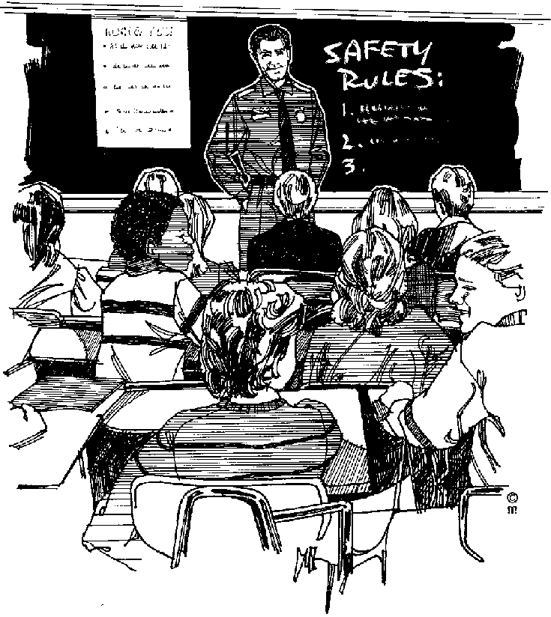It is fairly easy to determine whether you have the attention of the audience by taking note of verbal and nonverbal feedback from the audience. Verbal and nonverbal clues to communication has been covered has already been covered in a previous section. Refer to you notes.

If you are the participant in a debate you can judge from questions or remarks whether the audience is following you or not.

A person asking questions frequently indicates that he is following what you are saying and participating, while one who just sits there because he has to be there and doesn’t participate at all indicates that the person is not really interest in what you have to say.

Likewise if you are addressing a meeting you can observe the body language of the audience to indicate their level of participation or attention/interest.

A person that looks around and at his watch every now and then and follows it up with a big yawn is not listening to you with attention.

Some people will actually fall asleep.

On the other hand the person keeping eye contact with you and occasionally taking notes has your undivided attention.

During presentations it is of utmost importance to get feedback from the audience. If they are not asking questions or participating in the presentation you can ask them questions. Do not embarrass them, however. It is usually good practice to ask a question and then let someone from the audience answer the question. If no one answers, you can answer the question and then ask someone if they agree. This is only one example of many, watch what other people are doing and, if you like the technique, adopt it.

If you have the interest and attention of your audience you know that what you are saying and conveying through your body language is getting through to your audience, but if you realise that your audience is not paying attention you need to employ some or all of the following strategies to capture their attention.

Repeat and emphasise key words to stress their importance.

Adjust the pace at which you speak to compliment what you are saying. You can talk slower and emphasise words to make a bigger impact on the audience.

Pause for a second or two after saying something of importance to give the audience a chance to think about what you have said. The audience will make the connection that what you have said is important. Increase the volume and raise the pitch of your voice to emphasise important facts.

Ask rhetorical questions: a rhetorical question is a question that does not require an answer.

Repeating words and phrases is very effective if you want to emphasise the importance of the statement. Sir Winston Churchill made very good use of repetition in his famous speeches during World War 11.

On 22 May 1940, after the British soldiers had been evacuated from Dunkirk, he said:

“We shall fight on the beaches, we shall fight on the landing-grounds, we shall fight in the fields and in the streets, we shall fight in the hills; we shall never surrender…

On 13 May 1940, just after he was elected prime Minister, he said that he had one aim:

“Victory – victory at all costs, victory in spite of terror; victory, however long and hard the road may be.”

Of course, he said many more memorable things and it is worthwhile reading about him. He was the Prime Minister of Britain during World War 11 and he was a rather colourful character – just what the British needed during wartime.

Political speakers are very good at capturing and holding the attention of the audience: sometimes they bang their hands or make use of exaggerated gestures to emphasize certain points they want you to think is important. They also adjust tone, pitch and volume to emphasize what they are saying.

Another good example is a musical awards ceremony: have you noticed how the presenter drags out the moment of the announcement and then dramatises the announcement:

“And the WINNER is….. SO AND SO FOR ….”

By mastering these techniques you can improve the effectiveness of your verbal communication. Learn from public speakers and apply their methods. You must, however, be careful of dramatising too much in the business world. Use their techniques, but tone it down – don’t shout or bang your hands on the dais or desk, instead talk louder and faster or slower to emphasize what your are saying.

As indicated previously, body language is a form of nonverbal communication and you as speaker can deduce what the level of interest of the audience is by observing their body language.

Likewise you can use body language to enhance what you are saying.

Hand gestures,

Facial expressions,

Posture, etc.

should be used by the speaker to reinforce important ideas and messages.

### Ask Questions

Asking questions is one of the ways in which you can involve the audience in your presentation. To do this, however, you have to know the different types of questions and how to use them.

Certain types of questions will be more helpful than others:

#### Open Questions

These generally begin ‘How …?’ ‘What …?’ “Where …?’ “Who …?’ They require a fuller answer than ‘Yes’ or ‘No’. They may be used to:

Gain information: ‘What happened as a result?’

?

Explore thoughts, feelings, attitudes and opinions: ‘What were you hoping to achieve?’ “How are you feeling having done that?’ “What’s your view on that?’

Consider hypothetical situations and explore options: ‘What would help?’; ‘How might you deal with …?’; ‘What are the possible options for …?’

‘Why?’ questions are useful open questions, but can sometimes be less helpful if they sound too much as if they are judgmental – seeking justification for action. In such circumstances they can sound moralising: ‘Why did you do that?’

#### Closed questions

These invite a ‘Yes’ or ‘No’ answer and as such may unhelpfully close down the options for responding: ‘Did you not think of that possibility?’; ‘Do you get on well?’

Repeated use of closed questions can take the discussion along a downward spiral of awkward communication with the client saying less and less and you becoming pressured to ask more and more questions.

There are times when closed questions are useful as a questioning summary: ‘So, overall, you are saying you were pleased with that session?’

#### Elaboration questions

These may or may not be open questions, and are used to encourage the person to elaborate on what has already been said: ‘Can you give me an example?’; ‘Can you say a little more about that?’

#### Leading questions

These suggest to the audience that a particular answer is expected, and that there are particular beliefs or values that should be held: ‘Do you really think that …?’ ‘Shouldn’t you be considering …?’

#### Multiple questions

Several different questions are asked in one sentence leading to potential confusion for both the client and yourself: ‘Is it that you feel … or that you think it would be better if … or perhaps that she should …?’

?

Usually, you would not use a mixture of the above questions when trying to elicit a response from the client.

#### Then, of course, you have to

LISTEN to the answer,

Pay attention to person’s body language for any hidden messages.

### Active Listening

Now that you know how to capture and hold the audience’s attention and get feedback from the audience, you have to apply active listening skills to hear and understand what they are saying. You have to pay attention and focus on what the speaker says in order to respond appropriately to their comments and questions.

Active listening is a skilland is as important as giving orders in obtaining results.

Give your full attention to what is being said.

Make sure that you really understand.

Listen between the lines.

Look for non-verbal clues.

Mentally summarise and evaluate objectively.

Be empathetic.

Determine whether he expects: guidance, support, motivation, action or silence.

#### What Makes A Good Listener?

This is actually a question of feedback. Good listeners use a variety of non-verbal and minimal cues to keep the other person talking. These include the use of phrases such as:

“Yes”

“I understand”

“And then what”

“Tell me more”

“If I understand you correctly…”

Although the above illustrates how your natural reactions to different states of emotion can influence the manner in which you speak, it must be mentioned that you can intentionally alter some or all of these factors to enhance what you are saying.

Do not to overdo such variations as this might have exactly the opposite effect on what you are trying to communicate.

When communicating with someone else you must always strive to do it as naturally and evenly as possible. Be yourself!!

### Continuity And Interaction

During your address you need to maintain continuity and interaction throughout. This can be achieved by employing the following techniques.

Respond to queries from the audience. This promotes participation from the audience and helps to maintain interest and attention.

Repeat information to stress importance and to allow for time to take notes.

Reword important ideas to ensure repetition of the message. This means that you say the same thing more than once, using different words.

Ask questions to promote interaction and ensure understanding of the idea or message.

Refer to cue cards to refresh listeners’ memory.

Use timing techniques – coordinate use of visual and other aids to be appropriate to the message or idea.

Respond to cues that audience contact is being lost. Employ techniques discussed thus far to overcome and remedy this problem.

### Pointers before you speak

When you communicate, there are four critical factors to consider:

What you meant to say – the message in your thoughts

What you actually say – the words, tone of voice and body language

What the other person hears – words, tone and body language

What the other person thinks he heard

55% of a message is conveyed by body language and facial signals

38% of a message is determined by your tone of voice

7% of a message is conveyed by the words you use

When you feel good, you sound great too! I cannot see your smile on the other side of the telephone, but I sure can hear your smile – and it is a lovely sound

#### Pointers

If you are uncertain ask questions. Do not make assumptions by hearing what you want to hear. Make sure what you hear is correct.

Be well prepared. If you know what you are speaking about you command attention and respect.

Choose your words carefully as they not only express your thoughts, they also impress the listener or receiver. The impression your words make motivates the reaction you receive.

Think before you speak. Organise your thoughts and know what you want to say. Don’t just ramble on.

Use clear simple language. Select vocabulary that your audience will relate to and understand.

Be specific in your choice of words so that your message or information can be correctly interpreted. Assumptions result in the incorrect interpretation of your message, your answer or the information you are sharing.

Use correct pronunciation. Use your mouth, relax your jaw and move your lips to help you pronounce words correctly.

Watch your pace, don’t speak too fast and don’t speak too slowly either.

Watch your stance, or the way in which you stand and move about. Certain movements such as fidgeting and twitching can be irritating.

Remember that your body language, and your voice control, together with your facial expressions, especially your eyes, is the mirror of your emotions. They will tell whether you are nervous, afraid, uncertain, happy, sad, angry, irritated, uncertain, confident, satisfied, positive, hesitant, insolent, sure of yourself, etc.

Be polite and considerate. Respect the thoughts and opinions of others even if you do not agree.

The pitch of your voice must be acceptable, not too high or too low.

Listen to the rise and fall (inflection) of your voice. Do not speak on the same note it becomes monotonous or boring.

The tone of your voice creates the atmosphere or setting for the conversation. It could be friendly or aggressive, sad or happy. The tone determines the response or the amount of interaction you will receive.

Make use of the pause especially if you want to make a point or stress an important fact. But don’t pause too often.

Avoid making use of qualifiers such as repeatedly using “OK” or “Um or Er and Ah”

Listen before you answer

Never chip in or interrupt to say something

### Guidelines for better explaining

Make each explanation sound fresh and spontaneous

Make your explanations conversational and descriptive

Be direct with recommendations, but not directive

Be enthusiastic

Value your customer’s style of interaction

Be truthful

Avoid jargon

Note : It is the duty of anyone involved in communication to make an all out effort to ensure that all communication is as successful as possible.

Here are some basic rules to help you communicate a little better:

#### Know what you want to say before saying it

Plan your communication

Think before your communicate

#### Allow a margin of time in which to communicate

Avoid rushing communication. Take your time

Avoid communicating just before knock off time

#### Be clear and concise. Keep it simple. Keep it short.

Use words people will understand

Watch out for “jargon”

#### Use the level of language that will be understood

Remember English is not everyone’s first language

#### Listen actively

Give your full attention

Check your own understanding of what was communicated

Use your senses to listen

#### Check for understanding

Get feedback

Give feedback

# MANIPULATIVE USE OF LANGUAGE

#### Specific outcome

Identify and respond to manipulative use of language. Range: News clips, summaries, political speeches, marketing material, advertisements

#### Assessment criteria

Identify and distinguish between facts and opinion

Note and address the omission of necessary information.

Explain the implications of how the choice of language structures and features, specifically tone, style and point of view affect the audience’s interpretations of spoken texts.

Explore the distortion of a contributor’s position on a given issue, with specific reference to what has been selected and omitted

## Manipulative Use Of Language

People use different techniques to manipulate their use of language to distort reality. This is used in advertising, news coverage and political speeches, to mention a few. This can be done deliberately or unintentionally.

### Different Techniques To Manipulate Use Of Language

Language is one of the most powerful tools we can use to get people to do what we want them to do. You can make someone happy, excited and inspired just with the words you use. Words can create love and they can cause hate. Stirring speeches have roused people to take up arms and go to war – that’s how powerful words are.

Note : To manipulate means to get someone to do or to feel something they might not necessarily want to. Are you aware of how often you are manipulated by the words around you – words that you hear on the radio, television, see on billboards and read in magazines and newspapers?

The worst culprits for manipulating with words are advertisers and politicians. They want your support and/or your money. They want you to buy their product so they tell you that if you buy this car, item of food, clothing – whatever – how much better your life will be. That is manipulation. For example:

Face creams that promise you will look 10 years younger in 12 weeks!

Take charge of your life with a Discovery credit card – get up to 44 days free interest free credit. (A credit card actually gets you further into debt where you end up feeling totally out of control of your life)

Lose 20 kilos in 2 months with Burn it Off diet pills.

Why not take that overseas trip or do those alterations on your house? We will lend you R20, 000 to make your dreams come true!

### Fact And Opinion

A fact is something that everyone accepts as being true, as it cannot be perceived to be anything else, e.g. night follows day follows night etc. This fact has always been true and will be true for as long as we exist.

Fact: a thing that is known to be true

An opinion, on the other hand, is not necessarily based on fact and can be challenged by proving the contrary, e.g. there are dark clouds in the sky, accompanied by thunder. Due to these factors you are of the opinion that it is going to rain, however, the storm can blow over without a drop of rain falling.

### Omission Of Necessary Information

Two of the tactics most used by journalists who write for newspapers and magazines are omissions and silence. Many people are misquoted in this way.

Omission is something that has been left out.

Below is a paragraph from an article about slavery. If I leave something out, it changes the entire meaning of the paragraph.

*Once the Arabs seized the cattle, they moved from hut to hut gathering grain, blankets and salt – and human booty. Deep in the shadows of one hut, they discovered Abuk. Grabbing the terrified woman by her bead necklace, a militiaman growled, “Now you belong to me!” In all, 282 Dinka, including Abuk’s mother, sister and niece were herded up and forced to march north.*

Now read the paragraph where human booty and the last sentence have been left out:

*Once the Arabs seized the cattle, they moved from hut to hut gathering grain, blankets and salt. Deep in the shadows of one hut, they discovered Abuk. Grabbing the terrified woman by her bead necklace, a militiaman growled, “Now you belong to me!”*

Do you see that the whole meaning of the paragraph has now changed and that there is now no reference to slavery?

Silence means not saying or writing anything.

If the author of the article about slavery did not write the article, we would never have known that it is going on. Silence can be just as dangerous as omission. If we don’t write and talk about what is going on in the world around us, we will never be able to identify problems. If problems are not identified, solutions cannot be found.

Note : Often it is not what is said, but that what is NOT said that conveys a specific, and sometimes deliberate, message to the receiver.

During compiling a summary of a speech or statement, some important ideas or facts may be omitted by the person compiling the summary, thus conveying a different message from the message originally intended by the speaker.

Politicians more than often emphasise what their party does in respect of a certain matter and then neglects to admit the shortcomings of the party regarding the same matter.

Advertisers often unscrupulously omit necessary information in order to promote their products. Before advertising of tobacco- and related products was banned by legislation, the niceties of using a certain brand of cigarette or related tobacco product was promoted, without warning the prospective user of the potential hazardous effects of smoking.

Smokers were always shown having so much fun in exotic holiday destinations: water skiing, swimming, lazing in the sun and then having a cigarette afterwards. The message was that you would have a good time if you smoked, which is, of course not true – not everyone can afford a luxury overseas holiday in Hawaii or some exotics place. In fact, if you smoke you can be sure of having a very sordid and agonising death from lung cancer or some other smoke related disease.

Most advertisers use some form of deceit when advertising their products: “You can buy a cell phone for only R….. “and then right at the end they say: “Terms and conditions apply.” In effect, you first have to find out what the terms and conditions are before you can decide whether the product is such a bargain.Newspaper and TV journalists are known for adding sensation to their stories. One of the ways in which they do this is by only giving one point of view.

Be alert when you deal with advertisements and other forms of mass communication. Always wait and see if there is something more behind the message than what is said. If you can, find out for yourself what the other facts of the matter are that they are not telling you.

We all use manipulative language from time to time. When I was a child and I got into trouble over doing something wrong, I did not usually tell my parents everything since I would get into even more trouble. Where possible I left out the worst details and hoped that they would not find out.

### Language Structures And Features

Writers use language structures and features all the time, in order to influence what you, the reader, thinks when you have read the written piece.

Language structures and features include

The choice of words.

Use of language.

Symbols.

Pictures.

Tone.

If we look at the quote from an article about slavery, we can see an example:

“But the blind Dinka woman could only pull her seven-year-old son and twelve-year-old daughter close. Shaking with fear, they hid in their windowless hut and prayed.”

If the author had not told us that they were shaking with fear, we would have felt differently about the paragraph.