# 119459 FORMATIVE ASSESSMENTS WORKBOOK

## Unit Standard 119459

### Exercise 1

Find articles in newspapers and identify:

* Hyperboles, understatements, repetition, questioning. Write a short paragraph about each example, quoting the source and explaining how the technique added interest to the article.
* Compare the logos of the following banks with each other: ABSA, Nedbank, Standard Bank and First National Bank. What does the logo say about the organisation?
* Businesses each have their own logo. Find out what the logos of two businesses look like and make a drawing of each. Write a paragraph about each logo: what they mean to you.

### Exercise 2

1. Refer to the article about the marriage of Mr. Mandela’s grandson in Hand-out 1 from the previous unit standard. Rewrite the article in the first person, as though you were the grandson or granddaughter. Write in the narrative style, without any dialogue.
2. Rewrite the following extracts from the article in passive voice:

* Thandi wore a flowing white gown.
* Mandla is studying politics at Rhodes University in Grahamstown.
* Thando chose her three sisters as bridesmaids.

1. Are the following sentences active voice or passive voice?

* The guests were treated to a meal by Mthatha chef Allen Paul.
* Beef stroganoff and a spitbraai of pork, lamb and chicken were also on the menu.

1. Are the following sentences active voice or passive voice?

* The guests were treated to a meal by Mthatha chef Allen Paul.
* Beef stroganoff and a spitbraai of pork, lamb and chicken were also on the menu.

1. Rewrite the following passage in the third person.

I rang the doorbell and instantly the afternoon peace was shattered by a distant baying like a wolf pack in full cry. The upper half of the door was of glass and, as I peered through, a river of dogs poured round the corner of a long passage and dashed itself with frenzied yells against the door. If I hadn’t been used to animals, I would have turned and run for my life. As it was I stepped back warily and watched the dogs as they appeared, sometimes two at a time, at the top of their leap, eyes glaring, jaws slavering. After a minute or two of this I was able to sort them out and I realised that my first rough count of about fourteen was exaggerated. There were, in fact, five.

### Exercise 3

* Write an imaginative text about any subject of your choice. Choose a subject that you are comfortable with. It can be your version of a fable or child’s story that was told to you. The text should be between 200 and 250 words, roughly 5 paragraphs. Remember to make your writing interesting through the use of punctuation, sentence structure and paragraph structure. The writing must be imaginary – fiction in other words. Write the text in the first person. The purpose of the written piece must be to entertain the readers.
* Write a personal interest text about any subject that interests you: a hobby, sport, a film, an event or even a book that you read. The text should not be shorter than 150 words and not longer than 300 words. Write to inform the reader. Your writing should be in the third person. Make use of an introductory paragraph, a conclusion, titles and visual aids.
* Following you will find factual writing about funeral customs across cultures and religions. Read through the text and then follow the instructions in Sections A, B and C. When you write your newspaper article, write in the third person. Include at least one sentence in passive voice. Write to inform the reader of the funeral practice in your culture. Include an introductory paragraph, a conclusion and make use of headings or titles. Also ensure that your facts and ideas follow logically.

**CULTURAL DIVERSITY: BURIALS AND FUNERALS**

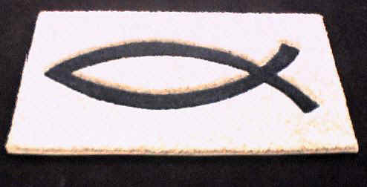

|  |  |
| --- | --- |
| **RELIGION** | **FUNERAL CUSTOMS ACROSS CULTURES AND RELIGIONS** |
| http://www.brentbrain.org.uk/brain/braincf.nsf/images/taoist_symbol2/$file/taoist_symbol2_content.jpg | While death is universal, ways of dealing with it are as varied as the languages people speak and the ways they think. Some cultures, such as those of the **Mediterranean**, encourage strong emotional reactions at funerals; others favour the ***stiff upper lip***.  The **Balinese**, who are not known to cry at all, at least in public, actually encourage laughter at funerals by dropping the coffin into a ***creek*** – sometimes more than once. The **Samoans** have an extremely brief period of mourning, whereas in **Greece**, widows are expected to wear black for the rest of their lives.  In **Southeast Asia**, emotional reactions are considered perfectly acceptable in public but in private mourners are expected to maintain some control. The **English** generally take the opposite approach.  What feels natural to one group may seem deeply unnatural to another; what is meant to be comforting in one tradition may, in the context of another, appear disrespectful. Styles of mourning vary widely. At the funeral and during the period of mourning that follows, behaviours considered utterly natural and important by one group, such as wearing black or visiting the grave, may strike another group as unnecessary.  Among **Africans**, funerals are occasions for large family and community gatherings, and attendance is given enormous emphasis, even for distant relations. Even within the ***context*** of a single ethnic heritage, patterns can vary markedly as families develop their own styles.  The goal in every era and in every culture is the same: **to provide a proper conclusion to a life and to begin the process of living without the deceased**. Those tasks are generally considered to fall into the realm of religion.  Whether the service takes place in a **church, synagogue, or funeral home** (as is increasingly the case), the solemnity of the proceedings, the religious trappings, and the presence of clergy underscore the gravity of the event. |
| http://www.customrugco.com/images/fishrug2.jpg | **Protestant** customs vary, depending on the denomination. Generally, there is a brief service at the church or funeral home that includes a reading from the Bible, prayers, organ music, possibly the singing of hymns, and a funeral sermon or ***meditation***. Selections of poetry or prose are sometimes read. The ***casket*** may be open or closed, depending on the ***denomination***, and there may or may not be a ***eulogy***.  At the grave there is a brief committal service. Afterwards, as in other groups, people usually gather together for a meal. |

|  |  |
| --- | --- |
| http://www.jsboard.co.uk/etac/etbb/benchbook/images/christianity_symbol.gif | **In Catholicism,** the rites ideally begin prior to death, when the dying person receives the final ***sacraments***. (When death is sudden, the priest is permitted to give ***penance*** and extreme ***unction*** up to several hours after death.)  The funeral itself is comprised of three parts: The ***wake***, the ***funeral mass***, and the ***grave side service***. The wake, which occurs the night before the funeral, is conducted in the presence of the body, which is in an open casket. Held either in the funeral parlour or in the mourners’home, the wake service mayinclude psalms, prayers, a rosary, and a short ***homily*** on the meaning of life, death and ***resurrection***. For many hours, friends and relatives come to offer ***condolences***, to pray, and to view the body; indeed, the term “viewing” is sometimes used instead of “wake”.  The next day, there is a funeral or ***requiem*** mass. The coffin is closed and covered with a white pall upon which a cross might be placed. Holy Water, incense, and candles accent the solemnity of the highly structured service, which emphasizes the concept of the new life the deceased has found with God.  After the funeral mass, the “final commendation and farewell” takes place either in church or at the grave site, which is blessed in advance. It is used to be that the family would avoid watching the casket being lowered into the earth. Today, the tendency is to stay, so that the reality of death cannot be denied. |
| http://www.riverstonebead.com/images/imagesinstone/Images%20Star%20of%20David2gif.gif | In **Judaism**, burial takes place immediately – within twenty four hours, if possible.  The simple, wooden coffin is closed, and there are few flowers. At the funeral, which is a short one including prayers and a eulogy, members of the immediate family are given a black ribbon which is then cut to indicate their grief.  After the funeral, there is a brief service at the cemetery during which the casket is lowered into the ground and the mourners shovel dirt on it.  “Shovelling the dirt is an incredibly healing thing to do. Although I would never require it, I encourage it very strongly because I find that the actual act of burying is the beginning of the acknowledgement that this horrible thing has happened and the world is forever different,” states Rabbi Laura Geller, director of Hillel at the University of Southern California.  Following the burial, friends and relatives gather for a traditional “meal of ***condolence***.” Perhaps the most distinctive aspect of the Jewish tradition is not the funeral but the mourning period that follows, when mourners return home for seven days of “sitting Shiva” (Shiva means “seven”). Traditionally they light a candle that burns for seven days, sit on wooden stools or benches, and receive visitors. All activities cease except for one: mourning. |
| http://gbgm-umc.org/missionstudies/interfaith/images/sym-islam-240.gif | The **Islamic religion** specifies **five** rituals concerning death: washing the body in a ***ceremonial*** manner; wrapping the entire body in clean, preferably white, cloth; prayer; the funeral itself, during which music and crying are forbidden; and burial.  If possible, the body is buried directly in the ground, without a casket, and with the face turned toward Mecca. A stone, a few bricks, or some soil can be put under the head, but nothing else is ***permitted*** in the grave.  Afterward, people bring food to the family. Death is expected to be met with equanimity. Consequently, the mourning period is short. For a three-day period after the funeral, known as Azah, mourners accept condolences. After that, talking about the deceased with the mourners is not encouraged.  After three days a return to normal life is expected (The sole exception occurs when a husband dies, in which case the wife is expected to stay home for three months and ten days.) Mourners are not supposed to become so immersed in their grief that it distracts them from their relationship with God. |
| http://www.akshin.net/images/dharmawheel2.gif | **Buddhists and Hindus** believe that life, death, and rebirth are part of the same ***continuum***, waves on the ocean of existence. The body dies; consciousness remains.  The traditional purpose of the funeral, which includes chanting, prayers, the reciting of sacred texts, and eulogies, is to help the deceased adjust to the after death state and prepare for rebirth.  At a Buddhist funeral, the priest speaks directly to the deceased. The funeral is followed by a forty-nine day period during which the person who died ***theoretically*** completes the journey from death to rebirth. During that time, mourners repeat prayers intended to ease the ***transition***. |

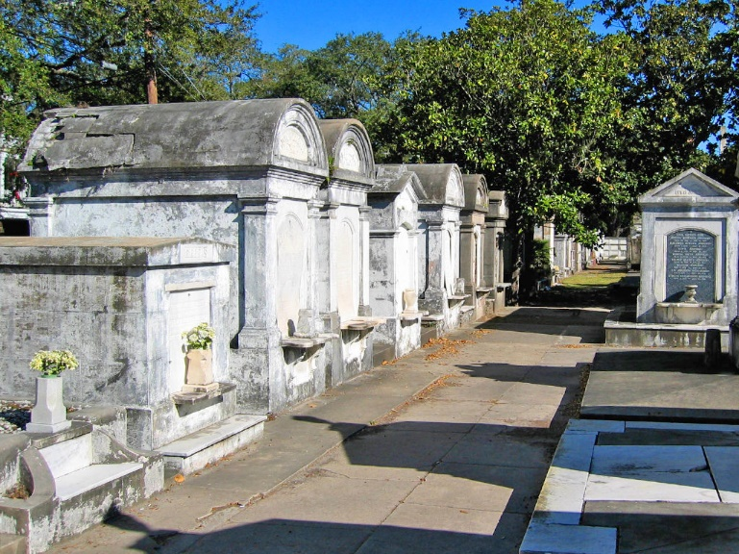

**SECTION A**

* Which religion doesn’t bury the dead in a casket or coffin?
* In which religion does the Priest speak directly to the dead?
* How many rituals are there in an Islamic funeral?
* Explain how the Muslims care for the dead body before burial.
* How long does it take to bury a Jewish body?
* What is a wake and which religion holds a wake?
* What happens at a Protestant funeral?
* Explain how the Balinese hold a funeral.
* Explain how the Samoans mourn.
* Explain African funerals.
* Explain in detail how Buddhists and Hindus handle a death.
* In which direction do Muslims bury their dead?
* Explain the mourning period of a Muslim Wife whose husband dies?

**SECTION B**

Write a newspaper report, expressing funerals in your own culture. Ask your parents, grandparents for information. Also do some kind of research, such as Library books or internet.

Include a bibliography of research.

### Exercise 4

During exercise 3 you were requested to produce three pieces of writing. These were your draft copies. Do the following for each written piece, you may consult with the facilitator if you are unsure:

* Check your writing for coherence, logical structure and sequence. Ask one of your fellow learners to read your written piece and comment on it: is the piece coherent, is the structure and sequence logical
* Rearrange the information so that it becomes more interesting and has more impact.
* Check the layout of the written piece, check the spelling of the words, check the punctuation, and make the necessary corrections.
* Is your written piece accurate and readable?
* Is your use of grammar correct?
* While you are redrafting your piece, experiment with the layout: use titles, headings, colour and so on. This way you can see what the finished product will look like. Add pictures, captions and visual effects at the appropriate places. Visualise what it will look like. Move them around until you are happy with the result – all the graphics, for example, should not be on the same side of the page. Vary their positions from the left to the centre to the right and so on.
* Check the completed text against your purpose for writing it and make sure that you have achieved your purpose.

**Keep your rough copies for your portfolio of evidence, as you have to prove that your did redraft your work.**

Find articles in newspapers and identify:

* Hyperboles, understatements, repetition, questioning. Write a short paragraph about each example, quoting the source and explaining how the technique added interest to the article.
* Compare the logos of the following banks with each other: ABSA, Nedbank, Standard Bank and First National Bank. What does the logo say about the organisation?