

EXPLORE AND USE A VARIETY OF STRATEGIES TO LEARN
US No: 119631 Credits 5

ENGAGE IN A RANGE OF SPEAKING/SIGNING AND LISTENING INTERACTIONS FOR A VARIETY OF PURPOSES
US No: 119635 Credits 6

WRITE/SIGN FOR A VARIETY OF DIFFERENT PURPOSES
US No: 119636 Credits 6

READ/VIEW AND RESPOND TO A RANGE OF TEXT TYPES
US No: 119640 Credits 6

Learner’s name
Facilitator’s name
Starting date

CLASSROOM ACTIVITIES


CLASSROOM ACTIVITY NO. 1
USE LANGUAGE FOR LEARNING
(119361:AC1.1 – 1.3)

- Write 1 sentence in your home language about your reasons for being on this learning
program.

_____________________________________________________________________

_____________________________________________________________________

_____________________________________________________________________

_____________________________________________________________________

- Now translate that same sentence into English / Afrikaans (it cannot be the same language as you have used previously).
_____________________________________________________________________

_____________________________________________________________________

_____________________________________________________________________

_____________________________________________________________________

CLASSROOM ACTIVITY NO. 2
TAKE RESPONSIBILITY FOR OWN LEARNING AND MAKE CHOICES ABOUT LEARNING (LM6)
(119361:AC2.1-2.7)

Take a minute to examine your goals & draft a plan how to reach it:

MY ULTIMATE GOAL:
BY WHEN:
Column A | Column B | Column C | Column D
Pathways to my goal | Time frames | Resources required | Sources of assistance

- Write down one personal goal that you would like to achieve with this course.

- By when would you like to have achieved this goal?

- Now write down 5 of the most important things or skills that you will need in order to achieve your goal (in Column A above).

- Write next to each of those things in Column B, how much time you will need to achieve each thing / skill.

- Now write in column C, what else you might need to get each of the things in column A. e.g. money, language skills, etc.
- In column D, write who / what can help you with the things you wrote in the first column.

CLASSROOM ACTIVITY NO. 3
TAKE RESPONSIBILITY FOR OWN LEARNING AND MAKE CHOICES ABOUT LEARNING (LM7)
(119361:AC2.1-2.7)

- Assess your textbook reading skills.

R = Rarely: S = Sometimes: F = Frequently: A = Almost Always

A | TEXTBOOK READING | R | S | F | A
1 | Do you read the introduction, headings and sub-titles of a chapter before you read the chapter? | 0 | 1 | 2 | 3
2 | When you reads a chapter for the first time, do you intend to learn it at a later stage rather than immediately? | 3 | 2 | 1 | 0
3 | As you read, do you stop periodically to explain what you have read in your own words? | 0 | 1 | 2 | 3
4 | Is your motivation to begin reading negatively affected when you discover how many pages there are to read? | 3 | 2 | 1 | 0
5 | Do you read several paragraphs before you start underlining or taking notes? | 0 | 1 | 2 | 3
6 | Do you try to complete an entire chapter in one long session? | 3 | 2 | 1 | 0
7 | Do you pay attention to graphs, charts and diagrams? | 0 | 1 | 2 | 3
8 | Do you find that you have to re-read? | 3 | 2 | 1 | 0
9 | Do you try to analyse how ideas are organised and how they relate to each other? | 0 | 1 | 2 | 3
10 | Do you have difficulty in selecting the important information from the passage? | 0 | 1 | 2 | 3

- Add up your score: _______________________________________________

- Interpretation:

26 - 30 | Excellent – you are using your reading skills productively and efficiently.
20 - 25 | Adequate – but not really efficient. You need to develop better reading skills if you are going to cope happily with your course. Reading requires practice
19 and less | Your reading skills are completely inadequate and you are likely to struggle if you do not take action to improve them. Check each item and specify exactly what you read

CLASSROOM ACTIVITY NO. 4
IDENTIFY DIFFERENT KINDS OF LEARNING STRATEGIES AND USE WHAT IS APPROPRIATE TO THE TASK (119361:SO2-SO5)

ANSWER THE FOLLOWING MATHEMATICAL WORKSHEET

Step 1:  Read the problem | 2 Friends are delivering leaflets. 1 person delivers 3 batches, the other delivers 2. How should they share the R20 they are paid?
Step 2:
Organise the calculation
Step 3:
Answer the calculation
Step 3:
Answer the problem

NOW CHECK THE ANSWER:

Step 1:  Read the problem | 2 Friends are delivering leaflets. 1 person delivers 3 batches, the other delivers 2. How should they share the R20 they are paid?
Step 2:  Organise the calculation | These do seem tricky at first. You need to find out how many batches were delivered in total and then work out how much you would be paid for delivering 1 batch. You v=can then work out the sum of money for 3 batches and 2 batches
Step 3:  Answer the calculation | 3 batches + 2 batches = 5 batches  R20 paid for 5 batches, so for 1 batch it will be R20 ÷ 5 = R4  So it costs R4 to deliver 1 batch. One person delivers 3 batches, so 3 x R4 = R12 and the other delivers 2, so 2 x R4 = R8
Step 3:  Answer the problem | The person who delivered 3 batches should get R12 and the person who delivered 2 batches should receive R8

Answer the following questions about the methods of learning that you applied:

- Did you know anything about the subject before starting the exercise?

_____________________________________________________________________

- Did you find the exercise difficult or easy?

_____________________________________________________________________

- Why do you think you found difficult/easy?

______________________________________________________________________

______________________________________________________________________

- Name two people or places that could have helped you get more information about how to complete the exercise successfully.

______________________________________________________________________

______________________________________________________________________

______________________________________________________________________

______________________________________________________________________

______________________________________________________________________

CLASSROOM ACTIVITY NO. 5
USE SPEAKING/SIGNING AND LISTENING STRATEGIES
(119635:SO1 / AC3.1-3.2)

TWENTY QUESTIONS - GROUP ACTIVITY

One of you pretends to be a person either living or dead. This person is either famous or someone everyone in the group knows. The group asks the pretender question to try to find out who he/she is e.: where do you live?

Each person in the group must get chance to ask a question. The only question no allowed is: “Who are you?”

The group members will have to listen carefully so that they don’t repeat questions and so that they can fill gaps in the knowledge they have so far.

The group may ask only twenty questions.

FACILITATOR MARKING SHEET
(NB: hand this sheet to your facilitator to mark while you conduct this activity).

DID THE LEARNER: | YES / NO
Identify the main message of the oral communication?
Successfully communicate the main message?
Use pitch, tone, body language, volume, pace, stress correctly?
Ask questions to clarify understanding?
Translate into other languages where appropriate?
Effectively communicate main ideas, topics or messages?

FACILITATOR - ADDITIONAL COMMENTS:

____________________________________________________________________________

____________________________________________________________________________

____________________________________________________________________________

____________________________________________________________________________

CLASSROOM ACTIVITY NO. 6
USE SPEAKING/SIGNING AND LISTENING STRATEGIES
(119635:SO1)

- Choose which pitch you would use for these situations: (circle your answer)

- You are excited high / low
- You are being serious high / low
- You are anxious high /low
- You are angry high / low

- What pace would you use for the following sentence? (circle your answer)

- Anna was sad and depressed and didn’t feel like seeing anyone. Slow/fast

- In the following sentences, very small letters indicate “softly”. Bigger, bold letters indicate “loudly”. Try saying the words shown. Do you think this is the right way to say them? If not, how would you change it?

- The lion roared and everyone was scared correct / incorrect

____________________________________________________________________

- She whispered: “I LOVE YOU.” Correct / incorrect

_____________________________________________________________

- You want to put across a specific meaning when speaking the following sentences. Which word would you STRESS most? (Underline the word).

- I went to visit my aunt in Gauteng. (Not my aunt in the Free State).

- Mr Jantjies is addressing the staff meeting this afternoon. (I am absolutely sure of this).

CLASSROOM ACTIVITY NO. 7
USE SPEAKING/SIGNING AND LISTENING STRATEGIES
(119635:AC1.3/ AC2.1-2.5; SO3; SO4)

- Look at the following people in pictures and decide what the person is saying in each case. (Circle your answer)

PICTURE 1: ARCHBISHOP TUTU
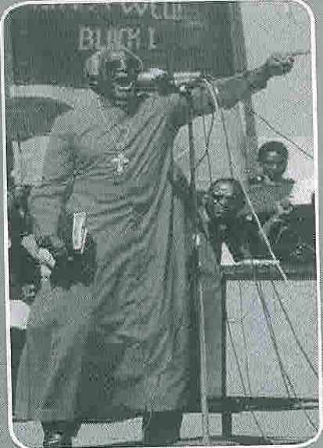
- I tell you that Africa must get rid of AIDS!

- Welcome to this meeting!

- The toilets are over there.

PICTURE 2: BELL BOY
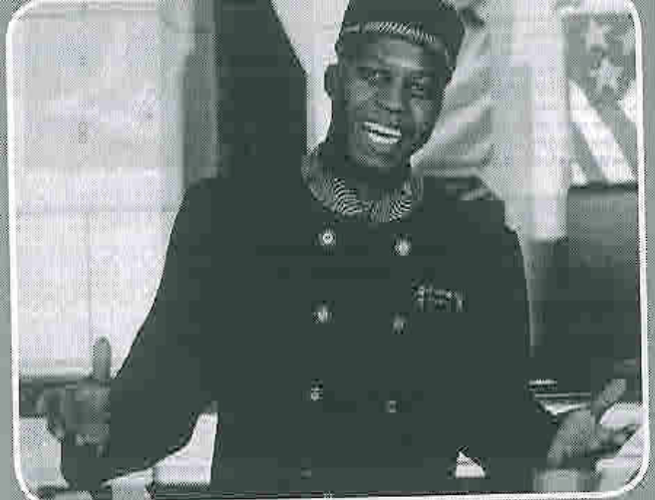

- I am sorry, but you have the wrong
Hotel!

- Welcome to the Royal Hotel. I hope
that you enjoy your stay.

- You are not allowed to smoke in here!

PICTURE 3: HESTRIE CLOETE
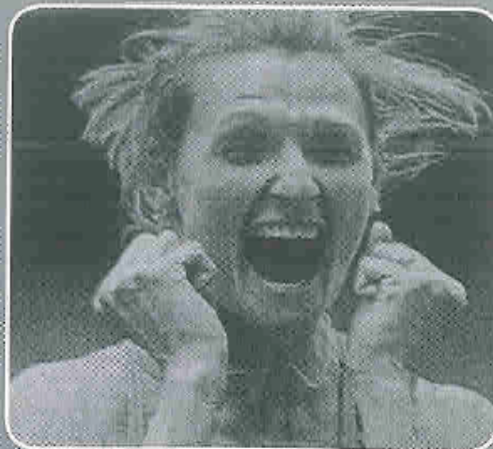

- Good morning ladies and gentlemen.

- My child is sick and I am worried about her.

- YES!

- GROUP ACTIVITY

Work in pairs. Look at each of the pictures in Activity 7.1 and decide:

- Who the target audience is
- What the purpose of the communication is
- Whether you can establish exactly what the speaker is saying – give a reason for your answer

Picture: | Target Audience | Purpose | Can you establish exactly what the speaker is saying? Give a reason
Pic 1

Pic 2

Pic 3

CLASSROOM ACTIVITY NO. 8
ENGAGE IN A RANGE OF SPEAKING/ SIGNING AND LISTENING STRATEGIES
(119635:AC1.3-1.4; AC4.7; 5.1 - 5.4; 6.5-6.6)
(119640: AC1.1; 1.5; 3.1; 3.5-3.6; 4.2; 4.6; 5.4-5.5; 6.1-6.2; 6.4)

- CHOOSE THE CORRECT WORD FROM THE THREE WORDS GIVEN BETWEEN BRACKETS (Underline your answer)
.
- Mr Jones: “I will just go and tell the girls in the office that they may go home early today.”
(sexist / racist / inappropriate politeness)

- I have three new black colleagues, and they are really great!
(sexist / racist / inappropriate politeness)

- I want you to give me a reference.
(sexist / racist / inappropriate politeness)

- What does bias language mean? Give an example of biased language.

_______________________________________________________________________

_______________________________________________________________________

_______________________________________________________________________

_______________________________________________________________________

Look at the following examples of figurative language in Column A. Match them up with their correct meanings in Column B.

FIGURATIVE LANGUAGE | MEANING
As sick as a dog | Bedraggled, dirty or untidy
As fit as a fiddle | Nervous
As light as a feather | In the best condition
Like a bull in a china shop | Very light
Like a cat on a hot tin roof | Lacking the delicacy that the situation calls for, a person who is careless or acts in a rough way in a place or situation where skill and care is needed
Like something the cat brought in | Very sick
CLASSROOM ACTIVITY NO. 9
WRITE FOR A VARIETY OF DIFFERENT PURPOSES
(119636:SO1)

- COMPLETE THE FOLLOWING:

- Ms X is our Managing Director. You speak to her in the incorrect register:
“Hey, Ms X, howz’bout you damn well decide to give me a chance to move up in this company?”

Rewrite this, using a more suitable register

______________________________________________________________________

______________________________________________________________________

______________________________________________________________________

- John is your good friend. You speak to him in the incorrect register:
“Good morning John. Would you like to come and have a bit to eat at my house?”

Rewrite this, using a more suitable register

______________________________________________________________________

______________________________________________________________________

______________________________________________________________________

- Baby Z is visiting you. You speak to him in the incorrect register:
“Young man, I consider you to be most appropriately dressed for such a cold day.”

Rewrite this, using a more suitable register

______________________________________________________________________

______________________________________________________________________

______________________________________________________________________

- Write a letter to your employer requesting a day’s leave for next month to go for your learner’s license.

______________________________________________________________________

______________________________________________________________________

______________________________________________________________________

______________________________________________________________________

______________________________________________________________________

______________________________________________________________________

______________________________________________________________________

______________________________________________________________________

______________________________________________________________________

______________________________________________________________________

______________________________________________________________________

______________________________________________________________________

______________________________________________________________________

______________________________________________________________________

______________________________________________________________________

______________________________________________________________________

______________________________________________________________________
______________________________________________________________________
CLASSROOM ACTIVITY NO. 10
WRITE FOR A VARIETY OF DIFFERENT PURPOSES
(119636:SO2)

The following letter uses only simple sentences. Rewrite the letter combining sentences to make compound and complex sentences. (Try not to begin sentences that are next to each other with the same words – vary the way you begin sentences.)

Dear Sir/Madam

I am writing to complain. I want to complain about this shirt. I bought this shirt from your catalogue. I bought this shirt two months ago. I enclose a photocopy of the relevant papers.

The label said it was machine washable. The label said that it was colour-fast. I followed all the directions on the label. I always use a 40-degree wash.
This does not shrink clothes. However, you can see that the shirt has shrunk.
The shirt is half the size it was. The colour on the shirt ran. It coloured all other items in the wash. The shirt is now a dirty brown with coloured streaks.

I would like a refund for this shirt. I do not want a replacement for the shirt.
The next shirt will shrink as well. The material is cheap and nasty, and the shirt’s badly cut.

Yours faithfully,
Leo Palmeit

_______________________________________________________________________

_______________________________________________________________________

_______________________________________________________________________

_______________________________________________________________________

_______________________________________________________________________

_______________________________________________________________________

_______________________________________________________________________

_______________________________________________________________________

_______________________________________________________________________

_______________________________________________________________________
CLASSROOM ACTIVITY NO. 11
READ/VIEW AND RESPOND TO A RANGE OF TEXT TYPES
(119640 SO1; AC2.1-2.5; 3.3-3.6; 6.1 Range)

- LOOK AT THE TEXT TYPES ON THE NEXT PAGE AND COMPLETE THE FOLLOWING TABLE IDENTIFYING:

- Type of text
- Target Audience
- Purpose of text

TEXT | TYPE OF TEXT | TARGET AUDIENCE | PURPOSE OF TEXT
TEXT B
TEXT C
TEXT D

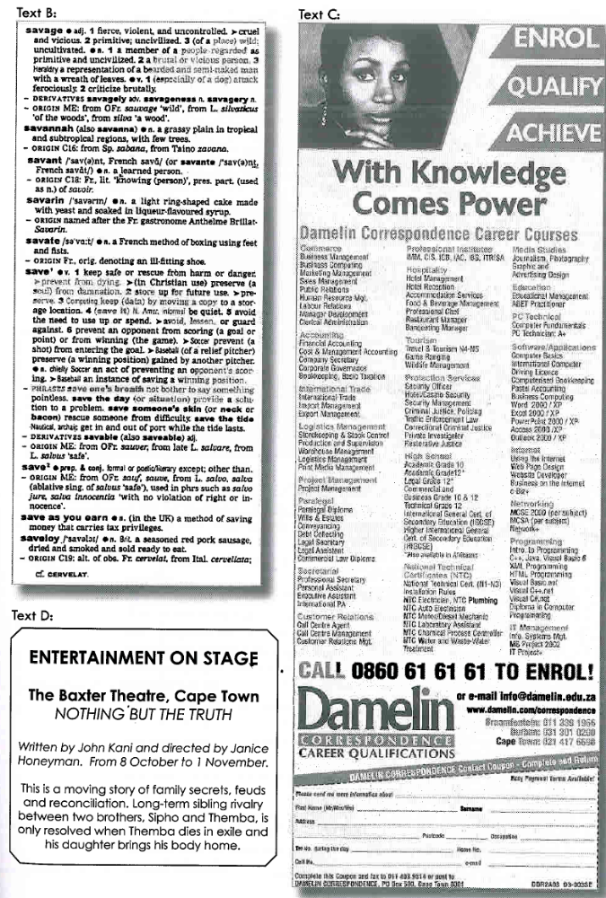

- WHAT DO THE FOLLOWING TERMS MEAN WHEN READING WRITTEN TEXTS?

- Scanning:

______________________________________________________________________
______________________________________________________________________

______________________________________________________________________

______________________________________________________________________

- Skimming:

______________________________________________________________________
______________________________________________________________________

______________________________________________________________________

______________________________________________________________________

- Careful / Intensive Reading:

______________________________________________________________________
______________________________________________________________________

______________________________________________________________________

______________________________________________________________________

CLASSROOM ACTIVITY NO. 12
READ/VIEW AND RESPOND TO A RANGE OF TEXT TYPES
(119640: AC4.6 – 7; AC5.1 – 5.5)

- UNDERLINE THE MOST SUITABLE EXPRESSION TO HELP SUPPORT YOUR POINT OF VIEW:

- Tim, a colleague, always uses your stationery without your permission. You need your stapler and once again, find it on Tim’s desk. You are very annoyed and tell him:
- You are a thief
- You have a problem, you know
- Please ask before you take my things
- Don’t be so stingy; buy your own stuff
- You are so irritating

- You have to show a junior, Ethel, how to do a certain task at work. She is very nervous and also slow to understand. You want to encourage her and say:

- Don’t worry, I also struggled a lot in the beginning
- Shame, it will still take a long time before you manage on your own
- Are you sure this is what you want to do?
- Just listen and concentrate when I show you and don’t panic!

Learner’s name: ___________________________________________________________

Learner’s signature: __________________________ Date: _____________________

EXPLORE AND USE A VARIETY OF STRATEGIES TO LEARN
US No: 119631 Credits 5

ENGAGE IN A RANGE OF SPEAKING/SIGNING AND LISTENING INTERACTIONS FOR A VARIETY OF PURPOSES
US No: 119635 Credits 6

WRITE/SIGN FOR A VARIETY OF DIFFERENT PURPOSES
US No: 119636 Credits 6

READ/VIEW AND RESPOND TO A RANGE OF TEXT TYPES
US No: 119640 Credits 6

Learner’s name
Facilitator’s name
Starting date

LEARNER WORKBOOK

FORMATIVE ASSESSMENT NO. 1
TAKE RESPONSIBILITY FOR OWN LEARNING AND MAKE CHOICES ABOUT LEARNING
(119361:AC2.1-2.7)



Read this passage and then answer the questions that follow:

John’s father attended an agricultural school. He stayed at school for 5 years. He learnt subjects such as marketing, farming theory, human resources, biology and science.

At the end of each year, he wrote a three-hour exam in each subject. The questions in the exam were based on facts, statistics, history and theories of management.

He used to stay awake for nights before the exams, studying and studying.

He was often very scared before an exam, and found that he suffered from stress and exhaustion for weeks after an exam was finished. He failed one of his subjects.

He struggled to find a job after finishing his schooling and have never understood how his schooling was related to his actual job. His job relates to ploughing, planting, irrigating crops, harvesting and ensuring that pests & weeds are under control.

- Which model of learning do you think this is?
- Outcomes based education or B. Old model of Education

______________________________________________________________________

- Which problems do you see with the above system?

______________________________________________________________________

______________________________________________________________________

- Which subjects do you think would have been of more use to John’s father’s, to learn in relation to his job?

______________________________________________________________________

______________________________________________________________________

______________________________________________________________________

______________________________________________________________________
FORMATIVE ASSESSMENT NO. 2
USE RESOURCES EFFECTIVELY TO SUPPLEMENT LEARNING
(119631:SO5)

Choose a subject as discussed with your Facilitator and then do some research.
Report back about your research, indicating correctly the resources used.

_________________________________________________________________________

________________________________________________________________________

________________________________________________________________________

________________________________________________________________________

________________________________________________________________________

________________________________________________________________________

________________________________________________________________________

__________________________________________________________________________

________________________________________________________________________

________________________________________________________________________

________________________________________________________________________

________________________________________________________________________

________________________________________________________________________

________________________________________________________________________

_________________________________________________________________________

________________________________________________________________________

________________________________________________________________________

________________________________________________________________________

________________________________________________________________________

________________________________________________________________________

________________________________________________________________________
FORMATIVE ASSESSMENT NO. 3
ENGAGE IN A RANGE OF SPEAKING AND LISTENING INTERACTIONS
(119635:AC1.1; 2.1 – 2.3; 2.6; SO3; SO4; SO5; SO6)

Read the following letter received by Mary, the local social worker and answer the questions that follow.

Dear Mary,

I have been married for fifteen years. Every Friday my husband comes home drunk. When he is drunk, he’s very loud and aggressive. The next morning he is usually very sorry. What must I do? I don’t want to live like this forever.

Anonymous

- What is the main concern of ‘Anonymous’?

_______________________________________________________________________

_______________________________________________________________________

- What do you think the purpose is of:

  - Mary’s column?

_______________________________________________________________________

_______________________________________________________________________

  - Anonymous letter?

_______________________________________________________________________

_______________________________________________________________________

- How do you think anonymous feels about the situation? Explain your answer.

______________________________________________________________________

_______________________________________________________________________

_______________________________________________________________________

FORMATIVE ASSESSMENT NO. 4
WRITE FOR A VARIETY OF DIFFERENT PURPOSES
(119636:SO1 – SO4)

- Make a rough draft of your CV.
- Look carefully through your CV and edit the document.
- Create a final edited copy
CV DRAFT

FINAL EDITED COPY

______________________________________________________________________

______________________________________________________________________

______________________________________________________________________

______________________________________________________________________

______________________________________________________________________

______________________________________________________________________

______________________________________________________________________

______________________________________________________________________

______________________________________________________________________

______________________________________________________________________

______________________________________________________________________

______________________________________________________________________

______________________________________________________________________

______________________________________________________________________

______________________________________________________________________

______________________________________________________________________

______________________________________________________________________

______________________________________________________________________

FORMATIVE ASSESSMENT NO. 5
READ/ VIEW AND RESPOND TO A RANGE OF TEXT TYPES
(119640:SO1 – SO4)

THE FOLLOWING ARTICLE – Never too late to learn – the story of Nothembi Mkhwebane was taken from The SA Reader. SCAN THE ARTICLE AND ANSWER THE FOLLOWING QUESTIONS.
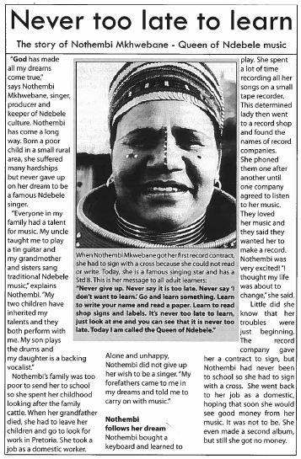

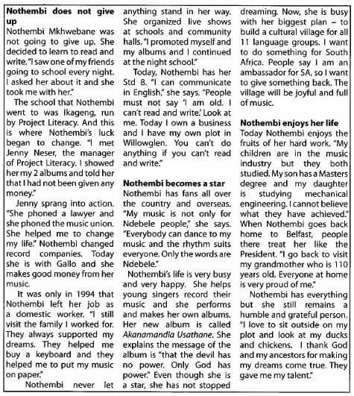

QUESTIONS:

- Look at the headings and sub-headings and indicate:

  - Who is the article about?

________________________________________________________________

  - What is the article about?

________________________________________________________________

________________________________________________________________
- Although you have not read the whole article, play the guessing game! Indicate whether the following statements are “True” or “False”. Write T of F in the end column.

TRUE / FALSE
The article is about a Ndebele lady.
Nothembi is a famous teacher
The article will tell us that we can all become famous singers.
Nothembi is called Queen of Ndebele music because she sings so well.
The article will tell us about her childhood and how she became a singer.
The article will describe how Nothembi goes back to school
The article will tell us about Nothembi’s music and singing
Nothembi did not learn to read and write as a child – only as an adult

- NOW SKIM THE ARTICLE. Read the first and last line of each paragraph and answer the following questions:

  - What was Nothembi’s dream?

______________________________________________________________________

  - Which special talent did her family have?

______________________________________________________________________

  - Did Nothembi go to school? Answer in a full sentence.

_______________________________________________________________________
- FINALLY – READ THE ARTICLE FOR DETAIL AND ANSWER THE FOLLOWING QUESTIONS.

  - What was the first instrument that she learnt to play?

______________________________________________________________________
  - What was her first job as an adult?

______________________________________________________________________
  - At the moment she is busy with her biggest plan – what is her plan?

______________________________________________________________________
Result of Assessment |  | C |  | NYC
Comments:

Assessor Name
Assessor Signature |  |  | Date
Learner Name
Learner Signature |  |  | Date
Result of Re-assessment |  | C |  | NYC
Comments:
Assessor Name
Assessor Signature |  |  | Date
Learner Name
Learner Signature |  |  | Date
Result of Re-assessment |  | C |  | NYC
Comments:
Assessor Name
Assessor Signature |  |  | Date
Learner Name
Learner Signature |  |  | Date

EXPLORE AND USE A VARIETY OF STRATEGIES TO LEARN
US No: 119631 Credits 5

ENGAGE IN A RANGE OF SPEAKING/SIGNING AND LISTENING INTERACTIONS FOR A VARIETY OF PURPOSES
US No: 119635 Credits 6

WRITE/SIGN FOR A VARIETY OF DIFFERENT PURPOSES
US No: 119636 Credits 6

READ/VIEW AND RESPOND TO A RANGE OF TEXT TYPES
US No: 119640 Credits 6

ASSESSMENT 1 |  |  | ASSESSMENT 2 |  |  | ASSESSMENT 3
Date |  |  | Date |  |  | Date
Outcome |  |  | Outcome |  |  | Outcome

Learner’s name
Learner’s signature
Assessment date
Assessor’s name

LEARNER ASSIGNMENTS

ASSIGNMENT NO. 1
IDENTIFY, ACCESS AND USE INFORMATION
(119361:SO2 – SO5)

YOU HAVE TO DEBATE IN CLASS ABOUT WHETHER IT IS BETTER TO:

(GROUP A)
Use a large, hard broom to sweep the outside area of your offices (cheaper in the short term)

OR

(GROUP B)
Whether it would be better to purchase a sweeping machine to sweep the outside areas of your offices (more expensive in the short term)

ANSWER THE FOLLOWING QUESTIONS ABOUT YOUR PROCESS:

- What are the main subjects that you will need to research?

_____________________________________________________________________________

_____________________________________________________________________________

_____________________________________________________________________________

- Where would you look for information to research (name at least 4 places)

_____________________________________________________________________________

_____________________________________________________________________________

_____________________________________________________________________________

_____________________________________________________________________________

- When you found written information – what method of reading did you apply to get the maximum information in the shortest time?

_____________________________________________________________________________

_____________________________________________________________________________

_____________________________________________________________________

- Draw a mind map detailing the information & strategy for the debate.

- Do you think that the time spent was worth while and well managed for the result that you have achieved (the information you have found?)

_____________________________________________________________________________

- How do you think you could have improved your time management?

_____________________________________________________________________________

_____________________________________________________________________________

- What did you do to record the sources of your information and give recognition to the original people who wrote / gave it to you?

______________________________________________________________________

______________________________________________________________________
______________________________________________________________________

______________________________________________________________________

ASSIGNMENT NO. 2
ENGAGE IN A RANGE OF SPEAKING AND LISTENING INTERACTIONS
(119635:SO1; SO2; AC3.1-3.3; AC4.1-4.3; 4.6-4.7; SO6)

GROUP ACTIVITY

Divide into groups of 2 and sit together in pairs A and B
- A start talking about him/herself and continues for one minute
- B listens BUT MAY NOT interrupt or ask questions. B may also not take notes.
- When A is finished talking, B may ask questions to ensure that he/she fully understands A’s message.
- B will now introduce A to others.

Now repeat the activity with A listening and B talking. A will then introduce B to the others.

SCORING SHEET (To be completed by partner/ facilitator)

DID THE LEARNER: | YES  NO | COMMENTS
Understand the main message of the communication?
Successfully communicate the main message of the communication?
Use the correct tone, body language, tempo, volume, pace and stress?
Check understanding through correct questioning?
Translate into other languages where helpful and appropriate?
Identify the speaker’s opinions, emotions and give an appropriate response?
Identify fact and opinions?
Identify whether any important information was left out?
Use relevant and appropriate vocabulary?
Use appropriate grammar?

Name of Observer: __________________________ Signature: ________________________

ASSIGNMENT NO. 3
WRITE FOR A VARIETY OF DIFFERENT PURPOSES
(119636:SO1 – SO4)

WRITE A 1 PAGE ESSAY ON THE FOLLOWING:

“CHANCES OF BAFANA BAFANA TO WIN THE SOCCER WORLD CUP 2014 IN BRAZIL”

NB: Compile a draft essay.
Edit and revise your own essay in order to make your opinions clearer.
Compile a final version

________________________________________________________________________

________________________________________________________________________

________________________________________________________________________

________________________________________________________________________

________________________________________________________________________

________________________________________________________________________

________________________________________________________________________

________________________________________________________________________

________________________________________________________________________

________________________________________________________________________

________________________________________________________________________

________________________________________________________________________

________________________________________________________________________

________________________________________________________________________

________________________________________________________________________

________________________________________________________________________

________________________________________________________________________

ASSIGNMENT NO. 4
READ/VIEW AND RESPOND TO A RANGE OF TEXT TYPES
(119640: SO1 – SO5)

LOOK AT THE FOLLOWING TEXTS AND ANSWER THE QUESTIONS TO FOLLOW:



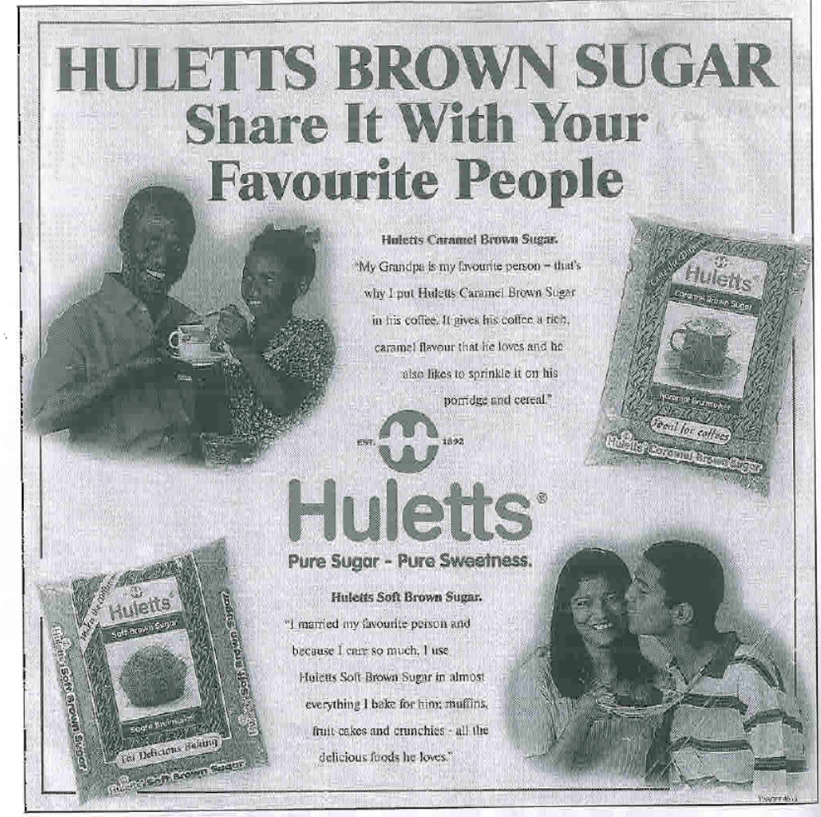

- What type of text is this? (Poem / Advertisement/ Article / Formal Letter)

_______________________________________________________________________

- What is the Main Message of this text?

_________________________________________________________________________
_________________________________________________________________________

- Identify the visual features of this text. (what catches your attention)

______________________________________________________________________
______________________________________________________________________

- What is the register/tone of this text?

______________________________________________________________________
______________________________________________________________________

- Choose one sentence from this text. Write your chosen sentence below.
Now translate the sentence into your own language.

Chosen sentence: ______________________________________________________

______________________________________________________________________

Translation: ____________________________________________________________

______________________________________________________________________

- What do you think the purpose of this text is? Give a reason for your answer.

_______________________________________________________________________
_______________________________________________________________________

- Who do you think the likely target group (audience) is? Give a reason for your answer.

_______________________________________________________________________
_______________________________________________________________________

- Why does the statement EAT SUGAR LOSE WEIGHT immediately attract the reader’s attention?

_______________________________________________________________________
_______________________________________________________________________

_______________________________________________________________________
- Do you think that this statement is factual? Give a reason for your answer.

_______________________________________________________________________
_______________________________________________________________________

- Why do you think they advertise HULETTS BROWN SUGAR and not just Huletts sugar or Huletts white sugar?

_______________________________________________________________________
_______________________________________________________________________

- Mention two techniques that are used in the Huletts advertisement to stress the idea of “sharing”

_______________________________________________________________________
_______________________________________________________________________

- Why do you think the two people use direct speech when they say what they do with the caramel brown sugar and soft brown sugar?

______________________________________________________________________
______________________________________________________________________

- When was Huletts established?

______________________________________________________________________

- Why do they advertise this date?

______________________________________________________________________

______________________________________________________________________

- Do you think the two advertisements are effective or not? Explain your answer.

______________________________________________________________________
______________________________________________________________________

______________________________________________________________________

______________________________________________________________________

Result of Assessment |  | C |  | NYC
Comments:

Assessor Name
Assessor Signature |  |  | Date
Learner Name
Learner Signature |  |  | Date
Result of Re-assessment |  | C |  | NYC
Comments:
Assessor Name
Assessor Signature |  |  | Date
Learner Name
Learner Signature |  |  | Date
Result of Re-assessment |  | C |  | NYC
Comments:
Assessor Name
Assessor Signature |  |  | Date
Learner Name
Learner Signature |  |  | Date

