LEARNER Guide

MS Excel Intro

Unit Standard 116937
Level 2 Credits 4

TABLE OF CONTENTS
TABLE OF CONTENTS 1
PERSONAL INFORMATION 5
INTRODUCTION 6
Programme methodology 6
What Learning Material you should have 7
Different types of activities you can expect 9
Learner Administration 10
Assessments 10
Learner Support 11
Learner Expectations 12
UNIT STANDARD 116937 13
PRINCIPLES OF SPREADSHEETS 17
Purpose of a spreadsheet 17
Properties of a spreadsheet 20
The Excel Window 20
Uses of spreadsheets 24
Benefits of spreadsheets 24
Examples of spreadsheet programs 25
A short history of spreadsheets 25
Examples of spreadsheet applications 25
Formative assessment 1 26
CREATE, OPEN AND SAVE SPREADSHEETS 26
Start Excel 26
Moving Around In A Workbook 27
Select cells, ranges, rows, or columns 27
Select the contents of a cell 29
Select rows and columns in an Excel table 30
Select one or multiple worksheets 30
Use the arrow keys to move through a worksheet 32
Use the scroll bars to move through a worksheet 33
Scroll and zoom by using the mouse 34
Enter data into cells 35
Enter numbers or text 36
Change the column width 36
Wrap text in a cell 36
Change the number format 37
Format numbers as text 38
Enter dates or times 38
Edit cell contents 38
Formative Assessment 3 40
Saving Your Work 41
Naming your Document 41
Save your workbook 42
Formative Assessment 4 43
Save a copy of a file 43
Save a file to another format 44
Closing A Workbook 47
Opening A New Workbook 48
To Open An Existing Workbook 49
Save your document to an external device 51
PRODUCE A SPREADSHEET 52
Formatting Numbers 52
Currency Format: Formative Assessment 6 52
Accounting Format: Formative Assessment 7 53
Entering Formulas Into Cells 54
Error Messages 55
Add A Column Using The Autosum Button: 56
Formative Assessment 10 56
Formative assessment 11 57
Subtracting 58
Multiplication 59
Division 59
Cell Reference 59
Create a cell reference on the same worksheet 60
Change a cell reference to another cell reference 60
Using names in formulas 60
Create a name using the name box 61
Create a name by using a selection of cells in the worksheet 62
Create a name by using the New Name dialogue box 63
Syntax rules for names 64
Values 64
Display numbers as fractions 65
Set Up Data Entry Validation 66
Prevent invalid data entry in a worksheet 66
EDIT A SPREADSHEET 72
What Is The Difference Between Copy And Move? 72
Move Or Copy Cell Data 72
Move or copy entire cells 72
Move or copy entire cells using the mouse 73
Use Autofill 74
Find And Replace 75
Find 76
Replace 77
FORMAT A SPREADSHEET 78
Format Fonts 78
Changing The Position Of Text And Numbers In A Cell 80
Text alignment 80
Text control 80
Right-to-left 80
Adjust Column Width And Row Height 81
Set a column to a specific width 81
Change the column width to fit the contents 81
Match the column width to another column 81
Change the width of columns by using the mouse 82
Change the row height to fit the contents 82
Change the height of rows by using the mouse 83
Apply Cell Borders 83
To apply a custom border style or a diagonal border: 84
Apply Cell Shading 85
Fill cells with solid colours 85
Fill cells with patterns 85
Remove cell shading 86
Apply AutoFormat 87
SPELLING AND GRAMMAR 92
Check spelling 92
Use custom dictionaries 93
Enable custom dictionaries 93
Create a custom dictionary 94
Use Autocorrect 96
Understand the AutoCorrect list 96
Add a text entry to the AutoCorrect list 97
Change the contents of a text entry in the AutoCorrect list 99
PRINTING 99
Print Your Worksheet 99
Preview your worksheet 99
Printing options 101
Page setup 102
Glossary 103
Enter the same data on other worksheets 108
View worksheets at the same time 108
Change the column width 109

PERSONAL INFORMATION
NAME
CONTACT ADDRESS
Code
Telephone (H)
Telephone (W)
Cellular
Learner Number
Identity Number
EMPLOYER
EMPLOYER CONTACT ADDRESS
Code
Supervisor Name
Supervisor Contact Address
Code
Telephone (H)
Telephone (W)
Cellular

INTRODUCTION

Welcome to the learning programme

Follow along in the guide as the training practitioner takes you through the material. Make notes and sketches that will help you to understand and remember what you have learnt. Take notes and share information with your colleagues. Important and relevant information and skills are transferred by sharing!

This learning programme is divided into sections. Each section is preceded by a description of the required outcomes and assessment criteria as contained in the unit standards specified by the South African Qualifications Authority. These descriptions will define what you have to know and be able to do in order to be awarded the credits attached to this learning programme. These credits are regarded as building blocks towards achieving a National Qualification upon successful assessment and can never be taken away from you!

Programme methodology


The programme methodology includes facilitator presentations, readings, individual activities, group discussions and skill application exercises.
Know what you want to get out of the programme from the beginning and start applying your new skills immediately. Participate as much as possible so that the learning will be interactive and stimulating.
The following principles were applied in designing the course:
- Because the course is designed to maximise interactive learning, you are encouraged and required to participate fully during the group exercises
- As a learner you will be presented with numerous problems and will be required to fully apply your mind to finding solutions to problems before being presented with the course presenter’s solutions to the problems
- Through participation and interaction the learners can learn as much from each other as they do from the course presenter
- Although learners attending the course may have varied degrees of experience in the subject matter, the course is designed to ensure that all delegates complete the course with the same level of understanding
- Because reflection forms an important component of adult learning, some learning resources will be followed by a self-assessment which is designed so that the learner will reflect on the material just completed.
This approach to course construction will ensure that learners first apply their minds to finding solutions to problems before the answers are provided, which will then maximise the learning process which is further strengthened by reflecting on the material covered by means of the self-assessments.

Different role players in delivery process
- Learner
- Facilitator
- Assessor
- Moderator

What Learning Material you should have
This learning material has also been designed to provide the learner with a comprehensive reference guide.
It is important that you take responsibility for your own learning process; this includes taking care of your learner material. You should at all times have the following material with you:
  Learner Guide | This learner guide is your valuable possession:  This is your textbook and reference material, which provides you with all the information you will require to meet the exit level outcomes.  During contact sessions, your facilitator will use this guide and will facilitate the learning process. During contact sessions a variety of activities will assist you to gain knowledge and skills.  Follow along in the guide as the training practitioner takes you through the material. Make notes and sketches that will help you to understand and remember what you have learnt. Take and share information with your colleagues. Important and relevant information and skills are transferred by sharing!  This learning programme is divided into sections. Each section is preceded by a description of the required outcomes and assessment criteria as contained in the unit standards specified by the South African Qualifications Authority. These descriptions will define what you have to know and be able to do in order to be awarded the credits attached to this learning programme. These credits are regarded as building blocks towards achieving a National Qualification upon successful assessment and can never be taken away from you!
  Formative Assessment Workbook | The Formative Assessment Workbook supports the Learner Guide and assists you in applying what you have learnt.  The formative assessment workbook contains classroom activities that you have to complete in the classroom, during contact sessions either in groups or individually.  You are required to complete all activities in the Formative Assessment Workbook.  The facilitator will assist, lead and coach you through the process.  These activities ensure that you understand the content of the material and that you get an opportunity to test your understanding.

Different types of activities you can expect
To accommodate your learning preferences, a variety of different types of activities are included in the formative and summative assessments. They will assist you to achieve the outcomes (correct results) and should guide you through the learning process, making learning a positive and pleasant experience.

The table below provides you with more information related to the types of activities.
Types of Activities | Description | Purpose
Knowledge Activities   | You are required to complete these activities on your own. | These activities normally test your understanding and ability to apply the information.
Skills Application Activities   | You need to complete these activities in the workplace | These activities require you to apply the knowledge and skills gained in the workplace
  Natural Occurring Evidence | You need to collect information and samples of documents from the workplace. | These activities ensure you get the opportunity to learn from experts in the industry.  Collecting examples demonstrates how to implement knowledge and skills in a practical way

Learner Administration


Attendance Register
You are required to sign the Attendance Register every day you attend training sessions facilitated by a facilitator.

Programme Evaluation Form
On completion you will be supplied with a “Learning programme Evaluation Form”. You are required to evaluate your experience in attending the programme.
Please complete the form at the end of the programme, as this will assist us in improving our service and programme material. Your assistance is highly appreciated.

Assessments
The only way to establish whether a learner is competent and has accomplished the specific outcomes is through the assessment process. Assessment involves collecting and interpreting evidence about the learners’ ability to perform a task.
To qualify and receive credits towards your qualification, a registered Assessor will conduct an evaluation and assessment of your portfolio of evidence and competency.
This programme has been aligned to registered unit standards. You will be assessed against the outcomes as stipulated in the unit standard by completing assessments and by compiling a portfolio of evidence that provides proof of your ability to apply the learning to your work situation.



How will Assessments commence?

Formative Assessments
The assessment process is easy to follow. You will be guided by the Facilitator. Your responsibility is to complete all the activities in the Formative Assessment Workbook and submit it to your facilitator.

Summative Assessments
You will be required to complete a series of summative assessments. The Summative Assessment Guide will assist you in identifying the evidence required for final assessment purposes. You will be required to complete these activities on your own time, using real life projects in your workplace or business environment in preparing evidence for your Portfolio of Evidence. Your Facilitator will provide more details in this regard.
To qualify and receive credits towards your qualification, a registered Assessor will conduct an evaluation and assessment of your portfolio of evidence and competency.

Learner Support
The responsibility of learning rests with you, so be proactive and ask questions and seek assistance and help from your facilitator, if required.


Please remember that this Skills Programme is based on outcomes based education principles which implies the following:
- You are responsible for your own learning – make sure you manage your study, research and workplace time effectively.
- Learning activities are learner driven – make sure you use the Learner Guide and Formative Assessment Workbook in the manner intended, and are familiar with the workplace requirements.
- The Facilitator is there to reasonably assist you during contact, practical and workplace time for this programme – make sure that you have his/her contact details.
- You are responsible for the safekeeping of your completed Formative Assessment Workbook and Workplace Guide
- If you need assistance please contact your facilitator who will gladly assist you.
- If you have any special needs please inform the facilitator

Learner Expectations
Please prepare the following information. You will then be asked to introduce yourself to the instructor as well as your fellow learners


Your name:
The organisation you represent:
Your position in organisation:
What do you hope to achieve by attending this course / what are your course expectations?

UNIT STANDARD 116937

Unit Standard Title
Use a Graphical User Interface (GUI)-based spreadsheet application to create and edit spreadsheets

NQF Level
2

Credits
4

Purpose
This unit standard is intended for people who need to create and edit spreadsheets using a Graphical User Interface (GUI)-based spreadsheet application either as a user of computers or as basic knowledge for a career needing this competency, like the ICT industry.
People credited with this unit standard are able to:
- Demonstrate an understanding of the principles of spreadsheets.
- Create, open and save spreadsheets.
- Produce a spreadsheet from a given specification.
- Edit a spreadsheet.
- Format a spreadsheet.
- Check spelling in a spreadsheet.
- Print a spreadsheet using features specific to spreadsheets.
The performance of all elements is to a standard that allows for further learning in this area.

Learning Assumed To Be In Place
The credit value of this unit standard is calculated assuming a person is competent in:
- Mathematical literacy and communication skills at least at NQF Level 1.
- Operate a personal computer system (ID 116932 - NQF Level 1).
- Use generic functions in a Graphical User Interface (GUI)-environment (ID 117902 - NQF Level 1).

Unit Standard Range
This standard is applicable to any spreadsheet application that runs on any Graphical User Interface(GUI) operating system.
Where spreadsheets are referenced, it refers to a whole spreadsheet, a single page of a spreadsheet, or selected text in a spreadsheet.
Where wording are not exact for the chosen operating system, the learner can choose the equivalent item or option to demonstrate competence in the specific outcome or assessment criteria.

Specific Outcomes And Assessment Criteria
Specific Outcome 1: Demonstrate an understanding of the principles of spreadsheets.
Assessment Criteria
- Spreadsheet is defined in terms of its purpose and use. Uses include but are not limited to: Automation of repetitive calculation tasks, organisation of data into rows and columns.
- Examples of spreadsheets that can be produced using a spreadsheet application are provided. At least three examples.
- The benefits of using a spreadsheet application for producing and working with spreadsheets are explained. At least 3 benefits
- Examples of spreadsheet programs are named.
- Properties of a spreadsheet are identified and described in terms of its purpose and use. Properties include but are not limited to: Rows, columns, cells, cell cursor.
Specific Outcome 2: Create, open and save spreadsheets. When creating new spreadsheets, the name of the new spreadsheet must allow the spreadsheet to be easily identified in terms of its purpose and content.
Assessment Criteria
- The spreadsheet application program is opened.
- A new spreadsheet is created. At least 4 columns and 4 rows of data are entered, no calculations.
- Methods of moving the cell cursor are demonstrated in order to move about the spreadsheet. At least 2 methods are demonstrated.
- Saving spreadsheets is explained in terms of its purpose and the destination of the saved filed.
- The spreadsheet is saved with a specific name in a specific folder. At least two different methods of saving a spreadsheet.
- The spreadsheet is closed.
- An existing spreadsheet is opened and closed.
- The spreadsheet application program is closed.
Specific Outcome 3: Produce a spreadsheet from a given specification. At least 8 rows and 5 columns should be contained in the spreadsheet produced.
Assessment Criteria
- A spreadsheet is produced with the required data from given specification. Text, numbers, dates.
- Formulae are entered to achieve the given specification. Formulae: addition, subtraction, division, multiplication, sum.
- The differences between data cells, label cells, and formula cells are explained.
- The spreadsheet is in accordance with the given specifications.
- Practices are demonstrated to ensure the integrity of the data. Check against data source, check-totals, audit formulae
- The benefits of saving a file in different formats is explained. Formats: Text, CSV, HTML, other software versions, other software types.
- A spreadsheet is saved in a different format. At least two of: Text, CSV, HTML, other software versions, other software types.
Specific Outcome 4: Edit a spreadsheet.
Assessment Criteria
- An existing spreadsheet is opened.
- Cells are selected for manipulation and de-selected. Cell, cell range, entire column, entire row, entire spreadsheet.
- Cells are manipulated. Move, copy, delete.
- Use the automatic fill feature to automatically enter data in cells. At least two of: Year, Quarter, Month, Week, Day.
- Text is located and replaced in a spreadsheet by using features of the application.
Specific Outcome5: Format a spreadsheet.
Assessment Criteria
- Cells are formatted using formatting features of the spreadsheet application. Formatting features include the following: Style, Alignment, Font, Background colour. At least one option listed out of each formatting feature must be performed: Style (Text, number, date, currency, percentage), Alignment (left, center, right, justified, text direction), Font (type, size, style - italic, bold, underlined, colour, strike-through, superscript, subscript), Background colour.
- Rows are formatted. Height, automatic fit.
- Columns are formatted. Width, automatic fit.
Specific Outcome6: Check spelling and grammar in a spreadsheet.
Assessment Criteria
- The dictionary to be used for spelling and word usage is set up.
- Text is entered and corrected automatically while entering.
- Text is checked for spelling and grammar and corrections made based on judgement. Cell, range of cells.
- Words are added to the custom dictionary.
Specific Outcome7: Print a spreadsheet using features specific to spreadsheets.
Assessment Criteria
- The printing of gridlines is altered. Printing of gridlines on or off.
- A row is selected to print on each page of the printed spreadsheet.
- Different ways of printing sheets within a spreadsheet are demonstrated, according to given specifications. Different ways include but are not limited to: Entire workbook, active sheets.

Unit Standard Essential Embedded Knowledge
- Proficient in relevant application packages.
- Performance of all elements is to be carried out in accordance with organisation standards and procedures, unless otherwise stated. Organisation standards and procedures may cover: quality assurance, documentation, security, communication, health and safety, and personal behaviour.
- Performance of all elements complies with the laws of South Africa, especially with regard to copyright, privacy, health and safety, and consumer rights.
- All activities must comply with any policies, procedures and requirements of the organisations involved, the ethical codes of relevant professional bodies and any relevant legislative and/or regulatory requirements.
- Performance of all elements is to be completed within the normal range of time and cost that would be expected in a professional environment (e.g. In a commercial or government organisation).

Critical Cross-Field Outcomes (CCFO)
- Identify and solve problems in which responses display that decisions using critical and creative thinking have been made by using a spreadsheet application to perform calculations.
- Organise and manage oneself and one’s activities responsibly and effectively by using a spreadsheet application to organize information into rows and columns for a specific purpose.
- Collect, analyse, organise, and critically evaluate information by using a spreadsheet application to organize and perform calculations.
- Communicate effectively using visual, mathematical and/or language skills in the modes of oral and/or written persuasion when engaging with the subject by using a spreadsheet application to organize information into rows and columns for a specific purpose to each communication.
- Use science and technology effectively and critically, showing responsibility towards the environment and health of others by using a spreadsheet application effectively.

Unit Standard Notes
This unit standard has replaced 7572, which was "Demonstrate knowledge of and produce computer spreadsheets using basic functions", Level 2, 3 Credits.
Assessor Notes:
- GUI functions like printing, using a pointing device and using the HELP facility are covered in a generic unit standard (ID 117902) and should be assessed as part of the mentioned standard.
- Possible laws applicable to this standard could include acts like Access to Information Acts; Copyright Acts, Constitution of the Country being assessed in.
Abbreviations:
- PC - Personal computer.
- CD - Compact disk.
- GUI - Graphical User Interface.

PRINCIPLES OF SPREADSHEETS

Specific Outcome
Demonstrate an understanding of the principles of spreadsheets

Assessment Criteria
On completion of this section you will be able to ensure that:
- Spreadsheet is defined in terms of its purpose and use. Uses include but are not limited to: Automation of repetitive calculation tasks, organisation of data into rows and columns.
- Examples of spreadsheets that can be produced using a spreadsheet application are provided. At least three examples.
- The benefits of using a spreadsheet application for producing and working with spreadsheets are explained. At least 3 benefits
- Examples of spreadsheet programs are named.
- Properties of a spreadsheet are identified and described in terms of its purpose and use. Properties include but are not limited to: Rows, columns, cells, cell cursor.
Purpose of a spreadsheet
Excel is a spreadsheet program.
Note A spreadsheet is a computer application (software program) that looks like a paper accounting worksheet.
The desktop displays many cells in rectangular grid that consists of rows and columns.
The word "spreadsheet" came from "spread" in its sense of a newspaper or magazine item (text and/or graphics) that covers two facing pages, extending across the center fold and treating the two pages as one large one.
The compound word "spread-sheet" came to mean the format used to present book-keeping ledgers:
- with columns for categories of expenditures across the top,
- invoices listed down the left margin,
- and the amount of each payment in the cell where its row and column intersect, which were, traditionally, a "spread" across facing pages of a bound ledger (book for keeping accounting records) or on oversized sheets of paper ruled into rows and columns in that format and approximately twice as wide as ordinary paper.
Tip An electronic spreadsheet program can be used for storing, organising and manipulating data.
A spreadsheet will add long columns or rows of figures for you. You can also do other calculations, such as determining the average of a row of figures, calculating interest or finding out the minimum or maximum values of a row or column of figures.
Once you have calculated the value of a row or column of figures, e.g. the average, and you make changes to any of the numbers, the value will be changed to the new value automatically.
In a spreadsheet application, each value (the numbers you are working with) sits in a cell.when you are working on the spreadsheet, you define the type of data in each cell and how the different cells depend on each other.
Tip The relationships between cells are called formulas (for example multiply or add the values of two or more cells), and the names (invoice number or amount, etc.) of the cells are called labels.
The first thing therefore is to define the cells and the formulas for linking them together. Now you will enter the data you want to manipulate
A simple example of a useful spreadsheet application is one that calculates mortgage payments for a house. You would define five cells:
1. total cost of the house
2. down payment
3. mortgage rate (the interest rate)
4. mortgage term (the number of years or months in which you will repay the house)
5. monthly payment
You have now defined how the cells depend on each other and now you can manipulate the data: you could change the interest rates to find out how that will affect your monthly payments, or you could change the amount of the housing loan to find out how
Once you had defined how these cells depend on one another, you could enter numbers and play with various possibilities. For example, keeping all the other values the same, you could see how different inbterest rates would affect your monthly payments or how different monthly payments will affect your repayment term.
You can therefore study various “what if” scenarios
In short, Excel will automate repetitive calculation tasks for you by,f or example, adding rows or columns of figures.
The basic working environment in Excel is a workbook that can contain one or more worksheets.
Tip Remember, in Word we spoke about a document - in Excel it is called a worksheet.
We have said that a worksheet is similar to an accountant’s ledger, with numbers; text and calculations lined up in columns and rows. However, unlike in an accountant’s ledger, Excel will do the calculations for you.
Excel also makes it easier for you to change, delete or add information. You can also arrange multiple worksheets within a workbook – for example, you can place all the worksheets for one client in one workbook.

Properties of a spreadsheet

The Excel Window
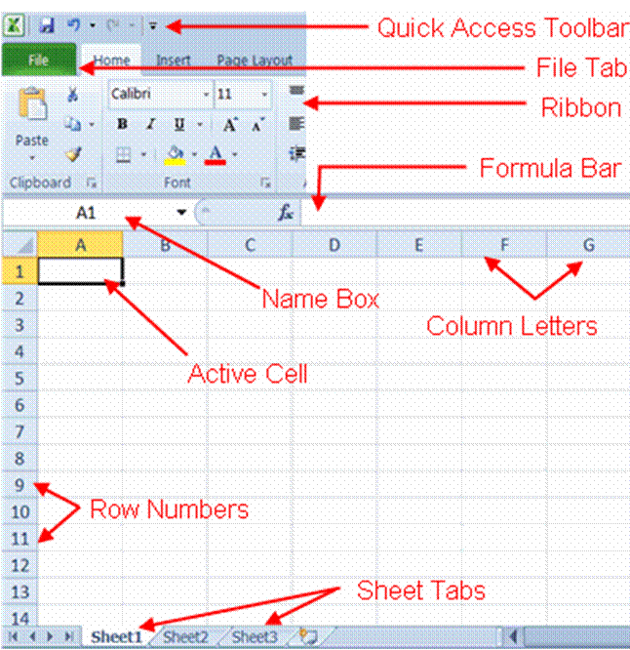

Excel 2010 has a results-oriented user interface, making it easier for you to perform tasks in Excel. The features of the Excel window include:

Quick Access Toolbar
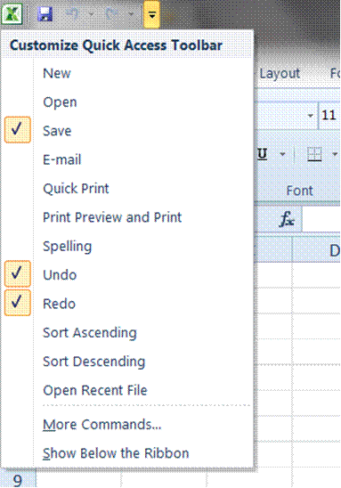
This customizable toolbar allows you to add frequently used commands. Click on the down arrow at the end of the toolbar to display the toolbar's options.

Title Bar
The Title bar is where we find the name of the program as well as the document we are working in – the Quick Access Toolbar is situated on the Title Bar
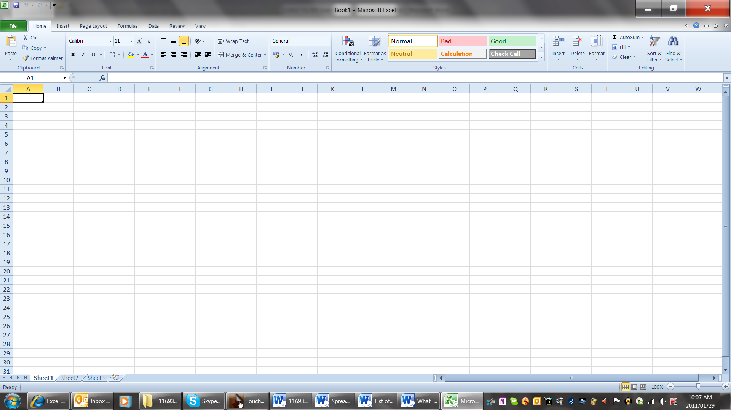

Ribbon
The Ribbon is the strip of buttons and icons located above the work area. The Ribbon is organized into a series of tabs - such as File, Home, and Formulas. Each tab contains a number of related features and options. First introduced in Excel 2007, the Ribbon replaced the menus and toolbars found in Excel 2003 and earlier versions.
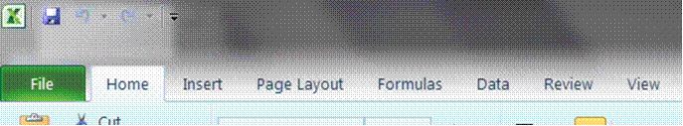

File Tab
The File tab is new to Excel 2010 - Sort of. It replaces the Office Button that was found in Excel 2007 and also the File menu from older Excel versions
Like the old file menu, the File tab options have to do with file management, e.g. opening new or existing worksheet files, saving, printing
Tip A new feature – has been added: saving and sending Excel files in PDF format
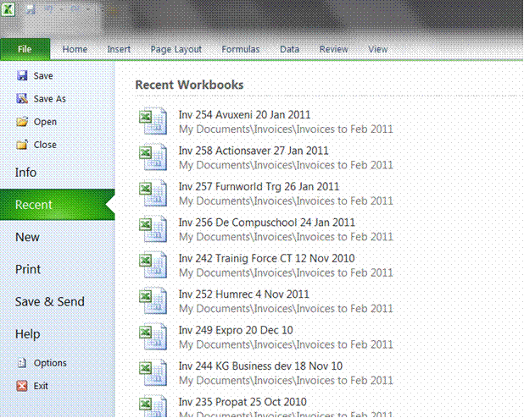

Formula bar
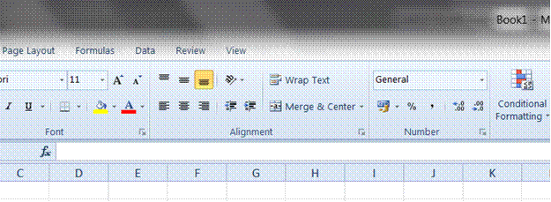
It is situation directlyabove the worksheet. This area displays the contents of the active cell. It is also used for entering or editing data and formulas into the active cell.

Name Box
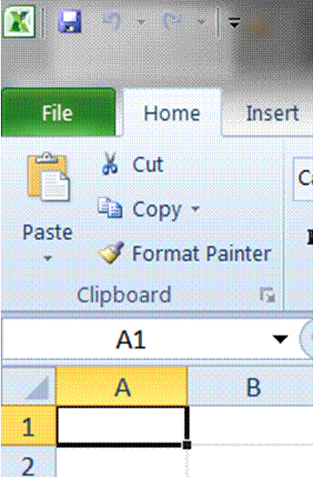
This is situated right next to the formula bar and displays the cell reference or the name of the active cell.

Scroll bars
Scroll Bars: are used to view parts of the workbook that are not visible.

Active cell
The active cell is recognized by its black outline. Data s always entered into the active cell. Different cells can be made active by clicking on them with the mouse or by using the arrow keys on the keyboard.

Column headings or letters
Columns run vertically on a worksheet and each one is identified by a letter in the column header.

Row headings or numbers
Rows run horizontally in an Excel 2010 worksheet and are identified by a number in the row header.
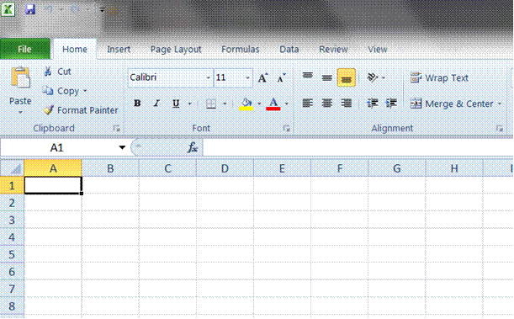

Sheet tabs
Switching between worksheets in an Excel 2007 file is done by clicking on the sheet tab at the bottom of the screen.

Windows Taskbar
This is a part of Windows and displays the buttons of the programs, which have been opened, as well as the time and the Start button.

Status Bar
A horizontal bar at the bottom of the screen that displays information about the current condition of the program, such as the status of items in the window, the progress of the current task, or information about the selected item..
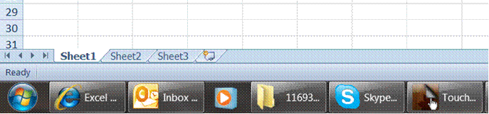

Uses of spreadsheets
- You can use a spreadsheet to calculate your monthly budget
- You can work out the amount of interest your savings will earn for the next 2 or even 5 years
- You can work out average sales per person for a certain period
- You can calculate average school marks per subject for yourself or your children
- You can work out how much an increase of 10% will be on the prices of food or even your salary
- A computer spreadsheet will also act as a database: You can also put together a list of clients or contacts with all their details: addresses, telephone numbers, postal addresses, etc.
- Companies use spreadsheets to calculate average income, cash flow and even fluctuations in budgets
We can therefore say that spreadsheet are used for:
- Performing basic mathematical operations such as summing columns and rows of figures.
- Finding values such as profit or loss.
- Calculating repayment plans for loans or mortgages.
- Finding the average, maximum, or minimum values in a specified range of data.
- graphing or charting data to assist users in identifying data trends.
- sorting and filtering data to find specific information.

Benefits of spreadsheets
Spreadsheets make it easy to:
- Automate repetitive calculation tasks
- Update changes in figures by re-calculating the entire sheet automatically after a change to a single cell is made
- Use formulas in your calculations
- Develop your own formulas
- Group information together
- Make difficult calculations quickly

Excel Sparklines
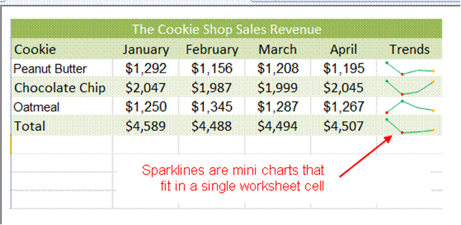
This is a new feature in Excel 2010. Sparklines are tiny charts that fit into a single cell in a worksheet. This give you a quick look at changes that may be difficult to see from the data itself.
There are three types of sparklines available in Excel 2010: bline sparklines, columns sparklines and win/loss sparklines

Tip From the graphical illustration we can see that, although sparklines can be located in any cell, they have their best affect when you place them next to the data they represent.
Examples of spreadsheet programs

A short history of spreadsheets
Visicalc is mostly considered the first electronic spreadsheet (although this has been challenged), and it helped turn the Apple II computer into a success.
When DOS was the dominant operating system, Lotus 1-2-3 became the leading spreadsheet.
MS Excel now has the largest market sheet on the Windows and Macintosh platforms.

VisiCalc
The spreadsheet concept became widely known in the late 1970s and early 1980s. It was the first spreadsheet that combined all essential features of modern spreadsheet applications, such as
- WYSIWYG interactive user interface,
- automatic recalculation,
- status and formula lines,
- range copying with relative and absolute references,
- formula building by selecting referenced cells

Lotus 1-2-3 and other MS-DOS spreadsheets
Lotus 1-2-3 was released on January 26, 1983, started outselling then-most-popular Visicalc the very same year, and for a number of years was the leading spreadsheet for DOS.

Examples of spreadsheet applications
Microsoft Excel: Starting in the mid 1990s continuing through the present, Microsoft Excel has dominated the commercial electronic spreadsheet market.
Apple Numbers: Numbers is Apple Inc’s spreadsheet software and is part of iWork.
OpenOffice.org Calc: a free, open-source program modelled after MS Excel. Calc can both open and save in the Excel (XLS) file format Calc can be acquired as both an installation file and a portable program, capable of being run from a device such as a USB memory drive. It can be downloaded from the OpenOffice.org website.
Gnumeric: a free spreadsheet program that is part of the GNOME Free Software Desktop Project. A Windows version is available. It is intended to be a free replacement for prorietary spreadsheet programs such as MS Execl.
Web based spreadsheets: With the coming of advanced web technologies such as Ajax circa 2005, a new generation of online spreadsheets have been developed. Equipped with a rich Internet application user experience, the best web based online spreadsheets have many of the features seen in desktop spreadsheet applications, such as strong multi-user collaboration features and real time updated from remote sources such as stock prices

Other spreadsheets
- IBM Lotus Symphony (2007)
- KSpread
- ZCubes-Calci
- Resolver One

Formative assessment 1
- There are so many things you can do with a spreadsheet. Think about how you will use a spreadsheet, how companies use spreadsheets and then make a list of uses for spreadsheets.
- Make a lsit of at least 3 benefits that spreadsheets could have for you and your company.
- Discuss your lists in your groups and add any new suggestions to your list.

CREATE, OPEN AND SAVE SPREADSHEETS

Specific Outcomes
An existing spreadsheet is opened

Assessment Criteria
On completion of this section you will be able to ensure that:
- The spreadsheet application program is opened.
- A new spreadsheet is created. At least 4 columns and 4 rows of data are entered, no calculations.
- Methods of moving the cell cursor are demonstrated in order to move about the spreadsheet. At least 2 methods are demonstrated.
- Saving spreadsheets is explained in terms of its purpose and the destination of the saved file.
- The spreadsheet is saved with a specific name in a specific folder. At least two different methods of saving a spreadsheet.
- The spreadsheet is closed.
- An existing spreadsheet is opened and closed.
- The spreadsheet application program is closed.
Start Excel
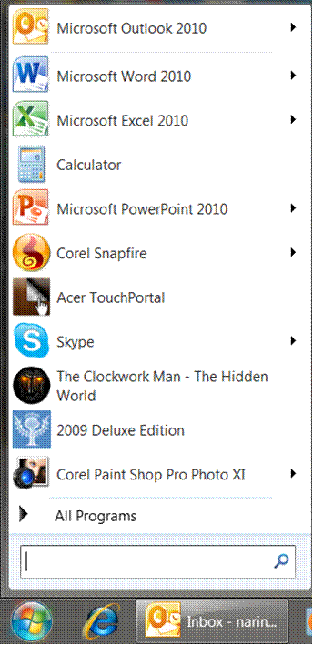
First, you must start Excel. Click the Start button, point to All Programs, select Microsoft Office and then click on Excel
The Excel desktop, with a blank worksheet pops up on your screen. Do this now, so that you can see what the Excel desktop looks like.

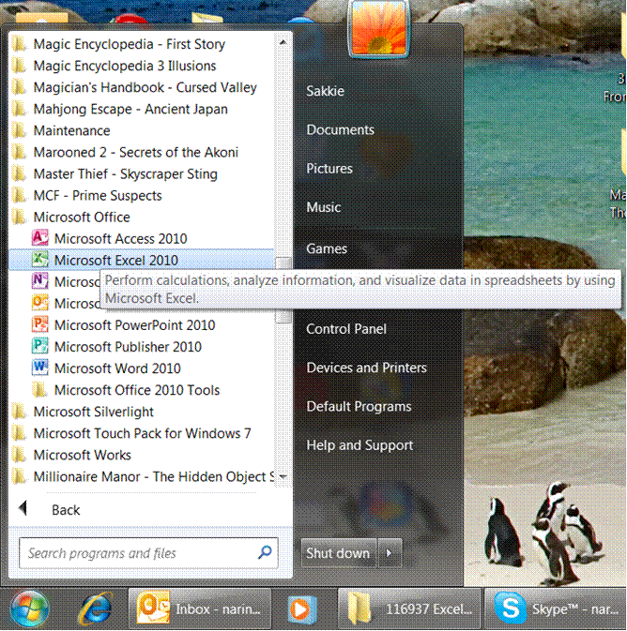

Moving Around In A Workbook

Select cells, ranges, rows, or columns
To select | Do this
A single cell | Click the cell, or press the arrow keys to move to the cell.
A range of cells | Click the first cell in the range, and then drag to the last cell, or hold down SHIFT while you press the arrow keys to extend the selection.
A large range of cells | Click the first cell in the range, and then hold down SHIFT while you click the last cell in the range. You can scroll to make the last cell visible.
All cells on a worksheet | Click the Select All button.  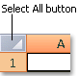  To select the entire worksheet, you can also press CTRL+A.  Note: If the worksheet contains data, CTRL+A selects the current region. Pressing CTRL+A a second time selects the entire worksheet.
Nonadjacent cells or cell ranges | Select the first cell or range of cells, and then hold down CTRL while you select the other cells or ranges.  Note: You cannot cancel the selection of a cell or range of cells in a nonadjacent selection without canceling the entire selection.
An entire row or column | Click the row or column heading.  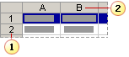  Row heading  Column heading  You can also select cells in a row or column by selecting the first cell and then pressing CTRL+SHIFT+ARROW key (RIGHT ARROW or LEFT ARROW for rows, UP ARROW or DOWN ARROW for columns).
Adjacent rows or columns | Drag across the row or column headings. Or select the first row or column; then hold down SHIFT while you select the last row or column.
Nonadjacent rows or columns | Click the column or row heading of the first row or column in your selection; then hold down CTRL while you click the column or row headings of other rows or columns that you want to add to the selection.
The first or last cell in a row or column | Select a cell in the row or column, and then press CTRL+ARROW key (RIGHT ARROW or LEFT ARROW for rows, UP ARROW or DOWN ARROW for columns).
The first or last cell on a worksheet or in a Microsoft Office Excel table | Press CTRL+HOME to select the first cell on the worksheet or in an Excel list.  Press CTRL+END to select the last cell on the worksheet or in an Excel list that contains data or formatting.
Cells to the last used cell on the worksheet (lower-right corner) | Select the first cell, and then press CTRL+SHIFT+END to extend the selection of cells to the last used cell on the worksheet (lower-right corner).
Cells to the beginning of the worksheet | Select the first cell, and then press CTRL+SHIFT+HOME to extend the selection of cells to the beginning of the worksheet.
More or fewer cells than the active selection | Hold down SHIFT while you click the last cell that you want to include in the new selection. The rectangular range between the active cell and the cell that you click becomes the new selection.

Notes
- To cancel a selection of cells, click any cell on the worksheet.
- Excel marks selected cells or ranges by highlighting them. These highlights do not appear in a printout. If you want to display cells with a highlight when you print a worksheet, you can use formatting features to apply cell shading.
- If the selection is extended when you click a cell or press keys to move around, it may be because F8 or SHIFT+F8 have been pressed to extend or add to the selection, displaying Extend Selection, or Add to Selection on the status bar: To stop extending or adding to a selection, press F8 or SHIFT+F8 again.

Select the contents of a cell
To select the contents of a cell | Do this
In the cell | Double-click the cell, and then drag across the contents of the cell that you want to select.
In the formula bar: | Click the cell, and then drag across the contents of the cell that you want to select in the formula bar.
By using the keyboard | Press F2 to edit the cell, use the arrow keys to position the insertion point, and then press SHIFT+ARROW key to select the contents.

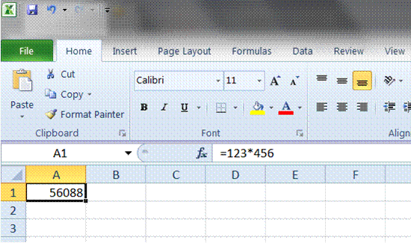

Select rows and columns in an Excel table
To select | Do this
A table column with or without headers | Click the top edge of the column header or the column in the table. The selection arrow will appear to show you that clicking selects the column.  You can also click anywhere in the table column, and then press CTRL+SPACEBAR,
A table column with worksheet headers | Click the worksheet column heading that displays the table header of the table column that you want to select.  OR  You can also click anywhere in the table column, and then press CTRL+SPACEBAR.
A table row | Click the left border of the table row. The following selection arrow will appeat to show you that clicking selects the row.
All table rows and columns | Click the upper-left corner of the table. The following selection arrow appears to indicate that clicking selects the entire table.  You can also click anywhere in the table, and then press CTRL+A, or you can click the top-left most cell in the table, and then press CTRL+SHIFT+END.

Select one or multiple worksheets
By clicking the tabs of worksheets (or sheets) at the bottom of the window, you can quickly select a different sheet.
Note If you want to enter or edit data on several worksheets at the same time, you can group worksheets by selecting multiple sheets.
You can also format or print a selection of sheets at the same time.

To select | Do this
A single sheet | Click the sheet tab.  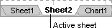  If you don't see the tab that you want, click the tab scrolling buttons to display the tab, and then click the tab.  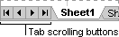
Two or more adjacent sheets | Click the tab for the first sheet. Then hold down SHIFT while you click the tab for the last sheet that you want to select.
Two or more nonadjacent sheets | Click the tab for the first sheet. Then hold down CTRL while you click the tabs of the other sheets that you want to select.
All sheets in a workbook | Right-click a sheet tab, and then click Select All Sheets on the shortcut menu.

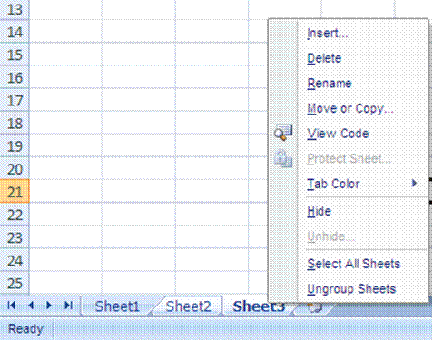

Notes
- Group: When multiple worksheets are selected, [Group] appears in the title bar at the top of the worksheet. To cancel a selection of multiple worksheets in a workbook, click any unselected worksheet. If no unselected sheet is visible, right-click the tab of a selected sheet, and then click Ungroup Sheets on the shortcut menu.
- Data that you enter or edit in the active sheet is reflected
- Shortcut menu: A menu that shows a list of commands relevant to a particular item. To display a shortcut menu, right-click an item or press SHIFT+F10
- Active sheet: The sheet that you're working on in a workbook. The name on the tab of the active sheet is bold.

Use the arrow keys to move through a worksheet
To move between cells on a worksheet, click any cell or use the arrow keys. When you move to a cell, it becomes the active cell
To scroll | Do this
To the start and end of ranges | Press CTRL+ARROW key to scroll to the start and end of each range in a column or row before stopping at the end of the worksheet.  To scroll to the start and end of each range while selecting the ranges before stopping at the end of the worksheet, press CTRL+SHIFT+ARROW key.
One row up or down | Use the UP ARROW key or DOWN ARROW key to scroll one row up or down.
One column left or right | Use the LEFT ARROW key or RIGHT ARROW key to scroll one column left or right.
One window up or down | Press PAGE UP or PAGE DOWN.
One window left or right | Press SCROLL LOCK, and then hold down CTRL while you press the LEFT ARROW or RIGHT ARROW key.
A large distance | Press SCROLL LOCK, and then simultaneously hold down CTRL and an arrow key to quickly move through large areas of your worksheet.

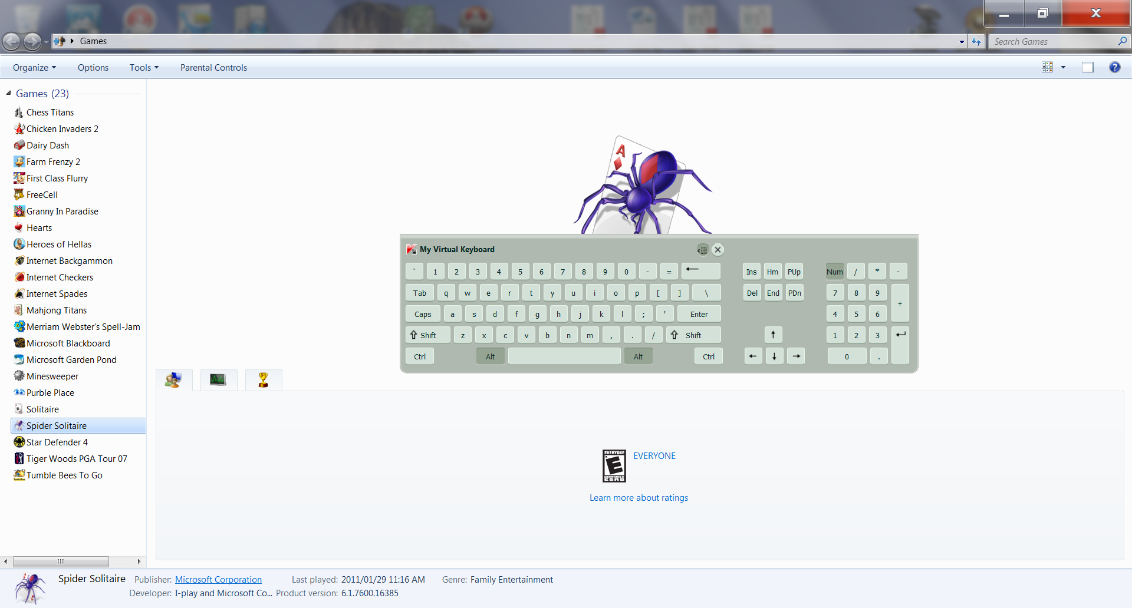

Use the scroll bars to move through a worksheet

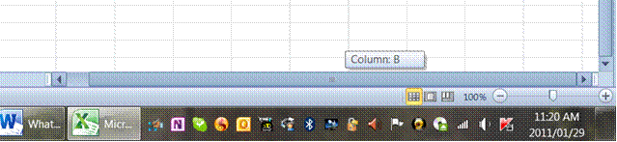
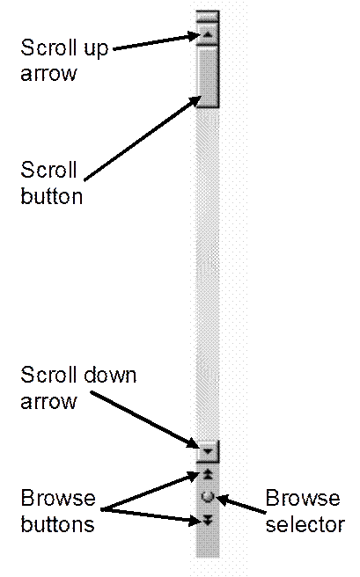

To scroll | Do this
One row up or down | Click the scroll arrows or on the vertical scroll bar to move the sheet one row up or down.
One column left or right | Click the scroll arrows or on the horizontal scroll bar to move the sheet one column to the left or right.
Scroll through a worksheet with increased scroll speed | While scrolling, hold down the mouse at the farthest end of the screen for more than 10 seconds to increase the scrolling speed.  Moving the mouse in the opposite direction slows down the scroll speed.
One window up or down | Click above or below the scroll box on the vertical scroll bar.
One window left or right | Click to the left or right of the scroll box on the horizontal scroll bar.
A large distance | Hold down SHIFT while dragging the scroll box .

Notes
- When you use the scroll boxes to move through a worksheet, Excel displays a tooltip to indicate row numbers or column letters (or numbers if you specified to use R1C1 reference style for the workbook) so that you know where you are in the worksheet.
- The size of a scroll box indicates the proportional amount of the used area of the sheet that is visible in the window. The position of a scroll box indicates the relative location of the visible area within the worksheet.
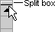
- You can quickly split the window so that you can scroll in two or four panes simultaneously. Point to the split box on either the vertical or the horizontal scroll bar. When the pointer becomes a double-headed arrow , drag the split bar onto the worksheet where you want to split the window. Double-click the split bar to remove it.

Scroll and zoom by using the mouse
Some mouse devices and other pointing devices, such as the Microsoft IntelliMouse pointing device, have built-in scrolling and zooming capabilities that you can use to move around and zoom in or out on your worksheet or chart sheet. . You can also use the mouse to scroll in dialogue boxes that have drop-down lists with scroll bars. For more information, see the instructions for your pointing device.
To | Do this
Scroll up or down a few rows at a time | Rotate the wheel forward or back.
Scroll through a worksheet with increased scroll speed | While scrolling, hold down the mouse at the farthest end of the screen for more than 10 seconds to increase the scrolling speed.  Moving the mouse in the opposite direction slows down the scroll speed.
Pan through a worksheet | Hold down the wheel button, and drag the pointer away from the origin mark in any direction that you want to scroll. To speed up scrolling, move the pointer away from the origin mark. To slow down scrolling, move the pointer closer to the origin mark.
Pan through a worksheet automatically | Click the wheel button, and then move the mouse in the direction that you want to scroll. To speed up scrolling, move the pointer away from the origin mark. To slow down scrolling, move the pointer closer to the origin mark. To stop automatic scrolling, click any mouse button.
Zoom in or out | Hold down CTRL while you rotate the IntelliMouse wheel forward or back. The percentage of the zoomed worksheet is displayed on the status bar.
Show detail in outlines | Point to a cell that summarizes data in the outline, and then hold down SHIFT while you rotate the wheel forward.
Hide detail in outlines | Point to any cell that contains detail data, and then hold down SHIFT while you rotate the wheel back.

Formative Assessment 2
Practice the selecting of cells by means of the above methods for about 5 minutes, or until you are familiar with the procedure.
Enter data into cells
When you open a new worksheet, all the cells have general format. The format of the cell determines what the numbers, text, dates and so on in the cell look like after you have entered data into a cell.

Entering data into cells
When you type numbers into a cell, they are automatically aligned to the right. If the number is too long, Excel will automatically widen the column. To enter a negative amount, either type a minus (-) before the amount or enclose it within a parentheses (1234).

Protected worksheet
A worksheet may have been protected by you or someone else to prevent data from being changed accidentally. On a protected worksheet, you may be able to select cells to view the data, but you won't be able to type information in cells that are locked.
In most cases, a protected worksheet should not be unprotected unless you have permission to do so from the person who created it. If a password was set when the worksheet protection was applied, you must type that password to unprotect the worksheet.

Enter numbers or text
- On the worksheet, click a cell.
- Type the numbers or text that you want, and then press ENTER or TAB.
- To start data on a new line within a cell, enter a line break by pressing ALT+ENTER.
Note: By default, pressing ENTER moves the selection down one cell, and pressing TAB moves the selection one cell to the right.

Change the column width
When a cell displays the following, ###### it means that the data in the cell is wider than the width of the column. To see all the text, you have increase the width of the column.
- Click the cell for which you want to change the column width.
- On the Home tab, in the Cells group, click Format.
- Under Cell Size, do one of the following:
- To fit all text in the cell, click AutoFit Column Width.
- To specify a larger column width, click Column Width, and then type the width that you want in the Column width box.
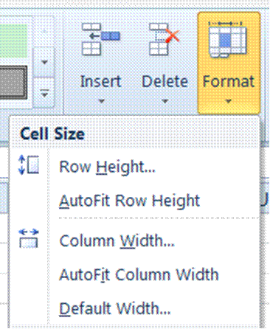

Wrap text in a cell
You can display multiple lines of text inside a cell by wrapping the text:
- Click the cell in which you want to wrap the text.
- On the Home tab, in the Alignment group, click Wrap Text.
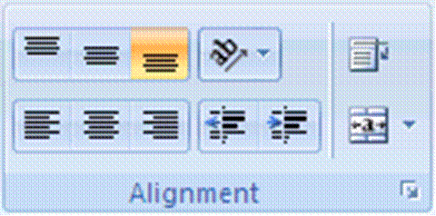
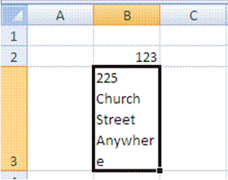

Notes
- If the text is a single long word, the characters won't wrap. In this case you can widen the column or decrease the font size to see all of the text.
- If not all of the text is visible after you wrap the text, you may need to adjust the height of the row. On the Home tab, in the Cells group, click Format, and then under Cell Size click AutoFit Row.
- In Microsoft Office Excel, the appearance of a number in a cell is separate from the number that is stored in the cell. When a number that you enter is rounded, in most circumstances, only the displayed number is rounded. Calculations use the actual number stored in the cell, not the number that is displayed.

Change the number format
It is possible to change the format in which numbers are displayed in the cell once you have typed the numbers into the cell.
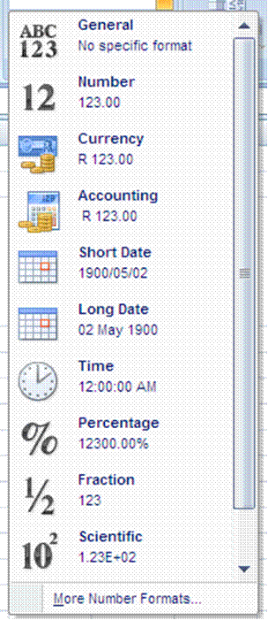
- Click the cell that contains the numbers that you want to format.
- On the Home tab, in the Number group, point to General, and then click the format that you want.

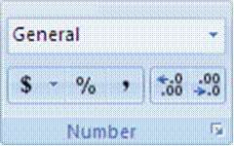

- To select a number format from the list of available formats, click More, and then click the format that you want to use in the Category list.

Format numbers as text
At times you will work with numbers, such as phone numbers and postal codes, that you will not use in calculations. In this case you have to change the formatting of the numbers to text before you type the number in the cell.
- Select an empty cell.
- On the Home tab, in the Number group, point to General, and then click Text.
- Type the numbers that you want in the formatted cell.
Note Numbers that you typed before you applied the Text format to the cells need to be reentered in the formatted cells. To quickly reenter numbers as text, select each cell, press F2, and then press ENTER.

Enter dates or times
- On the Home tab, in the Number group, point to General, and then select either short date or long date.
- Add the date
OR
On the worksheet, click a cell and type a date or time as follows:
- For a date, use a slash mark or a hyphen to separate the parts of a date; for example, type 9/5/2002 or 5-Sep-2002.
- To enter the current date, press CTRL+; (semicolon).
- To enter the current time, press CTRL+SHIFT+; (semicolon).
Tip For a time that is based on the 12-hour clock, type a space, and then type a or p after the time; for example, 9:00 p. Otherwise, Excel enters the time as AM.

Notes
- When a date or time is typed in a cell, it appears either in a default date or time format or in a format that was applied to the cell before the date or time was entered. The default date or time format is based on the date and time settings in the Regional and Language Options dialogue box (Control Panel). If these date and time settings have changed, any existing dates or times in your workbooks that have not been formatted by using the Format Cells command also change.

Edit cell contents
You can edit the contents of a cell directly in the cell. You can also edit the contents of a cell in the formula bar
- Double-click the cell that contains the data that you want to edit.
OR
- Click the cell that contains the data that you want to edit, and then click anywhere in the formula bar.
This positions the insertion point in the cell or formula bar.
Tip To move the insertion point to the end of the cell contents, click the cell and press F2.

To edit the cell contents, do any one of the following:
- To delete characters, click where you want to delete them, and then press BACKSPACE, or select them, and then press DELETE.
- To insert characters, click where you want to insert them, and then type the new characters.
- To replace specific characters, select them, and then type the new characters.
- To turn on Overtype mode so that existing characters are replaced by new characters while you type, press INSERT.
- To start a new line of text at a specific point in a cell, click where you want to break the line, and then press ALT+ENTER.
- To enter your changes, press ENTER.

Notes
- When you are in editing mode, many Ribbon commands will be inactive, and you will not be able to use them.
- Overtype mode can be turned on or off only when you are in editing mode. When Overtype mode is turned on, the character to the right of the insertion point is highlighted in the formula bar, and it will be overwritten when you type.
- Before you press ENTER, you can cancel any changes that you made by pressing ESC. After you press ENTER, you can cancel any changes that you made by clicking Undo on the Quick Access Toolbar.
- A cell may display ##### when it contains data that has a number format and that is wider than the column width. To see all text, you must increase the width of the column.

Formative Assessment 3
Enter the following data into a blank worksheet:
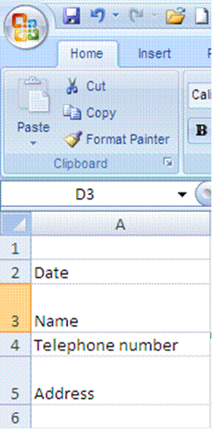

Then add:
- Today’s date
- Your name
- Telephone number
- Address
- Widen column A so that the text for telephone number fits into the cell
- Change the alignment of the date cell to left aligned
- Change the formatting of the telephone number to text
- Wrap the text of your address so that everything fits
Your worksheet should look like this:

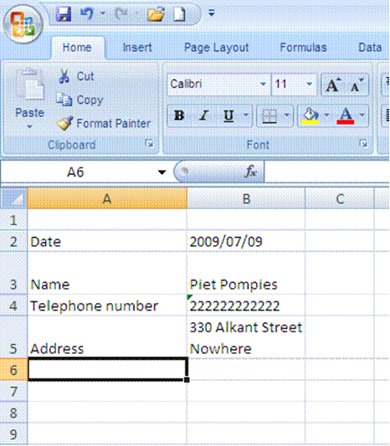
Saving Your Work

Naming your Document
When you create and save a new document, you have to take care that you:
- Give the document an appropriate name
- Save it in the correct folder
Note: When naming a document in Excel, you must follow the same rules as when you name a document in the workplace.
Do not give the document silly names such as: Annatjie’s workbook or figures dated 7 September.
In your workplace you will have certain filing rules that have to be followed, e.g. the client’s name, followed by the date or even the kind of letter you are creating:
- BMW quote 7 Sep
- Telkom account query 3 Feb 2009
- XYZ Traders order 7 July 2009
When you save your document, you must also follow the filing rules of your workplace. If you have a filing cabinet at work, and correspondence for XYZ Trading is filed in a drawer, in a folder named XYZ trading, you must do the same on your computer. You will have to open a folder called XYZ Trading in your My Documents folder and then save all the correspondence and worksheets relating to this customer in that folder.

Save your workbook
Now you must Save your document to make sure that it is not lost when you exit out of Excel. At the moment your document is called: Book 1 as you can see in the title bar of your workbook.
When you save a file, you can save it to
- a folder on your hard disk drive,
- a network location,
- disk,
- CD,
- the desktop,
- or another storage location.
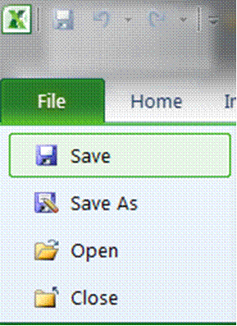
When you save a worksheet, you have to decide the location where the workbook has to be saved to. For this you have to select a the target location in the Save in list.
Otherwise, the saving process is the same, no matter what location you choose.
If you are saving the file for the first time, you are asked to give it a name.
- Go to the File tab and select Save
OR
- Click the Save icon on the Quick Access Toolbar.

Complete the Save As dialogue box
- Select the location
- Give the workbook a name
- Selet the type (formatting): usually Excel Workbook
- Click Save
Tip Keyboard shortcut: To save the file, press CTRL+S.

Rules for naming workbooks
Some rules when you are giving a workbook a name: The following characters cannot be used: / forward slash; \ backslash; > greater than; < less than; * asterisk; ? question mark; “ quotation mark; ¦ pipe symbol; (☺ colon or (;) semi-colon.

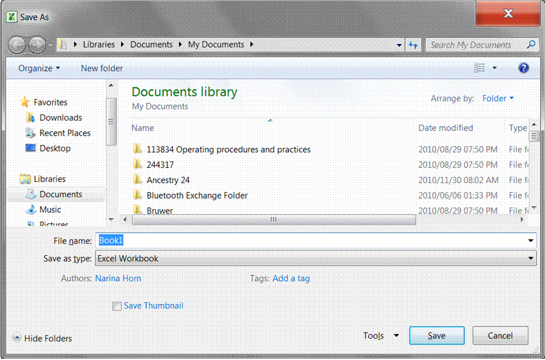
Tip It is safer to save your work every couple of minutes. Work for a couple of minutes and when you want to save again, click the Save icon on the Quick Access toolbar. Your workbook will automatically be saved under the name Practice.

Formative Assessment 4
Ensure that you are saving your workbook in My Documents as an Excel file, name the workbook Practice and then click Save.
You workbook has now been saved as Practice. Note how the name in the Title Bar has changed.

Save a copy of a file
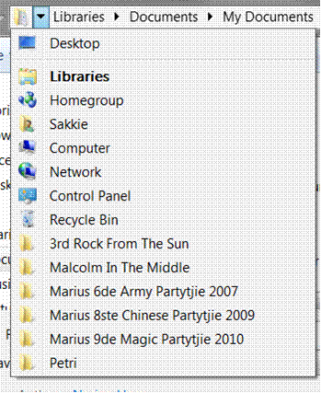
- Go to the File tab and select Save As
- Select the folder or drive to which you want to save from the Save In list
- To save the copy in a different folder, click a different drive or a different folder in the folder list.

- To save the copy in a new folder, click New Folder.
- In the File name box, enter a new name for the file.
- Click Save.
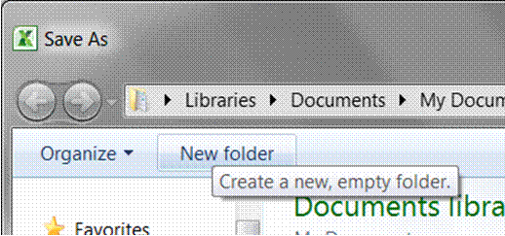

Save a file to another format
A file format is a particular way to encode information for storage in a computer file..
Since a any computer storage, can store only bits, , the computer must have some way of converting information to 0s and 1s and vice-versa. There are different kinds of formats for different kinds of information.
Put differently, a file format is the way in which information is stored in a file so that a program can open and save the file. A file's format is indicated by a three-letter extension after the file name.
For example, when you save a new document in Microsoft Excel 2010, Excel by default stores with an .xml file extension. If you want to convert a document to a different format so that you or someone else can open it in another program or in an earlier version of Excel, you can select that file format when you save the document.
You can save a Microsoft Excel workbook in the file format of an earlier version of Excel, in a text file format, and in other file formats, such as PDF or XPS.
Excel 2010 uses the same XML-based file format as Excel 2007. You can also save any file format that you can open in Excel 2010 to the current XML-based file format. By default, files are saved in the .xlsx file format, but you can change the default file format for saving.
Tip If you frequently use the Save As command, you may want to add it to the Quick Access Toolbar.
By default, , worksheets that you create in Excel 2010 are saved in XML format with new file name extensions that add an "x" or an "m" to the file name extensions that you are already familiar with. The "x" signifies an XML file that has no macros, and the "m" signifies an XML file that does contain macros. In the past, Excel workbooks were stored as .xls extensions
When you save a file as a template, you see the same sort of change. The template extension used in earlier versions is there, but it now has an "x" or an "m" on the end. If your file contains code or macros, you must save it by using the new macro-enabled XML file format, which adds an "m" for macro to the file extension.
The table below shows the new Excel file formats:

XML file type | Extension
Workbook | .xlsx
Macro-enabled workbook | .xlsm
Template | .xltx
Macro-enabled template | .xltm
Non-XML binary workbook | .xlsb
Macro-enabled add-in | .xlam

What is XPS format?
XML Paper Specification (XPS is a platform-independent technology that preserves the formatting of your document and and enables you to share files.
XPS embeds all fonts in the file so they appear as intended, regardless of whether the specified font is available on the recipient's computer, and has more precise image and colour rendering on the recipient's computer than PDF. This means that when the XPS file is viewed online or printed, it retains exactly the format that you intended, and the data in the file cannot be easily changed.

Follow these steps
- Click the File tab.
- Click Save As.
- In the File Name box, enter a name for the file, if you haven't already.
- In the Save as type list, click XPS Document

Notes:
- If you want the file to open in the selected format after saving, select the Open file after publishing check box.
- If the document requires high print quality, click Standard (publishing online and printing).
- If file size is more important than print quality, click Minimum size (publishing online).

Save as PDF
Note Portable Document Format (PDF) preserves document formatting and enables file sharing.
When you want to save files in a way that other people cannot change them, but you want to be able to share and print the file, you can save the file in PDF format.
You will use this format when you want a workbook that:
- Looks the same on most computers
- Has a small file size
- Complies with an industry format
This is often done for learning material, resumes, legal documents, newsletters, files intended to only be read and printed, documents intended for professional printing.
When the PDF format file is viewed online or printed, it retains the format that you intended. Data in the file cannot be easily changed, and can be explicitly set to prohibit editing.
The PDF format is also useful for documents that will be reproduced using commercial printing methods.
Tip Important To view a PDF file, you must have a PDF reader installed on your computer such as the Acrobat Reader, available from Adobe Systems.

To save a file in PDF format, follow these steps
- Click the File tab.
- Click Save As.
- In the File Name box, enter a name for the file, if you haven't already.
- In the Save as type list, click PDF (*.pdf).
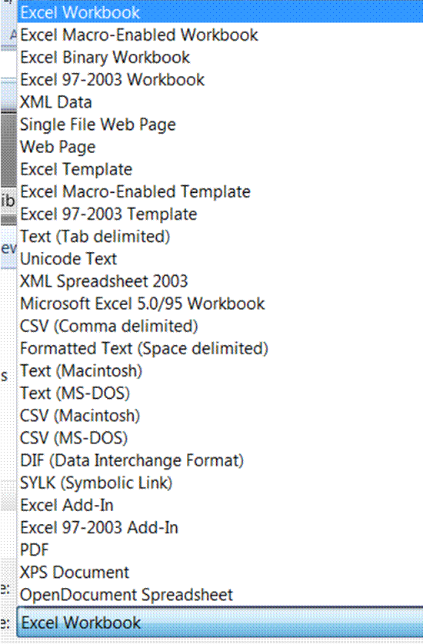

Closing A Workbook
When you close a document, it clears your screen and enables you to start working on a new workbook. You have two options when closing a workbook:

- Go to the File tab and click on Exit
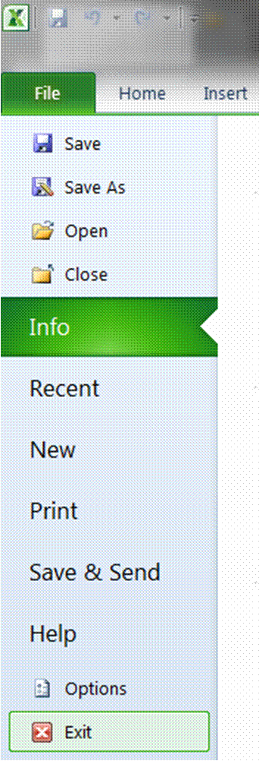

OR
- Click on the bottom X in the right hand corner of your screen
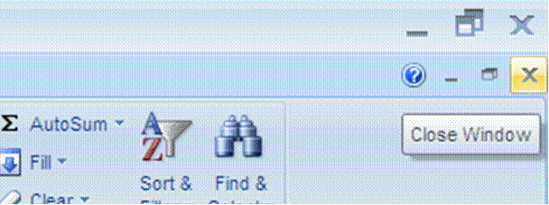

- A dialogue box appears; asking you whether you want to save the changes you made to the document. You can choose Yes, No or Cancel.


- If you choose Yes, the worksheet and the changes will be saved.
- If you choose No, all the changes you made since the last time you saved this worksheet, will be ignored.
- If you choose Cancel, you will exit the File, Close menu and return to the worksheet.
Note: You don’t have to close one worksheet to open another, you can have more than one open worksheet at a time.
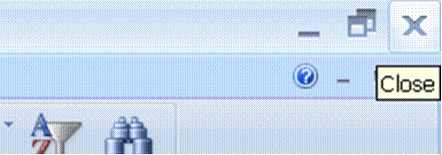
Tip The X at the top will close the Excel program
Opening A New Workbook
- Go to the File tab , and then click New.
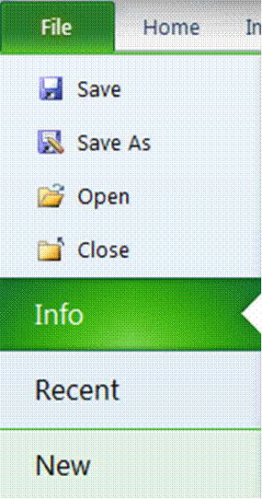

OR
- click on the New button on the Quick Access Toolbar
- A new, blank workbook will be opened.

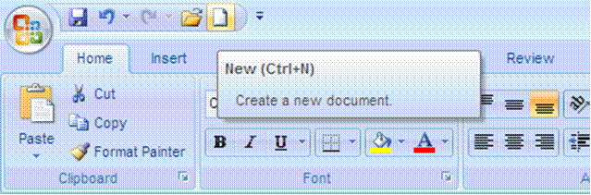
Tip Keyboard shortcut: CTRL+N
To Open An Existing Workbook
- Go to the File tab , and then click Open.
OR
- click on the Open button on the Quick Access Toolbar
Tip Keyboard shortcut: To display the Open dialogue box, press CTRL+O.
- In the Look in list, click the folder, drive, or Internet location that contains the file that you want to open.
- In the folder list, locate and open the folder that contains the file.
- Click the file, and then click Open.
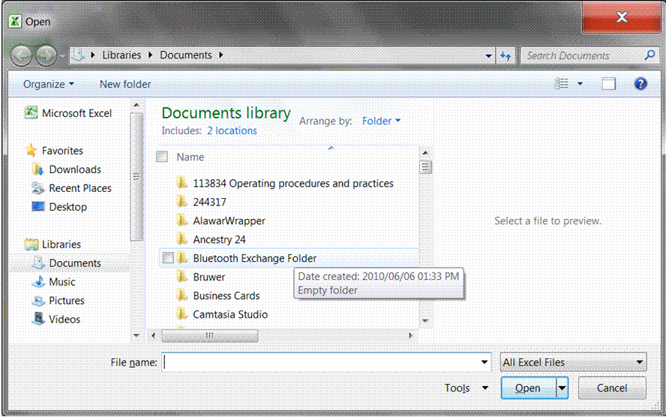

Note: By default, the files that you see in the Open dialogue box are only those files that are created by the program that you are using.
For example, if you are using Microsoft Office Excel, you do not see files that are created by using Microsoft Office Word unless you click All Files in the Files of type box.
Save your document to an external device
Why would you want to save your workbook to an external device such as a flash drive or an external hard drive? Well, this way you can take the external device, with the information saved on it and download it to someone else's computer. Then you can print from their computer, you can make changes to the document or whatever the need may be.
Of course, someone else can also save information to an external device and download it to your computer. This means that you won't have to retype the entire document!
This is a method of sharing and transferring information between computers (and people of course), without carrying the whole computer around!
- Go to the File taband then click on Save As.
- You now have to tell Excel where you want to save to: select the drive from the navigation pane on the left
- The right hand pane will display the various external devices available under Devices with removable storage. Our example shows: DVD RW Drive (E)
- Make sure that the name in the File Name box is the correct name, as this is the name that your document will be saved as.
- Make sure that you are saving your workbook as an Excel worksheet and then click Save.
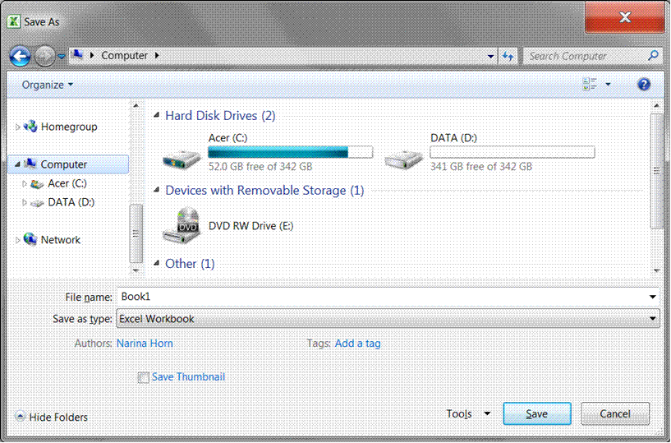

Formative Assessment 5
- Sace your workbook as Practice and add your name.
- Close your Practice workbook

PRODUCE A SPREADSHEET

Outcome
Produce a spreadsheet from a given specification

Assessment Criteria
On completion of this section you will be able to ensure that:
- A spreadsheet is produced with the required data from given specification. Text, numbers, dates.
- Formulae are entered to achieve the given specification. Formulae: addition, subtraction, division, multiplication, sum.
- The differences between data cells, label cells, and formula cells are explained.
- The spreadsheet is in accordance with the given specifications.
- Practices are demonstrated to ensure the integrity of the data. Check against data source, check-totals, audit formulae
- The benefits of saving a file in different formats is explained. Formats: Text, CSV, HTML, other software versions, other software types.
- A spreadsheet is saved in a different format. At least two of: Text, CSV, HTML, other software versions, other software types.

Formatting Numbers

Currency Format: Formative Assessment 6
In your practice file enter the following amounts in cells D1 to D5:
- D1: 28443;
- D2: 31296;
- D3: 8543;
- D4: 12;
- D5: 96.

Then select these cells,
- On the Home tab, click the Dialogue Box Launcher next to Number.
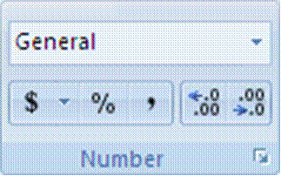
- In the Category box, click Currency.
- In the Symbol box, click the currency symbol that you want.
- In the Decimal places box, enter the number of decimal places that you want to display.
- In the Negative numbers box, select the display style for negative numbers.

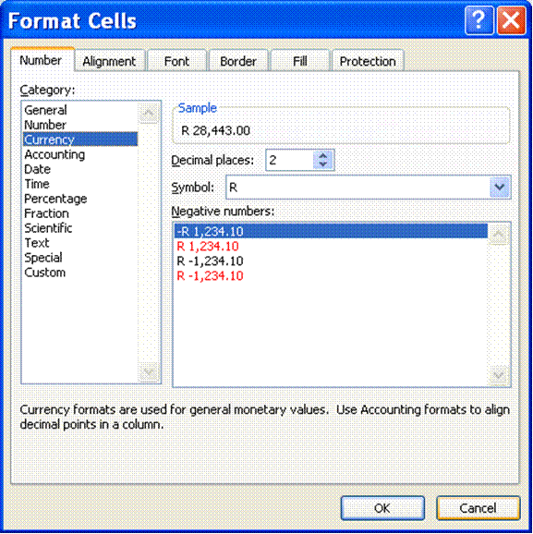

Tip If you want to display a monetary value without a currency symbol, you can click None.

Accounting Format: Formative Assessment 7
Tip Accounting formats line up the currency symbols and decimal points in a column
- In Cells E1 to E5, enter the following numbers: E1: 86236; E2: 789654; E3: 789; E4: 86; E5: 98746.
- Once again, select Cells E1 to E5
- On the Home tab, click the Dialogue Box Launcher next to Number.
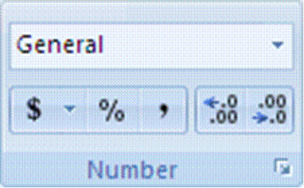
- In the Category box, click Accounting.
- In the Symbol box, click the currency symbol that you want.
- In the Decimal places box, enter the number of decimal places that you want to display.

Note The Negative numbers box is not available for the Accounting number format.
- Change the decimal places option to two; click on OK.
- All the R signs will be aligned underneath each other.
Tip If you want to display a monetary value without a currency symbol, you can click None.
Formative Assessment 8: budget
Tip Put simply, a budget is a statement of your income and expenses, showing you how much money you have left once you have paid all your debts.
Income is of course all your earnings: salary, commission, interest, maintenance, etc. Expenses are everything you have to pay: house rent, water and lights, telephone, school fees, transport, accounts, etc.
Complete your monthly budget or an imaginary one on a new sheet in your Practice document. and save it to the hard drive.
Entering Formulas Into Cells
Tip Formulas are equations that perform calculations on values in your worksheet.
A formula starts with an equal sign (=).
Note You ALWAYS begin with a = in the cell where you want the answer!
Excel uses the following arithmetic operators that you will find on your numeric keyboard on the right hand side of the keyboard:
- To Add use the + (plus)
- To Subtract use the - (minus)
- To Multiply use the * (asterisk)
- To Divide use the / (forward slash)

Formative Assessment 9
- Click on a new sheet in your Practice workbook.
- In cell A1 type 250; in cell A2 type 320; in cell A3 type 125.
- Start your calculation (your sum) by entering an = in cell A4
- Click cell A1 and press + .See how the formula shows in cell A4
- Click cell A2 and press+ .See how the formula shows in cell A4 as well as the Formula Bar
- Click cell A3 and press Enter - DO NOT PRESS + IN CELL A3!!! Press Enter!!!
- The answer will display in cell A4.
- If you press + and then Enter in cell A3, an error message will display. You can click on Yes and Excel will make the corrections as proposed, or you can click No and make the corrections yourself.

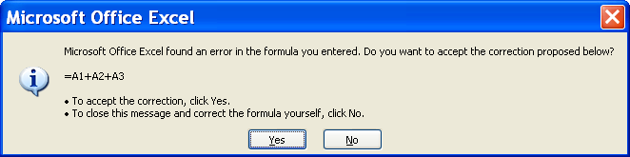

Error Messages
When you are adding in Excel, it is similar to adding on a calculator. You will type + in all the cells except the last one, where you press enter. Excel will automatically calculate and display your answer in the cell nominated by you, where you typed the =.
If a formula cannot properly evaluate a result, Microsoft Excel will display an error value. Each error type has different causes, and different solutions. Error messages display in two ways: via the Office Assistant as in the example above and then as a message in a cell.
##### Occurs when a column is not wide enough, or a negative date or time is used. Enlarge the column
#VALUE! Occurs when the wrong type of argument or operand is used. There is something wrong with your formula, check the formula again. Also check that you used the correct cell formatting.
#NAME? Occurs when Microsoft Excel doesn't recognize text in a formula. Usually this happens when you used a label in a formula, without labels being allowed. This is covered later in the manual.
#REF! Occurs when a cell reference is not valid
This lesson is important, because if you do not do the calculations in the right sequence, Excel will not be able to display the answer.

Add A Column Using The Autosum Button:

To do this task, use AutoSum.

- Click a cell below the column of numbers or to the right of the row of numbers.
- On the Home tab, in the Editing group, click AutoSum , and then press ENTER.
- Excel will add the total of the column automatically. Columns can only be added from the top to the bottom and rows from the left to the right

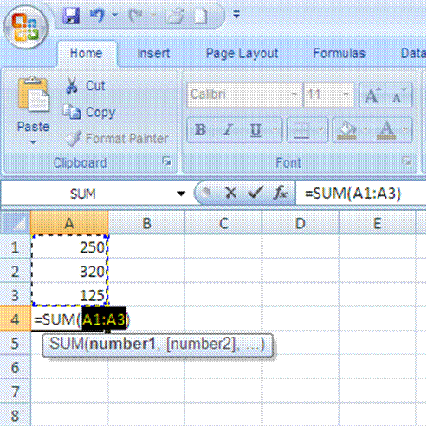

Formative Assessment 10
- Enter the following amounts in column C:
- C1:1230; C2: 4387; C3:2598; C4: 1121; C5: 7683; C6: 5576
- Add the numbers using Autosum
Adding Using The SUM Function
The SUM function is used to add noncontiguous numbers (numbers that do not follow each other).

Formative assessment 11
Insert the following information in a new worksheet:
A | B
Salesperson | Invoice
Buchanan | 15,000
Buchanan | 9,000
Suyama | 8,000
Suyama | 20,000
Buchanan | 5,000
Dodsworth | 22,500

- In the following blank cell, enter the following formula: =SUM(B2:B3, B5) Adds two invoices from Buchanan, and one from Suyama (44,000)
- In the following blank cell, enter the following formula: =SUM(B2,B5,B7) Adds individual invoices from Buchanan, Suyama, and Dodsworth (57,500)
- The SUM function can include up to 30 cell or range references
You can also access the SUM function from the Insert function on the formula bar:

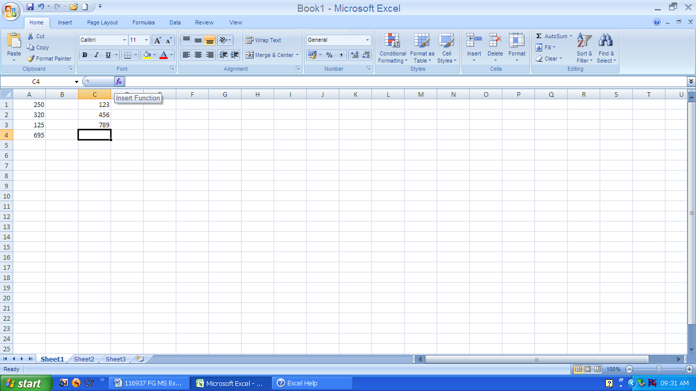

Note: You can also use the Sum Function to do calculations in rows rather than in columns.

Subtracting
The procedure to subtract is the same as to add: click the cell where you want the answer and then process the calculation.
Remember, to subtract use the - (minus) on the numeric keyboard.
=SUM(A2:A4) Adds all numbers in the list, including negative numbers
Tip Adding a negative number is the same as subtracting.
Formative Assessment
In any two cells, type the following:
15000
-9000
Use the SUM function to subtract 9000 from 15000:

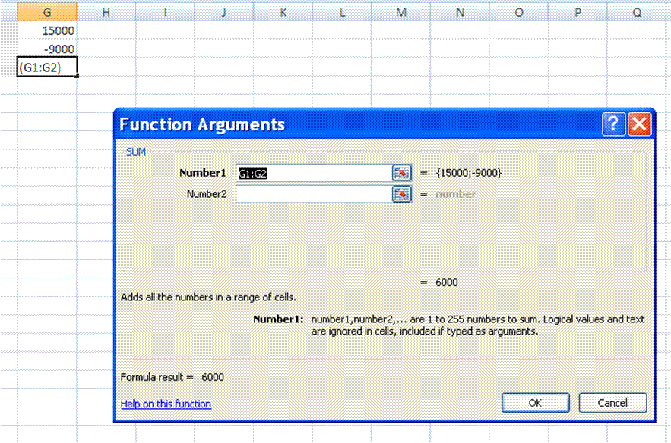

Multiplication

Multiply numbers in a cell
- To do this task, use the * (asterisk) arithmetic operator.
- If you type the following formula in a cell: =5*10
- The cell displays the following result: 50

Division
To divide, use the / (forward slash) on the numeric keyboard.
Formative Assessment 12
- Enter the following amounts: cell A20: 8585; cell B20: 123.
- Click on cell C20, enter = .
- Click cell A7 and enter /, click cell B7 and press enter.
- The answer will be displayed in cell C20
Cell Reference
Tip Cell reference refers to a cell or a range of cells on a worksheet and tells Microsoft Office Excel where to look for the values or data that you want to use in a formula.
With cell references, you can use data that is contained in different parts of a worksheet in one formula, or you can use the value from one cell in several formulas.
You can also refer to cells on other worksheets in the same workbook. Here are some common examples:

This formula: | Refers to: | And Returns:
=C2 | Cell C2 | The value in cell C2.
=Sheet2!B2 | Cell B2 on Sheet2 | The value in cell B2 on Sheet2.
=Asset-Liability | The cells named Liability and Asset | The value of the cell named Liability subtracted from the cell named Asset.
{=Week1+Week2} | The cell ranges named Week1 and Week2 | The sum of the values of the cell ranges named Week1 and Week 2 as an array formula

Create a cell reference on the same worksheet
Click the cell in which you want to enter the formula.

- In the formula bar, type = (equal sign).

- To create a reference, select a cell or range of cells on the same worksheet.
Cell references and the borders around the corresponding cells are colour-coded to make it easier to work with them

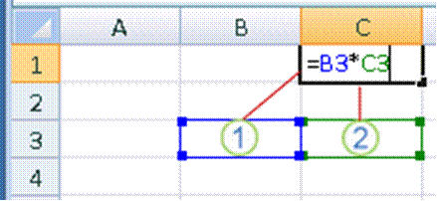
- The first cell reference is B3, the colour is blue, and the cell range has a blue border with square corners.
- The second cell reference is C3, the colour is green, and the cell range has a green border with square corners.

Change a cell reference to another cell reference
Double-click the cell that contains the formula that you want to change. Note that Microsoft Excel will highlight each cell or range of cells with a different colour.
Do one of the following:
- To move a cell or range reference to a different cell or range, drag the colour-coded border of the cell or range to the new cell or range.
OR
- To include more or fewer cells in a reference, drag a corner of the border.

- In the formula, select the reference, and then type a new one.
- Press F3, select the name in the Paste name box, and then click OK.
- Press ENTER

Using names in formulas
Worksheets often have labels (text) at the top of each column and to the left of each row that describe the data within the worksheet. You can use these labels within formulas when you want to refer to the related data. You can also create descriptive names that are not labels on the worksheet to represent cells, ranges of cells, formulas, or constants.
Tip In Excel a name is a word or string of characters that represents a cell, range of cells, formula, or constant value.
A name is a meaningful shorthand that makes it easier to understand the purpose of a cell reference, so when you give a cell a name, make sure that you use easy-to-understand names, such as Products, to refer to hard to understand ranges, such as Sales!C20:C30.
You can create defined name to represent cells, ranges of cells, formulas, constant values or Excel tables. The following information shows common examples of names and how they can improve clarity and understanding.

Example Type | Example with no name | Example with a name
Reference | =SUM(C20:C30) | =SUM(FirstQuarterSales)
Constant | =PRODUCT(A5,8.3) | =PRODUCT(Price,WASalesTax)
Formula | =SUM(VLOOKUP(A1,B1:F20,5,FALSE), —G5) | =SUM(Inventory_Level,—Order_Amt)
Table | C4:G36 | =TopSales06

Types of names
There are several types of names you can create and use, for example:
- Defined name: A name that represents a cell, range of cells, formula, or constant value. You can create your own defined name, and Excel sometimes creates a defined name for you, such as when you set a print area.
- Table name: A name for an Excel table, which is a collection of data about a particular subject that is stored in records (rows) and fields (columns). Excel creates a default Excel table name of "Table1", "Table2", and so on, each time you insert an Excel table, but you can change the name to make it more meaningful. Creating and entering names

Create a name using the name box
- Select the cell, range of cells, or nonadjacent selections that you want to name.
- Click the Name box at the left end of the formula bar


- Type the name that you want to use to refer to your selection. Names can be up to 255 characters in length.
- Press ENTER.
- You cannot name a cell while you are changing the contents of the cell.

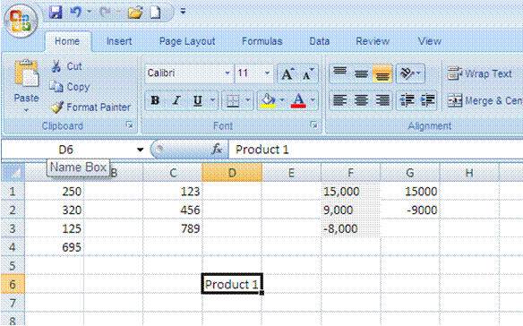

Create a name by using a selection of cells in the worksheet
You can convert existing row and column labels to names.
- Select the range that you want to name, including the row or column labels.
- On the Formulas tab, in the Defined Names group, click Create from Selection.
- In the Create names from Selection dialogue box, designate the location that contains the labels by selecting the Top row, Left column, Bottom row, or Right column check box.
Note: A name created by using this procedure refers only to the cells that contain values and does not include the existing row and column labels.

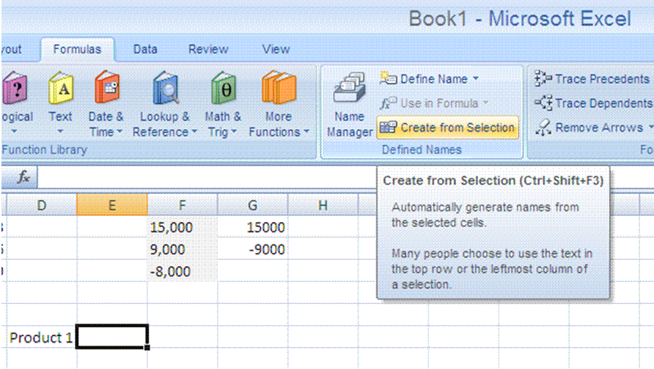

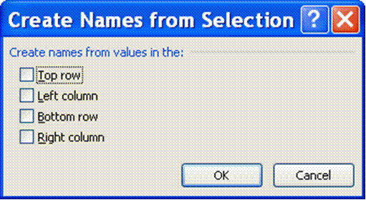

Create a name by using the New Name dialogue box
- On the Formulas tab, in the Defined Names group, click Define Name.
- In the New Name dialogue box, in the Name box, type the name that you want to use for your reference. Names can be up to 255 characters in length.

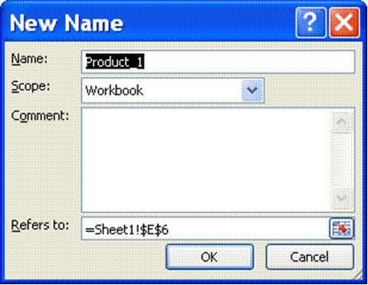

In the name box, enter the defined name that you want to create.
- To specify the scope of the name, in the Scope drop-down list box, select Workbook, or the name of a worksheet in the workbook.
- Or enter a descriptive comment up to 255 characters.
In the Refers to box, enter one of the following:
- Cell referenc: The current selection is entered by default. To enter other cell references as an argument, click Collapse Dialogue (which temporarily hides the dialogue box), select the cells on the worksheet, and then press Expand Dialogue .
- Formula: Type an = (equal sign) followed by the formula.
To finish and return to the worksheet, click OK.
Tip To make the New Name dialogue box wider or longer, click and drag the grip handle at the bottom.

Syntax rules for names
The following is a list of syntax rules that you need to be aware of when you create and edit names.
- Valid characters: The first character of a name must be a letter, an underscore character (_), or a backslash (\). Remaining characters in the name can be letters, numbers, periods, and underscore characters.
- You cannot use the letters "C", "c", "R", or "r" as a defined name, because both of these letters are used as a shorthand for selecting a row or column for the currently selected cell when you enter them in a Name or Go To text box.
- Cell references disallowed: Names cannot be the same as a cell reference, such as Z$100 or R1C1.
- Spaces are not valid: Spaces are not allowed. Use the underscore character (_) and period (.) as word separators, such as, Sales_Tax or First.Quarter.
- Name length: A name can contain up to 255 characters.
- Case sensitivity: Names can contain uppercase and lowercase letters. Excel does not distinguish between uppercase and lowercase characters in names. For example, if you created the name Sales and then create another name called SALES in the same workbook, Excel prompts you to choose a unique name.
Values
There are two types of information that can be stored in cells in the worksheet.
- Constant value: data that is typed directly into the cell. It can be numeric, or text. Constant values do not change unless you select the cell and edit the value yourself.
- A formula is a sequence of values, cell references, names, functions, or operators that produces a new value from existing values. Formulas always begin with an equal = sign. A number that is produced as the result of a formula can change when other values in the worksheet changes.

Entering Text/Labels
- Text can be any combination of numbers and characters
- Labels can contain numbers and may begin with numbers
- If you start a label with numbers, it will change to a label as soon as a label character is typed
- Any set of characters entered into a cell that Excel does not interpret as a number, formula, date, time, logical value or error value is interpreted as text
- Numbers may appear in labels, but they cannot be manipulated arithmetically
- If you want to enter a number as text, e.g. a postal code, precede the entry with an apostrophe. The number will then align to the left of the cell
Entering Numbers/Values:
- A number entry can contain only numerals (0-9), a leading negative (-), positive (+), equal (=) or dollar ($) sign; a trailing percent sign (%) or an E (scientific notation). All other combinations of numbers and nonnumeric characters are treated as text.
- It is better to use a negative sign (-) rather than a parenthesis (()) to indicate a negative number.
- You cannot include spaces and commas in numbers, the decimal point is a full stop.
- Excel keeps track of up to 15 decimal places, the formula bar shows only 9
- An entry can end with % that tells Excel to divide the preceding value by 100.

Display numbers as fractions
Use the Fraction format to display or type numbers as actual fractions, rather than decimals.
- Select the cells that you want to format.
- On the Home tab, click the Dialogue Box Launcher next to Number.

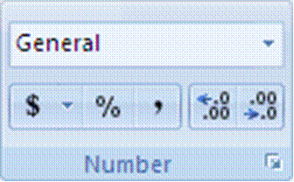

- In the Category list, click Fraction in the Category list.
- In the Type list, click the fraction format type that you want to use.

Available fraction formats
Fraction format | This format displays 123.456 as
Single-digit fraction | 123 1/2, rounding to the nearest single-digit fraction value
Double-digit fraction | 123 26/57, rounding to the nearest double-digit fraction value
Triple-digit fraction | 123 57/125, rounding to the nearest triple-digit fraction value
Fraction as halves | 123 1/2
Fraction as quarters | 123 2/4
Fraction as eighths | 123 4/8
Fraction as sixteenths | 123 7/16
Fraction as tenths | 123 5/10
Fraction as hundredths | 123 46/100

Notes
- The number in the active cell of the selection on the worksheet appears in the Sample box, so that you can preview the number formatting options that you select.
- After you apply a fraction format to a cell, decimal numbers as well as actual fractions that you type in that cell will be displayed as a fraction. For example, typing .5 or 1/2 results in 1/2 when the cell has been formatted with a fraction type of Up to one digit.
- If no fraction format is applied to a cell, and you type a fraction such as 1/2, it will be formatted as a date. To display it as a fraction, apply a Fraction format, and then retype the fraction.
- If you don't need to perform calculations on fractions, you can format a cell as text before you type a fraction into it by clicking Text in the Category list. This way, the fractions that you type will not be reduced or converted to decimals. However, you cannot perform mathematical calculations on fractions that are displayed as text.
- To reset the number format, click General in the Category box (Format Cells dialogue box) or in the Number Format box (Home tab, Number group). Cells that are formatted with the General format do not have a specific number format.
Set Up Data Entry Validation
Data validation is setting up criteria for any data entered into the cell. If the data entered does not match the criteria, an error message can be displayed and the data entry cancelled.
Validation checks data entered either manually or by a macro and also applies to the results of formulas.
- Select the cell(s) to be validated
- From the Data tab, select the Data tools group.ans select data validation
- Select the Settings tab
- From the Allow: box, select the type of data that you want to allow in the cell
- Additional selection boxes are displayed depending on the validation type.
Note Various selections are available. You can specify a range of whole numbers, decimals, dates or times. You can limit selections to items on a list or restrict the length of text entries.

Prevent invalid data entry in a worksheet

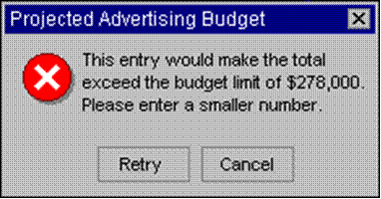

In many worksheets that you create, users will enter data to get the desired calculations and results. Ensuring valid data entry is an important task. You may want to restrict data entry to a certain range of dates, limit choices by using a list, or make sure that only positive whole numbers are entered. Providing immediate help to instruct users and clear messages when invalid data is entered is also essential to make the data entry experience go smoothly.
To Apply Data Validation To A Cell
Once you decide what validation you want to use on a worksheet, you can set up the validation by doing the following:
- Select one or more cells to validate.
- On the Data tab, in the Data Tools group, click Data Validation.

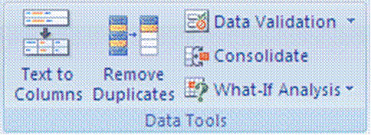
- The Data Validation dialogue box is displayed.

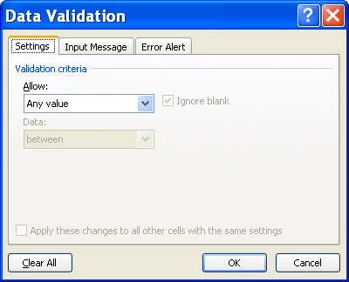

- Click the Settings tab.
To specify the type of validation that you want, do one of the following:

Allow values from a list:
- In the Allow box, select List.
- Click the Source box and then type the list values separated by the Microsoft Windows list separator character (commas by default).
For example:
- To limit entry to a question, such as "Do you have children?", to two choices, type Yes, No.
- To limit a vendor's quality reputation to three ratings, type Low, Average, High.
.
The width of the drop-down list is determined by the width of the cell that has the data validation. You may need to adjust the width of that cell to prevent truncating the width of valid entries that are wider than the width of the drop-down list.
Make sure that the In-cell dropdown check box is selected.

Allow a whole number within limits
- In the Allow box, select Whole Number.
- In the Data box, select the type of restriction that you want. For example, to set upper and lower limits, select between.
- Enter the minimum, maximum, or specific value to allow. You can also enter a formula that returns a number value.
For example, to set a minimum limit of deductions to two times the number of children in cell F1, select greater than or equal to in the Data box and enter the formula, =2*F1, in the Minimum box.

Allow a decimal number within limits
- In the Allow box, select Decimal.
- In the Data box, select the type of restriction that you want. For example, to set upper and lower limits, select between.
- Enter the minimum, maximum, or specific value to allow. You can also enter a formula that returns a number value.
For example, to set a maximum limit for commissions and bonuses of 6% of a salesperson's salary in cell E1, select less than or equal to in the Data box and enter the formula, =E1*6%, in the Maximum box.

Allow a date within a timeframe
- In the Allow box, select Date.
- In the Data box, select the type of restriction that you want. For example, to allow dates after a certain day, select greater than.
- Enter the start, end, or specific date to allow. You can also enter a formula that returns a date.
For example, to set a time frame between today's date and 3 days from today's date, select between in the Data box, enter =TODAY() in the Minimum box, and enter =TODAY()+3 in the Maximum box.

Allow a time within a timeframe
- In the Allow box, select Time.
- In the Data box, select the type of restriction that you want. For example, to allow times before a certain time of day, select less than.
- Enter the start, end, or specific time to allow. You can also enter a formula that returns a time value.
For example, to set a time frame for serving breakfast between the time when the restaurant opens in cell H1 and 5 hours after the restaurant opens, select between in the Data box, enter =H1 in the Minimum box, and then enter =H1+"5:00" in the Maximum box.

Allow text of a specified length
- In the Allow box, select Text Length.
- In the Data box, select the type of restriction that you want. For example, to allow up to a certain number of characters, select less than or equal to.
- Enter the minimum, maximum, or specific length for the text. You can also enter a formula that returns a number value.
For example, to set the specific length for a full name field (C1) to be the current length of a first name field (A1) and a last name field (B1) plus 10, select less than or equal to in the Data box and enter =SUM(LEN(A1),LEN(B1),10) in the Maximum box.

Calculate what's allowed based on the content of another cell
- In the Allow box, select the type of data that you want.
- In the Data box, select the type of restriction that you want.
- In the box or boxes below the Data box, click the cell that you want to use to specify what's allowed.
For example, to allow entries for an account only if the result won't go over the budget in cell E4, select Decimal for Allow, select less than or equal to for Data, and in the Maximum box, enter =E4.

Use a formula to calculate what's allowed
- In the Allow box, select Custom.
- In the Formula box, enter a formula that calculates a logical value (TRUE for valid or FALSE for invalid entries).
For example:
To make sure that | Enter this formula
The cell for the picnic account (B1) can only be updated if nothing is budgeted for the discretionary account (D1) and the total budget (D2) is less than the $40,000 allocated. | =AND(D1=0,D2<40000)
The cell containing a product description (B2) only contains text. | =ISTEXT(B2)
For the cell containing a projected advertising budget (B3), the subtotal for subcontractors and services (E1) must be less than or equal to $800, and the total budget amount (E2) must also be less than or equal to $97,000. | =AND(E1<=800,E2<=97000)
The cell containing an employee age (B4) is always greater than the number of full years of employment (F1) plus 18 (the minimum age of employment). | =IF(B4>F1+18,TRUE,FALSE)
All the data in the cell range A1:A20 contains unique values. | =COUNTIF($A$1:$A$20,A1)=1  You must enter the formula in the data validation for cell A1, and then fill the cells A2 though A20 so that the data validation for each cell in the range has a similar formula, but the second argument to the COUNTIF function will match the current cell.
The cell containing a product code name (B5) always begins with the standard prefix of ID- and is at least 10 characters in length. | =AND(LEFT(B5, 3) ="ID-",LEN(B5) > 9)

Blank values
- To specify how you want to handle blank (null) values, select or clear the Ignore blank check box.
If your allowed values are based on a cell range with a defined name, and there is a blank cell anywhere in the range, setting the Ignore blank check box allows any values to be entered in the validated cell. This is also true for any cells referenced by validation formulas: if any referenced cell is blank, setting the Ignore blank check box allows any values to be entered in the validated cell.
Optionally, display an input message when the cell is clicked.
- Click the Input Message tab.
- Make sure the Show input message when cell is selected check box is selected.
- Fill in the title and text for the message.
- Specify how you want Microsoft Office Excel to respond when invalid data is entered.
- Click the Error Alert tab, and make sure that the Show error alert after invalid data is entered check box is selected.
- Select one of the following options for the Style box:
- To display an information message that does not prevent entry of invalid data, select Information.
- To display a warning message that does not prevent entry of invalid data, select Warning.
- To prevent entry of invalid data, select Stop.
- Fill in the title and text for the message (up to 225 characters).
If you don't enter a title or text, the title defaults to "Microsoft Excel" and the message to: "The value you entered is not valid. A user has restricted values that can be entered into this cell."
- Test the data validation to make sure that it's working correctly.
Try entering both valid and invalid data in the cells to make sure that your settings are working as you intended and your messages are appearing when you expect.
Note: If you make changes to the validation in one cell, you can automatically apply your changes to all other cells that have the same settings.

Formative Assessment 13
- Open the workbook Sales Projections
- In cell B7 (Overheads Growth) create a validation entry
- Set these validation settings: Whole Number, Less than 1; and switch off Ignore blank
- Set the Input Message title to "Input Overheads" and the message to "Enter a fraction such as .15, or a percentage such as 15%"
- Set the Error Alert to Stop; title to "High Overheads", and the message as "Unrealistic figure, please re-enter."
- In cell B7 enter the number 2
- Reset the validation Error Alert to Warning
- In cell B7 enter the number 2, and accept the number
- Display the Data Tool group
- Use the Circle Invalid Data button to highlight the number 2 in cell B7
- Close the file without saving it
Tip To distribute data to people who do not have access to the Microsoft Excel application (or are using a different version of it), you can save a workbook in a different file format to allow them to open and edit it in whatever spreadsheet software they have.

EDIT A SPREADSHEET

Specific Outcome
Edit a spreadsheet

Assessment Criteria
On completion of this section you will be able to ensure that:
- An existing spreadsheet is opened.
- Cells are selected for manipulation and de-selected. Cell, cell range, entire column, entire row, entire spreadsheet.
- Cells are manipulated. Move, copy, delete.
- Use the automatic fill feature to automatically enter data in cells. At least two of: Year, Quarter, Month, Week, Day.
- Text is located and replaced in a spreadsheet by using features of the application.
What Is The Difference Between Copy And Move?
When you copy a part of your workbook, or even the whole workbook, it is similar to photo copying a document: you have the original and the photocopy. With Excel it works like this - the original remains in its place in the workbook and you have a copy that you can paste in a new location.
When you move a part of your workbook, or the entire workbook, it is like cutting out the part that you want to move. This means that the portion that you are moving will no longer be in its original position. You will have the original portion that you are going to paste into a new place (location).
Move Or Copy Cell Data

Move or copy entire cells
When you move or copy a cell, Excel moves or copies the entire cell, including formulas and their resulting values, cell formats, and comments.
- Select the cells that you want to move or copy.
On the Home tab, in the Clipboard group, do one of the following:

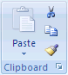

- To move cells, click Cut .
Tip Keyboard shortcutYou can also press CTRL+X.
- To copy cells, click Copy .
- Keyboard shortcut: You can also press CTRL+C.
- Select the upper-left cell of the paste area.
- On the Home tab, in the Clipboard group, click Paste .
- Keyboard shortcut: You can also press CTRL+V.

Notes
- To move or copy a selection to a different worksheet or workbook, click another worksheet tab or switch to another workbook, and then select the upper-left cell of the paste area.
- To choose specific options when you paste cells, you can click the arrow below Paste , and then click the option that you want. For example, you can click Paste Special or Paste As Picture.
- By default, Excel displays the Paste Options button on the worksheet to provide you with special options when you paste cells, such as Keep Source Formatting and Match Destination Formatting.
- Excel replaces existing data in the paste area when you cut and paste cells to move them.
- When you copy cells, cell references are automatically adjusted. When you move cells, however, cell references are not adjusted, and the contents of those cells and of any cells that point to them may be displayed as reference errors. In this case, you will need to adjust the references manually.
- If the selected copy area includes hidden cells, Excel also copies the hidden cells. You may need to temporarily unhide cells that you don't want to include when you copy information.
- If the paste area contains hidden rows or columns, you might need to unhide the paste area to see all of the copied cells.

Move or copy entire cells using the mouse
By default, drag-and-drop editing is turned on so that you can use the mouse to move and copy cells.
- Select the cells or range of cells that you want to move or copy.
Do one of the following:
- To move a cell or range of cells, point to the border of the selection. When the pointer becomes a move pointer , drag the cell or range of cells to another location.
- To copy a cell or range of cells, hold down CTRL while you point to the border of the selection. When the pointer becomes a copy pointer , drag the cell or range of cells to another location.

Use Autofill
This option allows you to enter a series into a worksheet. You can automatically fill in dates, time periods and series of numbers, including numbers combined with text. AutoFill works both horizontally and vertically.

Use the fill handle to fill data
You can use the Fill command to fill data into worksheet cells. You can also have Excel automatically continue a series of numbers, number and text combinations, dates, or time periods, based on a pattern that you establish. However, to quickly fill in several types of data series, you can select cells and drag the fill handle. This is the small black square in the lower-right corner of the selection. When you point to the fill handle, the pointer changes to a black cross. .
After you drag the fill handle, the Auto Fill Options button appears so that you can choose how the selection is filled. For example, you can choose to fill just cell formats by clicking Fill Formatting Only, or you can choose to fill just the contents of a cell by clicking Fill Without Formatting.

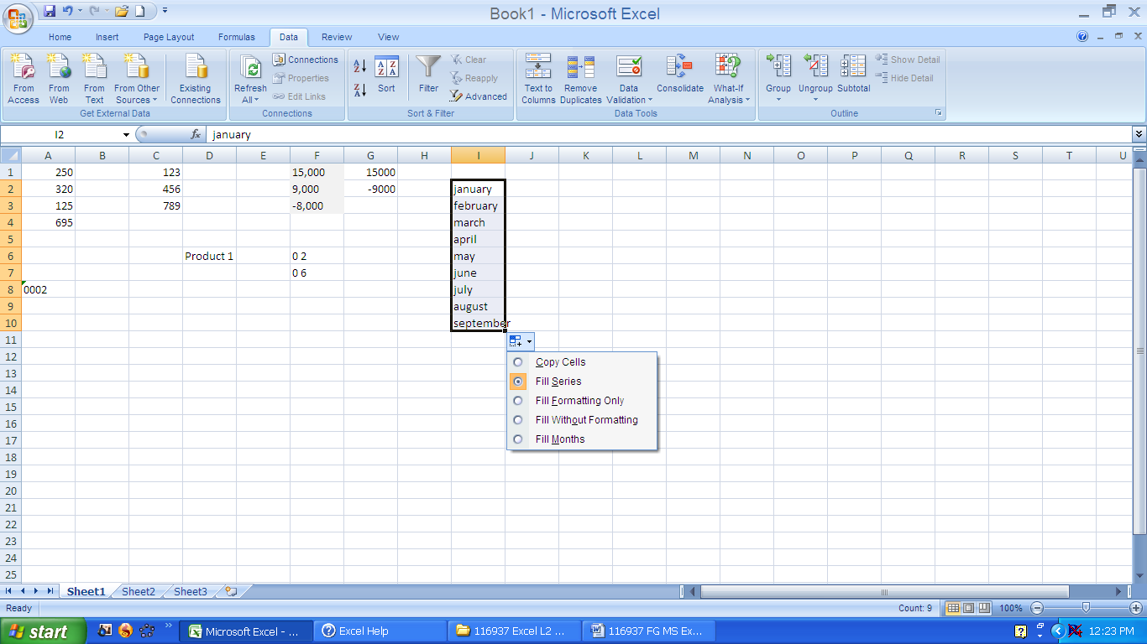

Formative Assessment 14
- Click on sheet two. In cell A1, type January. Place the mouse on the fill handle, (This is the little black handle in the lower right corner of the active cell) click and holding down the mouse button, drag the mouse to cell A12. Notice how Excel automatically enters the months for you.
- In cell B1 type Monday. Place the mouse on the fill handle, click and drag down to cell B7. Excel will enter the days automatically.
- In cell C1 type 1 and in cell C2 type 2. select both cells and drag the fill handle down to cell C10. Autofill will fill the cells.
- In cell D1 type Jan-2009. Right click the fill handle and drag down to cell D12. Select Fill Months and Excel will autofill the months for the year 2009.

Automatically repeat items already entered in the column
If the first few characters that you type in a cell match an existing entry in that column, Excel automatically enters the remaining characters for you. Excel automatically completes only those entries that contain text or a combination of text and numbers. Entries that contain only numbers, dates, or times are not automatically completed.
Do one of the following:
- To accept a proposed entry, press ENTER. The completed entry exactly matches the pattern of uppercase and lowercase letters of the existing entry.
- To replace the automatically entered characters, continue typing.
- To delete the automatically entered characters, press BACKSPACE.
Find And Replace
Use Find and Replace to locate specific text or numbers on a worksheet to review or edit. You can automatically replace data you find. You can also specifically choose to select all cells containing the same type of data, for example, formulas, or those cells whose contents do not match the active cell.
The Find and Replace group is on the Home tab

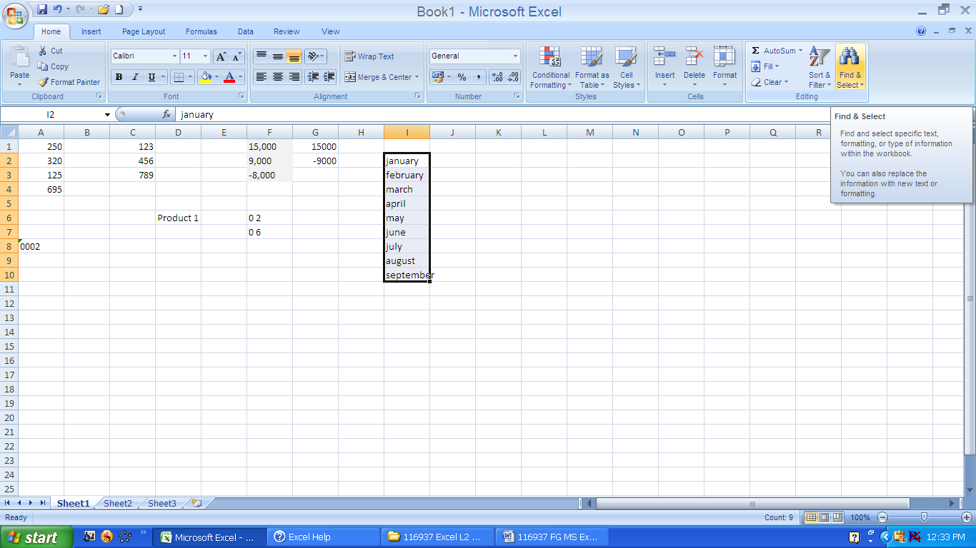

Find
- Find what: Enter the information that you want to search for. You can use a question mark (?) to match any single character or an asterisk (*) to match any string of characters. For example, sm?th finds "smith" and "smyth" and *east finds "Northeast" and "Southeast."
- Format: Allows you to search for text or numbers that also have specific formatting. If you want to find cells that just match a specific format, you can delete any criteria in the Find what box and then select a specific cell format as an example. Click the arrow next to Format, click Choose Format From Cell, and then click the cell that has the formatting that you want to search for.
- Options: Displays advanced search options. This button changes to Options << while these advanced options are displayed. Click Options << to hide the advanced options.
- Within: Select Sheet to restrict your search to the active worksheet. Select Workbook to search all sheets in the active workbook.
- Search: Click the direction that you want to search: down through columns by using By columns or to the right across rows by using By rows. To search up in columns or to the left across rows, hold down SHIFT and click Find Next. In most cases, it is faster to select By columns.
- Look in: Specifies whether you want to search the value of the cells or their underlying formulas. For instance, a cell could appear on the worksheet as “11” but actually contain a formula =”1”&”1”. Look in: Values would find this cell when searching for "11". Look in: Formulas would not. You can also choose to search comments attached to cells. On the Replace tab, Look in: Formulas is the only option.
- Match case: Distinguishes between uppercase and lowercase characters.
- Match entire cell contents: Searches for an exact and complete match of characters that are specified in the Find what box.
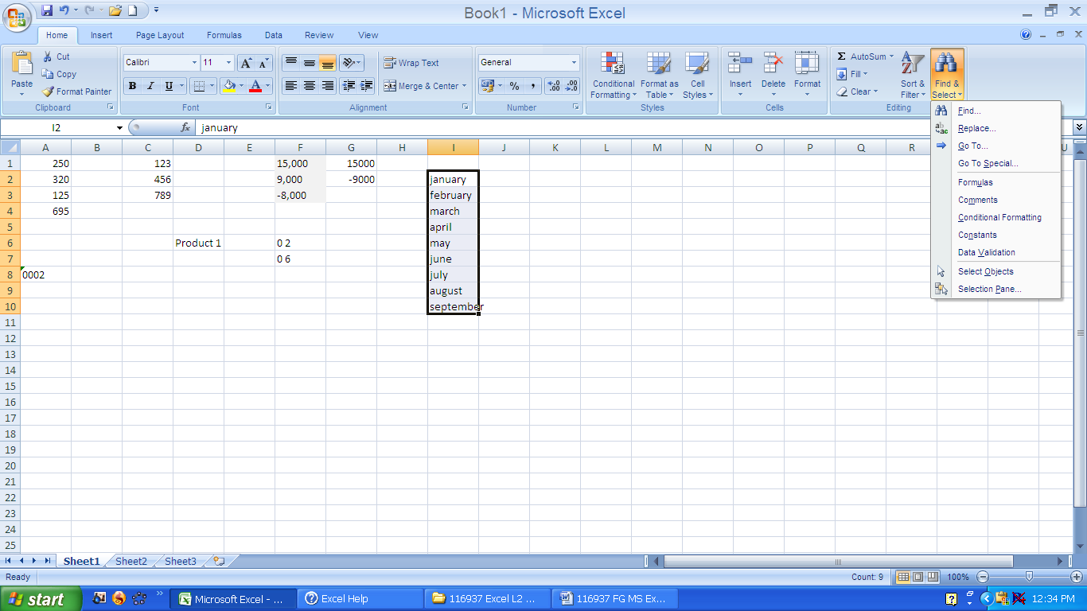
- Find All: Finds all occurrences of the search criteria in your document. If you want to find and review each occurrence separately, click Find Next instead of Find All.
- Find Next: Searches for the next occurrence of the characters specified in the Find what box. To find the previous occurrence, hold down SHIFT and click Find Next.
- Close: Closes the Find and Replace dialogue box when you've completed your search.

Replace
The Replace tab has the same options as the Find tab, with the following additional options that you can use to replace the data that you search for.
- Replace with: Type the replacement characters that you want to use to replace the characters in the Find what box. To delete the characters in the Find what box from your document, leave the Replace with box blank.
- Replace All: Replaces all occurrences of the search criteria in your document. If you want to review and selectively replace each occurrence, click Replace instead of Replace All.
- Replace: Replaces the selected occurrence of the criteria in the Find what box, finds the next occurrence, and then stops. If you want to automatically replace all occurrences of the search criteria in your document, click Replace All.

FORMAT A SPREADSHEET

Specific Outcome
Format a spreadsheet

Assessment Criteria
On completion of this section you will be able to ensure that:
- Cells are formatted using formatting features of the spreadsheet application. Formatting features include the following: Style, Alignment, Font, Background colour. At least one option listed out of each formatting feature must be performed: Style (Text, number, date, currency, percentage), Alignment (left, center, right, justified, text direction), Font (type, size, style - italic, bold, underlined, colour, strike-through, superscript, subscript), Background colour.
- Rows are formatted. Height, automatic fit.
- Columns are formatted. Width, automatic fit.

Format Fonts
Change The Font Or Font Size
Tip All the options to format fonts can be found in the Fonts group on the Home tab

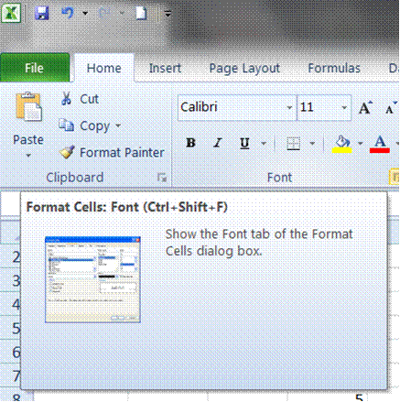

- Select whole cells or the specific text in a single cell that you want to format.
- On the Home tab, click the Dialogue Box Launcher next to Font.
- Select the Font tab

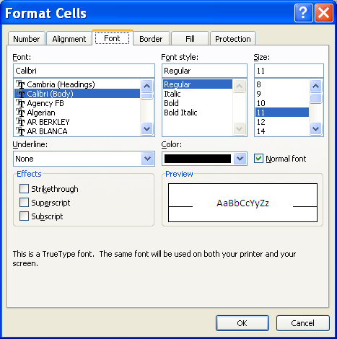

You have the following options:
- Font: Select the font type for the text in selected cells. The default font is Calibri.
- Font style: Select the font style for the text in selected cells. The default font style is Regular
- Size: Select the font size for the text in selected cells. You can type any number between 1 and 1638. The default font size is 11.
- Underline: Select the type of underlining that you want to use for text in selected cells. The default underline is None
- Colour: Select the colour that you want to use for selected cells or text. The default colour is Automatic.
- Normal font: Select the Normal font check box to reset the font, font style, size, and effects to the Normal (default) style.
- Effects: Allows you to select one of the following formatting effects.
- Strikethrough: Select this check box to display the text in selected cells as strikethrough.
- Superscript: Select this check box to display the text selected cells or text as superscript.
- Subscript: Select this check box to display the text in selected cells as subscript.
- Preview: See a sample of text that is displayed with the formatting options that you select.

Changing The Position Of Text And Numbers In A Cell
You can change the position of text and numbers in a cell. You can also choose whether to align right, left or centre. You will use the Format Cells dialogue box to format the contents of selected cells.
- Select whole cells or the specific text in a single cell that you want to format.
- On the Home tab, click the Dialogue Box Launcher next to Font.
- Select the Format Cells tab

Text alignment
- Horizontal: Select an option in the Horizontal list box to change the horizontal alignment of cell contents. By default, Microsoft Office Excel aligns text to the left, numbers to the right, and logical and error values are centered. The default horizontal alignment is General. Changing the alignment of data does not change the data type.
- Vertical: Select an option in the Vertical box to change the vertical alignment of cell contents. By default, Excel aligns text vertically on the bottom of a cell. The default horizontal alignment is General.
- Indent: Indents cell contents from any edge of the cell, depending on your choice under Horizontal and Vertical. Each increment in the Indent box is equivalent to the width of one character.
- Orientation: Select an option under Orientation to change the orientation of text in selected cells. Rotation options may not be available if other alignment options are selected.
- Degrees: Sets the amount of text rotation in the selected cell. Use a positive number in the Degree box to rotate the selected text from lower left to upper right in the cell. Use negative degrees to rotate text from upper left to lower right in the selected cell.

Text control
- Wrap text: Wraps text into multiple lines in a cell. The number of wrapped lines is dependent on the width of the column and the length of the cell contents.
- Shrink to fit: Reduces the apparent size of font characters so that all data in a selected cell fits within the column. The character size is adjusted automatically if you change the column width. The applied font size is not changed.
- Merge cells: Combines two or more selected cells into a single cell. The cell reference for a merged cell is the upper-left cell in the original selected range.

Right-to-left
- Text direction: Select an option in the Text direction box to specify reading order and alignment. The default setting is Context, but you can change it to Left-to-Right or Right-to-Left
Adjust Column Width And Row Height

Set a column to a specific width
- Select the column or columns that you want to change.
- On the Home tab, in the Cells group, click Format.

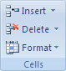

- Under Cell Size, click Column Width.
- In the Column width box, type the value that you want.

Change the column width to fit the contents
- Select the column or columns that you want to change.
- On the Home tab, in the Cells group, click Format.

- Under Cell Size, click AutoFit Column Width.
Tip To quickly autofit all columns on the worksheet, click the Select All button and then double-click any boundary between two column headings.

Match the column width to another column
- Select a cell in the column.
- On the Home tab, in the Clipboard group, click Copy, and then select the target column.

- On the Home tab, in the Clipboard group, click the arrow below Paste, and then click Paste Special.
- Under Paste, select Keep Source Column widths.

Change the width of columns by using the mouse
- Do one of the following:
- To change the width of one column, drag the boundary on the right side of the column heading until the column is the width that you want.
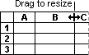
- To change the width of multiple columns, select the columns that you want to change, and then drag a boundary to the right of a selected column heading.
- To change the width of columns to fit the contents, select the column or columns that you want to change, and then double-click the boundary to the right of a selected column heading.
- To change the width of all columns on the worksheet, click the Select All button, and then drag the boundary of any column heading.
Set a row to a specific height
- Select the row or rows that you want to change.
- On the Home tab, in the Cells group, click Format.
- Under Cell Size, click Row Height.
- In the Row height box, type the value that you want.

Change the row height to fit the contents
- Select the row or rows that you want to change.
- On the Home tab, in the Cells group, click Format.

- Under Cell Size, click AutoFit Row Height.
- To quickly autofit all rows on the worksheet, click the Select All button and then double-click the boundary below one of the row headings.

Change the height of rows by using the mouse
Do one of the following:
- To change the row height of one row, drag the boundary below the row heading until the row is the height that you want.
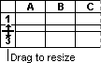
- To change the row height of multiple rows, select the rows that you want to change, and then drag the boundary below one of the selected row headings.
- To change the row height for all rows on the worksheet, click the Select All button, and then drag the boundary below any row heading.
- To change the row height to fit the contents, double-click the boundary below the row heading.
Formative Assessment 15
Practice changing the column widths and row heights using all the above methods for about 5 minutes
Apply Cell Borders
Borders and shading can be used to mark out different areas of the worksheet, making it easier to edit and read data. A variety of different border and shading line styles, colours, and patterns is available.
- On a worksheet, select the cell or range of cells that you want to add a border to, to change the border style on, or to remove a border from.
- On the Home tab, in the Font group, do one of the following:
- To apply a new or different border style, click the arrow next to Borders , and then click a border style.
OR
- To remove cell borders, click the arrow next to Borders , and then click No Border .

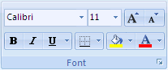

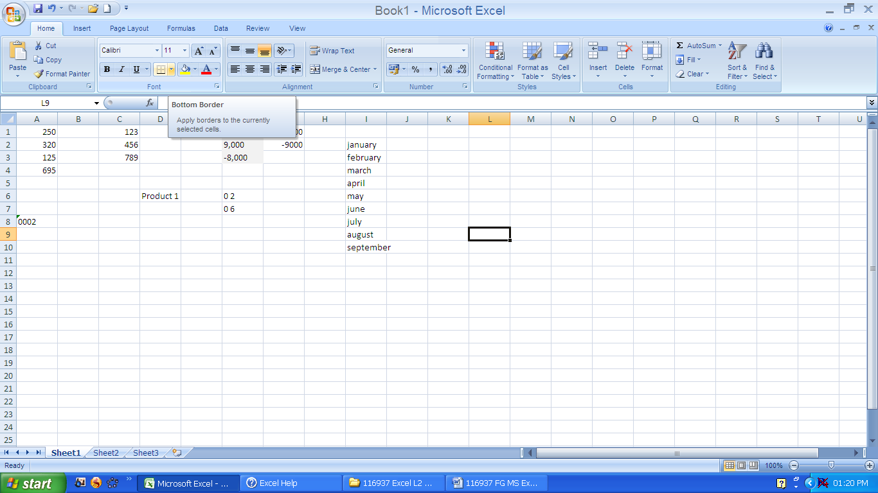

To apply a custom border style or a diagonal border:
- Click More Borders.
- On the Border tab, under Line and Colour, click the line style and colour that you want.
- Under Presets and Border, click one or more buttons to indicate the border placement.
Tip Two diagonal border buttons are available under Border.

Notes
- The Borders button displays the most recently used border style. You can click the Borders button (not the arrow) to apply that style.
- If you apply borders to a selected cell, the border is also applied to adjacent cells that share a bordered cell boundary. For example, if you apply a box border to enclose the range B1:C5, the cells D1:D5 acquire a left border.
- If you apply two different types of borders to a shared cell boundary, the most recently applied border is displayed.
- A selected range of cells is formatted as a single block of cells. If you apply a right border to the range of cells B1:C5, the border is displayed only on the right edge of the cells C1:C5.
If you want to print the same border on cells that are separated by a page break, but the border appears on only one page, you can apply an inside border. This way, you can print a border at the bottom of the last row of one page and use the same border at the top of the first row on the next page. Do the following:
- Select the rows on both sides of the page break.
- Click the arrow next to Borders , and then click More Borders.
- Under Presets, click the Inside button .
- Under Border, in the preview diagram, remove the vertical border by clicking it.

Apply Cell Shading
If you apply shading to a cell, make sure that you also adjust the font colour if necessary. The text and its background should use contrasting colours to ensure legibility.

Fill cells with solid colours
- Select the cells that you want to apply shading to or remove shading from.
- On the Home tab, in the Font group, do one of the following:
- To fill cells with a solid colour, click the arrow next to Fill Colour in the Font group on the Home tab, and then click the colour on the palette that you want.
OR
- To apply the most recently selected colour, click Fill Colour .

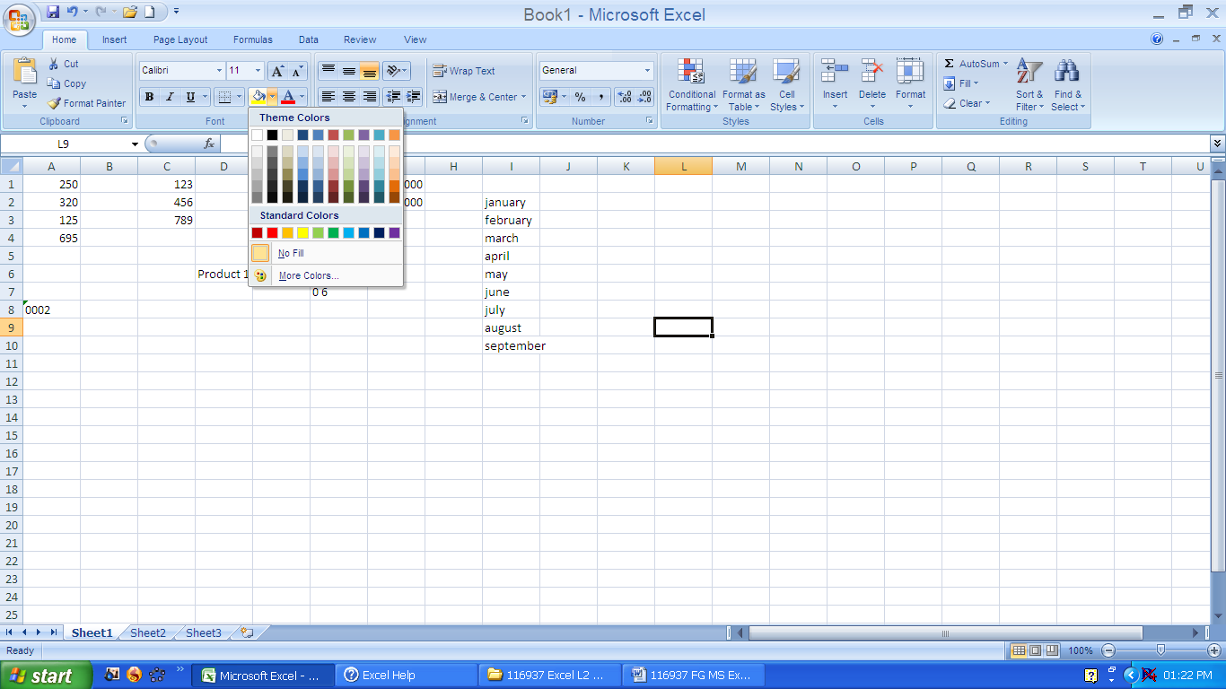

Fill cells with patterns
- Select the cells that you want to fill with a pattern.
- On the Home tab, click the Dialogue Box Launcher next to Font, and then click the Fill tab.

- Under Background Colour, click the background colour that you want to use.
- Do one of the following:
- To use a pattern with two colours, click another colour in the Pattern Colour box, and then click a pattern style in the Pattern Style box.
OR
- To use a pattern with special effects, click Fill Effects, and then click the options that you want on the Gradient tab.

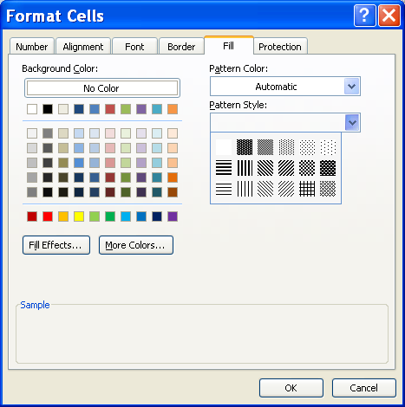

Remove cell shading
- Select the cells that contain a fill colour or fill pattern.
- On the Home tab, in the Font group, click the arrow next to Fill Colour, and then click No Fill.

Apply AutoFormat
Tip AutoFormats are a list of predefined formats to make formatting all or part of a worksheet easier.
Automatic formatting can make entering certain kinds of text faster and easier. To see and modify automatic formatting options, do the following:
Do one of the following:
- Go to the File tab, and click Options
- select Proofing and then AutoCorrect Options
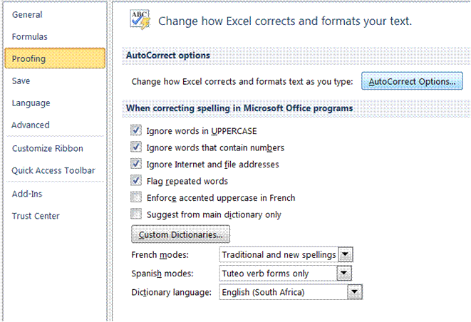

- Click the AutoFormat As You Type tab.
- Select or clear the check boxes for the options that you want to enable or disable.

Formative Assessment 16
Open the workbook Bathini Expense Form
- If necessary, adjust the Zoom control so that you can see all the data
- Select column A and column N
- From the Format menu, select Column then Width and set it to 1
- Resize rows 1, 8, and 26 to 10
- Change the height of row 7 to 27 and change the vertical alignment to Top
- Draw a dark blue border around B8:N26
- Draw a thin dashed line border on the bottom of cells D10:M10
- Select D22:D25 and change the colour to pale orange and 25% Gray pattern with Pale Yellow colouring
- Click OK
- Click in cell M24 then change the colour and pattern as follows: Select the Indigo colour chip. Click the arrow on the Pattern box and select the 50% Gray pattern with Pale Blue colouring
- Select the Black colour chip and a thick line weight then click the Outline button
- Click OK
- Change the Font Colour of M24 to White and apply Bold
- Save and close the workbook

Open your Practice workbook and go to your budget
- Improve the presentation - add borders, shading, change number format, font styles and so on
- Save and the Practice workbook
Below is an example of how the worksheet could be formatted.

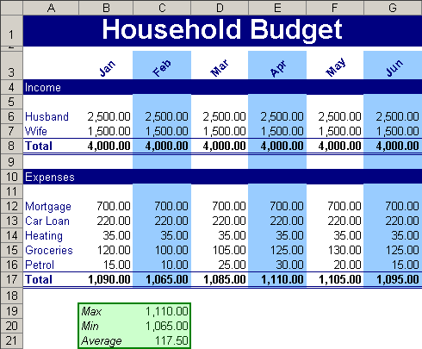

Deleting A Cell And A Range
You can clear a cell or you can delete a cell:
- When you clear a cell, the contents and formatting is cleared from that cell.
- Deleting a cell removes the cell and closes up the space occupied by the cell.

Delete cells, rows, or columns
- Select the cells, rows, or columns that you want to delete.
- On the Home tab, in the Cells group, do one of the following:

- To delete selected cells, click the arrow next to Delete, and then click Delete Cells.
- To delete selected rows, click the arrow next to Delete, and then click Delete Sheet Rows.
- To delete selected columns, click the arrow next to Delete, and then click Delete Sheet Columns.
- If you are deleting a cell or a range of cells, in the Delete dialogue box, click Shift cells left, Shift cells up, Entire row, or Entire column.
- If you are deleting rows or columns, other rows or columns automatically shift up or to the left.

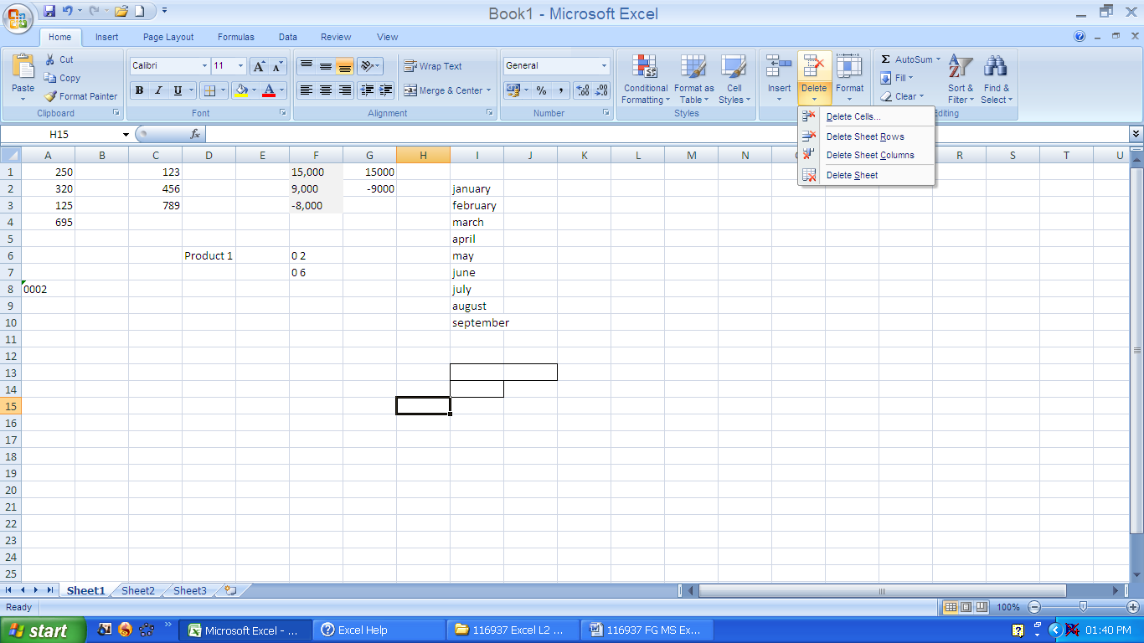

Notes
- You can also right-click a selection of cells, rows, or columns, click Delete on the shortcut menu, and then click the option that you want.
- To quickly repeat deleting cells, rows, or columns, select the next cells, rows, or columns, and then press CTRL+Y.
- If needed, you can restore deleted data immediately after you delete it. On the Quick Access toolbar menu, click Undo Delete, or press CTRL+Z.
- Pressing DELETE deletes the contents of the selected cells only, not the cells themselves.
- Microsoft Office Excel keeps formulas up to date by adjusting references to the shifted cells to reflect their new locations. However, a formula that refers to a deleted cell displays the #REF! error value.
Undo And Redo
Excel offers you the option to undo or redo your last actions.

Undo the last action or actions that you made
To undo an action, do one or more of the following:
- Click Undo on the Quick Access toolbar.
- Keyboard shortcut: You can also press CTRL+Z.
- To undo several actions at once, click the arrow next to Undo , select the actions in the list that you want to undo, and then click the list.
Excel reverses all of the selected actions.
To cancel an entry in a cell or the formula bar before you press ENTER, press ESC.
Note: Some actions can't be undonesuch as saving a workbook. If you can't undo an action, the Undo command changes to Can't Undo.

Redo actions that you undid
- To redo an action that you undid, click Redo on the Quick Access toolbar.
- Keyboard shortcut:You can also press CTRL+Y.
- When you redo all of the actions that were undone, the Redo command changes to Repeat .

Repeat the last action
- To repeat the last action, click Repeat on the Quick Access toolbar.
- Keyboard shortcut: You can also press CTRL+Y.
- Some actions, such as using a function in a cell, cannot be repeated. If you can't repeat the last action, the Repeat command changes to Can't Repeat.
Formative Assessment 17
- Select column A and then select the Format, Cells menu. Click the alignment tab. Select the Centre option and click OK. See how your cell contents are arranged in the centre of the cells. Now select the Right option and click OK. The contents of the cells will be aligned to the right. While your column is still selected, click the Left option and OK. The contents of the cell will be aligned to the left.
- Select Column A and click the left align button on the formatting toolbar. See how the text automatically aligns to the left. Now click the centre button and the right align button to see the text centre and then align to the right.
- In cell A7 type My Journal. Select cells A7 to D7 and click on the Merge and Centre button of the formatting toolbar. See how the text is centred in the row.
- In cell A9 type My Year 2000 Journal. Select cells A9 to E9 and click on format, cells. Click on the alignment tab and then select Centre across selection. The text will be centred in the row.
- Select cells A3 to D3, choose the Edit menu and select the delete command in the dialogue box. Choose the shift cells up option and click OK. Watch how the cells shift up. Now select cells A1 to D1 and press the delete key on the keyboard.
- Your last two actions were to delete the entire row 1 and to delete row 3. Click the Undo command on the toolbar and watch Excel undo the very last action. Click on the arrow box next to the Undo button to see a list of your last actions that can still be undone. Click on clear and Excel will undo the clear action.
- Click on the Redo button once and row 1 will be cleared again. Click on the arrow next to the Redo button to see a list of actions you can redo. Click on the first one, delete and Excel will delete row 3 again.
- Undo the last two actions again.
- Click in cell A3 and type 1250. Notice how the old numbers are replaced by the new numbers.
- In cell A1 type 158, then press the backspace key once and type a 9. The figure now reads 159.
- Double click cell B1 now. Use the arrows to move back in the cell and then delete the s of Mrs, so that the name now reads Mr B. Otto.

SPELLING AND GRAMMAR

Specific Outcome
Check spelling and grammar in a spreadsheet

Assessment Criteria
On completion of this section you will be able to ensure that:
- The dictionary to be used for spelling and word usage is set up.
- Text is entered and corrected automatically while entering.
- Text is checked for spelling and grammar and corrections made based on judgement. Cell, range of cells.
- Words are added to the custom dictionary
Check spelling
Click inside a worksheet that you are editing to check the entire active worksheet, including cell values, cell comments, embedded charts, text boxes, buttons, headers, and footers.

Notes
- Excel does not check protected worksheets, formulas, or text that results from a formula.
- Also, if the formula bar is active when you check spelling, Excel checks only the contents of the formula bar.
- Optionally, to check only a specific piece of text, select the text you want to check.

Do one of the following:
- Press F7.
- Use the mouse: On the Review tab, in the Proofing group, click Spelling (in Word, click Spelling & Grammar).

The program finds spelling mistakes, a dialogueue box or task pane is displayed, and the first misspelled word found by the spelling checker is selected. You decide how you want to resolve each error that the program finds. The following are instructions about different ways to resolve a misspelled word:
- I want to fix the error by using one of the suggested words: Select the word from the Suggestions list, and then click Change.

- I want to fix the error by changing the word myself
- Click the Not in Dictionary box.
- Edit the word.
- Click Change.

- The misspelled word is actually a real word that I use. I want all the Microsoft Office programs to recognize this word and not treat it as a misspelling: Click Add or Add to Dictionary.

- I want to ignore the misspelled word and move on to the next word: Click Ignore Once.

- I want to ignore all instances of the misspelled word and move on to the next word: Click Ignore All.

- I tend to make this mistake a lot, so I want the program to automatically fix this mistake for me whenever I type it: Select the correct word from Suggestions, and then click AutoCorrect.
Formative Assessment 18
- Open the workbook List Of Products and run a spell check
- Find and replace all uses of "Beverage" with "Drinks"
- Find and replace all uses of "pieces" to "pcs"
- Add a line total column with a formula to calculate it
- Save and close the workbook
Use custom dictionaries
When you use the spelling checker, it compares the words in your document with those in the tool's main dictionary. The main dictionary contains most common words, but it might not include proper names, technical terms, or acronyms. In addition, some words might be capitalized differently in the main dictionary than in your document. Adding such words or capitalization to a custom dictionary prevents the spelling checker from flagging them as mistakes.
Note: Any custom dictionary setting you change in one Microsoft Office program affects all the other programs.

Enable custom dictionaries
You can use the Custom Dictionaries dialogue box to manage your custom dictionaries. However, none of the settings in this dialogue box take effect unless you enable custom dictionaries.
Do the following:
Note: A file must be open before you can click Spelling Options.

Open the Custom Dictionaries dialogue box
Do the following:
- Go to the File tab, click Options and select Proofing
- Click Custom Dictionaries.

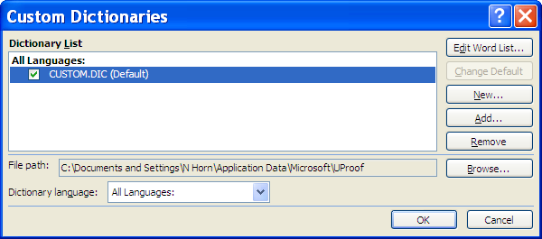

Create a custom dictionary
- Open the Custom Dictionaries dialogue box.
- Click New.
- In the File name box, type a name for the custom dictionary.
- Click Save.
Tip If you want the new dictionary to be used for another language, while the new dictionary is still selected on the Dictionary List, select the language on the Dictionary language menu.

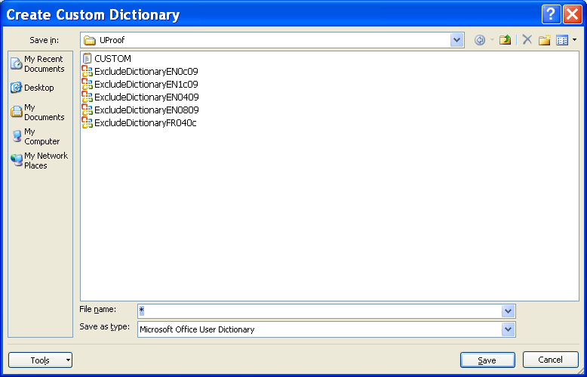

Add, delete, or edit words in a custom dictionary
- Open the Custom Dictionaries dialogue box.
- Select the dictionary you want to edit. Make sure you do not clear the check box.
- Click Edit Word List.
- Do one of the following: To add a word, type it in the Word(s) box, and then click Add.
- To delete a word, select it in the Dictionary box, and then click Delete.
- To edit a word, delete it, and then add it with the spelling you want.
- To remove all words, click Delete all.
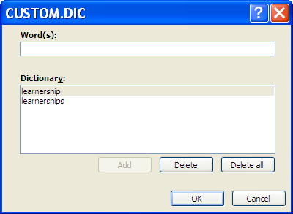
Use Autocorrect
AutoCorrect is a feature that edits text automatically as you type. For example, you may repeatedly misspell a commonly used word. AutoCorrect will correct it as you type. You can customise AutoCorrect to recognise and correct specific words you regularly mistype. Additionally, you can enter a short form (abbreviations) and press the for the long form to appear (for example, names, descriptions, and technical references).

Understand the AutoCorrect list
You can use the AutoCorrect feature to do the following:
- Automatically detect and correct typing errors and misspelled words. For example, if you type teh plus a space, AutoCorrect replaces what you typed with the. Or if you type This is theh ouse plus a space, AutoCorrect replaces what you typed with This is the house.
- Quickly insert symbols. For example, type (c) to insert ©. If the list of built-in AutoCorrect entries doesn't contain the symbols that you want, you can add entries.
- Quickly insert any long piece of text. For example, if you need to repeatedly enter a phrase such as return on investment, you can set up the program to automatically enter this phrase when you type roi.
All of these uses of the AutoCorrect feature are supported by two parallel lists of words. The first word is the word that you type, and the second word or phrase is what the program enters to replace that word.

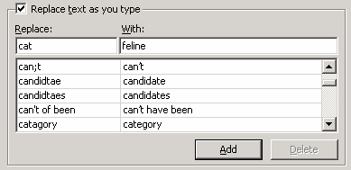
The AutoCorrect list is global across the Office programs that support this feature, which means that when you add or delete a word from the list in one Microsoft Office program, the other Office programs are also affected.

Add a text entry to the AutoCorrect list
- Go to the File tab, click Options and select Proofing
- Click AutoCorrect Options.
- On the AutoCorrect tab, make sure the Replace text as you type check box is selected.
- In the Replace box, type a word or phrase that you often mistype or misspell— for example, type usualy.
- In the With box, type the correct spelling of the word— for example, type usually.
- Click Add.
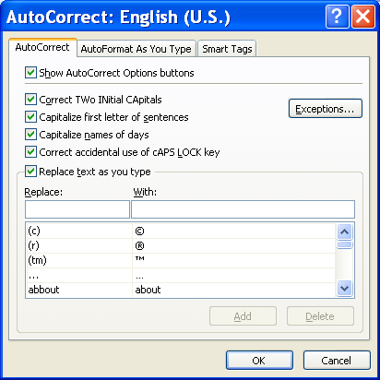

Change the contents of a text entry in the AutoCorrect list
- Go to the File tab, click Options and select Proofing
- Click AutoCorrect Options.
- On the AutoCorrect tab, make sure the Replace text as you type check box is selected.
- Click the entry in the list under the With box.
- Type the new entry in the With box.
- Click Replace.

PRINTING

Outcome
Print a spreadsheet using features specific to spreadsheets

Assessment Criteria
On completion of this section you will be able to ensure that:
- The printing of gridlines is altered. Printing of gridlines on or off.
- A row is selected to print on each page of the printed spreadsheet.
- Different ways of printing sheets within a spreadsheet are demonstrated, according to given specifications. Different ways include but are not limited to: Entire workbook, active sheets.
Print Your Worksheet
Whenever you want to print a worksheet, always first go to print preview to see what your worksheet will look like when it is printed.

Preview your worksheet
- Go to the File tab and click Print
- The Preview is shown on the right

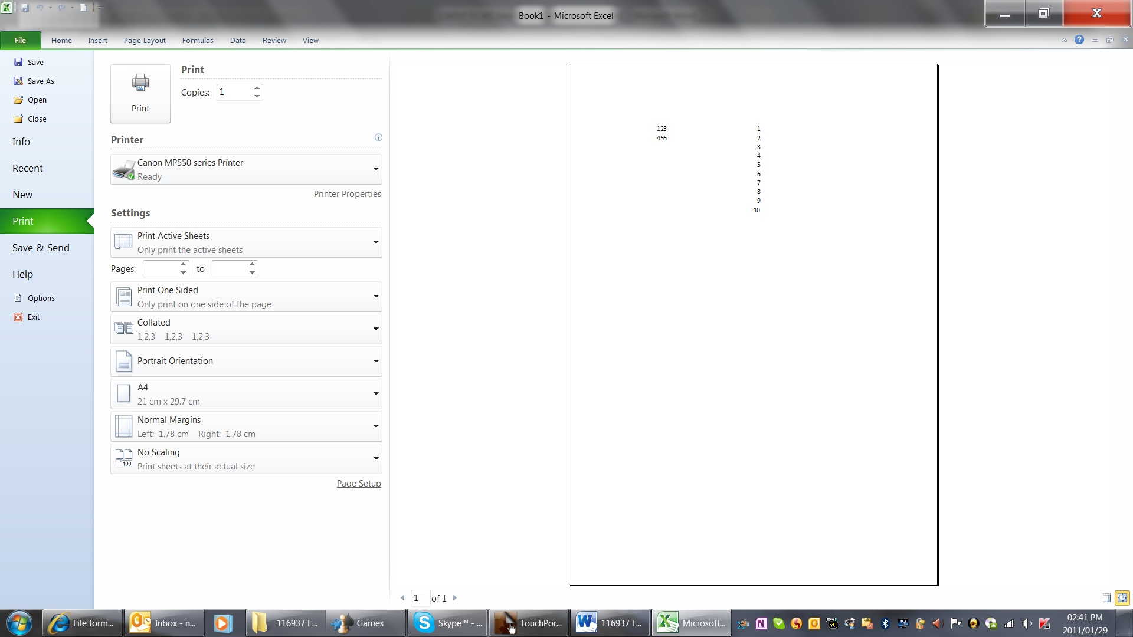

Printing options
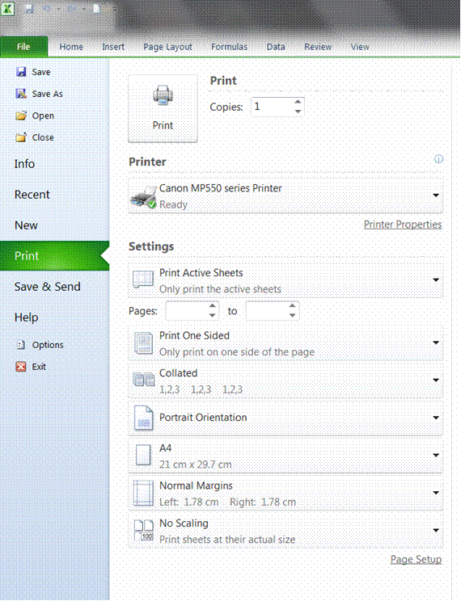

- Go to the File tab and click Print
- Your printing options will be displayed

Print selection
Select the text that you want to print
- Go to the File tab and click Print
- Click the arrow next to print active sheets
- Select Print Selection

Print active sheets
- Select this option to print only the active sheets
OR
- Select the pages you want to print

Print one sided
- This option will print only one side of the page.
- To print both sides, select print on both sides

Collated
Will collate the pages when you print more than one copy of the document

Orientation
Use this option to change the orientation of your workbook to portrait or landscape

A4
This option allows to select the size of the page

Margins
Select the size of the margins for your printed workbook

Page setup

Print gridlines
- Click Page Setup and select the Sheet tab
- Click the Print Gridlines box
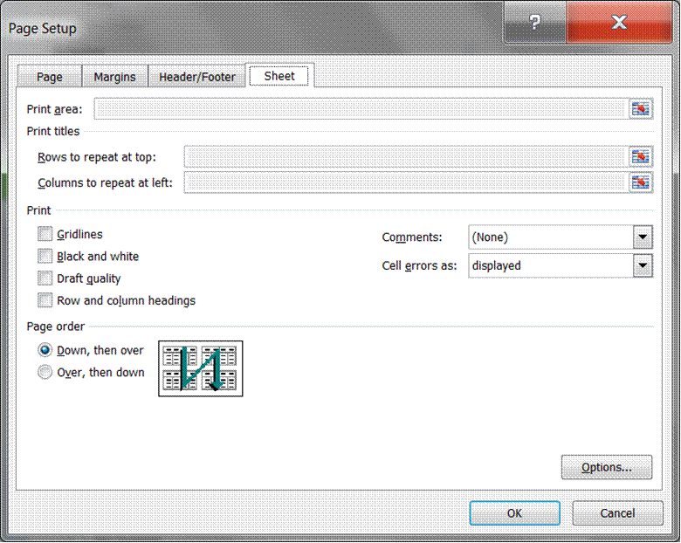

Print Row Labels On All The Sheets
- Click Page Setup, and then click the Sheet tab.
- Click Columns to repeat at left, and then enter the entire columns that contain the row labels.

To Print Column Headings On All The Sheets
- Click Page Setup, and then click the Sheet tab.
- Click Rows to repeat at top, and then enter the rows that contain the column labels. Restore a split window to a single pane

Add headers or footers to your workbook
- Click Page Setup, and then click the Header/Footer tab.
- Enter the details for the header or footer as required
Formative Assessment 19
Print your Practice workbook

Glossary
Term | Definition
Absolute Reference | Cells in a formula refer to specific cells on a worksheet. If the formula is moved or copied the cell references remain the same. Absolute and relative references can be mixed, for example to refer to a column absolutely but a row relatively.
Add-in | A mini application designed to add extra functionality to Office software.
Address | The location of a cell on the worksheet.
Argument | Information that is supplied to a function for calculation. Arguments can be values, names, references, formulae or another function.
AutoFill | A feature of Excel that allows you to automatically enter a series of values or text.
AutoShapes | A series of predefined shapes available from the Drawing toolbar.
AutoSum | In Excel, a toolbar shortcut to using the SUM function to add up a series of cells.
Axis | The part of a graph showing the range of data values to plot. Most charts have a category (X) axis showing the type of values and a value axis (Y) showing the range of values.
Boolean | A true or false value.
Chart | A graphical representation of data.
Chart Area | The whole area of the chart.
Circular Reference | A formula that refers to its own cell, either directly or indirectly.
Clip Art | A library of graphics for use in Office programs.
Consolidate | Sum (or perform other arithmetic) values from multiple ranges.
Criteria | A value or expression to match as the basis for selecting records.
Criteria Range | A cell range that contains the search criteria for advanced filters.
Custom List | A user created list that can be used in conjunction with the AutoFill feature.
Data Source | A connection to a database setup in Windows Control Panel. The connection defines the type and location of the database and optionally specific logon information.
Data Type | Cell values can be text, number/date values or formulae. The data type affects the way some formulae operate on the cell.
Data Validation | Checking that data entered by the user meets the criteria set for the field.
Database | A set of one or more fields (columns) defining the data held in one or more records (rows).
Embed | Storing a data object created and edited using a different application to the file the object is stored in.
External Reference | When a formula, reference to a cell, range or named area refers to a different worksheet.
Field | A column in a database.
Find and Replace | A tool for locating text or values in fields that match search criteria. The found values can be replaced with alternative text.
Form | An interface for entering, editing and viewing data. Most forms display one record at a time, to make data entry easier.
Function | A built-in formula that uses a series of values to perform a calculation and returns the result of that operation.
General Format | The default cell value format in the worksheet.
Header/Footer | An area reserved for text and graphics that appear at the top/bottom of every page.
Import | Transferring or copying data stored in one file to another. Data can be imported using the cut, copy and paste, drag-and-drop or Insert/Import commands.
Landscape | Page orientation where the page is wider than it is tall.
Legend | Part of a graph identifying different data series. A legend may identify series using different colours or by using different marker shapes or line.
Link | Storing a link to a file (or part of a file) within another file.
LOOKUP | Reference functions that return a value from one location in a table based on a value in a different part of the table.
Macro | A sequence of commands recorded in a module or macro sheet to automate a process.
Margins | The white areas between the paper edges and the text boundaries on the page.
Name | A unique identifier that is created to refer to one or more cells, an array of values, a formula or object.
Name Box | A list box that displays the current cell reference and allows you to select named ranges in the worksheet.
Object | A unit of data that can be copied between different files and applications. Examples of objects include pictures, charts and tables.
ODBC | Open DataBase Connectivity. A standard for connecting to data sources from different systems. If the correct ODBC driver is installed, a data source can be setup through Windows Control Panel.
Office Clipboard | An extension to the Windows Clipboard allowing multiple items to be collected and pasted in Office applications.
OLE | Object Linking and Embedding. OLE allows different applications to share data. You can insert an OLE object or file in any other file created in an OLE-compliant application. The object can be edited from the destination file using the original application.  An embedded object is saved as part of the destination file. A linked object is saved in the original file and can be edited from either file.
Orientation | The direction of an object, usually used to refer to the dimensions of a page (portrait or landscape) but also of the direction of text.
Paper Size | The type of paper on which a document is printed. UK standard paper size is A4 (8.27x11.69" or 21x29.7 cm). US standard paper size is Letter (8.5x11" or 21.59x27.94 cm).
Pivot Table | An interactive worksheet table that enables you to summarise and analyse data.
Plot Area | The part of a graph where data is plotted. This can include the data series, axes and data labels.
Points | Units of measurement relating to the height of text characters.
Portrait | Page orientation where the page is taller than it is wide.
Preview | To view a document as it will print.
Query | A way of selecting data from a database. A query specifies the location of the database, which fields to select and any criteria to limit the number of records returned. A query can be used to import data into a worksheet.
Range | Two or more cells on a worksheet.
Record | Data entered into a single row in a database. The fields (columns) determine what data makes up a record.
Reference | The location of a cell or range of cells on a worksheet.
Relative Reference | Cell references in a formula refer to cells in a position relative to the cell containing the formula. The references are updated to maintain the same relative position if the formula is moved or copied.
Report | A method of formatting and displaying data for printing or summary.
Round Trip | Switching data from its native Office file format to HTML and back again. You can work on HTML files with much the same functionality as native format files.
Sans-serif | Fonts where the text has plain ends.
Series | Values plotted on a chart. If there are multiple data series, each series is identified by a different colour and/or line/marker style.
Serif | Fonts where the text has curly feet.
Smart Tag | A feature for modifying data.
Spelling Checker | A tool to check spelling in the document. The Office products use the same spelling tool, though some features are not available in all applications. The checker uses a custom dictionary to keep track of words that are correct but that it does not recognise.
Symbol | Non-alphanumeric characters. Symbols cannot be inserted using normal keystrokes.
Task Pane | Part of the application window giving access to commonly-used commands.
Template | A file that contains specific formatting, design and colour that is applied to a spreadsheet. Templates give a spreadsheet a consistent appearance.
Trendline | An extra line plotted on a chart by extrapolating actual values to show and/or predict changes in data more clearly.
True Type | Fonts designed to match printed output with the screen display.
Web | A collection of linked web page documents published on the internet.
Workbook | An Excel file that contains at least one worksheet.
Worksheet | A document that you work on in Excel to store and manipulate data.
Workspace | A file containing a snapshot of workbooks and views in use.
Xlstart | A folder containing workbooks to open when Excel starts.

Enter the same data on other worksheets
If you already entered data on one worksheet, you can quickly fill this data into corresponding cells on other worksheets.
- Click the tab of the worksheet that contains the data. Then hold down CTRL while you click the tabs of the worksheets into which you want to fill the data.
- If you don't see the tab that you want, click the tab scrolling buttons to display the tab, and then click the tab.

- In the worksheet, select the cells that contain the data that you entered.
- On the Home tab, in the Editing group, click Fill, and then click Across Worksheets.

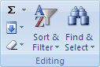

- Under Fill, select the option that you want.

Note: Data that you type appears in all selected worksheets, and may inadvertently replace existing data. To avoid replacing existing data, view worksheets at the same time.

View worksheets at the same time

- On the View tab, in the Window group, click New Window.

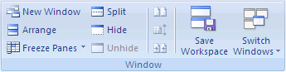

- Switch to the new window, and then click the sheet tab of the worksheet that you want to view.
- Repeat steps 1 and 2 for each worksheet that you want to view.
- On the View tab, in the Window group, click Arrange All.
- To cancel a selection of multiple worksheets, click any unselected worksheet. If an unselected worksheet is not visible, right-click the sheet tab of a selected worksheet, and then click Ungroup Sheets.

Change the column width
- Click the cell for which you want to change the column width.
- On the Home tab, in the Cells group, click Format.

Under Cell Size, do one of the following:
- To fit all text in the cell, click AutoFit Column Width.
- To specify a larger column width, click Column Width, and then type the width that you want in the Column width box.
- You can display multiple lines of text inside a cell by wrapping the text.

