VACUUM DRY SURFACES

US No: 243201 Level 1: Credits 4

REMOVE SPOTS AND SPILLAGES FROM CARPETS AND UPHOLSTERY

US No: 243197 Level 1: Credits 5

Learner’s name
Facilitator’s name
Starting date

LEARNER MANUAL

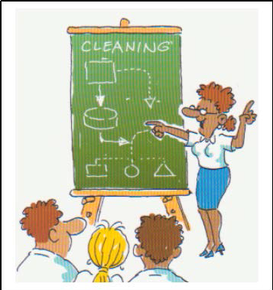

Hi there!

Welcome to a learning experience that will give you all you need to know about vacuuming dry surfaces and removing spots and spillages from carpets and upholstery

Most of the activities are practical. Your facilitator will demonstrate and explain how to do certain things and then you will practice them. We hope you will enjoy this!

We have included some new words to learn so that you can improve your vocabulary. If you are not sure about the meaning of a word or how to say it, ask your facilitator.

We hope that when you have learnt these skills you will share them with others and take them from the workplace into your life

Have fun!

INDEX

Section | Contents | Page number
1 Skills clusters and learning pathway 4
2 Introduction to your workbook 5
3 Unit standard learning outcomes 5
4 Critical Cross-field outcomes 6
5 What I must know 7
6 What I must be able to do 8
7 Learning signs 9
Plan and prepare for vacuuming & removing spots 10
Vacuum dry surfaces 14
Remove spots and spillages from carpets and 19
upholstery
Perform end of task procedures after vacuuming and 23
removing spots

Skills clusters and learning pathways

Introduction to Cleaning

Use chemicals to clean

Ablution cleaning
Module 1.
Plan and prepare to vacuum dry surfaces

Above the floor & window cleaning
Qualification
Hygiene & Cleaning Level 1
Module 2 Vacuum Dry Surfaces

Textile surface cleaning
Module 3 Perform end of task
duties

Hard and resilient floor cleaning

Kitchen cleaning

Customer service and teamwork

Environmental awareness

J You are here!

Life skills – Health

Life skills – Literacy

Life skills – Numeracy

Life skills - Finance

- You need to have completed the Introduction to cleaning before doing any of the others.
- Other skills clusters may be done in any order

Introduction to your workbook
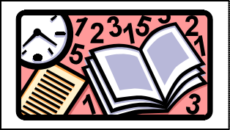

This book belongs to you!

It is for you to work with and write in so that you can use the information at a later stage.

This workbook contains a lot of detail and ideas to help you learn. Your facilitator will be available to guide you during the learning process.
You will be expected to complete the activities in the workbook to show your understanding. You will learn more by:
  - Asking questions
  - Participating in group discussions
  - Reading additional material
  - Completing the assignments
  - Doing homework activities Remember - this book is to help you succeed!

Unit Standard Learning Outcomes

Purpose

To impart understanding, skills, knowledge and values of on the vacuuming of dry surfaces to an employee in the cleaning services industry.

Learners credited with this unit standard are able to:

- Plan and prepare to vacuum dry surfaces
- Vacuum dry surfaces
- Perform end of task procedures for vacuuming dry surfaces

Learning assumed to be in place

It is assumed that learners are competent in:
- Communication at ABET Level 3
- The Unit standards:
  - Understand basic cleaning principles (Level 1)

CRITICAL CROSS-FIELD OUTCOMES

This list contains all Critical Cross-field Outcomes identified by the South African Qualifications Authority.

The complete list of Critical Cross-field Outcomes is:

- Identify and solve problems in which response displays that responsible decisions, using critical and creative thinking, have been made.

- Collect evaluate organize and critically evaluate information.

- Work effectively with others as a member of a team, group, organization or community.

- Organize and manage oneself and one’s activities responsibly and effectively.

- Communicate effectively by using mathematical and/or language skills in the modes of oral and/or written presentation

- Use science and technology effectively and critically, showing responsibility towards the environment and health of others.

- Demonstrate an understanding of the world as a set of related systems by recognizing that problem solving contexts do not exist in isolation.

- Contribute to the full personal development of each learner and the social and economic development of the society at large by:

  - Participating as a responsible citizen in the life of local, national and global communities. Being culturally and aesthetically sensitive across a range of social contexts.

  - Being culturally and aesthetically sensitive across a range of social contexts

your work 4 1 1
WHAT I MUST KNOW | SO | AC | CCFO
The learner needs to explain the reasons why PPE is used. 1 1 6
Surfaces to be vacuumed are identified. 1 3 1
The learner must give a reason why a certain vacuum cleaner
is chosen for dry vacuuming. 1 4 1
The reason for choosing the correct accessories is explained. 1 5 1
The learner must explain the safety procedures for using a
vacuum cleaner. 1 6 6
The learner must explain the effect that a poor vacuum
cleaner filtration has on indoor air quality. 1 7 6
The learner gives the reason why litter is removed, giving 3
examples of the types of litter. 1 8 6
The reasons why liquids should not be vacuumed using a dry
vacuum cleaner is explained. 1 9 6
The learner explains the reason why a specific plug point is
chosen. 2 1 6
The learner explains the reason why the filters are removed
and cleaned. 2 3 1
The learner must identify blockages. 2 4 1
The learner must explain why the surfaces that have been
vacuumed are quality checked. 3 1 4
WHAT I MUST KNOW SO AC CCFO
The learner needs to explain the reasons why PPE are used 1 2 6
The learner must identify spots and spillages to be removed
from carpets and upholstery 1 3 1
The learner must choose the correct method for removing
spots 1 4 1
The learner must explain the reasons for choosing the
equipment, consumables and chemicals to remove spots and 1 5 4
spillages
The learner must explain the reason why spots and spillage
must be removed as soon as possible. 2 2 1
The learner must explain the reason for removing chemical
residue from carpets and upholstery 2 3 1
The learner must explain the reason for re-setting the pile or
nap on certain upholstery fabrics 2 4 4
The learner must explain the difference the difference
between spots and spillages 3 1 4
The learner must identify stains 3 2 1
The reasons for reporting the stains to the supervisor is given 3 3 1
The learner must explain the consequences of repeated
unsuccessful efforts to remove stains 2 4 1
The learner must explain the reasons for checking

SO - Specific Outcome
AC - Assessment Criterion
CCFO - Critical Cross-field Outcomes

WHAT I MUST BE ABLE TO DO | SO | AC | CCFO
PPE is used. 1 1 6
The learner chooses a suitable vacuum cleaner for
dry vacuuming. 1 4 4
The correct accessories are chosen for the surface to
be cleaned. 1 5 4
The learner must remove the litter before vacuuming. 1 8 6
The learner chooses the correct plug points. 2 1 4
The learner vacuums the carpet. 2 2 4
The learner must remove and clean the filter bags. 2 5 4
The learner must clear blockages in the vacuum
cleaner. 2 4 1
The learner must check the surfaces that have been
vacuumed. 3 1 4
The learner must dispose of all waste in the
designated areas. 3 2 6
The learner must remove, clean and store all
equipment and consumables 3 3 4
Problems that arose are reported. 3 4 1
Remove, clean and store all equipment consumables
and chemicals. 4 3 4
Report Problems to supervisor/manager. 4 4 1
WHAT I MUST BE ABLE TO DO SO AC CCFO
PPE is used 1 1 6
The learner chooses the correct equipment,
consumables and chemicals 1 5 4
The learner must check the carpet and upholstery for
colour-fastness 1 6 1
The learner must remove the spots and spillage 2 1 4
The learner report stains 3 2 1
The quality of the of the spot removal is checked 4 1 4
The learner must remove all waste generated when
removing spots and spillages 4 2 6
The learner must remove, clean and store all
equipment used to remove spots and spillages from 4 3 4
carpets and upholstery

SO - Specific Outcome
AC - Assessment Criterion
CCFO - Critical Cross-field Outcomes

6. Learning signs

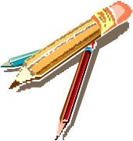

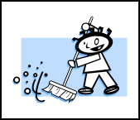

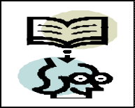

DICTIONARY

Explanation of Words and Terms
WORKPLACE ACTIVITY
CLASS ACTIVITY
FILE IN PORTFOLIO

Add to portfolio of Evidence (Formative and Summative Assessment)
HOMEWORK

Work to be done at Home
MY NOTES

Written reminders
IMPORTANT INFORMATION
LET US REFRESH OUR MINDS

Revision of work done.

PLAN AND PREPARE TO VACUUM DRY SURFACES AND REMOVE SPOTS AND SPILLAGES FROM CARPETS AND UPHOLSTERY

PREPARE TO VACUUM DRY SURFACES

- Carpets, blinds, hard floors etc are exposed to dust and dirt caused by traffic (large numbers of people and machinery) through an area.
- A carpet can hide up to three times its own weight in dirt before you can see it.
- This is why it is important to vacuum carpets and high traffic areas regularly.

PREPARE TO REMOVE SPOTS AND SPILLAGES:

Background information

The types of surfaces that would need removal of spots and spillage would include:
- Carpets
- Soft floor coverings made of synthetic fibers.
- Upholstery could be fabric, padded fabric which covers a frame, inside cars boats and planes.

Sand and grit carried on people’s shoes are wiped off and trapped on to carpets.
Liquids such as coffee and tea, wine, spills on carpets and upholstery, soak into the material and may not easily be removed.

This is why we need to be able to remove spots and spillages

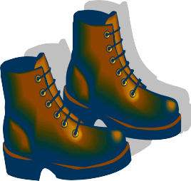

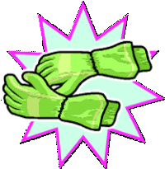

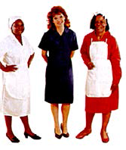

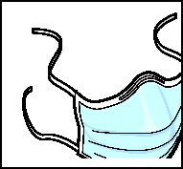

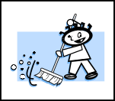

Before you start vacuuming, you must do the following:

You must plan your actions according to your worksite procedures and the vacuuming schedule.

STEP 1: CHOOSE PERSONAL PROTECTIVE EQUIPMENT OR PPE

  - Look at the pictures below and tell your vacillator why you should wear the protective clothing below. Remember your worksite procedure and the area where you will be vacuuming.
o

STEP 2
You need to know what area you need to vacuum and what equipment you need to use. You have to know what type of surface you need to vacuum so that you choose the correct equipment.

Identify the surfaces you need to clean.
The types of surfaces you would be required to clean could be any of the following:

  - Hard floors.
  - Resilient floors.
  - Carpets.
  - Upholstered surfaces.
  - Furniture.
  - Fittings.
  - Shelves.
  - Skirting.
  - Pipes.
  - Curtains.
  - Blinds.

Dictionary

    - : Personal Protective Equipment
PROTECTIVE: Giving protection
HARD FLOORS: Slate, wood, quarry tile, ceramic, granite, marble
RESILIENT FLOORS: Vinyl, Cushioned Vinyl, Asphalt, Linoleum, Profiled Rubber.

COMPLETE WORKSITE ACTIVITY NO 1 IN YOUR WORKBOOK

STEP 3: CHOOSE THE RIGHT EQUIPMENT AND ACCESSORIES

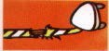

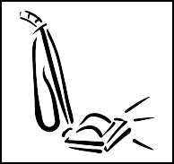

EQUIPMENT ACCESSORIES
Drum vacuum cleaner Flexible hoses.

Wet and dry vacuum cleaner. Extension cables

Dry vacuum cleaners. Nozzles.

Upright vacuum cleaner Paper and / or cloth filter bags. Backpack vacuum cleaner.

Choosing the right accessories

      - When vacuuming textile surfaces like upholstery and carpets you could use different accessories than the one we would use for hard surfaces.
      - When vacuuming difficult to reach corners you would need to use a small, narrow nozzle like a crevice tool.
      - When vacuuming overhead fixtures, you may need to use extension tubes to enable the nozzle to reach these fixtures.
      - When vacuuming overhead pipes, you may need to use a cured pipe cleaning tool to remove the dust effectively

COMPLETE CLASSROOM ACTIVITY NO 2 IN YOUR WORKBOOK

Equipment and accessories must be checked before use:

- To ensure that all the equipment and accessories are in good working order.
- To ensure that you have the right equipment for the job.
- To ensure that there are no blockages in the pipes.
- To ensure that the cable is not damaged.
- To ensure that you are using the correct filter bags.

Safety procedures to be followed when using a vacuum cleaner:
- Check that the electrical cable is not damaged
- Check that the plug is not damaged
- Do not vacuum liquids such as petrol or paraffin as this could cause the motor to explode
- The cable must be behind the person vacuuming so that you do not vacuum over the cord

STEP 4:

Choosing the correct plug point is important.
- If the wrong plug point is used serious consequences could occur which could damage a customer’s equipment or even be life threatening.
- As a cleaner, you need to check with the customer first before using a plug point.

Indoor Air Quality:

In factories, shops and offices the quality of the air we breathe is of great importance for the workers and people in these areas, that is why laws have been passed by the government to regulate this.

Dust is a health hazard as it contains large numbers of germs or allergens which could cause allergies, asthma and bronchitis. As a cleaner vacuuming, you perform an important part of the system in controlling dust and dirt in our environment. This will be discussed in more detail when handling the cleaning of filter bags in the vacuuming process.

Dictionary
ALLERGEN: an organism or micro (small) organism which may cause an allergic reaction in some people

STEP 5: REMOVE LITTER, RUBBER BANDS, PAPERCLIPS, ETC OFF THE FLOOR

These objects could get into the motor of the vacuum and damage it

NEVER USE A DRY CLEANER TO VACUUM WATER!

- The liquids would pass through the electrical parts of through-flow vacuums motor and cause a short circuit and destroy the motor.
- The liquid is sucked up with a dry vacuum cleaner and the motor will be damaged

COMPLETE FORMATIVE ASSESSMENT NO.1 IN YOR WORKBOOK

LET’S VACUUM DRY SURFACES:
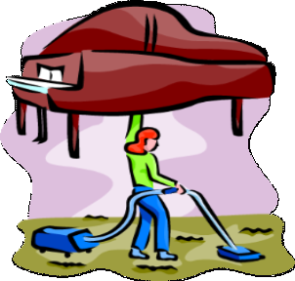

STEP 6:

Vacuum dry surfaces

- You need to gain access to the area you need to clean.
- Vacuum according to the scope of work.
- The method must be systematic.
- Vacuuming strokes must overlap.
- The basic principles of cleaning to be applied.
- Vacuum according to your vacuuming schedule.

If there is furniture in the area to be vacuumed, MOVE IT so that you can clean under it!!!!!

Dictionary

ACCESS: Gaining entry into the area to be cleaned.
SCOPE OF WORK: Worksite procedure or list of what you have to clean.
SYSTEMATICALLY: You should work in an organised, manner

Can you remember the cleaning principles?

Start from furthest end to the door
  - Clean according to shape
  - Clean from top to bottom

DEMONSTRATION OF HOW TO VACUUM DRY SURFACES

The trainer will demonstrate how to vacuum dry surfaces.
After the demonstration, you will show how well you have observed by vacuuming an area.

IMPORTANT TIPS TO REMEMBER:

- Always start from the furthest end to the door and vacuum in straight lines, remembering to overlap.
- If you have moved furniture, replace it.
- Filter bags are removed and cleaned.
- Blockages in the vacuum cleaner pipe/machine are cleared.
- Inspect your work to make sure it is of a high quality.

Cleaning soft and upholstered surfaces

- When cleaning an upholstered chair remove all the cushions.
- Vacuum the whole chair or sofa; do not forget the narrow opening where the chair is
joined.
- Fluff the cushions and replace.
- If there are any marks on the upholstered area that should be
removed (See Module 2: Remove spots and spillages).

NOTES
- Make sure to check how stable the colour of the material is that you are removing a spillage from.
- Clean a small area that is not visible.
- This way you will establish if you could clean the surface and remove the spot or spillage

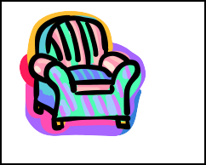

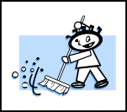

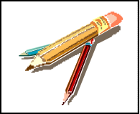

  - Working away from the electric plug allowing the cable to stay behind you saves time.
  - Keep your back straight and relax your shoulders so that you do not place strain on your back.

COMPLETE WORKPLACE ACTIVITY NO.2 IN YOUR WORKBOOK

ACTIVITY

    - Put your hand over your mouth and draw in your breath.
    - Describe the result in your own words.

      - You cannot inhale any air with your mouth blocked!
      - If your vacuum filter is dirty or the pipe is clogged the vacuum cleaner will not
be able to suck in the air either.
      - The amount of dirt that the vacuum cleaner can suck depends on the amount of air that can be drawn through the machine.

CLEARING BLOCKAGES

To understand how the airflow in a vacuum cleaner works:

In order for a vacuum cleaner to work (suck), air must flow into and out of the vacuum cleaner. Anything that partially blocks this flow will cause a drop in suction.
Filters collect the dirt and dust and protect the vacuum motor.

If you have a drop in suction, check for blockages, a full filter bag and dirty filters.

Bags and filters trap dust and solid particles
- air

continues

Final filters trap any remaining dust and clean airflows through vacuum

Air together with dirt flows into vacuum

LET US PREPARE TO CLEAR BLOCKAGES

Step 1
Unplug the flexible vacuum hose from the machine

Step 2
Switch on the machine

Step 3
Test the suction

Step 4
Plug in the flexible hose

If the suction is restricted there is a blockage in the hose

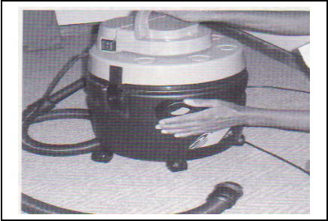

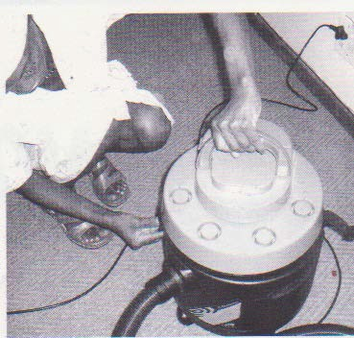

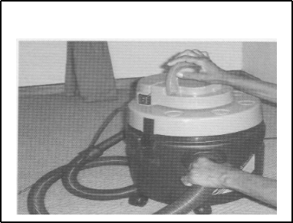

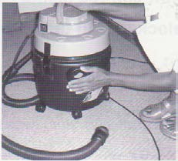

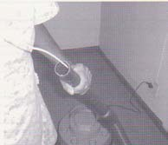

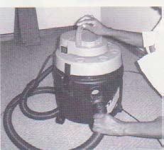

Step 6
Use a wire hook to clear blockage

Step 5
Test the suction

DEMONSTRATION-UNBLOCKING THE HOSE IN A VACUUM CLEANER.

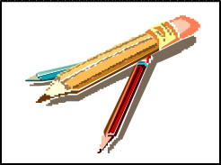

The trainer will demonstrate unblocking the hose by following specific steps.
After the demonstration, you will show how well you have observed by unblocking the vacuum cleaner.

My notes

COMPLETE FORMATIVE ASSESSMENT NO.2 IN YOR WORKBOOK

REMOVE SPOTS AND SPILLAGES FROM CARPETS

Once you have identified the type of surface that needs the spot or spillage removed, you will be able to choose the correct chemical to remove it. Always take into account your worksite procedures.

SELECT THE CHEMICAL ACCORDING TO THE SURFACE AND YOUR WORKSITE PROCEDURE

CHEMICALS
Spotting chemicals can include:
- Liquid spot removers
- Aerosol (spray) removers
- Carpet powder

EQUIPMENT:
The correct equipment and accessories you would need for the removal of spots and spillages are:
- A white absorbent cloth
- A paper towel
- A spotting brush
- A scraper, blunt knife, or spatula

Why must you select the correct spotting chemicals and accessories?
- To remove spots effectively
- To remove spots without damaging the carpet fibre, material or dyes.

THE METHOD TO CHECK FOR COLOUR -FASTNESS

  - Select an area behind furniture, or in a corner to carry out the colour-fastness test.
  - Apply the spotting chemical to a white absorbent towel or cloth
  - Rub the damp cloth lightly on the carpet surface
  - Check if the cloth is absorbing any of the dyes in the carpet fibres or material fabric
  - If no dye is absorbed it is safe to use the spotting material

COMPLETE FORMATIVE ASSESSMENT NO.3 IN YOR WORKBOOK

We need to know the difference between a Spot, a Spill and a Stain.

A spot: (Removable stain) Is a substance on the fibre that can be removed using the correct spot removal procedures

A spill: A wet substance that is on the fibre or surface and can be removed using the right procedure

A stain: Is a substance that has permanently damaged or changed the colour of the fibre or material. It cannot be removed

Factors affecting successful spot and spill removal
- Removal procedure- the way you use the chemicals and techniques

- Type of spot- some are easier to remove than others

- Age of spot – an old spot is difficult to remove

- Temperature when spilled- if the liquid is hot, it will be more difficult to remove

- Type of carpet or fibre- wool stains easier than nylon

- If a carpet has a high pile- it is more difficult to remove the stain

- Previous cleaning attempts – using an incorrect method might have made the stain permanent

Methods of spot removal when using liquid & aerosol spot removers

- Blotting – Liquid spills are “Blotted” with an absorbent towel

- Solids - Removed by scraping and collecting using a blunt scarper or knife

- Apply the liquid spotting chemical to white absorbent cloth and dab the spot, working from the outside towards the centre of the spot.
- An aerosol spotting chemical is applied directly to the spot on the carpet.

- Dab the spot working from the outside towards the centre

- Check that the spot is transferring from the carpet/upholstery to the white absorbent cloth
- BE PATIENT…Keep dabbing the spot until you remove as much as possible

- Use a clean part of the white cloth when the section you are using is dirty

Practical spot removal technique when using carpet powder

  - Blot all liquid spillages using a white absorbent cloth or paper towel
  - Remove solids such as food by scraping and collecting the spill using a scraper,
blunt knife or spatula.
  - Apply the carpet powder directly on to the spot on the carpet
  - Brush the carpet powder through the carpet fibres using a spotting brush in both a
backwards-and- forwards and side –to- side brushing action.
  - Vacuum the dirty carpet powder from the carpet
  - Re-set the pile or nap

NAP: Short fibers on upholstery e.g. velvet
PILE: Cut or uncut loops on carpets and upholstery

Although the carpet powder is often referred to as “dry” powder, it is not true.
A carpet powder contains chemicals that give the powder a moist or damp feel and these chemicals assist with the spot removal process.

Always work from the outside of the spot to the center
Do not use a scrubbing action, as this will spread the spot or spill

COMPLETE FORMATIVE ASSESSMENT NO. 4 IN YOR WORKBOOK

Remember a stain permanently damages or changes the colour of the carpet fiber.

Stains cannot be removed. You must report stains:
- So that the customer knows that you have attended to the work and the stain cannot be removed.

- So that the supervisor can advise you on further action you need to take

- So that measures can be taken to prevent further damage of the carpet/upholstery in the future...

See below for the method to clean a spillage using a powder (you can either use a powder or liquid spot remover)

Using a dry powder

A liquid spill

Blotting a spill
Dry powder

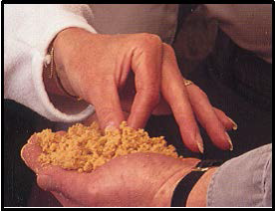

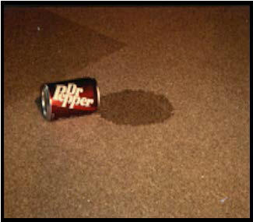

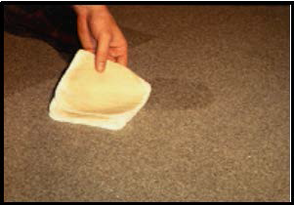

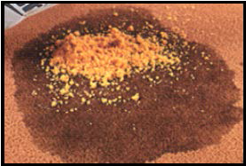

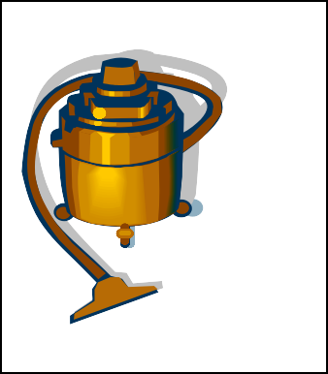

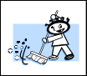

Vacuum the powder

COMPLETE WORKPLACE ACTIVITY NO 3 IN YOR WORKBOOK

COMPLETE FORMATIVE ASSESSMENT NO.5 IN YOR WORKBOOK

o o o o
PERFORM END OF TASK DUTIES AFTER VACUUMING AND SPOT REMOVAL

LET’S FINISH UP

Before leaving the area, you have vacuumed,

- CHECK…. to see that all work is completed.

- CLEAN EQUIPMENT …. Our work is not done until we have cleaned ALL the equipment we have used and stored it correctly.

Make sure the vacuum cleaner is unplugged.
  - Take the removable parts off.
  - Clean the filter bags and replace them.
  - Damp wipe the machine with a cloth.
  - Check the equipment in case it needs to be repaired and report to the supervisor.
  - Store vacuum and accessories in the designated area.

- REPORT …any broken items to the supervisor according to your worksite procedures.
- REMOVE…all litter and waste must be removed and disposed of according to worksite
procedure.
- Use the correct bins for emptying the bags.

Before leaving the area where you have removed spots:

- All litter and waste must be removed and disposed of according to worksite procedure
- Spotting chemicals and containers must be properly closed
- Dry powder must be stored in a sealed packet or bucket
- Spotting chemicals and accessories must be correctly stored
- White absorbent cloths must be washed and dried
- Vacuum cleaners and accessories must be cleaned and stored correctly
