Kitchen Cleaning
US No: 243205 Level 1, Credits 15

LEARNER MANUAL
Learner’s name
Facilitator’s name
Starting date

Hi there!

Welcome to a learning experience that will give you all you need to know about cleaning kitchens.

Most of the activities are practical. Your facilitator will demonstrate and explain how to do certain things and then you will practice them. We hope you will enjoy this!

We have included some new words to learn so that you can improve your vocabulary. If you are not sure about the meaning of a word or how to say it, ask your facilitator.

We hope that when you have learnt these skills you will share them with others and take them from the workplace into your life

Have fun!

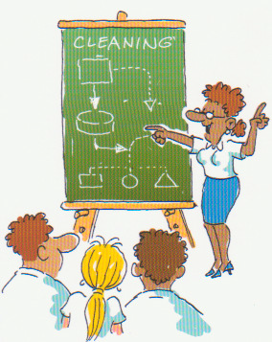

INDEX

Section | Contents | Page NO
1 | Introduction to your workbook | 3
2 | Unit standard learning outcomes | 3
3 | Critical Cross-filed Outcomes | 4
4 | What I must know | 5
5 | What I must be able to do | 5
 | Module 1: Plan and Prepare to Clean | 6
 | Module 2: Cleaning the Kitchen | 15
 | Module 3: Completing the Task | 23

1. Introduction to your workbook

This book belongs to you!

It is for you to work with and write in so that you can use the information at a later stage. This workbook contains a lot of detail and ideas to help you learn. Your facilitator will be available to guide you during the learning process. You will be expected to complete the activities in the workbook to show your understanding.

You will learn more by:
- Asking questions
- Participating in group discussions
- Reading additional material
- Completing the assignments
- Doing homework activities

Remember - this book is to help you succeed!

______________________________________________________

2. Unit Standard Learning Outcomes

Purpose

To clean kitchenettes, tea serveries, domestic kitchens and sculleries found in a residential, commercial, industrial or institutional environment

Learners credited with this unit standard are able to:

- Understand kitchen hygiene practices
- Plan and prepare for cleaning kitchens
- Clean kitchens
- Perform end of task procedures after cleaning kitchens

Learning assumed to be in place

It is assumed that learners are competent in:
- Communication at ABET Level 3
- The Unit standards:
  - Understand basic cleaning principles (Level 1)
  - Use chemicals in the cleaning services environment (Level 1)

3. Critical Cross-filed Outcomes

NB This list contains all Critical Cross-field Outcomes identified by the South African Qualifications Authority.

The complete list of Critical Cross-field Outcomes is:

- Identify and solve problems in which response displays that responsible decisions, using critical and creative thinking, have been made.
- Collect evaluate organize and critically evaluate information.
- Work effectively with others as a member of a team, group, organization or community.
- Organize and manage oneself and one’s activities responsibly and effectively.
- Communicate effectively by using mathematical and/or language skills in the modes of oral and/or written presentation.
- Use science and technology effectively and critically, showing responsibility towards the environment and health of others.
- Demonstrate an understanding of the world as a set of related systems by recognizing that problem solving contexts do not exist in isolation.
- Contribute to the full personal development of each learner and the social and economic development of the society at large by:

- Participating as a responsible citizen in the life of local, national and global communities.
- Being culturally and aesthetically sensitive across a range of social contexts.

4. What I must know

 | SO | AC | CCFO
The reasons for practicing good hygiene | 1 | 1.1 | 4 & 6
The unhygienic conditions found in kitchens | 1 | 1.2 | 1, 2 & 6
What the term micro-organism means | 1 | 1.3 | 6 & 7
What the term cross-contamination means | 1 | 1.4 | 6 & 7
The reasons for using colour coded cleaning methods | 1 | 1.5 | 2, 4 & 6
The reasons for using personal protective equipment (PPE) | 2 | 2.2 | 4
The reasons for selecting the chemicals and consumables I am going to use for cleaning | 2 | 2.7 | 2,4, 6 &  7
The reasons for storing items in their correct positions | 3 | 3.4 | 4 & 6
The reasons for checking my work after completion | 4 | 4.1 | 4 & 5

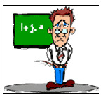

5. What I must be able to do

 | SO | AC | CCFO
Use the correct personal protective equipment (PPE) | 2 | 2.1 | 4
Select the kitchen items that must be cleaned | 2 | 2.3 | 1 & 2
Use the correct cleaning process for each item selected | 2 | 2.4 | 2, 4, 6  & 7
Clean kitchen items in the correct order | 2 | 2.5 | 1, 3, 4  & 8
Select the correct chemicals, consumable and equipment for cleaning | 2 | 2.6 | 2, 4 & 6
Clean kitchen items and surfaces | 3 | 3.1 | 4 & 8
Store cleaned items | 3 | 3.2 | 4 & 8
Dispose the waste and litter is collected during cleaning | 3  4 | 3.3  4.3 | 6, 7 & 8
Store or replace items in their correct positions | 3 | 3.4 | 4 & 6
Check kitchen items and surfaces cleaned | 4 | 4.1 | 1 & 4
Clean and store equipment, consumables and  chemicals used | 4 | 4.2 | 4 & 6
Report problems and damages identified | 4 | 4.4 | 1 & 5

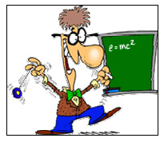

MODULE 1: Plan and Prepare to Clean

KITCHEN HYGIENE PRACTICES
Hygiene in the kitchen includes:
- Personal hygiene - That’s ME!!
- The hygiene of the environment / room
- Food hygiene

PERSONAL HYGIENE
- Clean uniforms - Dirty uniforms will contribute to cross contamination
- Proper headgear
- No jewellery - Jewellery can lead to accidents and bacteria can multiply under jewellery
- Correct personal protective wear - To protect against accidents
- Clean body
DICTIONARY
Hygiene - Clean and free of germs

HYGIENE OF THE ENVIRONMENT / ROOM
- Appliance cleaning
- Work surface cleaning
- Floor cleaning
FOOD HYGIENE
- Food must be stored according to worksite procedure to ensure kitchen hygiene practises.
- Clean storage areas e.g. clean shelves in storage areas, clean refrigerators, clean freezers
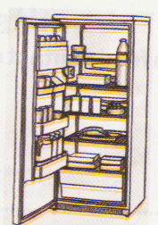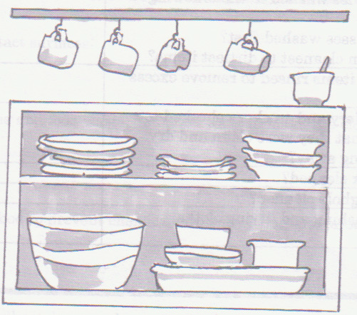

Hygiene is very important in a kitchen, as it is the place where food is prepared and stored.
Add other reasons here:
________________________________________________________________________________________________________________________________________________________________________________________________________________________________________________________________________________________________________________________________________
UNHYGIENIC CONDITIONS IN A KITCHEN
These include:
- poor personal hygiene
- unhygienic behaviour
- open waste bins
- presence of pests
- dirty surfaces
- spoilt food
Kitchen hygiene is so important because

DIRT IS DANGEROUS!!!
DIRT contains micro-organisms which can be harmful to our health!
Examples of micro-organisms:
- bacteria
- virus
- fungi
These are things than can make us sick or can spoil the food.
Micro-organisms grow best in:
- Moisture - damp / wet areas
- Food - dust, body fluids (blood, urine etc)
- Warmth - speeds up growth, but some can live in cold
- Darkness - cracks, scratched surfaces, under rims, broom cupboards, bins, stores etc
Some important notes about bacteria

- Cannot be seen with the naked eye
- Multiply under certain conditions
- Are spread by dirty hands and equipment
- Can be harmful – can cause food poisoning
- Can affect the quality of the food
- Can be controlled by cleaning
- Can be useful – like when we make yoghurt

How do we know they are there if we cannot see them?
SMELL!!!
How do we pick up bacteria and spread it?
- From using the same cloths for different tasks
- We touch door handles where other people with dirty hands have touched
- We use dirty equipment
- Dustbin lids are not clean, they are left dirty
- Table tops are often dirty

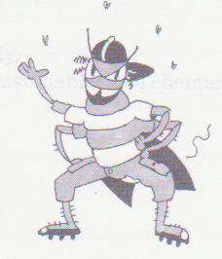

What is CROSS-CONTAMINATION?
________________________________________________________________________________________________________________________________________________________________________________________________

Examples of where cross contamination could occur in a kitchen include, but are not limited to: contact surfaces such as door handles, knobs, light switches, taps and food contact surfaces such as cutting boards, work surfaces
How do bacteria spread using a cleaning cloth?
________________________________________________________________________________________________________________________________________________________________________________________________
PLANING AND PREPARING TO CLEAN
Let us look at what we are going to do! . . . .
In order to do our cleaning job well we have to know the following:
- What is meant by clean?
- What does cleaning consist of?
- How do I clean?
- What equipment do I need for cleaning?
- When do I need to clean?
- What do I have to clean?
The principles of cleaning must be adhered to when planning to clean the kitchen
- From the furthest end toward the entrance
- From top to bottom
- Dry cleaning before wet cleaning
The first thing we must check when preparing to clean a kitchen is:
- To check if it is a convenient time to clean
To clean while someone is still busy will be not be productive.
- You will be in their way.
- You will have to clean the same area over.
- You will risk getting soap mixed with the food.
- The customer will not be happy

Personal protective equipment (PPE) - What will you wear during the cleaning of a kitchen?
I will wear the following: Reason
______________________________ __________________________________________
______________________________ __________________________________________
______________________________ __________________________________________
______________________________ __________________________________________
______________________________ __________________________________________
______________________________ __________________________________________
______________________________ __________________________________________
CONSUMABLES AND CLOTHS TO BE USED
- Washing up cloths - for washing crockery, cutlery etc. (plates, cups spoons etc)
- Colour coded cloths - dedicated cloths for dedicated areas. The same cloth must not be used for food preparation areas and floors
- Abrasive pads - to remove heavy buildup on sinks and trolleys.
- Brushes - to assist scrubbing to loosen the dirt.
Steel wool
- Steel wool is an unhygienic method of cleaning.
- The pieces of metal can get into the food making it unfit for consumption.
- Dirt gets trapped in the steel wool.
- Surfaces are scratched by the steel wool.
- Health authorities do not recommend its use.
An abrasive pad is only used when:
- There is heavy dirt needing scrubbing
- The surface is suitable for abrasive cleaning and the abrasive pad.

DICTIONARY
Dedicated means specific. e.g. used for a specific purpose or in a specific area.

Using colour-coded cloths, buckets and brush ware
Colour coding of cloths and buckets enables cleaners to easily identify the cloths and buckets that must be used to clean a specific area, for example:
A cleaning system for example, consists of three different coloured buckets and matching cloths colour-coded red, green and blue. (Refer to your worksite procedure for your cleaning system).
RED: For cleaning toilets, urinals and sluice
GREEN: for cleaning bathrooms
BLUE: for cleaning above
Write down other reasons for using colour coded cloths and buckets
__________________________________________________________________________________________________________________________________________________________________________________________________________________________________________________________________________________________________________________________________________________________________________________________________________________________

What could happen if the wrong cloths / consumables are used for the wrong purpose?
- The wrong consumable can damage a surface (e.g. abrasive on Teflon)
- The cleaning may be ineffective (e.g. soft cloth on a heavily soiled surface)
- One can spread germs/ microbes if a cloth used for cleaning the floor is used for washing the dishes or food contact surfaces
Do not use the same cloth to clean the floors and food contact surfaces

MODULE 2: Cleaning the Kitchen

Clean cutlery and crockery.
Cutlery and crockery includes but is not limited to knives, forks, spoons, glassware, plates, platters, cups, saucers, mugs and other items that will be washed by hand
A detergent is a chemical that:
- Helps dissolve fats or grease
- Helps remove dirt
If too little detergent is used during the cleaning process there will be dirt that may be more difficult to remove and dirt that may not be removed properly.
If too much detergent is used during the cleaning process there may be too much foam, which will be difficult to rinse off and this wastes the detergent and water.
Preparing to wash the dishes
Before you start to wash the dishes you need to prepare the dirty dishes for the washing process, this includes:
- Stacking the dishes according to size
- Putting all the cutlery into one place
- Pre-washing / rinsing the crockery
- Removing the excess dirt from the crockery
Why should one prepare the cutlery and crockery before washing?
________________________________________________________________________________________________________________________________________________________________________________________________________________________________________________________________________________________________________________________________________
What can happen if fat or food waste goes into the drainpipes?
________________________________________________________________________________________________________________________________________________________________________________________________________________________________________________________________________________________________________________________________________
Change wash when necessary!
The sequence used when washing dishes is:
• Glasses
• Cleanest to dirtiest dishes
• Cutlery
• Plastic

Glasses
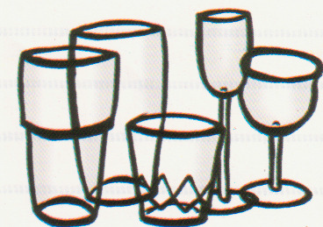 Then 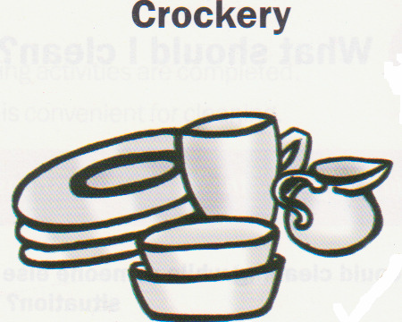 Then 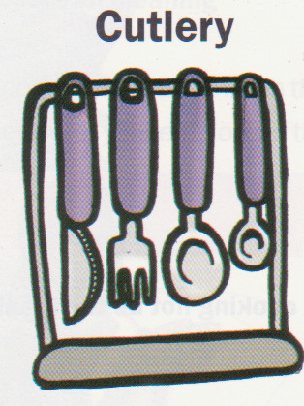 Then 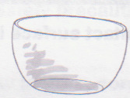

Rinsing the washed dishes
All dishes washed should be rinsed before drying. This ensures that:
• Traces of detergent and food particles are removed
• Microbes/germs are reduced.
Drying the washed dishes
All dishes washed must be dried properly before storage as germs / microbes can grow in the moisture while wet items are stored.
Why should dishcloths not be used for drying hands?
Hands are full of germs / microbes. When hands are dried on dishcloths people can transfer germs to the dishcloth and then to the cleaned dishes.
End of task procedure for washing dishes
• Plugholes and basins need to be cleaned after washing up.
Plugholes: - bits of food found in the plug hole must be removed from the plughole and thrown away
Basins: - need to be washed, rinsed, wiped and dried
• Cloths need to be cleaned after washing up.
Cloths need to be rinsed and then soaked in a disinfectant solution for at least 10 minutes (at least once a day) and hung out to dry.
Drying up cloths will spread bacteria if they are not kept clean.
Why should washing up equipment be cleaned and left to dry after use?
If equipment is not cleaned and dried, germs and microbes can grow on the food and moisture.
WHAT WOULD YOU DO IF THERE WERE BLOCKED DRAINS?
• Check for items causing obvious blockage
• Remove the items
• Use a plunger if available
• Report to person as stated in your worksite procedures

Clean food preparation equipment.
Food preparation equipment refers but is not limited to food processors, mixers, mincers, slicers, graters, pots, pans, cookware, utensils or any other equipment used for preparation of food where there is direct contact with the food.
Preparing to clean food preparation equipment.
- Switch off and unplug any electrical equipment before cleaning.
- Remove food stuck to the equipment
- Take the equipment apart to ensure effective cleaning (food processors, cutters, mixers, coffee makers etc.)
Why does equipment need to be taken apart before cleaning?
Taking equipment apart will help cleaning difficult to reach areas
Washing the equipment
All equipment must be washed / cleaned according to the manufacturer’s instructions.
Electric appliances MUST NOT be put into water as this could cause:
• The appliance may stop working
• The appliance can blow up
If the electric appliance does get wet it is important for you to report it to your supervisor and try to dry the appliance as best as possible.
Keep to these safety precautions when cleaning Food Preparation Equipment.
- Never allow motors, cords and plugs to get put into water. When wet, these items, could shock you when switched on. You could damage them. (They could stop working or blow up).
- Use colour-coded cloths to prevent cross contamination.
- Never use steel wool. Steel wool is unhygienic method of cleaning. The pieces of metal can get into the food making the food unfit for consumption. Dirt gets trapped in the steel wool. Steel wool scratches the surfaces.
- Dry all items before storage. Moisture encourages germs to grow
Cleaning food contact surfaces
Flat food contact surfaces refer to surfaces that come into contact with raw or high-risk foods such as counters and cutting boards where there is direct contact with food.
Before starting to clean the flat food contact surface you must:
- Remove loose items and food waste
  - To prevent spreading dirt from one place to another
  - To clear the area to make cleaning easier and faster.

- Store or cover food left on the flat food surface
  - To prevent chemicals or dirt from landing on the food.
To ensure effective cleaning and to prevent damage to surfaces the correct chemical and dilution of the chemical must be used for cleaning the flat food contact surface. Only use the chemical stated in your worksite procedure.
Let us identify food contact surfaces
Identify the food contact surfaces by ticking the pictures below . . .
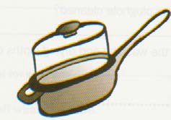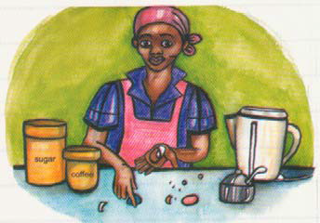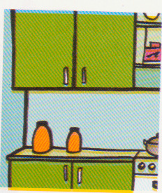
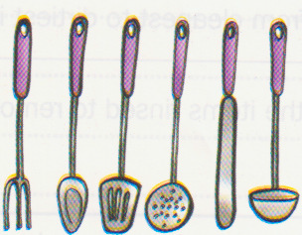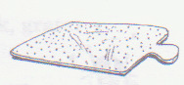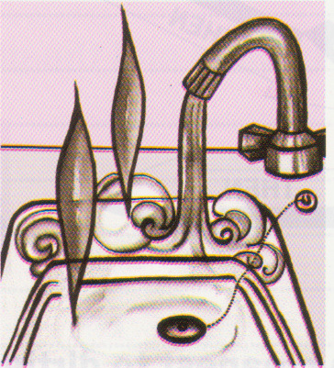

Why must the correct cloth be used when cleaning food contact surfaces?
To ensure that germs / microbes are not spread from dirty areas to food contact surfaces.
Cleaned items can be dried before storage.
• It can be left to air dry before storage
• It can be dried with a dishtowel used only for drying

Cleaning hand contact surfaces.
Hand contact surfaces refers to areas that are frequently touched by hands. They include but are not limited to taps, light switches, door handles, refrigerator doors, cupboard doors, drawer handles, stove knobs and microwave doors.
Why is it important to clean hand contact surfaces in kitchens?
- We clean to lessen the spread of germs from hand contact surfaces to other people and clean areas (cross-contamination).
- Hands are full of germs/microbes. When hands touch surfaces often, there are many germs and people can transfer germs to clean areas
How often do hand contact surfaces need to be cleaned?
• At least daily or as per cleaning specification
Clean appliances
Kitchen appliances are items used for cooking or keeping food hot or cold. They are usually electrical.
Which of these do you have at home? Tick the pictures.
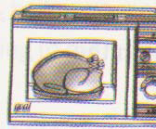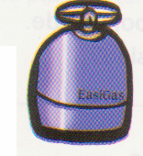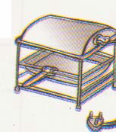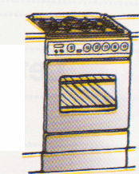

- All kitchens should have a cleaning schedule for appliance cleaning.
- Unless the visually dirty or the workplace procedure recommends more specified cleaning, the following could be your routine:
  - Daily - Tops of stoves, hand contact areas and food contact areas
  - Weekly - Inside fridges
  - Monthly - Inside ovens
  - Quarterly - Underneath fridges and freezers
Steps for cleaning appliances
STEP | WHAT YOU MUST DO
1 | Check if electrical appliances are switched off  Switch electrical appliances off before cleaning
2 | Choose the correct cleaning chemical as specified in the worksite procedure.  The wrong chemical may be ineffective or damage the surface. (These may vary from a neutral detergent to an alkaline oven cleaner dependent on the task).
3 | Choose the correct cloth and consumables. The cloth must be the correct colour if specified. The wrong cloth or consumable may not be effective for removing the dirt or could damage to appliance. Fold cloth into squares to allow all surfaces to be used effectively.
4 | Check the manufacturer’s instructions and worksite procedures regarding cleaning to avoid damage to the appliance.
5 | Clean the whole outside surface.  Appliance surface must be visually clean
6 | Clean detail example - knobs, handles  All hand contact surfaces of the appliance must be cleaned.
7 | Check the inside for dirt. Follow your checklist for cleaning.  Clean if required according to manufacturer’s instruction.
8 | Replace items removed in the same place after cleaning.

REMEMBER!!! Always use correct chemicals, Cloths and Consumables

MODULE 3 Completing the Task

As you know, problems and damaged items must be reported. Herewith is a list of examples:
- accidents and personal injury,
- damaged/missing equipment and/or personal protective equipment;
- insufficient or incorrect chemicals and/or consumables,
- staff problems,
- customer requirements,
- the cleaning schedule
- scratched, dented, cracked or broken items and surfaces
Correct disposal of wastewater - Chemicals must be thrown away correctly so that you do not damage the environment around us.
Waste is a residue that must be thrown away after cleaning
Never pour oil down a drain. WHY NOT?
- It can block the drain
- It will make the drain / pipes very oily which then need to be cleaned
- Could cause the drain to smell
- Oil floats on top of water so it does not drain away

