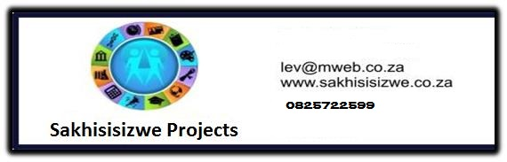

Clean Toilets and Bathrooms

US No: 243206 Level 1 6 Credits

Learner’s name
Facilitator’s name
Starting date

LEARNER MANUAL

Hi there!

Welcome to a learning experience that will give you all you need to know about cleaning toilets and bathrooms.

Most of the activities are practical. Your facilitator will demonstrate and explain how to do certain things and then you will practice them. We hope you will enjoy this!

We have included some new words to learn so that you can improve your vocabulary. If you are not sure about the meaning of a word or how to say it, ask your facilitator.

We hope that when you have learnt these skills you will share them with others and take them from the workplace into your life

Have fun!
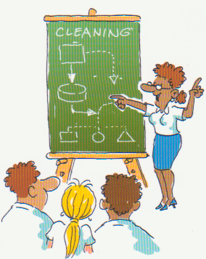

INDEX

Section | Contents | Page number
1 | Skills clusters and learning pathway | 5
2 | Introduction to your workbook | 6
3 | Unit Standard Learning Outcomes | 6
4 | Critical Cross-field outcomes | 7
5 | What I must know | 8
6 | What I must be able to do | 9
7 | Learning signs | 10
Module 1: Plan and prepare for cleaning |  | 12
Module 2: Clean toilets and bathrooms |  | 18
Module 3: Perform end of task procedures after cleaning toilets and bathrooms |  | 25

1. Skills clusters and learning pathways

Qualification  Hygiene & Cleaning Level 1 |  | Introduction to Cleaning
Qualification  Hygiene & Cleaning Level 1 |  | Use chemicals  to clean
Qualification  Hygiene & Cleaning Level 1 |  | Ablution  cleaning |  | Module 1  Plan & Prepare
Qualification  Hygiene & Cleaning Level 1 |  | Above the floor & window cleaning |  | Module 2  Clean Toilets
Qualification  Hygiene & Cleaning Level 1 |  | Textile surface cleaning |  | Module 3  Perform End of task
Qualification  Hygiene & Cleaning Level 1 |  | Hard and resilient floor cleaning
Qualification  Hygiene & Cleaning Level 1 |  | Kitchen  cleaning
Qualification  Hygiene & Cleaning Level 1 |  | Customer service and teamwork
Qualification  Hygiene & Cleaning Level 1 |  | Environmental awareness
Qualification  Hygiene & Cleaning Level 1 |  | Life skills – Health
Qualification  Hygiene & Cleaning Level 1 |  | Life skills – Literacy
Qualification  Hygiene & Cleaning Level 1 |  | Life skills – Numeracy
Qualification  Hygiene & Cleaning Level 1 |  | Life skills - Finance
☺ You are here!

- You need to have completed the Introduction to cleaning and the Use chemicals skills clusters before doing any of the others.
- Other skills clusters may be done in any order

2. Introduction to your workbook

This book belongs to you!

It is for you to work with and write in so that you can use the information at a later stage.

This workbook contains a lot of detail and ideas to help you learn. Your facilitator will be available to guide you during the learning process.

You will be expected to complete the activities in the workbook to show your understanding.

You will learn more by:
- Asking questions
- Participating in group discussions
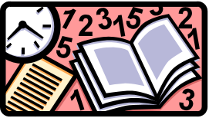
- Reading additional material
- Completing the assignments
- Doing homework activities

Remember - this book is to help you succeed!

3. Unit Standard Learning Outcomes

Purpose

To impart understanding, skills, knowledge and values of cleaning toilets and bathrooms found in a residential, commercial, industrial or institutional environment

Learners credited with this unit standard are able to:

- Plan and prepare for cleaning toilets and bathrooms
- Clean toilets
- Clean bathrooms
- Perform end of task procedures after cleaning toilets and bathrooms

Learning assumed to be in place

It is assumed that learners are competent in:
- Communication at ABET Level 3
- The Unit standards:
  - Understand basic cleaning principles (Level 1)
  - Use chemicals in the cleaning services environment (Level 1

4. Critical Cross-field Outcomes

 | This list contains all Critical Cross-field Outcomes identified by the South African Qualifications Authority.

The complete list of Critical Cross-field Outcomes is:

- Identify and solve problems in which response displays that responsible decisions, using critical and creative thinking, have been made.
- Collect evaluate organize and critically evaluate information.
- Work effectively with others as a member of a team, group, organization or community.
- Organize and manage oneself and one’s activities responsibly and effectively.
- Communicate effectively by using mathematical and/or language skills in the modes of oral and/or written presentation.
- Use science and technology effectively and critically, showing responsibility towards the environment and health of others.
- Demonstrate an understanding of the world as a set of related systems by recognizing that problem solving contexts do not exist in isolation.
- Contribute to the full personal development of each learner and the social and economic development of the society at large by:
  - Participating as a responsible citizen in the life of local, national and global communities.
  - Being culturally and aesthetically sensitive across a range of social contexts.

5. What I must know

 | SO | AC | CCFO
Reasons for using PPE explained | 1 | 2 | 7
Toilets & Bathroom to be cleaned are identified | 1 | 3 | 2
Surfaces to be cleaned are identified | 1 | 4 | 2,3
Cleaning process identified and reason for choice given | 1 | 5 | 2
Reasons for choice of equipment chemicals and consumable are explained | 1 | 6 | 4
Reasons for using the knock and enter procedure is explained | 1 | 7 | 8
Give reasons for checking toilet for damage | 2 | 1 | 1
Reason why toilet must be flushed and free flowing before cleaning is explained | 2 | 2 | 1
Reasons to check why toilet is free of waste is explained | 2 | 3 | 1
Reasons for treating removable marks explained | 2 | 4 | 1
Reasons for checking bathroom for damage explained | 3 | 1 | 1
The choice of chemical for the removal of body fat and lime-scale build up is explained | 3 | 3 | 7
Reason for quality check is explained | 4 | 1 | 1

SO - Specific Outcome
AC - Assessment Criterion
CCFO - Critical Cross-field Outcomes

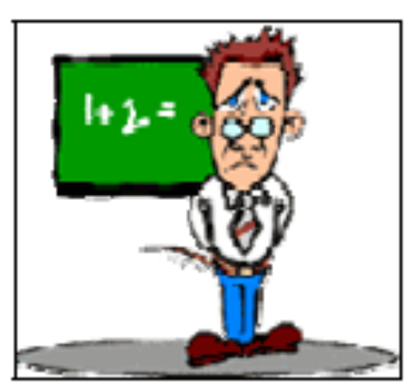

6. What I must be able to do

 | SO | AC | CCFO
PPE is used | 1 | 1 | 7,4
Equipment and consumables and chemicals are collected selected | 1 | 6 | 8
Use knock and enter procedure | 1 | 7 | 2
Check toilet for damage | 2 | 1 | 4
Check for waste in toilet and free flowing of drain | 2 | 2 | 7
Treat removable marks | 2 | 4 | 2
Clean toilet | 2 | 5 | 2
Toilet consumables are replenished | 2 | 6 | 1
Bathroom checked for damage and plumbing problems | 3 | 1 | 2
Clean Bathroom | 3 | 2 | 2
Replenish bathroom consumables | 3 | 4 | 1
Check toilet and bathroom surfaces – quality check | 4 | 1 | 7
Dispose of waste | 4 | 2 | 1
Remove , clean and store all equipment consumables and chemicals | 4 | 3 | 1
Report Problems | 4 | 4 | 1

SO - Specific Outcome
AC - Assessment Criterion
CCFO - Critical Cross-field Outcomes

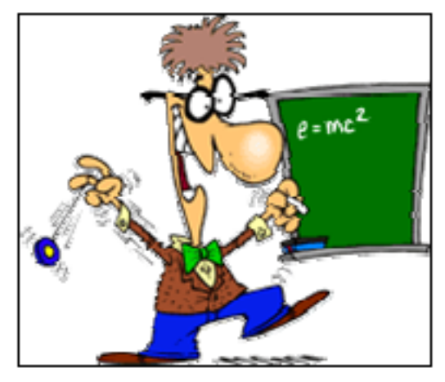

7. Learning signs

 | DICTIONARY  Explanation of Words and Terms
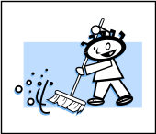 | WORKPLACE ACTIVITY
 | CLASS ACTIVITY
 | FILE IN PORTFOLIO  Add to portfolio of Evidence (Formative and Summative Assessment)
 | HOMEWORK  Work to be done at Home
 | MY NOTES  Written reminders
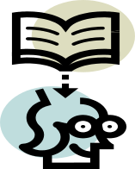 | IMPORTANT INFORMATION
  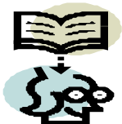 | LET US REFRESH OUR MINDS  Revision of work done.

MODULE 1:
Plan and prepare for cleaning toilets and bathrooms

A Toilet or Bathroom must not only look clean but must also be hygienically clean in accordance with hygiene requirements. A spotlessly clean and sanitary ablution will result in customer satisfaction, and will ensure the health and hygiene requirements are met.

Why is it important to clean an Ablution facility?

The Bathroom and Toilet should be kept clean, as it could be a breeding place for Bacteria.

BACTERIA IS A MICRO ORGANISM

Bacteria cannot be seen with the naked eye

Multiply under certain conditions

Spread by dirty hands and equipment

Bacteria can make me ill.

CLASSROOM DISCUSSION ACTIVITY NO 6

What protects me from Bacteria when cleaning?
I need to wear Personal protective equipment (PPE) when cleaning Ablutions.
For example: Gloves, overalls, safety shoes and a dust mask if needed.

DICTIONARY | 
GERMS/ MICRO ORGANISMS:
- Are living things that cause illness
- They are tiny and not visible to the eye.

ABLUTIONS:
- Toilets, urinals, showers & bathrooms

CLASSROOM DISCUSSION ACTIVITY NO 7

COLOUR-CODED CLOTHS
Suggested colour to use:
 | Red | Toilets
 | Green | 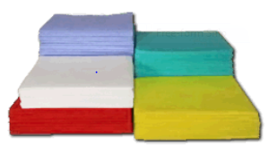  Baths, Showers and Basins
 | Blue | Other above the floor surfaces

What do we use to clean?
We use specific chemicals, consumables and equipment to clean Ablution facilities.
It is important to select the right chemicals, consumables and equipment for the job.
It is important to identify the surfaces because different surfaces need to be cleaned with different chemicals.
Select the correct chemical, consumables and equipment to clean the surfaces of the bath, shower, toilet, bidet, basins and general areas.

What care should be takes when cleaning surfaces?

If you use the incorrect chemicals and equipment it can damage the surface or the dirt.
- Incorrect chemicals can cause discoloration, breaking down of the surfaces
- Certain chemicals can loosen the glue underneath wallpaper or linoleum or can “eat away” the grouting between tiles.
- When cleaning baths, basins, toilet bowls and tiles on the walls we should not use abrasives as it could damage the surface.
- Incorrect chemicals will not clean properly

CLASSROOM DISCUSSION ACTIVITY NO 8

HOMEWORK
Identify surfaces in your bathroom / toilet at home.

What chemicals do we use to clean toilets?

We use:
  - Acidic chemicals to clean calcium or lime-scale in toilets and urinals and
  - Alkaline chemicals to clean acid oily based dirt such as body fat in the bath or finger marks on the tiles/mirrors.
  - Neutral detergents are used for general cleaning

Can you still remember?

Why do we use alkaline to clean acid oily based dirt and Acidic chemicals to clean alkaline dirt?

An acidic detergent will “break up” (react chemically with) the alkaline soil, which will make it easy to remove.
An alkaline detergent will “break up” (react chemically with) the acidic soil, which will make it easy to remove.

Getting ready for cleaning….

We know now what we are going to clean and what we are going to use for cleaning. To save time it is important to plan and prepare the chemicals, equipment and materials before starting the job. Collect all the chemicals and equipment that you will use to clean the Ablution facilities. Make sure that the chemicals are mixed in the correct dilution!

What must we do before entering a toilet to clean?

We must knock before entering to check if there is somebody in the restroom or bathroom.
To make the person aware that you will be coming in to clean so that you
do not embarrass the customer.

Complete Formative Assessment No.4 and Worksite Activity No. 4 in your Workbook

MODULE 2:
Cleaning toilets and bathrooms

There are certain methods that make cleaning easier and more efficient generally. These important principles should always be remembered and it will make your job easier!
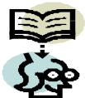

CLASSROOM DISCUSSION
Let us Discuss PRINCIPLES OF CLEANING:
- To protect the right of all to a healthy environment
(In terms of the Bill of Rights contained in the South African Constitution)
- Clean from the furthest end to the entrance
- Clean from top to bottom
- Complete dry-cleaning procedures before wet cleaning procedures
- Clean systematically
- Use colour coded cleaning methods
- Get optimum use from cleaning cloths and consumables

We will clean the bathroom and toilet (Ablutions) according to our cleaning principles. Start to clean from the top to the bottom. It is also good to start with the toilet first as the chemicals used to clean the toilet bowl need time to stand before you start with the cleaning (Contact time) While the chemical is doing its work, you can start with the cleaning.

DEMONSTRATION: TOILET CLEANING

The trainer will demonstrate how to clean a toilet following the steps below.
After the demonstration you will show how well you have observed by cleaning the toilet.

Toilet cleaning and cleaning the bidet are similar.
The bidet does not have a lid.
Clean the taps as for all the other taps in the bathroom.

DICTIONARY
Contact Time:
The time it takes for a chemical to react successfully to dirt

7 STEPS FOR CLEANING TOILETS
STEP 1 | CHECK TOILET FOR DAMAGE (so that broken items may be repaired)  - Check for leaks  - Faulty flushing handle  - Broken seats  - Broken lids  - Leaking pipes  - Check for Blockages |  | 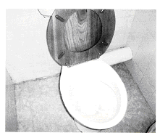
STEP 2 | CHECK THAT THE TOILET IS FREE  OF WASTE  - Flush to remove debris and to check that the toilet drains freely after flushing to make sure that there are no blockages. |  | 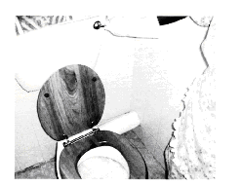
STEP 3 | PRE-TREAT  - Pre-treat the removable marks and dirt with the correct cleaning chemical that is used by your worksite.  - Spray the toilet on the inside of the toilet/urinal.  - Take care to spray under the rim. |  | 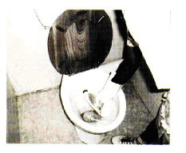
STEP 4 | SCRUB and WIPE  - Scrub the bowl with a brush or abrasive sponge to spread the chemical all over the surface.  - Clean under the rim.  - Scrub under the water line and into the u-bend  - Spray detergent/ disinfectant on the seat, lid, outside the toilet and the cistern.  - Wipe sprayed area with Red cloth or toilet sponge |  | 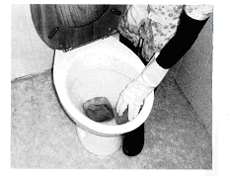
- Leave the chemical to stand according to the recommendations of the manufacturer so that the chemical can clean efficiently.
- The chemical is now working …! Let’s go on with the rest of the bathroom. We will come back to the toilet and then we will clean it as follows

STEP 5 | FLUSH  - Flush the toilet and rinse away the Cleaning Chemical
STEP 6 | DRY  - Dry all areas with a cloth. |  | 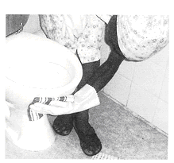
STEP 7 | INSPECT  - Inspect if you have done your work correctly. |  | 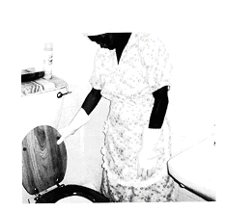
- Close the lid (Ask your Employer how she/he would prefer the lid to be. Up or down?)
Replenish the consumables. (toilet paper, air freshener, disposable seat covers, sanitizing blocks etc.)

Complete Formative Assessment No.5 in your workbook

DEMONSTRATION: BATH AND BASIN CLEANING

The trainer will demonstrate how to clean a bath / basin following the steps below.
After the demonstration, you will show how well you have observed by cleaning a basin/bath.

Neutral detergents are not harmful to anything that can be cleaned with water. The further away from Neutral in either direction, the more care must be taken. We can use Neutral detergent to clean tiles, chrome, enamel, marble, glass, plastic, stainless steel and ceramic. To clean stubborn dirt, we may use a neutral mild abrasive cream cleaner or a mild abrasive pad. Be careful to rinse well or the surfaces may appear dull. For cleaning the mirror and tiles we could use a glass cleaner.
Remember, when working behind a bath or when you have to stretch to clean, be careful not to hurt your back. Don’t stand on the sides of the bath, the toilet seat or cistern to clean higher areas, rather use a stepladder. When cleaning the bath rather kneel next to the bath.

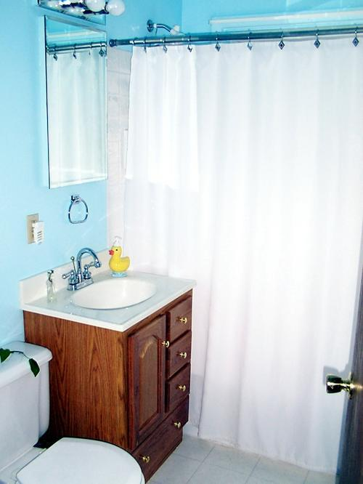

7 STEPS FOR CLEANING BATHROOMS
STEP 1 | CHECK BATHROOM/SHOWER FOR DAMAGE (so that broken items may be repaired)  - Check for leaking taps  - Leaking pipes  - Check for Blocked drain outlets  - Broken lights | 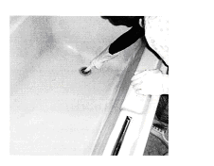
STEP 2 | PRE-TREAT  - Pre-treat removable marks and dirt on all surfaces, fixtures and fittings by spraying with the correct chemical.  - Allow sufficient contact time | 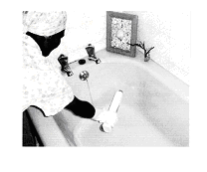
STEP 3 | CLEAN  - Run water into the bath and wipe the inside of the bath with a sponge, mild abrasive pad or a cloth. | 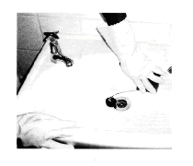
STEP 4 | CLEAN SOAP DISH, PLUG HOLE AND TAPS  - Clean soap dish, taps and plug hole making sure that there is no soap build up  - Use a soft brush or mild abrasive sponge or pad to scrub the pug-hole, plug and overflow. | 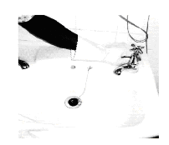
STEP 5 | DRAIN AND RINSE  - Drain water and rinse the bath with clean water.  - Wipe all surfaces with a clean cloth

STEP 6 | DRY  - Dry bath with a dry cloth.  - Rub taps until shiny | 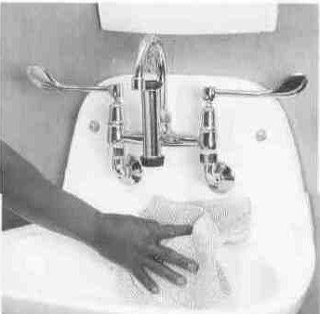
STEP 7 | REPLENISH  - Replenish items as specified on worksite  E.g. toilet paper, towelling, hand soap, tissues, glassware | 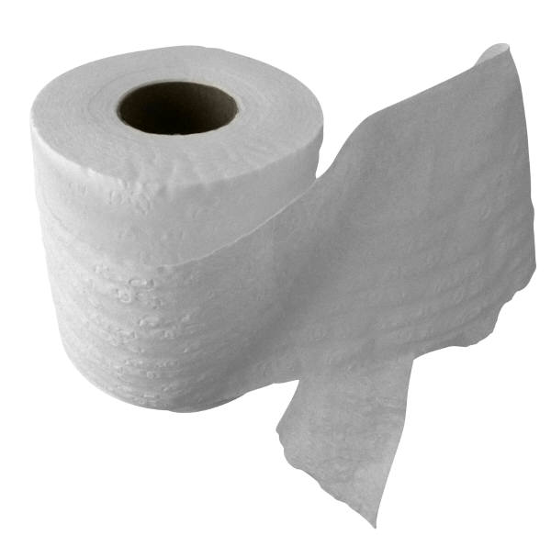

Basins and showers are cleaned in the same manner.
- Make sure that the grouting between the tiles are cleaned
- If needed scrub the shower with chlorine based chemical to remove the mould and mildew.
- Body fat is acid and may require an alkaline cleaner (Handy Andy) or a mild abrasive pad.
- Lime scale is alkaline and may require an acid cleaner to remove it.

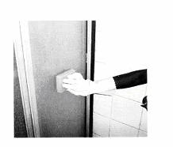 | 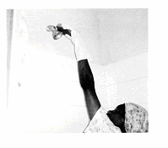
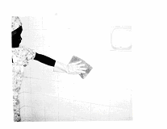 | 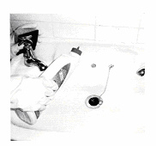

CLASSROOM DISCUSSION ACTIVITY NO 9

MODULE 3:
Perform end of task duties after cleaning toilets & bathrooms

My work is not done until I have cleaned up

What must I do after I have finished cleaning?

- Clean and wipe equipment and chemical containers (spray bottles)
- Remove litter and clean the waste bin
- Store equipment and chemicals in correct designated area
- Prepare for next days cleaning.
- Remove and discard or wash PPE as per worksite procedure
- Wash and dry hands thoroughly.
- Report any problems that may have occurred

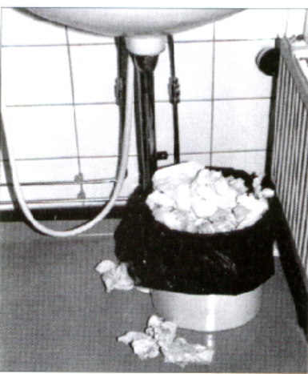
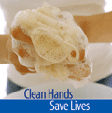

CLASSROOM DISCUSSION ACTIVITY NO 10

Why must I do the job right the first time?

It saves time.
It saves chemicals.
It saves money.
It makes me a professional cleaner.
It saves time.
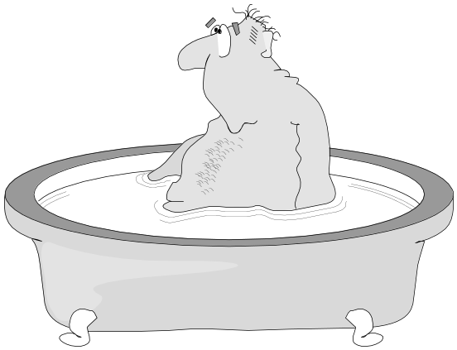

Customers demand quality!

Productivity means:
- Working smarter
- Doing our jobs in a better way
- Increasing the quality and amount of what we deliver to our customers.
- Being consistent
- YOU make the difference!
COMPLETE WORKSITE ACTIVITY NO. 5 IN YOUR WORKBOOK

