

USE MAPS TO ACCESS AND COMMUNICATE INFORMATION CONCERNING ROUTES, LOCATION AND DIRECTION
US No: 7461 Credits 1

Learner’s name
Facilitator’s name
Starting date

LEARNER WORKBOOK


FORMATIVE ASSESSMENT NO. 1
DIFFERENT TYPES OF MAPS
(7461: SO1 & 2)



Identify the following map (e.g. Street, Local, and National)

__________________________________

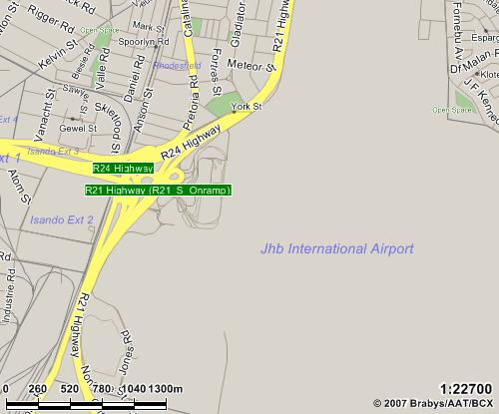

2. LOOK AT THE MAPS BELOW AND COMPLETE THE INSTRUCTIONS:
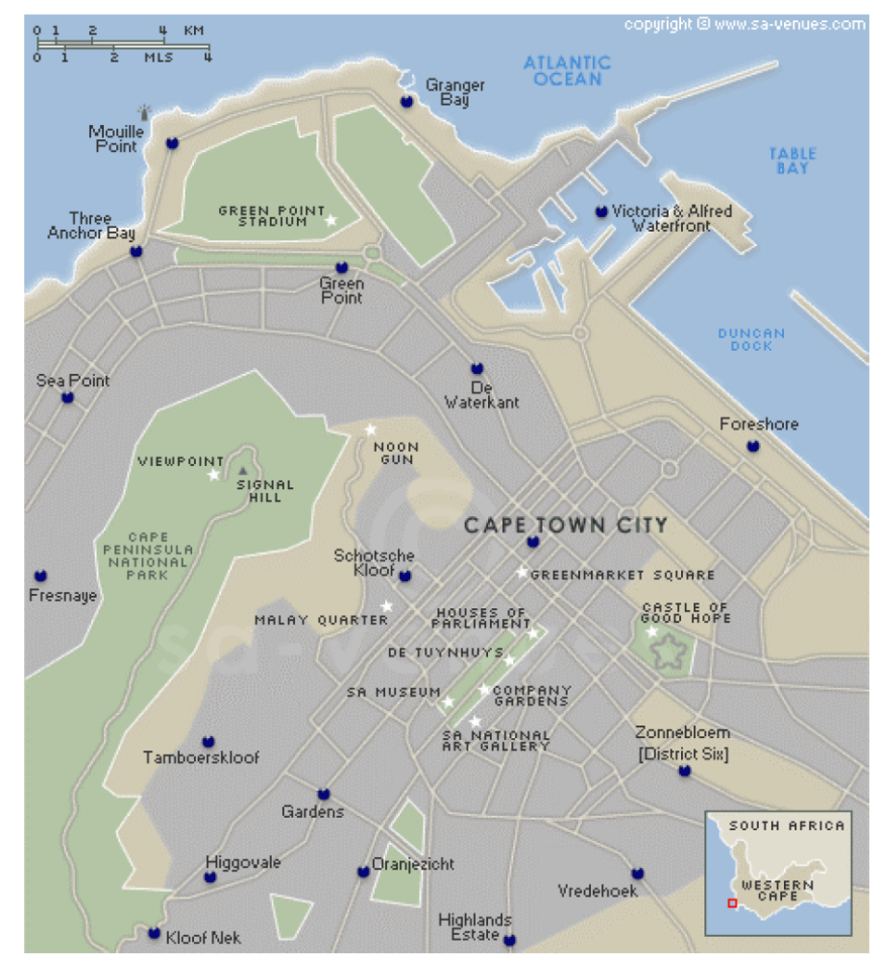

A

BA

- Draw two different routes that one could follow (one in red and one in blue) on the city map of Cape Town, in order to travel from Sea Point (Point A), to the Houses of Parliament (Point B).

- Identify the scale of the map below. Then measure Adderly and Heerengracht streets on the map. Do the mathematical conversion and calculate how long the two streets are together (in metres).

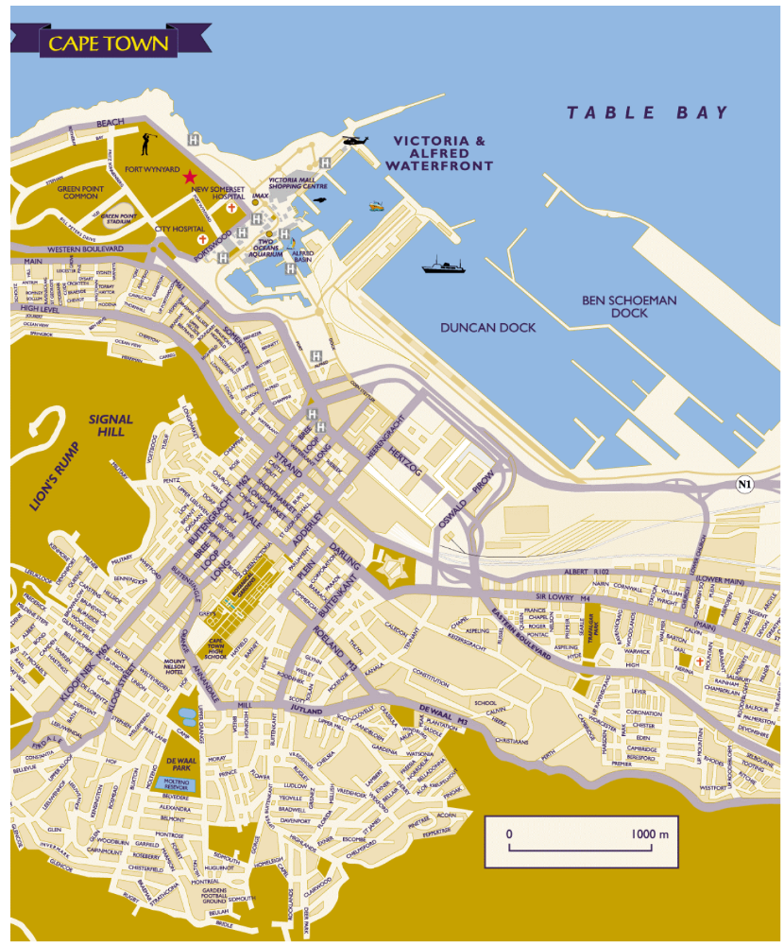

_______________________________________________________________________

_______________________________________________________________________

- Use the above map and write down detailed directions for a person who wants to get from Somerset Hospital to De Waal Park.

_______________________________________________________________________

_______________________________________________________________________

_______________________________________________________________________

_______________________________________________________________________

_______________________________________________________________________

_______________________________________________________________________

Learner name: __________________________________________________________

Learner’s signature: ________________________ Date: _________________________

BINARY WORKSHEET
 |  |  |  | 2¹⁰ | 2⁹ | 2⁸ | 2⁷ | 2⁶ | 2⁵ | 2⁴ | 2³ | 2² | 2¹ | 2⁰
 |  |  |  | 1024 | 512 | 256 | 128 | 64 | 32 | 16 | 8 | 4 | 2 | 1

Result of Assessment |  | C |  | NYC
Comments:
Assessor Name
Assessor Signature |  |  | Date
Learner Name
Learner Signature |  |  | Date
Result of Re-assessment |  | C |  | NYC
Comments:
Assessor Name
Assessor Signature |  |  | Date
Learner Name
Learner Signature |  |  | Date
Result of Re-assessment |  | C |  | NYC
Comments:
Assessor Name
Assessor Signature |  |  | Date
Learner Name
Learner Signature |  |  | Date

