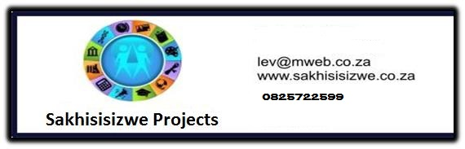

USE MAPS TO ACCESS AND COMMUNICATION INFORMATION CONCERNING ROUTES, LOCATION AND DIRECTION
US No: 7461 Credits 1

Learner’s name
Facilitator’s name
Starting date

LEARNER MANUAL

Hi there!

Welcome to a learning experience that will give you all you need to know about numeracy.

Your facilitator will demonstrate and explain how to do certain things and then you will practice them. We hope you will enjoy this!

We have included some new words to learn so that you can improve your vocabulary. If you are not sure about the meaning of a word or how to say it, ask your facilitator.

We hope that when you have learnt these skills you will share them with others and take them from the workplace into your life

Have fun!
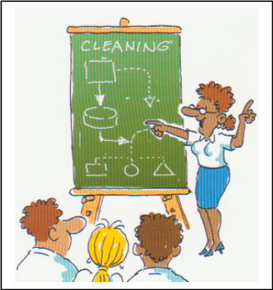

Learning signs

 | DICTIONARY  Explanation of Words and Terms
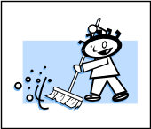 | WORKPLACE ACTIVITY
 | CLASS ACTIVITY
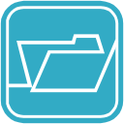 | FILE IN PORTFOLIO  Add to portfolio of Evidence (Formative and Summative Assessment)
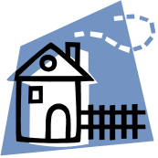 | HOMEWORK  Work to be done at Home

Module 1
Maps – An Introduction

WHAT ARE MAPS?

A map is a graphical representation drawn to scale of natural and artificial features (objects) on the Earth’s surface. Some of these features such as roads, buildings or rivers, you would be able to see from a hill-top or aeroplane. A map is a portrayal of the real world.

Other features such as names of places, boundaries or heights are added to the map because of the importance that they have for the map user. A map can tell us about things that are happening around us, close by and far away. It gives us this information without having to necessarily be at that place.

The map maker has the task of bringing the real world to the map user. This is no easy task as the space available on the map is limited and the real world must be represented by symbols (points, lines and area fills). The process of making the map involves collecting data and making measurements (usually from aerial photographs) of objects in the real world. This information is then translated into understandable symbols and names and other relevant information are added which the map user can interpret to get knowledge about the real world.

The Earth is round while the map is flat and so the map maker has to project the round surface on the Earth onto the flat surface on the map. This process is known as map projection. There are different map projections, each with different properties of preserving the true shape, area or distance.

For a map to be useful it must be a good representation of the real world. This means that as things change, such as new roads or dams or houses, the map must be changed to show these changes. It is important, therefore, that maps show the date at which the information is valid. It is also these changes that make it necessary for maps to be updated at intervals. The updated map is shown as a new edition of the map with a new date.

Various Used of Maps

Position (location)

A map gives the location or position of places or features. The positions are usually given by the co-ordinates of the place, either as the Cartesian co-ordinates (x, y) in metres or as geographical co-ordinates (latitude and longitude) in degrees, minutes and seconds. The co-ordinates can be measured using the co-ordinate grid shown at set intervals along the borders of the map. The map user can, for example, find out that the position of Cape Town is 33º56’ South latitude, 18 º 25’ East longitudes.

Spatial Relationships

A map gives us the spatial relationship between features. For example: What province is the neighbour of another province? Which side of the road is the river on? Is there a dam on the farm? Where is the nearest railway station?

Distance, Direction, Area

We can determine a lot of information from a map such as distances, directions and areas. We can measure the distance from Johannesburg to Durban, determine that Pretoria is to the north of Johannesburg, or calculate the size of the Gauteng province. In determining distances and areas the scale of the map has to be taken into consideration.

Directions are based on true north, but if you are using a magnetic compass then it must be remembered that the compass needle points to magnetic north, which is different from true north. The difference between magnetic north and true north is called the magnetic declination.

Different types of Maps

Being a representation of the real world on a limited size of paper means that a map is restricted as to what can be shown. The map maker (cartographer) has to select what to show and what to leave off. The map maker is guided by what the main purpose of the map is, such as a road map, a topographical map or a thematic map. A road map emphasises the roads and towns with little else, while a topographic map, also called a general map, shows as much of the landscape, elevations, roads, towns etc as possible. A thematic map is designed to depict a specific theme such as a population of various magisterial districts, the occurrence of crime in different districts, or annual rainfall.

- Street Maps
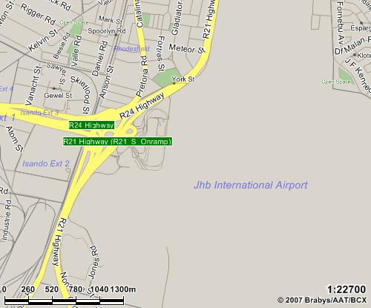

- Local Maps
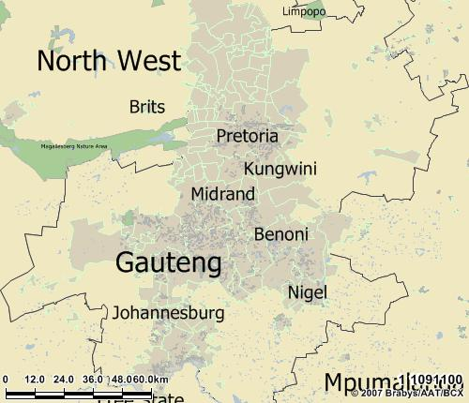

- National Maps
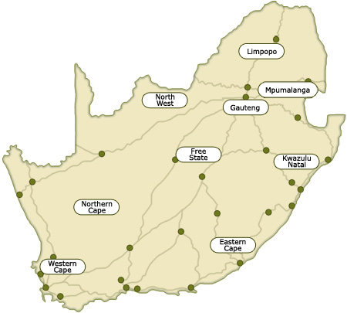

COMPLETE FORMATIVE ASSESSMENT NO 18 IN YOUR WORKBOOK

Module 2 & 3
Read, Interpret and Use Maps
Draw Maps According to Scale

Map Legends

For a map to contain a large amount of easily read information, a system of symbols must be employed. Many commonly used symbols have become generally accepted or are readily understood. Thus cities and towns are indicated by dots or patches of shading; streams and bodies of water are often printed in blue; and political boundaries are shown by coloured ribbons or dotted lines. A cartographer, as mapmakers are called, may, however, devise a great variety of symbols to suit various needs. For example, a dot may be used to symbolize the presence of 10 000 head of cattle, or crossed pickaxes may be used to denote the location of a mine. The symbols used on a map are defined in the map’s key or legend.

Below is an example of a map legend found in a standard road map:

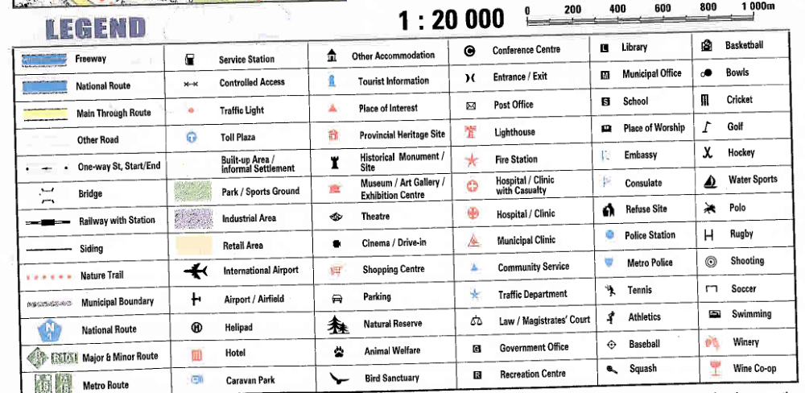

COMPLETE FORMATIVE ASSESSMENT NO 19 IN YOUR WORKBOOK

How does one draw a map?

Maps and associated site information can be hand drawn, computer drawn, or made through a combination of both.

Manually drawn maps do not require any special tools or skills and is useful to quickly produce a simple map for a particular purpose. Hand-drawing maps can, however, be time consuming for detailed maps, they are not likely to be very accurate, and need to be redrawn every time.

Site information can be labelled in the original print or written on by hand.

Many digital mapping tools are now available as computer based tools, and have become easier to use. There are many different mapping programmes available. These allow you to draw features on the computer and label them with basic site information. The maps can easily be updated without the need to redraw them each time. You can quickly print out professional maps of the area and layers that you choose.

How long will it take to draw a map?

How long it takes you to produce a map largely depends on how easy it is to obtain basic maps and information you need, and how much detail you wish to record.

Scale

A map represents a portion of the earth’s surface. Since an accurate map represents the land, each map has a “scale” which indicates the relationship between a certain distance on the map and the distance to the ground. The scale is usually located in the legend box of a map, which explains the symbols and provides other important information about the map. A scale can be printed in a variety of ways.

- A ratio or representative fraction (RF) indicates how many units on the earth’s surface are equal to one unit on the map. It can be expressed as 1/100,000 or 1: 100,000. In this example, one centimetre on the map equals 100,000 centimetres (1 Kilometre) on the earth.

- A word statement gives a written description of the scale, such as “One centimetre equals one kilometre” or “One centimetre equals ten kilometres”. Obviously, the first map would show much more detail that the second because one centimetre on the first map covers a much smaller area than on the second map.

The first two methods of indicating scale would be ineffective if the map is reproduced by a method such as photocopying and the size of the map is modified. If this occurs, and one attempts to measure a centimetre on modified map, it’s not the same as a centimetre on the original map.

- A graphic scale does solve this problem because it is simply a line marked with distance on the ground which the map user can use along with a ruler to determine scale on the map.

- Maps are often known as large scale or small scale. A large-scale map refers to one which shows greater detail because the representative fraction (i.e. 1/25,000) is a larger fraction than a small-scale map which would have an RF of 1/250,000 to 1/7,500,000. Large scale maps will have a RF of 1:50,000 or greater (i.e. 1: 10,000). Those between 1:50,000 to 1: 250,000 are maps with an intermediate scale. Maps of the world which fit on two 8¹/₂ by 11 inch pages are very small scale, about 1 to 100 million.

How to measure distance on a map

Maps aren’t just useful for directions; they can also help to determine the distance between two (or more) places. Here’s how:

- Find the scale of the map you’re going to use – it might be a ruler-looking bar scale or a written scale, in words or numbers.
- Use a ruler to measure the distance between two places. If the line is quite curved, use a string to determine the distance and then measure the string.
- If the scale is a representative fraction (and looks like 1/100,000 or 1: 100,000), multiply the distance of the ruler by the denominator, giving distance in the ruler units.
- If the scale is a word statement (i.e. “One centimetre equals one kilometre”) then determine the distance.
- For a graphic scale, you’ll need to measure the graphic and divide the scale into the measured units on the ruler.
- Convert your units of measurement into the most convenient units for you.
- Watch out for maps that have been reproduced and have had their scale changed. A graphic scale will change with the reduction or enlargement but the other scales become wrong

What you need:

- Ruler
- String
- Map
- Calculator

COMPLETE FORMATIVE ASSESSMENT NO 20 IN YOUR WORKBOOK

Acknowledgements:
This material was taken from the AgriSETA website (www.agriseta.org.za).

