Shape, Space, Time and Motion
US No: 7463 Level 1, Credits 2
LEARNER MANUAL

Learner’s name
Facilitator’s name
Starting date

Before we start…
Dear Learner - on completion of this Learner Guide, you will have acquired all the knowledge and skills to be assessed against the following unit standard:
Title: Describe and represent objects and the environment in terms of shape, space, time and motion
US No: 7463 NQF Level: 1 Credits: 2
The full unit standard is attached at the end of this module. Please read the unit standard at your own time. Whilst reading the unit standard, make a note of your questions and aspects that you do not understand, and discuss it with your facilitator.
You will also be handed a Learner Workbook. This Learner Workbook should be used in conjunction with this Learner Guide. The Learner Workbook contains the activities that you will be expected to do during the course of your study. Please keep the activities that you have completed as part of your Portfolio of Evidence, which will be required during your final assessment.
You will be assessed during the course of your study. This is called formative assessment. You will also be assessed on completion of this unit standard. This is called summative assessment. Before your assessment, your assessor will discuss the unit standard with you.
Enjoy this learning experience!
How to use this guide …
Throughout this guide, you will come across certain re-occurring “boxes”. These boxes each represent a certain aspect of the learning process, containing information, which would help you with the identification and understanding of these aspects. The following is a list of these boxes and what they represent:
Definition | What does it mean? Each learning field is characterized by unique terms and definitions – it is important to know and use these terms and definitions correctly. These terms and definitions are highlighted throughout the guide in this manner.

Activity | You will be requested to complete activities, which could be group activities, or individual activities. Please remember to complete the activities, as the facilitator will assess it and these will become part of your portfolio of evidence. Activities, whether group or individual activities, will be described in this box.

Example | Examples of certain concepts or principles to help you contextualise them easier, will be shown in this box.

What are we going to learn?
Section | Contents | Page  No
 | What will I be able to do? | 3
 | Learning Assumed to be in Place | 3
 | Learning Outcomes | 3
 | Introduction | 3
1 | Position and change of an object in space | 4
2 | The development of the base-ten number system | 11

What will I be able to do?
When you have achieved this unit standard, you will be able to:
- Describe and represent the position and change in position of an object in space.
- Illustrate changes in size and shape of the appearance of objects as a result of changes in orientation.
Learning Assumed to be in Place
It is assumed that a learner attempting this unit standard will show competence against the following ABET standards:
- Describe, draw, analyse and construct planar shapes and patterns, and spatial objects.
- Describe, interpret and represent the environment geometrically.
- Apply concepts of lines of sight, views and perspectives in drawing, pictures and photographs.
Learning Outcomes
When you have achieved this unit standard, you will be able to:
- Describe and represent the position and change in position of an object in space.
- Illustrate changes in size & shape of appearance of objects as result of changes in orientation.
An Introduction
Is mathematics important?
Knowing mathematics is more than being able to balance your chequebook. Mathematical skills are needed to shop wisely, buy the best insurance, build your house, buy furniture, and follow a recipe and, especially critical today, in the world of work.
How would one be able to make sure you earned the correct salary, you measured correctly or that an items cost you the correct price without mathematics?
Let’s take a bit of time to examine this in more detail:
Attitudes and misconceptions
Do your experiences in mathematics cause you anxiety? Have you been left with the impression that mathematics is difficult and only some people are 'good' at mathematics? Are you one of those people who believe that you 'can't do mathematics', that you're missing that 'math gene'? Do you have the dreaded disease called Math Anxiety? Read on, sometimes our school experiences leave us with the wrong impression about mathematics. There are many misconceptions that lead one to believe that only some individuals can do mathematics. It's time to dispel those common myths…

Tick off true or false:
Statement | True | False | Answer
There is one way to solve a problem… |  |  | There are a variety of ways to solve mathematical problems and variety of tools to assist with the process.
You need a 'math gene' or dominance of your left-brain to be successful at mathematics… |  |  | Like reading, the majority of people are born with the ability to do mathematics.  Children and adults need to maintain a positive attitude and the belief that they can do mathematics.  This self-belief has often been scarred somewhere in the past… today is the day to make a fresh start and begin from scratch!
People don't learn the basics anymore because of a reliance on calculators and computers…. |  |  | Research at this time indicates that calculators do not have a negative impact on achievement.  The calculator is a powerful teaching tool when used appropriately. Most facilitators now help you to learn how to use any technological tool to your advantage!
You need to memorize a lot of facts, rules and formulas to be good at math… |  |  | As stated earlier, there's more than one way to solve a problem. Memorizing procedures is not as effective as conceptually understanding concepts!

The question to ask yourself is: Do I really understand how, why, when this will work?
Positive attitudes towards mathematics are the first step to success!
When does the most powerful learning usually occur?
- When one makes a mistake!
- If you take the time to analyse where you go wrong, you can't help but learn. Never feel badly about making mistakes in mathematics!
- Mathematics has never been more important, technology demands that we work smarter and have stronger problem-solving skills!

Session 1: Position and change of an object in space

After completing this session, you will be able to: SO 1: How to describe and represent the position and change in position of an object in space.
In this session, we are going to explore the following concepts:
- How to describe and represent the position and change in position of an object in space.
- Words, rough sketches and abstract representation on a Cartesian plane.
- The positions of objects described in relation to each other using graphs, sketches and written or verbal descriptions.
- How to represent the positions of objects correctly on a Cartesian plane.
- The change of position of objects in terms of the relationship between space and time.
- What is a tessellation and how to identify it?
1.1 Describe and represent the position and change in position of an object in space
A bit of history about a man called Descartes and the Cartesian plane...
Way back mathematics was divided into geometry and algebra, and these were two separate subjects. Equations weren’t done in geometry, and pictures weren’t used in algebra. Around 1637, a French guy named René Descartes (pronounced "ray-NAY day- CART") came up with a way to put these two subjects together.
A street map will be used to explain Descartes' method. If you're trying to find a street that you've never been on before, you look for the street name in the index of the street map. Suppose the index says that the street is located at D12. This means that you go across the top of the map and find "D", and then go down the side and find "12". You trace down and across to find the box labelled as "D12", and then you look inside the box for the street you need. “Somebody” figured out this way to give you directions on the map, by telling you "how far over" and "how far down" you need to look. Descartes did something similar.
You’ve learned about the basic (counting) number line back in elementary school:

1 2 3 4 5 6 7 8 9 10

Later on, you were introduced to zero and negatives, which completed the number line:

1 2 3 4 5 6 7 8 9 10

Descartes' breakthrough was in taking a second number line, standing it up on its end, and crossing the first number line at zero:
The number lines are called "axes" (pronounced "ACK-seez"). The horizontal number line is called the "x-axis" ("eks-ACKsiss"); the vertical one is the y-axis. (The arrows at the ends of the axes indicate the direction in which the numbers are getting larger. Therefore, only the axes should have arrows at the end. The whole flat expanse, top to bottom, side to side, is called the "plane". When you put the axes in the plane like this, it is called the "Cartesian" ("Carr-TEE-zhun") plane. ("Cartesian" is derived from the name "Descartes".
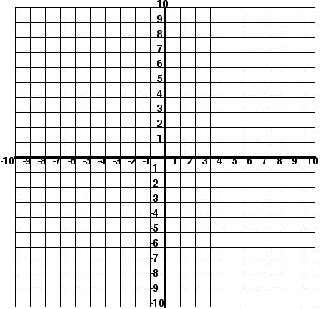
Definition | To draw or graph a point on a number line or on a coordinate plane.

Example | Let’s look at this example of how one would use plotting points:

When you were reading the map, you went over to D and then down to 12. The Cartesian plane works similarly. However, the "D12" designation was unambiguous, because it was easy to tell which stood for which. Even if the designation had been written as "12-D", you still would have known which box to go to, because the "D" would still have been across the top and the "12" would still have been along the side. But in the Cartesian plane, both axes are labelled with numbers.
For instance, if you were given the direction "(5, 2)" (pronounced as "the point five two" or just "five two"), where would you look? To understand the meaning of "(5, 2)", you have to know the following rule: The x-coordinate (the number for the x-axis) always comes first. The first number (the first coordinate) is always on the horizontal axis.
(Referring to points as “(x, y)” or “x-y points”, reinforcing that the first coordinate is counted off along the x-axis and the second coordinate is counted off along the y-axis sometimes indicates this. Some people keep track of this by noting that the letters are used in alphabetical order.)
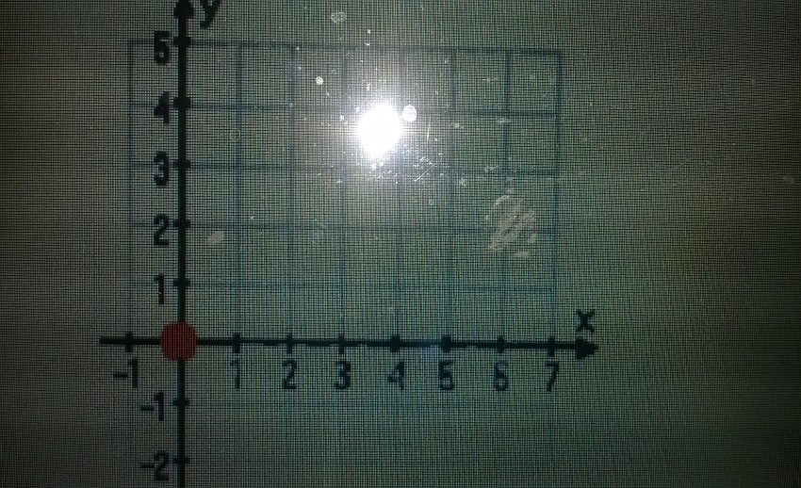
The modern Cartesian coordinate system in two dimensions (also called a rectangular coordinate system) is commonly defined by two axes, at right angles to each other, forming a plane (an x y-plane). The horizontal axis is labelled x, and the vertical axis is labelled y. In a three-dimensional coordinate system, another axis, normally labelled z, is added, providing a sense of a third dimension of space measurement. The axes are commonly defined as mutually orthogonal to each other (each at a right angle to the other). (Early systems allowed "oblique" axes, that is, axes that did not meet at right angles.) All the points in a Cartesian coordinate system taken together form a so-called Cartesian plane. Equations that use the Cartesian coordinate system are called Cartesian equations.
The point of intersection, where the axes meet, is called the origin normally labelled O. With the origin labelled O, we can name the x axis Ox and the y axis Oy. The x and y axes define a plane that can be referred to as the x-y plane. Given each axis, choose a unit length, and mark off each unit along the axis, forming a grid. To specify a particular point on a two-dimensional coordinate system, you indicate the x unit first (abscissa), followed by the y unit (ordinate) in the form (x, y), an ordered pair. In three dimensions, a third z unit (applicate) is added, (x, y, and z).
The choices of letters come from the original convention, which is to use the latter part of the alphabet to indicate unknown values. The first part of the alphabet was used to designate known values. An example of a point P on the system is indicated in the picture below using the coordinate (3, 5).
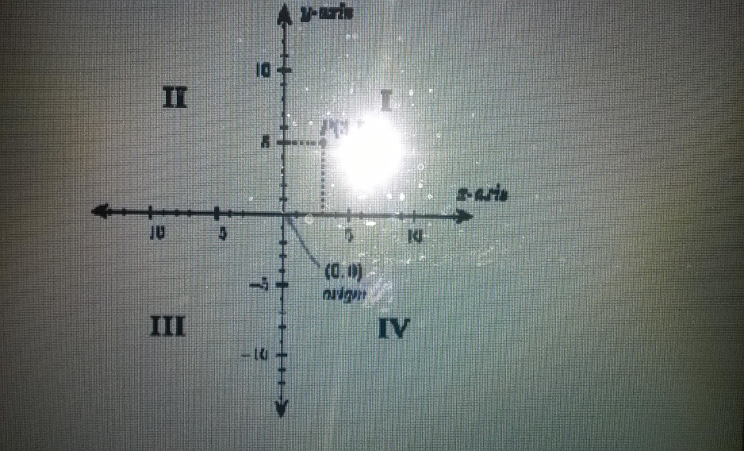

The arrows on the axes indicate that they extend forever in the same direction (i.e. infinitely). The intersection of the two x-y axes creates four quadrants indicated by the Roman numerals I, II, III, and IV. Conventionally, the quadrants are labelled counter-clockwise starting from the northeast quadrant. In Quadrant, I the values are (x, y), and II :( x, y), III :( x y) and IV :( x, y). (See table below.)
Quadrant | x-values | y-values
I | > 0 | > 0
II | < 0 | > 0
III | < 0 | < 0
IV | > 0 | < 0

1.3 The positions of objects described in relation to each other using graphs
Physics is the study of the universe in terms of its basic constituents (what is it made of?), and the rules of its operations (why do things work the way they do?). The first true advances in the modern era of science began with observation and experimentation on motion. The reason is quite simple. Those things, which are of interest in science, are the things, which undergo change. To understand how something works, you have to see it in action. The workings of the universe include anything in the universe which experiences change according to some repetitive pattern. Change could be in the form of a chemical reaction, an increase or decrease in the population of butterflies, etc. The easiest changes to observe are those of motion. An object is moved from one position in space to another. The motion generally leaves the object itself unchanged and thus simplifies the observation.
Although it may seem trivial to discuss an object moving from one spot to another, the quantitative description of motion quickly advances one's understanding of observations of the operation of the universe, first on a descriptive level then on the deeper level of explaining why things occur. In the short span of time between Galileo and Newton, mankind went from understanding the motion of falling bodies to understanding the motion of the moon around the earth. The study of motion explained the regularity of the pendulum clock and predicted the position of the planets in the night time sky. The reason for this rapid success is the relative simplicity of the mathematics associated with motion as well as the ready availability of experiments to clarify ideas. For this reason, it is inevitable that studies of physics also begin with the study of motion.
To begin any serious study, we first need to find a method for quantifying data. In the case of motion, the evidence that motion has occurred is a displacement of the object that moved or changed position. The position is quantified by measuring it relative to some fixed position (usually referred to as the origin) in terms of an internationally agreed upon standard. The standard unit of distance is the meter. In mathematical terms, we use a symbol, like x, to specify the position of an object relative to the origin. This use of symbols requires some patience if you are not already comfortable with it.
The normal tendency of students new to physics is to immediately replace symbols with numbers as soon as possible. Experience will show you that this is generally not a good thing to do. What's most important to you is the very practical problem of mistakes: you tend to make more algebra errors with numbers than with symbols (despite what your instincts may tell you, this is always true!). What's most important to a scientist, however, is that the symbols represent the essence.
The numbers are hardly ever the important point in understanding what's going on. Numbers can be changed by situation, choice, or any number of unexplained reasons, but the mathematical description of what happens to the symbols is what represents the underlying truth. In other words, if you derive an equation by mathematical rules that correctly describe the way nature works; it’s the equation that is always true. The numbers that go into the equation can vary by large amounts, but whatever their values, they must always satisfy the equation! Our hope for the course is to make the language of the equations second nature to you so that the essence of the science represented by them is clear.
As you have seen, visualization is vital to understanding what equations tell us. We will commonly make use of graphs to understand the behaviour of the equations we derive. For motion, the Cartesian graph is the standard means of looking at position (and hence displacement) and time. An example of such a graph for a person running a 100-meter dash is shown below (on the next page).
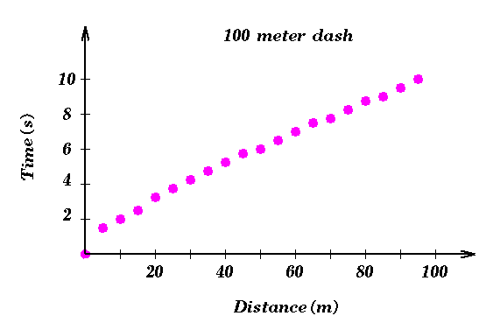
The power of graphs like this is in giving a concise description of what happened during the race. To see this, all we need to do is to give a description, in words, of what the graph depicts as a picture. For example, we see that the runner starts at the origin, moves 5 meters in the first 1.6 seconds, moves 5 meters more (to a position 10 meters from the origin) in the next .4 seconds, etc. From this kind of direct information, we can infer all kinds of other information. For example, we can quantify how long it takes a runner to get out of the starting blocks, how effective the runner's late kick at the end of the race is, and so forth. We also have some notion of how fast the runner is moving. If we compare this runner's motion to that of another runner in the race as in the graph below, we find that we can compress even more information into the picture.
Sketches
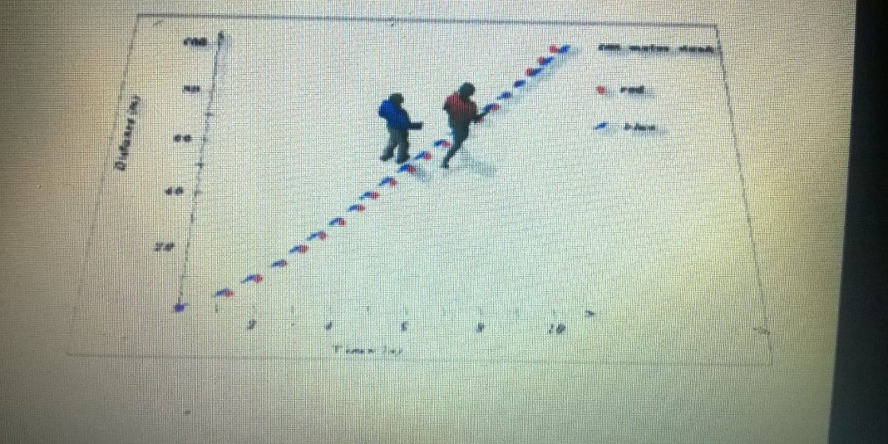
This graph shows two runners (red and blue) which are racing each other. They start at the same origin, but blue is faster out of the blocks, so that red is left behind (i.e. blue gets to each 5-meter marker at less time than red). Eventually, red's late kick for the finish line blows past blue and red wins the race. The picture sums up all of this and much, much more in a very neat fashion.
Written or verbal descriptions
In order to understand how one would represent shapes and movement in mathematics, one has to examine the use of Vectors.
What is a Vector?
This simple question is surprisingly difficult to answer. Vectors are an essential scientific concept, indispensable for both the physicist and the mathematicians. It is strange then, that despite the obvious importance, there is no clear, universally accepted definition of this term. A physicist needs to be able to say that velocities, forces, fluxes are vectors.
A geometer, and for that matter a pilot, will think of a vector as a kind of spatial displacement. Everyone would agree that a choice of a vector involves multiple degrees of freedom, and that vectors can linearly superimposed. This description of “vector” evokes useful and intuitive understanding, but is difficult to formalize.
All quantities that have a direction, like a step-in space, are called vectors. A vector is three numbers. In order to represent a step-in space, we really need three numbers, but we are going to invent a single mathematical symbol, r, which is unlike any other mathematical symbols we have so far used. It is not a single number, it represents three numbers: x, y, and z. It means three numbers, but not only those three numbers, because if we were to use a different coordinate system, the three numbers would be changed to, x1, y1, and z1., and. However, we want to keep our mathematics simple and so we are going to use the same mark to represent the three numbers (x, y, and z) and the three numbers (x1, y1, z1). That is, we use the same mark to represent the first set of three numbers for one coordinate system, but the second set of three numbers if we are using the other coordinate system. This has the advantage that when we change the coordinate system, we do not have to change the letters of our equations.
1.4 Why would someone represent the positions of objects correctly on a Cartesian plane?
- It is often used in mapping and land surveying.
- It helps us to plan and construct the structures such as dams, irrigation systems, sheds, stores and silos.
How to represent the positions of objects correctly on a Cartesian plane
In order to represent it, we will need to “plot” the correct “coordinates” on the graph (or Cartesian plane).
What does that mean?
What is a coordinate system? Coordinate systems as a basic method for geo-referencing are used to locate the position of objects in two or three dimensions into correct relationship with respect to each other.

What kind of coordinate systems are used in mapping?
Coordinate systems are often classified in spatial coordinate systems: e.g. spatial geographic and geocentric coordinate systems and in plane coordinate systems: e.g. 2D Cartesian and polar coordinate systems. Generally, two types of coordinate systems are given on maps: Cartesian coordinates (or X, Y map projection coordinates) and projected geographic coordinates.
Satellite positioning systems (e.g. GPS) make use of 3-dimensional spatial coordinate systems to define positions on the earth surface, with reference to a mean reference surface for the earth (e.g. GPS measurements use the WGS84 ellipsoid). 2D Polar coordinates are often used in land surveying. For some types of surveying instruments, it is advantageous to make use of this coordinate system.
What is a graticule? The graticule represents the projected position of selected meridians (lines with constant longitude l) and parallels (lines with constant latitude j).
What is a grid? The grid represents the lines having constant X or Y coordinates and situated at constant intervals depending on map scale.
Let’s practice everything that we have learnt together…
Activity  Please complete Activity 1 in your learner workbook | My Notes

1.5 The change of position of objects in terms of the relationship between space and time
A physical vector (follow the link to a formal definition and in-depth discussion) is a geometric quantity that corresponds to a linear displacement. It is customary to depict a physical vector as an arrow. By choosing a system of coordinates a physical vector V, can be represented by a list vector (v1…, v n) T. Physically, no single system of measurement cannot be preferred to any other, and therefore such a representation is not canonical. A linear change of coordinates induces a corresponding linear transformation of the representing list vector.
What is a tessellation and how to identify it?
Activity  Please complete Activity 2 in your learner workbook | My Notes

Session 2: The development of base-ten number system

In this session, we are going to explore the following concepts:
- How to illustrate changes in size & shape of appearance of objects as result of changes in orientation.
- How to describe the perception of the changes in an object is described from different observational points.
- How 3-dimensional objects are represented in 2 dimensions in such a way that the size and shape of the object are correctly represented.
- The relationships between surface area and volume are described.
2.1 Illustrate changes in size & shape of appearance of objects as result of changes in orientation
2-Dimensional shapes
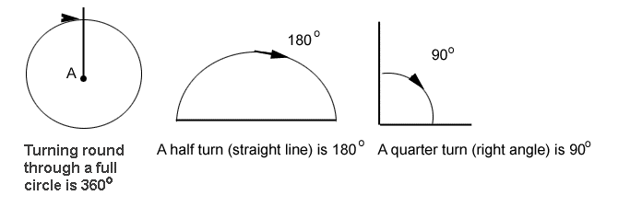
You probably have a tiling pattern on a wall or floor of your home, usually in the kitchen or bathroom. Patterns made from pieces that fit together without leaving any gaps are called tessellations. The simplest ones are made from regular shapes.
A regular shape has straight sides all the same length and all its angles equal

Definition | Tessellation: The repeated use of geometric figures to completely cover a plane without overlapping.

Three regular shapes can each tessellate. They are:
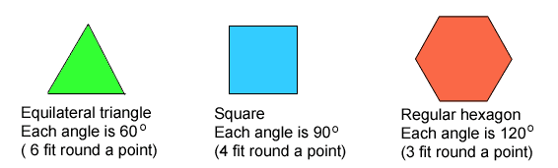
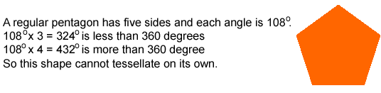
Combination
Shapes can often be put together to make tessellations.
Example | Example 1  Regular octagons (eight sides) will not tessellate alone, but they can be combined with squares.

Example | Example 2  Rectangles can be used with triangles.

Example | Example 3  Parallelograms and triangles can be combined.

Using symmetry
Some shapes have a line (or lines) of symmetry - sometimes called 'mirror lines'.
In each case, if you stood a mirror on the line of symmetry, the shape would look unchanged. (You can check this by using a mirror, or by tracing a shape and folding it along the mirror line.)
Jed and Mita each used rectangular tiles to make a tessellation.
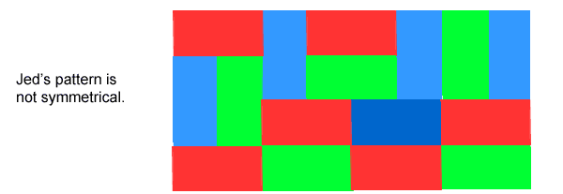
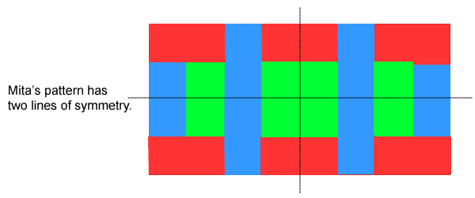
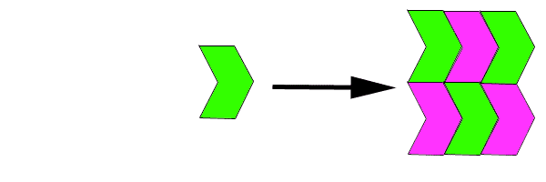
Drawing and using floor plans
Zindzi measured her new garden and drew a plan using squared paper. Each square has side length 1 cm, so she used 1 cm to represent 1 m. She drew and labelled the features she wants:
- A patio near the house 2.5 m wide.
- A flowerbed close to the fence, 1.5 m wide.
- A path 0.5 m wide along the length of the flowerbed.
The rest of the garden will be grassed. Her plan looks like this:
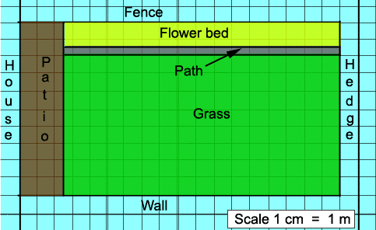

Activity  Please complete Activity 3 in your learner workbook | My Notes
Rectangles and squares
In a rectangle opposite sides are equal, so to work out the perimeter of a rectangle you just need to know the length and width.
Example | Example 1  Here the length is 15 cm and the width 6 cm.  Method 1  Length = 15 cm and width = 6 cm  Perimeter = 15 + 6 + 15 + 6 = 42 cm  Method 2  Because opposite sides are equal you can also work out the perimeter in this way: double the length, double the width, and then add the results together.  (15 x 2) + (6 x 2) = 30 + 12 = 42  Method 3  Add the length and width then double it.  15 + 6 = 21  21 x 2 = 42  The method you choose is up to you - each one will give the same answer

Example | Example 2  A square is a rectangle with four equal length sides. So, you only need to know the measurement of one side. The perimeter of this shape can be worked out as 5 + 5 + 5 + 5 = 20 m or you can multiply the length by four. 5 x 4 = 20

Activity  Please complete Activity 4 in your learner workbook | My Notes

Perimeter and rectangles
Introduction
The perimeter of a shape is the distance all the way round its edges. Perimeter is measured in units such as centimetres, feet or metres. The measurements needed to calculate a perimeter depend on the shape. For a rectangle, you will need to know the length and width of the shape. (It is usual to call the longest side the length and the shortest the width or breadth.)

Example | Example 1  This diagram represents a pen for Thabo’s hens. How much netting does he need to go around the plot? All measurements are in metres.  Here the length is 5 m and the width is 4 m.  The perimeter of the plot is 5 + 4 + 5 + 4 = 18  So, he needs 18 m of netting.

Example | Example 2  A square is a rectangle with four equal length sides. So, you only need to know the measurement of one side. The perimeter of this shape can be worked out as 5 + 5 + 5 + 5 = 20 m or you can multiply the length by four. 5 x 4 = 20

Further examples
Remember that perimeter is the total length of the boundary of the shape.
Example | Example 1  Kit's allotment is this shape. Work out the perimeter. You need to know all four lengths.  30 + 18 + 22 + 17 = 87 m.

Example | Example 2  Dennis wants to apply an ornamental strip to the edge of this planter. How much does he need? All the sides of this regular hexagon are equal, so a single measurement is all you need.  You can work out 25 + 25 + 25 + 25 + 25 + 25 = 150cm (= 1.5m)  or use 25 x 6 = 150cm (= 1.5m)

Example | Example 3  This flowerbed has a low rail round it. What is its perimeter? The shape is symmetrical, so you do not need every length. Work your way round the twelve sides. Starting with the 4 m and moving round clockwise you get:  4 + 1 + 1 + 5 + 1 + 1 + 4 + 1 + 1 + 5 + 1 + 1 = 26 m  or  4 + 1 + 1 + 5 + 1 + 1 = 13  13 x 2 = 26 m

Activity  Please complete Activity 5 in your learner workbook | My Notes

2.2 Moving from 2-Dimensional shapes to 3-Dimensional shapes
Volume in space
Volume is a measure of the space taken up by a solid object and is measured in cubic units such as cubic centimetres (cm³) or cubic metres (m³). The Imperial system uses units such as cubic feet (ft³).
A solid such as a cube or a cuboid is three-dimensional (3D). That simply means that you need three measurements in order to work out its volume, length, width and height. Sometimes the last measurement is called depth or thickness.
A unit cube has six square faces, and all three dimensions are the same, 1cm. The volume of the cube is 1 cubic centimetre (1 cm³).
In simple cases you can find the volume of an object by counting the number of unit cubes it contains.
Each of the following diagrams represents a shape made from unit cubes.
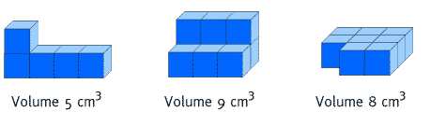
Volume and capacity is not quite the same thing; capacity is the amount a solid can contain. In the metric system capacity is usually measured in litres. (The Imperial system uses gallons). Remember: 1000 cm³ = 1000 millilitres = 1 litre.
Cubes and cuboids
A cuboid is a solid with six rectangular faces and all its angles right angles. (A cube is a special example of a cuboid because all its faces are squares.).

Example | Example 1  Each of these two  cuboids has the  same volume, 8  cm³, and the same  dimensions: length  4 cm, width 2 cm,  and height 1 cm.  The volume of the first can be found by counting the unit cubes.  The volume of the second is found using the rule:  Volume of a cuboid = length x width x height  The dimensions of a cube are all the same, so the rule for finding the volume is:  Volume of a cube = length x length x length = length³

Example | Example 2  Its volume is  2 x 2 x 2 = 8 cm³

Activity  Please complete Activity 5 in your learner workbook | My Notes

Practical examples
The most important thing to remember when you are working out practical examples of volume or capacity is that all measurements must be in the same units.
You will often have measurements in both metres and centimetres; change them all into the same units before you begin your calculation.
Example | Example 1  Vijay's window box is a cuboid of  length 1 m, width 20 cm and  height 30 cm. Work out its  volume.  Make all the units centimetres.  1 m = 100 cm, so the volume is 100 x 20 x 30 = 60 000 cm³

Example | Example 2  Igor is working out how many cubic metres of concrete he will need for his patio. It will be 2 metres wide and 8 metres long and he needs to make it 10 cm deep. How much concrete will he need? Make all the units metres.  10 cm = 0.1 m, so the volume = 8 x 2 x 0.1 = 16 x 0.1 = 1.6 m³

Example | Example 3  Bonny has made a rectangular garden pond 2 m long and 1 m wide. She wants to fill it to a depth of 30 cm. How many litres of water will she need?  Make all the units’ centimetres.  200 x 100 x 30 = 600 000 cm³  Remember that 1 litre = 1000 cm³  600 000 ÷ 1 000 = 600  She will need 600 litres of water.

Cylinders
Look at this box. The volume is width x height x length. The width x height is the area of the end. So the volume can be written area of end x length. This works for cylinders too. This cylinder has a circular end, straight sides, and is the same width all the way along.

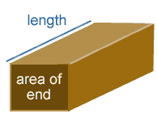 | 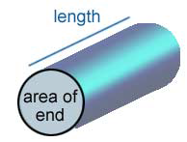

Example | How many litres of compost do you need to fill this plant holder? The volume is end area  X length. That is  1 000 x 50 =  50 000 cm³  A litre is 1 000 cm³. So the volume of the plant holder is  50 000 ÷ 1 000 = 50 litres  So you need 50 litres of compost to fill it.  She will need 600 litres of water.  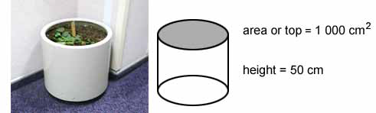

2.3 Perception of the changes in an object is described from different observational points
The relationships between surface area and volume
When we speak in normal language about the changes in shape, it can be verbalised as follows:
Number of dimensions | 1 | 2 | 3
Words we would use | meter | Square meter | Cubic meter
How we could write it  mathematically | m | m2 | m3
How we can calculate  it | m | m x m | m x m x m
What it would look like if we had to visualise it | 1 m | 1m2 | 1m3
The relationship  between the dimensions | Straight line | Surface | Volume

Example | How 3-dimensional objects are represented in 2 dimensions in such a way that the size and shape of the object are correctly represented.

Three-dimensional coordinate system
Sometime in the early 19th century the third dimension of measurement was added, using the z-axis.
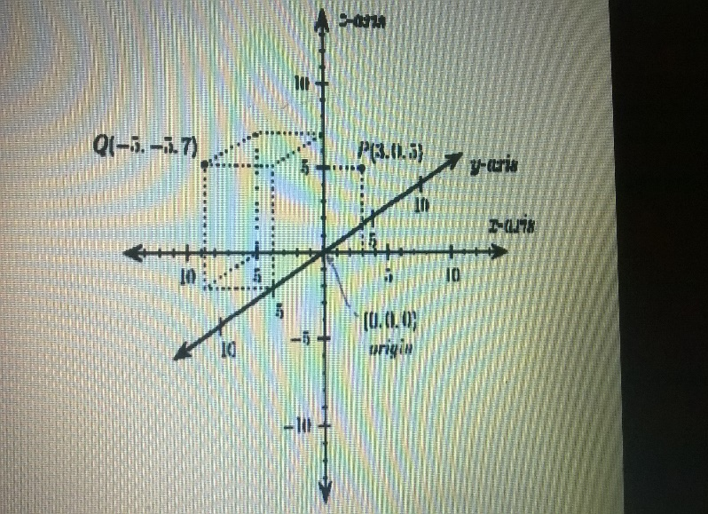
The coordinates in a three-dimensional system are of the form (x, y, z). An example of two points plotted in this system is in the picture above, points P (3, 0, and 5) and Q (5, 5, and 7). Notice that the axes are depicted in a world coordinates orientation with the z-axis pointing up. The x-, y-, and z-coordinates of a point (say P) can also be taken as the distances from the y z-plane, x z-plane, and x y-plane respectively. The figure below shows the distances of point P from the planes.
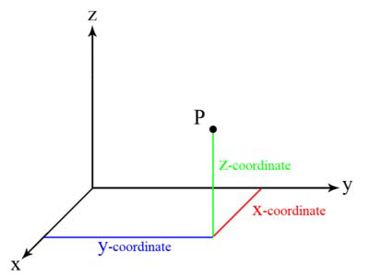
The x y-, y z-, and x z-planes divide the three-dimensional space into eight subdivisions known as octants, similar to the quadrants of 2D space. While conventions have been established for the labelling of the four quadrants of the x'-y plane, only the first octant of three-dimensional space is labelled. It contains all of the points whose x, y, and z coordinates are positive. That is, no point in the first octant has a negative coordinate.
The three-dimensional coordinate system provides the physical dimensions of space — height, width, and length, and this is often referred to as "the three dimensions". It is important to note that a dimension is simply a measure of something, and that, for each class of features to be measured, another dimension can be added. Attachment to visualizing the dimensions precludes understanding the many different dimensions that can be measured (time, mass, colour, cost, etc.). It is the powerful insight of Descartes that allows us to manipulate multi-dimensional object algebraically, avoiding compass and protractor for analysing in more than three dimensions.
Orientation and "handedness"
The three-dimensional Cartesian coordinate system presents a problem. Once the x- and y-axes are specified, they determine the line along which the z-axis should lie, but there are two possible directions on this line. The two possible coordinate systems which result are called 'right-handed' and 'left-handed'.
The origin of these names is a trick called the right-hand rule (and the corresponding left-hand rule). If the forefinger of the right hand is pointed forward, the middle finger bent inward at a right angle to it, and the thumb placed a right angle to both, the three fingers indicate the relative directions of the x-, y-, and z-axes respectively in a right-handed system. Conversely, if the same is done with the left hand, a left-handed system results.
The right-handed system is universally accepted in the physical sciences, but the left-handed is also still in use.
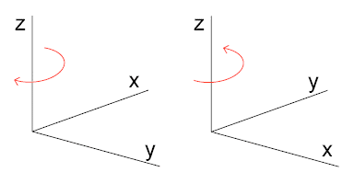
The left-handed orientation is shown on the left, and the right-handed on the right. If a point plotted with some coordinates in a right-handed system is replotted with the same coordinates in a left-handed system, the new point is the mirror image of the old point about the x y-plane.
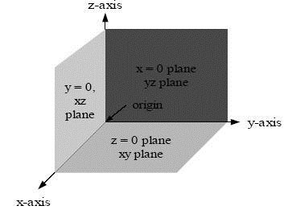
The right-handed Cartesian coordinate system indicating the coordinate planes.
More ambiguity occurs when a three-dimensional coordinate system must be drawn on a two-dimensional page. Sometimes the z-axis is drawn diagonally, so that it seems to point out of the page. Sometimes it is drawn vertically, as in the above image (this is called a world coordinates orientation).
In general, in the three-dimensional Euclidean space, a single linear Cartesian equation represents a plane, whereas an algebraic surface of order is given by a polynomial equation of degree. Curves are represented as the intersection of two surfaces. For example, lines are represented as the intersection of two planes, circles as the intersection of a sphere and a plane (or of two spheres). Of course, a given curve can be realized by intersection in infinitely many ways, which correspond to infinitely many different equivalent systems of equations representing the same curve. In any case two equations are needed since a single Cartesian equation can represent a curve only in the plane.
An alternative way to represent a locus is to use parametric equations. Cartesian equations of lines can be derived from parametric ones by algebraic elimination of the parametric variable(s).

