

ANALYSE CULTURAL PRODUCTS AND PROCESSES AS REPRESENTATIONS OF SHAPE, SPACE AND TIME
US No: 7464 Credits 2

US No: 7464 Credits 2

Learner’s name
Facilitator’s name
Starting date

LEARNER W0RKBOOK


FORMATIVE ASSESSMENT NO. 1

IDENTIFY GEOMETRIC SHAPES AND PATTERNS IN CULTURAL PRODUCTS (7464:SO1)


- Look at the following patterns. They consist of repetitive geometric shapes. Identify the TRANSFORMTIONS used to create the pattern.
(Translation, Rotation, Reflection)

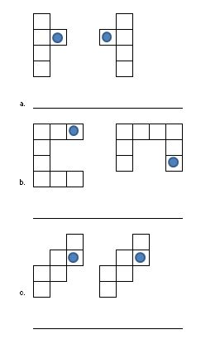

FORMATIVE ASSESSMENT NO. 2

SIMILARITIES AND DIFFERENCES IN SHAPES AND PATTERNS
(7464:SO2)

- Look at the following pairs of designs and note similarities and differences:
Indicate the geometric shapes used

DESIGN   | SIMILARITIES | DIFFERENCES
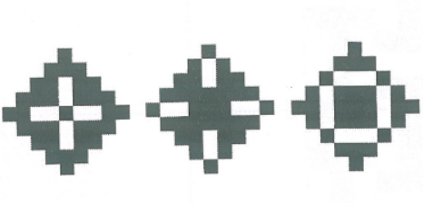

- Look at the shapes of the following pots. Give reasons for the specific shapes of pots in each instance.

  - Cooking and storage pots
____________________________________________
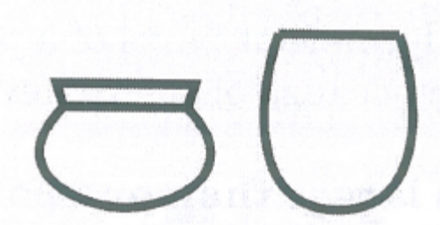
____________________________________________

____________________________________________

____________________________________________

  - Transport and drinking pots
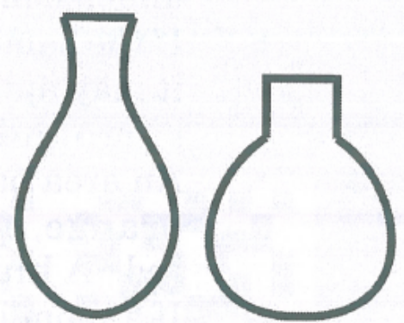
____________________________________________

____________________________________________

____________________________________________

____________________________________________

  - Cooking and eating pots
____________________________________________
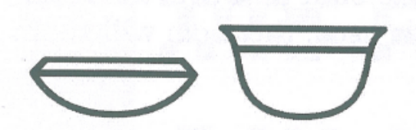
____________________________________________

____________________________________________

____________________________________________

FORMATIVE ASSESSMENT NO. 3

THE EFFECT OF COLOUR ON SHAPE AND SYMMETRY
(7464:SO3)

- Sketch a traditional hut used by the Zulu people.

- Look at the use of space in:

  - A traditional Cameroon Village and;

  - A Zulu settlement:

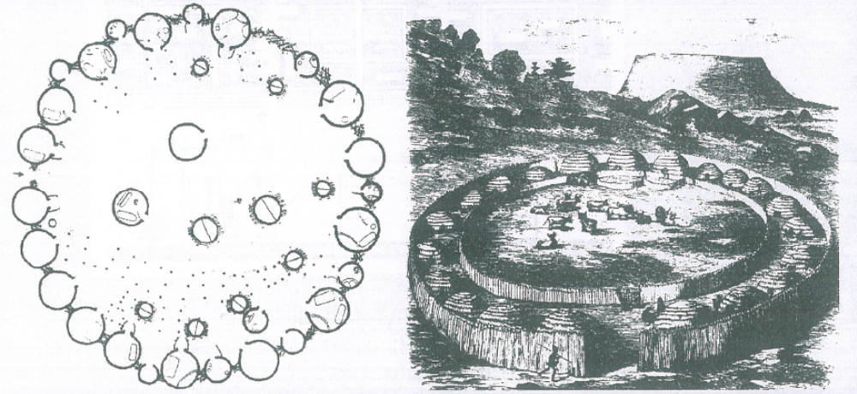

Why do you think that it was advisable to have a circular settlement plan?

_______________________________________________________________________

_______________________________________________________________________

_______________________________________________________________________

_______________________________________________________________________

Learner Name: ____________________________________________________________

Learner signature: _______________________________ Date: ______________________

Result of Assessment |  | C |  | NYC
Comments:
Assessor Name
Assessor Signature |  |  | Date
Learner Name
Learner Signature |  |  | Date
Result of Re-assessment |  | C |  | NYC
Comments:
Assessor Name
Assessor Signature |  |  | Date
Learner Name
Learner Signature |  |  | Date
Result of Re-assessment |  | C |  | NYC
Comments:
Assessor Name
Assessor Signature |  |  | Date
Learner Name
Learner Signature |  |  | Date

