Analyse cultural products and processes as representations of shape, space and time

US No: 7464 Level 1, Credits 2

LEARNER MANUAL

Learner’s name
Facilitator’s name
Starting date

Before we start…
Dear Learner - on completion of this Learner Guide, you will have acquired all the knowledge and skills to be assessed against the following unit standard:
Title: Analyse cultural products and processes as representations of shape, space and time
US No: 7464 NQF Level: 1 Credits: 2
The full unit standard is attached at the end of this module. Please read the unit standard at your own time. Whilst reading the unit standard, make a note of your questions and aspects that you do not understand, and discuss it with your facilitator.
You will also be handed a Learner Workbook. This Learner Workbook should be used in conjunction with this Learner Guide. The Learner Workbook contains the activities that you will be expected to do during the course of your study. Please keep the activities that you have completed as part of your Portfolio of Evidence, which will be required during your final assessment.
You will be assessed during the course of your study. This is called formative assessment. You will also be assessed on completion of this unit standard. This is called summative assessment. Before your assessment, your assessor will discuss the unit standard with you.
Enjoy this learning experience!
How to use this guide …
Throughout this guide, you will come across certain re-occurring “boxes”. These boxes each represent a certain aspect of the learning process, containing information, which would help you with the identification and understanding of these aspects. The following is a list of these boxes and what they represent:
Definition | What does it mean? Each learning field is characterized by unique terms and definitions – it is important to know and use these terms and definitions correctly. These terms and definitions are highlighted throughout the guide in this manner.

Activity | You will be requested to complete activities, which could be group activities, or individual activities. Please remember to complete the activities, as the facilitator will assess it and these will become part of your portfolio of evidence. Activities, whether group or individual activities, will be described in this box.

Example | Examples of certain concepts or principles to help you contextualise them easier, will be shown in this box.

What are we going to learn?
Section | Contents | Page  No
 | What will I be able to do? | 3
 | What do I need to know? | 3
1 | Identify geometric shapes and patterns in cultural products | 3
2 | Analyse similarities and differences in shapes and patterns, and the effect of colour, used by different cultures | 12
3 | Uses of shapes and space in different epochs and cultures | 18

What will I be able to do?
When you have achieved this unit standard, you will be able to:
- Describe and represent the position and change in position of an object in space; and
- Illustrate changes in size and shape of the appearance of objects as a result of changes in orientation.
- Identify geometric shapes and patterns in cultural products.
- Analyse similarities and differences in shapes and patterns, and effect of colour, used by cultures.
- Analyse and explain the way shapes and space are used in different epochs and cultures.
What do I need to know?
The following competency at ABET Numeracy level 3 is assumed to be in place:
- Describe, draw, analyse and construct planar shapes and patterns, and spatial objects;
- Describe, interpret and represent the environment geometrically;
- Apply concepts of lines of sight, views and perspectives in drawing, pictures and photographs.

Session 1: Identify geometric shapes and patterns in cultural products

After completing this session, you will be able to: SO 1: Identify geometric shapes and patterns in cultural products.
In this session we are going to explore the following concepts:
- How to identify geometric shapes and patterns in cultural products.
- Basic shape transformations.
- Basic geometric shapes - identified and described.
- Basic patterns - identified and described.
1.1 Identification of geometric shapes and patterns in cultural products
In visual art, shape can be defined as simple or complex, geometric or natural, and abstract, based on the qualities of the shape. A shape may combine different qualities, for example one shape can be both simple and natural, and another shape can be simple, geometric, and abstract.
Simple Shapes
Simple shapes are the square, rectangle, circle, ellipse, and triangle. These are the basic shapes that are used as the foundation to describe all other forms and shapes.
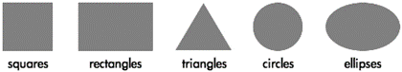
Squares and rectangles are the most common shapes in man-made objects. From architecture to the arrangement of text on a page to the shape of the page itself, most of what people encounter on a daily basis is composed of squares and rectangles. Because so much of the man-made world is composed of these shapes, squares and rectangles are familiar, safe, and comfortable, but their uniformity can also create a conservative or rigid effect. They can be used to suggest stability and truth. Squares are considered to be one of the most honest shapes, even more than other types of rectangles, because of their mathematical and visual simplicity.
Triangles suggest action because of movement from the corners “pointing” in a direction. Equilateral triangles are the most stable of the triangle shapes because all sides and angles are the same. Triangles can suggest growth or “reaching the top.”
Circles suggest infinity, completeness, softness, and security. Many ancient cultures considered the circle to be a perfect and even a sacred form. Circles are useful for focusing attention because of the closure of the shape, and because they are less common in man-made objects than shapes with straight lines. Ellipses share the psychology of circles, but to a lesser extent depending on the how close they are to a true circle.
Complex Shapes
Complex shapes combine parts or all simple shapes. Complex shapes include polygons or less “definable” shapes that may include parts of circles, squares, triangles, ellipses, and rectangles.
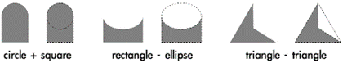
The effects of complex shapes can be predicted by identifying similarities to simple shapes. An easy way to visually simplify a complex shape is to squint and/or to watch from some distance. As the complex shape becomes more blurred, the details “disappear” and the overall effect will be easier to see.
Symmetry
The easiest way to explain symmetry is by cutting an object in half through the middle. If the two pieces are the same, the original object is symmetrical. Asymmetry is when the two halves are not the same.
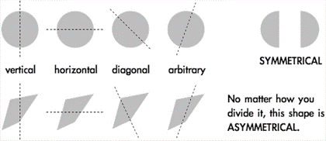
The direction of the cut is the axis of symmetry, and it can be horizontal, vertical, diagonal, or arbitrary. A circle is the most symmetrical of all objects, meaning that no matter how you cut it in half the two pieces will always be exactly the same as long as the cut is down the middle. Squares are also highly symmetrical, exhibiting vertical, horizontal, and diagonal symmetry. Ellipses and rectangles are horizontally and vertically symmetrical, but lack diagonal symmetry.
Another method used to view symmetry is reflection. Imagine holding a mirror down the middle of an object. If the reflection in the mirror completes the shape, the object is symmetrical along the axis with which the mirror is aligned.
Shapes like circles and squares gain some of their positive visual emotional reactions, like completion and honesty, from their symmetry.
Geometry
Geometry, in mathematics, is the study of shapes and their relationships, but the definition of geometric shape in visual art is more flexible. Geometric shapes are structured, often symmetrical, and often contain straight lines. The simple shapes squares, rectangles, circles, ellipses, triangles, are all geometric. While knowing all of geometry isn’t necessary to create visual art, understanding some of the principles helps to explain human responses.
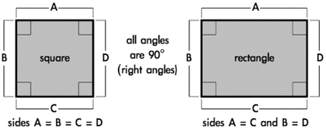
People naturally tend to align objects to the horizontal and vertical plane. This is based upon instinctive interpretations of the world around us, where gravity holds objects close to the earth’s surface. The horizon, where the earth meets the sky, is a long horizontal line when seen from a standing position with a clear view into the distance. These instinctive visual interpretations make horizontal alignment the strongest method of visually arranging objects. Vertical alignment (90° from horizontal) is also a strong method, but not as strong as horizontal.
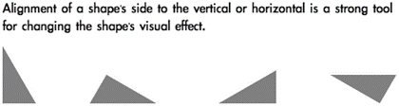
Because of their straight lines, symmetry, and comfort, rotating squares and rectangles from horizontal/vertical alignment can create dynamic effects. The visual reaction to the object changes based on the extent of rotation and whether the angle is arbitrary or more rigid 30° and 45° increments. Shapes of all kinds with right angles (90°) share visual stability, but that can be changed with rotation.
Being simple or geometric doesn’t mean a shape isn’t a powerful tool. Placement, scale, and rotation of simple and geometric shapes can alter the stability and predictability of the original shapes and thus increase their complexity. Even the circular effects of ellipses can change when rotated.
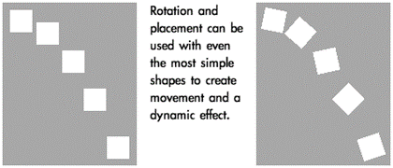
Triangles can be various shapes or sizes, but there are three specific types of triangles that are geometrically defined and used most often. Equilateral triangles are visually the most “complete” triangle, because all sides are the same length and all angles are 60°. This gives equilateral triangles some of the same simplicity and “honesty” that is interpreted from squares.
The two other commonly used triangles are a 30/60/90° and a 45/45/90°, both named from the angles used to construct the shape. The 30/60/90° is one-half of an equilateral triangle, and the 45/45/90° is one-half of a square, cut diagonally.
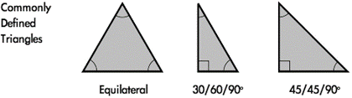
Natural Shapes
Natural shapes are usually complex and most often represent real world objects. Because the real world is rarely perfect, natural shapes are more irregular, asymmetrical, or random than geometric shapes.
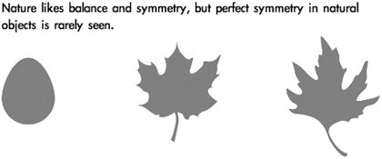
Perfect symmetry can create an unnatural, conservative or even stagnant appearance. Even slightly asymmetrical shapes can create more visual interest by allowing the viewer to subconsciously discover symmetry instead of having it perfectly defined. This can make natural asymmetrical shapes feel more dynamic and spontaneous.
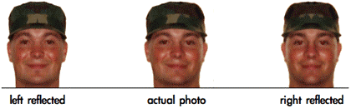
A good example of natural variation of symmetry can be found in the human face. Even with many facial features balanced in pairs, there is variation between the placement and shape of the features. In some cases, if one half of a person’s face reflected to create a symmetrical “face” it creates an entirely different and unrecognisable person.
Abstract Shapes
Abstract shapes are images used to convey concise meaning or identity without the use of written language. Abstract shapes may be universal to all people or culturally based, and are often stylised natural shapes. Many signs, icons, and logos use abstract shapes.
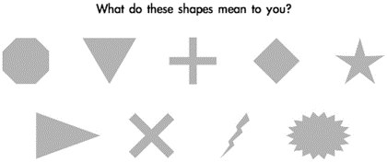
The most universal symbols are based upon nature and easily recognizable human shapes and tools. Most people, regardless of background, can recognize a stick figure as a person, or the silhouette of a wave or a bird because these are abstractions of natural shapes they have experienced in the world around them.
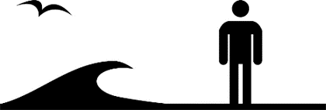
One of the most basic abstract shapes that are taken for granted is the arrow. Combining the effects of triangles and line, arrows are used to illustrate and indicate movement. Because of this universal visual interpretation, arrows are used worldwide to control movement of people and their vehicles.
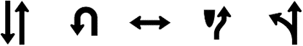
Cultural symbols can evolve to become universal symbols once they are utilised by a majority of societies. One hundred years ago the shape of a car or bicycle might not have been recognized by most people. These symbols have influenced people across the world and are now more universal.
Because of their widespread use in electronics, triangles can symbolise play, action, and next. Triangles are also used to represent stability, a cultural reference to the pyramids. They are also used for beacons, arrows, and pendants, and can symbolize the Christian principles of the Holy Trinity and the unifying concept of three.
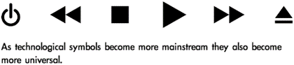
The “power/on/off” symbol is a combination of the 0 and 1 logic expressions of true of false. This symbol is not yet universal, but it is possible to watch it change from being only recognized by the computer-literate to mainstream use. This icon is now used on many computers and electronics, and many people are already unaware of the digital expressions in the symbol and accept it as an abstract shape representing the power switch.
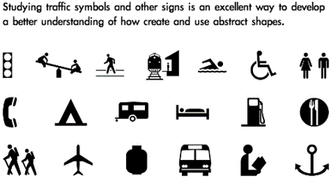
Basic Shape Transformations

Basic Geometric Shapes – identified and described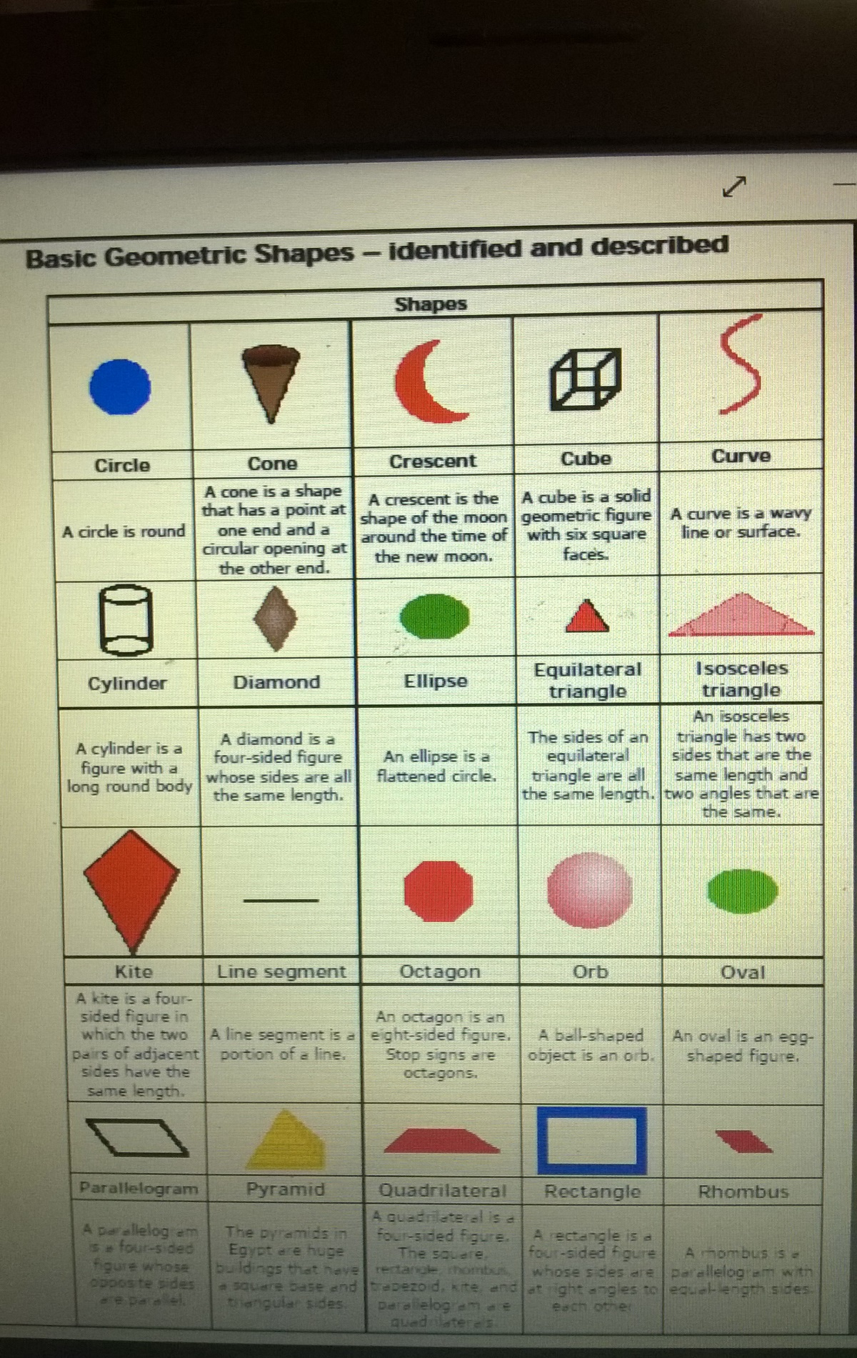
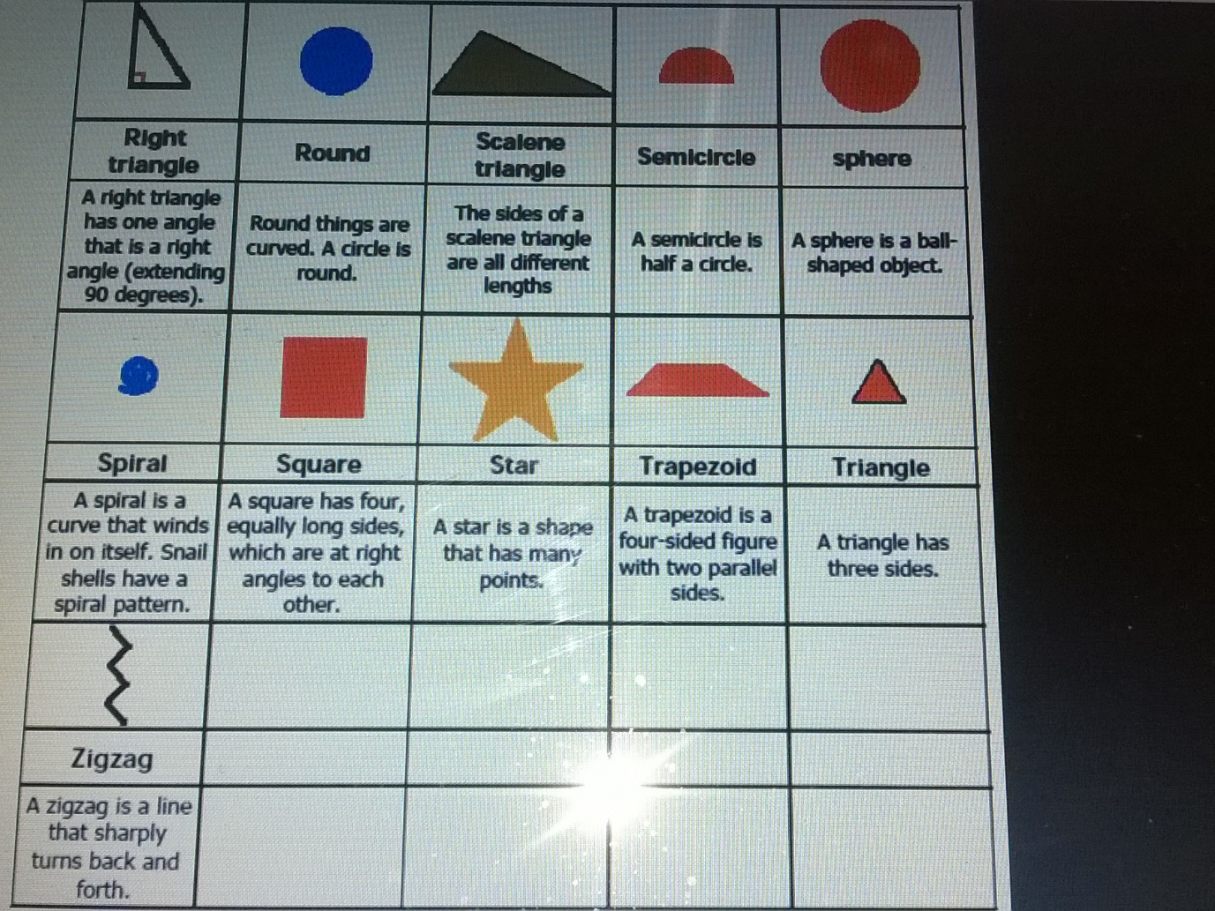

Basic Patterns – identified and described
Tessellations are regular patterns of shapes fitting snugly together.
Definition | Pattern:  A pattern is a repeating visual element that can be created by duplicating size, shape, position, symmetry, frequency, value, and colour.

Patterns are usually stronger when combining two or more repeating elements. Most often, people associate size, shape, and position of visual objects with pattern, but value and colour are also strong pattern tools.
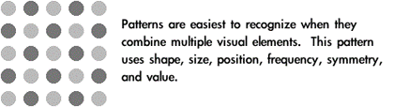

Pattern in visual arts is used for building larger objects, decoration, organization, association with other patterned objects, and meaning.
When a unit is used for building a larger object, patterns are created. When the shape of the units is similar, the pattern becomes more pronounced. Media such as textiles, ceramics, jewellery, and masonry use repeated smaller elements for the construction of a larger work. Because of their methods of fabrication, these media are naturally suited for the creation of decorative patterns.
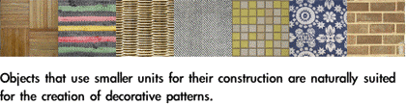
Pattern can be used to allude to these media, or it can borrow from them to suggest less direct associations. A pattern similar to one seen on a woven silk damask may suggest wealth, expense, quality, and conservatism, significantly more than just an association with fabric. Using pattern in design to create associations with patterns in the real world is a simple and effective method of pattern application.
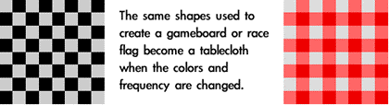
Patterns have cultural, religious, and philosophical significance. Many patterns have traditional meanings that symbolize the place of mankind in relation to nature and the universe. While this symbolism can be found in patterns from most cultures, it is very prominent in Islamic art and architecture where pattern is used for the philosophical discussion between humans and God.
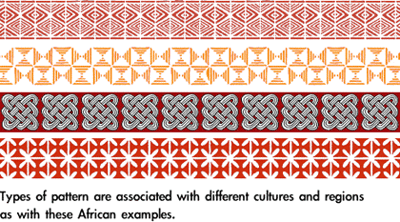

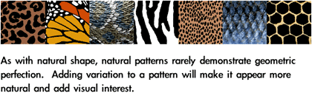
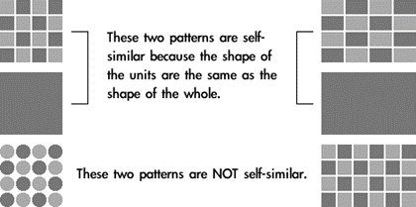

Session 2: Analyse similarities and differences in shapes and patterns, and the effect of colour, used by different cultures

After completing this session, you will be able to: SO 2: Analyse similarities and differences in shapes and patterns, and the effect of colour, used by different cultures.
In this session we are going to explore the following concepts:
- How to analyse similarities and differences in shapes and patterns, and the effect of colour, used by different cultures.
- Similarities in shapes and patterns.
- Differences in shapes and patterns.
- Possible reasons for similarities and/or differences in shapes and patterns used by different cultures.
- The effect of colour on shape and symmetry - described and illustrated.

2.1 How to analyse similarities and differences in shapes and patterns, and the effect of colour, used by different cultures

Type as Shape
Type and written language are abstract shapes, lines and shapes arranged to create images that have symbolic meaning. Typography is the study of type, typefaces, and the evolution of the printed alphabet.

The earliest forms of visual written communication and storytelling were sculptures and pictures that our ancestors created to represent and possibly worship the world around them. Representations of the sun, moon, trees and plants, and especially people and animals were common in these early works of art. These images could communicate, but they were not yet a developed written language. Eventually visual communication developed into pictograms (abstract shapes that are visually recognizable as real objects), ideograms (stylised illustrations that can represent an event or idea), and phonograms (sounds represented by images).
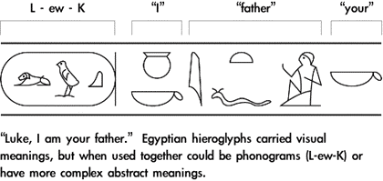

Through the millennia, the written languages of different cultures blended and mutated with trade, war, and the rise and fall of civilizations. One of the most influential trading cultures was the Phoenicians. Because of their travel they adopted and spread ideas from one society to another, both drawing from and influencing other cultures. Over time they adapted and merged language and writing from other cultures into new forms of Phoenician, which then spread throughout the other societies they came into contact with. Phoenician language heavily influenced the Greeks and Romans, who in turn spread their languages throughout other societies with trade and warfare. Most modern Western letterforms can be directly related to Roman chiselled writing from around 100 AD.

Type Definitions

A typeface is the full collection of a type design. A font is a specific selection within a typeface. A letterform is the development or design of the shape of a character. The point system is how type is measured, with 72 points per inch. Point-size is the height of the stamp, the space that contains the individual letters. The baseline is the line on which the letters sit, much like the rules used for handwriting on notebook paper. X-height is the height of the lowercase “x” in the font, generally the height of lowercase letters excluding ascenders and descenders. An ascender is any part of a letter that extends above the body height, usually the strokes that extend above the x-height in lowercase characters. A descender is any part of a letter that extends below the baseline.

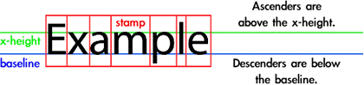

The body is the major lines of a character. Serifs are the strokes (fillips) attached to the ends of a character’s body. Bracketed serifs have rounded joints to the major lines of the letters. Serifs help the reader’s eye follow the baseline and facilitate reading. They can also help define the vertical spaces separating letters in a word.

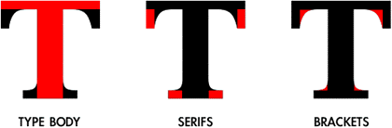

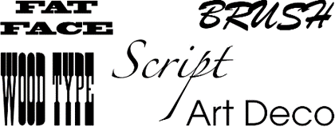

2.2 Similarities and differences in shapes and patterns are identified

2.3 A regular shape has straight sides all the same length and all its angles equal

Three regular shapes can each tessellate. They are:

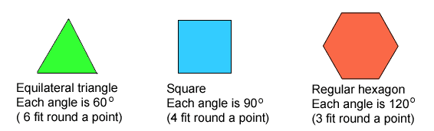
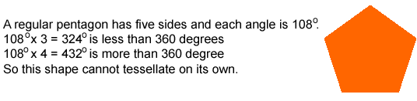
2.4 Possible reasons for similarities and/or differences in shapes and patterns used by different cultures are identified

2.5 2-Dimensional shapes
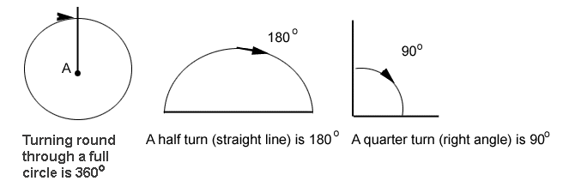
You probably have a tiling pattern on a wall or floor of your home, usually in the kitchen or bathroom. Patterns made from pieces that fit together without leaving any gaps are called tessellations. The simplest ones are made from regular shapes.
2.6 Combining shapes
Shapes can often be put together to make tessellations.
Example | Example 1  Regular octagons (they have eight sides) will not tessellate alone, but they can be combined with squares. 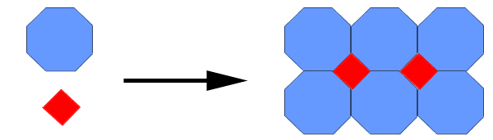

Example | Example 2  Rectangles can be used with triangles. 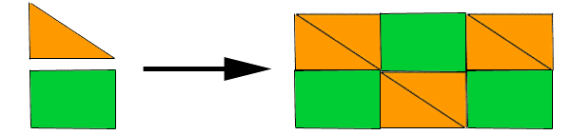

Example | Example 3  Parallelograms and triangles can be combined.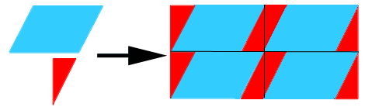

2.7 The effect of colour on shape and symmetry - described and illustrated
Some shapes have a line (or lines) of symmetry - sometimes called 'mirror lines'.
Here are some examples.
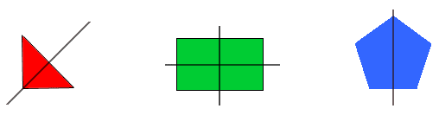
In each case, if you stood a mirror on the line of symmetry, the shape would look unchanged. (You can check this by using a mirror, or by tracing a shape and folding it along the mirror line.)
Jed and Mita each used rectangular tiles to make a tessellation.
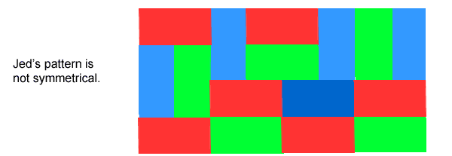
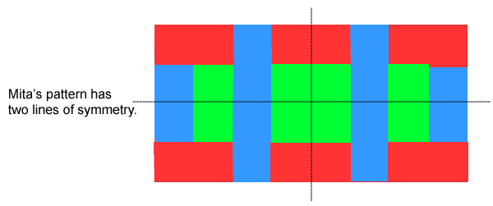
2.8 How to illustrate changes and size and shape of appearance of objects as result of changes in orientation
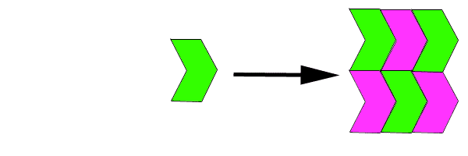

Session 3: Uses of shapes and space in different epochs and cultures

After completing this session, you will be able to: SO 3: Analyse and explain the way shapes and space are used in different epochs and cultures.
In this session we are going to explore the following concepts:
- An analysis and explanation of the way shapes and space are used in different epochs and cultures.
- Architecture and settlement planning.
- Shapes used by different cultures.
- The use of space in different cultures is analysed and explained.
- The use of space in different epochs is analysed.
3.1 Architecture, town and settlement planning
Definition | Architecture: Easier - is the activity of designing buildings. Architecture can also mean the style in which buildings are designed. Architecture: Harder - The term architecture can be used to mean several things, all related to buildings. It may mean the art and science of building, practiced by persons called architects. Or, architecture may mean the actual buildings. Architecture can also be the building style of a particular culture or artistic movement.

Throughout the life of mankind, there has always been architecture. Houses, castles, even a room has to do with architecture. Of course, each room, house, or castle would have to conform to a certain type of mould and have designs, which were considered the norm of that period. Those designs and moulds are now known as a style. With every few generations the styles of a town, city, a county, even a continent's architecture will change Through this section of Architecture through the Ages, you will see how different period of time brought along different styles of architecture and how they differed from each other.
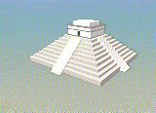 | 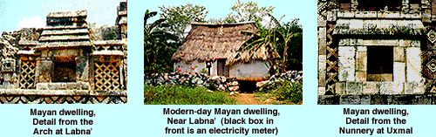

The people of Meso America have some of the most interesting types of architecture known to man. Their elaborate temples housed many sacrificial rituals and their palaces were beautifully crafted with the utmost care. Explore on your own and discover how these masters of war were also masters of architecture. China, the land known for its dragons, famous food, and karate movies possesses one of the few man-made objects visible by astronauts in orbit around the earth, the Great Wall. The buildings of China are considered architectural masterpieces. From their temples and palaces to the humble roofs of their buildings, the Chinese have always taken pride in their beautiful buildings.
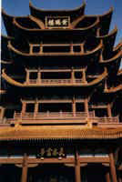
The country known for scorching sun, endless desert, and the magnificent Nile River, which flows north, not south, is truly a world of its own. The architecture would prove it true, also. The architecture made by the Egyptians is so unique, that some people believed that aliens made them.
The newest pyramids of ancient Egypt have a pyramidal form, with four congruent triangular sides that meet at a point at the top. Pyramids were built from circa 2700 BC to circa 1000 BC as tombs for royalty. Originally, the tombs were shaped like rectangular prisms. Then, about 2630 BC, Pharaoh Djoser built the first step pyramid at Saqqara as his tomb. At the time, his sixtier pyramid was the largest building in the world, standing 204 feet high. Around 2600 BC, Pharaoh Snefru built the first real pyramid (with smooth sides instead of tiers) which stood 341 feet high; later, his son, Khufu, built the Great Pyramid of Gîza. Architects tested several slopes on the new pyramids they built and discovered that unless the sides were built at a certain slope, the pyramid would implode on itself or collapse. When this was discovered, all of the Egyptian pyramids were built to conform to a strict geometrical plan and a specific slope.
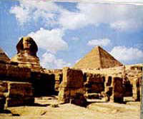
Europe has always been a place where imaginations come alive. There have been numerous discoveries and inventions throughout history. From weapon making, military tactics, writing, and yes, even architecture. Some of the greatest advances in architecture happened in the Greek and Roman empires. From the Roman Colosseum to the Greek Corinthian Column, they helped to shape the way architecture is today. Please proceed, and learn more about these two empires' architecture.
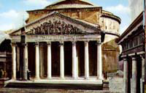 | 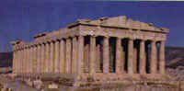

There are many important and fascinating architectural achievements made by the Islamic people. Please continue and learn about its unique style of architecture. One of the greatest challenges of the architecture during the old days was figuring out how to place a circular dome over a square building. Early attempts with slanted square slabs to make an octagonal shape was irregular and failed. In the fifth century the Byzantine and Sassanians started to use the squinch, an arched vault or half dome, which were placed across the corner angles. The Muslims started to use this method with great success. Instead of plane squinches, they started to use decorations.
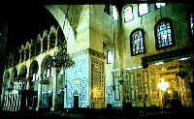
As for the domes, they were constructed of wood or brick, plastered on the inside the outsides were covered with plaster, lead or tiles. The structure rested on an octagonal base within a rectangle, or on a drum. To let light in, the middle of the dome was sometimes left open, or windows were placed in various areas. Known as a holy sanctuary from the evils of the world, the Cathedral is also famous for their architectural marvels. From the beautiful stained glass to the ominous looking gargoyles, the cathedral is just full of eye candy. Of course, building all of these wonders is not easy and they have purposes other than for looks. If you would like to learn more, then continue and learn how a holy house is made.
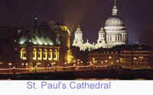
During the Middle Ages, a castle was the house of a nobleman or prince who ruled a small piece of land. Everyone who lived on this land had to work for that ruler every day by either farming the land, fighting, or building structures for the ruler.
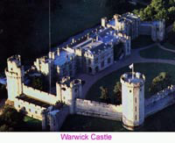
Shape and design also plays a role in African daily life:
- African Village design.
- African Art.
- African Beadwork.
- African Tool and Weapon Design.
- African traditional colour and pattern signifying clan.
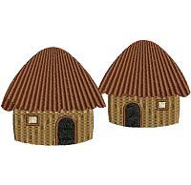 | 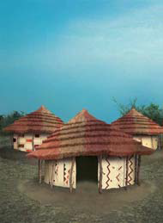
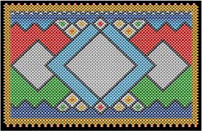 | 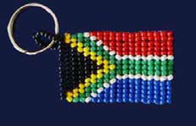

3.2 Shapes used by different cultures are identified
The Greeks made many contributions to our understanding of geometry. For example, Archimedes is credited as the first to calculate the ratio between a circle's diameter and its circumference now known as pi. Pythagoras is famous for his theorem which states that in any right-angled triangle the sum of the squares on the two shorter sides equals the square of the hypotenuse. However, many people think the Egyptians and Babylonians knew this math much earlier.
3.3 The use of space in different epochs is analysed
Definition | Epoch:  An epoch is a division of a geologic period; it is the smallest division of geologic time, lasting several million years.  Era:  Two or more geological periods comprise an Era, which is hundreds of millions of years in duration.

Example | Let’s look at an obvious example of different shapes and colours in different  “Epochs”, which should have a similar meaning, but that holds a lot of different meanings to different people. Do you understand the meaning now?
Additive Colour and the RGB Process
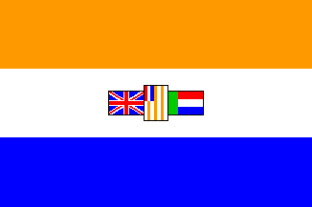 | 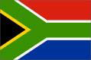

3.4 Colour and shape in different Epochs - influenced by light, electricity and technology
The 20th century brought readily available electric power and abundant artificial lighting. These technologies were necessary for advances in the scientific understanding of colour. Additive colour is how light is mixed to create colour. Every time additive colour is mentioned, think of the world “light.” The most common method used to explain additive colour mixing is the flashlight model.
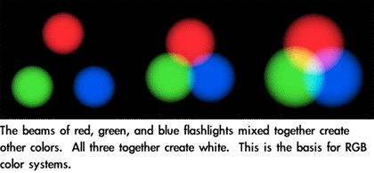
Glossary
Asymmetry | No symmetry possible for the shape or pattern
Complex Shapes | Shapes consisting of a combination of two or more simple shapes
Geometry | The science related to the properties and magnitudes of lines, surfaces and solids
Gravity | The attractive force towards the centre of the earth
Horizontal | The line with the same orientation as the horizon ( the line where the earth and sky seem to meet)
Symmetry | A shape or pattern forming mirror image across a centre line
Tessellate | A closely fitted pattern of shapes. Or shapes forming a mosaic. Often found with tiling
Vertical | The line perpendicular horizontal

