119457 FORMATIVE ASSESSMENTS WORKBOOK

Unit Standard 119457

Exercise 1
- In a group, find other words that you don’t know the meaning of and then try to determine the meaning by looking at the whole sentence.
- In a group, make a list of at least five words that your native language has borrowed from other South African languages.
- In a group, make a list of at least five known acronyms. Also write down what they mean.

Exercise 2

Following is an extract from an article about slavery in Africa. Read the extract and then answer the following questions.

At the first cracks of gunfire, the villagers of Nyamlell in southern Sudan dropped their hoes and scattered into the bush. Abuk Marou Keer also heard the guns. But the blind Dinka woman could only pull her seven-year-old son and twelve-year-old daughter close. Shaking with fear, they hid in their windowless hut and prayed.
Minutes later 300 men on foot, horseback and camels crashed through the fields of maize. Clad in turbans and the long, white robes of the desert, they brandished rifles, pangas and spears. Soon 80 village men lay dead.
The invaders were Muslim Arabs from northern Sudan; the victims darker-skinned Dinka tribes people who are Christians or practice native religions
Once the Arabs seized the cattle, they moved from hut to hut gathering grain, blankets, salt – and human booty. Deep in the shadows of one hut, they discovered Abuk. Grabbing the terrified woman by her bead necklace, a militiaman growled, “Now you belong to me!” in all, 282 Dinka, including Abuk’s mother, sister and niece were herded up and forced to march north.
Two days later Abuk and the rest of the prisoners reached a compound, which she was told would be her “home.” Like the other Dinka women and children, she was ordered to carry water, wash clothes and collect firewood for her Arab masters. Abuk had become a slave.

- What happened to the villagers of Nyamlell?
- Who did that to them?
- Where were they forced to go?
- Where did the invaders come from?
- Why did the invaders take the villagers with them?
- How did the invaders overpower the villagers?
- When did it happen – during the day or the night?
- How do you know this?
- What were the invaders wearing?
- Which weapons did they use?
- Why couldn’t Abuk run away with her children?
- How many invaders were there?
- What did the invaders take with them when they left the village?

What happened to the villagers of Nyamlell?
Who did that to them?
Where were they forced to go?
Where did the invaders come from?
Why did the invaders take the villagers with them?
How did the invaders overpower the villagers?
When did it happen – during the day or the night?
How do you know this?
What were the invaders wearing?
Which weapons did they use?
Why couldn’t Abuk run away with her children?
How many invaders were there?
What did the invaders take with them when they left the village?

Exercise 3
- Refer back to the section where you answered the who, what, where, why and how questions and write a summary of the article in your own words.
- Remember to use headings, sub-headings and paragraphs.
- Compare your summary with the rest of the class.
- Write the summary in points form.
- Summarise the article as a mind map. Compare your mind-map with that of the rest of the class.
- Now, paraphrase the following paragraph in your own words. You are welcome to use slang, or to write exactly as you speak.

Exercise 4
- Read the cartoon and then, in a group, discuss how the author uses a cartoon to demonstrate the corruption of traffic officers.
- As an experiment, look at something that is low down on the ground – a flower, a dog or a cat or anything else – from above. You can stand on a chair or something high if you want to, then stand upright and look down on the subject. Lastly, lie down on your stomach and look at the object from its height. Can you see how different the views are? In photography, it is called perspective.
- Write down in your own words what the object looked like from above and how different it was when you were lying on your stomach.
- Find two photos or pictures: one that has a high viewpoint and one that is on the same level as the subject. Compare what they look like. Glue and stick the pictures on a blank piece of paper for inclusion in your portfolio of evidence.
- In a group, discuss how the photos differ.

Exercise 5
What do you think of when you look at the following pictures? Write down your observations. Also write down why you think so.
Picture 1 Picture 2

Picture 3 Picture 4

Picture 5

Exercise 6
Look at the advertisements on the following pages and answer the following questions about them:
- What is being advertised?
- What was the first thing you noticed?
- How did they make use of font types and sizes to make key points stand out?
- Is the layout of the page done in a way that is interesting and gets your attention?
- Was it easy to understand the message?
Then look at the cover page of a novel that tells you at a glance what the story is about. The novel is called “THEY’RE ALL MY CHILDREN”. Answer the following questions:
- Who wrote the book?
- What do you think the book is about? A mother writing about her children, a grandmother writing about her children and grandchildren, a teacher writing about the schoolchildren she taught or someone saving war orphans?
- Why do you think so?
- There are two clues in this cover page that helps you identify what the story is about. What are they?
- What do you think of the page layout?
The next piece of writing is called: “Notes from all over”.
Note how titles, subtitles and visual aids are used to highlight main points and helps you to decide whether to read the article or simply skim until you get to something that interests you.
- Which part of the written piece would you read first?
- Why?
Which technique is used to indicate main points in the article: “Tips for Beating the Clock”?
On the next page is the first page of a magazine article about slavery.
Answer the following questions about this page:
- Who wrote the article?
- Which techniques are used to catch your attention and encourage your to read further?
- To which continent did slavery return, according to the author?
- Why do you think so?
- Who is being taken prisoner?

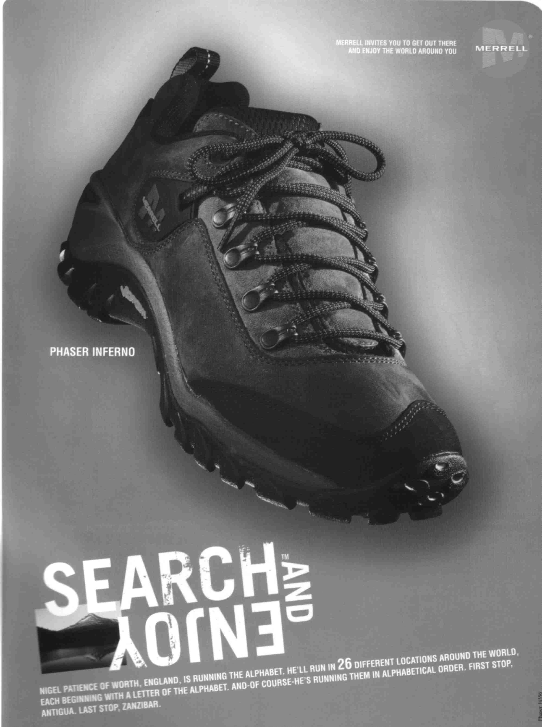

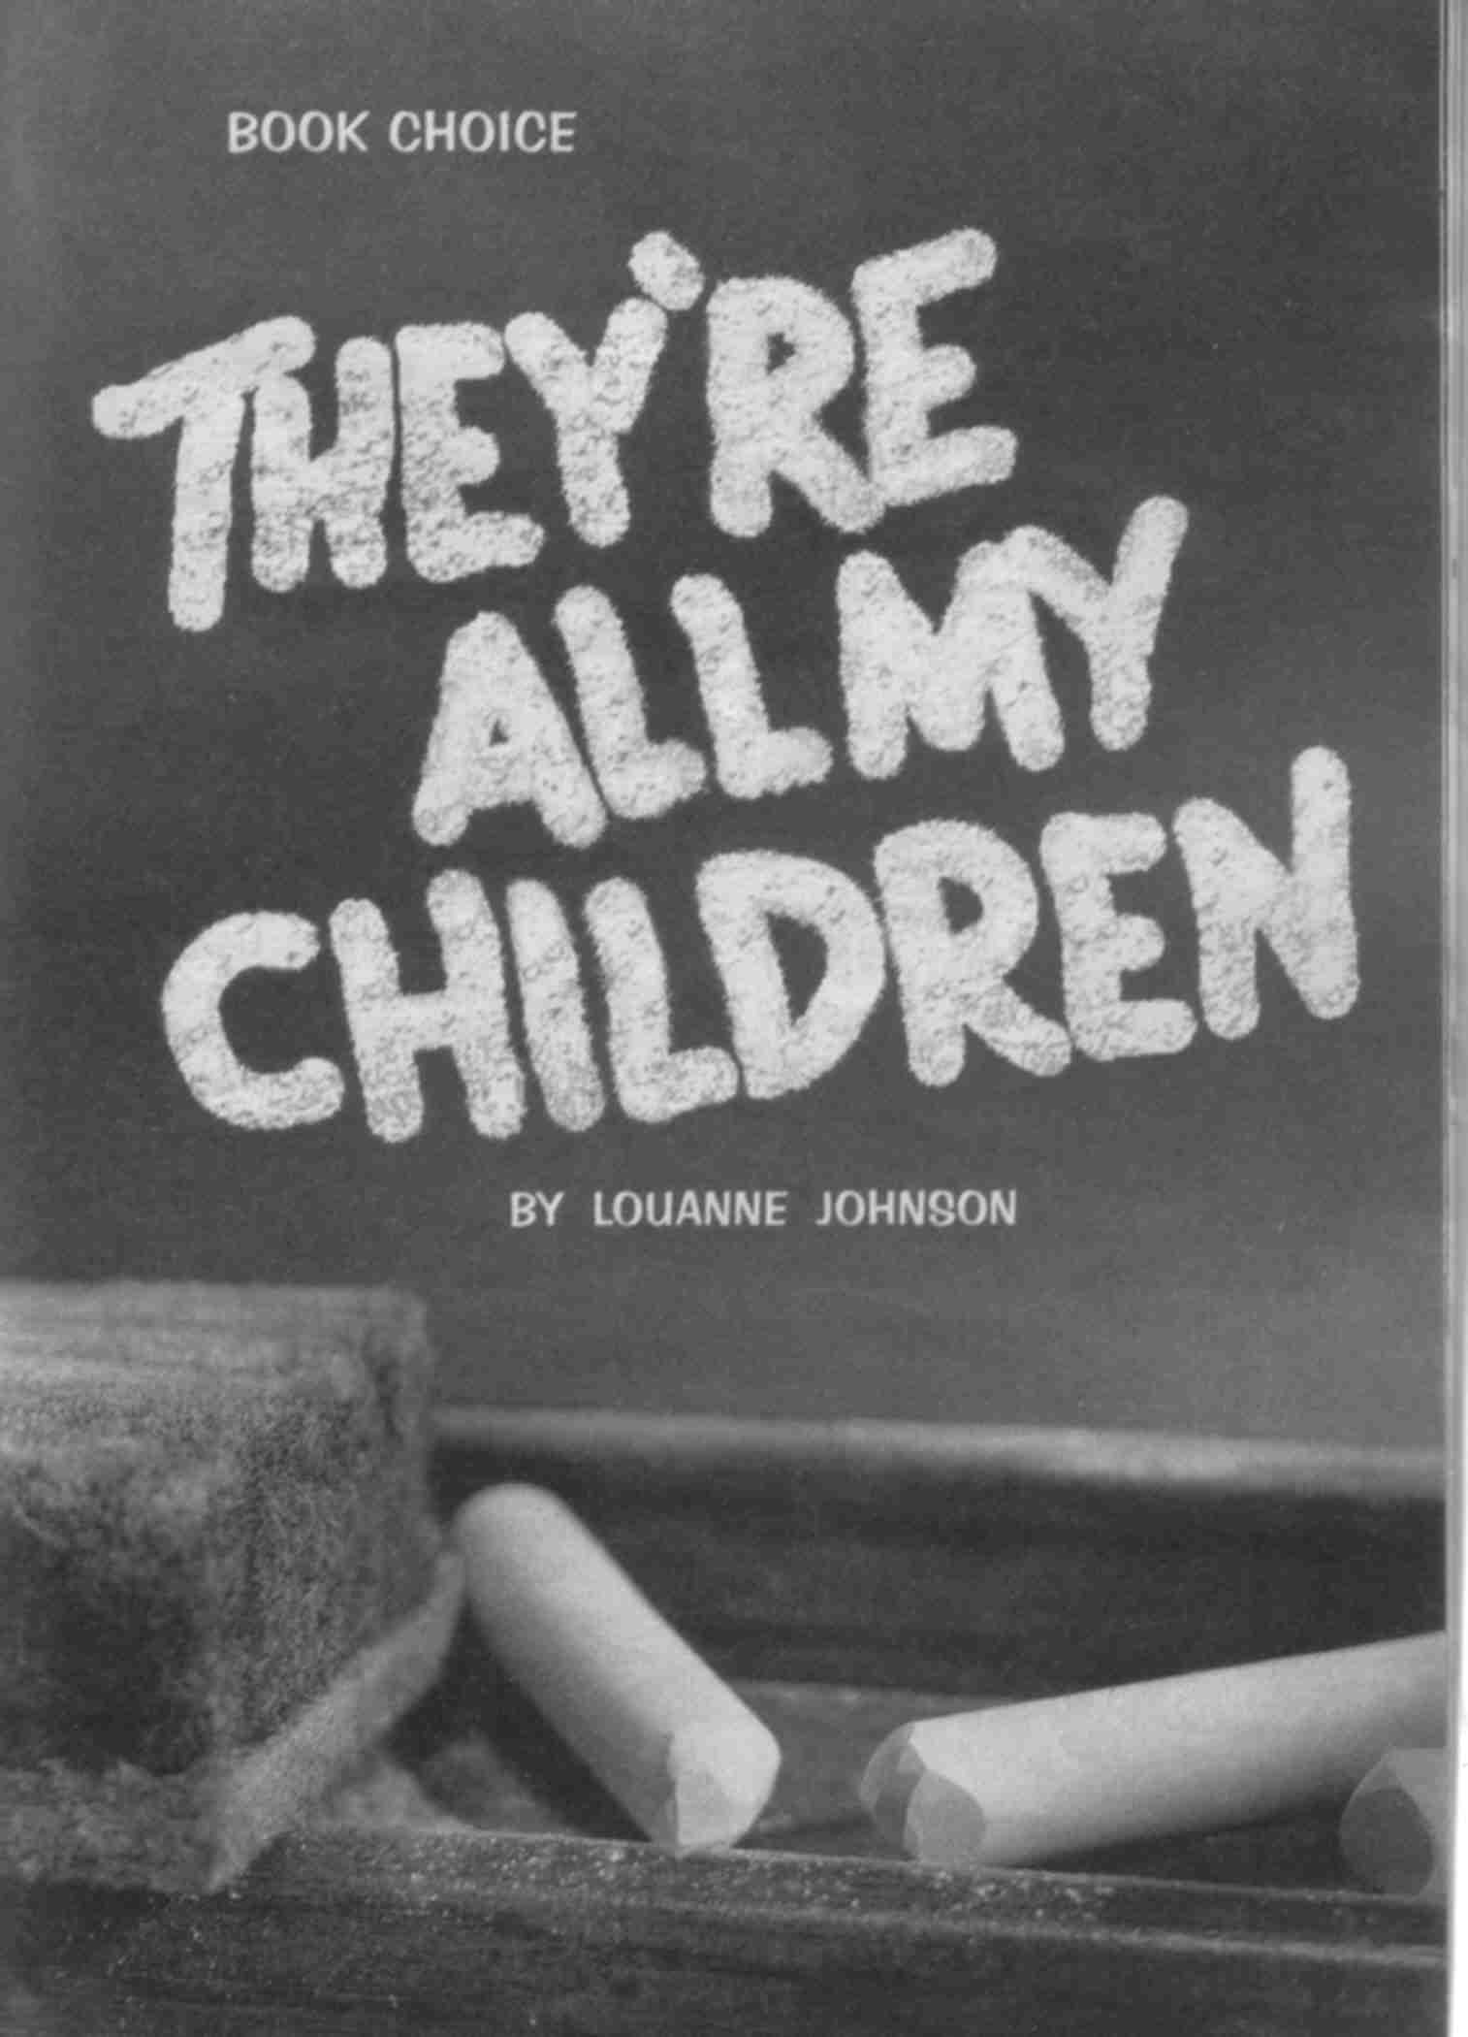

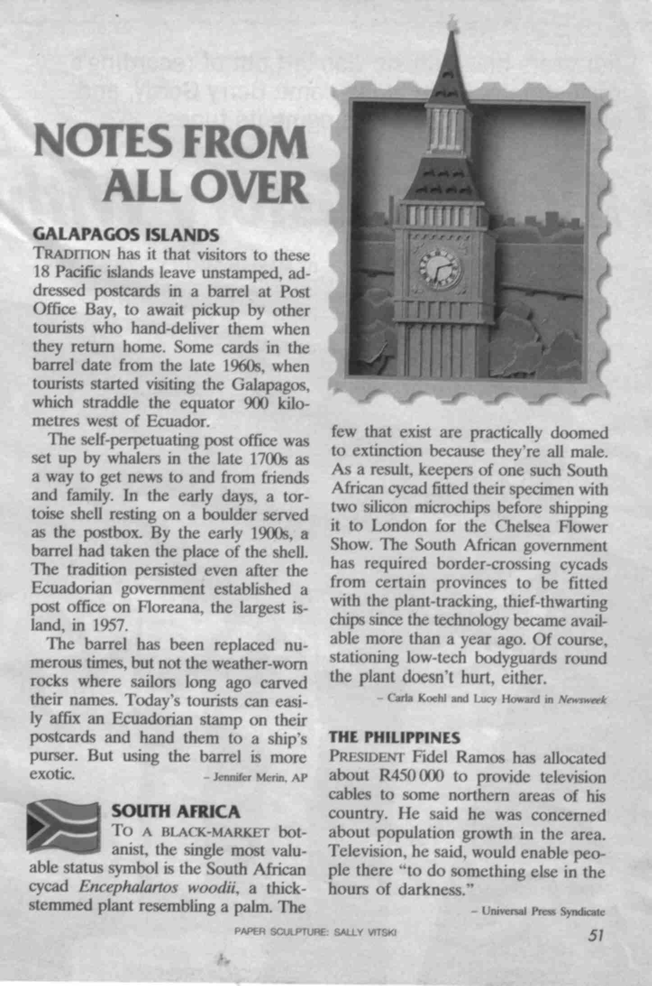

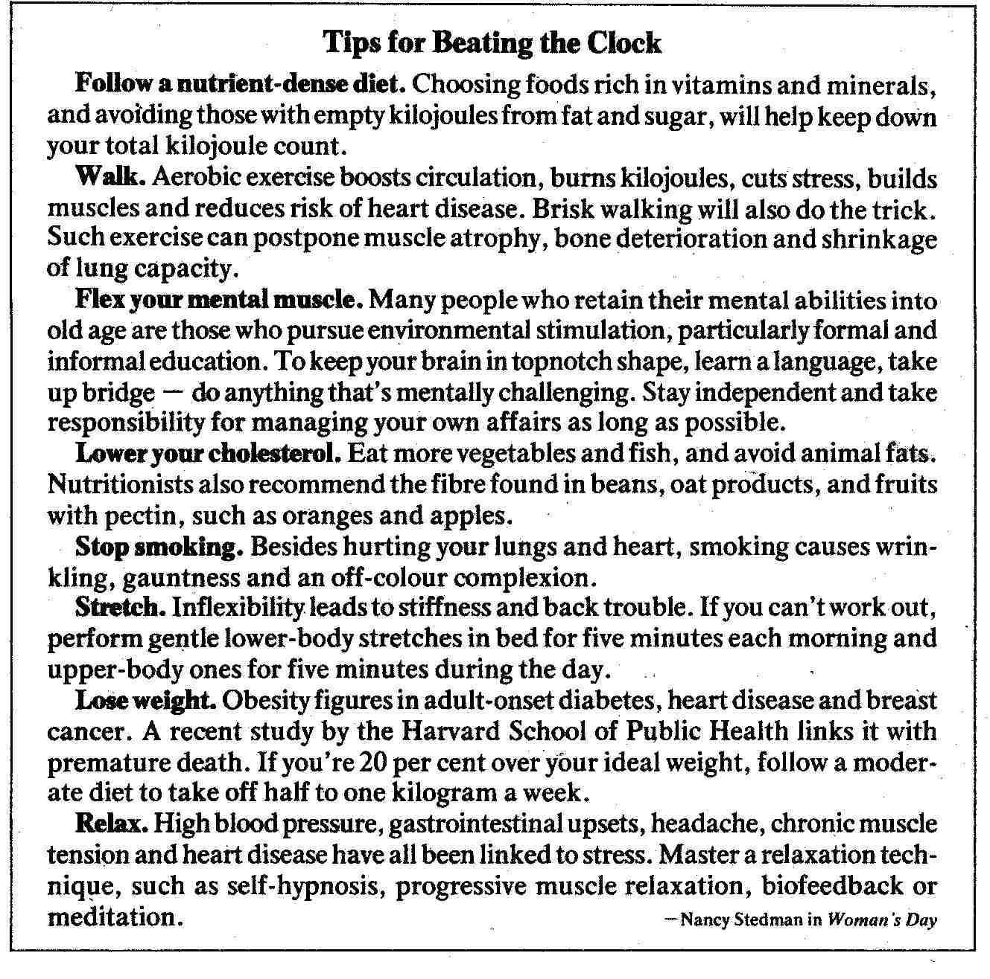

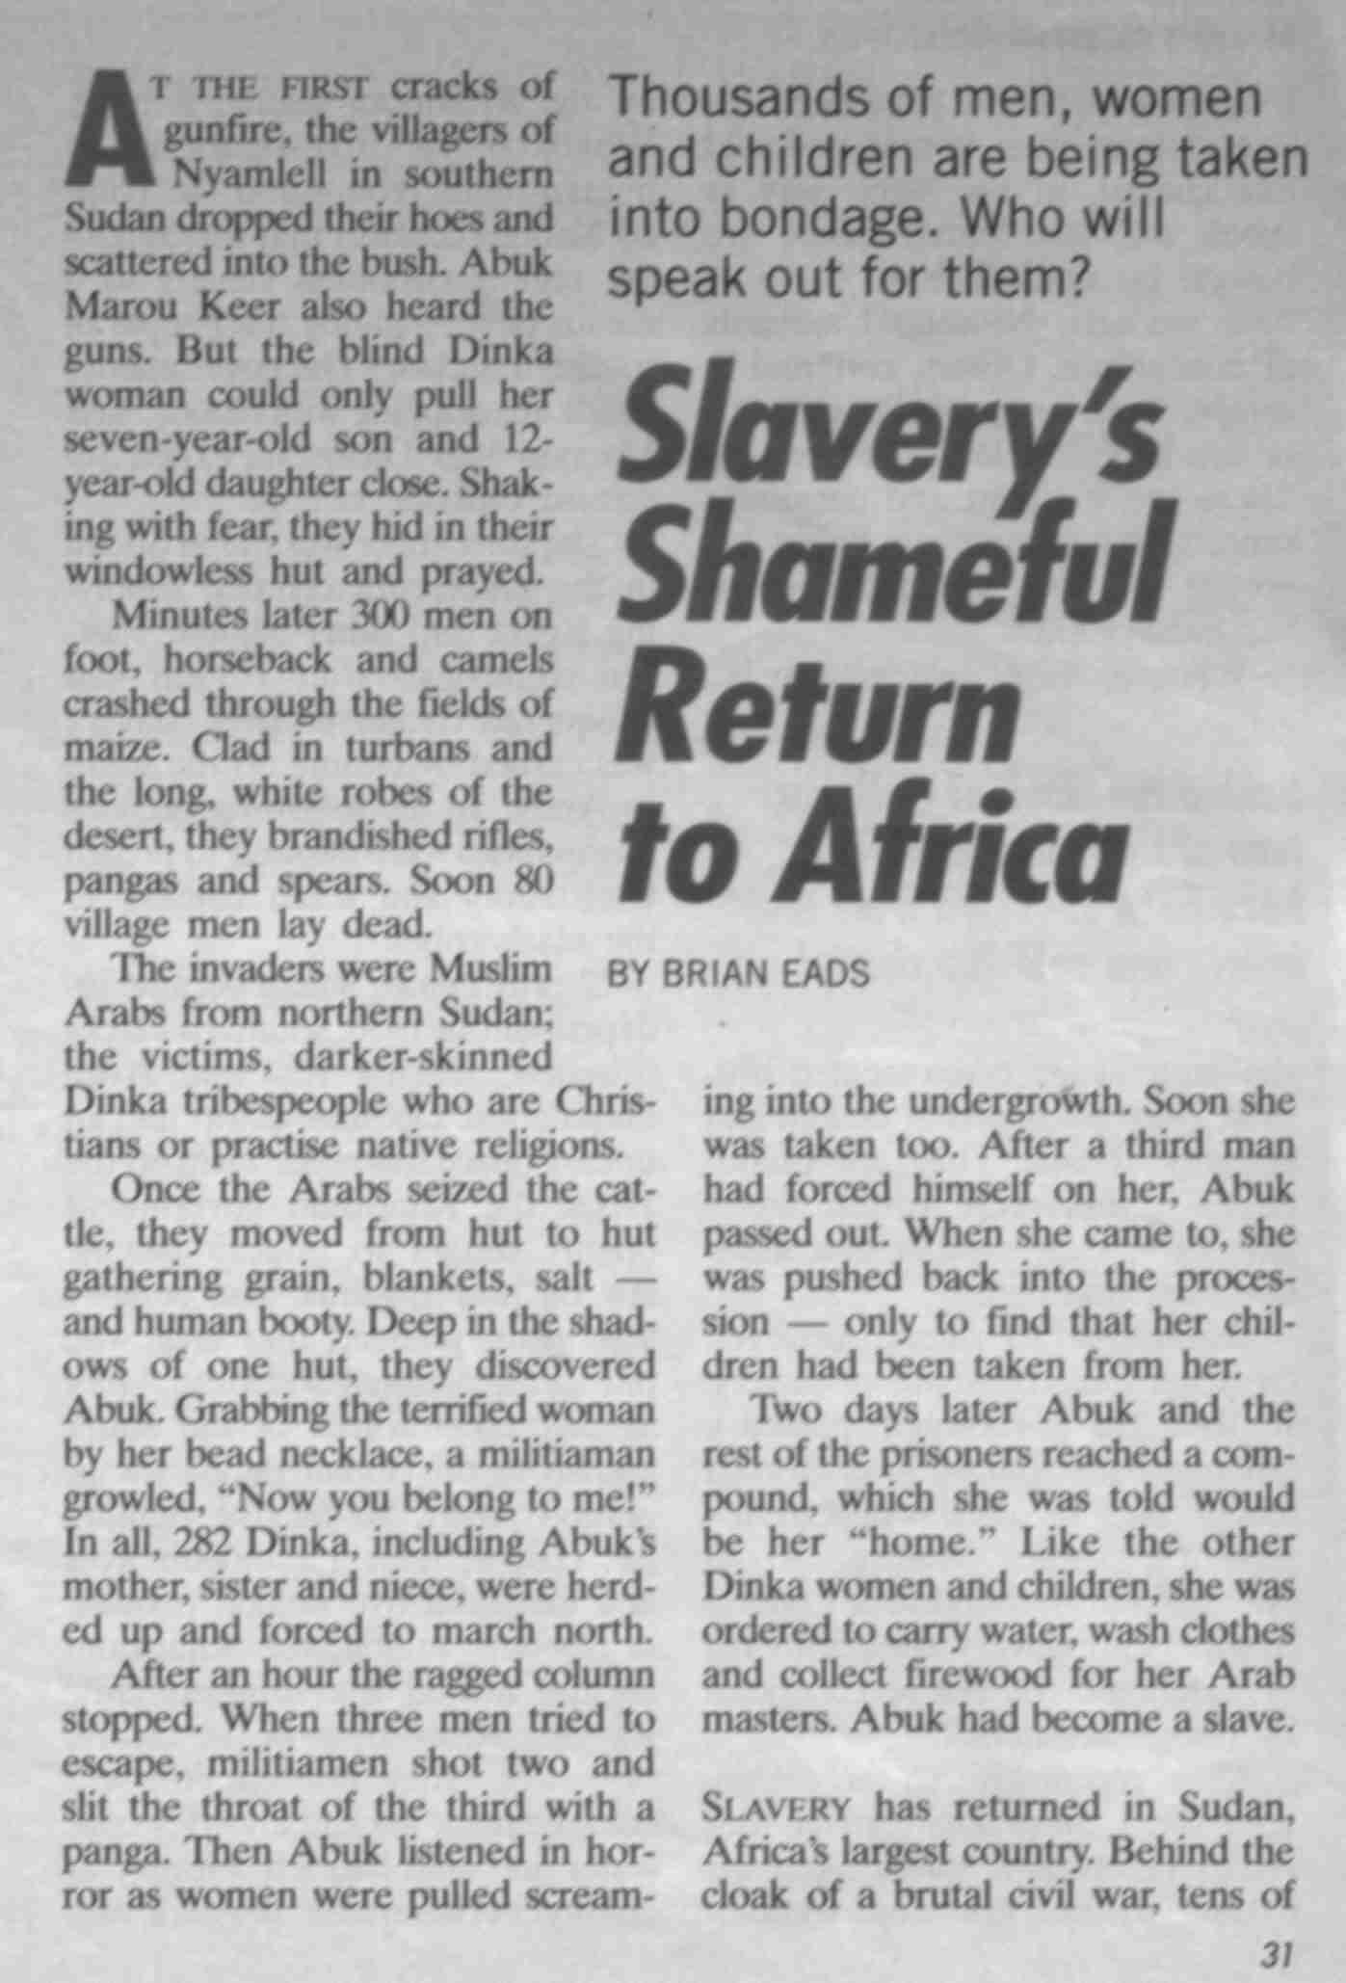

Exercise 7
- In a group, find the equivalent in your mother tongue (home language) of at least three of the previously mentioned expressions.
- In a group, quote at least three other expressions from your mother tongue. State them in English and also explain what they mean.
- In a group, give three examples of generalisations.
- In a group, give three examples of stereotyping.
- In a group, give at least three examples of figurative expressions.
- In a group, think of more examples of repetition.
- In a group, add some captions to the following picture:

What was your most painful experience as a result of bias? You must also state whether the bias was due to cultural differences, religious beliefs, racist or sexist beliefs, due to discrimination or due to peer pressure.
Give one example of each of the following biases:
- Cultural
- Religious
- Peer pressure
- Racial discrimination
- Discrimination due to your sex
- Discrimination due to age
- In the article about slavery, the slave traders discriminate against the Dinka tribe. At least two forms of discrimination are mentioned. Identify them.
Following is a quote from a book called My Family and Other Animals, by Gerald Durrell. The book contains short stories about his family’s move from England to Greece, in the time before the Second World War. They took their dog, called Roger, with them. Gerald had two older brothers, Larry and Leslie.
This is an example of humour. Did you find the piece funny? Motivate your answer.
“That dog’s been a nuisance all the way from England,” said Larry. “I had hoped to give an impression of gracious majesty, and this is what happens … we arrive in town like a troupe of medieval tumblers.”
“Don’t keep on, dear,” Mother said soothingly, straightening her hat: “we’ll soon be at the hotel.”
So our cab clopped and jingled its way into the town, while we sat on the horsehair seats and tried to muster the appearance of gracious majesty Larry required. Roger, wrapped in Leslie’s powerful grasp, lolled his head over the side of the vehicle and rolled his eyes as though at his last gasp. Then we rattled past an alley-way in which four scruffy mongrels were lying in the sun. Roger stiffened, glared at them and let forth a torrent of deep barks. The mongrels were immediately galvanized into activity, and they sped after the cab, yapping vociferously. Our pose was irretrievable shattered, for it took two people to restrain the raving Roger, while the rest of us leaned out of the cab and made wild gestures with magazines and books at the pursuing horde. This only had the effect of exciting them still further, and at each alley-way we passed their numbers increased, until by the time we were rolling down the main thoroughfare of the town there were some twenty-four dogs swirling about our wheels, almost hysterical with anger.

Exercise 8
- Still working with the article on slavery, what do you think is the author’s purpose in writing this article? Motivate your answer by quoting from the article.
- Identify at least two examples of explicitly stated facts in the article about slavery.
- Identify at least three examples of implicitly stated points in the article about slavery.

