**LEARNER GUIDE**

**Communication Level 3**

**Write texts for a range of communicative contexts**

Unit Standard 119465

Level 3 Credits 5

# TABLE OF CONTENTS

TABLE OF CONTENTS i

PERSONAL INFORMATION 1

INTRODUCTION 2

Programme methodology 2

What Learning Material you should have 3

Different types of activities you can expect 4

Learner Administration 5

Assessments 5

Learner Support 6

Learner Expectations 7

UNIT STANDARD 119465 8

WRITE FOR A SPECIFIED AUDIENCE 11

Identify Unfamiliar Words 11

Syntax 11

A set of rules for the formation of sentences. 11

Contextual Clues 12

Borrowed Words 12

Borrowed words are words that are incorporated into a language from another language. 12

Acronym 13

An acronym is a word formed from the first letter of other words. 13

Neologisms 13

A new word or expression 13

Colloquialism 13

An informal word or phrase. 13

Slang 14

Very informal words and phrases that are more common in speech than in writing and are used by a particular group of people 14

Dialect 14

A form of language used in a particular region or by a particular social group. 14

Jargon 14

Words or expressions that are used by a specific trade, business or industry. 14

Complex Terms 15

Words or phrases that are complex and usually technical and relate to a specific industry or sector. 15

Ambiguous Words 15

Ambiguous means unclear or undecided, having more than one meaning. 15

Summarise And Paraphrase 16

Summaries 16

A summary is a brief statement of the main points of something. 16

It therefore makes sense to do this with written material as well. 16

Paraphrasing 17

Paraphrasing is rewriting something using different words. 17

Visual And Graphic Representations 17

Mind-map 17

Diagram 18

Photographs 19

Arial Photography 20

Pie Chart 22

Bar Graph 22

Cartoons 23

Pictures And Drawings 23

Maps 24

Schema 25

A schema is a shcematic presentation of a piece of writing, the outline without the content. 25

Critical Thinking Skills 25

A mind map is an excellent technique to improve your critical thinking skills. 25

Brainstorming 25

Highlighting 26

WRITE USING LANGUAGE STRUCTURES AND FEATURES 27

Styles Of Writing 27

Narrative 27

Discursive 28

Reflective 28

Thoughtful. 28

Argumentative 28

A set of reasons given in support of something 28

Descriptive 29

Describing without expressing judgement 29

Expository 29

A full description and explanation of a theory 29

Transactional 29

Relating to a business transaction 29

Business correspondence 29

Electronic texts 29

Multi-media presentations 29

Language Structures And Features 30

Sentences 30

Paragraphs 30

Document 31

Research 32

Sources of Information 32

Organise the material 32

DRAFT OWN WRITING 34

Produce Writing That Is Appropriate 34

Meaningful Written Communication 35

The ten golden rules of meaningful written communication 35

Correctness grammar, spelling, punctuation, style, format and composition 35

Conciseness Brief, specific and to the point, include only what is really necessary. Don’t elaborate on facts and details. 35

Completeness Include all the relevant information you want to share as well as what the reader wants to know 36

Clarity Clarity and readability – choose words carefully to eliminate any assumptions and misinterpretations. 36

Courtesy be considerate of the readers, respect their feelings and their rights. Test your approach by asking yourself; “Would I enjoy reading what I have written?” 36

Simplicity Keep writing simple, use short yet detailed sentences, avoid using too many descriptive words (adverbs and adjectives) 36

Accuracy Always give accurate hones information – incorrect information can cost time and money. 36

Concreteness be realistic, positive, appeal to the readers by keeping their background, needs, and level of understanding in mind. 36

Personality the readers must know that you care about their interests 36

Sincerity being sincere builds confidence, watch the tone of your writing, focus on expressing yourself clearly and creating a good impression. 36

There are many reasons why authors write texts 36

Plan your writing 36

Pointers to think of before you write 37

Make Your Writing/Signing Interesting 37

Think about and remember 38

Redrafting 38

It is important to edit 38

Words or expressions that are used by a specific trade, business or industry. 39

Obfuscation 39

Obfuscation means to make unclear or hard to understand. 40

Putting Pen To Paper 40

Features of a written document 40

Edit 41

Always read through your document or text when you have completed a first draft and revise where necessary. Revision can include the following changes to: 41

# PERSONAL INFORMATION

|  |  |
| --- | --- |
| ****NAME**** |  |
| ****CONTACT ADDRESS**** |  |
|  |
| ****Code**** |  |
| ****Telephone (H)**** |  |
| ****Telephone (W)**** |  |
| ****Cellular**** |  |
| ****Learner Number**** |  |
| ****Identity Number**** |  |
|  | |
| ****EMPLOYER**** |  |
| ****EMPLOYER CONTACT ADDRESS**** |  |
|  |
| ****Code**** |  |
| ****Supervisor Name**** |  |
| ****Supervisor Contact Address**** |  |
|  |
| ****Code**** |  |
| ****Telephone (H)**** |  |
| ****Telephone (W)**** |  |
| ****Cellular**** |  |

# **INTRODUCTION**

#### Welcome to the learning programme

Follow along in the guide as the training practitioner takes you through the material. Make notes and sketches that will help you to understand and remember what you have learnt. Take notes and share information with your colleagues. Important and relevant information and skills are transferred by sharing!



This learning programme is divided into sections. Each section is preceded by a description of the required outcomes and assessment criteria as contained in the unit standards specified by the South African Qualifications Authority. These descriptions will define what you have to know and be able to do in order to be awarded the credits attached to this learning programme. These credits are regarded as building blocks towards achieving a National Qualification upon successful assessment and can never be taken away from you!

### Programme methodology



The programme methodology includes facilitator presentations, readings, individual activities, group discussions and skill application exercises.

Know what you want to get out of the programme from the beginning and start applying your new skills immediately. Participate as much as possible so that the learning will be interactive and stimulating.

The following principles were applied in designing the course:

* Because the course is designed to maximise interactive learning, you are encouraged and required to participate fully during the group exercises
* As a learner you will be presented with numerous problems and will be required to fully apply your mind to finding solutions to problems before being presented with the course presenter’s solutions to the problems
* Through participation and interaction the learners can learn as much from each other as they do from the course presenter
* Although learners attending the course may have varied degrees of experience in the subject matter, the course is designed to ensure that all delegates complete the course with the same level of understanding
* Because reflection forms an important component of adult learning, some learning resources will be followed by a self-assessment which is designed so that the learner will reflect on the material just completed.

This approach to course construction will ensure that learners first apply their minds to finding solutions to problems before the answers are provided, which will then maximise the learning process which is further strengthened by reflecting on the material covered by means of the self-assessments.

#### Different role players in delivery process

* Learner
* Facilitator
* Assessor
* Moderator

### What Learning Material you should have

This learning material has also been designed to provide the learner with a comprehensive reference guide.

It is important that you take responsibility for your own learning process; this includes taking care of your learner material. You should at all times have the following material with you:

|  |  |
| --- | --- |
| **Learner Guide** | **This learner guide is your valuable possession:**  This is your textbook and reference material, which provides you with all the information you will require to meet the exit level outcomes.  During contact sessions, your facilitator will use this guide and will facilitate the learning process. During contact sessions a variety of activities will assist you to gain knowledge and skills.  Follow along in the guide as the training practitioner takes you through the material. Make notes and sketches that will help you to understand and remember what you have learnt. Take and share information with your colleagues. Important and relevant information and skills are transferred by sharing!  This learning programme is divided into sections. Each section is preceded by a description of the required outcomes and assessment criteria as contained in the unit standards specified by the South African Qualifications Authority. These descriptions will define what you have to know and be able to do in order to be awarded the credits attached to this learning programme. These credits are regarded as building blocks towards achieving a National Qualification upon successful assessment and can never be taken away from you! |
| **Formative Assessment Workbook** | The Formative Assessment Workbook supports the Learner Guide and assists you in applying what you have learnt.  The formative assessment workbook contains classroom activities that you have to complete in the classroom, during contact sessions either in groups or individually.  You are required to complete all activities in the Formative Assessment Workbook.  The facilitator will assist, lead and coach you through the process.  These activities ensure that you understand the content of the material and that you get an opportunity to test your understanding. |

### Different types of activities you can expect

To accommodate your learning preferences, a variety of different types of activities are included in the formative and summative assessments. They will assist you to achieve the outcomes (correct results) and should guide you through the learning process, making learning a positive and pleasant experience.



The table below provides you with more information related to the types of activities.

| **Types of Activities** | **Description** | **Purpose** |
| --- | --- | --- |
| **Knowledge Activities** | You are required to complete these activities on your own. | These activities normally test your understanding and ability to apply the information. |
| **Skills Application Activities** | You need to complete these activities in the workplace | These activities require you to apply the knowledge and skills gained in the workplace |
| **Natural Occurring Evidence** | You need to collect information and samples of documents from the workplace. | These activities ensure you get the opportunity to learn from experts in the industry.  Collecting examples demonstrates how to implement knowledge and skills in a practical way |

### Learner Administration



#### Attendance Register

You are required to sign the Attendance Register every day you attend training sessions facilitated by a facilitator.

#### Programme Evaluation Form

On completion you will be supplied with a “Learning programme Evaluation Form”. You are required to evaluate your experience in attending the programme.

Please complete the form at the end of the programme, as this will assist us in improving our service and programme material. Your assistance is highly appreciated.

### Assessments

The only way to establish whether a learner is competent and has accomplished the specific outcomes is through the assessment process. Assessment involves collecting and interpreting evidence about the learners’ ability to perform a task.

To qualify and receive credits towards your qualification, a registered Assessor will conduct an evaluation and assessment of your portfolio of evidence and competency.

This programme has been aligned to registered unit standards. You will be assessed against the outcomes as stipulated in the unit standard by completing assessments and by compiling a portfolio of evidence that provides proof of your ability to apply the learning to your work situation.



**How will Assessments commence?**

#### Formative Assessments

The assessment process is easy to follow. You will be guided by the Facilitator. Your responsibility is to complete all the activities in the Formative Assessment Workbook and submit it to your facilitator.

#### Summative Assessments

You will be required to complete a series of summative assessments. The Summative Assessment Guide will assist you in identifying the evidence required for final assessment purposes. You will be required to complete these activities on your own time, using real life projects in your workplace or business environment in preparing evidence for your Portfolio of Evidence. Your Facilitator will provide more details in this regard.

To qualify and receive credits towards your qualification, a registered Assessor will conduct an evaluation and assessment of your portfolio of evidence and competency.

### Learner Support

The responsibility of learning rests with you, so be proactive and ask questions and seek assistance and help from your facilitator, if required.



Please remember that this Skills Programme is based on outcomes based education principles which implies the following:

* You are responsible for your own learning – make sure you manage your study, research and workplace time effectively.
* Learning activities are learner driven – make sure you use the Learner Guide and Formative Assessment Workbook in the manner intended, and are familiar with the workplace requirements.
* The Facilitator is there to reasonably assist you during contact, practical and workplace time for this programme – make sure that you have his/her contact details.
* You are responsible for the safekeeping of your completed Formative Assessment Workbook and Workplace Guide
* If you need assistance please contact your facilitator who will gladly assist you.
* If you have any special needs please inform the facilitator

### Learner Expectations

Please prepare the following information. You will then be asked to introduce yourself to the instructor as well as your fellow learners



|  |
| --- |
| Your name: |
|  |
|  |
| The organisation you represent: |
|  |
|  |
| Your position in organisation: |
|  |
|  |
| What do you hope to achieve by attending this course / what are your course expectations? |
|  |
|  |
|  |
|  |
|  |
|  |
|  |
|  |

# UNIT STANDARD 119465

#### Unit Standard Title

Write texts for a range of communicative contexts

#### NQF Level

3

#### Credits

5

#### Purpose

Learners at this level write texts with complex subject matter and a need for various levels of formality in language and construction. They select text type, subject matter and language to suit specific audiences and purposes. Writers can use linguistic structures and features to influence readers. They edit own writing to meet the demands of a range of text-types. They use language appropriate to the socio-cultural, learning or workplace/technical environment as required.

Learners credited with this unit standard are able to:

Write for a specified audience and purpose.

Use language structures and features to produce coherent and cohesive texts for a wide range of contexts.

Draft own writing and edit to improve clarity and correctness.

#### Learning assumed to be in place

The credit calculation is based on the assumption that learners are already competent in terms of the following outcomes or areas of learning when starting to learn towards this unit standard: NQF Level 2 Unit Standard.

US: FET-C/03 Write for a defined context.

#### Unit standard range

Controls language patterns and structures and engages with context, purpose and audience.

Specific range statements are provided in the body of the unit standard where they apply to particular specific outcomes or assessment criteria.

#### Specific Outcomes and Assessment Criteria

Specific Outcome 1: Write for a specified audience and purpose: Narrative, discursive, reflective, argumentative, descriptive, expository, transactional, business correspondence, electronic texts, multi-media presentations.

Assessment Criterion 1: Unfamiliar words are identified. Their meanings are correctly determined by using knowledge of syntax, word-attack skills, and contextual clues. Range: Borrowed words, complex terms, acronyms, neologisms, colloquialisms, slang, jargon, dialect.

Assessment Criterion 2: Different options for the meanings of ambiguous words are tested, and selected meanings are correct in relation to the context.

Assessment Criterion 3: Main ideas are separated from supporting evidence and paraphrased or summarised.

Assessment Criterion 4: The purpose of visual and/or graphic representations in texts are recognised and explained. Range: Photographs, aerial photographs, schema, bar graphs, pie charts, pictures, drawings, illustrations, cartoons, maps, mind-maps, diagrams.

Assessment Criterion 5: Critical thinking skills are used as strategies for planning: Brainstorming, mind-mapping, spider diagram, highlighting.

Assessment Criterion 6: Arguments are supported with sound reasons and facts, and writing reflects a clear point of view, and shows logical development of a clearly articulated premise.

Assessment Criterion 7: Research skills are evident in the way data and information relevant to the context is identified, located and selected for inclusion in the final text: Accessing information from different sources; sorting; categorising; classifying; sifting for relevance, validity and reliability; recording; reporting; formulating conclusions.

Specific Outcome 2: Use language structures and features to produce coherent and cohesive texts for a wide range of contexts.

Assessment Criterion 1: Meaning is clearly expressed through the use of a range of sentence lengths, types, and complexities.

Assessment Criterion 2: The use of paragraph conventions, including links between paragraphs in texts, promotes coherence and cohesion in writing. Their use is explained with reference to logical progression, cause and effect, and contrast.

Assessment Criterion 3: The overall structure of a piece of writing is controlled and the conclusion is clearly formulated.

Specific Outcome 3: Draft own writing and edit to improve clarity and correctness.

Assessment Criterion 1: Writing produced is appropriate to audience, purpose and context. Corrections are an improvement on the original.

Assessment Criterion 2: Control of grammar, diction, sentence and paragraph structure is checked and adapted for consistency.

Assessment Criterion 3: Logical sequencing of ideas and overall unity is achieved through redrafting.

Assessment Criterion 4: There is clear evidence that major grammatical and linguistic errors are edited out in redrafts.

Assessment Criterion 5: Inappropriate or potentially offensive language is identified and adapted/removed: Obfuscation, excessive use of jargon, jargon used to exclude, insensitive choice of words, (gender, rank, hierarchies in familiar settings or organisations, family, sports, wealth) offensive or incorrect register.

Assessment Criterion 6: Experimentation with different layout and options for presentation are appropriate to the nature and purpose of the task.

#### Unit Standard Essential Embedded Knowledge

The following essential embedded knowledge will be assessed through assessment of the specific outcomes in terms of the stipulated assessment criteria:

Learners can understand and explain that language have certain features and conventions which can be manipulated. Learners can apply this knowledge and adapt language to suit different contexts, audiences and purposes.

Candidates are unlikely to achieve all the specific outcomes, to the standards described in the assessment criteria, without knowledge of the stated embedded knowledge. This means that for the most part, the possession or lack of the knowledge can be directly inferred from the quality of the candidate’s performance. Where direct assessment of knowledge is required, assessment criteria have been included in the body of the unit standard.

#### Critical Cross-field Outcomes (CCFO)

Unit Standard CCFO Identifying: Identify and solve problems: using context to decode and make meaning individually and in groups in oral, reading and written activities.

Unit Standard CCFO Working: Work effectively with others and in teams: using interactive speech in activities, discussion and research projects.

Unit Standard CCFO Organizing: Organise and manage oneself and one’s activities responsibly and effectively through using language.

Unit Standard CCFO Collecting: Collect, analyse, organise and critically evaluate information: fundamental to the process of developing language capability across language applications and fields of study.

Unit Standard CCFO Communicating: Communicate effectively using visual, mathematical and/or language skills: in formal and informal communications.

Unit Standard CCFO Science: Use science and technology effectively and critically: using technology to access and present texts.

Unit Standard CCFO Demonstrating: Understand the world as a set of inter-related parts of a system: through using language to explore and express links, and exploring a global range of contexts and texts.

Unit Standard CCFO Contributing: Contribute to the full development of self by engaging with texts that stimulate awareness and development of life skills and the learning process.

# WRITE FOR A SPECIFIED AUDIENCE

#### Specific outcome

Write for a specified audience and purpose: Narrative, discursive, reflective, argumentative, descriptive, expository, transactional, business correspondence, electronic texts, multi-media presentations.

#### Assessment criteria

Identify unfamiliar words and correctly determine their meanings by using knowledge of syntax, word-attack skills, and contextual clues.

Test different options for the meanings of ambiguous words and select meanings are correct in relation to the context.

Separate main ideas from supporting evidence and summarise or paraphrase the content.

Recognise and explain the purpose of visual and/or graphic representations in text.

Use critical thinking skills as strategies for planning.

## Identify Unfamiliar Words

### Syntax

A set of rules for the formation of sentences.

Each sentence should have a noun (subject) and a verb (the subject doing something) and they should be in the correct order. A sentence must also end with a punctuation mark, usually a full stop, which is also called a period.

If you do not quote them in the correct order, you can change the meaning of the sentence.

“He sits” is correct, while “Sits he” is incorrect.

“She walks down the street” is the correct verb-noun order. She is the noun and walks is the verb. If you say “Walks down the street she” or “She down the street walks” it is incorrect. These are silly examples to show you the correct order in which to construct a sentence.

Of course, sentences usually contain more than a noun and a verb:

Nouns: the subject and the object. “He kicks the ball.” He is the subject and ball is the object and both are nouns.

Pronouns: used to describe the subject and the object. “The small boy kicks the soccer ball.” Small and soccer are pronous used to describe the nouns.

Verbs: the action of doing something, even if that something is just sitting. In the above example, kicks is the verb.

Adverbs: used to describe the verb. “The small boy kicks the soccer ball hard.” In this example, hard is an adverb, as it describes the way the ball is kicked – it describes the verb.

If I change the sentence: “The small boy kicks the hard soccer ball.” The word hard becomes a pronoun, since it describes the ball and not the way in which the ball is kicked. Can you see that the syntax of a sentence can change the meaning of the sentence?

You have to be aware that while we are talking, we tend to put the words in the incorrect order. This means that we never write in the same way that we speak. The implication here is that we will usually write a draft first, so that we can make changes to our written pieces.

When done properly, the syntax of a written piece can give you clues as to the meaning of unfamiliar words.

### Contextual Clues

The parts that immediately come before or after a word or passage and clarify its meaning.

Sometimes when you read a piece of writing, there will be words that you don’t know the meaning of. Very often, when this happens, you can determine the meaning of the word by looking at the whole sentence.

Below is a quote from a newspaper article in the Pretoria News of 26 July 2005 about Orlando Pirates:

*Orlando Pirates will not take part in future Telkom Charity Cup tournaments.*

*That’s unless what club chairman Irvin Khoza called a “fake voting contest to select the participating teams, which in no way resembles reality” is abolished.*

*The scathing outburst by the “Iron Duke” of South African football, follows the bizarre omission of The Buccaneers from Saturday’s four-team annual extravaganza at FNB stadium.*

If there are words you don’t understand, you can infer the meaning by looking at the whole sentence, for example in the last paragraph the word scathing is used. Without knowing the meaning of the word, we can deduce that it means something like angry, disgusted, nasty or something similar.

In the same way that you use contextual clues in order to determine the meaning of unfamiliar words, other people will use contextual clues to find out what unfamiliar words mean when they read a piece that you have written.

When your piece has been badly written, other people will not understand what you are trying to say.

### Borrowed Words

Borrowed words are words that are incorporated into a language from another language.

This happens a lot in South Africa, where we have Afrikaans, Zulu and Xhosa word in English, and so on.

The English language has borrowed from other languages for a long long time, that is why there is an estimated vocabulary of over one million words in English.

In Afrikaans, we have borrowed words such as lorry and box from English. It is spelt differently in Afrikaans: a lorrie and a boks, but the word originated from English.

Using borrowed word in a written piece can be controversial. Although there is nothing wrong with using borrowed words, it can offend language purists.

For example, in Afrikaans, I would never write a formal piece of writing using lorrie or boks, as language purists will be very offended by this. The only time I would use borrowed words in Afrikaans, is when I am writing a story and I am quoting the way people talk.

This attitude varies from language to language, most South African languages don’t mind borrowed words.

If you are unsure, use a different word or quote the borrowed word in italics or inverted commas.

### Acronym

An acronym is a word formed from the first letter of other words.

SDF: skills development facilitator

FNB: First National Bank

ABET: adult basic education and training

ESCOM: Electricity Supply Commission

Soweto: South Western Township

Soshanguve: Sotho, Shangaan, Nguni, Venda

It is perfectly acceptable to use acronyms in a piece of writing, you have to ensure, however, that the people who will be reading your work will know the meaning of the acronym.

One way of ensuring that the meaning is clear, is to first state all the words involved in the acronym and then quote the acronym in parentheses directly afterwards:

… Skills Development Facilitator (SDF) …

Then you can use the acronym freely in your written piece.

### Neologisms

A new word or expression

This is, of course, a borrowed word, before it is officially incorporated into the language. It can also be a new word that is created around a particular circumstance or happening.

Surf the web

Internet

World Wide Web

e-mail

All the above are words and expressions that were created when computers became popular and new terms had to be found to describe the functions available.

Once again, neologisms can be used freely if your reader is familiar with them. It not, you will have to include an explanation of the neologism the first time you use it, so that your readers are informed.

### Colloquialism

An informal word or phrase.

This will be used in ordinary conversation, not when addressing a conference or writing business letters.

Ag sis man.

I’m going to latch onto my connection (I’m going to see my friend).

Don’t take you eye off the ball (don’t lose sight of the goals).

We talk like this every day, however, writing is considered more formal and you would never write business correspondence (even an e-mail) using colloquialisms. Of course, when writing to friends or family, you can use informal words and phrases.

# Slang

Very informal words and phrases that are more common in speech than in writing and are used by a particular group of people

My Bra

Howzit Broe

Whazzup

Never use slang for:

Business correspondence.

Writing to people you don’t know.

Writing to the press.

Writing to you local municipality, logal government or central government.

In fact, not for any formal correspondence.

### Dialect

A form of language used in a particular region or by a particular social group.

The way we speak English and Afrikaans in Gauteng is different to how it is spoken in the Cape. The people in the Cape have their own unique way of speaking, which is legitimate even though not always grammatically correct. When this happens, it is called a dialect.

A dialect is usually mainly one language, but with a lot of borrowed words and neologisms, and a unique way of pronouncing the words.

If you write in a dialect, most people will not understand you. The only people who will understand you, will be those who speak like that every day. If you send an e-mail to England or Australia and you base your e-mail on a dialect of Afrikaans or English as it is spoken in the Cape, chances are that the receipient of the message will not be able to understand.

### Jargon

Words or expressions that are used by a specific trade, business or industry.

A paper tiger: when a committee or other body is established to investigate an occurrence, and nothing much happens, it is called a paper tiger. It means that the committee is not doing what it is supposed to do, the members of the committee postpone actions and make up imaginary problems as to why they cannot do the work in time.

In the training environment in South Africa we find a lot of jargon – words that are used in a context not previously used and existing words put together to mean something that is unique to the education and training environment. We talk about Unit Standards, which previously was called training courses, we talk about assessments rather than tests and we have standards generating bodies and standards governing bodies, and so on.

### Complex Terms

Words or phrases that are complex and usually technical and relate to a specific industry or sector.

Electrocardiograph: monitors the heartbeat

Government fiscal matters: to do with the government’s budget and how they spend the money that we pay in taxes.

The metallurgist in charge is Karis Allen, 35, a specialist in fractions and corrosion: a metallurgist is a person who specialises in studying metals, fractions and corrosion in this instance means how metal, such as steel, breaks and corrodes.

Jargon and complex terms can be used in writing, when the readers will understand, for example when they are also involved in your specific industry. When you are writing for the general public, you have to be careful of using jargon and complex terms, unless you also enclose explanations.

### Ambiguous Words

Ambiguous means unclear or undecided, having more than one meaning.

So an ambiguous word can have more than one meaning. When you come across a word like this, you have to refer to the context in which it is used in the sentence.

The boxer was boxed in.

A boxer can be a person who boxes as a sport or a medium-sized breed of dog with a brown coat and pug-like face.

Boxed: a box can be a container with a flat base and sides and a lid; it can also be an enclosed area for a group of people in a theatre, sports ground or law court, it can also be a service at a newspaper office for receiving replies to an advertisement, and so on.

The boxer was boxed in a small area between the house and the gate and was barking his head off.

During the fight, the boxer in the red shorts was boxed into one corner of the boxing ring by the boxer in the blue shorts.

You, as the writer, have to take care that you do not use ambigous words as the reader can come to an entirely different conclusion to what you had in mind.

## Summarise And Paraphrase

### Summaries

A summary is a brief statement of the main points of something.

The purpose of a summary is to take a big piece of text and break it into smaller parts that are easy to understand and, when you are learning something, memorise it easily, separating main ideas from supporting information.

In everyday life we break big things into smaller parts all the time: when you have a big piece of steak in your plate, you don’t put the whole steak into your mouth, you cut it into smaller pieces so that you can eat it.

We also do this with big tasks: doing the weekly washing, we break it into smaller pieces by sorting clothes into colours and materials and then we wash them, using more than one load. When we mow the lawn, we start with one piece, once that is finished we do the next piece, and so on.

It therefore makes sense to do this with written material as well.

A Summary should be a precise summing up of the major thoughts of a communication. It is a smooth, coherent and readable prose passage consisting of complete sentences.

By practising summaries you are training yourself to write minutes of meetings, telephone messages, summaries of business correspondence and reports, news releases and so on.

The ability to write a good summary is a necessary skill in the business and professional world today. It is almost a daily routine to select relevant matter and express the main ideas concisely, coherently and correctly.

There are two basic principles for writing summaries:

Do not leave out major ideas or important facts.

The summary should be an accurate reflection of the ideas contained in the original writing.

#### Hints for writing summaries:

Read through the material quickly to grasp the general idea. Find out what the main idea or theme is and formulate it briefly.

Re-read slowly, concentrate on how the paragraphs are divided and try to understand all the words involved. You can write down headings for the main points or draft an outline. Leave out descriptive words that are not required. You can also leave out illustrations, quotations, examples, rhetorical questions, figurative speech and any unnecessary detail.

Write a draft summary but make sure that the key sentences are arranged logically.

Compare your summary with the original writing. Make sure that all the main points are contained in your summary.

Edit your summary and correct spelling, punctuation, choice of words and your use of paragraphs.

Write the final summary.

A summary can take many forms:

You can summarise as explained above.

You can summarise in point form, but ensure that you follow the principles as described above.

When you are summarising a big piece of text, you will make use of headings and sub-headings. This manual is an example of using headings and sub-headings to break a big piece of text into smaller pieces.

Another method of summarising is using a mind-map. A mind-map is a summary that looks like a diagram**.** When you are learning and trying to memorise facts, a mind-map is your easiest and best method of summarising.

### Paraphrasing

Paraphrasing is rewriting something using different words.

The purpose of summarising a piece of writing is to clarify the meaning of a passage by means of simpler language than that of the original.

If you answer the question: “what do you really mean by …”, you are paraphrasing.

Paraphrasing is valuable for interpreting and understanding of written work.

#### Hints for paraphrasing:

Read and re-read the passage until you understand the meaning.

Keep to the style and tone of the original piece.

Make sure that the main theme of the writing is identified.

A paraphrase should be in the same person, number and tense as the original.

Questions and exclamations are changed into statements.

Compare your draft to the original to check that you have not added anything or left something out.

Edit your work, ensuring that you are using language correctly and that your paraphrase is continuous and coherent.

Write the final passage.

## Visual And Graphic Representations

Visual and graphic representations are used to illustrate what the written piece is about. It is used to give more information about the subject, without writing long lines of text to explain the point the author is trying to make.

Using visuals with your writing helps you to emphasise main or important points, it also helps to persuade the reader to your point of view.

### Mind-map

A mind-map is a summary that looks like a diagram. When you are learning and trying to memorise facts, a mind-map is your easiest and best method of summarising. A mind map is also an exellent way of improving your critical thinking skills.

A mind-map is more effective for studying than summarising facts in points, underneath each other, since the human brain is capable of absorbing facts in all directions. Not only from top to bottom, but also from left to right.

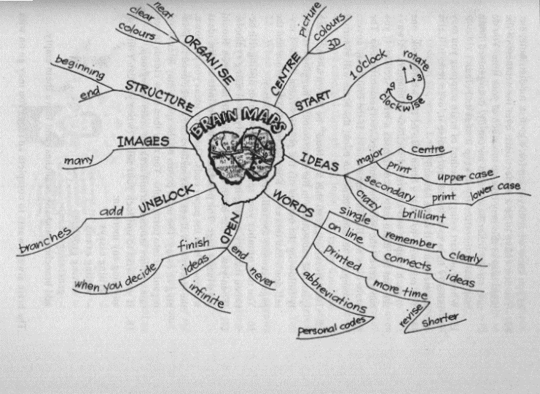With a mind-map, you follow the same procedures as for any other summary. You take a big piece of writing, break it into smaller parts by using headings and sub-headings, and then you summarise in point form or paragraph form.

A mind-map looks different, since it resembles a diagram. The one main point of the summary is quoted in the middle. This would be a heading in your summary.

The sub-headings are written on lines that flow out of the main point. Any further points would branch out from the lines that contain sub-headings.

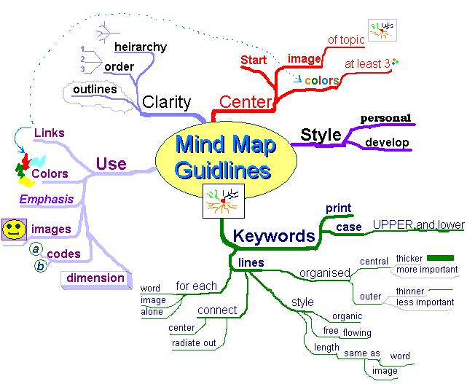

### Diagram

A simplified drawing showing the appearance or structure of something.

This is a diagram of a human’s intestines. Can you see how easy it would be to explain the look, position and function of each separate organ in the human body by using a diagram?

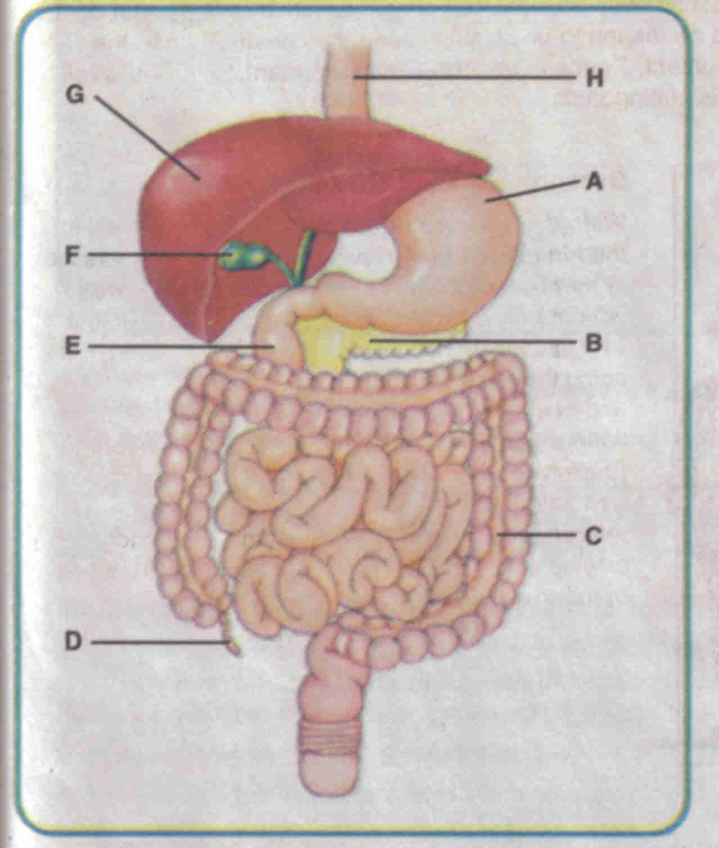

The diagram below illustrates the five thinking hats as explained by de Bono:

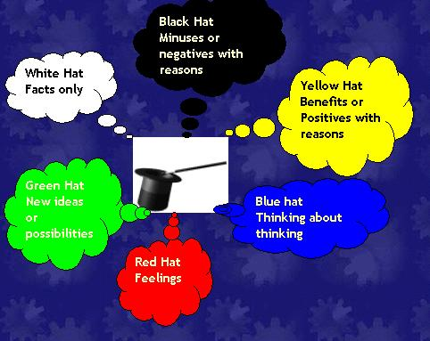

### Photographs

As with any visual representation that is used to supplement written material, photos can have a big impact. The old saying: “A picture paints a thousand words” is very true of photos.

Newspaper photos of the weekend’s sport events illustrate what happened. Photos, of a big natural disaster, such as the tsunami around Christmas 2004, or a hurricane or earthquake, a plane crash or a train that has derailed, sells many newspapers, as people want to see what it looks like after the disaster.

Of course, photos are used in more positive ways than negative ways and it is important for you to consider using photos with your written work. The photo has to add to your writing, please don’t use photos that are not relevant to your written work.

Photos are very effective when you want to persuade readers to your point of view: If you want investors to buy a nice seaside or bushveld property, including a colourful, clear photo of the property will give the reader a positive visual stimulation.

If you want readers to contribute towards a hunger relief fund, showing photos of hungry children will encourage many people to contribute.

If you want voters to vote for you, show them photos of what you have achieved, for example, the houses that have been built, the roads that have been built, and so on.

### Arial Photography

Aerial photography has been around for a long time. It was used as early as 1858 from hot air balloons. Aerial photography was used widely during the first World War.

Photos taken from the air was used to gather information about the enemy’s position, moves and strength. At times, this was done daily. During the second World War and the Korean War aerial photography was also used a lot to gather information about the other side’s movements.

Today, aerial photography is used for the following purposes: to gather military information, to draw maps, to make survey photographs of natural resources such as forests, crops, rivers and so on.

Photos taken from the air can be done from a hot air balloon, a helicopter, a parachute (although this will be difficult) and an aeroplane.

The view from the air is vastly different from the view from the ground. Compare the following two photographs, both are of rice paddies. One was taken from the air and the other one was taken from a slightly higher viewpoint than the woman collecting rice seeds.

Of course, the height at which the photo is taken also affects what the photo looks like.

In an aerial photo all vertical lines, such as poles and tall buildings, tend to disappear at a “vanishing point” in the centre. In other words, it is difficult to judge the height of things from an aerial photo.

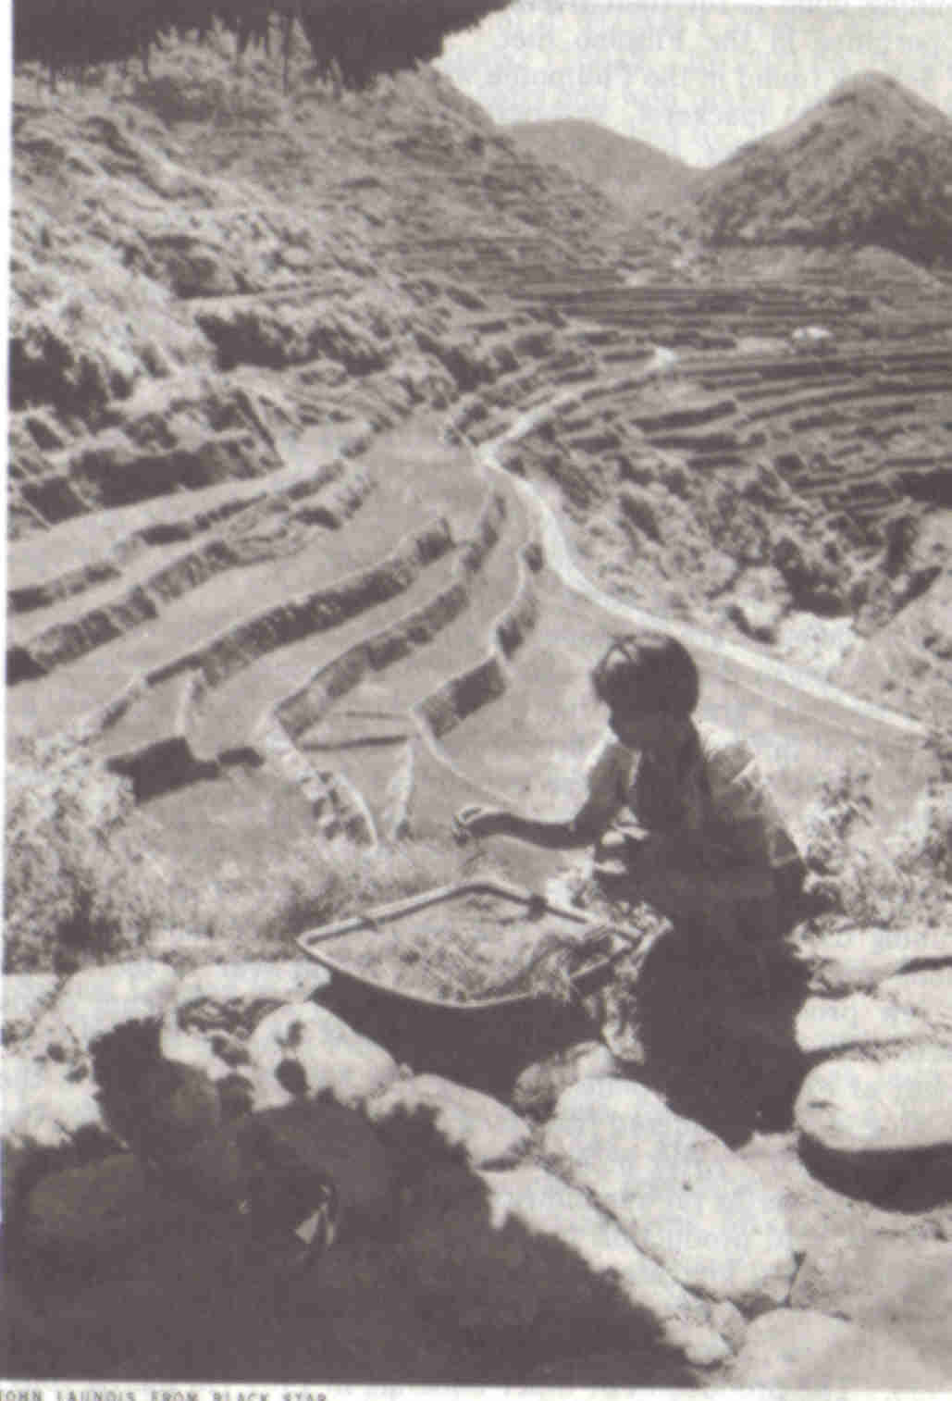

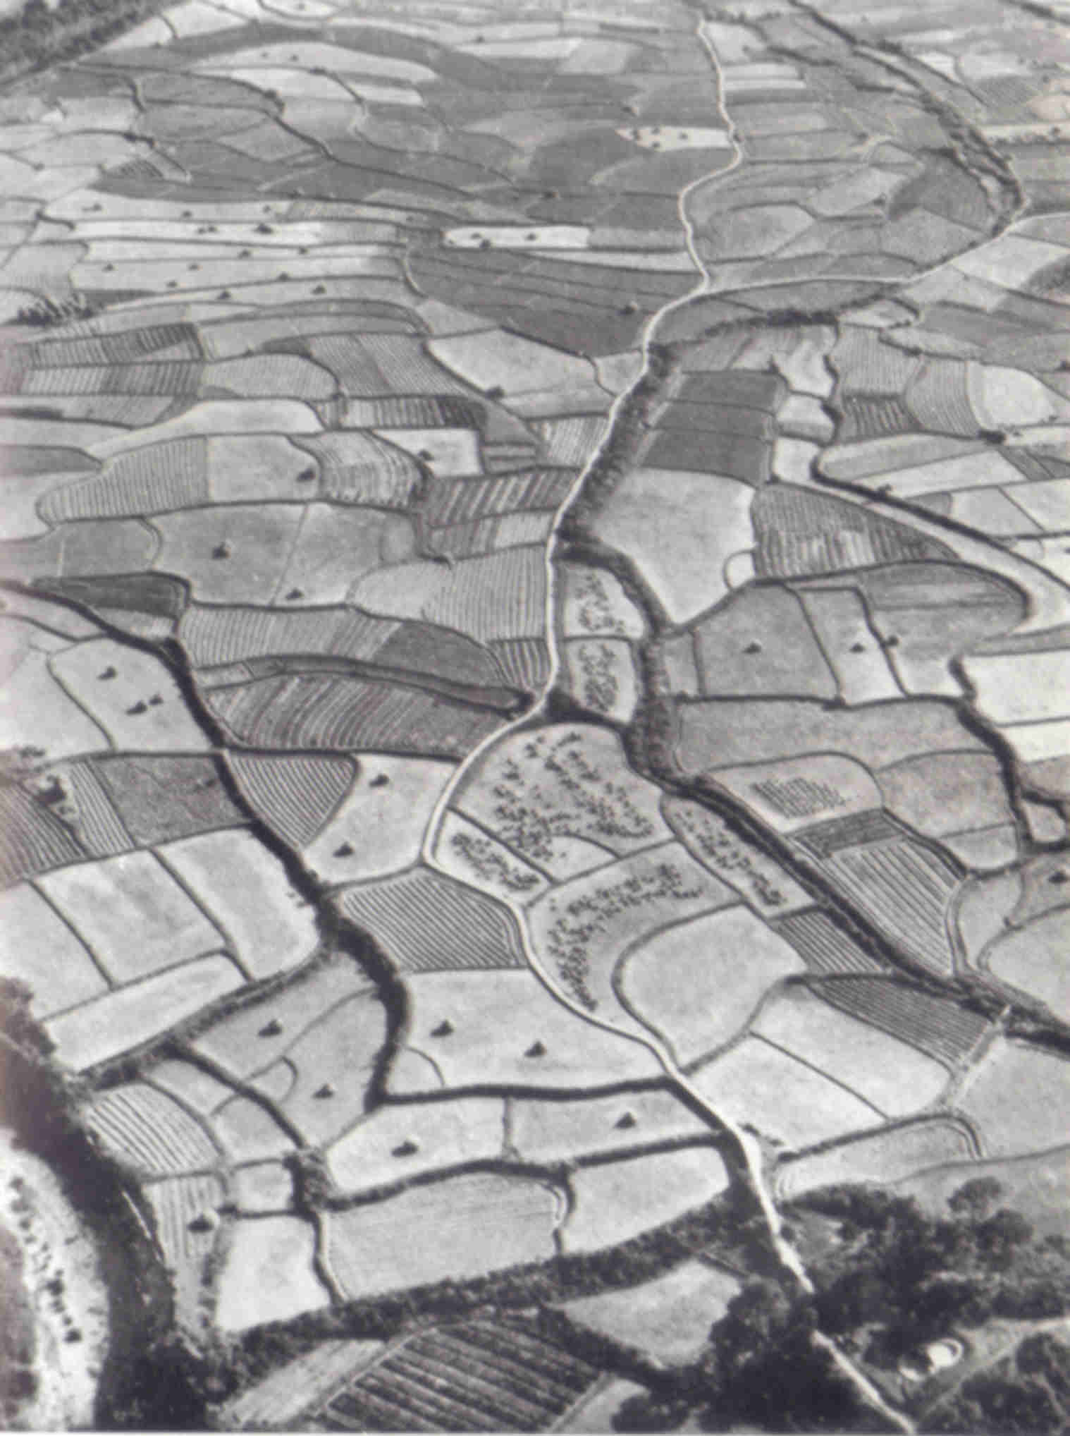

### Pie Chart

A pie chart is used to show how a total breaks down. For example, you have R3000 per month to spend on rent, transport, food, etc. You can use a pie chart to give a visual demonstration of how you spend your R3000. Or you could write an explanation of a paragraph or two to prove to your parents that you are not spending money on unnecessary things.

The minister of finance, the city council, the local governments usually use pie charts to illustrate what they are doing with the tax payers’ money.

A pie chart is only effective when you are working with 100% of something and want to show the breakdown of the 100%. Pie charts are not used to compare production figures, sales targets and so on.

|  |  |
| --- | --- |
| Rent | 900 |
| Transport | 300 |
| Food | 800 |
| Clothes | 500 |
| Spending | 500 |
| Total | 3000 |

### Bar Graph

Is used to compare values at intervals, the bars run horizontally. For example, you can compare your marks for your matric subjects per school term.

You can compare the results on paper, which is lengthy, or you can use a bar graph.

Bar graphs can be used to compare production figures, sales targets and so on.

This example shows only your mathematics results.



This example shows all your subjects



### Cartoons

Cartoons in magazines and newspapers usually make a statement about something newsworthy that happens.

Cartoons are usually the author’s point of view about a subject and should be read with the enjoyment of the cartoon in mind and should not be taken literally, since it only conveys one person’s point of view. Cartoons also usually exagerate the author’s point of view.

One of my favourite cartoons is Madam and Eve, because it is so uniquely and typically South African. They usually make a statement about something that has happened in our own country and, while I do not always agree with them, I can really enjoy the cartoon.

Newspapers and magazines usually have cartoons.

### Pictures And Drawings

Writers also use pictures to illustrate their points and to influence your thinking of the matter.

Text books have good examples of pictures and drawings: in history we have pictures or drawings of leaders and magazines often have drawings to accompany fictional stories and feature articles.

The picture following illustrates how to clear a paper jam in a printer:

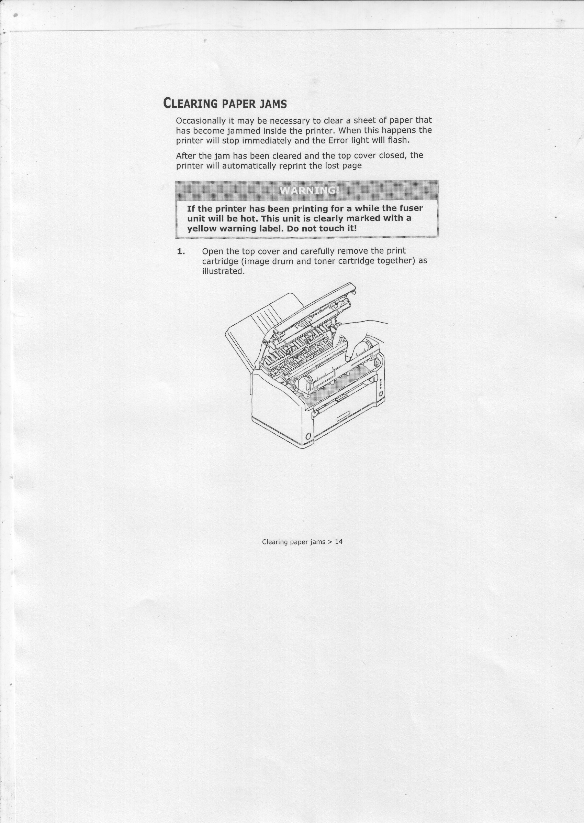

### Maps

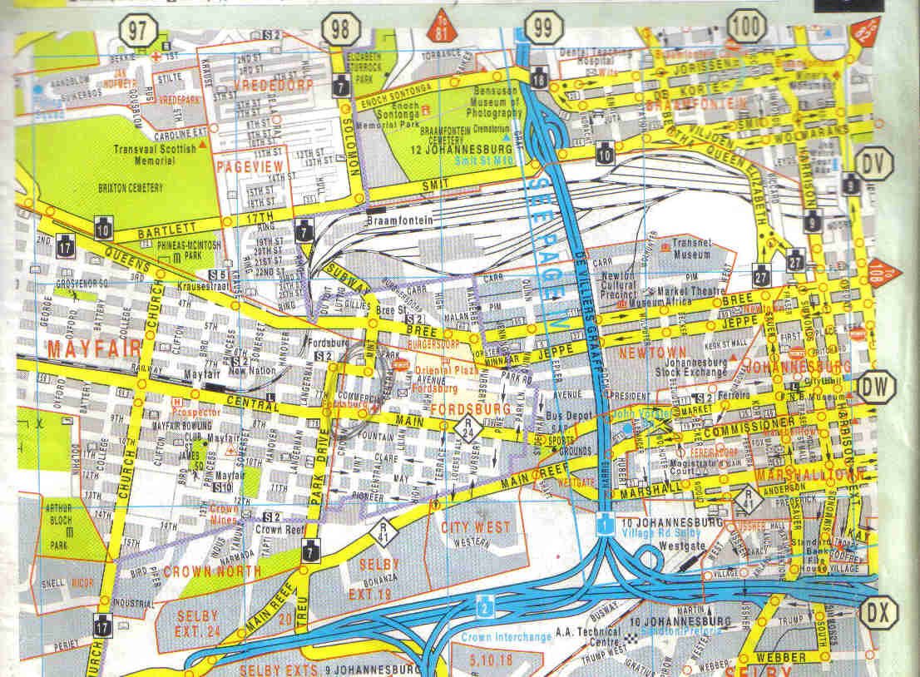It is much easier to explain a route through using a map than giving long written instructions.

### Schema

An outline of what the written piece is about. The outcomes for this course, as well as the Course Content on page 7 gives you an outline of what this course is about.

A schema is a shcematic presentation of a piece of writing, the outline without the content.

If you were writing an article for a magazine, the schema could look as follows:

Introduction: a summary of the article where you answer the Who? What? Where? When? and Why? questions. Who did what where when and why.

Body or development: here you will present the contents in paragraphs that follow one another in a logical way.

Conclusion: where you arrive at the conclusion of the article.

## Critical Thinking Skills

Before you start writing an essay, a summary, a message to someone or business correspondence you have to plan what you are going to write. Remember, writing something is formal and it forms a permanent record. It is not as easy to correct a mistake as with verbal communication.

Part of your planning process is to write an outline of what you want to write – the main points that you wish to express. In order to do this, most of us have to improve out thinking skills. Luckily, there are strategies available to help us with our critical thinking skills.

Critical thinking is when you understand how others think and you also understand your own thinking process. When you can gather evidence to support your reasoning and also evaluate this evidence objectively, you are also applying critical thinking skills.

A mind map is an excellent technique to improve your critical thinking skills.

### Brainstorming

This is a highly effective way of finding solutions to problems, provided you implement the process correctly.

It involves the generation of a large number of unconventional ideas whilst eliminating the usual tendencies to criticise or prematurely reject these unusual ideas.

#### The Brainstorming Process

#### Selection

Select a topic for brainstorming and also select the members of the group.

#### The Topic

The group is given advance notice of the topic in the form of a brief description of one or two sentences. The group facilitator discusses with the group a limited amount of background information relating to the problem.

#### Warm-up session

Members are introduced to the concepts of brainstorming in a relaxed manner.

The group discussion should try to identify the barriers of creative thinking and show how they can be overcome.

The purpose of brainstorming is to generate as many ideas as possible in a short period of time. It does not matter if the ideas are silly, this is actually the purpose of brainstorming.

When using brainstorming, creative thinking is very important, as is overcoming the barriers to creative problem-solving.

The actual brainstorming process is explained, together with the four rules of brainstorming:

Free association: participants must state the first idea that came into their heads, no matter how silly or absurd it may seem.

Clarification: the person whose idea it was can elaborate on the idea, or someone else can, as one idea leads to another. No evaluation of the idea is allowed at this time.

Suspension of judgement: nobody is allowed to pass any comment on anyone else’s ideas. This is not the purpose of brainstorming at all.

Speed: brainstorming should happen as quickly as possible.

Short practice-runs will demonstrate how little time it takes to produce 50 to 100 ideas. At the end of the warm-up session, the original problem is restarted in as many ways as possible. For example, the problem of reduced profit could be redefined as how to beat competitors, or how to improve marketing. All statements are written down by the leader.

It should develop in a light-hearted, easy-going atmosphere. Brainstorming is a fun thing to do and it should be so for everyone.

#### Brainstorm

The facilitator reads out the statements and calls for ideas. As they flow, they are numbered and written up on a large flipchart with a large felt-tip pen.

Each sheet is torn off when full and displayed elsewhere in the room. Freedom of expression should be encouraged. The ideas may number from 150 to 600, or more.

There should be pre-set timescale for this session.

Now the solutions can be considered for practicality and so on.

### Highlighting

While you are reading text you are always looking for the main points. You can make notes of the main points while reading, or you can highlight them. Highlighting can be done by making a note in the margin of the book, by underlining the relevant passages or you can use a highlighting pen.

If the book is your property or belongs to your organisation, feel free to highlight important points. When the book belongs to someone else or a library, please don’t use the highlighting technique – make photo copies of the pages you require and highlight important points on these.

You can also use various coloured highlighters to distinguish between different main points or headings and sub headings. How you use the different colours is up to you, as long as there is method and order in the way you use colour.

You can, for example, highlight all the points relating to one topic in blue, all the points relating to another topic in yellow and so on. Or you can highlight all the main points, irrespective of topic, in blue, all the supporting information in yellow.

Feel free to experiment but make sure that you have your system worked out before you start using your highlighter.

# WRITE USING LANGUAGE STRUCTURES AND FEATURES

#### Specific outcomes

Write for a specified audience and purpose: Narrative, discursive, reflective, argumentative, descriptive, expository, transactional, business correspondence, electronic texts, multi-media presentations.

Use language structures and features to produce coherent and cohesive texts for a wide range of contexts.

#### Assessment criteria

Express meanings clearly through the use of a range of sentence lengths, types and complexities.

Use paragraph conventions, including links between paragraphs in texts, promote coherence and cohesion in writing. Explain their use with reference to logical progression, cause and effect and contrast.

Control the overall structure of a piece of writing and formulate the conclusion clearly.

Support your arguments with sound reasons and facts. Your writing will reflect a clear point of view and show logical development of a clearly articulated premise.

Show your research skills in the way date and information relevant to the context is identified, located and selected for inclusion in the final text.

Access information from different sources; sort; categorise; classify; sift for relevance, validity and reliability; record; report; and formulate conclusions

## Styles Of Writing

To express yourself clearly in writing you should pay special attention to:

Reading and understanding, also called comprehension.

Assembling fact and constructing prose (text).

Sentence structure.

Paragraphing.

Assembling paragraphs.

Making a summary.

Taking notes.

Expanding notes.

Paraphrasing.

We have already covered some of these topics, such as reading and understanding, paraphrasing and so on. We will now move on to actual writing of text.

### Narrative

Narrative style means to tell the story without using dialogue. It is also used to provide a commentary for a film or television programme.

*Scared but holding steady, a Brazilian boy offers his arm for vaccination against the mosquito-born yellow fever virus. Bringing misery to the vulnerable, viruses cause diseases ranging from the common cold and measles to hepatitis and AIDS. Viruses appear to infect all living things – yet are not quite alive themselves. Particles of genetic material – the essence of life – they lie as inert as the dead until an opportunity arises to invade a host.*

You can see it’s like telling a story, where the emphasis is on the sequence of events. Articles in the newspaper, on the radio, on TV and in news reports are written in a narrative mode. Diary entries, autobiographies, a report, etc are also written in this mode. A narrative is easier to follow because it is easier to visualise.

### Discursive

Write about a topic in detail, similar to when you are having a discussion with friends about a topic. It might also happen that you include unrelated topics in the text.

### Reflective

Thoughtful.

In the following text, the person is thinking about growing up.

*As my stepfather’s postings and later my own were all at the whim of the Foreign Office, I’d mostly lived those twenty years abroad in scattered three- or four-year segments, some blazing, some boring, from Caracas to Lima, from Moscow to Cairo to Madrid, housed in Foreign Office lodgings from one-bedroom concrete to gilt-decked mansions, counting nowhere home. I was rootless and nomadic, well used to it and content.*

### Argumentative

A set of reasons given in support of something

Following is an extract from National Geographic October 1995, when civil war was raging in Rwanda with devastating effects not only on the people but also on the wildlife.

***A fragile home threatened by war.***

*Among the last of its kind, a young gorilla peers from its leafy refuge in Rwanda – a nation bloodied by ethnic slaughter. Conservationists fear that Rwanda’s instability could endanger the gorilla’s survival. Others ask: How should the plight of the world’s rarest ape be weighed against more than 500,000 human dead?*

When you are expressing an opinion and giving reasons for it, you are using the argumentative style of writing. The audience may or may not agree with the arguments. An argument can be for persuasive reasons, or it ca be informative or to interact. Always be precise and clear in your reasoning. Consider arguments that could be against your reasoning. Remember:

People tend to accept factual evidence.

Work progressively and systematically through your reasoning to reach the point you want to make. This approach could be convincing.

Take contrary arguments into consideration. In the beginning mention both sides of the argument then focus on your reasoning.

Explain your reasoning carefully. State your opinion and express your views yet acknowledge the contrary arguments even if you don’t agree.

### Descriptive

Describing without expressing judgement

In the following passage, the writer does not try to persuade you to buy the item; he merely states the features of the product.

*The Nokia HS-12W Wireless Stereo Headset has been designed for people who listen to MP3s on their phones and need to effortlessly switch between music and phone mode in an instant. The display serves to provide music information, caller ID and MMS/SMS notification, while the built-in stereo FM RDS radio provides automatic channel search.*

A descriptive is when you are saying what something looks like. Is used any many different situations such as

writing about specific events where detail is necessary as in travel writing,

biographies when you write about specific people and specific events,

technical and scientific works where detail is very important.

### Expository

A full description and explanation of a theory

Usually used in the media to reveal something discreditable. Any scandal that is reported in the media is written in expository style.

Expository style is also when you are explaining how something works. This writing is concerned with the pattern of things, how things work, how to do something and the underlying reality of a situation. It is clear, logic, ordered and to the point. The focus is on what is practical and useful such as articles on gardening, features in newspapers, articles about institutions, organizations, etc.

### Transactional

Relating to a business transaction

This would usually be invoices, debit and credit notes, notes to purchase and so on.

### Business correspondence

Will include all business correspondence: letters, faxes, memos, buying orders, invoices, credit notes, debit notes and so on.

### Electronic texts

Would be sent via e-mail. There is a specific set of rules regulating e-mails.

### Multi-media presentations

A multi-media presentation is what it says: a presentation using more than one medium. In other words, you include a visual presentation on a PC, you can also use a projector or a TV and video combination, or even photos and other visual images posted against the wall, as long as you use more than one medium. The first medium is usually paper-based in the form of a manual, a book, notes and so on. Multi-media presentations are very effective since they make use of more senses than just our eyes.

## Language Structures And Features

### Sentences

Too many short sentences will make your text appear choppy and curt. Too many long sentences will have the opposite effect; your text will appear confusing. Short sentences should be varied with longer sentences to give your text an even flow.

There are three basic types of sentences.

#### Simple sentences

These have a single verb and a single subject and object.

*“The boy is playing with the ball.”*

#### Compound sentences

Are made up of two or more independent sentences or thoughts, that are interrelated. They are connected by the following words: but, and, or.

*“The boy is playing with the ball, but his mother is calling him.”*

Sentences should have the same topic if you want to create a compound sentence.

The following two sentences are not related and should not be joined: “It is late.” and “I like reading.” “It is late and I like reading” does not make sense since the topic is not shared. “It is late and I am going to bed.” is a better example.

#### Complex sentences

Consist of one independent sentence with one or more dependent clause that relates to it. The sentence and the clauses are separated by a comma.

*“Although it is raining, the boy is playing outside.”*

“Although it is raining” is not a full sentence, it does not have a subject, so it is called a clause and has to be added to a sentence. The clauses and the sentence must relate to the same topic if you want to create a complex sentence.

“Although it is raining, I like reading.” is a pointless sentence, since they do not share the same subject. “I have to go to the shop, even though it is raining,” is a better example of a complex sentence.

### Paragraphs

The sentences in a paragraph should form a unit. The reader can easily see how a sentence follows on the one preceding it. A paragraph starts with a topic sentence, that introduces the topic of the paragraph to the reader. The topic sentence acts as a base and holds the paragraph together. Sentences that follow in the same paragraph should enlarge on the topic or theme introduced in the first sentence. We call them supporting sentences. Supporting sentences should provide specific details about the topic in order to clarify the topic sentence and make the paragraph interesting.

If the sentence does not contribute to the theme of the paragraph, it should not be included. You should also avoid adding data that is not relevant to the topic

#### Hints for writing good paragraphs

Each paragraph should have only one theme.

Do not write paragraphs that are longer than 10 or 12 lines, as longer paragraphs become boring and confusing.

Mix long and short paragraphs in a document to create interest and attention with the reader.

### Document

When you are writing a document, it will usually be about a specific topic or theme. The text you are writing will usually consist of more than one paragraph, each with its own topic but relating to the main topic of the document.

Your piece of writing should start with an introduction of the theme of the document. Your first paragraph would therefore be the introductory paragraph. The introductory paragraph should be short, relevant, it must introduce the theme of the document and it must get the attention of the reader.

Your paragraphs must follow each other in a logical way, from point A to point B to point C. The last sentence of the previous paragraph should lead to the next paragraph. One thought should be connected to the next thought in a logical way. Do not jump around from one topic to another without giving the reader some clues as to your purpose.

You can use cause and effect, and contrast to help you arrange your paragraphs in a logical way.

Contrast is when you contrast one theme, thought, opinion or product with another. Refer back to the introduction of the article about the gorillas: you can contrast the concern of conservationists who were worried about the gorillas, with the views of humanists who were more concerned about the people being killed.

Cause and effect: referring back to the same text, you can progress from the causes of the war to the consequences (effect) of the civil war on ordinary people.

If you are writing about something that happens over a period of time, you can arrange your paragraphs chronologically: start with the earliest date and end with the latest date. When writing about droughts in South Africa you can start with the big drought in the 1930s and end with the current drought.

Any arguments used in your document must be supported by sound reasons and facts. You have to justify your feeling about the matter with facts in order to persuade the reader to your point of view. Something your neighbour said about the matter is not fact – you have to verify the statement your neighbour made.

Ensure that you state your point of view clearly. Remember other people also have to understand your point of view.

***A fragile home threatened by war.***

*Among the last of its kind, a young gorilla peers from its leafy refuge in Rwanda – a nation bloodied by ethnic slaughter. Conservationists fear that Rwanda’s instability could endanger the gorilla’s survival. Others ask: How should the plight of the world’s rarest ape be weighed against more than 500,000 human dead?*

As it stands the paragraph above is clear. If I leave out certain key words, I can change the paragraph so that it does not make any sense:

*“A young gorilla peers from its leafy refuge and instability could endanger the gorilla’s survival.” What on earth am I talking about? Where is the gorilla, why would its survival be endangered and what is the instability that I wrote about?*

If you want your writing to be clear, you have to ensure that you give the reader all the information he/she requires to understand your reasoning.

*“They said it is going to rain today.”*

This is a terrible sentence. Who are “they”, where did they get their information from, where is it going to rain, where do they live – do they even live in the same area as you and I? Always check your facts for correctness before you commit them to writing. Readers are very critical and will never forgive you if you get your facts wrong. Anything you write in future will be viewed with suspicion. “The Weather Bureau predicts that there is an 80% chance of rain in Gauteng today.” Now you have stated the source of your fact, you have backed your statement with an estimate of the possibility of rain and you have also made it clear where it will rain. If it doesn’t rain, your readers cannot be angry with you, since you only reported what the Weather Bureau predicted.

At the end of your document, you have to come to a conclusion, where you connect all the facts that you stated previously. State your conclusion or recommendation clearly and make sure that it is based on the facts you stated. The conclusion can be:

A short summary of the main points of your document.

A direct-approach conclusion where you show the reader how the message relates to him/her.

Plan of action conclusion where you answer the question of what should be done about the matters discussed in the body of your document.

## Research

### Sources of Information

Before you start writing your document, you have to plan what you are going to write. First, you are going to define the topic and then you have to gather information about the topic.

|  |  |
| --- | --- |
| Information can be gathered from: | In the case of business correspondence, you will find information in: |
| Libraries | Minutes of meetings. |
| Encyclopaedias | Correspondence with clients and suppliers. |
| Manuals | Operations and procedures manuals |
| Magazines | Internal correspondence between departments, branches and regions. |
| Newspapers | Correspondence between management and their departments. |
| Interviews with experts | Internet |

When doing research about a topic it is important that you gather as much information about a subject as possible. The more information you have, the better. Of course, the information and data must be relevant to the topic that you are going to write about.

### Organise the material

Once you have gathered information, the material you have collected has to be organised.

#### Sorting and categorizing

Arrange or organise the information with common features or characteristics systematically in groups. All the information with similar content is grouped together. Your classification will depend on the order in which you are going to write the document: you can sort the information chronologically, using contrast or cause and effect.

#### Sifting for relevance

Once you have classified the information and data, you have to sift through it for relevance. You should keep only the information that is relevant to your topic, everything else can be discarded. In other words, if you are writing about plants that flower in summer, all information about plants that flower in autumn is not relevant, you cannot use it to enhance your writing and you should discard it.

#### Validity and reliability

Now you have to check your information for validity and reliability. The obvious way of doing this is to check your facts with more than one source: check more than one manual, talk to more than one person, visit more than one website, to ensure that your facts are correct. Preferably, you should use more than one manual, more than one website and the knowledge of more than one expert for each aspect that has to be checked. If most or all you sources state the same basic fact, you can be reasonably sure that the fact is correct.

#### Recording

Once you have sifted and verified your information, record it in the categories you have selected. This recording is in draft form, usually in the form of rough notes.

Now you are ready to draft your first copy of the final document.

# DRAFT OWN WRITING

#### Specific outcome

Draft own writing and edit to improve clarity and correctness.

#### Assessment criteria

Produce writing that is appropriate to the audience, purpose and context. Make corrections to your writing that is an improvement on the original.

Control grammar, diction, sentence and paragraph structure, check and adapt for consistency.

Achieve logical sequencing of ideas and overall unity through redrafting.

Show clear evidence that major grammatical and linguistic errors are edited out in redrafts.

Identify and remove inappropriate or potentially offensive language: obfuscation, excessive use of jargon, jargon used to exclude, insensitive choice of words, (gender, rank, hierarchies in familiar settings or organisations, family, sports, wealth) offensive or incorrect register.

Experiment with different layouts and ensure that the options for presentation are appropriate to the nature and purpose of the task.

## Produce Writing That Is Appropriate

When you write, you always have to take the audience into consideration. For a letter to friends, you will use the informal register, you can use slang and jargon freely and your layout will be informal. The diction, language features and structures, pictures and sentence lengths will all be more informal than you would use for a business document.

When you are writing a document for the Information Technology department, your presentation will be formal, so you will use the formal register. You can use jargon and technical language freely, without explanatory notes. Your diagrams and other visual aids can be technical, as long as it relates to the IT industry.

When you are writing to a client who is not an expert in IT, you will still use the formal register. You will, however, use less jargon and technical language and, where you have to, you will add explanations. Language structure and features will be formal.

This is a layout of a letter done in the formal register. Your choice of words will be formal, you will use headings and sub headings, you will use bold or italic fonts, and so on.

Can you see that this letter does not look the same as the letter to your friend? It is important to use the register that is appropriate to the audience you are writing to. If you don’t, the reader can feel insulted or even refuse to take you seriously.

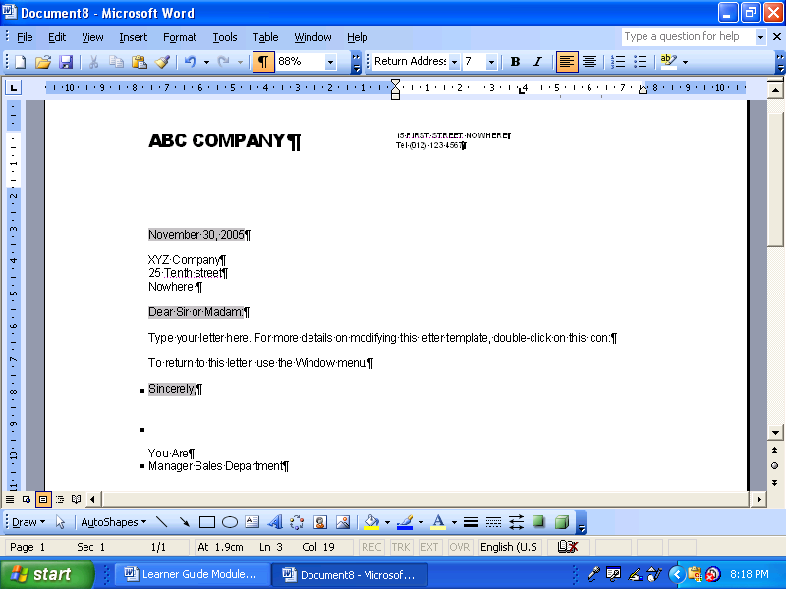

The form that your writing takes must also be appropriate to the context and purpose. For example, a friend’s mother has died and you must write a letter of condolence. Your writing will be more formal than if you were writing to the friend, although not quite as formal as when you are writing to our President. You will not use humour, jargon, technical or ambiguous words. The style will be sympathetic.

When you are inviting a client to a Christmas function, you will use the formal register but you will tone down the formality. You could introduce the theme of the party with a little humour or a funny picture; you will not use titles, heading and so on.

If you are unsure of the difference in the registers, go to a stationer that sells cards and look at birthday cards, cards about illness and death, invitations. There will be more than one example of each and some will be more formal than others. Take note of the tone and style that is used; note the diction and the language structure. Make notes, if necessary and refer back to your notes when necessary.

Keep your rough copies for your portfolio of evidence, as you have to prove that you did redraft your work.

## Meaningful Written Communication

### The ten golden rules of meaningful written communication

Correctness grammar, spelling, punctuation, style, format and composition

Conciseness Brief, specific and to the point, include only what is really necessary. Don’t elaborate on facts and details.

Completeness Include all the relevant information you want to share as well as what the reader wants to know

Clarity Clarity and readability – choose words carefully to eliminate any assumptions and misinterpretations.

Courtesy be considerate of the readers, respect their feelings and their rights. Test your approach by asking yourself; “Would I enjoy reading what I have written?”

Simplicity Keep writing simple, use short yet detailed sentences, avoid using too many descriptive words (adverbs and adjectives)

Accuracy Always give accurate hones information – incorrect information can cost time and money.

Concreteness be realistic, positive, appeal to the readers by keeping their background, needs, and level of understanding in mind.

Personality the readers must know that you care about their interests

Sincerity being sincere builds confidence, watch the tone of your writing, focus on expressing yourself clearly and creating a good impression.

### There are many reasons why authors write texts

To persuade readers to his/her point of view: When an author is writing to persuade, he wants you to accept his opinion about issues, policies and situations.

To inform readers: in SA Computer you will find a lot of articles that inform readers about new developments in Information Technology. In other magazines you will find fashion articles, articles about healthy eating and fitness, etc. These articles were all written to inform readers.

To entertain readers: the short stories found in magazines were written to entertain. Fables, fairy tales, fictional novels, cartoons, short, funny pieces in magazines were all written to entertain.

### Plan your writing

BOOK054Before you start writing your text you have to plan what you are going to write

Who will you be writing for: your friends and family, the general public, a business document, a newspaper or magazine article, etc.?

In which register will you be writing the text: formal or informal

Which writing style will you use: narrative, discursive, expository, etc?

Determine the research you will do

Organise your writing: make sure ideas and facts flow logically

### Pointers to think of before you write

If you are uncertain ask questions. Do not make assumptions make sure your interpretation is correct.

Be well prepared. If you have a clear understanding of what is required of you, your feedback will be more meaningful. Know your topic or subject matter and you will command attention and respect.

Choose your words carefully as they not only express your thoughts, they also impress the receiver. The impression your words make motivates the reaction you receive.

Think before you write. Organise your thoughts and know what you want to say. Don’t just ramble on. Develop a logical pattern when putting pen to paper.

Use clear simple language. Select vocabulary that your audience will relate to and understand.

Be specific in your choice of words so that your message or information can be correctly interpreted. Focus on what you want to say.

Give complete details- address all the relevant facts and answer all the questions and give the necessary explanatory information.

Apply the KISS rule (Keep it Short and Simple) too much unnecessary information can lead to reading boredom.

Focus on correctness. Correct facts, correct answers, correct language usage, correct grammar, correct spelling, correct punctuation, correct format and style. Always use a dictionary.

Be polite and considerate**:** respect the thoughts and opinions of others even if you do not agree.

Always try to write as you would speak. Don’t make the written format too complicated.

Avoid using slang (it’s cool) make sure you use appropriate jargon and subject vocabulary that is relevant.

### Make Your Writing/Signing Interesting

Use numbers and bullets to separate ideas, facts and paragraphs. You will find examples of bullets and numbers in this learner guide

BOOK032Use punctuation correctly: commas, periods, etc.

Use titles, subtitles, headings, contents and index

Use an introduction and a conclusion

Use visual images and captions with these images

Vary the length of your sentences

Structure your paragraphs correctly

If any action is required, make suggestions about the actions

Put ideas forward

Use appendices or addenda if required

#### Remember:

People tend to accept factual evidence.

Work progressively and systematically through your reasoning to reach the point you want to make. This approach could be convincing.

Take contrary arguments into consideration. In the beginning mention both sides of the argument then focus on your reasoning. Explain your reasoning carefully. State your opinion and express your views yet acknowledge the contrary arguments even if you don’t agree.

#### All writing has:

a beginningwhere the main ideas, themes or key concepts are outlined.

a middlewhere these concepts are explained; arguments are developed and examples are discussed.

an endwhere the writer shows how the relevant points made in the beginning are related to the ideas outlined in the middle.

### Think about and remember

Always apply the process of unpacking and repacking when preparing any written task.

Brainstorm to unpack all the key information you need.

Then systematically develop this information into a mind map or flow diagram using questioning techniques to help you interpret the information correctly.

Next you sequence and restructure all the key issues you have included in your flow diagram.

Finally you repack (speak or write) this information in the required format e.g. a report, an assignment, a letter, a statement, a presentation, etc.

The document must be edited before it is submitted.

## Redrafting

You will never use your first draft for the final document without reading and rereading and making changes.

Your first draft is never good enough for the final product, you have to check and recheck and recheck again in order to make corrections to your writing that is an improvement on the original.

When you are checking your document, check the following:

Your use of grammar.

Diction.

The sentence and paragraph structure.

If necessary, which it usually is, make changes to ensure consistency.

Ensure that your ideas and topics flow logically from one to the other in the sentences as well as the paragraphs.

Identify and remove inappropriate or potentially offensive language. Be on the lookout specifically for jargon and technical language. Don’t use them too much; replace them with other explanatory words. Too much jargon and technical language confuses a reader who is not familiar with it. The reader will lose interest and stop reading. I am sure you have stopped reading an article or document because of excessive use of jargon and technical language.

Beware of using offensive language with regards to gender, rank, family, sports, wealth and obfuscation.

You might find a sexist joke funny, the other party might not. Do not make fun of a person’s gender or rank. Also, do not refer to “that old woman”; she might be someone’s mother. Do not call your boss the “Big Chief” call him by his proper rank.

### It is important to edit

or read over the final product before you submit it. Decide how you must revise it by asking yourself:

Whether all the required aspects of the subject have been addressed?

If all the information is relevant

If you have achieved the purpose you had in mind?

Whether it will be suitable for the audience you have identified; Will they understand what you have written and will they be able to identify with the contents?

If the tone you have used is suitable to the audience?

If you your approach and writing style is user friendly approach

If the paragraphs link in a logical sequence

If your sentences are clear and easy to read and interpret?

Make sure your sentences are not too long or too short.

Is the vocabulary you have used applicable to the level of the audience?

Is the language polite and acceptable and without slang, jargon, clichés?

Make sure you have not repeated yourself.

#### When you are checking your document, check the following:

Your use of grammar

Diction

The sentence and paragraph structure

If necessary, which it usually is, make changes to ensure consistency.

Ensure that your ideas and topics flow logically from one to the other in the sentences as well as the paragraphs.

Identify and remove inappropriate or potentially offensive language.

Be on the lookout specifically for jargon and technical language. Don’t use them too much; replace them with other explanatory words. Too much jargon and technical language confuses a reader who is not familiar with it. The reader will lose interest and stop reading. I am sure you have stopped reading an article or document because of excessive use of jargon and technical language.

Beware of using offensive language with regards to gender, rank, family, sports and wealth

You might find a sexist joke funny, the other party might not. Do not make fun of a person’s gender or rank. Also, do not refer to “that old woman”; she might be someone’s mother. Do not call your boss the “Big Chief”; call him by his proper rank.

Experiment with the layout of your writing/signing: change the headings, change the font type and size, move the pictures around until your writing looks pleasing to the eye

#### Jargon

Words or expressions that are used by a specific trade, business or industry.

A paper tiger: when a committee or other body is established to investigate an occurrence, and nothing much happens, it is called a paper tiger. It means that the committee is not doing what it is supposed to do; the members of the committee postpone actions and make up imaginary problems as to why they cannot do the work in time.

In the training environment in South Africa we find a lot of jargon – words that are used in a context not previously used and existing words put together to mean something that is unique to the education and training environment. We talk about Unit Standards, which previously was called training courses, we talk about assessments rather than tests and we have standards generating bodies and standards governing bodies, and so on

### Obfuscation

Obfuscation is the deliberate use of words/phrases/jargon/idioms that will not be understood by the listener/reader. Authors who do this cloud the issue in order to avoid taking responsibility for an action or to confuse the listener into accepting something that should not be lightly accepted

Obfuscation means to make unclear or hard to understand.

“I will horizontalise your perpendicularity” actually means that I will knock you over. Perpendicular means upright and horizontal means parallel to the ground. When you write something, do not make it more difficult than it has to be.

While you are redrafting your piece, experiment with the layout: use titles, headings, colour and so on. This way you can see what the finished product will look like. Add pictures, captions and visual effects at the appropriate places. Visualise what it will look like. Move them around until you are happy with the result – all the graphics, for example, should not be on the same side of the page. Vary their positions from the left to the centre to the right and so on.

#### Insensitive choice of words

Be careful of words, sentences and paragraphs that may appear insensitive or give offence, especially regarding the following topics: gender, rank, hierarchies in familiar settings or organisations, family, sports, wealth.

Do not make fun of rich or poor people; do not make fun of people based on their gender, etc.

## Putting Pen To Paper

The format in which you present the final task makes a decisive impression. Each format has its own specific layout: There are certain features you have to take note of when putting pen to paper. Please note that not all the features listed below will be relevant in every written task you submit, it will depend on the required format.

### Features of a written document

| **Features** | **Purpose** |
| --- | --- |
| Lay out | This will depend on the type of text and the purpose of the text, as well as the intended audience.  The layout must make the text clear and easy to read.  Make generous use of space so that it is easy to recognise the different section. |
| Table of contents | This is only required when you write a manual, workbook, guide or even a report. Indicate page numbers making it easy to find topics. |
| Title | This can be derived from the topic or the theme. The title tells you what the subject is all about. |
| Chapters or modules | The title of a module or chapter can be extracted from key components that have been grouped together.  These can be seen as sub sections if the title or main topic. |
| Sub headings and headings | These can be extracted from the keywords and key concepts that have been grouped together.  Use different weights for each heading as it will help to identify the structure of the text. |
| Paragraphs | They can be developed from the individual key words and key concepts (the puzzle pieces) starting with a single sentence and then using questioning techniques to develop it into a paragraph. The purpose of a paragraph is to:  Develop the structure the whole text  Shape the argument/thought while you are writing  Ensure that the argument/thought flows through the text or links with other paragraphs making the text easy to read. |
| Font | Choose a font that is easy to read such as Arial, Times New Roman or Tahoma at 12pts.  Make sure your text is readable and that there are not too many words in a line. Limit to 15 words per line.  If you write free hand please write neatly and legibly. |
| Grammar | Remember to write as you speak. Watch your tenses and concord (when to use the singular or plural from of the verb) |
| Spelling | Use a dictionary to check spelling when you are uncertain. |
| Vocabulary | Take care to choose your words correctly and with care. Do not use slang. Keep your intended audience in mind when writing. Make sure you use subject vocabulary or jargon correctly. |
| Punctuation. | Do not over punctuate. Punctuation marks: - full stop., comma, question mark?, exclamation mark!, colon:, semi colon;, apostrophe’, inverted commas””. Capital letters. Hyphen - and a dash-. |
| Visuals photographs diagrams | When making use of visual aids make sure they are relevant and they supplement or define the written text. They must also be appealing to the audience. |
| Edit | Always read through your document or text when you have completed a first draft and revise where necessary. Revision can include the following changes to:  the structure or organization of the document  the choice of words and the construction of some sentences.  Spelling, punctuation, choice of vocabulary and the grammar used. |