**LEARNER GUIDE**

**Communication Level 3**

**Use language and communication in occupational learning programmes**

Unit Standard 119467

Level 3 Credits 5

# TABLE OF CONTENTS

[TABLE OF CONTENTS i](#_Toc87623812)

[PERSONAL INFORMATION 1](#_Toc87623813)

[INTRODUCTION 2](#_Toc87623814)

[Programme methodology 2](#_Toc87623815)

[What Learning Material you should have 3](#_Toc87623816)

[Different types of activities you can expect 4](#_Toc87623817)

[Learner Administration 4](#_Toc87623818)

[Assessments 5](#_Toc87623819)

[Learner Support 5](#_Toc87623820)

[Learner Expectations 7](#_Toc87623821)

[UNIT STANDARD 119467 8](#_Toc87623822)

[LEARNING RESOURCES 10](#_Toc87623823)

[**Learning Resources** 10](#_Toc87623824)

[**Textbooks** 10](#_Toc87623825)

[**Using Textbooks To Collect Information** 10](#_Toc87623826)

[**Encyclopaedia** 14](#_Toc87623827)

[**Internet** 14](#_Toc87623828)

[**Magazines And Newspapers** 15](#_Toc87623829)

[**Libraries** 15](#_Toc87623830)

[**Other People** 15](#_Toc87623831)

[**Acknowledgement Of Sources** 15](#_Toc87623832)

[LEARNING STRATEGIES 17](#_Toc87623833)

[**How You Remember** 17](#_Toc87623834)

[**Association** 17](#_Toc87623835)

[**The Three Stages Of Memory** 17](#_Toc87623836)

[**The Three Kinds Of Memory** 18](#_Toc87623837)

[**The Three Stages Of Remembering** 18](#_Toc87623838)

[**Structures To Remember** 19](#_Toc87623839)

[**Associations** 19](#_Toc87623840)

[**If Your Study Method Does Not Work, Change It!** 20](#_Toc87623841)

[**The Process Of Learning** 21](#_Toc87623842)

[**Scanning** 21](#_Toc87623843)

[**Summaries** 21](#_Toc87623844)

[**Highlighting And Underlining** 22](#_Toc87623845)

[**Taking Notes** 22](#_Toc87623846)

[**Ask And Answer Questions** 22](#_Toc87623847)

[??? 23](file:///C:\Users\User\Desktop\LM\PATIENCE\57712%20M4\119472%20LG.docx#_Toc87623848)

[**Mind-Map** 23](#_Toc87623849)

[**Peer And Self-Assessment** 24](#_Toc87623850)

[**Communicating With Others** 24](#_Toc87623851)

[**Brainstorming** 24](#_Toc87623852)

[**The Brainstorming Process.** 25](#_Toc87623853)

[**Listening For Detail** 25](#_Toc87623854)

[MANAGE OCCUPATIONAL LEARNING MATERIALS 26](#_Toc87623855)

[**Occupational Learning Materials** 26](#_Toc87623856)

[**A Filing System** 26](#_Toc87623857)

[**Methods Of Classification** 27](#_Toc87623858)

[**Alphabetical Order** 27](#_Toc87623859)

[**Numerical Order** 27](#_Toc87623860)

[**Alpha-Numeric Filing** 27](#_Toc87623861)

[mom031z 27](file:///C:\Users\User\Desktop\LM\PATIENCE\57712%20M4\119472%20LG.docx#_Toc87623862)

[**Selecting A Classification System** 27](#_Toc87623863)

[**Lending Of Learning Materials** 27](#_Toc87623864)

[**Technical language** 28](#_Toc87623865)

[CONDUCT RESEARCH AND PRESENT FINDINGS 29](#_Toc87623866)

[**Sources Of Information** 29](#_Toc87623867)

[**Organise The Material** 29](#_Toc87623868)

[**Sorting And Categorizing** 29](#_Toc87623869)

[**Sifting For Relevance** 30](#_Toc87623870)

[**Validity And Reliability** 30](#_Toc87623871)

[**Recording** 30](#_Toc87623872)

[**Write Effectively** 30](#_Toc87623873)

[**Reasons Why Authors Write Texts** 30](#_Toc87623874)

[**Plan Your Text Before Writing** 31](#_Toc87623875)

[**Make Your Writing Interesting:** 31](#_Toc87623876)

[**Diction** 31](#_Toc87623877)

[**Always** 31](#_Toc87623878)

[FUNCTION IN A TEAM 32](#_Toc87623879)

[**Purpose Of A Team** 32](#_Toc87623880)

[**Team Members** 32](#_Toc87623881)

[**The Lesson Of The Geese** 32](#_Toc87623882)

[**Roles and responsibilities of team members** 34](#_Toc87623883)

[**The Role Of The Team Leader** 34](#_Toc87623884)

[**Conflict** 35](#_Toc87623885)

[**Constructive Conflict** 35](#_Toc87623886)

[**Negative Conflict** 35](#_Toc87623887)

[**Deal With Conflict Situations** 36](#_Toc87623888)

[**Outcomes Of Conflict** 38](#_Toc87623889)

[**The common consequences of unresolved conflicts:** 40](#_Toc87623890)

[**Steps in conflict resolution** 40](#_Toc87623891)

[**Negotiation** 41](#_Toc87623892)

[**Characteristics of the Successful Negotiator** 41](#_Toc87623893)

[**Preparation** 41](#_Toc87623894)

[**Building Understanding** 42](#_Toc87623895)

[**Bargaining** 43](#_Toc87623896)

[**Closing** 43](#_Toc87623897)

[WORKPLACE CHARACTERISTICS 44](#_Toc87623898)

# PERSONAL INFORMATION

|  |  |
| --- | --- |
| ****NAME**** |  |
| ****CONTACT ADDRESS**** |  |
|  |
| ****Code**** |  |
| ****Telephone (H)**** |  |
| ****Telephone (W)**** |  |
| ****Cellular**** |  |
| ****Learner Number**** |  |
| ****Identity Number**** |  |
|  | |
| ****EMPLOYER**** |  |
| ****EMPLOYER CONTACT ADDRESS**** |  |
|  |
| ****Code**** |  |
| ****Supervisor Name**** |  |
| ****Supervisor Contact Address**** |  |
|  |
| ****Code**** |  |
| ****Telephone (H)**** |  |
| ****Telephone (W)**** |  |
| ****Cellular**** |  |

# **INTRODUCTION**

#### Welcome to the learning programme

Follow along in the guide as the training practitioner takes you through the material. Make notes and sketches that will help you to understand and remember what you have learnt. Take notes and share information with your colleagues. Important and relevant information and skills are transferred by sharing!



This learning programme is divided into sections. Each section is preceded by a description of the required outcomes and assessment criteria as contained in the unit standards specified by the South African Qualifications Authority. These descriptions will define what you have to know and be able to do in order to be awarded the credits attached to this learning programme. These credits are regarded as building blocks towards achieving a National Qualification upon successful assessment and can never be taken away from you!

### Programme methodology



The programme methodology includes facilitator presentations, readings, individual activities, group discussions and skill application exercises.

Know what you want to get out of the programme from the beginning and start applying your new skills immediately. Participate as much as possible so that the learning will be interactive and stimulating.

The following principles were applied in designing the course:

* Because the course is designed to maximise interactive learning, you are encouraged and required to participate fully during the group exercises
* As a learner you will be presented with numerous problems and will be required to fully apply your mind to finding solutions to problems before being presented with the course presenter’s solutions to the problems
* Through participation and interaction the learners can learn as much from each other as they do from the course presenter
* Although learners attending the course may have varied degrees of experience in the subject matter, the course is designed to ensure that all delegates complete the course with the same level of understanding
* Because reflection forms an important component of adult learning, some learning resources will be followed by a self-assessment which is designed so that the learner will reflect on the material just completed.

This approach to course construction will ensure that learners first apply their minds to finding solutions to problems before the answers are provided, which will then maximise the learning process which is further strengthened by reflecting on the material covered by means of the self-assessments.

#### Different role players in delivery process

* Learner
* Facilitator
* Assessor
* Moderator

### What Learning Material you should have

This learning material has also been designed to provide the learner with a comprehensive reference guide.

It is important that you take responsibility for your own learning process; this includes taking care of your learner material. You should at all times have the following material with you:

|  |  |
| --- | --- |
| **Learner Guide** | **This learner guide is your valuable possession:**  This is your textbook and reference material, which provides you with all the information you will require to meet the exit level outcomes.  During contact sessions, your facilitator will use this guide and will facilitate the learning process. During contact sessions a variety of activities will assist you to gain knowledge and skills.  Follow along in the guide as the training practitioner takes you through the material. Make notes and sketches that will help you to understand and remember what you have learnt. Take and share information with your colleagues. Important and relevant information and skills are transferred by sharing!  This learning programme is divided into sections. Each section is preceded by a description of the required outcomes and assessment criteria as contained in the unit standards specified by the South African Qualifications Authority. These descriptions will define what you have to know and be able to do in order to be awarded the credits attached to this learning programme. These credits are regarded as building blocks towards achieving a National Qualification upon successful assessment and can never be taken away from you! |
| **Formative Assessment Workbook** | The Formative Assessment Workbook supports the Learner Guide and assists you in applying what you have learnt.  The formative assessment workbook contains classroom activities that you have to complete in the classroom, during contact sessions either in groups or individually.  You are required to complete all activities in the Formative Assessment Workbook.  The facilitator will assist, lead and coach you through the process.  These activities ensure that you understand the content of the material and that you get an opportunity to test your understanding. |

### Different types of activities you can expect

To accommodate your learning preferences, a variety of different types of activities are included in the formative and summative assessments. They will assist you to achieve the outcomes (correct results) and should guide you through the learning process, making learning a positive and pleasant experience.



The table below provides you with more information related to the types of activities.

| **Types of Activities** | **Description** | **Purpose** |
| --- | --- | --- |
| **Knowledge Activities** | You are required to complete these activities on your own. | These activities normally test your understanding and ability to apply the information. |
| **Skills Application Activities** | You need to complete these activities in the workplace | These activities require you to apply the knowledge and skills gained in the workplace |
| **Natural Occurring Evidence** | You need to collect information and samples of documents from the workplace. | These activities ensure you get the opportunity to learn from experts in the industry.  Collecting examples demonstrates how to implement knowledge and skills in a practical way |

### Learner Administration



#### Attendance Register

You are required to sign the Attendance Register every day you attend training sessions facilitated by a facilitator.

#### Programme Evaluation Form

On completion you will be supplied with a “Learning programme Evaluation Form”. You are required to evaluate your experience in attending the programme.

Please complete the form at the end of the programme, as this will assist us in improving our service and programme material. Your assistance is highly appreciated.

### Assessments

The only way to establish whether a learner is competent and has accomplished the specific outcomes is through the assessment process. Assessment involves collecting and interpreting evidence about the learners’ ability to perform a task.

To qualify and receive credits towards your qualification, a registered Assessor will conduct an evaluation and assessment of your portfolio of evidence and competency.

This programme has been aligned to registered unit standards. You will be assessed against the outcomes as stipulated in the unit standard by completing assessments and by compiling a portfolio of evidence that provides proof of your ability to apply the learning to your work situation.



**How will Assessments commence?**

#### Formative Assessments

The assessment process is easy to follow. You will be guided by the Facilitator. Your responsibility is to complete all the activities in the Formative Assessment Workbook and submit it to your facilitator.

#### Summative Assessments

You will be required to complete a series of summative assessments. The Summative Assessment Guide will assist you in identifying the evidence required for final assessment purposes. You will be required to complete these activities on your own time, using real life projects in your workplace or business environment in preparing evidence for your Portfolio of Evidence. Your Facilitator will provide more details in this regard.

To qualify and receive credits towards your qualification, a registered Assessor will conduct an evaluation and assessment of your portfolio of evidence and competency.

### Learner Support

The responsibility of learning rests with you, so be proactive and ask questions and seek assistance and help from your facilitator, if required.

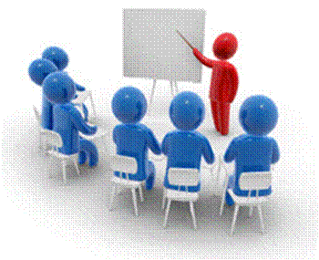

Please remember that this Skills Programme is based on outcomes based education principles which implies the following:

* You are responsible for your own learning – make sure you manage your study, research and workplace time effectively.
* Learning activities are learner driven – make sure you use the Learner Guide and Formative Assessment Workbook in the manner intended, and are familiar with the workplace requirements.
* The Facilitator is there to reasonably assist you during contact, practical and workplace time for this programme – make sure that you have his/her contact details.
* You are responsible for the safekeeping of your completed Formative Assessment Workbook and Workplace Guide
* If you need assistance please contact your facilitator who will gladly assist you.
* If you have any special needs please inform the facilitator

### Learner Expectations

Please prepare the following information. You will then be asked to introduce yourself to the instructor as well as your fellow learners



|  |
| --- |
| Your name: |
|  |
|  |
| The organisation you represent: |
|  |
|  |
| Your position in organisation: |
|  |
|  |
| What do you hope to achieve by attending this course / what are your course expectations? |
|  |
|  |
|  |
|  |
|  |
|  |
|  |
|  |

**UNIT STANDARD 119467**

***Unit Standard Title***

Use language and communication in occupational learning programmes

***NQF Level***

3

***Credits***

5

***Purpose***

The purpose of this unit standard is to facilitate learning and to ensure that learners are able to cope with learning in the context of learnerships, skills programmes and other learning programmes. Many adult learners in the FET band have not been in a learning situation for a long time, and need learning and study strategies and skills to enable successful progression.

Learners competent at this level will be able to deal with learning materials, to access and use useful resources, to seek clarification and help when necessary, and apply a range of learning strategies. They do this with an understanding of the features and processes of the workplaces of the workplaces and occupations to which their learning programmes refer

***Learning assumed to be in place***

The credit calculation is based on the assumption that learners are already competent in terms of the full spectrum of language knowledge and communication skills laid down in the national curriculum statements up to NQF level 2.

***Unit standard range***

Learning materials appropriate to the learners in a given context

Specific range statements are provided in the body of the unit standard where they apply to particular outcomes or assessment criteria

***Specific Outcomes and Assessment Criteria***

Specific Outcome 1: Access and use suitable learning resources.

Relevant learning resources are identified: Resource centres, literature, internet, other people

Learning resources are used effectively through appropriate selection of information and acknowledgement of sources.

Specific Outcome 2: Use learning strategies.

Information is summarised for learning purposes

Specific techniques are selected and applied appropriately: Group activities such as brainstorming, group analysis, peer and self-assessment mind maps, note taking, memorising, key words, underlining, skimming and scanning

Relevant questions are asked: Checking understanding, clarifying meaning, getting information, confirm accuracy of information

Texts are read for detail and interpreted and analysed for a given context

Spoken input is listened to for detail, interpreted and analysed for a given context.

Learning takes place through communicating with others in groups or as individuals: Facilitators, other learners, colleagues

Specific Outcome 3: Manage occupational learning materials.

Occupational learning materials are well organised: Videos, internet, texts, handouts, text books, charts, maps, plans, diagrams

Layout and presentation of learning materials are understood and used effectively: Index, contents page, or glossaries, electronic texts

Specific Outcome 4: Conduct basic research and analyse and present findings.

Appropriate or relevant topic and scope is identified and defined

Research steps are planned and sequenced appropriately

Research techniques are applied: Gathering information, reading, interviewing, using appropriate electronic sources

Information is evaluated for relevance

Information is classified, categorised and sorted

Research findings are analysed and presented in the appropriate format

Specific Outcome 5: Function in a team.

Active participation takes place in group-learning situations: Meetings, site/field visits, excursions, discussions, activities, workshops

Responsibilities in the team are taken up and group work conventions are applied in learning situations: Supervision, mentoring, rotation of roles: conducting, chairing, recording, reporting

Conflict management and negotiating techniques are practised

Team work results in meaningful product or outcomes: Reaching consensus, completed projects/assignments

Specific Outcome 6: Reflect on how characteristics of the workplace and occupational context affect learning.

Features of the occupational environment are described and discussed: Workplace/occupational focus: Services, manufacturing, financial, educational. Organisation type: Government, parastatal, heavy/light industry, large organisation, small business

Ways in which these features affect learning processes and/or application of learning are described and discussed: Technological resources, communication resources, communication strategies and multilingual needs in relation to necessary client or colleague interaction

***Unit Standard Essential Embedded Knowledge***

Learners can understand and explain that language has certain features and conventions, which can be managed for learning purposes. Learners are aware that there are skills, strategies and resources which will facilitate learning. They are familiar with the workplace context in which their learning will be applied

***Critical Cross-field Outcomes (CCFO)***

Unit Standard CCFO Identifying: Identify and solve problems: using learning programme material and learning tasks to solve problems.

Unit Standard CCFO Working: Working effectively with others and in teams: using interactive speech and roles in activities, discussions and projects.

Unit Standard CCFO Organizing: Organise and manage oneself and one’s activities responsibly and effectively: through organisation of learning materials and assignments.

Unit Standard CCFO Collecting: Collecting, analysing, organising and critically evaluating information: through application of information processing skills in study.

Unit Standard CCFO Communicating: Communicate effectively using visual, mathematical and/or language skills in formal and informal learning situations.

Unit Standard CCFO Science: Use science and technology effectively and critically: using electronic media for learning.

Unit Standard CCFO Demonstrating: Reflect on and explore a variety of strategies to learn more effectively.

Unit Standard CCFO Contributing: Explore education and career opportunities.

**LEARNING RESOURCES**

***Specific outcome***

Access and use suitable learning resources

***Assessment criteria***

On completion of this section you will be able to ensure that:

Relevant learning resources are identified Resource centres, general texts, printed and visual media, internet, other people

Learning resources are used effectively through appropriate selection of information and acknowledgement of sources

***Learning Resources***

**Textbooks**

A textbook is a book that is used as a standard work for the study of a subject. We all used textbooks in school in order to study the grammar, spelling and language rules for English, Afrikaans, Sotho or Zulu, we also used textbooks to study economics, history, geography and so on.

Having a textbook for a language is a valuable reference resource, because you can refer to the textbook to solve issues

Of course, you get more kinds of textbooks than language textbooks. As stated, you get textbooks about geography, history, architecture, interior decorating, garden landscaping, computer software and hardware. There are textbooks about arts and crafts, woodworking, driving, just about anything that you want to learn about.

If you look up the word textbook in a thesaurus, you will find the following list:

Schoolbook

Manual

Workbook

In other words, a textbook, or manual, contains information about a subject. This means that you can use a textbook to look up information about a subject. This learner guide is an example of a textbook or manual.

**Using Textbooks To Collect Information**

You could read the entire book and hope you get the specific information you are looking for, but there are easier ways.

Textbooks are divided into chapters. Each chapter will contain information about a specific subject. The chapters can be subdivided into sections and, if the manual is comprehensive, even sub-sections.

***Contents Page***

The writers who compile textbooks always try to make it easy for us to find specific information about a certain subject. Every textbook will have a contents page or table of contents, which will give the main headings of the different chapters or sections of the textbook.

Each entry in the table of contents will refer to a page number. You can then turn to that page and look at the contents from that page on.

If you want to get an idea what a textbook or manual is about, the table of contents should give you the main points of the contents in a simple and understandable format.

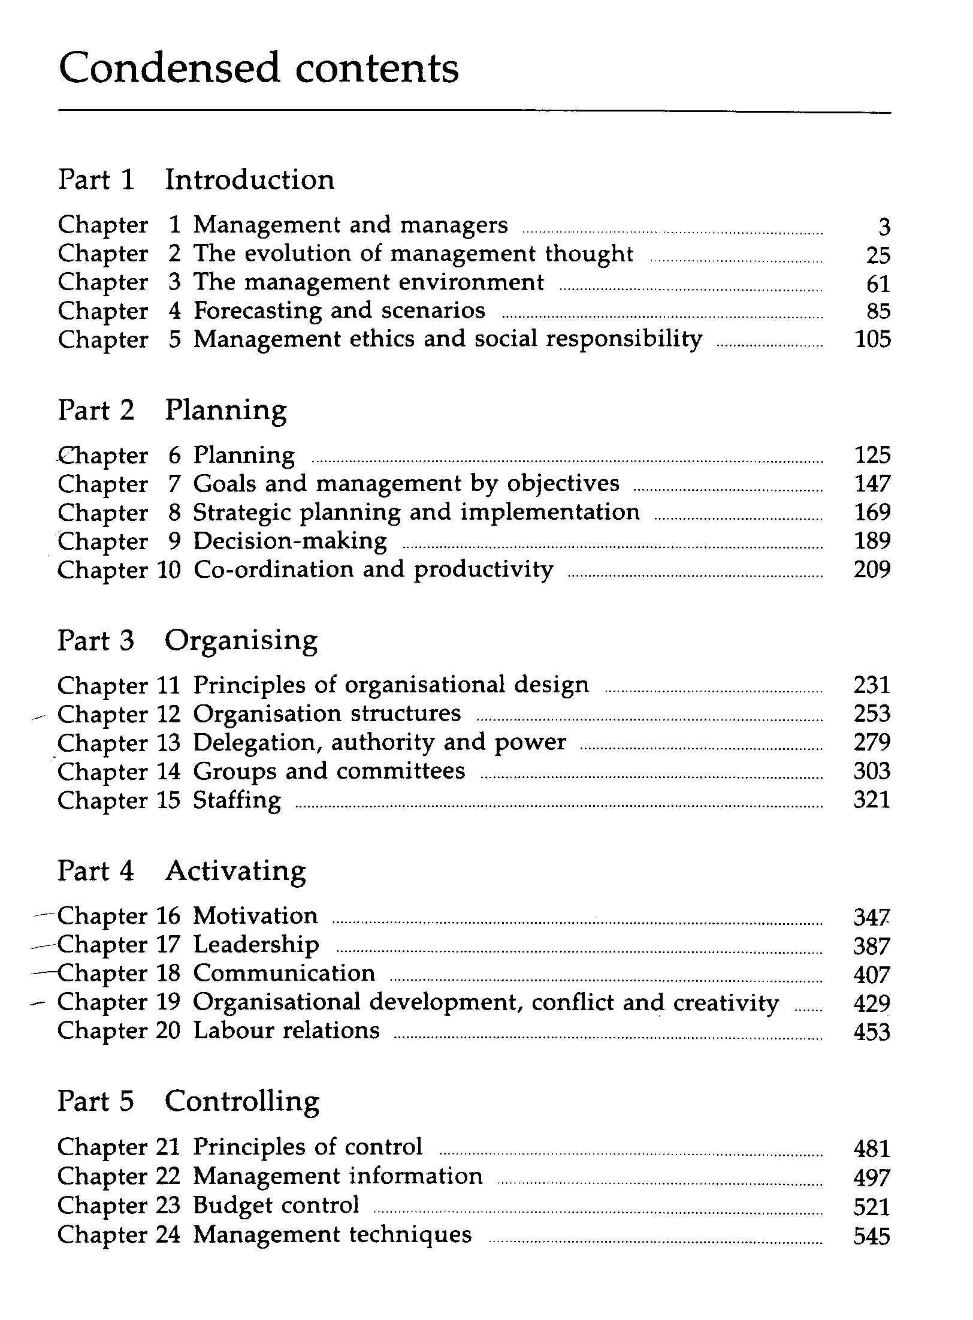Following is a contents page from a textbook about General Management.

Can you see that subjects are grouped together in a sensible manner? Can you see that it is easy to obtain information about a specific subject?

If I need information about motivation, I will go to page 347, as indicated in the contents page. Here I will see that the chapter is further divided into sections, which are indicated by text typed in bold.

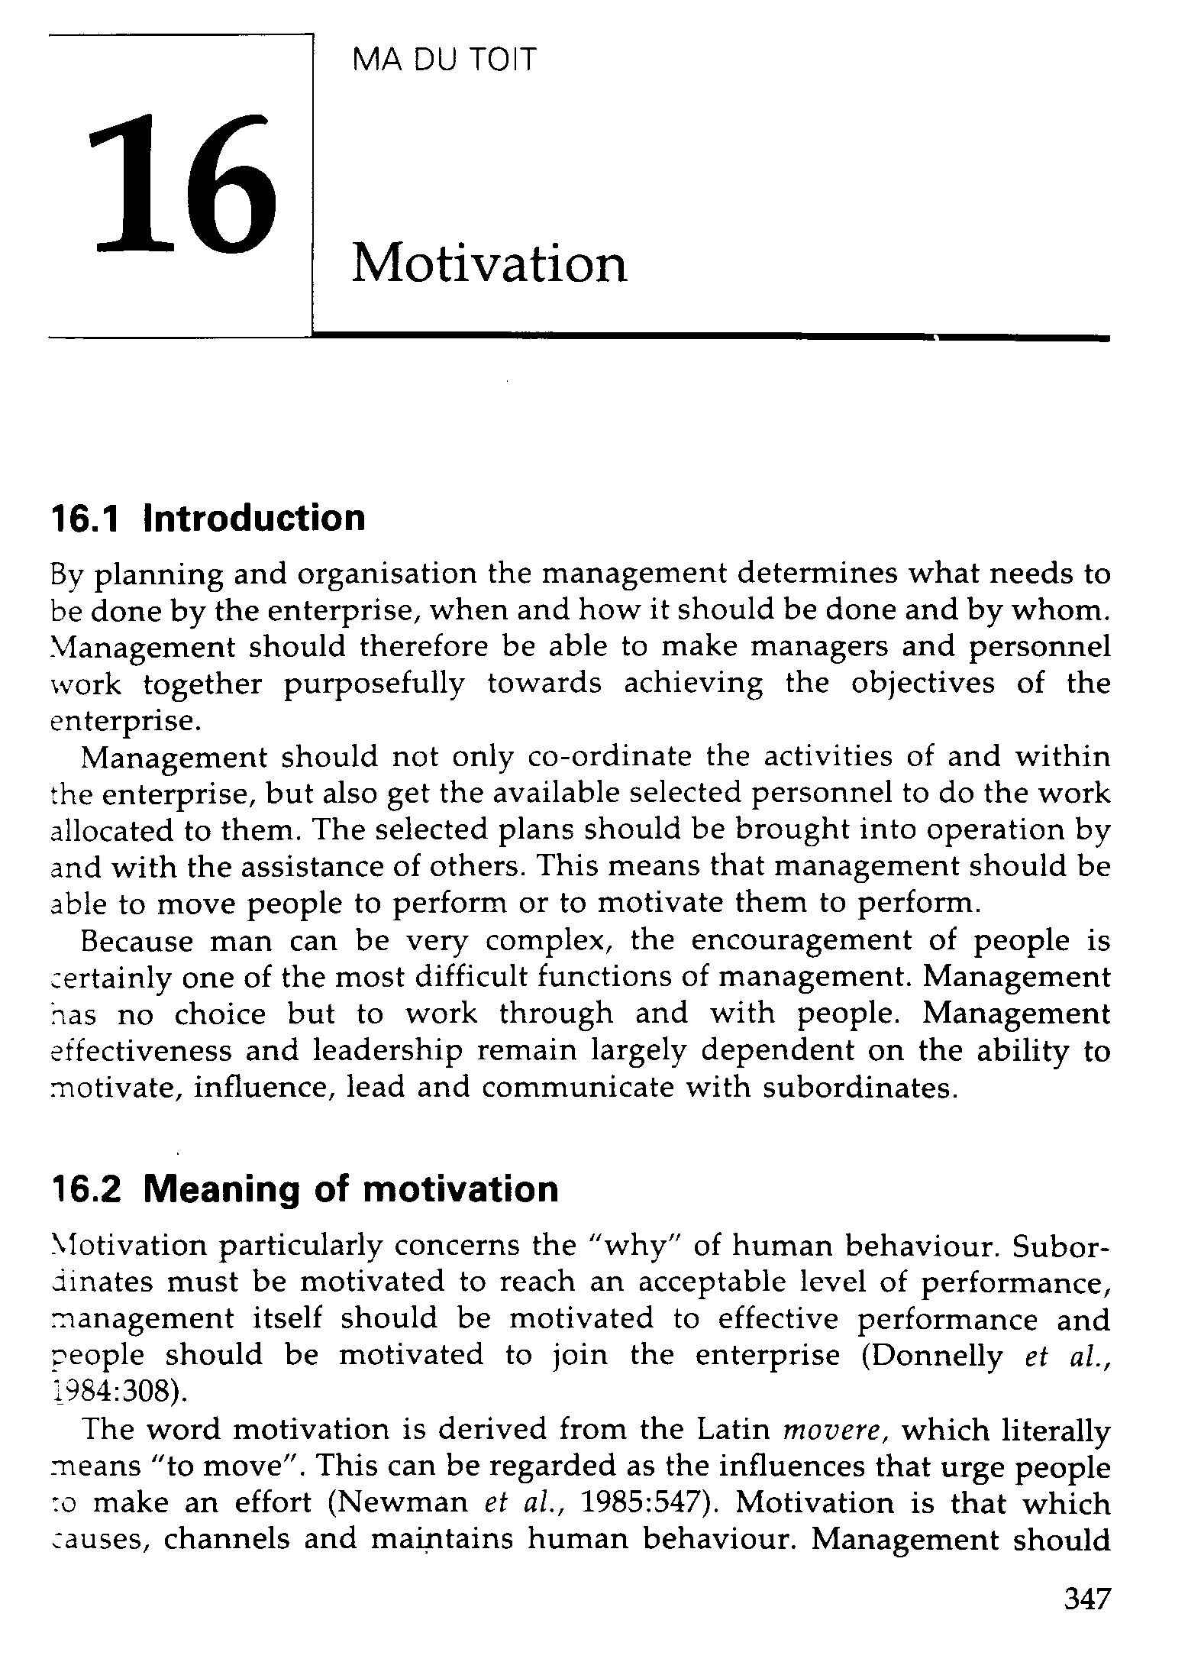

Now I can page through the chapter, looking only at the headings of sections until I find the information I am looking for. Did you notice that the headings in this textbook are also numbered? All this is done to make it easy for you to find the information again. I would make a note of the page number, as well as the heading number: p347, 16.2 Meaning of motivation.

All this makes it easy for you to find the information the first time and also to refer back to the information afterwards.

***Index***

Most textbooks also contain an Index, situated at the back of the book. Using the Index, you can look up information by looking for a specific word. The Index is always sorted alphabetically, so if I want to look up the word motivation, I will have to go to M in the Index.

From the Index, under M, I can see that there are references to motivation on pages 10 as well as 347. I can therefore find information about motivation on page 10 and 347.

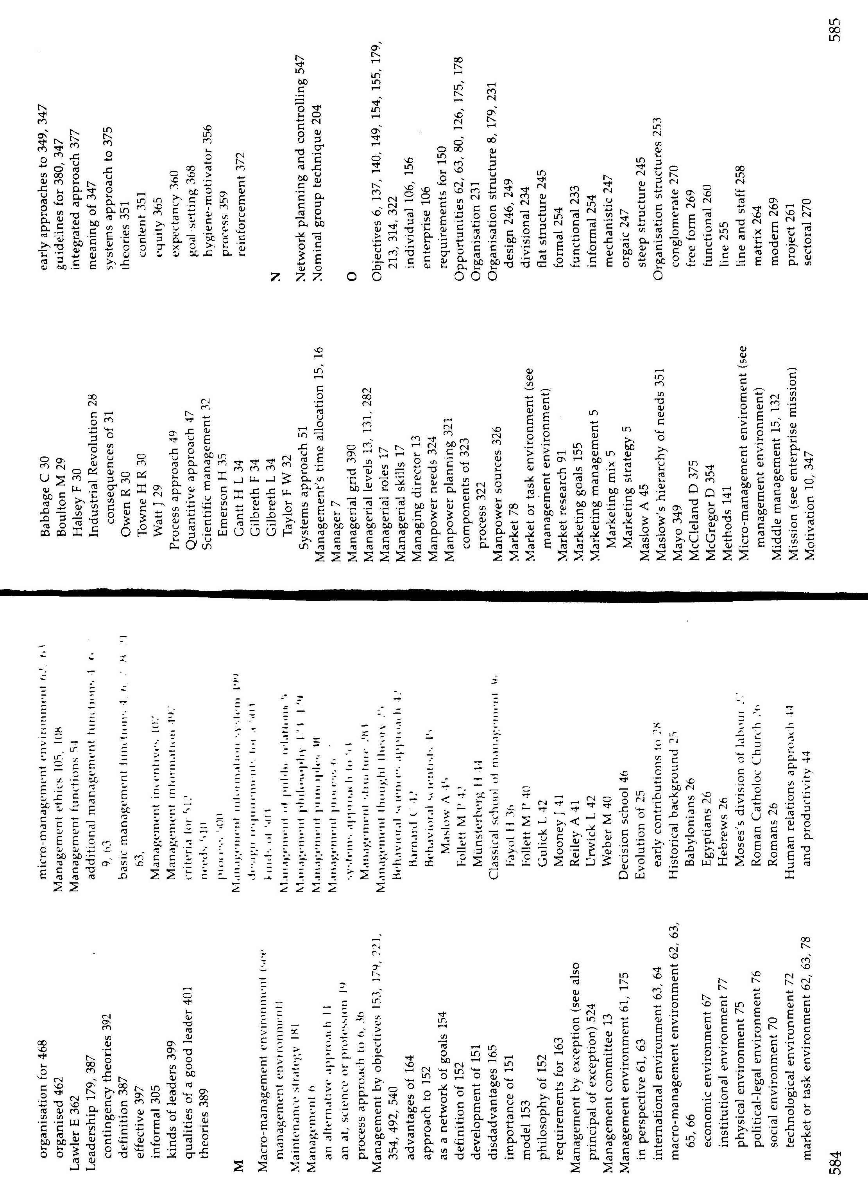

**Encyclopaedia**

An encyclopaedia is a book or a set of books giving information about many subjects.

Encyclopaedias are organised alphabetically, according to subject, from A to Z. When you are looking for information in an encyclopaedia, you have to refer to the Index Book first.

The Index Book is organised like an index in a textbook. It is a lot bigger, since an encyclopaedia contains information about every known subject.

You will use the Index Book in an encyclopaedia the same way as the Index section in a textbook. First, you will identify the subject you are looking for: **helicopters**. Then you go to the Index Book and look under H for helicopters.

The Index Book will then tell you in which book, on which page and where on the page you will find the information you require on the subject, in this case helicopters.

From this example of an Index book, you can see what information you can find about helicopters.

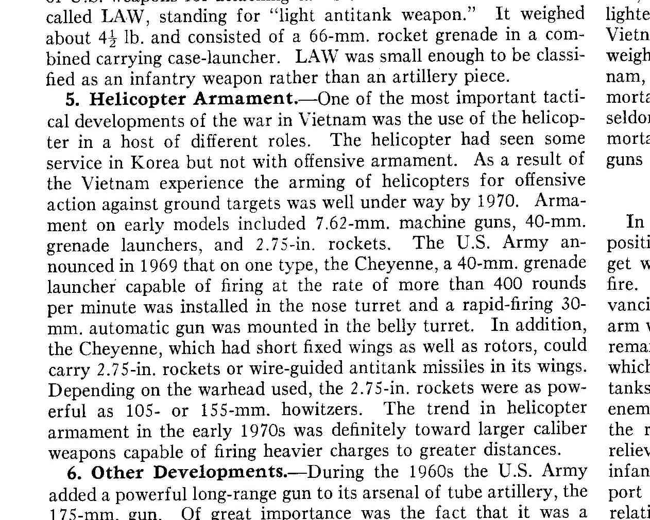

If you want information about military helicopters, you will go to book 2 of the encyclopaedia, then page 544, section b of the page.

This particular encyclopaedia is called Encyclopaedia Britannica and it consists of 27 books filled with information, plus the Index book.

Many people are fortunate enough to own encyclopaedias. If you don’t own one, you can go to your local library and use their encyclopaedias to look for information.

These days you can also find encyclopaedias on DC-ROM and DVD-ROM.

**Internet**

You can also search the Internet for information. The Internet is like a very large library. Where a library is filled with books containing information, the Internet is made up of web sites that are filled with information.

Searching the Internet is a lot like using an Index book: you go online to a website such as MWEB or MSN and you will find a Search option somewhere on the first page, that is also called the Home page of the website.

The Search option will give you space in which to enter a keyword or keywords, just like you would look in an Index. You then click on a button and the computer searches for websites that contain information about the word you typed in.

Because the Internet is a worldwide resource of information, there is an awful lot of information to be found out there, so you have to be very specific when you search for information on the Internet.

If you, for example, enter dogs as your keyword, you will end up with a couple of million hits. It is impossible for you to visit all those websites, so you have to narrow down your search, for example by typing in the specific breed of dog you want information on: golden retriever or whatever breed of dog you want information on. This will give you less hits, hopefully only about twenty or thirty websites, which is much more manageable.

Some websites you can use:

[*www.howstuffworks.com*](http://www.howstuffworks.com)

[*www.answers.com*](http://www.answers.com)

**Magazines And Newspapers**

Magazines and newspapers always contain a lot of information. You will find information about developments in the business world such as labour unrest, technology as well as industry specific information.

Most newspapers and magazines have sections about: business, sport, new developments, technology, books, music, art, general news and more.

You will also find industry specific magazines that are about computers and IT, language and culture, transport industry, training and education, mining, marketing and advertising, the HR industry, the retail industry, etc.

Then there are magazines dedicated to geography, aviation, wildlife, animals, the Internet, computer games, sport, fashion, home improvements, gardening – in short for just about any subject you will find a magazine.

**Libraries**

Libraries stock most of the magazines and newspapers read in their areas. There are also encyclopaedias, textbooks on any subject, biographies and autobiographies and, of course books of fiction available in libraries.

If you are unsure where to find a book about a specific subject, you can ask the librarian to assist you.

Certain books can be taken out of the library, but the so-called reference books may only be used inside the library.

Many bigger organisations have in-house libraries. These libraries typically contain books about the industry in which the organisation operates, as well as operational procedures and training manuals.

**Other People**

Friends, family, colleagues at work are all sources of information. Often, if they cannot give you the information or confirm the information, they can tell you who will be able to give you the information. Or, they can tell you where to find the information – in the operations manual, the training manual, the in-house library or which magazines or books contain the information.

Never be afraid to ask someone if you need help to gather information.

***Acknowledgement Of Sources***

You will often find information in a book, magazine article or even a web site that someone else has written. When you use this information, you have to give credit to the person whose written work you are using, even if you get the information from the Internet.

Sometimes you have to get the approval of the author or publisher of the book before you are allowed to use the information. If this is the case, you have to contact them and get their permission before you can use the information.

Mostly, though, it is sufficient to acknowledge the original author and publisher by quoting their details in your work. This is called a bibliography.

A bibliography is a record of the resources and sources you used during your research. Follow the following format when quoting the sources of your information:

Author surname and initials

The year it was published

The title of the book

Where it was published

The name of the publisher

When you quote the author directly, you have to add the following to your text where you use the quote: (Sayles & Chandler, 1971:185)

Sayles & Chandler are the authors

1971 is the year the book was published

185 is the page number where the quote appears

Then, of course, you have to add the details of the book to the bibliography.

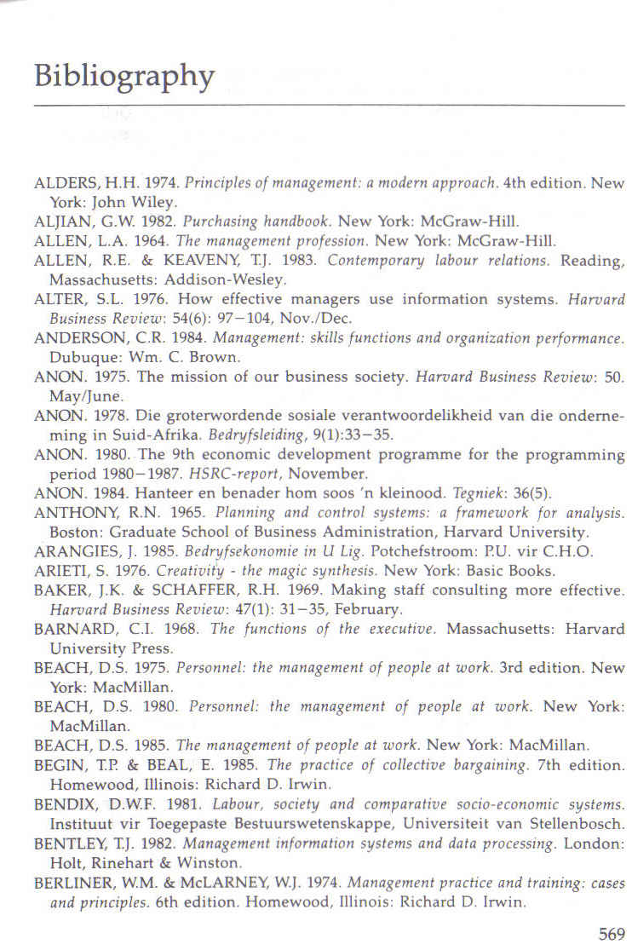

**LEARNING STRATEGIES**

***Specific outcome***

Use learning strategies.

***Assessment criteria***

On completion of this section you will be able to ensure that:

Summarise information for learning purposes

Select and apply specific techniques appropriately: group activities such as brainstorming, group analysis, peer and self-assessment mind maps, note taking, memorising, key words, underlining, skimming and scanning

Ask relevant questions: Checking understanding, clarifying meaning, getting information, confirm accuracy of information

Read/ View, interpret and analyse texts for detail for a given context

Listen to spoken input/ view signed input for detail, then interpret and analyse input for a given context

Ensure that learning takes place through communicating with others in groups or as individuals: Facilitators, other learners, colleagues

***How You Remember***

**Association**

In the antique world, Aristotle named four kinds of associations that stimulate the memory:

PL_MS005Things that are close to each other, such as the sea and the beach

Things that happen at the same time, such as teenage years and pimples

Things that are similar, such as ice skates and roller skates

Things that are different, contrasts such as rural and urban areas

James D Weinland added a couple of items to this list:

Cause and effect: fire and heat

Part and whole: nose and face

Detail and general: bee and insect

Numbers that lie next to each other: 5 and 6

**The Three Stages Of Memory**

All the memory stages have two characteristics: how much information can be stored and the time it can be stored.

The **immediate memory**: lasts about two seconds and makes it possible for us to undertake continuous activities such as walking. Volume: thousands.

**Short Term Memory**: volume 7 things and time stored: thirty seconds to two days. When you memorise, you transfer knowledge from your short term memory to your long term memory.

**Long Term Memory**: Volume unlimited, time stored forever.

**The Three Kinds Of Memory**

You need to know how you remember things in order to choose the best memorising technique for you.

***Verbal***

situated in the left half of the brain. People who remember like this, see the words L I O N, spelling lion, when someone says “lion”.

***Visual***

situated mainly in the right half of the brain. This person sees a picture of a lion, teeth, feet, muscles, etc.

Children usually remember visually until they develop language skills and then they change to verbal codes.

***Kinaesthetic (Muscle Memory)***

This is when we remember with our muscles, e.g. when driving a car, playing tennis or tying shoelaces. Blind people use this sort of memory a lot, as does dancers, athletes, musicians, etc. How often have you waved your arms in the air to try and describe something? At that moment, you remembered through your muscles.

Humans tend to remember muscle skills longer and better than visual or verbal skills, just think of riding a bicycle. Humans cannot really function without a measure of kinaesthetic memory.

It would appear that we actually use all three kinds of memory, which can be an indication that we use both sides of the brain, but that we use one more than the other. By fitting your memorising technique to your memory type, you will make the learning process easier for yourself.

Think about this: is it the thought of the taste of strawberries that recall the word or does the word remind us of the taste? Smell, taste and touch are all important tools to store information and recall it at a later stage.

**The Three Stages Of Remembering**

When you have stored information in your long term memory, you have to be able to find this information again. It is not good enough just to store information in your long term memory; you have to be able to recall it again. The steps of learning are mentioned below, very shortly:

***Register***

You receive the information. You cannot forget something that you never knew to begin with. Be careful of interruptions when you are busy taking in information

***Storing***

When you store information, you are creating the ability to recall it. You registered something and the information successfully completed the trip from your short term to your long term memory and it has been filed. Now the fun starts.

***Recall (Recall, Recognise)***

You can find the information later, or recognise it if you come across it. There are two ways of finding information again – through recall or recognition.

When you recall, the information comes back to your conscious thoughts. You can choose to recall it, or it can happen spontaneously – a friend’s face or the words of a song.

When you recognise information, you did not try to bring it back, or you were not successful in bringing it back; but when you encounter it you recognise it. For example, you will recognise the Eiffel Tower when you see it, but without a picture of it in front of you will find it difficult to draw it.

The biggest part of remembering is recognising and we can also recognise more that we can recall. This means that when we are studying, we do it in such a way that we can find the information again when we need it. This is why we use associations and why it is not necessary to learn your work word for word.

The reason you study for tests and exams is to transfer the information from your short term memory to your long term memory. As with everything else in life, you need to make the right choices. You can acquire new strategies and structures or you can carry on as you always have. Please bear in mind that, if you don’t change direction, you will surely end up where you are headed! In other words, if your current study method is not helping you get the marks you can get, and you don’t change it, you will never do as well as you can.

There are many techniques to help you to memorise. We will first focus on strategies to remember – plans you make in order to better remember things.

Be **emotional** about what you are studying. We remember the rugby or soccer score because we get emotional about it!

Be **logical** and create structures to help you to remember: sequence, categories or whatever.

**Reward** yourself: when you have done well, finished your studies on time and you know the work, reward yourself. Also reward yourself when you have done well in a test.

Use as many **senses** as you can: see, hear, feel, smell, taste.

**Structures To Remember**

The brain wants structures in order to store information in the long term memory and to be able to recall it later.

***Sequence***

Number the information so that they follow logically; you can number from 1-10, from A to Z, from birth to death or chronologically. Learn events and happenings in the sequence they happen, the brain does not like facts that are mixed up.

***Categorise The Information***

Group things that is similar together. If you have to remember 25 animals, remember them as follows: 4 birds, 3 farm animals, 6 reptiles, etc.

***Visualise Similar Things***

Connect things that are visually similar, such as everything that is round or red or even everything that reminds you of Christmas, etc.

**Associations**

***Numbers***

There are a couple of ways to remember long lists or rows of numbers: One method is associations.

Think of 1 as a pen,



2 as a swan

3 as a double chin

4 as a sailboat

5 as a fish hook

6 as a golf club

7 as a precipice

8 as an hourglass

9 as a pipe

10 as a bat and ball

These are just examples; you can create your own associations. Of course, this method works well for a visual memory.

To use the association technique for a verbal memory:

1 bun

2 shoe

3 knee

4 floor

5 dive

6 sticks

7 heaven

8 gate

9 pine

10 hen

Once again, these are examples; you can create your own associations.

***Rhythm And Rhyme***

We’re not all poets, but those who are should use this technique to their advantage. A rhyme is when you take the first letter of every fact and arrange them in a rhyme that is easier to remember. When you remember the rhyme during the test, you will also remember the facts.

Rhythm is similar but different. The most well-known example is the spelling of the work Mississippi: Mr. M Mr. I Mr. S S I Mr. S S I Mr. P P I. If you have the knack of working out a rhythm, use it to your advantage.

***Abbreviations***

Some of us can make abbreviations of the first letter of the facts that have to be memorised.

If you think about well-known abbreviations that we know, like UNISA or CNA and even AIDS, it is clear that it is a good technique to use. Please ensure that the abbreviations make sense to you, otherwise you are likely to store the information in the wrong place. Once you have stored information in the wrong place, chances are that you will not be able to recall the information when writing the exam.

Do You Know The Following Study Method?

Overview – quickly scan the chapter to give you a general idea of the contents

Questions – ask yourself general questions about the chapter

Read – now read the chapter with the view to summarising it

Summary – make a brief and to the point summary, preferably using mind maps. Your summary should not take longer than 5 to 10 minutes for each hour’s worth of studying. Do not write down whole sentences, use keywords that will help you to remember the facts.

Memorise – memorise the summary

Revise – test your knowledge through revision

**If Your Study Method Does Not Work, Change It!**

Move your desk or study in another room

Change the way you are studying.

Change your attitude toward studying

If it’s not working for you, change it!

***The Process Of Learning***

The learning process works as follows:

Summarise by means of mind maps

Determine how much time you have to memorise and how much work there is per mind map

Set a time limit per mind map

Memorise

Break

Revise

Memorise new work

When you read through something very quickly, noting only the main points, or to pick out words in capital letters, bold or underlined, you are skimming. We tend to do this when we are in a hurry, or when we are not interested enough in the writing to read the whole article. We skim, looking only for the main points, and do not take notice of the body of the writing.

As an example let’s take a newspaper article about a crime that took place. Very often, I only read the basic details of the crime: what happened, where and when it happened, were the criminals caught. I do not read what witnesses and bystanders or even the victims of the crime had to say about it. I am only interested in certain aspects of the article and I therefore skim through it.

Skimming allows you to go through a lot of reading material that might not be relevant to your need for information, in a very short time.

**Scanning**

Look at quickly in order to find a particular piece of information. This is different from skimming: when you skim, you look for the main points of the reading material, when you scan you look for information that is important to you. This information may not be included in the main points.

For example, this morning I skimmed the newspaper article about the crime, now it’s evening and I want to know what one specific eye witness said. I’m not going to read the entire article, instead I scan only for the witness’s name in order to get to the part that I am interested in.

**Summaries**

A summary is a brief statement of the main points of something.

The purpose of using reading strategies and then rereading a piece of written word is to separate the main ideas from supporting information and also to identify the author’s purpose.

At the first cracks of gunfire, the villagers of Nyamlell in southern Sudan dropped their hoes and scattered into the bush. Abuk Marou Keer also heard the guns. But the blind Dinka woman could only pull her seven-year-old son and twelve-year-old daughter close. Shaking with fear, they hid in their windowless hut and prayed.

If we take the first paragraph of the article about slavery, we can summarise as follows, using the who what where when how and why questions:

What happened? Where did it happen? Who fled? Why did Abuk not flee with her children?

During the day, the villagers heard gunfire and fled. A blind Dinka woman could not flee, so she and her children hid in their hut.

I have now summarised a 54-word paragraph into a 24-word paragraph, quoting only the main ideas of the paragraph. Everything else is supporting information: the villagers dropping their hoes indicate that they were working in the fields, so it must be daytime. The blind woman’s name is supporting information, as well as the ages of her children. The last sentence is also supporting information.

The purpose of a summary is to take a big piece of text and break it into smaller parts that are easy to understand and, when you are learning something, memorise it easily, separating main ideas from supporting information.

In everyday life we break big things into smaller parts all the time: when you have a big piece of steak in your plate, you don’t put the whole steak into your mouth, you cut it into smaller pieces so that you can eat it. We also do this with big tasks: doing the weekly washing, we break it into smaller pieces by sorting clothes into colours and materials and then we wash them, using more than one load. When we mow the lawn, we start with one piece, once that is finished we do the next piece, and so on.

It therefore makes sense to do this with reading material as well.

A summary can take many forms:

As per the example above, which is called paraphrasing. Paraphrasing is when you rewrite something using your own words.

You can summarise in point form

When you summarise a large volume of text, you will make use of headings and sub-headings. This manual is an example of using headings and sub-headings to break a big piece of text into smaller pieces.

Another method of summarising is using a mind-map.

**Highlighting And Underlining**

While you are reading text you are always looking for the main points. You can make notes of the main points while reading, or you can highlight them. Highlighting can be done by making a note in the margin of the book, by underlining the relevant passages or you can use a highlighting pen.

If the book is your property or belongs to your organisation, feel free to highlight important points. When the book belongs to someone else or a library, please don’t use the highlighting technique – make photo copies of the pages you require and highlight important points on these.

You can also use **various coloured highlighters** to distinguish between different main points or headings and sub headings. How you use the different colours is up to you, as long as there is method and order in the way you use colour.

You can, for example, highlight all the points relating to one topic in blue, all the points relating to another topic in yellow and so on. Or you can highlight all the main points, irrespective of topic, in blue, all the supporting information in yellow.

Feel free to experiment but make sure that you have your system worked out before you start using your highlighter.

**Taking Notes**

As mentioned, while you are scanning or skimming or reading a piece of text, always look for the main points and key words. Key words are words that you have to remember. When you are summarising, taking notes or drawing a mind map, for the purpose of studying, you do not have to write down full sentences. Writing down the only the main points and key words will help you to recall the entire idea when you have to.

Of course, if you summarise this way, you have to understand what you are reading. If you do not understand, main points and key words will not help you to recall the facts or the main ideas of the text.

**Ask And Answer Questions**

Using this technique will help you to recognise when you are confused and it encourages active learning.

Before reading, think about the subject based on the title, chapter heads and visual information. Make notes about anything you are curious about.

While reading, pause and write down any questions. Be sure to write down questions if you are confused.

Look for the answers while reading. Pause and write down the answers.

???

Were all your questions answered? Could the answers come from other sources?

While you are taking notes, make sure that you understand what is being said.

If there are words you don’t understand, look up their meaning in a dictionary

Always make sure that your information is accurate. You will do this by checking more than one source: e.g., not only a website but a textbook as well.

**Mind-Map**

A mind-map is a summary that looks like a diagram. When you are learning and trying to memorise facts, a mind-map is your easiest and best method of summarising.

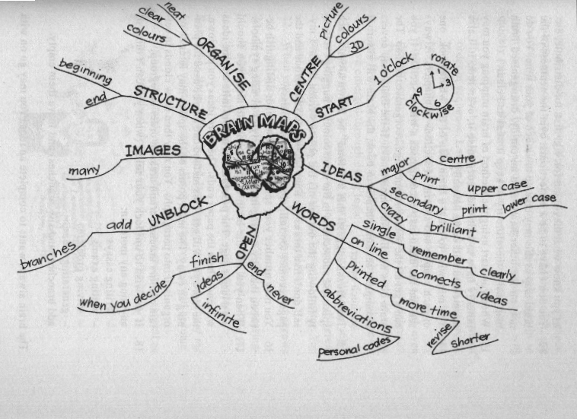

A mind-map is more effective for studying than summarising facts in points, underneath each other, since the human brain is capable of absorbing facts in all directions, not only from top to bottom, but also from left to right.

With a mind-map, you follow the same procedures as for any other summary. You take a big piece of writing, break it into smaller parts by using headings and sub-headings, and then you summarise in point form or paragraph form.

A mind-map looks different, since it resembles a diagram. The one main point of the summary is quoted in the middle. This would be a heading in your summary.

The sub-headings are written on lines that flow out of the main point. Any further points would branch out from the lines that contain sub-headings.

If we were to summarise our example in a mind-map, it would look like this:

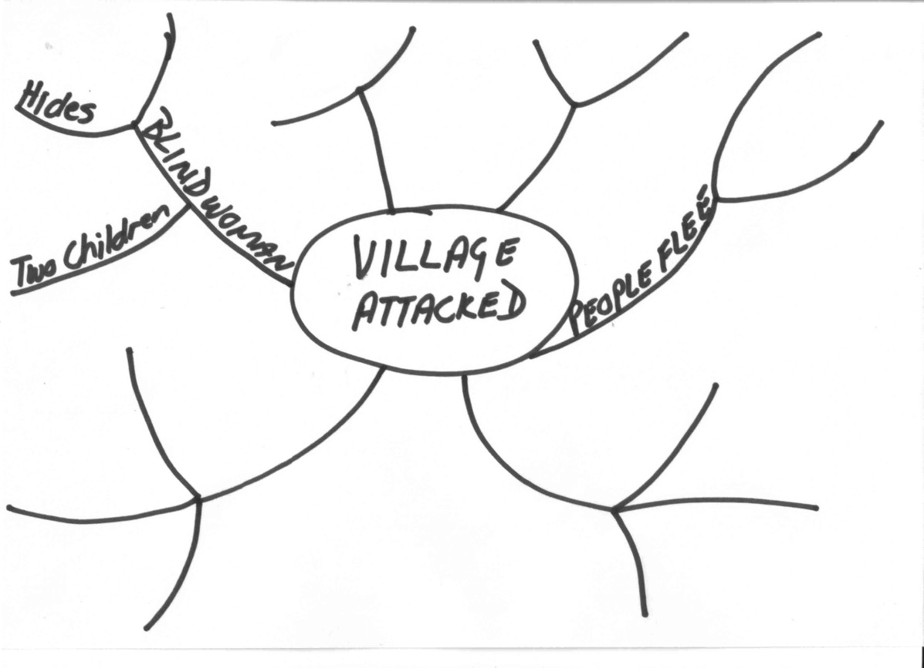

**Peer And Self-Assessment**

It is always a good thing to check your notes, summaries, mind maps and understanding of the work.

You can do a self-assessment by reading through the main text again and comparing your notes to what you understand from the main text.

Then compare your notes and understanding to the notes and understanding of your colleagues and fellow students. When you find points that you do not agree on, you then go through the main text together, ask questions and make notes in order to clarify your understanding.

If you still do not agree, go to the facilitator or another colleague or fellow student. Carry on in this way until you all agree about what the content of the text is. Use all the strategies you have learnt to clarify the meaning of text.

**Communicating With Others**

Studying and the learning process do not have to be an individual activity. In fact, if you do it alone, without consulting your facilitator, colleagues and fellow students, you are making it hard on yourself.

There is always a collective knowledge in a group, where the total knowledge in the group is more than the knowledge of individuals: you might know something about computers that the other group members do not know, while some other members of the group may have more knowledge about Labour Law, etc.

Talk to your facilitator, your colleagues and your fellow students if you do not understand a subject.

In the same way, you must be willing to share the knowledge you have with the group. In the end, everyone benefits from working in a group.

**Brainstorming**

This is one technique the group can use to clarify text and make sure that everyone understands the subject.

It involves the generation of a large number of unconventional ideas whilst eliminating the usual tendencies to criticise or prematurely reject these unusual ideas.

**The Brainstorming Process.**

***Selection***

Select a topic for brainstorming and also select the members of the group.

***The Topic***

The group is given advance notice of the topic in the form of a brief description of one or two sentences. The group facilitator discusses with the group a limited amount of background information relating to the problem.

***Warm-Up Session***

Members are introduced to the concepts of brainstorming in a relaxed manner. The group discussion should try to identify the barriers of creative thinking and show how they can be overcome. The purpose of brainstorming is to generate as many ideas as possible in a short period of time. It does not matter if the ideas are silly, this is actually the purpose of brainstorming.

The actual brainstorming process, and the four rules of brainstorming:

Free association: participants must state the first idea that came into their heads, no matter how silly or absurd it may seem.

Clarification: the person whose idea it was can elaborate on the idea, or someone else can, as one idea leads to another. No evaluation of the idea is allowed at this time.

Suspension of judgement: nobody is allowed to pass any comment on anyone else’s ideas. This is not the purpose of brainstorming at all.

Speed: brainstorming should happen as quickly as possible.

Short practice-runs will demonstrate how little time it takes to produce 50 to 100 ideas. At the end of the warm-up session, the original problem is restarted in as many ways as possible. For example, the problem of reduced profit could be redefined as how to beat competitors, or how to improve marketing. All statements are written down by the leader.

It should develop in a light-hearted, easy-going atmosphere. Brainstorming is a fun thing to do and it should be so for everyone.

The facilitator reads out the statements and calls for ideas. As they flow, they are numbered and written up on a large flipchart with a large felt-tip pen.

Each sheet is torn off when full and displayed elsewhere in the room. Freedom of expression should be encouraged. The ideas may number from 150 to 600, or more.

There should be pre-set timescale for this session.

Now the solutions can be considered for practicality and so on.

**Listening For Detail**

When you are attending a class, a seminar or a workshop, you can bring a lot of knowledge with you when you leave by:

Taking notes of main points and key words while the presenter is talking

Summarising what he said

Drawing a mind-map of what he said.

If you are unsure about anything, ask questions of the presenter. They will usually leave time for a question and answer session. Do not leave without making sure that you understand what was said.

Then check your understanding with that of your classmates and colleagues.

**MANAGE OCCUPATIONAL LEARNING MATERIALS**

***Specific outcome***

Manage Occupational Learning Materials

***Assessment criteria***

On completion of this section you will be able to ensure that:

Ensure that occupational learning materials are well organised: Videos, internet, texts, handouts, textbooks, charts, maps, plans, diagrams

Understand and discuss the layout and presentation of learning materials and use them effectively: Index, contents page, or glossaries, electronic texts

Use technical language/ terminology and seek clarification if needed

***Occupational Learning Materials***

There are many types of learning materials available:

Training videos and DVD’s

Textbooks

Charts

Maps

Plans

Diagrams

Handouts

Internet

***A Filing System***

This material has to be stored in a safe place and a record of everything must be kept, so a filing system for the learning materials is necessary. A good filing system has certain essential features:

|  |  |
| --- | --- |
| Simplicity | Appropriate classification |
| Accessibility | Selection of suitable equipment |
| Safety in terms of minimizing loss | Safety in terms of avoiding damage by fire, water, dust |
| Safety in terms of maintaining confidentiality | Compactness – using space efficiently |
| Elasticity – it must be able to expand if required | Speed of retrieval |
| Trained staff | Economical in terms of time, cost of equipment and accessories |
| Sufficient cross-referencing | An “out” guide or “tracer” system should be incorporated |
| Thinning out should be performed on a regular basis | Daily filing |

***Methods Of Classification***

**Alphabetical Order**

bd05090_Items are grouped alphabetically. The file for Mahotsi would be placed before that for Ndengwe, because m comes before n. Baker would be placed before Barker, as bak comes before bark

Should more than one client have the same name, their files would be arranged in order of initials: Mahotsi, C would be placed before Mahotsi T

Short before long: if all the other letters in a name are the same, you arrange the shorter name in front of the longer: Cole will be placed before Coleman.

Prefixes before surnames, such as de der le van von O, etc are considered part of the name: du Plessis will be placed alphabetically with D and not P, so will van der Merwe be placed with V.

Should more than one client have the same name and initials, a number could be added after the initials: Mahotsi T1 would be followed by Mahotsi T2

Impersonal names, such as company names are placed in the order they are written: Gilbert Enterprises will be filed with G and Tiger Brands with T.

Official or descriptive names: the most important word is the first filing unit: The Hotel Shelly will be filed as Hotel (The) Shelly and City of Durban will be filed as Durban City (of).

**Numerical Order**

bd05092_A number is allocated to each item, regardless of surname and initials. This is how banks file our records.

Files are then arranged numerically

As it is not possible to remember each client’s number, a separate card index is kept to record clients’ personal details and file numbers

New clients receive the very next number after the last allocated number. The new file is placed last in the drawer.

**Alpha-Numeric Filing**

This consists of a combination of alphabetical and numerical filing systems

Files are placed alphabetically, but not strictly so

mom031z

Each file is labelled with the client’s name and a number, e.g. J Maxwell could be M5. The next file could be B Mason, with the number M6

You will find this form of numbering used for example for spare parts of cars or motorbikes

A separate index system is used to record files and this will be arranged alphabetically.

Then there must be a form of control over the “lending” of the material by individuals, so that the material can be traced if someone else needs it.

**Selecting A Classification System**

Occupational learning materials will usually be sorted according to subject, with cross-references to the authors, publishers and date of publishing.

If you have access to a computer, draw up a database of learning materials, so that items can be searched for according to subject, author, publisher, etc.

**Lending Of Learning Materials**

Ensure that the “out” cards are completed and signed for before handing over the files.

It will also be your responsibility to ensure that the item is returned. Follow up on outstanding items on a weekly or daily basis, depending on the procedure in your organization.

When the item is returned, remember to sign it in again.

|  |  |  |  |
| --- | --- | --- | --- |
| **OUT CARD** | | | |
| NAME OR SUBJECT | DATE | TAKEN BY | DATE RETURNED AND INITIALS |
| Smith James | 15/05/05 | NDP | 31/05/05 NDP |
| Tiger Brands | 15/05/05 | BJP | 26/05/05BJP |
| ABC Trading Co | 26/05/05 | ISN |  |

***Technical language***

The terminology used in a field or understood by a trade, profession or group of people e.g. in metal -working, the term "pig" means a mould for casting metal. It differs from jargon in being more generally understood and used, for example, by many people rather than a few and it does not have the negative connotations that the word "jargon" carries.

For example, the locksmithing trade has specific terms and language, such as:

Mortise locks

Cracking a safe

Key duplicating

Coded keys

Unsafe acts

Unsafe conditions, etc.

The IT industry also has specific terms and language:

Hard drives: storage devices

Motherboard

Expansion slots

**CONDUCT RESEARCH AND PRESENT FINDINGS**

***Specific outcome***

Conduct basic research and analyse and present findings.

***Assessment criteria***

On completion of this section you will be able to ensure that:

Identify and define the appropriate or relevant topic and scope

Plan and sequence research steps appropriately.

Apply research techniques: Gathering information, reading, interviewing, using appropriate electronic sources

Evaluate information for relevance

Classify, categorise and sort information

Analyse and present research findings in the appropriate format

***Sources Of Information***

Before you start writing your document, you have to plan what you are going to write. First, you are going to define the topic and then you have to gather information about the topic.

|  |  |
| --- | --- |
| **Information can be gathered from:** | **In the case of business correspondence, you will find information in:** |
| Libraries | Minutes of meetings. |
| Encyclopaedias | Correspondence with clients and suppliers. |
| Manuals | Operations and procedures manuals |
| Magazines | Internal correspondence between departments, branches and regions. |
| Newspapers | Correspondence between management and their departments. |
| Interviews with experts |  |
| Internet |  |

When doing research about a topic it is important that you gather as much information about a subject as possible. The more information you have, the better. Of course, the information and data must be relevant to the topic that you are going to write about.

***Organise The Material***

Once you have gathered information, the material you have collected has to be organised.

**Sorting And Categorizing**

Arrange or organise the information with common features or characteristics systematically in groups.

All the information with similar content is grouped together. Your classification will depend on the order in which you are going to write the document: you can sort the information chronologically, using contrast or cause and effect.

You can use cause and effect, and contrast to help you arrange your paragraphs in a logical way.

Contrast is when you contrast one theme, thought, opinion or product with another. Refer back to the introduction of the article about the gorillas: you can contrast the concern of conservationists who were worried about the gorillas, with the views of humanists who were more concerned about the people being killed.

Cause and effect: referring back to the same text, you can progress from the causes of the war to the consequences (effect) of the civil war on ordinary people.

If you are writing about something that happens over a period of time, you can arrange your paragraphs chronologically: start with the earliest date and end with the latest date. When writing about droughts in South Africa you can start with the big drought in the 1930s and end with the current drought.

**Sifting For Relevance**

Once you have classified the information and data, you have to sift through it for relevance. You should keep only the information that is relevant to your topic, everything else can be discarded. In other words, if you are writing about plants that flower in summer, all information about plants that flower in autumn is not relevant, you cannot use it to enhance your writing and you should discard it.

**Validity And Reliability**

Now you have to check your information for validity and reliability. The obvious way of doing this is to check your facts with more than one source:

check more than one manual,

talk to more than one person,

visit more than one website,

to ensure that your facts are correct.

Preferably, you should use more than one manual, more than one website and the knowledge of more than one expert for each aspect that has to be checked. If most or all you sources state the same basic fact, you can be reasonably sure that the fact is correct.

**Recording**

Once you have sifted and verified your information, record it in the categories you have selected. This recording is in draft form, usually in the form of rough notes.

Any arguments used in your document must be supported by sound reasons and facts. You have to justify your feeling about the matter with facts in order to persuade the reader to your point of view. Something your neighbour said about the matter is not fact – you have to verify the statement your neighbour made.

Now you are ready to draft your first copy of the final document.

***Write Effectively***

**Reasons Why Authors Write Texts**

BOOK054To **persuade** readers to his/her point of view: When an author is writing to persuade, he wants you to accept his opinion about issues, policies and situations.

To **inform** readers: in SA Computer you will find a lot of articles that inform readers about new developments in Information Technology. In other magazines you will find fashion articles, articles about healthy eating and fitness, etc. These articles were all written to inform readers.

To **entertain** readers: the short stories found in magazines were written to entertain. Fables, fairy tales, fictional novels, cartoons, short, funny pieces in magazines were all written to entertain.

**Plan Your Text Before Writing**

Who will you be writing for: your friends and family, the general public, a business document, a newspaper or magazine article, etc.

In which register will you be writing the text: formal or informal

Which writing style will you use: narrative, discursive, expository, etc.

Will you write in the first person or the third person?

Determine the research you will do

Organise your writing: make sure ideas and facts flow logically

**Make Your Writing Interesting:**

BOOK032Use punctuation correctly

Use titles, subtitles, headings, contents and index

Use an introduction and a conclusion

Use visual images and captions with these images

Vary the length of your sentences

Structure your paragraphs correctly

If any action is required, make suggestions about the actions

Put ideas forward

Use appendices or addenda if required

**Diction**

Choose words that are familiar and easy to understand

Make sure that you are using the correct words

Do not use technical language, legalisms, etc. when writing for the general public. When it is a business document, use of technical terms and jargon will be acceptable

Do not use slang or write in dialect unless you are writing to entertain

**Always**

Be ethical: readers must be able to trust your writing

Quote facts and substantiate your facts with evidence so that the readers can believe you

Be sensitive to the reader’s point of view, culture, etc.

**FUNCTION IN A TEAM**

***Specific outcome***

Function in a team.

***Assessment criteria***

On completion of this section you will be able to ensure that:

Ensure that active participation takes place in group-learning situations: Meetings, site/field visits, excursions, discussions, activities, workshops

Ensure that responsibilities in the team are taken up and group work conventions are applied in learning situations: Supervision, mentoring, rotation of roles: conducting, chairing, recording, reporting.

Practice conflict management and negotiating techniques

Ensure that team work results in meaningful product or outcomes: Reaching consensus, completed projects/assignments

***Purpose Of A Team***

Teams are responsible for attaining the goals of different departments and, of course, ultimately, the goals of the organisation.

In other words, teams are started in order to work together to achieve the specific goals of the team, which are linked to the goals of the department, in order to achieve the goals of the organisation in the end.

The workplace environment has become very competitive in the twenty first century: South African companies have to compete with international organisations and they therefore have to think up new ways of improving productivity. South African companies also have to train and develop their human resources and reward employees for their achievements.

This is an area where teams are very effective.

***Team Members***

**The Lesson Of The Geese**

*Every year, just before winter, the geese in the northern hemisphere fly south for the winter. They always fly in a V-formation and scientists have discovered the reason why they fly this way. As each bird flaps its wings, it creates uplift for the bird immediately following. By flying in a V-formation, the flock adds at least 71% more flying range than if each bird flew on its own.*

When we apply this to teamwork, we can say that people who share a common direction and sense of community can get where they are going quicker and easier because they are travelling on the thrust of one another.

*Whenever a goose falls out of formation, it suddenly feels the drag and resistance of trying to fly alone and it quickly gets back into formation to take advantage of the lifting power of the bird immediately in front.*

There is strength, power and safety in numbers when travelling in the same direction as others with whom we share a common goal.

*When the goose in the lead gets tired, it rotates back in the formation and another goose flies in front.*

It is worthwhile taking turns doing the hard jobs.

*The geese from behind honk to encourage those in the front to keep their speed.*

We all need to be encouraged with active support and praise.

*When a goose gets sick or is wounded and falls out, two geese fall out of the formation and follow it down to help and protect. They stay with the goose until the problem is resolved and then they fly out on their own or with another formation to catch up with their group.*

We must stand by each other and help each other in times of need.

(Source: Lussier, RN. 1997, Management: concepts, Applications, Skill Development. Cincinnati, OH: South Western, PP418-419)

To summarise, when you are working in a team each team member has to commit to the following in order to ensure the team functions effectively:

Commit to work together in a team, commit to the goals and purposes of a team, find your place in the team so that you can also feel you belong.

Ensure that all team members are travelling in the same direction – working towards the same goals and purposes.

Take turns doing the hard jobs; it will benefit the team in the long run and therefore also benefit individual team members.

Encourage, support and praise each other.

Stand by each other and help each other in times of need.

***Work Toward a Mutual Goal***

The team should have a clearly defined purpose. The purpose should be stated in goals and these goals should be defined clearly, the goals should be measurable and the team should be able to attain the goals. These goals should be aligned with the vision and mission of the team, which, in turn is aligned with the vision of the department and finally the organisation as a whole.

The goals should be important to each individual team member as well as this will lead to combined efforts to achieve the goal.

Examples of goals:

A production team might have a goal to achieve normal production against a tight deadline.

Heavy duty vehicle drivers may have a goal regarding accidents or fuel usage and maintenance cost saving to a specific amount.

The soccer team may have the goal of winning the 2010 Soccer World Cup, and are working towards this goal.

The church may have a goal to collect a specified amount by a certain date in order to enlarge the church.

***Accept Responsibility***

Team members have to take responsibility for their own jobs as well as the achievement of the goal or purpose of the team. Members support each other so that the objectives and goals can be met by entire team.

There should also be a culture of respect for each other and this is the responsibility of the entire team.

***Motivating the team***

When people are valued and rewarded for their knowledge and skill, they become self-motivating. Motivation also comes from sharing responsibility. Team members should always motivate each other through communication, acceptance and support of the team.

When a team successfully achieves it goals, every member in the team is highly motivated.

***Team Vision***

Every team should have a clear vision and meaningful purpose to which all members work. This vision should provide direction and guidance under all conditions.

The team vision should support the vision and strategic objectives of the organisation, so the team cannot draw up a vision in isolation.

Once the team has established a clear sense of its own purpose and reason for existence, it can begin to focus on the goals it has to achieve.

**Roles and responsibilities of team members**

When you are working in a team each team member has to commit to the following in order to ensure the team functions effectively:

Commit to work together in a team, commit to the goals and purposes of a team, find your place in the team so that you can also feel you belong.

Ensure that all team members are travelling in the same direction – working towards the same goals and purposes.

Take turns doing the hard jobs; it will benefit the team in the long run and therefore also benefit individual team members.

Encourage, support and praise each other.

Stand by each other and help each other in times of need.

Team members have to take responsibility for their own jobs as well as the achievement of the goal or purpose of the team. Members support each other so that the objectives and goals can be met by the entire team.

There should also be a culture of respect for each other and this is the responsibility of the entire team.

If team members commit to the above it means that they will actively participate in

Meetings

Site visits

Excursions

Discussions

Activities

Workshops

Participating in group activities means that you also take part in discussions by saying your say, agreeing or disagreeing with someone. It also means that at times you keep quiet and listen to what someone else is saying, without interrupting that person. You can have your say when that person has finished talking.

In effective teams, the roles of the team members are also rotated. Of course, specialist roles are not included, but the following roles should be rotated among the team members:

Chairman of meetings: each member should get an opportunity to preside as chairman of a meeting

Secretary: each team member should take a turn in arranging the agenda, taking the minutes and circulating the minutes of a meeting

Mentor: each team member should be a mentor for one other team member. A mentor is a trusted advisor who helps to develop the professional and personal skills of another team member.

Coach: the job of coaching other team members or newcomers to the team should be shared equally amongst team members

Team leader: this is not always possible, but if it can be done, each team member should be the team leader of the team for a period of, say, two weeks or a month

Reporting: each team member should get an opportunity to report to management about the progress of the team

***The Role Of The Team Leader***

What can you, as team leader (when your turn comes), do in order to promote the effectiveness of the team?

Be tolerant towards the team members, and promote and demonstrate this attitude of tolerance

Acknowledge you own faults and shortcomings. If team members have an insight into the mistakes of the team leader, they will be more inclined to confide their own mistakes to their leader.

Create a learning culture and not a knowing culture. The result of any exercise or task should be a learning result

Give credit and show appreciation for all contributions.

Stop taking decisions on behalf of team members. Involve the team in the decision making process.

Accept decisions made by team members.

j0299763Encourage differences of opinion.

Be consistent. Do not say one thing and do something else.

Trust your team members and encourage them to trust each other. It is important to note that when team members agree that trust is important, they invariably win. Teams that try to ignore the issue of trust rarely work. Trust is like customer relations. It takes a long time to achieve but it can be destroyed in a few seconds. Trust cannot be imposed and it only comes through experience some say.

Definition of Trust: “Trust is the belief that words will be translated into action and that others will take your interest into account”

Support your team members and encourage them to support each other. Support and trust go together for without the one the other cannot exist. Both can best be achieved where individual members do not feel they have to protect their territory or function, and feel able to talk straight to other team members. With trust people can talk freely about their fears and problems and receive from others the help which they need to be more effective.

Do not avoid conflict, address the problem. Conflict and avoidance in the name of support is like building relationships on sand. People working together must sense that their shortcomings or mistakes will be accepted along with their strengths and weaknesses, if a healthy supportive climate is to exist.

***Conflict***

Conflict can be good or bad, productive or destructive.

**Constructive Conflict**

Positive conflict deals in facts. It helps individuals or the team to improve by talking problems through until a sound understanding is reached. This kind of conflict encourages both OPENNESS and trust.

To promote constructive use of conflict, team members should be encouraged to express their views and concerns.

**Negative Conflict**

j0286034Negative conflict relies on rumour and opinion. It wounds and divides team members and it breeds mistrust and hostility.

When you have a problem, don’t just moan and groan about it in corridors, voice your problems at the appropriate time, usually in meetings. This way the problem might actually be solved. If you, as a team member, to choose to complain to the wrong people, the problem will not be solved.

To be an effective team, the atmosphere surrounding the team needs to be characterised by an open dialogue in which there is a certain amount of conflict, confrontation and differing points of view to encourage new ideas and patterns of behaviour so that the organisation will not lose its ability to adjust to external competition.

**Deal With Conflict Situations**

Most of us would agree that we do not enjoy being involved in conflict situations, and sometimes it’s even more challenging when you are called to moderate a conflict situation between a candidate and an assessor.

***Conflict Management Styles***

According to Thomas Killman there are five basic approaches to managing conflict:

Competing

Accommodating

Avoiding

Collaborating

Compromising

***Competing***

Competing is assertive and uncooperative - an individual pursues his own concerns at the other person’s expense. This is a power-orientated mode in which one uses whatever power seems appropriate to one’s own position - one’s ability to argue, one’s rank, economic sanctions. Competing might mean “standing up for your rights”, defending a position which you believe is correct, or simply trying to win.

***Accommodating***

Accommodating is unassertive and co-operative - the opposite of competing. When accommodating, an individual neglects his own concerns to satisfy the concerns of the other person; there is an element of self-sacrifice in this mode. Accommodating might take the form of selfless generosity or charity, obeying another person’s order when one would prefer not to, or yielding to another’s point of view.

***Avoiding***

Avoiding is unassertive and uncooperative - the individual does not immediately pursue his own concerns or those of the other person. He does not address the conflict. Avoiding might take the form of diplomatically sidestepping an issue, postponing an issue until a better time, or simply withdrawing from a threatening situation.

***Collaborating***

Collaborating is both assertive and co-operative - the opposite of avoiding. Collaborating involves an attempt to work with the other person to find some solutions which fully satisfy the concerns of both persons. It means digging into an issue to identify the underlying concerns of the two individuals and to find an alternative which meets both sets of concerns.

Collaborating between two persons might take the form of exploring a disagreement to learn from each other’s insights, concluding to resolve some condition which would otherwise have them competing for resources, or confronting and trying to find a creative solution to an interpersonal problem.

***Compromising***

Compromising is in the middle of both assertiveness and co-operation. The objective is to find some expedient, mutually acceptable solution which partially satisfies both parties. It falls on a middle ground between competing and accommodating. Likewise, it addresses an issue more directly than avoiding, but doesn’t explore it in as much depth as collaborating. Compromising might mean splitting the difference, exchanging concessions, or seeking a quick middle-ground position.

Usually, after getting back the results of any test, people first want to know: “What are the right answers?” In the case of conflict-handling behaviour, there are no universal right answers. All five modes are useful in some situations: each represents a set of useful social skills.

Our conventional wisdom recognises, for example, that often: two heads are better than one” (Collaborating).

But it also says, “Kill your enemies with kindness” (Accommodating),

“Split the difference” (Compromising),

“Leave well enough alone” (Avoiding),

“Might makes right” (Competing).

The effectiveness of a given conflict-handling mode depends upon the requirements of the specific conflict situation and the skill with which the mode is used.

Each of us is capable of using all five conflict-handling modes and none of us can be characterised as having a single, rigid style of dealing with conflict. However, any given individual uses some modes better than others and, therefore, tends to rely on those modes more heavily than others, whether because of temperament or practice.

The conflict behaviours which an individual uses are, therefore, a result of both his/her personal pre-dispositions and the requirements of the situations in which he finds himself. The Thomas-Killmann Conflict Mode Instrument is designed to assess this mix of conflict-handling modes.

***Which style is appropriate for a specific situation?***

To help you judge how appropriate your utilisation of the five modes is for your situation, we have listed a number of uses for each mode - based upon lists generated by company presidents. Your score, high or low, indicates its usefulness in your situation. It is, however, possible that your social skills may lead you to rely on some conflict behaviour more or less than necessary. To help you determine this, we have also listed some diagnostic questions concerning warning signals for the overuse or underuse of each mode.

Competing

Uses:

1. When quick decisive action is vital - e.g. emergencies.

2. On important issues where unpopular courses of action need implementing - e.g. cost cutting, enforcing unpopular rules, discipline.

3. On issues vital to company welfare when you know you’re right.

4. To protect yourself against people who take advantage of non-competitive behaviour.

Collaborating

Uses:

1. To find an integrative solution when both sets of concerns are too important to be compromised.

2. When your objective is to learn - e.g. testing your own assumptions, understanding the views of others.

3. To merge insights from people with different perspectives on a problem.

4. To gain commitment by incorporating other’s concerns into a consensual decision.

5. To work through hard feelings which have been interfering with an interpersonal relationship.

Compromising Uses:

1. When goals are moderately important, but not worth the effort or potential disruption of more assertive modes.

2. When two opponents with equal power are strongly committed to mutually exclusive goals - are in labour-management bargaining.

3. To achieve temporary settlements to complex issues.

4. To arrive at expedient solutions under time pressure.

5. As a backup mode when collaboration or competition fails to be successful.

Avoiding Uses:

1. When an issue is trivial, of only passing importance, or when other more important issues are pressing.

2. When you perceive no chance of satisfying your concerns - e.g. when you have low power or you are frustrated by something which would be very difficult to change (national policies, someone’s personality structure, etc.)

3. When the potential damage of confronting a conflict outweighs the benefits of its resolution.

4. To let people cool down - to reduce tensions to a productive level and to regain perspective and composure.

5. When gathering more information outweighs the advantages of an immediate decision.

6. When others can resolve the conflict more effectively.

7. When the issue seems symptomatic of another more basis issue.

Accommodating Uses:

1. When you realise that you are wrong - to allow a better position to be heard, to learn from others and to show that you are reasonable.

2. When the issue is much more important to the other person than to yourself - to satisfy the needs of others and, as a goodwill gesture, help maintain a co-operative relationship.

3. To build up social credits for later issues which are important to you.

4. When continued competition would only damage your cause - when you are outmatched and losing.

5. When preserving harmony and avoiding disruption are especially important.

6. To assist in the managerial development of subordinates by allowing them to experiment and to learn from their own mistakes.

**Outcomes Of Conflict**

The outcome of conflict will largely depend on the way people communicate in the process of dealing with the conflict.

Outcomes are what you create

Conflict may produce three distinct outcomes, depending on the approaches taken by the people involved.

***The first situation is termed ‘lose-lose’ (L- L)***

A conflict deteriorates to the point that both parties are worse off than they were before. An extreme example is the case of an executive who dismisses the only person who knows the secret formula for the organisation’s most successful product.

***The second outcome is ‘lose-win’ (L – W)***

One person (individual A) is defeated while the other one (individual B) is victorious. This is the outcome programmed in our minds when involved in conflict. It is often conceptualised by managers who use power as a tool for managing conflict.

***The third outcome is ‘win-win’***

Both parties perceive that they are in a better position than they were before the conflict began and the relationship is strengthened. This is the ideal outcome to try to achieve.

When we approach situations with a win-win philosophy we tend to focus on

Compromise as disagreement is more costly

Involving all parties concerned and searching for mutual solutions

Preserving the relationship

Attempting to understand the other’s needs and objectives

The creation of a free flow of information

Emphasise common ground

Expressing outcomes in the positive. Moving towards something you want, rather than away from something you don’t want. (‘Satisfied clients’ rather than ‘Don’t disappoint the client’)

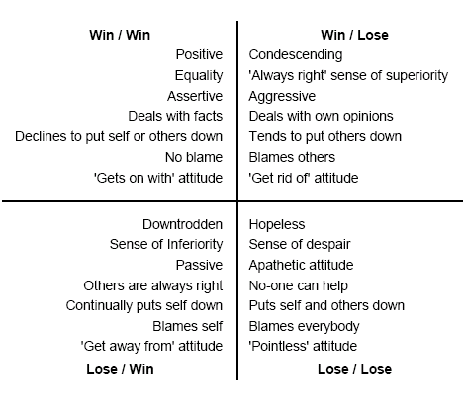

**The common consequences of unresolved conflicts:**

The conflict often escalates in people’s minds

The unresolved conflict resurfaces each time a new conflict occurs

Strained relationships and mistrust develop

Prejudiced attitudes restrict the exchange of views and information

Co-operation suffers and opportunities are missed

Problems are not resolved and productivity suffers

The conflict expands to other people and cliques are formed

Performance declines and parties try to prevent one another from achieving their goals

In business situations the customer suffers and finds another supplier

**Steps in conflict resolution**

The following steps should be taken to facilitate collaboration:

1. Ask person A to state his/her side of the conflict and get person B to paraphrase in his/her own words
2. Confirm that person A is satisfied that person B understands his/her side of the conflict
3. Ask person B to state his/her side of the conflict and get person A to paraphrase in his/her own words
4. Confirm that person B is satisfied that person A understands his/her side of the conflict
5. Focus on common goals
6. Decide on a strategy
7. Develop an implementation plan

***Negotiation***

Broadly speaking, negotiation is an interaction of influences. Such interactions, for example, include the process of resolving disputes, agreeing upon courses of action.

To negotiate means to trust inothers for a solution that is easier to reach and works out better for everyone.

Negotiation should be

a voluntary process

which involves joint decision-making.

Negotiation takes place where two or more people with different views or interests

meet to find a common solution to a problem or a dispute

and decide what to do and how to go about it.

In this way an agreeable common ground or solution can be found. Importantly negotiation only takes place between people who have different ideas or views which they want to implement in a fair manner.

**Characteristics of the Successful Negotiator**

Naturally seeks the win / win solution which means separating the customer from the problem

Seek only the facts, then logic can determine the next steps

Aim for a No Blame attitude

Develop as many options as possible

Recognize the emotional states of yourself and your customer, seek a compromise that is acceptable to all parties

**Preparation**

The first step in the bargaining process is to prepare. Follow these steps:

***Gathering Information***

CLICH046You have to be clear about ideas and views held by others and you must also identify the position of others before beginning to negotiate. You also have to clarify where a common ground can exist).

Find out what they think and where they stand so that you can find a point where you all agree. Always make sure that you are well prepared so that you are not caught off guard.

Define goals

* What do you want to achieve?
* Which issues are not negotiable?

***Which issues are negotiable***

Clarify the issues

In most conflict situations realistic negotiators are interested only in the most relevant circumstances. A broad understanding of the background is important, particularly a knowledge of any previous attempts at negotiation.. However, getting bogged down in arguments about history is usually a waste of time. Your main need is to understand the mood and the aspirations of the individuals that you will be talking with so that the common interests and common hopes can be put in the foreground.

As a negotiator one of your prime responsibilities will be to present your group's perception of the conflict. Discussion may occur at formal meetings round a negotiating table or in a street-corner cafe, but whatever the surroundings, your objective is always the same.

You want to put your case across in such a way that your opponents cannot fail to understand more clearly than before the needs and aspirations of your group. Their reactions cannot be predicted but it is your task to give them the clearest possible picture to start with.

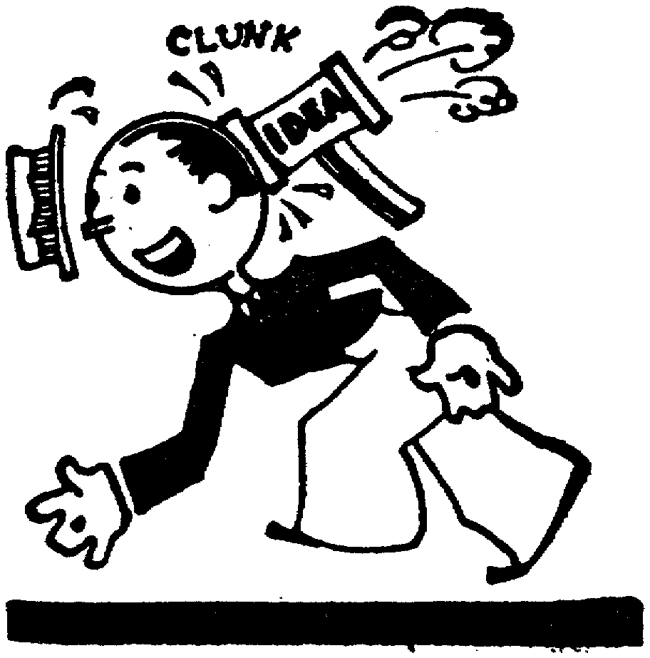Compromise/resolution

You have to determine what is vital for the success of the organisation and keep these points in mind when going into negotiation. However you should also remain realistic and think about both the ideal agreement or conclusion and the worst possible settlement which might have to be accepted.

At this stage you should also consider the disadvantages of each party to each bargaining position.

CALC002If we use a wage increase example, what happens to the business and the employees if an agreement is not reached and the employees go on strike:

The business has a shortage of skilled workers and has to employ workers who are not trained in the company’s procedures. The business will lose money while the matter is sent for mediation or arbitration. This is not ideal, if an agreement can be reached with just little effort.

The employees will not be paid for the entire period they are on strike. Can they really afford to do that for a mere 1% or 2% extra on their wages?

To calculate the impact on the employees, let us take a salary of R5000 per month. The offer on the table has gone up from 6% to 8%. The union, on behalf of employees, is demanding 10%. A 10% increase on R5000 would be R500 per month, or about R22,73 per day. If the union accepts the offer of 8%, the increase would be R400 per month, or about R18,18 per day.

If the employees go on strike for a period of two weeks, they will lose R5400 per month, or R245,45 per day, of which R18,18 per day would be the value of their increase, in order to gain R4,55 per day – the difference between a 10% increase and an 8% increase.

If the strike lasts for fourteen days, the worker will have lost R3436,30. How long must he now work to make up this loss if he gets an increase of 10%? He lost R3436,30 in order to gain R4,55 per day, so R3436,3 divided by R4,55 means that he must now work for 755 days to make up the loss. This is a period of more than two years.

So, the question remains, was it worth it? Should the workers not have settled for the 8% increase?

There would also be a cost to the business as production will be lower, there is negative publicity which impacts on the name of the business and there is a loss of faith between management and employees. In the end, taking a hard-line view means that everyone loses.

Always consider the disadvantages of not reaching a compromise as disadvantages impact negatively on both parties.

**Building Understanding**

Once the negotiation process has started, you have to build understanding between yourself and the other party. You can do the following to ensure that you build understanding:

Communicate main points effectively by paraphrasing, summarising, etc

Listening to the other party

Ask questions

When the discussion is becoming heated, consider adjourning the discussion for a body break, tea break, etc.

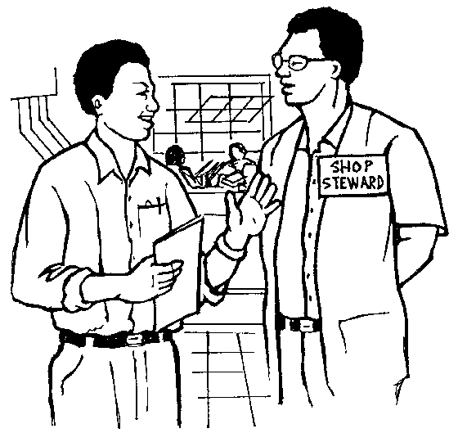Testing arguments and positions: you have to test the other side’s arguments and bargaining positions. Remember that negotiation is a process of giving and taking until a mutual agreement is reached.

When preparing your proposal, keep these guidelines in mind:

Know what you want to say and what you do not want to say

Use words that tell what is on your mind in such a way that the listener will get the same picture

Provide actual examples to make your point

Separate what you think (assumptions and opinions) from what you know (facts)

Encourage feedback. Check for understanding

Keep the talk centred on the main problem, not side issues

Try to make the other person feel good, and important

**Bargaining**

Negotiation is about listening and exchanging views – it is not about winning! When negotiation is taking place it is important that neither party takes over the discussions and puts their own views forward without the consent of others.

The bargaining process usually includes:

CPEPO011Getting and making concessions. Here you will refer back to your bargaining objectives. From these you will know which concessions you can make and which objectives are really not negotiable.

Breaking deadlock: at times during the negotiation process it could look like agreement cannot be reached. There are strategies for trying to break this deadlock.

Moving towards agreements: once the concessions have been made and given and deadlocks have been broken, the parties will start moving towards agreements on the issues at hand.

**Closing**

When closing negotiations, do the following:

COBJE155If an agreement has been reached, summarise the agreement points and get commitment from both parties to uphold the agreements. Ideally, these agreements should be put on paper and signed by both parties.

If an agreement has been reached but the negotiators have to go back to their organisation or members to confirm, set a follow up date to finalise the proceedings.

If an agreement has not been reached, both parties have to agree on the next step: set a new meeting to discuss issues that have not been resolved, maybe using a facilitator, mediation or arbitration

Walking out of the negotiation procedure is also a way of ending negotiations, but this is a very negative step.

Strikes and legal proceedings should really be a last resort, once all the other options have been tried and no agreement was reached.

**WORKPLACE CHARACTERISTICS**

***Specific outcome***

Reflect on how characteristics of the workplace and occupational context affect learning

***Assessment criteria***

On completion of this section you will be able to ensure that:

Describe and discuss features of the occupational environment: Workplace/occupational focus: Services, manufacturing, financial, educational. Organisation type: Government, parastatal, heavy/light industry, large organisation, small business

Describe and discuss ways in which these features affect learning processes and/or application of learning: Technological resources, communication resources, communication strategies and multilingual needs in relation to necessary client or colleague interaction

The characteristics of a workplace vary according to the industry in which the organisation is:

You will find that the workplace of a services organisation, a manufacturing organisation, a financial organisation and an educational organisation will differ in terms of the following resources:

Technological resources: such as computers, machinery and equipment

Communication strategies and resources: how the employees and different departments communicate with each other, as well as how the organisation communicates with the world outside the organisation

Multilingual needs regarding the interaction between clients and employees as well as between employees in the organisation: how languages differ in the organisation as well as between the organisation and the rest of the world.

The workplace of different types of organisation will also differ:

Government: the workplace of government organisations differ vastly from those in private enterprise.

Parastatal: a semi-government organisation such as Telkom

Heavy industry: mining, car manufacturers and so on

Light industry: providers of packaging materials,

Large organisation: such as De Beers, Putco bus company, etc

Small business: such as a hairdresser, taxi service and so on.

# 