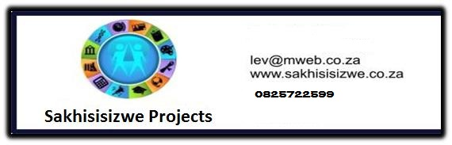

DEMONSTRATE AN UNDERSTANDING OF SEXUALITY AND SEXUALLY TRANSMITTED INFECTIONS INCLUDING HIV/AIDS

US No: 14656 Level 1, Credits 5

LEARNER MANUAL
Learner’s name
Facilitator’s name
Starting date

Hi there!

Welcome to a learning experience that will give you an understanding of sexuality and sexually transmitted infections (STIs) including HIV/AIDS

STIs are a common and serious problem worldwide. As you go through the learning experience, you will see the relationship between HIV and other STIs and the importance to prevent and control curable STIs. Your facilitator will explain each point and you will be required to participate in the discussions.

We hope you will enjoy this!

We have included some new words to learn so that you can improve your vocabulary. If you are not sure about the meaning of a word, or how to say it, ask your facilitator.

We hope that you will share your knowledge of this important subject with others and take what you have learnt from your workplace into your life at home and into your community.
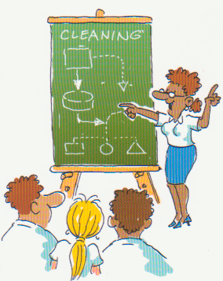
Have fun!

INDEX

Section | Contents | Page No
1 | Skills clusters and learning pathway | 4
2 | Introduction to your workbook | 5
3 | Unit standard learning outcomes | 5
4 | Critical Crossfield Outcomes | 6
5 | What I must know | 7
6 | What I must be able to do | 8
7 | Learning signs | 9
 | Introduction | 10
 | Rights and responsibilities | 11
 | Ways of infections and symptoms of STIs / STDs | 17
 | Counselling and social support systems | 27
 | Impact of lifestyle change | 35

1. Skills clusters and learning pathways

Qualification  Hygiene & Cleaning Level 1 |  | Introduction to Cleaning
Qualification  Hygiene & Cleaning Level 1 |  | Use chemicals  to clean
Qualification  Hygiene & Cleaning Level 1 |  | Ablution  cleaning
Qualification  Hygiene & Cleaning Level 1 |  | Above the floor & window cleaning
Qualification  Hygiene & Cleaning Level 1 |  | Textile surface cleaning
Qualification  Hygiene & Cleaning Level 1 |  | Hard and resilient floor cleaning
Qualification  Hygiene & Cleaning Level 1 |  | Kitchen  cleaning
Qualification  Hygiene & Cleaning Level 1 |  | Customer service and teamwork |  | Sexuality & sexually transmitted diseases
Qualification  Hygiene & Cleaning Level 1 |  | Environmental awareness |  | One module  Sexually transmitted infections – HIV/AIDS
Qualification  Hygiene & Cleaning Level 1 |  | Life skills – Health |  | Healthy living and good grooming
Qualification  Hygiene & Cleaning Level 1 |  | Life skills – Literacy |  | Module 1  Good health and grooming
Qualification  Hygiene & Cleaning Level 1 |  | Life skills – Numeracy |  | Module 2  Good food and exercise
Qualification  Hygiene & Cleaning Level 1 |  | Life skills - Finance |  | Module 3  Illness and medication
☺
You
are
here!

Although in the Cleaning Industry it is a requirement to have completed
the Introduction to cleaning and the Use chemicals to clean skills clusters
before doing any of the others, the Life Skills: Health cluster may be done at any time.

2. Introduction to your workbook

This book belongs to you!

It is for you to work with and write in so that you can use the information at a later stage.

This workbook contains a lot of detail and ideas to help you learn. Your facilitator will be available to guide you during the learning process.

You will be expected to complete the activities in the workbook to show your understanding.

You will learn more by:

- Asking questions
- Participating in group discussions
- Reading additional material
- Completing the assignments
- Doing homework activities

Remember - this book is to help you succeed!

3. Unit Standard Learning Outcomes

Purpose

Create an understanding of sexuality and sexually transmitted infections (STI’s), in HIV/ AIDS, and the impact of these infections on oneself, the workplace and society. It is also aimed to encourage a healthy lifestyle.

Learners credited with this unit standard are able to:

- Demonstrate an understanding of sexuality
- Demonstrate an understanding of the nature, transmission and prevention of sexually transmitted infections including HIV / AIDS
- Describe means to cope and deal with sexually transmitted infections including HIV / AIDS
- Describe human rights of individuals living with HIV / AIDS and other sexually transmitted infections

Learning assumed to be in place

4. Critical Crossfield Outcomes

 | This list contains all Critical Cross-field Outcomes identified by the South African Qualifications Authority.

The complete list of Critical Cross-field Outcomes is:

- Identify and solve problems in which response displays that responsible decisions, using critical and creative thinking, have been made.
- Collect evaluate organize and critically evaluate information.
- Work effectively with others as a member of a team, group, organization or community.
- Organize and manage oneself and one’s activities responsibly and effectively.
- Communicate effectively by using mathematical and/or language skills in the modes of oral and/or written presentation.
- Use science and technology effectively and critically, showing responsibility towards the environment and health of others.
- Demonstrate an understanding of the world as a set of related systems by recognizing that problem solving contexts do not exist in isolation.
- Contribute to the full personal development of each learner and the social and economic development of the society at large by:
  - Participating as a responsible citizen in the life of local, national and global communities.
  - Being culturally and aesthetically sensitive across a range of social contexts.

5. What I must know

I must know . . . . | SO | AC | CCFO
The different sexual orientations and preferences | 1 | 1.1
The rights and responsibilities in protecting sexuality | 1 | 1.2 | 7
The terms STI., STD, HIV and AIDS | 2 | 2.1
The ways of infection and the symptoms of sexually transmitted infections | 2 | 2.2 | 2
Risk taking behaviours and preventive methods and practices regarding transmission routes of sexually transmitted infections | 2 | 2.3 | 1 &2
The role of STD’s in transmission of HIV and how STIs if untreated could increase the risk of transmission | 2 | 2.4 | 2
Ways in which mother to child transmission can occur | 2 | 2.5 | 1
Why pre and post counselling is necessary and the implications of HIV testing in terms of making a personal decision to take an AIDS test | 2 | 2.7 | 8
How lifestyle change (diet and stress management) could boost the immune system | 2 | 2.8 | 8
The impact of living with HIV/AIDS on individuals, at home, workplace and society at large | 3 | 3.1 | 7
The social support systems for affected and infected people with HIV/AIDS and sexually transmitted infections | 3 | 3.2 | 7
The available treatment for HIV/AIDS and STIs | 3 | 3.3 | 1 & 7
The benefits of the organization’s HIV/AIDS policy | 3 | 3.4
The rights and responsibility of infected and affected people | 4 | 4.1 | 7
How the human rights of infected and affected are violated | 4 | 4.2 | 7

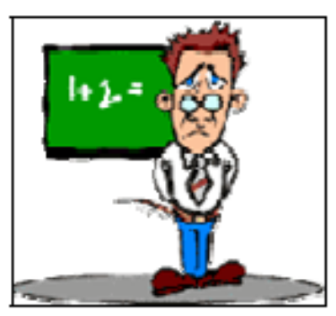

6. What I must be able to do

I must be able to . . .. | SO | AC | CCFO
Demonstrate interpersonal skills that will help to reduce the risk of sexually transmitted infections | 2 | 6 | 5



7. Learning signs

DICTIONARY
Explanation of Words and Terms

 | WORKPLACE ACTIVITY
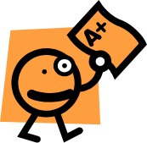 | CLASS ACTIVITY
FILE IN PORTFOLIO
Add to portfolio of Evidence (Formative and Summative Assessment)
 | HOMEWORK  Work to be done at Home
 | MY NOTES  Written reminders
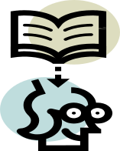 | IMPORTANT INFORMATION
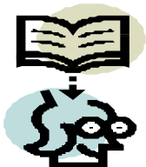 | JUST TO REMIND YOU  Revision of work done.
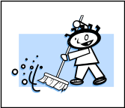



Introduction

At the start of the new century, more than 5 million South Africans had contracted HIV. Six to ten million South Africans could die of AIDS in the next 10 to 15 years.

The total number of HIV infected people in South Africa is expected to increase well into the next decade. As more infected people become ill with AIDS, the epidemic is becoming more and more visible. This means that the life of every person in the country will probably be affected in some way or another.

There are a number of reasons that have made and continue to put South Africans in danger of this very severe epidemic. These include:

- Epidemics of other sexually transmitted diseases - STDs
- Disrupted family and communal life
- People traveling into other areas which allows for rapid movement of the virus into new communities
- No wanting to use condoms
- Social norms that accept high numbers of sexual partners, especially amongst men
- Open discussions on sexual matters are not accepted by many people
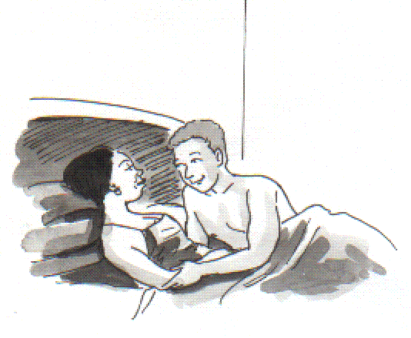

Epidemic - the word used to describe an increase in the number of people recorded to have a particular disease.

DICTIONARY

Rights and Responsibilities

Sexual orientation and preferences
Sexual orientation describes the choice of an individual's sexuality, often in relation to their own sex or gender.
Common terms for describing sexual orientation (ways) include
- bisexual (bi), - if it is both men and women
- heterosexual (straight) - if their sexual focus is primarily people of the opposite
sex / gender to their own
- homosexual (gay / lesbian) - if it is people of the same sex / gender

The term sexual preference has a similar meaning, but is often used by those who believe that sexuality is changeable and allows people to choose, whereas others believe sexuality is fixed early in life.

"Sexual identity” may be used as another word for sexual orientation, but the two are also sometimes known, with identity referring to an individual's view of themselves, and orientation referring to "fantasies, attachments and longings" and/or behaviour.
In addition, "sexual identity" may be used to describe a person's perception of his or her own sex, rather than sexual orientation.

.
The rights and responsibilities in protecting sexuality
(reference to RSA constitution)

Law
” Sexual orientation “is also a legal term. It is commonly used in anti-discrimination legislation that prohibits discrimination based on homosexuality, heterosexuality and bisexuality.
In South Africa, everybody has the right not to be discriminated against therefore it would be correct to respect others. This does not mean that you have to agree with the other person, you just show respect towards that person’s beliefs, religion and culture.

Rights and responsibilities of infected and affected people

Generally speaking, many people with or affected by HIV / AIDS are discriminated against and are embarrassed both in the workplace, and in their communities. However, it is a constitutional law that people living with or affected by HIV / AIDS may not be discriminated against. What’s more, they have the right to treatment, care and support services.

Know which laws protect people’s human rights

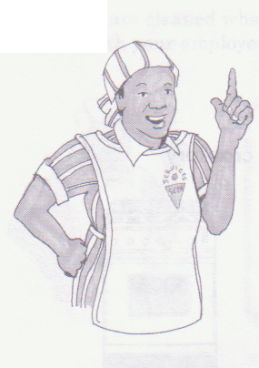

The Labour Relations Act
The Employment Equity Act
Basic Conditions of Employment Act
Promotion of Equality and Prevention of Unfair Discrimination Act
Occupational Health and Safety Act

The Labour Relations Act

States that:
- It is against the law for any employee to be unfairly discriminated against by an employer.
- It protects the rights of workers and employees against unfair dismissal. For example, an employee cannot be dismissed because they have HIV.
- The HIV status of a person has nothing to do with their ability to do their job
- A company has to follow fair labour practices in order to dismiss someone.
- If a person cannot do their work because they are too ill, the company can dismiss them. If this happens, it is because the person cannot do their work, not because they are HIV positive or ill with AIDS.

The Employment Equity Act

Supports equal opportunities for all South Africans

The Basic Conditions of Employment

This Act sets out what is expected of employers and employees in the workplace e.g. how many hours a person can work. It aims to protect employees from exploitation. However, these basic rights may be changed because of Collective Agreements between trade unions and employers.

A person infected with HIV or living with AIDS has exactly the same right to sick leave as anyone else. If that person is unable to work because of disability and illness, even if they have not used all of their sick leave, an employer can dismiss them. However, before an employee can be dismissed, an employer must find out whether the person's disability will be permanent or temporary. They should also try to accommodate the person by finding out whether the person can do a different job or change the conditions under which they work. A court will have to decide whether an employer has done enough to try and accommodate someone whose disabilities are interfering with their ability to do their job.

The Promotion of Equality and Prevention of Unfair Discrimination Act

This law protects people against unfair discrimination especially in relation to HIV status or AIDS. It prevents unfair discrimination in matters such as insurance.

Occupational Health and Safety Act and the Mine Health and Safety Act,

Employers must make sure that the workplace is as safe as possible. This means that employers must take all reasonable steps to prevent transmission of HIV in the workplace.

COMPLETE CLASSROOM ACTIVITY NO 1 IN YOUR WORKBOOK

Understand that the law protects confidentiality

The results of an HIV test are confidential. This means that only the person who took the test and the person who gave the test know whether it is positive or negative. No one else is allowed to know, unless the person who took the test decides to tell them.

If a person who took an employees’ HIV test tells someone else, they are breaking the law.

A person’s HIV status is private.

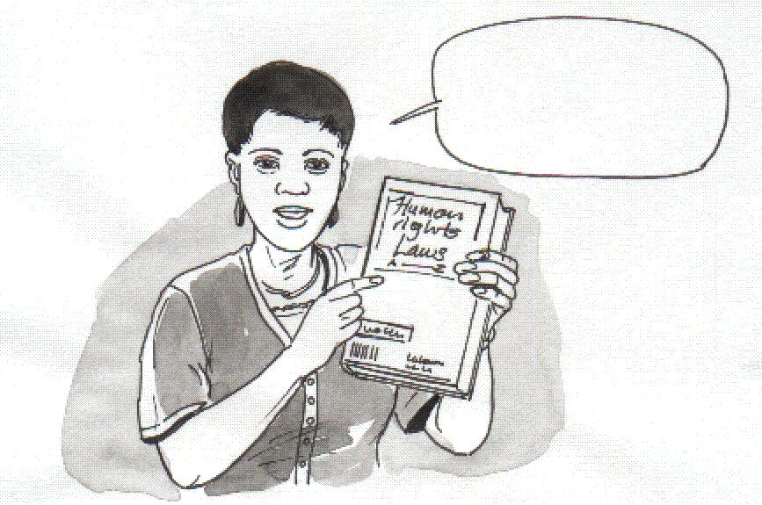
It does not have anything to do with their work.
My status
Is
confidential
s

If an employer knows an employees’ HIV status and tells
other people, they are also breaking the law.

Think more carefully about the issue of disclosure

The main reason for a person to disclose their HIV
status is to get the support of people who care about
them and can help them. Some people choose to
disclose their HIV status for a number of reasons:

- Disclosure can give people a feeling of control over their situation, rather than living in fear of unplanned disclosure.
- It allows a person to draw closer to their families and get involved with support groups, which help them to cope with the infection.
- People who have disclosed their status can do a very good job educating others about HIV and AIDS.

It is up to the person whether to disclose their status. They should do this in their own time and when they feel ready. People should choose who they want to tell. Before disclosing their status, they should consider all possibilities that may arise as a result of making their status known. A person also needs ongoing counselling if they choose to disclose.

Understand why it is important to fight discrimination

- People tend to blame others for things they do not understand. Blame doesn’t solve anything. Many people blame people living with HIV and AIDS for contracting the disease.
- They make moral assumptions and judgements about how the people became infected.
- They discriminate against them and make their lives more difficult.
- People who are living with HIV and AIDS want to be treated just like other people. They don’t need to be blamed – they need support and understanding.
- Discrimination does not help people to develop their understanding of HIV and AIDS. In fact, it can even put them at greater risk of catching the virus because they do not know enough about it.

Living with HIV and AIDS in the workplace

It is illegal to discriminate against people living with HIV and AIDS in the workplace. Everyone should receive the same benefits regardless of their HIV status. The Medical Aid Schemes Act does not allow medical aids to discriminate against people because of their health or their HIV status.

- All medical aids must offer minimum benefits for people living with AIDS (PLWA).

- Although they do not have to provide antiretroviral drugs, a number of medical aids do.

- All AIDS related illnesses must be treated.

- No one in a hospital or clinic is allowed to refuse treatment for an AIDS related illness, even if they have not been given protective equipment by the clinic or hospital.

- A nurse or doctor who refuses to treat a patient with an AIDS related illness should be reported immediately. They can face a disciplinary hearing.

COMPLETE CLASSROOM ACTIVITY NO 2 IN YOUR WORKBOOK

COMPLETE FORMATIVE ASSESSMENT NO 3 IN YOUR WORKBOOK

Ways of infection and symptoms of STIs and STDs

The term STI, STD, HIV and AIDS means . . ..

STI = Sexually Transmitted Infections

STD = Sexually Transmitted Disease

As the names states, these are infections that are passed from one person to another mainly through unprotected sexual intercourse.

STI’s are a common and a serious problem worldwide.

The most widely known are
- gonorrhoea
- syphilis
- herpes
- HIV - the virus that causes AIDS

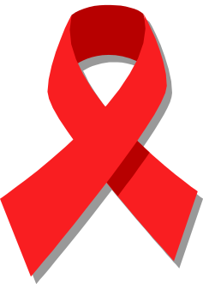
there are more than 20 others. Many of these are curable with effective treatment, but they continue to be a major public health concern all over the world.

Understand the difference between HIV and AIDS

HIV and AIDS is not the same thing:

HIV = stands for Human Immunodeficiency Virus. It is a virus that attacks
the body’s natural immune system.

HIV is a very small germ or virus, which infects people. The virus has to get inside another cell in order to multiply. In the case of HIV, it gets into the cells called T-cells of CD4 cells.

AIDS = stands for Acquired Immune Deficiency Syndrome and is the name
given to a number of different illnesses happening at the same time because
the immune system as the result of the immune system being weakened by HIV.

Ways of infection and the symptoms of sexually transmitted infections

How are STIs transmitted?

By far the most common mode of transmission of STI is through unprotected penetrative sexual intercourse. (vaginal or anal).

Other, rarer modes of transmission include:

- mother –to-child
  - during pregnancy (e.g. HIV and syphilis)
  - at delivery (e.g. gonorrhoea, chlamydia and HIV)
  - after birth (e.g. HIV)
- Unsafe (unsterile) use of needles or injections or other contact with blood or blood products (e.g. syphilis, HIV and hepatitis)

Examples and symptoms of the most common STI / STDs

Disease | Symptoms and signs
Bacteria infections
Gonorrhoea | Urethral discharge - cervix and lower abdominal pain in woman - neonatal conjunctivitis.
Chlamydia | Urethral discharge - cervix and lower abdominal pain in woman - neonatal conjunctivitis.
Syphilis | Anogenital ulcers - inguinal swelling - generalised skin rash
Cancroids | Genital ulcers with inguinal swelling
Viral infections
Acquired Immunodeficiency Syndrome - AIDS | Asymptomatic - generalized lymph node swelling - persistent fever - skin rash - weight loss etc.
Herpes genitalis | Anogenital vesicular lesions and ulcerations
Viral hepatitis | Predominantly asymptomatic - nausea and malaise - enlargement of the liver - jaundice

How is HIV transmitted?

As already stated HIV is a very small germ or virus, which cannot be seen with the naked eye but only under a microscope. HIV only survives and multiplies in body fluids such as:
- Semen / sperm
- Vaginal fluids
- Breast milk
- Saliva

People can only become HIV infected through contact with infected body fluids or blood. The virus can be transmitted in three ways:

1. Through having unsafe sex
2. Through blood
3. From a mother to her baby around the time of the birth

HIV is present in saliva, urine and faeces. However, the amounts are not large enough to be passed on from one person to another.

Different levels of risk of sexual transmission

Activity | Risk of HIV infection | Comment

Social kissing
Deep kissing |  | A person would need to swallow seven litres of saliva in order to transmit the virus. Bleeding sores and gums would increase the risk.

Masturbation

Thigh sex
Oral sex |  | The virus can enter into the blood through bleeding gums, mouth sores or scratches in the throat
Vaginal sex |  | In the case of rape there is likely to be force that will likely cause breaks in the vaginal membranes and blood vessels allowing the semen to come into immediate contact with the blood. This will increase the risk of infection if the rapist is HIV positive.
Anal sex |  | This sexual activity puts people at very high risk, as it is likely that the membranes in the anus will break and infected semen can more easily come into contact with the blood stream.

Risk taking behaviours and preventive methods and practices regarding transmission routes of sexually transmitted infections

Bahavioural factors
Many behavioural factors may affect the chance of getting an STI. Such behaviours are known as “risky”. Risky behaviours include:

- Changing sexual partners frequently
- Having more than one sexual partner
- Having sex with “casual” partners, sex-workers or their clients
- Having unprotected penetrative sexual intercourse in a situation where either partner is already infected
- Having previous STI
  - People who have had an STI in the last year are at risk of getting infected again if they have not been able to change their sexual behaviour

A number of social factors link both gender and behavioural issues and may affect a person’s risk of getting an STI:

- In most cultures women have very little power over sexual practices and choices, such as use of condoms
- Women tend to be economically dependent on their male partners and are therefore more likely to tolerate men’s risky behaviour of multiple sexual partners, thus putting them at risk of infections
- Sexual violence tends to be directed more towards women by men, making it difficult for women to discuss STI with their male counterparts
- In some societies, the girl-child tends to be married off to an adult male at a very young age, thus exposing the girl to infections
- In some societies, a permissive attitude is taken towards men allowing them to have more than one sexual partner
- Skin-piercing, this refers to a wide range of practices including the use of un-sterile needles to give injections or tattoos, scarification or body piercing and circumcision using shared knives
- Use of alcohol or other drugs before or during sex, alcohol or drug use may negatively affect condom use
- Alcohol may diminish the perception of risk, resulting in not using a condom, or if a condom is used it may not be used correctly
- Sex with others
- Has an STI
- Is HIV-positive
- Injects drugs
- Over indulges when drinking alcohol
- Male partner has sex with other men

The role of STD’s in transmission of HIV

Explain how STIs if untreated could increase the risk of transmission

STIs are a public health concern not only because it is found worldwide but also because they could cause serious and permanent complications in infected people who are not treated in time and effectively.

STIs are also are known to help spread HIV.

However, the relationship between STI and HIV is more serious: -

- Certain STI help the spread of HIV
- People who are HIV positive can get STIs much easier and quicker
- People who are HIV positive increase the seriousness of some STIs and makes it difficult to treat

A person with open sores in the genital area is much more likely both to contract and to transmit HIV.

The use of condoms can PREVENT both kinds of infection.

Ways in which mother to child transmission can occur

Although it is possible for a pregnant woman to pass HIV to her baby, not all babies born to HIV positive women will be positive - there is a 30% chance of the baby being infected.

The HIV antibodies are passed on to the baby through
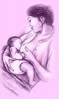
the placenta. These antibodies can take up to
15 months to disappear from the baby's bloodstream.
If a baby is tested for HIV antibodies while the mother's
antibodies are still in its bloodstream, the result will be
positive. To be sure whether a baby is infected, it
should be tested at three, nine and 15 months of age.
If the baby is still HIV positive at 15 months, the baby
has been infected.

If a pregnant woman is given drugs such as AZT or
Nevirapine just before the birth and just after, the
chance of the mother transmitting HIV to the child
(known as pregnant mother-to-child transmission
(PMTCT) is reduced by 15%.

It is also possible to pass HIV on through breast-feeding.

Communication, negotiation, interpersonal and decision-making skills could reduce the risk of getting or spreading the diseases

All STIs, including HIV are preventable. Prevention can be primary or secondary:

- Primary prevention aims to prevent people being infected with STIs and HIV
- Secondary prevention is about the provision of treatment and care for infected people in order to avoid further transmission of infection to others

PRIMARY PREVENTION

This is about adopting:

Safer sexual behaviour
- Abstain from sexual activity altogether
- Delaying the age of sexual activities
- Lifelong mutual monogamy (one partner)
Safer sexual activities
- Engaging only non-penetrative sex acts
- Engaging in penetrative sex acts on if condoms are used (this includes vaginal, oral and anal sex)

Think about this!

How aware are people in your community of safe-sex messages and the causes of STI including HIV?

SECONDARY PREVENTION

This may be achieved by:

- Making people aware that they must seek help when they are infected
- Quick and effective treatment of people with STIs
- Treatment of the partner
- Ensuring a continuous supply of condoms

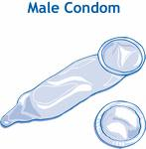

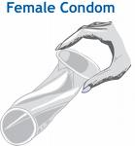

Promote healthy living and positive sexuality
COMPLETE FORMATIVE ASSESSMENT NO 4 IN YOUR WORKBOOK

Counselling and social support systems

Why is pre-and post counselling necessary?

When a person goes for counselling, a trained counsellor listens to the person's problems and feelings and tries to help them work out possible solutions. Counsellors focus on feelings but they also help with information.

It has been proven that people receiving support to cope with the psychological and emotional difficulties of being infected or affected by HIV and AIDS show the following strengths:
- They are more productive employees

- They have a greater sense of security

- They are able to be more open if there is acceptance and support from management and their fellow employees.

A very powerful way to provide emotional support for HIV positive people is to encourage them to form a support group. Here are some simple guidelines for how to do this:

- Find a private place for the group to meet so that members can talk about private and personal matters during meetings.

- Make sure someone with facilitation skills assists the group.
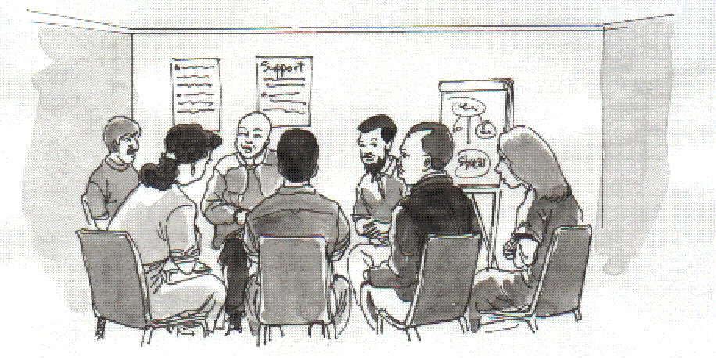
- Find a suitable time for the group to meet so that all interested people can attend.

- Decide on what the criteria are for joining the group.

- Make sure that the group continues to meet regularly.

Pre-test counselling

The only way to find out if you are infected with HIV is to have an HIV antibody test.

It is essential to have pre-test counselling and that there is time to reflect on the impact of an HIV positive diagnosis.

Remember your right to - CONFIDENTIALITY and ANONYMITY

People need to think carefully why they want to have an HIV test.
They need to consider how it will affect them if they have the test, and are found to have HIV.

How to go about getting help
- See your doctor for testing and counselling
- Workplace support
- Community help-lines in the area you live in
- Other Contacts
  - AIDS helpline
  - Love Life
  - AIDS Foundation of South Africa
  - Hospice Association of SA
  - National Association of People living with AIDS
  - Centre for the Study of AIDS

HIV / AIDS testing

HIV testing for healthy people is being promoted through a programme called voluntary counselling and testing (VCT).

It is aimed at people between the ages of 15 and 49 - those most at risk of infection. Women attending ante-natal clinics and people with STIs and TB are encouraged to go for VCT.

Having an HIV test is a very personal decision.
- Only the person concerned can decide.
- They should give themselves plenty of time to think about it carefully

Knowing you have HIV can change your life. It is important to seek advice from a doctor, health advisor or trained counsellor in order to discuss what taking the test will mean to you.

An HIV positive diagnosis can be very, very stressful and traumatic.

What is the HIV test?
An HIV test tells you whether or not there are special substances called anti-bodies in the blood. Antibodies are produced by the immune system to try to kill disease-causing agents, like HIV, which get into the body.

What does the result tell you?
- A negative result means that anti-bodies to HIV have not been found in the blood.
It takes two or three months, or sometimes longer, after becoming infected with HIV for
anti-bodies to develop and show up in the test. For this reason, you may be asked to wait to take the test, or if you have a test, it may need to be repeated if it’s too soon for anti- bodies to have developed. Do NOT assume you are not infected until you have a
confirmed negative result.

- A positive result means that anti-bodies to HIV have been found in the blood, and
indicates that infection with HIV has occurred.
A person who has had a positive HIV anti-body test will have the infection for the rest of
their life.
A positive result cannot say when a person will go on to develop AIDS, but it will give
you the opportunity to have your immune system checked and receive treatment which
can help slow down the development of the HIV infection and protect you from other
infections such as STI and STDs.

Post -test counselling

It is also very important to make sure that post-test counselling by a suitably qualified person takes place.

Post-test counselling is needed regardless of whether a person is negative or positive.

If the test is positive, the person should always get the help of a counsellor to help them to adjust to this reality.

Counselling can also help them to live a healthier lifestyle and get any medical care or support they need. It should provide them with information and put them in touch with a support group.

If a test is negative, counselling is still important to help people to stay free of HIV and practice safe sex.

Social support systems for affected and infected people with HIV / AIDS
and STIs

Learn more about the red ribbon

In 1991, the red ribbon was launched as an international symbol of AIDS awareness. The red ribbon is the international symbol of HIV and AIDS awareness. It stands for:

- Care and concern
- Hope
- Support

Care and concern:
It is being worn by increasing numbers of people around the world to show that they care about people living with HIV, people who are ill and those that have died. It is also worn to show care and support for all those people who care and support people affected by HIV and AIDS.

Hope:
The red ribbon is intended to be a symbol of hope:
- For a vaccine and cure to stop the suffering
- For a better quality of life for those living with HIV / AIDS
Think about this!

If you are offered a red ribbon, will you take it and wear it?

If you do wear the red ribbon, what statement are you making?

Support:
The red ribbon is a symbol of support for those living with HIV.
- It shows support for making sure that all those people infected and those that are affected continue to get the education they need.
- It shows support for the search for effective treatments, curers or vaccines.
- It shows support for the suffering of all those who have lost family members or loved ones to AIDS.

COMPLETE HOMEWORK ACTIVITY NO 1 IN YOUR WORKBOOK

Benefits of the organization’s HIV/AIDS policy in relation to stigma and discrimination is explained

According to the Occupational Health and Safety Act and the Mine Health and Safety Act, employers must make sure that the workplace is as safe as possible.

This means that employers must take all reasonable steps to prevent transmission of HIV in the workplace. The risk of transmission in the normal workplace setting is only really possible if there are accidents. For this reason, the best policy is to treat all employees in the same way and to assume that all blood could be infected and to practice Universal Precautions, these include;

- Knowing about diseases such as HIV, this can be passed on by coming into contact with infected blood.
- Keeping protective clothing in places where other employees know about it
- Knowing how to clean up after an accident
- Having one trained first aid worker for every 50 employees

The South African government has published a document called “The Code of Good Practice on Key Aspects of HIV / AIDS and Employment”. This code recommends that all employer’s trade unions and employees should adopt an HIV / AIDS policy at their workplace.

Everyone is affected by HIV / AIDS - whether you are HIV positive or not.

A policy can do the following:

- Guide companies on how to deal with the disease in the workplace
- Provide employees with valuable information that they can take back to their families and communities
- Help to prevent discrimination against who is HIV infected or ill with AIDS
- Educate people about their rights
- Encourage employers and employees to find positive ways to provide care and support for those living with HIV / AIDS
- Build a culture of openness and acceptance which will help people to speak openly about their HIV status and in so doing reduce the stigma of the disease

COMPLETE WORKPLACE ACTIVITY NO 3 IN YOUR WORKBOOK

The impact of lifestyle change

How lifestyle change (diet and stress management) can boost the immune system

There are two situations - it is a matter of choice.

1. The one is to sit and wait to die!

2. The other, takes WORK. You have to deal with:
- reality
- acceptance

In life, whether it be depression, loss of a loved one, a diagnosis of a terminal illness or a positive HIV test, acceptance of reality is necessary.

A person’s dreams, goals and ways of living need to be changed. Accepting reality means dealing with fear, loss, anger, denial, anxiety and feelings of suicide.

Looking after one’s immune system can prolong life

Patients need to be encouraged to live their life to the fullest.

Healthy living and HIV / AIDS

HIV / AIDS is not curable - but is a chronic manageable disease

Understanding that the HI virus attacks, weakens and eventually destroys the immune system if left untreated, makes it important to know one’s HIV status.

A diagnosis of being HIV positive is not a death sentence. It is an urgent call for one to take serious responsibility for one’s physical and mental health.

The immune system can be protected and boosted for many years if one takes positive steps such as:

- Keep to a healthy diet that consists of fresh fruit, vegetables and protein. This will ensure that the body is receiving the necessary vitamins, minerals and trace elements for health living.
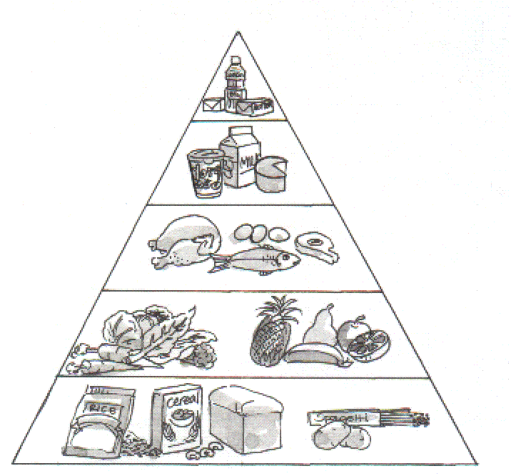

- Drink less caffeine (coffee and colas)

- Stop drinking or drink less alcohol. Too much alcohol makes HIV infection worse.

- Stop smoking, it makes HIV infection worse and damages a body's natural protection against pneumonia.

- Do more exercise

- Get enough rest, learn how to relax and enjoy life.

- Practice safe sex.

The impact of living with HIV/AIDS on individuals, the family, the community, workplace and society.

Individuals who have HIV / AIDS

People who have been tested for HIV /AIDS and are positive experience different feelings such as:
- Why me?
- Anger
- Disbelief
- Depression
- They pass the blame onto someone else
- Hatred
- And many more feelings

It is important that this person receives counselling and support.

How does it affect the family?

- Many families find it difficult to accept that one of their family members have been tested positive for HIV /AIDS.
- The family sometimes will be angry and not supportive.
- Counselling for the whole family is necessary

Write down how you think your family members would feel.

How does it affect the community and society?

- Communities in the neighbourhood need more support to cope with the crisis they experience.
- Has an impact on the number of deaths in the community which can be very depressing for the people in the community

How do you think it affects your community? Write down your answers below.

How does HIV/AIDS affect business?

HIV and AIDS affect young and middle-aged adults during their most productive years. The epidemic affects businesses by reducing their productivity, increasing costs.

Profits are affected by a number of factors, such as:

- Absenteeism - More and more workers are absent because they are ill, but also because they take time to attend funerals and care for their families. Women feel these demands most strongly.
- The morale of the workforce is dropping because so many co-workers, family and friends are developing AIDS and becoming sick or dying.
- Sick workers are less productive and cannot carry out more demanding physical jobs.
- Employees who retire for medical reasons have to be replaced. Their replacements may need more training if they are less skilled and experienced.

Available treatment for HIV/AIDS and STI’s

When a person is infected with HIV, they need to get the right kind of treatment as they experience problems with their health at different stages of illness.

There are two types of treatment:

- Treatment of infections because of damaged immunity

- Treatment of HIV itself.

Treatment of common infections in the early and middle stages

It is important to watch out for infections because people with HIV tend to get a lot more of the infections than other people get, but in a short space of time.

Common infections are:

- Pneumonia and TB
- Skin infections, STIs and pelvic infections
- Diarrhoea
- Infections of mouth, ears and throat.

All these infections can be treated easily at clinics by the local nurses and doctors using the treatment already available in the clinic.

People with HIV respond very well to the normal treatment. Hospital admission may be needed for serious infections

Treatment for HIV itself

- At the moment, there is no cure for HIV, but antiretrovirals make a big difference for most people at the stage of AIDS.
- Medicines that work on HIV itself are called Antiretrovirals (ARVs).
- These are the medicines that slow down the growth of the HIV virus and the damage to the white cells, so that the body has a chance to recover.
- However, they do NOT get rid of the virus permanently.
- ARVs increase the number of years that a person with HIV can live. A combination of different medicines has to be used together for life, for example: AZT, Nevirapine, 3TC, but there are many others.

COMPLETE FORMATIVE ASSESSMENT NO 5 IN YOUR WORKBOOK

