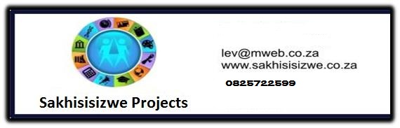

Life skills: Healthy living and good grooming

Practice good health and grooming habits US No: 243193- Level 1, Credits 4

Demonstrate an understanding of factors that US No: 14659 – Level 1, Credits 4

contribute towards healthy living

Learner’s name
Facilitator’s name
Starting date

Learner Manual

Hi there!

Welcome to a learning experience that will give you all you need to know about two valuable skills that will contribute towards healthy living and good grooming.

Some of the activities are practical. Your facilitator will show and explain how to do certain things and then you will practice them.

We hope you will enjoy this!

We have included some new words to learn so that you can improve your vocabulary. If you are not sure about the meaning of a word or how to say it, ask your facilitator.

We hope that when you have learnt these skills you will share them with others and take them from the workplace into your life

Have fun!

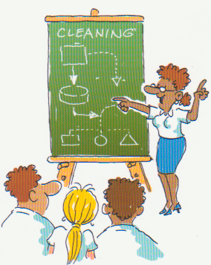

INDEX

Section | Contents | Page number
Section | Contents | Learner
1 | Skills clusters and learning pathway | 4
2 | Introduction to your workbook | 5
3 | Unit standard learning outcomes | 5
4 | Critical Cross-field Outcomes | 6
5 | What I must know | 7
6 | What I must be able to do | 8
7 | Learning signs | 9
Module 1 – Good health and grooming |  | 10 – 16
Module 2 – Good food and exercise |  | 20 – 22
Module 3 – Illness and medication |  | 24 – 26

1. Skills clusters and learning pathways

Qualification  ☺ You are here!  Hygiene & Cleaning Level 1 |  | Introduction to Cleaning
Qualification  ☺ You are here!  Hygiene & Cleaning Level 1 |  | Use chemicals  to clean
Qualification  ☺ You are here!  Hygiene & Cleaning Level 1 |  | Ablution  cleaning
Qualification  ☺ You are here!  Hygiene & Cleaning Level 1 |  | Above the floor & window cleaning
Qualification  ☺ You are here!  Hygiene & Cleaning Level 1 |  | Textile surface cleaning
Qualification  ☺ You are here!  Hygiene & Cleaning Level 1 |  | Hard and resilient floor cleaning
Qualification  ☺ You are here!  Hygiene & Cleaning Level 1 |  | Kitchen  cleaning
Qualification  ☺ You are here!  Hygiene & Cleaning Level 1 |  | Customer service and teamwork |  | Sexuality & sexually transmitted diseases
Qualification  ☺ You are here!  Hygiene & Cleaning Level 1 |  | Environmental awareness |  | One module  Sexually transmitted infections – HIV/AIDS
Qualification  ☺ You are here!  Hygiene & Cleaning Level 1 |  | Life skills  Health |  | Healthy living and good grooming
Qualification  ☺ You are here!  Hygiene & Cleaning Level 1 |  | Life skills – Literacy |  | Module 1  Good health and grooming
Qualification  ☺ You are here!  Hygiene & Cleaning Level 1 |  | Life skills – Numeracy |  | Module 2  Good food and exercise
Qualification  ☺ You are here!  Hygiene & Cleaning Level 1 |  | Life skills - Finance |  | Module 3  Illness and medication

Although in the Cleaning Industry it is a requirement to have completed
the Introduction to cleaning and the Use chemicals to clean skills clusters
before doing any of the others,
the Life Skills: Health cluster may be done at any time.

2. Introduction to your workbook

This book belongs to you!

It is for you to work with and write in so that you can use the information at a later stage.

This workbook contains a lot of detail and ideas to help you learn. Your facilitator will be available to guide you during the learning process.

You will be expected to complete the activities in the workbook to show your understanding.

You will learn even more by:
- Asking questions
- Participating in group discussions
- Reading additional material
- Completing the assignments
- Doing homework activities
- Doing classroom activities
- Making notes

Remember - this book is precious - so use it well!

3. Unit Standard Learning Outcomes
Purpose:

Practice good hygiene and grooming habits - To be able to practice good health and grooming habits.

Demonstrate an understanding of factors that contribute towards healthy living - To consider such factors as hygiene, cleanliness, nutrition, recreation and basic health care that contribute to healthy living.

Learners credited with these unit standards are able to:

- Deal with common health conditions to help prevent the spread of disease
- Practice good hygiene habits
- Practice good grooming and dress habits
- Explain the basic principles of personal hygiene
- Demonstrate an understanding of healthy and nutritious eating habits
- Demonstrate an understanding of the consequences of abusing drugs and medicine
- Demonstrate an understanding of sports and/or recreational activities for a healthy lifestyle

Learning assumed to be in place

It is assumed that learners are competent in communication skills at ABET Level 3

4. Critical Cross-field Outcomes

 | This list contains all Critical Cross-field Outcomes identified by the South African Qualifications Authority.  They do not all apply to both Unit Standards covered in this Learning Material.  Those marked by:
GH | Apply to Practice Good Health and grooming habits
HL | Apply to Demonstrate an understanding of factors that contribute towards Healthy Living

The complete list of Critical Cross-field Outcomes is:

- Identify and solve problems in which response displays that responsible decisions, using critical and creative thinking, have been made. GH
- Collect evaluate organize and critically evaluate information. GH HL
- Work effectively with others as a member of a team, group, organization or community. GH
- Organize and manage oneself and one’s activities responsibly and effectively. GH
- Communicate effectively by using mathematical and/or language skills in the modes of oral and/or written presentation. GH HL
- Use science and technology effectively and critically, showing responsibility towards the environment and health of others. GH
- Demonstrate an understanding of the world as a set of related systems by recognizing that problem solving contexts do not exist in isolation. GH HL
- Contribute to the full personal development of each learner and the social and economic development of the society at large by. GH HL
  - Participating as a responsible citizen in the life of local, national and global communities. GH HL
  - Being culturally and aesthetically sensitive across a range of social contexts. GH HL

5. What I must know

GH | Practice Good Hygiene and grooming habits
HL | Demonstrate an understanding of factors that contribute towards Healthy Living

I must know . . .. . | SO |  | AC |  | CCFO
I must know . . .. . | GH | HL | GH | HL
Common unhealthy conditions | 1 | - | 1.1 | - | 1 & 6
Good hygiene habits | 2 | - | 2.1 | - | 4 & 6
Unhygienic habits | 2 | - | 2.4 | - | 1 & 6
How to contain and limit spread of germs | 1 | - | 1.2 | - | 7 & 8a
Good lifestyle habits and consequences of poor hygiene and unhealthy habits | - | 1 | - | 1.2 | 4 & 6
Symptoms of Illnesses and where to find professional help | 1 | - | 1.3 | - | 1, 2, 4 & 5
Reasons for not sharing personal items | 2 | - | 2.5 | - | 1 & 6
Reasons for being well groomed | 3 | - | 3.1 | - | 3, 4 & 8b
How hair, make-up and jewellery could interfere with cleaning tasks | 3 | - | 3.4 | - | 3 & 4
Reasons for practicing effective hand washing | 2 | - | 2.2 | - | 4 & 6
Main food groups and how each contributes to health | - | 2 | - | 2.1 | 2 & 7
Health needs and special food requirements of individual and family | - | 2 | - | 2.2 | 1, 2, 6 & 7
The value of sports/ recreational activities | - | 4 | - | 4.2 | 4 & 8a
Opportunities for sports and or recreational activities in my community | - | 4 | - | 4.1 | 4 & 8a
The relationship between the functions of the body and its organs and personal hygiene | - | 1 | - | 1.1 | 7
When medication has a positive effect | - | 3 | - | 3.1 | 7 & 8a
When medication has a negative effect |  | 3 |  | 3.2 | 7 & 8a
The dangers of not following instructions for medication | - | 3 | - | 3.4 | 2, 4, 6 & 7
Effects of habit forming drugs | - | 3 | - | 3.3 | 6, 7 & 8a
Which habit forming drugs are illegal and the consequences of abuse | - | 3 | - | 3.5 | 1 & 8a

6. What I must be able to do

GH | Practice Good Hygiene and grooming habits
HL | Demonstrate an understanding of factors that contribute towards Healthy Living

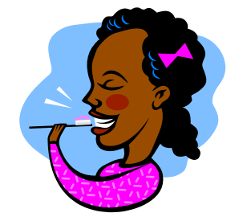
I must be able to . . .. . | SO |  | AC |  | CCFO
I must be able to . . .. . | GH | HL | GH | HL
Practice good grooming and dress habits | 3 | - | 3.2  3.3  3.4 | -  -  - | 1, 3, 4 & 7
Demonstrate correct hand washing technique | 2 | - | 2.3 | - | 4, 6 & 7
Plan a balanced meal based on health needs and special dietary requirements | - | 2 | - | 2.3 | 2, 6, 7 & 8b

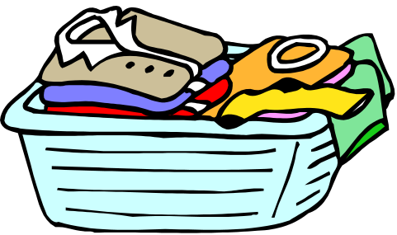

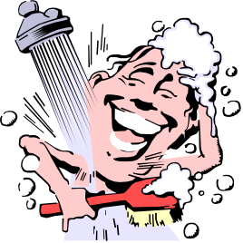

7. Learning signs

DICTIONARY
Explanation of words and terms
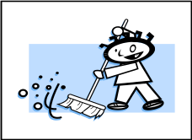 | WORKPLACE ACTIVITY
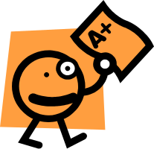 | CLASS ACTIVITY
FOR YOUR PORTFOLIO
Put this into your Portfolio of Evidence
 | HOMEWORK  Work to be done at Home
 | MY NOTES  To remind me
 | IMPORTANT INFORMATION
 | JUST TO REMIND YOU  Revision of work done



MODULE 1
Good health and grooming

If you want to be healthy and look good, you need to develop and keep good health, hygiene and grooming habits

CLASSROOM ACTIVITY

Let’s take a look at healthy and unhealthy conditions

Some common unhealthy conditions are in the white boxes below.
Select those that could be a risk to your health and the health of others, and then write the condition/s next to the part of the body that you think it affects.
The skin

The eye

The chest and upper respiratory area

The bowels

BOWELS
The passage that carries excrement (waste) from the lower stomach to the anus

Rashes

Open wounds

Pink eye/
Conjunctivitis

Diarrhoea
Boils

Sores
Influenza

Cuts
Coughs

Colds

CLASSROOM ACTIVITY | GERMS/ MICRO ORGANISMS:  are living things that cause illness. They are tiny and not visible to the naked eye.  CONSEQUENCE:  the result, or effect of doing/ or not doing something

The consequence of unhygienic habits is the spread of germs or micro-organisms that cause illness, unhealthy conditions or disease.

The best way to stop this is to have, and use, good hygiene habits.

Write down as many good health habits as you can that will help prevent the spread of germs
Write down as many unhygienic habits you can think of

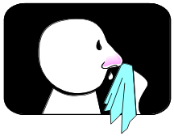

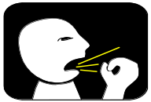

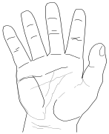

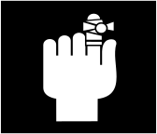

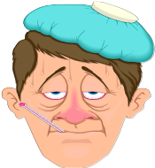

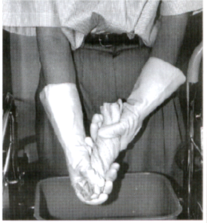

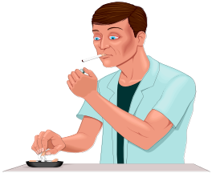

Just to remind you!

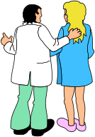
Sometimes, you will be, or feel unwell.
You need to report any illnesses to your supervisor
and seek professional help especially if you think, or know
your condition is contagious.

What are some of the contagious illnesses or unhealthy conditions you might have that should be reported?
CONTAGIOUS:
Something (a disease or illness) that can be spread by direct or indirect contact with people or organisms

And who are some of the health professionals you could turn to for help?

To help a friend, you might think about lending them a personal item. Some things though should never be lent.
What would you never lend - even to your best friend? Tick them.

Toothbrush
CLASSROOM ACTIVITY
Face cloth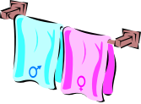

Unwashed crockery
Pen or pencil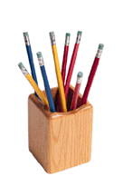
Razor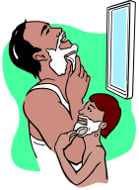
Brush & comb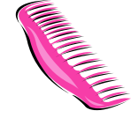

Cell-phone

What else can you think of?

Write down the consequences of sharing these items

Match the statement in Column B with the unhealthy condition in Column A

A |  | B
- Open wounds, cuts and sores |  | - When blowing your nose
- When coughing and sneezing |  | - Wash your hands
- Always use a tissue or a handkerchief (preferably disposable one) |  | - Cover your mouth and nose with your hands and wash your hands afterwards
- After touching body parts, wounds, scabs and sores you need to…. |  | - Seek medical/professional attention
- Pink eye, scabies, herpes could be spread by . . . |  | - Direct contact e.g. touching
- If infected with a contagious disease you need to stay at home and . . . |  | - Must be covered with water proof plaster
1. goes with -
2. goes with -
3. goes with -
4. goes with -
5. goes with -
6. goes with -

Let’s talk about looking good!

HOMEWORK ACTIVITY: 1 |  | PUT INTO YOUR PORTFOLIO

 | HOMEWORK ACTIVITY |  |  | COLLAGE:  A form of art in which pieces of paper, photographs, cloth etc are arranged and glued on to paper  GROOMING:  Usually has the word ‘good’ in front of it. To have a neat and tidy appearance

This is a fun project to do at home!

- Make a collage to show:
  - at least three examples of good hygiene habits
  - at least three examples of bad hygiene habits
  - examples of good grooming and a few examples of bad grooming.
- Cut out pictures from magazines, brochures or newspapers
- Paste the pictures on a sheet of A4 paper. Your collage should be colourful.

When you have finished your collage, make notes about why . . . . .

Grooming must be appropriate for the workplace
Clothing must look clean and worn neatly
Clothing must ‘be in good repair’ (not be torn or damaged)
A cleaner’s hairstyle, make-up or jewellery could be a problem

HAND WASHING . . .
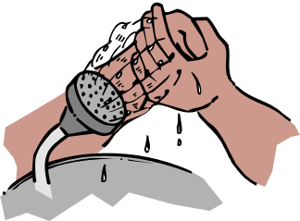

is the one thing, if done
correctly
often enough
by enough people
will go a long way to stopping the spread of illness and disease

CLASSROOM ACTIVITY | We seem to have forgotten how and why  our hands need to be washed!

Write down all the reasons you can think of for washing hands.

.

Think about what you’ve written and say when it is good practice to wash hands

This is what’s known as a taxi for germs
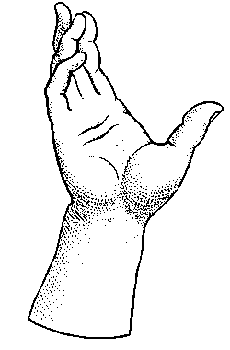

Your facilitator will now demonstrate the correct and most effective way to wash your hands.
Watch him or her carefully, and make notes of exactly what they do.

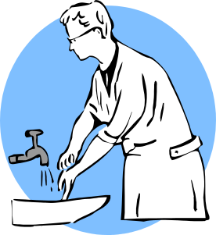  CLASSROOM ACTIVITY | THE 7 STEPS  TO EFFECTIVE HAND WASHING

Did you pick up all the steps?

 | 1 | Wet your hands and apply soap or hand washing detergent
 | 2 | Lather your hands for at least 10 seconds
 | 3 | Wash your palms, back of hands, wrists, between fingers and under jewellery
 | 4 | Rinse your hands
 | 5 | Close the tap(s)
 | 6 | Dry your hands thoroughly
 | 7 | Leave the basin area clean and ready for someone else

Now go and practice what you’ve learnt. Remember to use all 7 steps!!
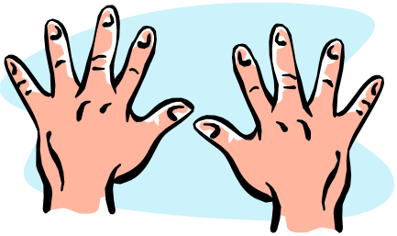

WORKSITE ACTIVITY No: 1 |  | PUT INTO YOUR PORTFOLIO

Complete this exercise in your workplace.
Over a period of a week or more, ask your supervisor to watch you washing your hands. You need to be observed by him or her three times.
After each hand wash, your supervisor needs to fill in each block to confirm how they saw you complete that specific activity correctly. All observations are to be signed by him or her.
Comments must be clear and describe what was observed by the supervisor or manager.
If your supervisor feels you are doing this task correctly, they will recommend you be assessed.

The 7 steps  of effective hand washing |  | Steps 1 & 2 | Step 3 | Steps 4 & 5 |  | Steps 6 & 7 |  | Supervisor’s signature after each observation
 |  | 1. Wet hands and apply soap or hand washing detergent, 2. Lather for 10 seconds | 3. Wash palms, back of hands, wrists, between fingers and under jewellery | 4. Rinse hands  5. Close the tap(s) |  | 6. Dry hands thoroughly 7. Leave the basin clean for someone else
1st Observation
2nd Observation
3rd Observation
Assessor’s Observation
Learner’s name |  |  |  |  | Learner’s signature
Supervisor’s name |  |  |  |  | Supervisor’s signature
Assessor’s name |  |  |  |  | Assessor’s signature

WORKSITE ACTIVITY No: 2 |  | PUT INTO YOUR PORTFOLIO

At work, you need to be well groomed, dressed neatly and in a uniform that is in good repair.
Over a period of two weeks or more, ask your supervisor to look at your grooming and clothing. You need to be observed twice by him or her.
After each observation, your supervisor needs to fill in the block to confirm what they saw. All observations are to be signed by him or her.
If after these observations, your supervisor feels you show good grooming and dress habits, they may recommend that you be assessed.

Good grooming and dress habits |  | Supervisor, please write in each space, what you actually saw for each good grooming and dress habit when you observed this learner. |  |  |  | Supervisor’s signature after each observation
 |  | Appearance in terms of grooming and personal hygiene and haircut and hairstyle, use of makeup and jewellery worn is appropriate | Cleanliness and condition of clothing and how it looks on the learner
Some examples could be |  | Hair neatly combed, no body odour and fingernails clean. Earrings are big and may interfere with cleaning. | Clothing meets the company’s Worksite Procedure. Overall is clean and ironed. It is being worn neatly. No buttons missing. Shoes need cleaning.
1st Observation
2nd Observation
Assessor’s Observation
Learner’s name |  |  |  | Learner’s signature
Supervisor’s name |  |  |  | Supervisor’s signature
Assessor’s name |  |  |  | Assessor’s signature

FORMATIVE ASSESSMENT No: 1 |  | PUT INTO YOUR PORTFOLIO

Make sure you and your facilitator sign the page and that it goes into your portfolio.

- Match the ailments below to the body parts that they normally affect:

BODY PART | AILMENT (Choose from list below)
The Eyes
The Bowels
The Chest and Upper Respiratory Area
The Skin

Rash Pink Eye Diarrhoea Flu

- Give three reasons for practicing effective hand washing

- Give four examples of when to wash your hands
- Give 3 reasons for being well groomed

- Give three examples of personal items that should not be shared with others and give a reason why it is not good to share these items:

PERSONAL ITEM THAT SHOULD NOT BE SHARED | REASON
Toothbrush
Brush or Comb

Face cloth

- What could happen if your ring or jewellery gets caught in machinery or appliance?

Learner’s name |  | Learner’s signature
Assessor’s name |  | Assessor’s signature
 |  | Date of assessment

MODULE 2
Good food and exercise

The body uses food to build itself, get energy, and repair or heal itself.
With good eating habits, a person gets all the nutrients needed for a good quality of life.
It is generally accepted that there are five main food groups
A good tip is to eat more of the foods towards the bottom of the pyramid
and less of those at the top!
Fats and oils
Soluble fats regulate the body functions. They make food nice to taste and the stomach feel full.
Milk and dairy
Milk, cheese, butter and yoghurt provide calcium and other minerals that strengthen bones and teeth
Meat, fish and eggs
The protein group allows the body to repair damaged tissue and build muscles. It includes all meat, fish, chicken and eggs. , Beans, peas and lentils, although vegetables, and milk and cheese which are dairy, also provide protein.
Fresh fruit and vegetables.
Seen as probably the most important group for good health. These are the immune boosting foods. They contain vitamins, minerals and dietary fibre to help protect the body from disease, especially heart disease, hypertension, diabetes, obesity and others.
Grains and cereals
The carbohydrate, starchy or energy foods. These are the body building foods. They are foods like bread, maize, pap, samp, mielie meal, rice, potatoes, sweet potatoes, pasta, wheat, rice, oats, millet, barley, rye, sorghum and cereals.

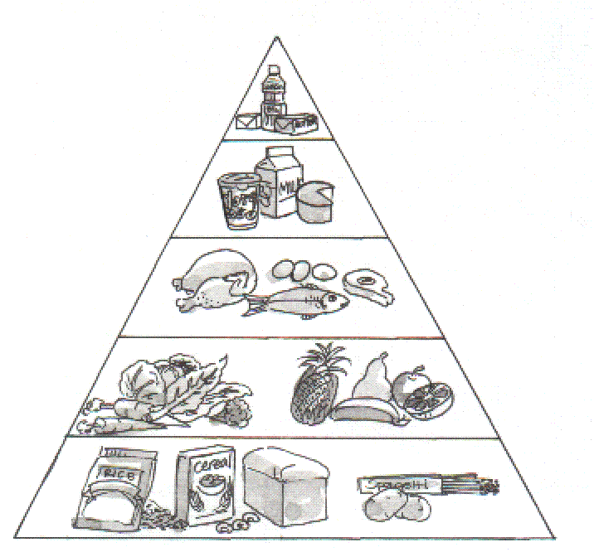

Why a balanced diet is necessary

for a healthy lifestyle

- Anything done by your body uses energy, no matter how simple or small the activity is.
- Proteins, fats and carbohydrates add to your energy pool, but to use and store this energy, you need vitamins and minerals.
- A diet short of foods that supply energy and the vitamins and minerals to make this energy available will lead to health problems.
- A balanced diet provides the body with the ‘fuel’ required to maintain life
- ‘Fuel’ is needed for the production and maintenance of body tissues, the mechanical work of muscles and heat production to maintain body temperature for example.

 | CLASSROOM ACTIVITY  Good eating habits |  | For your portfolio

ENERGY - The strength and vitality required for sustained activity
SUSTAIN - The ability to keep going over time
BODY TISSUE - The variety of materials or cells that make up the human body
VITIMINS - Essential materials the body needs for growth and health
DIABETES - A condition of the body that stops the conversion of food to energy

Here’s an exercise for you to do in the classroom on your own. Write down in the first column what you usually eat during the day, and in the second column, what you might be able to do differently, based on the information you now have on food groups and a balanced diet.

In the mornings (include breakfast and morning tea and any snack food you eat during the day) | I usually eat . . | Based on what I know now, I will . . .
Example | Jungle oats, white toast and tea | . . . stay with Jungle oats, but make the toast with whole wheat bread, and have a piece of fruit or fruit juice
At lunchtime (include afternoon tea and any snack food you eat during the day) | I usually eat . . . | Based on what I know now, I will . . .
At suppertime (and any snack food you eat just before or after supper) | I usually eat . . . | Based on what I know now, I will . . .

Some people may require more or less (or even none) of certain food types. What could be some dietary requirements?
‘If you say you haven’t got the time to exercise, you’d better find the time to be ill!’

So say the medical sports scientists and fitness specialists
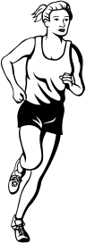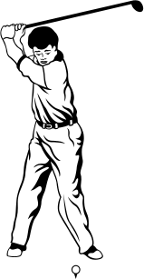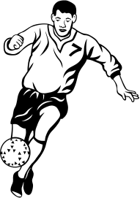
Write down how sport and recreation contribute to a healthy lifestyle

What are some of the sports that people play?

A HOMEWORK ACTIVITY

Of the sports you listed above, which are played at grounds, clubs or facilities in your community? Write down the name of each club or place.

HOMEWORK ACTIVITY: 2 |  | PUT INTO YOUR PORTFOLIO

HOMEWORK ACTIVITY

- List the five main food groups below. Now cut out pictures from magazines, newspapers, etc to show examples of each food group. (Stick your pictures on a blank A4 piece of paper and attach it to this activity)

The five food groups:

1.

- Find out if anyone in your family or friends have special food requirements. Write their names down below (3 names) and then write down next to each name what their special food requirements are.

NAME OF FAMILY MEMBER/FRIEND | SPECIAL FOOD REQUIREMENT

THE BACKGROUND

You are the parent responsible for choosing, buying and preparing the food for your family.
Your family consists of:

Grandpa | Your spouse’s father | He’s quite old - about 70. He has arthritis, and often has symptoms of colds and flu. He has false teeth that don’t fit so well, so he has them out most of the time.
Your spouse, (if you are a woman), is . . | Your husband | He’s a big strong guy. Aged 38. He drives a heavy earth-moving machine for a construction company. He plays social soccer for the local club twice a week.
Your spouse, (if you are a man), is . . . | Your wife | She’s ‘thirty-something’. Could maybe loose about 5Kg. She is a receptionist at a smart company. She doesn’t get much exercise at work. She likes to sew and uses her sewing machine at night.
Thomas | Your eldest son | He’s nearly 15 and built like his dad. Loves his sport. Has taken an interest in rugby and already plays for the school’s second team. Suffers a bit from acne (pimples on his face).
Thandi | Your eldest daughter | 13 years old. Very bright. She got through Grade 7 with ease. Got top marks in nearly everything. She hates sport, and would rather sit and study, read books or watch TV. She’s very skinny.
‘Little Angel’ | Your youngest daughter | A ‘laatlammetjie’ just 3 years old. Full of energy. Loves playing in the garden. Is always a mess at the end of the day having been rolling in the sand with the dog; picking up worms and snails etc.

You know how important it is for healthy living to give them balanced meals. You run the house on a tight budget, but you manage as long as you are careful about not adding too many fancy foods.

THE ASSIGNMENT

Plan two balanced meals based on the information you have.
  - Your family is described on the previous page.
  - All of you will be together this Sunday.
  - Plan the breakfast and lunch, which will be the main meal of the day.
  - Ideally, all the food you prepare should be suitable for everyone, but you might have to make exceptions.
  - Give a brief reason why you chose each type of food, and why it will suit each member of your family including yourself.

NOTES FOR ASSIGNMENT 3:

MODULE 3
Illness and medication

Hello, my name is VIRUS - GERM VIRUS, and I’m licensed to kill!  My brother is also in the business. His name is BACTERIA.  We enjoy making you sick.  We hate cleanliness and good hygiene.  We love dirt, it’s where we live.  And heat, darkness and moisture make us grow up tough.  We are happy when you neglect your personal hygiene, it makes it so easy to force an entry into that body of yours.  Oh, by the way, that licence to kill . . . . . . it’s for real. | 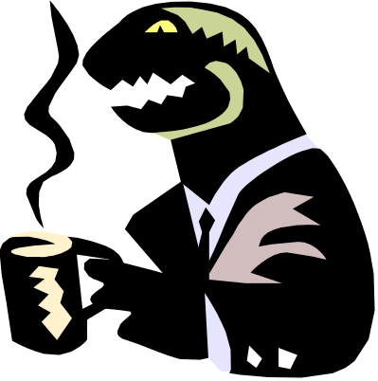

You need to know how the body works to be able to understand
how germs and disease enter the body.

INHALE - to breathe air into the lungs
POLLUTED - something that contains harmful or poisonous substances
REPRODUCE - to have children

Fill in the missing words

When I inhale fresh or polluted air, I use my?
When applying cream to my body it is applied to my?
When eating I use my?
When reproducing I use my?
All the above activities are part of our daily life, and yet these are the very ways we pick up infections that can make us ill. You can be infected by these microscopic creatures, germs, viruses and bacteria, at any time if you’re not careful. List the ways germs can enter and infect the body. Give an example of an illness you could get.

CLASSROOM ACTIVITY | Medication and drugs

MEDICATION - a treatment using (good) drugs
DRUGS - a medicine or substance that has a physiological effect on the body. Effect could be stimulant or narcotic
PHYSIOLOGICAL - the way in which a part of the body functions
STIMULANT - substance that increases physiological or nervous activity in the body
NARCOTIC - a substance, usually illegal, used for non-medicinal purposes, that affects mood or behaviour
ADDICT - someone who is physically dependent on a substance

You have seen medicines at home, in the pharmacy and even in the café around the corner. Think of those you see most of the time and list three that you have used in the past for illnesses and conditions.

When you go to hospital for an operation the doctor gives you drugs (anaesthetic) to put you to sleep. These drugs are necessary, as the doctor cannot operate on you whilst you are awake. Drugs used by a doctor for these and other purposes wont harm you.

Medication and drugs have to be prescribed by a qualified medical practitioner, although some medication can be bought ‘over the counter’.

Even though medication is prescribed to correct an unhealthy condition, there may be some negative side effects in some patients. Discuss the negative effects of medication on some patients

What are the dangers of not following instructions when taking medication?

Have you heard of any narcotic drugs? How many can you think of?

What are some of the drugs that are illegal in South Africa?

List the effect / consequences drug abuse could have on the body, in the workplace, in society and in the family

FORMATIVE ASSESSMENT No: 2 |  | PUT INTO YOUR PORTFOLIO

This exercise must be completed by a learner without help from notes or other learners.
Complete the following

- Give two examples of unhealthy conditions that can cause someone to become sick

- Imagine that a family member that is living with you is very ill with flue. Give two examples of what can be done to limit the spread of his/her germs to other members of your family

- Give two examples of illness or symptoms that would require that you go to the doctor

- Give two examples of when medication has a positive effect on a person.
.

- Give two examples of when medication could have a negative effect on a person.

- Name 2 drugs that are illegal in South Africa
- What effects can habit-forming drugs have on a person?
- Give two reasons why you should not share medication with a friend, family member or fellow worker
- When you get medicine from a pharmacy what should you do before taking the medication and why?

- When you have small children at home and you have medicine, why should you keep the medicine locked away or out of reach?

Learner’s name |  | Learner’s signature
Assessor’s name |  | Assessor’s signature
 |  | Date of assessment

