**LEARNER GUIDE**

**Deal with brand, product and service promotions**

Unit Standard 252202

Level 4 Credits 4

# TABLE OF CONTENTS

TABLE OF CONTENTS 2

PERSONAL INFORMATION 4

INTRODUCTION 5

Structure 5

Programme methodology 5

What Learning Material you should have 6

Different types of activities you can expect 7

Learner Administration 8

Assessments 8

Learner Support 9

Learner Expectations 10

UNIT STANDARD 252202 11

EVALUATE BRAND, PRODUCT AND SERVICE PROMOTION OPPORTUNITIES 14

Brand, Produce and Service Promotion Opportunities 14

What is a product? 17

Products, Services and Experiences 18

Product and Service Classifications 19

Consumer Products 20

Industrial Products 20

CO-ORDINATE BRAND, PRODUCT AND SALES PROMOTION 22

Product and Service Decisions 22

Individual product and Service Decisions 22

Branding 24

Most Expensive Perfumes 24

Brand Development 26

Sales Promotion 27

What are the uses of sales promotions? 27

Consumer Franchise Building 28

Non-Franchise building Promotions 28

Sampling 28

The Sales Promotion Dilemma 29

Objectives of Sales Promotion 30

Sales Promotion Trends: Internet Communication 31

Sales Promotion Planning & Objectives 32

Advertising objectives 32

Sales Promotion Objectives 32

EVALUATE BRAND, PRODUCT OR SERVICE PROMOTIONS 34

PERSONAL INFORMATION

|  |  |
| --- | --- |
| **NAME** |  |
| **CONTACT ADDRESS** |  |
|  |
| **Code** |  |
| **Telephone (H)** |  |
| **Telephone (W)** |  |
| **Cellular** |  |
| **Learner Number** |  |
| **Identity Number** |  |
|  | |
| **EMPLOYER** |  |
| **EMPLOYER CONTACT ADDRESS** |  |
|  |
| **Code** |  |
| **Supervisor Name** |  |
| **Supervisor Contact Address** |  |
|  |
| **Code** |  |
| **Telephone (H)** |  |
| **Telephone (W)** |  |
| **Cellular** |  |

INTRODUCTION

#### Welcome to the learning programme

Follow along in the guide as the training practitioner takes you through the material. Make notes and sketches that will help you to understand and remember what you have learnt. Take notes and share information with your colleagues. Important and relevant information and skills are transferred by sharing!



This learning programme is divided into sections. Each section is preceded by a description of the required outcomes and assessment criteria as contained in the unit standards specified by the South African Qualifications Authority. These descriptions will define what you have to know and be able to do in order to be awarded the credits attached to this learning programme. These credits are regarded as building blocks towards achieving a National Qualification upon successful assessment and can never be taken away from you!

Structure

### Programme methodology

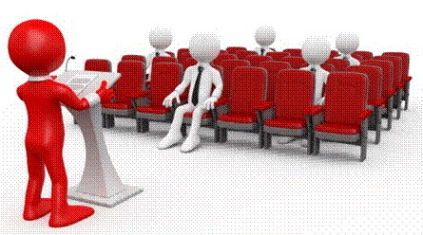

The programme methodology includes facilitator presentations, readings, individual activities, group discussions and skill application exercises.

Know what you want to get out of the programme from the beginning and start applying your new skills immediately. Participate as much as possible so that the learning will be interactive and stimulating.

The following principles were applied in designing the course:

* Because the course is designed to maximise interactive learning, you are encouraged and required to participate fully during the group exercises
* As a learner you will be presented with numerous problems and will be required to fully apply your mind to finding solutions to problems before being presented with the course presenter’s solutions to the problems
* Through participation and interaction the learners can learn as much from each other as they do from the course presenter
* Although learners attending the course may have varied degrees of experience in the subject matter, the course is designed to ensure that all delegates complete the course with the same level of understanding
* Because reflection forms an important component of adult learning, some learning resources will be followed by a self-assessment which is designed so that the learner will reflect on the material just completed.

This approach to course construction will ensure that learners first apply their minds to finding solutions to problems before the answers are provided, which will then maximise the learning process which is further strengthened by reflecting on the material covered by means of the self-assessments.

#### Different role players in delivery process

* Learner
* Facilitator
* Assessor
* Moderator

### What Learning Material you should have

This learning material has also been designed to provide the learner with a comprehensive reference guide.

It is important that you take responsibility for your own learning process; this includes taking care of your learner material. You should at all times have the following material with you:

|  |  |
| --- | --- |
| **Learner Guide** | **This learner guide is your valuable possession:**  This is your textbook and reference material, which provides you with all the information you will require to meet the exit level outcomes.  During contact sessions, your facilitator will use this guide and will facilitate the learning process. During contact sessions a variety of activities will assist you to gain knowledge and skills.  Follow along in the guide as the training practitioner takes you through the material. Make notes and sketches that will help you to understand and remember what you have learnt. Take and share information with your colleagues. Important and relevant information and skills are transferred by sharing!  This learning programme is divided into sections. Each section is preceded by a description of the required outcomes and assessment criteria as contained in the unit standards specified by the South African Qualifications Authority. These descriptions will define what you have to know and be able to do in order to be awarded the credits attached to this learning programme. These credits are regarded as building blocks towards achieving a National Qualification upon successful assessment and can never be taken away from you! |
| **Formative Assessment Workbook** | The Formative Assessment Workbook supports the Learner Guide and assists you in applying what you have learnt.  The formative assessment workbook contains classroom activities that you have to complete in the classroom, during contact sessions either in groups or individually.  You are required to complete all activities in the Formative Assessment Workbook.  The facilitator will assist, lead and coach you through the process.  These activities ensure that you understand the content of the material and that you get an opportunity to test your understanding. |

### Different types of activities you can expect

To accommodate your learning preferences, a variety of different types of activities are included in the formative and summative assessments. They will assist you to achieve the outcomes (correct results) and should guide you through the learning process, making learning a positive and pleasant experience.

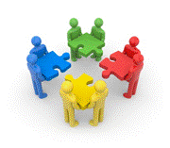

The table below provides you with more information related to the types of activities.

| **Types of Activities** | **Description** | **Purpose** |
| --- | --- | --- |
| **Knowledge Activities** | You are required to complete these activities on your own. | These activities normally test your understanding and ability to apply the information. |
| **Skills Application Activities** | You need to complete these activities in the workplace | These activities require you to apply the knowledge and skills gained in the workplace |
| **Natural Occurring Evidence** | You need to collect information and samples of documents from the workplace. | These activities ensure you get the opportunity to learn from experts in the industry.  Collecting examples demonstrates how to implement knowledge and skills in a practical way |

### Learner Administration



#### Attendance Register

You are required to sign the Attendance Register every day you attend training sessions facilitated by a facilitator.

#### Programme Evaluation Form

On completion you will be supplied with a “Learning programme Evaluation Form”. You are required to evaluate your experience in attending the programme.

Please complete the form at the end of the programme, as this will assist us in improving our service and programme material. Your assistance is highly appreciated.

### Assessments

The only way to establish whether a learner is competent and has accomplished the specific outcomes is through the assessment process. Assessment involves collecting and interpreting evidence about the learners’ ability to perform a task.

To qualify and receive credits towards your qualification, a registered Assessor will conduct an evaluation and assessment of your portfolio of evidence and competency.

This programme has been aligned to registered unit standards. You will be assessed against the outcomes as stipulated in the unit standard by completing assessments and by compiling a portfolio of evidence that provides proof of your ability to apply the learning to your work situation.



**How will Assessments commence?**

#### Formative Assessments

The assessment process is easy to follow. You will be guided by the Facilitator. Your responsibility is to complete all the activities in the Formative Assessment Workbook and submit it to your facilitator.

#### Summative Assessments

You will be required to complete a series of summative assessments. The Summative Assessment Guide will assist you in identifying the evidence required for final assessment purposes. You will be required to complete these activities on your own time, using real life projects in your workplace or business environment in preparing evidence for your Portfolio of Evidence. Your Facilitator will provide more details in this regard.

To qualify and receive credits towards your qualification, a registered Assessor will conduct an evaluation and assessment of your portfolio of evidence and competency.

### Learner Support

The responsibility of learning rests with you, so be proactive and ask questions and seek assistance and help from your facilitator, if required.



Please remember that this Skills Programme is based on outcomes based education principles which implies the following:

* You are responsible for your own learning – make sure you manage your study, research and workplace time effectively.
* Learning activities are learner driven – make sure you use the Learner Guide and Formative Assessment Workbook in the manner intended, and are familiar with the workplace requirements.
* The Facilitator is there to reasonably assist you during contact, practical and workplace time for this programme – make sure that you have his/her contact details.
* You are responsible for the safekeeping of your completed Formative Assessment Workbook and Workplace Guide
* If you need assistance please contact your facilitator who will gladly assist you.
* If you have any special needs please inform the facilitator

### Learner Expectations

Please prepare the following information. You will then be asked to introduce yourself to the instructor as well as your fellow learners

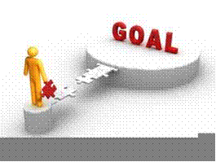

|  |
| --- |
| Your name: |
|  |
|  |
| The organisation you represent: |
|  |
|  |
| Your position in organisation: |
|  |
|  |
| What do you hope to achieve by attending this course / what are your course expectations? |
|  |
|  |
|  |
|  |
|  |

# UNIT STANDARD 252202

#### Unit Standard Title

Deal with brand, product and service promotions

#### NQF Level

4

#### Credits

4

#### Purpose

The person credited with this unit standard will be able to evaluate brand, product and service promotion opportunities while co-ordinating brand, product and sales promotions.

The qualifying learner is capable of:

* Evaluating brand, product and service promotion opportunities.
* Co-ordinating brand, product and sales promotions.
* Evaluating the brand, product or service promotions.

#### Learning Assumed To Be In Place And Recognition Of Prior Learning

Learners accessing this unit standard will have demonstrated competence in:

* Communication at NQF Level 3 or equivalent.
* Mathematical Literacy at NQF Level 3 or equivalent.

#### Unit Standard Range

* Marketing includes all forms of marketing communications, direct marketing and relationship marketing, sponsorship, event marketing, sales promotions, public relations and alternative strategies.
* Standard applies to marketing management, customer management, marketing communications and marketing research.
* Product life cycles including development, introduction, growth, maturity, saturation and decline.
* Positioning and repositioning including needs, wants, features, advantages, benefits, usage, users and competition.
* Promotion tools, including consumer tools, trade promotion tools, industry promotion tools and production promotion tools.
* Promotional methods including personal selling, mass selling, advertising, publicity, public relations and sales, product promotion.

#### Specific Outcomes and Assessment Criteria:

**Specific Outcome 1**

Evaluate brand, product and service promotion opportunities.

**Assessment Criteria**

* Assessments of specific promotional proposals are made in order to estimate the potential benefit to the customer.
* The nature and level of resources and expertise required to implement a promotional opportunity are assessed and estimations made of cost and resource requirements.
* Promotional opportunities are evaluated within agreed time frames.

**Specific Outcome 2**

Co-ordinate brand, product and sales promotion.

**Assessment Criteria**

* Sales promotional budgets are planned according to the overall budget structure.
* Promotional tools relevant to the type of promotion are evaluated and selected.
* Brand, product or service promotional programs are developed in accordance with the promotional objectives.
* The promotional program is communicated to all relevant stakeholders within the given time frame.
* Promotional program procedures are developed to provide for adequate lead time to prepare the components of the promotion before its launch.
* Processes to monitor the implementation and integration of promotions are established according to organisational requirements.

**Specific Outcome 3**

Evaluate brand, product or service promotions.

**Assessment Criteria**

* Appropriate testing of promotional tools is implemented to ensure optimum brand/product service promotion.
* Promotion results are analysed against original objectives.
* Promotion results are used to inform future promotional strategies and activities.

#### Unit Standard Accreditation And Moderation Options

* An individual wishing to be assessed (including through RPL) against this unit standard may apply to an assessment agency, assessor or provider institution accredited by the relevant ETQA.
* Anyone assessing a learner against this unit standard must be registered as an assessor with the relevant ETQA.
* Any institution offering learning that will enable achievement of this unit standard or assessing this unit standard must be accredited as a provider with the relevant ETQA.
* Moderation of assessment will be conducted by the relevant ETQA at its discretion.

#### Unit Standard Essential Embedded Knowledge

* Methods and techniques for establishing promotions.
* Methods and techniques for evaluating promotions and their effectiveness.
* Promotional tools.
* Promotional budgets.

#### Critical Cross-field Outcomes (CCFO):

**Unit Standard CCFO Identifying**

Identify and solve problems pertaining to any type of promotional activity.

**Unit Standard CCFO Working**

Work effectively with others in the implementation of brand, product and service promotions.

**Unit Standard CCFO Collecting**

Collect, evaluate, organise and critically evaluate information so that the establishment and development of sales programs, is accurate and understood by all.

**Unit Standard CCFO Communicating**

Communicate effectively with all stakeholders regarding the promotion of brand, products or services.

**Unit Standard CCFO Contributing**

Being culturally sensitive across a range of social contexts when planning and executing brand, sales and product promotions so that they are conducted in an appropriate and acceptable manner.

# EVALUATE BRAND, PRODUCT AND SERVICE PROMOTION OPPORTUNITIES

#### ***Specific Outcome 1***

Evaluate brand, product and service promotion opportunities.

#### ***Assessment Criteria***

* Assessments of specific promotional proposals are made in order to estimate the potential benefit to the customer.
* The nature and level of resources and expertise required to implement a promotional opportunity are assessed and estimations made of cost and resource requirements.
* Promotional opportunities are evaluated within agreed time frames.

## Brand, Produce and Service Promotion Opportunities

Now that you have had a good look at marketing strategy, we will take a deeper look at the marketing mix – the tactical tools that marketers use to implement their strategies.

Here we will look at how companies develop and manage products and brands. The product is actually the first and most basic marketing consideration.

We will start with a seemingly simple question: What is a product? As it turns out, the answer is not so simple.

To start things off, remember that seemingly easy question, what is a product? Well, what is water? That’s right, water. As it turns out, to a Fiji water customer, water is more than just a liquid you can draw out of a tap to wash down a sandwich or to quench your thirst after a workout. Fiji water is the “nature of water”.

The best things in life are free. Or so the song says. The flowers in spring; the birds that sing, the sunbeams that shine; this is all yours, and mine! The air that we breathe, the water we drink... oops, not so fast.

The water we drink? Free? Consider the following account:

*At Jean-Georges, a celebrated restaurant known for its artful cuisine and fine wines, a waiter lifts a tall decanter and fills three goblets from the bottle cradled within.*

*Its contents must be precious: Chef Jean-Georges Vongerichten even uses this beverage as an ingredient in broths and sorbets. Is it a rare vintage perhaps? Try again.*

*It’s Fiji Natural Artesian Water, the latest bottled water brand to elevate the world’s simplest drink to celebrity status. Today, at all of his restaurants, Mr. Vongerichten exclusively pours Fiji which looks and sounds almost as exotic as the French dishes on his menu.*

Fiji water may be one of the best things in life, but it is certainly not free. A quick check on the Jean-Georges menu shows that Fiji water sells there for R158 per 750 *ml* bottle. R158!!!

Shop around, perhaps at a lesser restaurant, and you are sure to find a bottle at the bargain price of R30. And we thought that petrol was expensive!?

Why would anyone pay those prices for a bottle of water, something they could get from the tap for free?

Well, it turns out that Fiji water is very, very good water. Drawn from an underground source in Viti Levu, the main island on the South Pacific country of Fiji, it has an ultra-clean taste and contains not a hint of impurities or pollutants.

But when you drink Fiji water, you are getting a lot more than just pure, good-tasting water. According to the company, not all waters are created equal.

Fiji water is untouched by man; it’s the true nature of water. Rainfall in a Fijian forest is a symphony of sound in a theatre of green.

Somewhere overhead, raindrops strike palm fronds that move in the wind, clicking and tapping like hundreds of castanets.

Around you is a glimpse of Eden: giant leaves, large enough to lie on, ferns like trees, bamboo and grasses taller than a man.

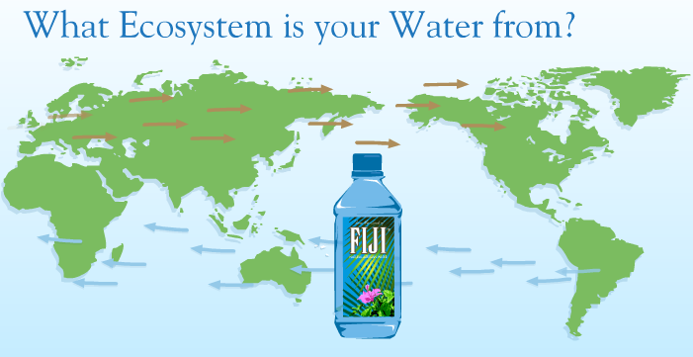

And the rain, formed in clouds above the blue Pacific Ocean, dances down through the forest canopy and seeps into the rich volcanic soil, wending its way to the aquifer far below the forest floor.

Water, like wine, gets its taste from the terrain that forms it. Fiji water comes from a virgin ecosystem deep in the South Pacific, from tropical rain filtered for hundreds of years through volcanic stone.

This natural artesian water is known for its signature soft, smooth taste and well balanced mineral content including a high level of silica, a youth preserving antioxidant.

You can taste the purity in every sip. It’s The Nature of Water!”

Everything about Fiji water contributes to this “nature of water” brand experience; from its

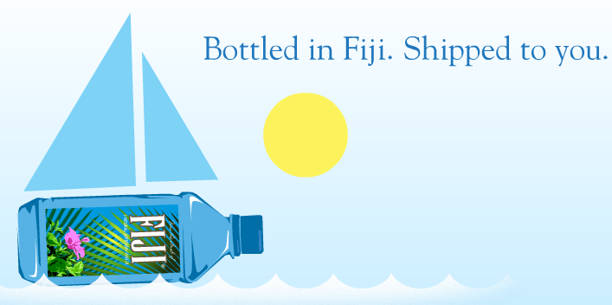

name, packaging and label to the places that sell and serve it, to the celebrities that drink and endorse it.

The name was a natural; Fiji Natural Artesian Water evokes visions of unspoilt natural beauty and purity.

The unique square bottle and colourful labelling also set the brand apart. The clear plastic front label presents the Fiji name with a flower resting below.



Looking through the front label to the inside of the back label, you can see an image of palm leaves.

In combination, the front and back labels create a striking three dimensional image that emphasises Fiji water’s clarity and purity.

The bottle seems to have a magic about it. Skilful marketing has also helped build the brands ultrachic image.

Initial ads played up Fiji’s exotic origins, raindrops falling into Fiji’s pristine tropical forests and filtering through layers of volcanic rocks.

“We’re sure you’ll agree, it was worth the 450 year wait” the ads said.

Clearly water is more than just water when Fiji sells it. This section began with a deceptively easy question:

“What is a product?”



After answering this question, we look at ways to classify products in consumer and business markets.

We will also discuss the important decisions that marketers make regarding individual products, product lines and product mixes.

### What is a product?

We define a product as anything that can be offered to a market for attention, acquisition, use or consumption that might satisfy a want or need. Products include more than just tangible goods.

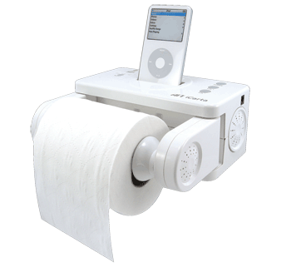

Broadly defined **products** include physical objects, services, events, persons, places, organisations, ideas or mixes of these entities. Throughout this section, we use the term product broadly to include any or all of these entities.

Thus an Apple iPod, a Toyota Camry and Café Mocha at Mug and Bean are products. But so are a European holiday, Fidelity online Investment Services and advice from your family doctor.

Because of their importance in the world economy, we give special attention to **services**. Services are a form of product that consists of activities, benefits, or satisfactions offered for sale that are essentially intangible and do not result in the ownership of anything.

Examples are banking, hotel, airline, retail, tax preparation and home repairs service. We will examine services more closely, later in this section.

### Products, Services and Experiences

Product is a key element in the overall market offering. Marketing-mix planning begins with formulating and offering that brings value to target customers. This offering becomes the basis upon which the company builds profitable relationships with customers.

A company’s market offering often includes both tangible goods and services. Each component can be a minor or major part of the total offer. At one extreme, the offer may consist of a pure tangible good, such as a soap, toothpaste or salt; no services accompany the product.

At the other extreme are pure services, for which the offer consists primarily of a service. Examples include a doctors’ exam or financial services. Between these two extremes, however many goods and services combinations are possible.

Today, as products and services become more commoditised, many companies are moving to a new level in creating value for their customers. To differentiate their offers, beyond simply making products and delivering services, they are creating and managing customer experiences with their products or company.

Companies that market experiences realises that customers are really buying much more than just products or services. They are buying what those offers will do for them.

**Levels of products and services**

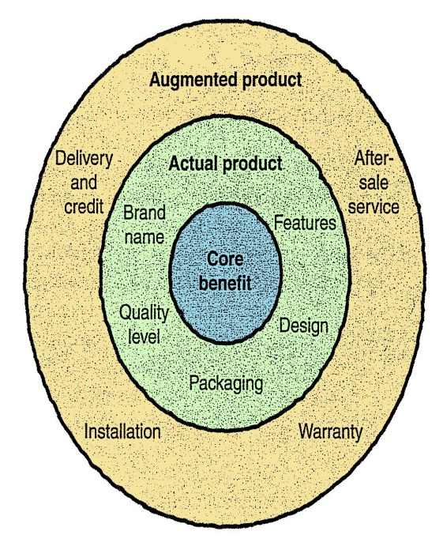Product planners need to think about products and services on three levels. Each level adds more customer value.

The most **basic level** is the core benefit, which addresses the question “*What is the buyer really buying?”* When designing products, marketers must first define the core, problem solving benefits or services that consumers seek. A woman buying lipstick, buys more than lip colour. Charles Revson of Revlon saw this early: “in the factory, we make cosmetics; in the store, we sell hope”.

People who buy a Blackberry are buying more than a wireless mobile phone, e-mail and web-browsing device, or personal organiser. They are buying freedom and on the go connectivity to people and resources.

At the **second level** product planners must turn the core benefit into an actual product. They need to develop product and service features, design, a quality level, a brand name, and packaging.

For example; the Blackberry is an actual product. Its name, parts, styling, features, packaging and other attributes have all been combined carefully to deliver the core benefit of staying connected.

**Finally**, product planners must build and augmented product around the core benefit and actual product by offering additional consumer services and benefits. Blackberry must offer more than just a communications device. It must provide consumers with a complete solution to mobile connectivity problems.

Thus, when consumers buy a Blackberry, the company and its dealers also might give buyers a warranty on parts and workmanship, instructions on how to use the device, quick repairs services when needed, and a toll free telephone number and web-site to use if they have problems or questions.

Consumers see products as complex bundles of benefits that satisfy their needs. When developing products, marketers must first identify the core consumer needs the product will satisfy. They must then design the actual product and find ways to augment it in order to create the bundle of benefits that will provide the most satisfying customer experience.

**Consumer product** – bought by final consumer for personal consumption

**Convenience product** – consumer product that the customer usually buys frequently, immediately and with minimum comparison and buying effort

### Product and Service Classifications

Products and service fall into two broad classes based on the type of consumers that use them; consumer products and industrial products. Broadly defined, products also include other marketable entities such as experience, organisations, persons, place and ideas.

|  |  |  |  |  |
| --- | --- | --- | --- | --- |
| **Marketing Consideration** | **Type of Consumer Product** | | | |
| **Convenience** | **Shopping** | **Speciality** | **Unsought** |
| Customer buying behaviour | Frequent purchase, little planning, little comparison or shopping effort, low customer involvement | Less frequent purchase, much planning and shopping effort, comparison of brands on price quality and style | Strong brand preference, loyalty, special purchase effort, little comparison, low price sensitivity | Little product awareness and knowledge |
| Price | Low price | High price | High price | Varies |
| Distribution | Widespread distribution, convenient locations | Selective distribution in fewer outlets | Exclusive distribution in only a few outlets per market area | Varies |
| Promotion | Mass promotion by the producer | Advertising and personal selling by both producer and resellers | More carefully targeted promotion by producer and reseller | Aggressive advertising and personal selling by producer and reseller |
| Examples | Toothpaste, magazines, laundry detergent | Major appliances, televisions, clothing | Rolex watches, crystal glasses | Life insurance, blood donations |

### Consumer Products

Consumer products are products and services bought by final consumers for personal consumption. Marketers usually classify these products and services further based on hoe consumers go about buying them.

Consumer products include convenience products, shopping products, speciality products and unsought products. These products differ in the ways consumers buy them and therefore in how they are marketed.

#### Convenience Products

Convenience products are consumer products and services that the customers usually buy frequently, immediately and with a minimum of comparison and buying effort.

Examples include soap, sweets, newspapers and fast food. Convenience products are usually low priced and marketers place them in many locations and make them readily available when customers need them.

#### Shopping Products

Shopping products are less frequently purchased consumer products and services that customers compare carefully on suitability, quality, price and style.

When buying shopping products and services, consumers spend much time and effort in gathering information and making comparisons between available products.

Examples include specific brands and types of cars, high-priced photographic equipment, designer clothes and the services of medical or legal specialists. A Lamborghini, for example, is a speciality product because buyers are usually willing to travel great distances to buy one.

Buyers normally do not compare speciality products. They invest only the time needed to reach dealers carrying the wanted products.

#### Unsought Products

These are consumer products that the consumer either does not know about or knows about but does not normally think of buying. Most major new innovations are unsought until the consumer becomes aware of them through advertising. Classic examples are life insurance and pre-planned funeral services.

### Industrial Products

Industrial products are those purchased for further processing and for use in conducting business. Thus, the distinction between a consumer product and an industrial product is based on the purpose for which the product is bought.

If a consumer buys a lawnmower for the use around home, the lawnmower is a consumer product. If the same consumer buys the same lawnmower for use in a landscaping business, the lawnmower is an industrial product.

The three groups of industrial products or services include materials and parts, capital items, and supplies and services.

**Materials and parts** include raw materials and manufactured materials and parts. Raw materials consist of farm products (wheat, cotton, livestock, fruits and vegetables) and natural products (fish, timber, crude petroleum, iron ore). Manufactured materials and parts consists of component materials (iron, cement, wire) and component parts (small motors, tyres, castings).

Most manufactured materials and parts are sold directly to industrial users. Price and service are the major marketing factors; branding and advertising tend to be less important.

**Capital items** are industrial products that aid in the buyers’ production or operations including installations and accessory equipment. Installations consist of major purchases such as buildings (factories, offices) and fixed equipment (generators, drill presses, large computer systems and elevators). Accessory equipment includes portable factory equipment and tools (hand tools, lift trucks) and office equipment (computers, fax machines and desks). They have a shorter life than installations and simply aid in the production process.

**Supplies and Services** are the final group of industrial products. Supplies include operating supplies (lubricants, coal, paper and pencils) and repair and maintenance items (paint, nails and brooms). Supplies are the convenience products of the industrial field because they are usually purchased with a minimum of effort or comparison. Business services include advisory services (legal, management consulting and advertising). Such services are usually supplied under contract.

# CO-ORDINATE BRAND, PRODUCT AND SALES PROMOTION

#### ***Specific Outcome 2***

Co-ordinate brand, product and sales promotion.

#### ***Assessment Criteria***

* Sales promotional budgets are planned according to the overall budget structure.
* Promotional tools relevant to the type of promotion are evaluated and selected.
* Brand, product or service promotional programs are developed in accordance with the promotional objectives.
* The promotional program is communicated to all relevant stakeholders within the given time frame.
* Promotional program procedures are developed to provide for adequate lead time to prepare the components of the promotion before its launch.
* Processes to monitor the implementation and integration of promotions are established according to organisational requirements.

## Product and Service Decisions

Marketers make product and service decisions on three levels; Individual product decisions, Product Line decisions and Product Mix decisions.

### Individual product and Service Decisions

The figure below shows the important decisions in the development and marketing of individual products and services.

We will focus on decisions about product attributes, branding, packaging, labelling and product support services.

Developing a product or service involves defining the benefits that it will offer. These benefits are communicated and delivered by product attributes such as quality, features and style and design.

**Product Quality** is one of the marketers’ major positioning tools. Quality has a direct impact on product or service performance; thus it is closely linked to customer value and satisfaction.

Product Quality is one of the marketer’s major positioning tools. Quality has a direct impact on product or service performance; thus it is closely linked to customer value and satisfaction.

In the narrowest sense, quality can be defined as “freedom from defects”. But most customer centred companies go beyond this narrow definition.

The US society for Quality defines quality as the characteristics of a product or service that bear on its ability to satisfy stated or implied customer needs.

Similarly, Siemens defines quality as: “Quality is when our customers come back, and our products don’t.”

Product quality has two dimensions – level and consistency. In developing a product, the marketer must first choose a quality level that will support the products’ positioning. Here product quality means performance quality; the ability of a product to perform its functions.

For example; Rolls-Royce provides higher performance equality than a Tata. It has a smoother ride, provide more creature comforts and it generally lasts longer.

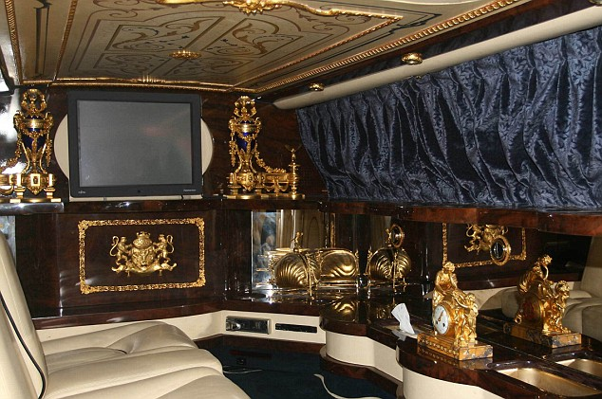

Beyond quality level, high quality can also mean high levels of quality consistency. Here, product quality means conformance quality; freedom from defects and consistency in delivering a targeted level of performance.

A product can be offered with varying features. A stripped-down model, one without and extras, is the starting point. The company can create higher-level models by adding more features.

Features are a competitive tool for differentiating the company’s product from competitor’s products. Being the first producer to introduce a valued new feature is one of the most effective ways to compete.

How can a company identify new features and decide which ones to add to its product? The company should periodically survey buyers who have used the product and ask these questions:

* How do you like the product?
* Which specific features of the product do you like most?
* Which features could we add to improve the product?

The answers provide the company with a rich list of feature ideas. The company can then assess each feature’s value to customers versus its cost to the company. Features that customers value highly in relation to costs should also be added.

Another way to add customer value is through distinctive product style and design. Design is a large concept than style.

Style simply describes the appearance of a product, this can be eye-catching or yawn-producing. A sensational style may grab attention and produce pleasing aesthetics, but it does not necessarily make the product perform better.

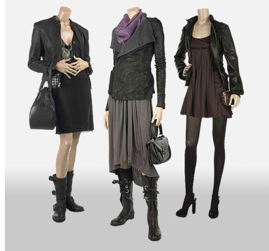

Unlike style, design is more than skin deep. It goes to the very heart of a product. Good design contributes to a products’ usefulness as well as its looks.

Good design begins with a deep understanding of customer needs. More than simply creating product or service attributes, it involves shaping the customers’ product-use experience.

### Branding

Perhaps the most distinctive skill or professional marketers is their ability to build and manage brands. A brand is a name, term, sign, logo, symbol or design or a combination of these, that identifies the maker or seller of a product or service.

Consumers view a brand as an important part of a product, and branding can add value to a product.

For example: most consumers would perceive a bottle of perfume as expensive because of the labelling and type of bottle. The same fragrance in an unbranded, simple bottle would not smell the same.

Let’s read the example below:

### Most Expensive Perfumes

Imperial Majesty, which costs $215,000 (R1.6 mil) a bottle, is the most expensive perfume in the world. Would it smell as sweet at any other price?

Actually, yes. Imperial Majesty is a limited edition of a Clive Christian signature scent. Sold simply as No. 1, the fragrance is priced at $2,150 (R16 000) an ounce (30 ml).

But the reason Imperial Majesty costs so much is that Christian, a British designer-turned-perfumer, poured 16.9 ounces (500 ml) of No. 1 into a Baccarat crystal bottle, stuck a five-carat diamond into the 18-carat gold collar and unveiled it at Harrods in London and Bergdorf Goodman in New York City this past holiday season.

Of the five bottles released for sale (the others were kept for Christian's archives), three have sold.

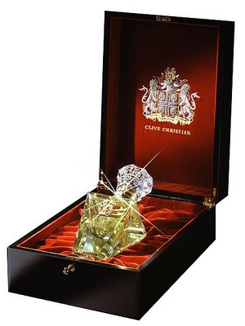

That's actually not as crazy as it sounds. There is a glut of new fragrances being dumped on the market from not only perfume makers and fashion houses, but also celebrities and movie stars, many of which scents have a shelf life as long or short as the celeb who introduced them.

From Paris to Britney, there were over 500 fragrance launches in 2005 alone. Feeling overwhelmed, people are not buying more perfumes, but they are willing to spend more on ones they like.

According to The NPD Group, a Long Island-based market research company, the U.S. fragrance industry grossed $2.8 billion (R18 billion) in sales in 2006, the last year for which annual numbers exist, up only 1% over the prior year.

"A lot of women now go to a perfume shop and say, 'What's your newest perfume, the one that you haven't shown anyone? I want it no matter what it costs,'" says Virginie Morel, a spokeswoman for the International Fragrance Association, which has offices in Brussels, Belgium and Geneva, Switzerland.

"Fragrances from the big houses have been tested a lot to please the most amount of people, and women don't want to look like their next door neighbour. Do you?"

"If you get a niche perfume, you won't smell like anyone else," she adds. "There's a demand for unique things, and it's a fact that people are more willing to pay."

Elisabeth Noel Jones, a fragrance, cosmetics and hosiery buyer at Bergdorf Goodman, agrees that customers are increasingly knowledgeable, and demanding--when it comes to perfume. "I'm moving away from things that are available at Barneys, Bloomingdale's, Lord and Taylor, Saks and Macy's," says Jones. "Our customer is in the know, and she doesn't want something that can be recognized walking down the street."

In the perfume industry, Christian isn't the only vendor smelling a profit. Last June, the Guerlain boutique on Champs Elysée in Paris launched a service called Le Parfum Sur Mesure, a personal consultation which takes between six months and a year and allows a customer to create her own perfume with the help of the store's fragrance director.

After that, no one else can buy it, but Guerlain will keep some in stock in case she ever runs out. The cost? €30,000, or about R282, 000!

### Brand Development

A company has four choices when it comes to developing brands. It can introduce line extensions, brand extensions, multi-brands or new brands.

**Line extensions** occur when a company extends existing brand names to new forms, colours, sizes, ingredients or flavours of an existing product category.

Thus, ABC Yoghurt introduced several line extensions, including new yoghurt flavours, a yoghurt smoothie and a yoghurt with added cholesterol reducers.

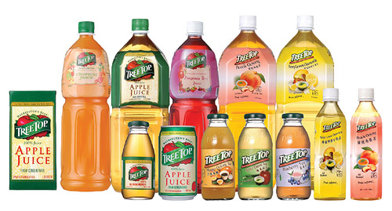

Morton Salt has expanded its line to include regular iodised salt, plus Morton Course Kosher Salt, Morton Sea Salt, Morton Lite Salt Morton Popcorn Salt and many others. The vast majority of all new product activity consists of line extensions.

**Brand Extension** extends a current brand name to new or modified products in a new category.

For example: Kimberly-Clark extended its market-leading Huggies brand from disposable nappies to a full line of toiletries for tots, from shampoos, lotions and nappy-rash ointments.

A brand extension gives a new product instant recognition and faster acceptance. It also saves the high advertising costs usually required to build a new brand name.

**Multi-branding** offers a way to establish different features and appeal to different buying motives. It also allows a company to lock up more reseller shelf space.

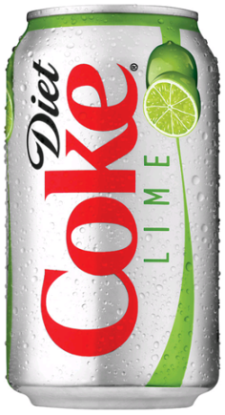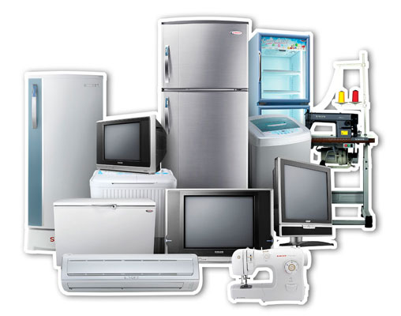

A company might believe that the power of its existing brand name is waning and a **new brand name** is needed.

Or it may create a new brand name when it enters a new product category for which none of the company’s current brand names are appropriate.

For example, Japans’ Matsushita uses separate names for all its different families of consumer electronic products: Panasonic, Techniques and JVC, to name but a few.

### Sales Promotion

#### What is sales promotion?

“A direct inducement that offers an extra value or incentive for the product to the sales force, distributors, or the ultimate consumer with the primary objectives of creating an immediate resale”

Basically, this is:

* An extra incentive to buy the specified product
* An acceleration tool for sales of the product
* An inducement to intermediaries
* Targeted to different parties

There are different sales promotion vehicles:

#### Consumer orientated:

* Samples
* Coupons
* Premiums
* Contests
* Refunds
* Bonus packs
* Event marketing

#### Trade orientated:

* Dealer incentives
* Trade allowances
* Point-of-purchase displays
* Training programs
* Trade shows
* Co-operative advertising

**Why increase Sales Promotions?**

There are numerous reasons why sales promotions are on the increase in markets:

* The growing power of retailers on consumers
* The declining of brand loyalty
* Increased promotional sensitivity
* Brand proliferation
* Fragmentation of consumer markets
* Increased accountability of brand owners
* Increased competition

### What are the uses of sales promotions?

* They introduce new products by encouraging trial and repurchase
* They get existing customers to buy more
* They attract new customers
* They defend their current customers
* They maintain sales in the off-seasons
* They target specific market segments
* They build brand equity

### Consumer Franchise Building

This activity communicates the distinctive brand attitudes and contributes to the development and reinforcement of the brand identity and its’ image.

Its objectives are to:

* Communicate distinctive brand attributes
* Develop and reinforce brand identity that is consistent with the image of the brand
* Building long-term brand preference with the customers
* Engage in active consumer involvement
* Encourages repeat and long term patronage

### Non-Franchise building Promotions

These are done to accelerate the purchase decision process and generate an immediate sales increase but they do not contribute to the building of a brand identity or image.

They may include

* Price-off deals
* Bonus packs
* Refunds or rebates

The shortcomings are:

* Trade promotions may not reach the consumers
* Customers may buy on the basis of price rather than brand equity
* They do not encourage the development of the brand loyalty

Next we will cover some ways in which promotional activities can be presented to the potential customers and the intended target market.

### Sampling

Sampling is the provision of the consumers with some quantity of the product for no charge to induce a trial use. It works best when:

* The products are of relatively low unit value, so the samples do not cost much
* The products are divisible and can be broken into small sizes that can reflect the products’ features and benefits
* The purchase cycle is relatively short so the consumer can purchase in a relatively short time period.

Sampling methods

* Door-to-door sample drop off’s
* Direct mail correspondence
* In-store sampling of the products
* Cross-product sampling by the comparison of products
* Samples are delivered with news papers, magazines and through the internet

**Coupons**

* This is the oldest and most widely used sales promotional tool
* Nearly 240 billion coupons are distributed in each year in South Africa
* 80% of consumers use the coupons they receive and 45% of the consumers use their coupons regularly

|  |  |
| --- | --- |
| **Advantages of coupons** | **Disadvantages of coupons** |
| Appeal to price sensitive consumer | Difficult to determine how many consumers will use the coupons and when they will use them |
| Can offer price break without retailers coop | Coupons are often used by loyal customers who may purchase anyway |
| Can be an effective way to introduce trial of new products | Declining redemption rates and high cost of couponing |
| Can defend the market share and encourage repurchase | Misredemption and fraud |

Coupon fraud:

* Consumers redeem without purchasing
* Clerks and staff exchange the coupons for cash
* Managers redeem coupons without sales
* Criminals counterfeit the coupons

### The Sales Promotion Dilemma

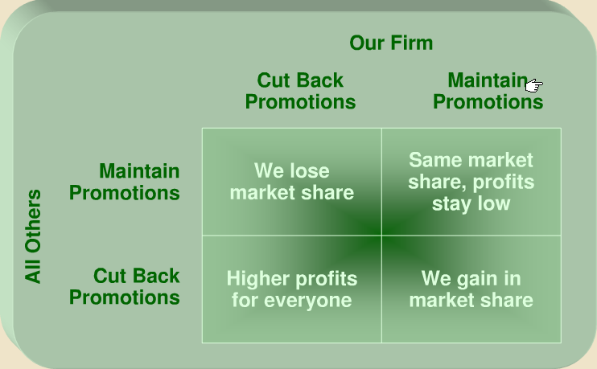

#### The shifting role of a sales promotion agency:

|  |  |
| --- | --- |
| **Then** | **Now** |
| Created tactics | Create strategy |
| Single project basis | Continuing service |
| Hired for speciality | One full service firm |
| Single agency contract | Agency team contact |
| Inferior to add agency | Equal to add agency |
| Indirect accountability | Directly accountable |

### Objectives of Sales Promotion

Sales promotion is a tool used to achieve most of the five major promotional objectives

**Building Product Awareness** - Several sales promotion techniques are highly effective in exposing customers to products for the first time and can serve as key promotional components in the early stages of new product introduction.

Additionally, as part of the effort to build product awareness, several sales promotion techniques possess the added advantage of capturing customer information at the time of exposure to the promotion.

In this way sales promotion can act as an effective customer information gathering tool (i.e., sales lead generation), which can then be used as part of follow-up marketing efforts.

**Creating Interest** – Marketers find that sales promotions are very effective in creating interest in a product. In fact, creating interest is often considered the most important use of sales promotion.

In the retail industry an appealing sales promotions can significantly increase customer traffic to retail outlets.

Internet marketers can use similar approaches to bolster the number of website visitors. Another important way to create interest is to move customers to experience a product.

Several sales promotion techniques offer the opportunity for customers to try products for free or at low cost.

**Providing Information** – Generally sales promotion techniques are designed to move customers to some action and are rarely simply informational in nature.

However, some sales promotions do offer customers access to product information. For instance, a promotion may allow customers to try a fee-based online service for free for several days.

This free access may include receiving product information via email.

**Stimulating Demand** – Next to building initial product awareness, the most important use of sales promotion is to build demand by convincing customers to make a purchase.

Special promotions, especially those that lower the cost of ownership to the customer (e.g., price reduction), can be employed to stimulate sales.

**Reinforcing the Brand** – Once customers have made a purchase sales promotion can be used to both encourage additional purchasing and also as a reward for purchase loyalty (see loyalty programs below).

Many companies, including airlines and retail stores, reward good or “preferred” customers with special promotions, such as email “special deals” and surprise price reductions at the cash register.

**Classification of Sales Promotion**

Sales promotion can be classified based on the primary target audience to whom the promotion is directed. These include:

**Consumer Market Directed** - Possibly the most well-known methods of sales promotion are those intended to appeal to the final consumer.

Consumers are exposed to sales promotions nearly every day, and as discussed later, many buyers are conditioned to look for sales promotions prior to making purchase decisions.

**Trade Market Directed** – Marketers use sales promotions to target all customers including partners within their channel of distribution.

Trade promotions are initially used to entice channel members to carry a marketer’s products and, once products are stocked, marketers utilize promotions to strengthen the channel relationship.

**Business-to-Business Market Directed** – A small, but important, sub-set of sales promotions are targeted to the business-to-business market.

While these promotions may not carry the glamour associated with consumer or trade promotions, B-to-B promotions are used in many industries.

**Sales Promotion Trends: Customers Expectations**

Marketers who employ sales promotion as a key component in their promotional strategy should be aware of how the climate for these types of promotions is changing.

For instance, the onslaught of sales promotion activity over the last several decades has eroded the value of the short-term requirement to act on sales promotions.

Many customers are conditioned to expect a promotion at the time of purchase otherwise they may withhold or even alter their purchase if a promotion is not present.

For instance, food shoppers are inundated on a weekly basis with such a wide variety of sales promotions that their loyalty to certain products has been replaced by their loyalty to current value items (i.e., products with a sales promotion).

For marketers the challenge is to balance the advantages short-term promotions offer versus the potential to erode loyalty to the product.

**Sales Promotion Trends: Electronic Delivery**

Sales promotions are delivered to customers in many ways such as by mail, in-person or within print media. However, the Internet and mobile technologies, such as cellphones, present marketers with a number of new delivery options.

For example, the combination of mobile devices and geographic positioning technology will soon permit marketers to target promotions to a customer’s physical location. This will allow retailers and other businesses to issue sales promotions, such as electronic coupons, to a customer’s mobile device when they are near the location where the coupon can be used.

**Sales Promotion Trends: Tracking**

As we discussed in our coverage of advertising, tracking customer’s response to marketers’ promotional activity is critical for measuring success of an advertisement.

In sales promotion, tracking is also used. For instance, grocery retailers, whose customers are in possession of loyalty cards, have the ability to match customer sales data to coupon use.

This information can then be sold to coupon marketers who may use the information to get a better picture of the buying patterns of those responding to the coupon.

### Sales Promotion Trends: Internet Communication

For many years consumers typically became aware of sales promotions in passive ways.

That is, most customers obtained promotions not through an active search but by being a recipient of a marketer’s promotion activity (e.g., received coupons in the mail). The Internet is changing how customers obtain promotions.

In addition to websites that offer access to coupons, there are a large number of community forum sites where members share details about how to obtain good deals which often include information on how or where to find a sales promotion.

Monitoring these sites may offer marketers insight into how customers feel about certain promotions and may even suggest ideas for future sales promotions.

Let’s take a look at a sample Sales Promotion Planning:

### Sales Promotion Planning & Objectives

SPS uses the definitions noted below.

Promotion marketing has traditionally been used to address specific, tactical objectives.

In today’s competitive market, SPS places an emphasis on integration of promotional activities with marketing objectives and strategies. SPS can prepare a Strategic Promotion Plan for your brands. We develop promotional strategies, concepts and tactics that are consistent with the brand’s marketing objectives and equity. We believe that strategic promotions must add value to the brand, and deliver an integrated consumer message.

#### Marketing Objectives

* Specific goals to be achieved by the brand in such broad areas as factory shipments, Rand sales revenue, consumer off-take, market share or profits.
* The achievement of these objectives depends not on just one marketing mix element (e.g. sales promotion), but on the total interrelationship of all marketing variables (e.g. distribution, pricing, personal selling, advertising, etc.)

Examples:

* Increase brand Z’s market share from X% to Y% within one year
* Improve brand Z’s profit margin from X% to Y% in the next six months

### Advertising objectives

* Specific communication effects to be achieved with advertising messages
* Advertising objectives mainly involve measures of awareness or comprehension of a sales message being communicated.
* They do not typically involve behavioural changes (e.g. generate a sale), as advertising is only one part of the total marketing and promotion mix which affects consumer.

Examples:

* Make 50% of the target audience aware of the new flavour of brand Z within a 3-month time frame

### Sales Promotion Objectives

* Unlike advertising, where the specific behavioural effects are difficult to measure, sales promotion is immediate.
* Hence, sales promotion objectives are defined in terms of some specific change that will occur in the marketplace.

Examples:

* Get 20% of the target market of competitive brand X user to try Z within the first 3 months.
* Get 40% of current brand z users to move to heavy use (from X to Y packs per month) within 6 months.
* Expand All Commodity Distribution for brand Z from X% to Y% in Large Independent Food Stores within 1 year.

# EVALUATE BRAND, PRODUCT OR SERVICE PROMOTIONS

#### ***Specific Outcome 3***

Evaluate brand, product or service promotions.

#### ***Assessment Criteria***

* Appropriate testing of promotional tools is implemented to ensure optimum brand/product service promotion.
* Promotion results are analysed against original objectives.
* Promotion results are used to inform future promotional strategies and activities.