**LEARNER GUIDE**

**Liaise With A Range Of Customers Of A Business**

Unit standard 252218

Level 4 Credits 4

# TABLE OF CONTENTS

[TABLE OF CONTENTS 1](#_Toc127364757)

[PERSONAL INFORMATION 3](#_Toc127364758)

[INTRODUCTION 4](#_Toc127364759)

[Structure 4](#_Toc127364760)

[Programme methodology 4](#_Toc127364761)

[What Learning Material you should have 5](#_Toc127364762)

[Different types of activities you can expect 6](#_Toc127364763)

[Learner Administration 7](#_Toc127364764)

[Assessments 7](#_Toc127364765)

[Learner Support 8](#_Toc127364766)

[Learner Expectations 9](#_Toc127364767)

[UNIT STANDARD 252218 10](#_Toc127364768)

[EXPLAIN THE BENEFITS OF CUSTOMER LIAISON 12](#_Toc127364769)

[The value of prospective customers SO1 AC1 12](#_Toc127364770)

[Attract the customer 13](#_Toc127364771)

[Retain the customer 13](#_Toc127364772)

[Maintain the customer 13](#_Toc127364773)

[The value of existing customers SO1 AC2 13](#_Toc127364774)

[What is a customer? 13](#_Toc127364775)

[Nothing happens until something is sold. 14](#_Toc127364776)

[The benefits of liaising with customers SO1 AC3 16](#_Toc127364777)

[Why is Customer communication important? 16](#_Toc127364778)

[The risk of not liaising with customers SO1 AC4 17](#_Toc127364779)

[Cost effective contact methods SO1 AC5 18](#_Toc127364780)

[Telephone 18](#_Toc127364781)

[Electronic mail (Email) 18](#_Toc127364782)

[Post Office 18](#_Toc127364783)

[Short Message System (SMS) 19](#_Toc127364784)

[INITIATE CONTACT WITH A RANGE OF CUSTOMERS 20](#_Toc127364785)

[Identify the range of customers SO2 AC1 20](#_Toc127364786)

[Loyal customers 20](#_Toc127364787)

[Discount customers 20](#_Toc127364788)

[Impulsive customers 20](#_Toc127364789)

[Need-based customers 21](#_Toc127364790)

[Wandering customers 21](#_Toc127364791)

[Customers according to their personality types 21](#_Toc127364792)

[Current status of satisfaction is identified, assessed and maintained SO2 AC2 22](#_Toc127364793)

[Key Questions Pertaining To Customer Service 22](#_Toc127364794)

[Report the situation to the appropriate internal authority 28](#_Toc127364795)

[Inform customers of the business activities SO2 AC3 28](#_Toc127364796)

[MAINTAIN CONTACT WITH A RANGE OF CUSTOMERS 29](#_Toc127364797)

[Establish communication processes with customers SO3 AC1 29](#_Toc127364798)

[Different Customers 29](#_Toc127364799)

[How to Approach Different Customers 30](#_Toc127364800)

[Different Selling to Different Customers 32](#_Toc127364801)

[Establish communication processes following organisational procedures 34](#_Toc127364802)

[Contact customers at predetermined intervals SO3 AC2 35](#_Toc127364803)

[Establish a reason to contact the customer SO3 AC3 35](#_Toc127364804)

[Build partnerships with customers SO3 AC4 36](#_Toc127364805)

[Why customer partnership 36](#_Toc127364806)

[Creating Customer Rapport 36](#_Toc127364807)

[ADMINISTER CONTACT WITH A RANGE OF CUSTOMERS 38](#_Toc127364808)

[Complete contact reports SO4 AC1 38](#_Toc127364809)

[Recording information from customers 39](#_Toc127364810)

[Identify and input correct information 40](#_Toc127364811)

[Repeat information 41](#_Toc127364812)

[Relevant and Consistent Information 42](#_Toc127364813)

[What to capture? 43](#_Toc127364814)

[Methods to grade customers SO4 AC2 44](#_Toc127364815)

[Why Should You Grade Your Customer’s Value? 45](#_Toc127364816)

[Grade your customers 45](#_Toc127364817)

[Present analysis and/or report to correct individuals SO4 AC3 47](#_Toc127364818)

[Identify trends and/or problems in the report SO4 AC4 47](#_Toc127364819)

[REFERENCES 51](#_Toc127364820)

PERSONAL INFORMATION

|  |  |
| --- | --- |
| ****NAME**** |  |
| ****CONTACT ADDRESS**** |  |
|  |
| ****Code**** |  |
| ****Telephone (H)**** |  |
| ****Telephone (W)**** |  |
| ****Cellular**** |  |
| ****Learner Number**** |  |
| ****Identity Number**** |  |
|  | |
| ****EMPLOYER**** |  |
| ****EMPLOYER CONTACT ADDRESS**** |  |
|  |
| ****Code**** |  |
| ****Supervisor Name**** |  |
| ****Supervisor Contact Address**** |  |
|  |
| ****Code**** |  |
| ****Telephone (H)**** |  |
| ****Telephone (W)**** |  |
| ****Cellular**** |  |

INTRODUCTION

#### Welcome to the learning programme

Follow along in the guide as the training practitioner takes you through the material. Make notes and sketches that will help you to understand and remember what you have learnt. Take notes and share information with your colleagues. Important and relevant information and skills are transferred by sharing!



This learning programme is divided into sections. Each section is preceded by a description of the required outcomes and assessment criteria as contained in the unit standards specified by the South African Qualifications Authority. These descriptions will define what you have to know and be able to do in order to be awarded the credits attached to this learning programme. These credits are regarded as building blocks towards achieving a National Qualification upon successful assessment and can never be taken away from you!

Structure

### Programme methodology



The programme methodology includes facilitator presentations, readings, individual activities, group discussions and skill application exercises.

Know what you want to get out of the programme from the beginning and start applying your new skills immediately. Participate as much as possible so that the learning will be interactive and stimulating.

The following principles were applied in designing the course:

* Because the course is designed to maximise interactive learning, you are encouraged and required to participate fully during the group exercises
* As a learner you will be presented with numerous problems and will be required to fully apply your mind to finding solutions to problems before being presented with the course presenter’s solutions to the problems
* Through participation and interaction the learners can learn as much from each other as they do from the course presenter
* Although learners attending the course may have varied degrees of experience in the subject matter, the course is designed to ensure that all delegates complete the course with the same level of understanding
* Because reflection forms an important component of adult learning, some learning resources will be followed by a self-assessment which is designed so that the learner will reflect on the material just completed.

This approach to course construction will ensure that learners first apply their minds to finding solutions to problems before the answers are provided, which will then maximise the learning process which is further strengthened by reflecting on the material covered by means of the self-assessments.

#### Different role players in delivery process

* Learner
* Facilitator
* Assessor
* Moderator

### What Learning Material you should have

This learning material has also been designed to provide the learner with a comprehensive reference guide.

It is important that you take responsibility for your own learning process; this includes taking care of your learner material. You should at all times have the following material with you:

|  |  |
| --- | --- |
| **Learner Guide** | **This learner guide is your valuable possession:**  This is your textbook and reference material, which provides you with all the information you will require to meet the exit level outcomes.  During contact sessions, your facilitator will use this guide and will facilitate the learning process. During contact sessions a variety of activities will assist you to gain knowledge and skills.  Follow along in the guide as the training practitioner takes you through the material. Make notes and sketches that will help you to understand and remember what you have learnt. Take and share information with your colleagues. Important and relevant information and skills are transferred by sharing!  This learning programme is divided into sections. Each section is preceded by a description of the required outcomes and assessment criteria as contained in the unit standards specified by the South African Qualifications Authority. These descriptions will define what you have to know and be able to do in order to be awarded the credits attached to this learning programme. These credits are regarded as building blocks towards achieving a National Qualification upon successful assessment and can never be taken away from you! |
| **Formative Assessment Workbook** | The Formative Assessment Workbook supports the Learner Guide and assists you in applying what you have learnt.  The formative assessment workbook contains classroom activities that you have to complete in the classroom, during contact sessions either in groups or individually.  You are required to complete all activities in the Formative Assessment Workbook.  The facilitator will assist, lead and coach you through the process.  These activities ensure that you understand the content of the material and that you get an opportunity to test your understanding. |

### Different types of activities you can expect

To accommodate your learning preferences, a variety of different types of activities are included in the formative and summative assessments. They will assist you to achieve the outcomes (correct results) and should guide you through the learning process, making learning a positive and pleasant experience.



The table below provides you with more information related to the types of activities.

| **Types of Activities** | **Description** | **Purpose** |
| --- | --- | --- |
| **Knowledge Activities** | You are required to complete these activities on your own. | These activities normally test your understanding and ability to apply the information. |
| **Skills Application Activities** | You need to complete these activities in the workplace | These activities require you to apply the knowledge and skills gained in the workplace |
| **Natural Occurring Evidence** | You need to collect information and samples of documents from the workplace. | These activities ensure you get the opportunity to learn from experts in the industry.  Collecting examples demonstrates how to implement knowledge and skills in a practical way |

### Learner Administration



#### Attendance Register

You are required to sign the Attendance Register every day you attend training sessions facilitated by a facilitator.

#### Programme Evaluation Form

On completion you will be supplied with a “Learning programme Evaluation Form”. You are required to evaluate your experience in attending the programme.

Please complete the form at the end of the programme, as this will assist us in improving our service and programme material. Your assistance is highly appreciated.

### Assessments

The only way to establish whether a learner is competent and has accomplished the specific outcomes is through the assessment process. Assessment involves collecting and interpreting evidence about the learners’ ability to perform a task.

To qualify and receive credits towards your qualification, a registered Assessor will conduct an evaluation and assessment of your portfolio of evidence and competency.

This programme has been aligned to registered unit standards. You will be assessed against the outcomes as stipulated in the unit standard by completing assessments and by compiling a portfolio of evidence that provides proof of your ability to apply the learning to your work situation.



**How will Assessments commence?**

#### Formative Assessments

The assessment process is easy to follow. You will be guided by the Facilitator. Your responsibility is to complete all the activities in the Formative Assessment Workbook and submit it to your facilitator.

#### Summative Assessments

You will be required to complete a series of summative assessments. The Summative Assessment Guide will assist you in identifying the evidence required for final assessment purposes. You will be required to complete these activities on your own time, using real life projects in your workplace or business environment in preparing evidence for your Portfolio of Evidence. Your Facilitator will provide more details in this regard.

To qualify and receive credits towards your qualification, a registered Assessor will conduct an evaluation and assessment of your portfolio of evidence and competency.

### Learner Support

The responsibility of learning rests with you, so be proactive and ask questions and seek assistance and help from your facilitator, if required.



Please remember that this Skills Programme is based on outcomes based education principles which implies the following:

* You are responsible for your own learning – make sure you manage your study, research and workplace time effectively.
* Learning activities are learner driven – make sure you use the Learner Guide and Formative Assessment Workbook in the manner intended, and are familiar with the workplace requirements.
* The Facilitator is there to reasonably assist you during contact, practical and workplace time for this programme – make sure that you have his/her contact details.
* You are responsible for the safekeeping of your completed Formative Assessment Workbook and Workplace Guide
* If you need assistance please contact your facilitator who will gladly assist you.
* If you have any special needs please inform the facilitator

### Learner Expectations

Please prepare the following information. You will then be asked to introduce yourself to the instructor as well as your fellow learners



|  |
| --- |
| Your name: |
|  |
|  |
| The organisation you represent: |
|  |
|  |
| Your position in organisation: |
|  |
|  |
| What do you hope to achieve by attending this course / what are your course expectations? |
|  |
|  |
|  |
|  |
|  |

# UNIT STANDARD 252218

#### Unit Standard Title

Liaise with a range of customers of a business

#### Unit Standard ID

252218

#### NQF Level

4

#### Credits

4

#### Purpose

The person credited with this unit standard will be able to explain the benefits of customer service they are able to initiate contact with customers, maintain contact with them, administer the contact with customers to ensure effectiveness.

#### Unit standard range

* Marketing including all forms of marketing communications, direct marketing and relationship marketing, sponsorship, event marketing, sales promotions, public relations and alternative strategies.
* Customers include walk-in customers, canvassed customers, and telephonically contacted customers, customers obtained through marketing communications, e-mail customers and customers contacted through electronic means.

#### Learning Assumed To Be In Place And Recognition Of Prior Learning

Learners accessing this unit standard will have demonstrated competence in:

* Communication at NQF Level 3 or equivalent.
* Mathematical Literacy at NQF Level 3 or equivalent.

#### Specific Outcomes and Assessment Criteria

**Specific Outcome 1:** Explain the benefits of customer liaison.

**Assessment Criteria**

1. The value of prospective customer is identified by the organisation.

2. The value of existing customers is identified by the organisation.

3. The benefits of liaising with selected customer groups is explained to appropriate internal authority.

4. The risks of not liaising with selected customer groups is explained to appropriate internal authority.

5. The selection of cost effective contact methods is agreed with appropriate internal stakeholders.

**Specific Outcome 2**: Initiate contact with a range of customers.

**Assessment Criteria**

1. The range of customers are identified according to organisational requirements.

2. Current status of satisfaction is identified, assessed and maintained according to organisational procedures.

3. Customers are informed of the relevant business activities.

4. The situation is reported on to appropriate internal authority.

**Specific Outcome 3**: Maintain contact with a range of customers.

**Assessment Criteria**

1. Communication processes with customers are established according to organisational requirements.

2. Customers are contacted at predetermined intervals.

3. A reason to contact the customer is established according to organisational requirements.

4. Partnerships are built with a range of customers.

**Specific Outcome 4**: Administer contact with a range of customers.

**Assessment Criteria**

1. Contact reports are completed as per company requirements.

2. Customers are graded according to specific methods of grading customers as per organisational requirements.

3. Analysis and/or report is presented to correct individuals.

4. Trends and/or problems are identified in report.

#### Unit Standard Essential Embedded Knowledge

* A broad understanding of how to initiate, maintain and administer contacts with a range of customers.
* A basic understanding of methods and techniques for grading customers.
* A comprehensive understanding of methods and techniques for visiting or telephoning customers.
* A general, broad understanding of the company or organisations business activities.

#### Critical Cross-field Outcomes (CCFO)

**UNIT STANDARD CCFO WORKING**

Work effectively with others when making contacts with a range of customers.

**UNIT STANDARD CCFO ORGANISING**

Organise oneself and one's activities so that contacts made with customers are initiated, maintained and administered to enhance a business.

**UNIT STANDARD CCFO COMMUNICATING**

Communicate effectively when making contacts with a range of customers.

**UNIT STANDARD CCFO SCIENCE**

Use science and technology to administer contacts with customers.

**UNIT STANDARD CCFO CONTRIBUTING**

Being culturally sensitive to a range of social contacts when making contact with range customers, so that this contact is acceptable to a broad range of cultural background individuals.

# EXPLAIN THE BENEFITS OF CUSTOMER LIAISON

#### Specific Outcome 1

Explain the benefits of customer liaison.

#### Assessment criteria

1. The value of prospective customer is identified by the organisation.

2. The value of existing customers is identified by the organisation.

3. The benefits of liaising with selected customer groups is explained to appropriate internal authority.

4. The risks of not liaising with selected customer groups is explained to appropriate internal authority.

5. The selection of cost effective contact methods is agreed with appropriate internal stakeholders.

## The value of prospective customers SO1 AC1

Prospective customers are those customers who are not yet part of your business, in other words who are not yet purchasing from your business. These customers are very valuable in the sense that they are a future prospect and should be handled with extreme care. Prospective customers should be identified and a business should do everything in its power to attract those customers.

A list of the contacts identified by the company, who can become the buyer of a company's product, is known as potential customers.

Any individual can be a potential customer for the company, only if there are chances that he will buy the product or service.

The value of prospective customers is, of course, the amount they will spend at your company in the future. This could be any period from 2 days to 20 or 30 years.

**Example 1**

For example, your company sells exclusive shoes and handbags at R1500 per pair of shoes or handbag. If you attract 10 customers who are able to purchase at least one pair of shoes or one handbag every three months, you potential sales for a year would be:

R1 500 x 10 x 4 = R60 000.

If you are also able to convince the customer to buy some more clothes from the shop, let us say one more item each time and the value of that item is the same as the shoes or handbag, the potential sales for 10 customers would be R120 000.

The value of a prospective customer does not end there. If each of these 10 customers recommends your shop to 3 other people, it means that you could gain 30 more customers with even more sales.

**Example 2**

If you sell smaller products such as soap that people have to buy every month and you attract 100 new customers who each buy two bars of soap at R5.00 each, the potential value of these customers would be:

2 bars of soap at R5 = R10 per customer per month. R10 for 100 customers equals R1000 per month and the potential sales per year would then be R12 000.

This is just for one item, but chances are that the customer who walks into your shop will not only buy two bars of soap, but some other goods as well. So, let us say this customer buys R100 worth of goods from you every month and you have 100 customers like that, the potential sales would be R10 000 per month and R120 000 per year

Now, if each of these 100 customers bring 3 customers to your business, the value would be tripled.

### Attract the customer

There are three very important aspects to follow through when a business wants to turn prospective customers into existing customers:

1. Attract the customer
2. Retain the customer
3. Maintain the customer

To attract a customer is one of the most important functions in any business. A customer is a curious being and is always on the lookout for a business which can satisfy his/her needs. A customer also looks for a business which can offer him/her the right product at the right price and at the right time.

There are basically two ways to attract a customer: Through advertising and through word of mouth. Advertising is a vital function of a business and a business should ensure that their advertisements reach the right customer target market. Word of mouth is when existing customers are so satisfied with the service and products they’ve received from a business that they spread the word. Imagine if one customer tells ten people and those ten people tell another ten people. The word of mouth regarding good customer service multiplies with a speed. It is important to remember that the word of mouth can also let the opposite happen – if a business gave poor customer service, the word of mouth regarding poor customer service will also multiply.

### Retain the customer

Once the customer decides to purchase from a business, it is vitally important to retain that customer. Retaining a customer means that a business actually does everything in its power to keep that customer. There is an old saying that goes: “A new broom sweeps clean” and this should never be the case in a business. A business shouldn’t just give good customer service the first time a customer purchases from a business – good customer service should be a standard and should always occur.

### Maintain the customer

Maintaining customers in a business is equally important as attracting and retaining customers. Customers are high maintenance but it is worthwhile to look after customers due to the fact that customers are the biggest asset of any business. Ways to maintain customers is to do regular follow-up sessions with customers regarding their satisfaction levels. A simple telephone call or email after a customer purchased something will make the customer feel special and valued. This is called after-sales service. Always remember that the sales transaction doesn’t end once the customer leaves the business with the purchases.

## The value of existing customers SO1 AC2

### What is a customer?

Webster's definition can be considered as a logical starting point:

1) A person who buys, especially on a regular basis;

2) A person with whom one must deal.

At the end of the day customers are the sole provider of every business—the revenue stream that pays for everything else.

You can have the best product, the best accountant, the best management, and so on, but you have nothing without a revenue stream. And the revenue stream is the direct contribution of sales, period.

The value of existing customers cannot be emphasised enough.

* Existing customers are those customers who make regular purchases which leads to a business generating turnover.
* Existing customers should feel like “family” to a business. By family it is meant that existing customers should be encouraged and treated in such a way that the customers always feel valued and special, as if they are part of the business.
* Regular follow-up sessions with existing customers should be a standard and a rule in any business. Follow-up can be done by communicating with the customers regarding their satisfaction levels and also to introduce new products/services to them.

### Nothing happens until something is sold.

Let's look at the six types of existing customers.

#### 1. External Customer

These are the people and organizations who have a need for your product or service. They purchase your stuff in exchange for money.

They have a budget and will give you some of it in exchange for a solution that meets their needs and expectations. Given that, we affectionately refer to external customers as ones with the bag of money.

They have the financial autonomy to decide where and how they will spend their budget—the bag of money.

The question is, who gets the bag of money, you or your competitor?

Who has earned the confidence and trust of the customer? You and your competitor are vying for a piece of their budget—the best solution wins.

Know this: Customers vote with their money and complain with their feet.

#### 2. Allies

These are the users of your product or service, not the ultimate decision maker. These customers usually don't have a bag of money but they play a vital role in your success.

They do not make the final decision but they may have tremendous impact on the outcome. They are often closely connected to the bag of money and positioning them as an ally to your cause is critical for your success.

You must earn their trust and confidence if you expect them to support you at the bag of money level.

A caution about allies: They have veto power, the authority to say no. They can give you a hundred no's but can't give you the one yes needed to close the deal. We have seen countless selling hours wasted on allies with the hope of closing the deal.

However, allies can be a tremendous wealth of information. Pick their brains and learn how you can differentiate yourself from the competition. Customers buy differences, not similarities. It can sometimes be difficult to ascertain who the bag of money is and who the allies are.

Ask questions early in the call to determine who's who in the zoo. Shrink your sales cycle by understanding the players within your accounts. Simply ask them who else may be involved with decisions.

#### 3. Internal Customer

These are fellow employees and managers within your place of business. They support you and make you look good to your external customers. Appreciate them and treat them with respect.

Unfortunately, they are often the victims of your blame fest: "The jerks in production screwed up again ..." or "The idiots in shipping messed up . . ." or "Management gave me a lousy price . . ." and so it goes.

Poor internal relationships can have fatal consequences for your external customers. I recently saw an anonymous quote that supports my point.

"We have less to fear from outside competition than from inside conflict, inefficiencies, discourtesy, and bad service."

So true.

Take ownership for customer concerns. After all, you are an ambassador for your company, so don't abdicate responsibility for late deliveries, poor service, and inadequate support.

* Customers really don't care whose fault a problem is or how it happened. Customers aren't interested in fixing the blame.
* They want to fix the problem. It's up to you to use the company's resources to resolve their problem.

When you work in harmony with your internal customers, external customers become the beneficiary of your internal relationships.

#### 4. Repeat Customer

They are the jewels of your business. Do the job well the first time and you often get rewarded with another opportunity to serve them.

And guess what? They give you more money!

You may have heard that it costs up to five times as much to replace a customer as it does to keep one.

So, keep them happy. Under-promise and over-deliver.

#### 5. Born-Again Customer

These are previous customers who no longer do business with you. For some reason they have forgotten about you or they are still upset with you.

We suggest you dig up their file, give them a call, and settle any outstanding grievance. Put your ego aside and offer restitution to satisfy the customer.

Do what it takes to resolve the situation. Make amends. Very frequently they will once again be receptive to doing business with you.

They often become loyal customers provided you resolve the problem to their satisfaction. As you work with your customers, you will find the Sequential Model is applicable to all six types.

Remember: Pay particular attention to your internal customers.

#### 6. Bag of Wind

You guessed it, these people have little or no impact on the decision. They are often an easy point of entry into an account but they seldom contribute to the sales process.

In fact they do more harm than good by creating a false sense of authority. There is nothing worse than wasting valuable selling hours on people who cannot help advance the sale.

However, we’re not suggesting ignoring these people, but rather exploiting their knowledge to deepen your understanding and confidence about the account.

They may also provide clarity as to who the allies are and who the bag of money is.

Knowing these people can prove to be a huge advantage; knowledge is power.

Every business should have a good customer database with all the information regarding its customers on it.

The customer database will assist the business in identifying customers buying patterns, the amount they spend per transaction, and their preferences in certain products/services.

## The benefits of liaising with customers SO1 AC3

According to the Concise Oxford Dictionary; liaise means:

“Connection, co-operation and to act as a go-between for allied forces or units of the same force”.

A business and its customers should be “allied forces or units of the same force”. This basically means that a business and its customers should have the same idea of what each other need. A business should know what its customers need in order to satisfy their needs and a customer should know exactly to which business to go in order to satisfy those needs.

When a business liaises with its customers, the business will be able to identify exactly what the customer’s needs are. A business will also be able to identify if the customers are totally satisfied with the products and customer service of the business.

Many businesses have a Customer Liaison Officer whose job it is to liaise with customers and to keep the communication levels open between the business and its customers in order to connect with the customers and to get customers co-operation.

### Why is Customer communication important?

Organizations are open dynamic systems for transforming resource inputs into saleable outputs (goods & services). They are created to provide useful products and services that satisfy the needs of customers and provide value to stakeholders.

But the interests of various stakeholders (whether employees, customers, suppliers, or stakeholders) are not always aligned. This places conflicting pressures and demand on managers.

To maintain organisational viability, managers seek to navigate competitive environmental forces and work to achieve goals in the areas of productivity, satisfaction, and revitalization.

One of the realities of life in organizations is that today's effective practices are not likely to suffice tomorrow. Whether pulled by the success of growth or jolted by crisis and downturn, managers must periodically transform the system to adapt to environmental realities.

In the process of transformation, managers can target changes in the key internal resources such as tasks, technology, organization, people, and culture. Maintaining a dynamic balance among these resources is what human resources management is all about.

Particularly, in order to analyze the changes that occur to an organization's strategy, structure, and culture, due to consumer demand, the human resource management communication framework becomes the dominant tool.

Effective communication is essential for transmitting directives, building co-operation and team spirit, optimizing performance and satisfaction, and avoiding and solving problems.

Formal communication channels flow in downward, upward, and horizontal directions. Informal networks, essential for any contemporary business unit, are extremely useful as the need to tap into current feelings and reactions of employees, apart of customers, is evident.

Thus, messages need to be encoded carefully so that they clearly communicate intentions, feelings, and expectations. Then these should be sent through the most appropriate channels, and feedback should be solicited from the receiver to be sure that the message was decoded as intended.

Such barriers as frames of reference, value judgments, selective listening, filtering and distrust complicate the internal and external communication systems of companies.

They can be overcome by sending clear, complete, and specific messages. Demonstrating expertise, clarifying intentions, being reliable and dynamic can enhance credibility, exhibiting warmth and friendliness, and building a positive image.

Soliciting and providing specific feedback can also enhance communication effectiveness. One of the most important consumer satisfaction elements is the ability to ask questions and being able to receive appropriately answers from company executives.

Gaining information, uncovering motives, giving incentives, obtaining participation, checking understanding, initiating the thinking process, inducing agreements, and refocusing attention, are all essential components of an effective consumer communication plan.

Thus, employees' active listening skills assist a company to build rapport with customers and help them obtain the relevant information they need. Moreover, body language is useful both in reading the emotions and attitudes of customers and in reinforcing an employee's verbal messages.

Understanding vocal qualities can enhance the reading of other people's messages by a company's employees and help them to project their own, more effectively.

Concluding, due to the growing complexity and turbulence of the business environment and the related growth in research knowledge about customer behaviour patterns, managers of the 21st century have to take four themes as paramount; the necessity of managing the challenges of change; functioning within a global environment; being sensitive to the diversity among people; and behaving with ethical integrity.

## The risk of not liaising with customers SO1 AC4

The risk of not liaising with customers is fatal for any business. This will lead to a business not knowing and not being able to identify customers’ needs in order to satisfy those needs. A business should always be connected with its customers in order to have the full co-operation of the customers.

When a business does not talk to its customers, it does not know exactly what the customer wants, whether the customer is happy with the service or whether the customer actually still shops there.

This is the time when the business’s competitors will step in and attract, retain and maintain customers. Remember that once a customer decides to take his/her business somewhere else, that customer is forever lost to the business. A business has one chance to attract, retain and maintain a customer. And also remember that the customer who decided to take his/her business somewhere else can easily take ten other existing customers with them.

A business should not risk poor or no liaison with customers. This can have devastating results which could lead to a business closing its doors.

## Cost effective contact methods SO1 AC5

When a business contacts customers, the business should realise that the cost of contact is usually very pricey. A business should identify the most cost effective contact methods, but these methods should also add value to the business and the customer. The business needs to ensure that customers are reached through the chosen contact methods.

Let’s discuss some cost effective contact methods.

* Telephone
* Electronic mail (email)
* Postage
* Short Message System (SMS)

### Telephone

When we think about telephonic communication, the first thought that goes through our mind is that it is very expensive. But that is not always the case. If a business uses a telephone to its advantage and does not waste time on unnecessary telephone calls, it can become a very effective and cost effective method of communicating with customers.

Whether a business uses a landline or a cellular phone in order to contact customers, the cost of each call should be determined before attempting the call.

There are certain times during the day that telephone calls are a bit cheaper, but the business should always keep in mind that those hours might be the time when a customer does not want to be contacted.

### Electronic mail (Email)

Email is a very effective method to contact a customer.

The only disadvantage is that sometimes customers just don’t have the time to read all their emails and then decide to leave the business’s email in the inbox and then later totally forget to read it.

For this reason a business should keep its emails short but ensure that the most important message is conveyed to the customer.

A lot of customers consider special offer emails from businesses as “junk mail” and treat it as such. A business should rather send the email to a customer in a personal way, for example address the customers on his/her surname (Dear Mr. Jones) rather than to address the subject of the email as “Get great discounts today”.

### Post Office

Contacting customers via Post Office mail (also called snail mail) is another cost effective way because post offices usually give discounts if bulk letters are send. The only disadvantage of postage is again just like with emails that customers consider it as “junk mail” and therefore treat it as such.

A good idea is if a business purchases a computer program which can print customers’ details on envelopes. This will ensure that the customer feels valued and special and will definitely open the envelope to read the contents. The contents should also be directed to the customer in name and should not be too long but still contains all the necessary important information which the customer needs to know.

### Short Message System (SMS)

SMS is a very reliable and cost effective method to contact customers. Due to the fact that the message is sent to the customers’ personal cellular phone, it leaves the customer no choice but to read the message. The business also needs to keep the SMS personal by directing it to the customer in person. This makes the customer feel valued and special. It is important to keep the message short but it should still contain all the necessary important information which the customer needs to know.

# INITIATE CONTACT WITH A RANGE OF CUSTOMERS

#### Specific Outcome 2

Initiate contact with a range of customers.

#### Assessment criteria

1. The range of customers are identified according to organisational requirements.

2. Current status of satisfaction is identified, assessed and maintained according to organisational procedures

3. Customers are informed of the relevant business activities.

4. The situation is reported on to appropriate internal authority.

## Identify the range of customers SO2 AC1

Customers play the most significant part in business. In fact the customer is the actual boss in a deal and is responsible for the actual profit for the organisation. A customer is the one who uses the products and services and judges the quality of those products and services. Hence it’s important for an organisation to retain customers or make new customers and have a flourishing business. To manage customers, organisations should follow some sort of approach like segmentation or division of customers into groups because each customer has to be considered valuable and profitable.

Let’s discuss some ranges of customers:

### Loyal customers

This type of customer is less in number but promote more sales and profit as compared to other customers as they are the ones which are completely satisfied. These customers revisit the organisation time after time, hence it is crucial to interact and keep in touch with them on a regular basis and invest much time and effort with them. Loyal customers want individual attention and that demands polite and respectful responses from supplier.

### Discount customers

Discount customers are also frequent visitors but they are only a part of business when offered discounts on regular products and brands or they buy only low cost products. The more the discount the more they tend towards buying. These customers are mostly related to small industries or the industries that focus on low or marginal investments on products. Focus on this type of customer is also important as they also promote a distinguished part of profit into business.

### Impulsive customers

These customers are difficult to convince as they want to do business on an urge or impulse. They don’t have any specific item on their product list but have an urge to buy what they find good and productive at that point in time. Handling these customers is a challenge as they are not looking for a product in particular. They want the supplier to display all the useful products they have in front of them so that they can buy what they like. If impulsive customers are treated accordingly then there is high probability that these customers could be responsible for a high percentage of selling.

### Need-based customers

These customers are product specific and only tend to buy items which they habitually buy or have a specific need for. These are frequent customers but do not become a part of buying most of the times so it is difficult to satisfy them. These customers should be handled positively by showing them ways and reasons to switch to other similar products and brands and initiating them into buy these. These customers could possibly be lost if not tackled efficiently with positive interaction.

### Wandering customers

These are the least profitable customers as sometimes they themselves are not sure what to buy. These customers are normally new in the industry and most of the times visit suppliers only for confirming their needs for certain products. They investigate features of most prominent products in the market but do not buy any of those or show less interest in buying. To grab such customers they should be properly informed about the various positive features of the products so that they develop a sense of interest.

An organisation should always focus on loyal customers and should expand or multiply the product range to leverage impulsive customers. For other types of customers, strategies should be renovated and enhanced for satisfying their needs and modifying these types of customers to let them fall under the “loyal” and “impulsive” category.

### Customers according to their personality types

There are many different types of customers, and knowing the differences in their personality types can help sales associates in more ways than one.

Here are four of the most common personality types you are likely to encounter:

#### The take-charge customer

This type of customer wants to make an informed decision in the least possible amount of time. They will ask direct questions and want short and to-the-point answers. They will often interrupt sales associates who takes too long to get to the point, and always feel that they know best. It’s best not to give this sort of customer too many options — if they come into the store seeking something specific but are trying to decide between two or three options, do not guide them to a fourth option unless it’s obviously superior to the others, or they will get frustrated. These customers want confirmed what they already know, so often they’ve already made a decision before entering the store, and merely want the sales associate to confirm they’re doing the right thing.

#### The deal-seeker

This type of customer always wants to feel like they’ve gotten the best possible deal — much better than most other shoppers. These customers appear when you have big sales or clearance events, and will try to talk you down on the price if there’s any room for negotiation. The way to make a sale to these customers is by making sure they feel like they’re getting away with an incredible deal. You can often increase sales by showing customers how buying an additional product will get them a better deal on their current purchases.

#### The sociable type

This type of customer wants to talk and tell stories, often unrelated to the products. They may ask the same question several times and not focus for long on the task of choosing a product, as they often have a hard time listening, but enjoy talking. Let these buyers talk as they need to unless you have other customers waiting, and if you do need to interrupt a story to help someone else, be polite when you do so. Given affirmation and signs of interest in what the customer has to say — remember that genuine interest is always better than feigned.

#### The emotional-connection buyer

This sort of customer wants to make an interpersonal connection to sales associates. They will not buy from sales associates they don’t like, even if the product is what they’re looking for. This type of customer is similar to the sociable type in needing to connect with the sales associate, but is much more reserved than the sociable customers, often preferring to listen and ask questions rather than talk. They need to feel like they have something in common with the sales associate, so when associates sense they have an emotional-connection buyer on their hands, they should try to find similarities between themselves and the buyer. For example, they might say, “I see you’re wearing a shirt from X university. My sister went there too. Did you go there?” or “I own those same shoes!” (Note: don’t lie to force an emotional connection where there is none. This always backfires.)

## Current status of satisfaction is identified, assessed and maintained SO2 AC2

Every business needs customer feedback. Customer feedback informs a business about the current status of satisfaction (or dissatisfaction) levels which the customer experiences. Customer feedback enables a business to identify, assess and maintain the current status of customer service in a business.

Customer feedback can take place using different methods, for example

* customer surveys,
* customer questionnaire forms,
* on-line questionnaire etc.

All these should be completed by the customer in order for the business to specifically identify its strengths and weaknesses. This will also enable the business to turn those weaknesses into strengths and to maintain the current strengths of the business.

Some businesses employ people on a short time basis to go to shopping malls and ask consumers to test-try some of their products. Tobacco companies usually prefer to do this and then give the consumer a packet of a tobacco product for free if they are willing to complete a survey form.

A good idea as well is to place questionnaire forms or a “Customer compliment, complaint, request and feedback” book at strategic places on the business’s premises like at a pay point.

This invites the customer to write his/her opinion/s regarding the business in the book. The manager/supervisor should read this book on a daily basis and follow up on everything in the book, for example, if the customer had a complaint, the manager/supervisor should deal with it. And if the customer had a compliment, the manager/supervisor should contact the customer and thank him/her for the compliment.

One the questionnaires have been completed, they have to collected and the results analysed. Based on this, management will make a decision about the types and quantities of products to stock.

### Key Questions Pertaining To Customer Service

Consider the following:

1. **How good (or bad) is the service that we are rendering?** It is of the utmost importance that you know whether your company is rendering a good service or not. If you don’t know about problems, you cannot rectify them.
2. **How do we know?** There are many ways to find out if customers are satisfied or not. You can conduct a customer survey, where customers are randomly interviewed and a report is compiled of the findings. Surveys are normally very costly, as it may involve contracting market research specialists, e.g. Markinor.

Good customer service makes any customer happy!!!

Very often customers will pay more for the same product/service, providing they get good customer service during service delivery and thereafter.

1. **What makes our customers unhappy?**

Bad customer service makes any customer…\*!@#\*‡€!!! unhappy and/or disgruntled)

To avoid having unhappy customers, it is essential for us to know if, and when customers are unhappy, and most importantly, for what reason!

1. **How do we compare with our competitors in the market?** To be competitive in the market, we need to know who and what we are up against. In any race you keep your eye on your competitors all the time. This allows you to adjust your own performance to stay ahead of your competitors.
2. **What makes our company special?** Look at your company critically from a customer’s point of view, comparing it with competitors. Would you, as a potential customer, wish to make use of the services that your company offers?

Examples of questions to ask:

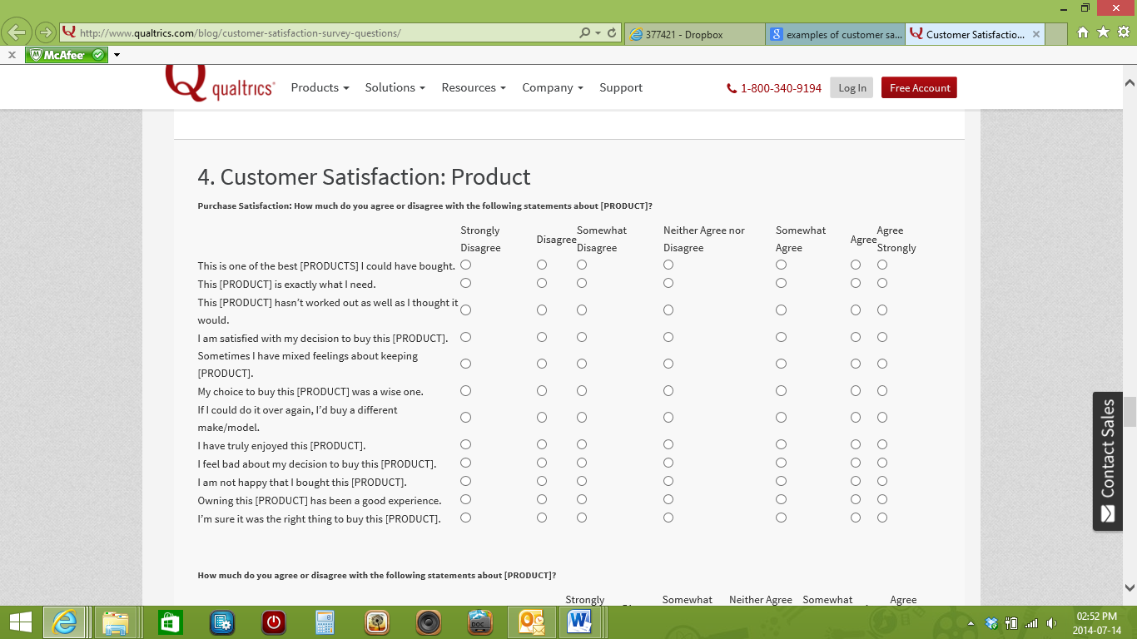

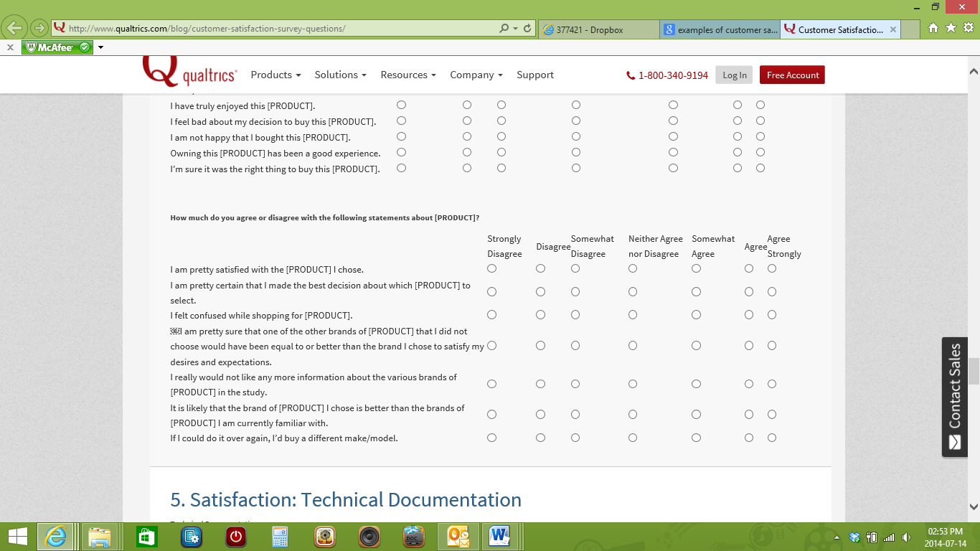

#### Satisfaction and Customer Retention: General

Dear Customer:

Thank you for giving us the opportunity to better serve you. Please help us by taking a few minutes to tell us about the service that you have received so far. We appreciate your business and want to make sure we meet your expectations. Attached, you will find a coupon good for …… We hope that you will accept this as a token of our good will.

Sincerely, [MANAGER\_NAME] Manager

**How often do you typically use the product?**

**Once a year  
Daily  
Weekly  
Once a month  
Every 2-3 months  
2-3 times a year less often  
Do not use**

**How did your [PRODUCT] perform?**

|  |  |  |  |  |
| --- | --- | --- | --- | --- |
|  | Miserably | Somewhat Satisfactory | Very Satisfactory | Delightfully |
| Overall quality |  |  |  |  |
| Value |  |  |  |  |
| Purchase experience |  |  |  |  |
| Installation or first use experience |  |  |  |  |
| Usage experience |  |  |  |  |
| After purchase service (warranty, repair, customer service etc) |  |  |  |  |

**How important was performance on these attributes?**

|  |  |  |  |  |
| --- | --- | --- | --- | --- |
|  | Not Important | Somewhat Important | Important | Very Important |
| Overall quality |  |  |  |  |
| Value |  |  |  |  |
| Purchase experience |  |  |  |  |
| Installation or first use experience |  |  |  |  |
| Usage experience |  |  |  |  |
| After purchase service (warranty, repair, customer service etc) |  |  |  |  |

**Overall, how satisfied were you with your new [PRODUCT]?**

**Not at all satisfied  
Somewhat Satisfied  
Satisfied  
Very Satisfied  
Delighted**

**Have you ever contacted customer service?**

**Yes  
No**

**If you contacted [COMPANY] customer service, have all problems been resolved to your complete satisfaction?**

**Yes, by the company or its representatives.  
Yes, by me or someone outside the company  
￼￼ No, the problem was not resolved**

**Based on your awareness of [PRODUCT/SERVICE],is it better, the same, or worse than other brands of [ENTER CATEGORY}?**

**Much Better  
Better  
About the same  
Worse  
Much Worse**

**Please share with us a few things Product/Service] could do better.**

**Based on your experience with [PRODUCT], how likely are you to buy [PRODUCT] again?**

**Definitely will  
Probably will  
Might or might not  
Probably will not  
Definitely will not**

**Based on your experience with [PRODUCT], would you recommend this product to a friend?**

**Definitely will  
Probably will  
Might or might not  
Probably will not  
Definitely will not**

**If you would like to share any additional comments or experiences about [PRODUCT], please enter them below.**

Once you have all the survey forms or questionnaires, collate the information. Add the number of completed questionnaires, e.g. 185

Then add the total for the answers for each question:

For example:

How often do you typically use the product?

Once a year 12 clients

Daily 35 clients

Weekly 42 clients

Once a month 46 clients

Every 2-3 months 23 clients

2-3 times a year less often 20 clients

Do not use 7 clients

Convert the answers into percentages:

12 clients 6.48 % use the product once a year

35 clients 18.92 % use it daily

42 clients 22.77% use it weekly

46 clients 24.86% use it monthly

23 clients 12.43% use it every 2 – 3 months

20 clients 10.81% use it 2-3 times a year

7 clients 3.73% do not use it at all

These answers will give you an indication of the following:

* How much stock to keep of the product
* If clients are using 2 – 3 times a year while they should use weekly, you need to inform your clients of the benefits of weekly use

You will analyse the entire questionnaire and gather data and information from this. Once this has been done, you have to write a report to the manager or supervisor, depending on the procedures in the company.

Use the answers to find out if you have to improve the customer service in your section or branch.

If customers are happy overall, you have to maintain the high level of service to keep them busy.

If customers are unhappy, you will now know why and you can take steps to make sure that you have happy customers.

## Report the situation to the appropriate internal authority

It is vitally important in any business to inform and report to the internal authority of the business of the current status of satisfaction and the successes achieved in informing customers of business activities.

The internal authority of a business is the management and stakeholders who need to be up to date with this information in order to compile their business marketing plan and all other strategic plans for the future. If there was any sort of dissatisfaction regarding customer service, it should be number one on the internal authority’s list to fix. Poor customer service can ruin a business and lead to the business closing its doors.

We have discussed the actions of attracting, retaining and maintaining customers. The same actions can be applied to customer service and business activities. The internal authorities should attract the required information, and then retain the good that came out of it, and maintain the good standards and good results.

When any type of dissatisfactory feedback reaches the internal authorities, it should be dealt with immediately and if, for example, poor customer service was the fault of the employees, they should be either trained or disciplined. Poor customer service should NEVER be allowed in a business.

## Inform customers of the business activities SO2 AC3

Just like customer feedback is vital to a business, so are advertisements. Customers need to be informed of business activities on a regular basis in order to promote the products/services of the business.

This is why you will find the advertisements of various retail organisations in newspapers and magazines at month ends – they are informing customers about special prices, new products, as well as the store closest to the client.

When a new branch is opened, it is also good business practice to inform your clients as this branch may be closer to them.

Sales, promotions and new products must also be advertised so that your clients are aware of them

Thanks to the vast amount of different technology today it is possible to reach any audience which a business wishes to target.

Different ways to advertise include:

* on the television,
* the radio,
* short message systems (SMS),
* electronic mail (email),
* mail,
* the internet.

The type of advertisement medium used will depend on the target audience to be reached. If the business caters for the “masses” the type of advertising medium will be something like television which reaches the “masses”. If the business targets a more secluded group of customers, the advertising medium will be more in the line of personalised emails or SMS’s.

# MAINTAIN CONTACT WITH A RANGE OF CUSTOMERS

#### Specific Outcome 3

Maintain contact with a range of customers.

#### Assessment criteria

1. Communication processes with customers are established according to organisational requirements.

2. Customers are contacted at predetermined intervals.

3. A reason to contact the customer is established according to organisational requirements.

4. Partnerships are built with a range of customers.

## Establish communication processes with customers SO3 AC1

An effective customer communication process contributes to the success of any business’s quality management system and ultimately to the success of the business itself. However, many problems that a business experiences with its customers can often be traced back to poor communication.

Businesses should determine and implement the following regarding customer communication:

* Product information
* Enquiries, contracts or order handling, including amendments
* Customer feedback including customer complaints

Customer communication falls in three general categories:

* An organisation’s general communication to existing or potential customers – such as advertisements or marketing information
* Specific information relating to a customer enquiry, requirement or order
* Communication in response on customer feedback and complaints

In terms of specific customer communication, the business should also observe enquiries, contracts or order handling, including amendments. The list is vast and may include examining quotations, order forms, confirmation of orders, amendments to orders, delivery documentation, invoices, credit notes, emails, general correspondence and visit reports and notes to and from customers. The business should also assess customer feedback and the business’s complaints management process. This refers to letters in response to complaints and acknowledgments.

### Different Customers

It is important to realize that each customer will make their buying decision in a unique way. Not everyone needs to see the same information.

Some make decisions spontaneously while others will do a lot of research. Most marketing materials and websites are designed to attract or sell to only one style of customer, and this is usually the same style as the person who created it.

If your website only speaks to one type of customer, then that is the only type of customer that it will work for. The real benefit of a website as a marketing tool is the ability to speak to all types of different customers at the same time.

The visitor to a website has the choice to read, view, and click on the sections that interest them most. This allows you to create multiple paths to a sale to cover all of your bases. Each customer should be able to get all of the information that they need to make a buying decision so they can actually make that decision.

So how do you achieve this? Well first you have to understand what motivates people to buy. Decisions can be broken down to logical and emotional or a combination of the two. Some customers make decisions based on numbers, some customers make decisions based on features, and some based on image or other people using the product, while some will just pick arbitrarily based on name, colour, or packaging. The key is to try and understand why customers choose to buy your product or service and get each of those messages across to them.

If you are only selling to one type of customer on your website, then you are leaving sales on the table. By simply changing the information that you provide to appeal to more types of customers, you will find an increase in your sales.

When the customers cannot easily see the difference in the product or when the product itself provides no competitive advantage it is the absolute right thing to do find unique benefits that a business can differentiate itself and stand above the competition.

It is not enough that the benefits are unique – there are other prerequisites for uniqueness to become competitive advantage:

1. Customers must see the difference the way the marketer sees it

2. Customers must value the difference – there is an urgent need in the minds of customers

3. Customers must be willing to pay for the value they perceive they receive from the difference

4. Marketer must be able to produce and deliver (on scale) the difference at the price the customer is willing to pay and at cost that is profitable

5. Marketer can continue to maintain this difference and improve on it

### How to Approach Different Customers

Every customer is different, which is why every approach towards customer communication should be different, as well. While this is easier said than done, it helps to first understand what, if anything, a customer is looking for.

By understanding this, you can position yourself to better support your customer with their shopping needs.

#### First Impressions

Some customers will want their own space to shop whether they have a purchase in mind or are just browsing.

Others love the simple chitchat that boutique shopping often allows itself and likewise, they enjoy the suggestions and ideas of products throughout your store.

To help you get an idea of what a customer prefers, start with a simple welcome within the first minute or two of when they enter your store.

By acknowledging their arrival, you are opening yourself up to the customer and the customer is now aware of your presence.

Based on the customer's response, you should do one of two things—continue the conversation or step back for a bit.

The first option is to immediately take the initial opportunity of conversation and ask them if they are looking for something special or something in particular.

Not only does this quickly tell you the purpose of your customer's store visit, but it also allows you to prepare your plan of sales support. The other option you have is to let your customer begin to shop without any additional conversation details from your end.

Typically, this is best suited for customers who barely acknowledge your hello, lack any eye contact with you, or are quick to answer just looking.

Once you have determined a first impression of your customer's shopping intentions, you can then decide how to best support them throughout the rest of their store visit.

#### Customers Shopping With a Purpose

When a customer is shopping with a specific purchase in mind, it is important to respect their purchase desire. If you are able to show them what they are looking for, and they react with relief and excitement of having found what they want, then your job is easier than usual.

More often than not, however, store owners don't always have exactly what customers want. As a response, stores tend to try and sell what they have versus accepting what they don't have—which in many cases can be a better sales approach.

By recognizing that you may not have what they want, you can quickly and honestly guide them to some new ideas without them thinking you are trying to sell them something they don't need.

And trust me, many customers will let this thought cross their mind. For example, if they are looking for a light blue baby blanket with silky edges, you may not have this. On the other hand, you may have a fabulous blanket just like this but in beige or possibly a blanket very similar without the silky edges they were hoping for.

By introducing them to alternatives, you are opening up the idea of them purchasing something other than what they had planned.

If you cannot support them at all with some likely alternatives, you may need to accept that you might not make a sale. But that doesn't mean you can't make a returning customer.

If there is no hope that you can support them with what they need, offer suggestions as to where they can get what it is they are looking for. This support will be remembered by the customer and will likely result in a repeat guest to your store .

#### Supporting Customers with No Shopping Direction

Let's face it—ladies love to shop; moms love to just look around and everyone makes purchases they don't plan for. These are great details to have on your side. Often the easiest sale isn't one of someone who knows what they want but rather that of someone who wants something but doesn't know it.

If you are like most consumers out there, then you know that buying something just because or when you didn't expect to can be a lot of fun.

You can support this kind of customer by being open, friendly, and flexible with their shopping direction.

Once you have found out they aren't shopping for anything specific, you can engage them in some open ended questions that may lead to ideas for now purchases. For example, you can ask them if they have any upcoming birthday parties they need to get gift ideas for.

Or ask if they have children and what their children's interests are. Listen to what they tell you and respond with some purchase ideas of products in your store.

By listening to them, you will be better able to support them with what they may want without knowing they want it. While conversation is among the best ways to make a sale, you can also support customers with silent selling tools.

This includes incentives for customers to make a purchase by using signage and merchandising, promoting sales, special offers and other promotional details.

By utilising your voice in many ways, not just verbally, you will allow yourself to better support all the customers that walk through your doors, not just the ones that know what they want.

### Different Selling to Different Customers

It’s a bit prosaic to say that today’s marketplace is global in nature and more competitive than ever.

However, while these observations may be old hat, they are, nevertheless, facts. More competition means more comparisons being made among vendors.

Customers know they have more choices. To make sure they make the right choices, customers have become more knowledgeable about the products they buy.

Many organizations have put more checks and balances into the buying decision. As a result, the selling cycle has been lengthened and made more complex.

The need for the organization and the sales force to differentiate themselves from their competition has become paramount.

In addition, more competitors often mean not much difference between one product or service and another. Given these factors, how is it possible to influence the customer’s buying decision when so few distinct advantages exist?

Our own experience and common sense tells us that the decision to buy from one organization rather than from another often comes down to the difference between the relationship between the buyer or buyers and the organization's salesperson.

#### What attributes do we usually associate with a successful salesperson?

All the traditional attributes still apply — professional appearance; product and service knowledge; deep understanding of the customer’s organization, its marketplace, and competition.

Most everyone would agree that all these are essential for any salesperson. In the current market, however, salespeople need more than these essentials — they need a competitive edge.

Among the questions that one needs to ask and answer are . . . how to personally stand out from the crowd . . . how to make yourself the competitive plus.

We believe and our common sense tells us that the salesperson must develop a unique relationship with each unique customer. One thesis is that a salesperson develops strong and binding relations by recognizing that he/she must be good at “selling different customers differently.”

How does one do that? It must start with a salesperson having a clear picture of each different and unique customer. What does that mean?

Let’s take a closer look at the customer. Customers today not only want salespeople with all the aforementioned attributes, but also they want salespeople to understand them — both their business needs and their personal needs. What is meant by “personal needs”? It boils down to the way each individual wants to be treated, not only how a product or service will benefit him/her.

Armed and acting in accordance with this understanding, the salesperson can actually offset the lack of clear product differentiators or some of the perceived negatives of a product or service.

When the salesperson develops a trusting relationship, the customer, instead of seeing the salesperson as an outsider, regards him/her as an advisor. Customers are more inclined to buy from a salesperson who is attentive and who meets their personal as well as their business needs.

We see it every day in our personal lives. Quite often, we’ll forsake convenience and efficiency by going an extra mile or paying a few Rands more to buy a product or service from a company who treats us better.

One way to stand out from the crowd in sales, then, is to focus on the customer. That means developing the skills to:

* Recognize the differences between individual customers
* Adapt sales behaviour to the needs of each customer
* Build trust and get commitment by fulfilling each customer’s unique needs.

This goes beyond traditional needs-based selling, which is much too simplistic for the intense competition facing today’s sales professional.

Think about the competition again. Think of the number of vendors who may offer products or services so similar that there is virtually no difference.

When almost anything in the marketplace could potentially satisfy a customer’s business needs, competitive knowledge won’t help, nor will product knowledge. This is the time when the only skill that can provide an advantage is the ability to recognize and satisfy personal needs. Uncovering personal needs demands full concentration on the customer — total customer focus.

This requires skills that are not included in traditional sales training. Traditionally, salespeople are taught to handle a “typical” customer with a single, rigid approach. It doesn’t take a salesperson long to discover that the only “typical” customer is the one in the training session.

Customers are different. It makes sense that they have different needs. The key to uncovering those needs is through observing each customer's behaviour.

For example, a customer who views the sales call as a contest, who wants to argue and control the call, is obviously different from a customer who is guarded, indifferent, and hard-to-read. The sales approach that works with the first customer will fail miserably with the second and vice versa.

Psychologists have noted for years that people express their personal needs through their behaviour. How can you learn to do this?

Let’s look again at the two customers we described.

The first customer is combative — a person showing this behaviour has underlying needs to be in the forefront, to be respected and satisfy ego needs. One way to meet the personal needs of such a customer may be to demonstrate how your product or service is exclusive, used by leaders or one that boosts status.

The second customer is almost the opposite— this person has underlying needs for keeping things as they are and minimizing risk. Here, stressing a product’s safety, reliability, or long-term warranty will help meet this customer’s unique personal needs. The same real product or service benefits remain unchanged for both customers. However, highlighting different benefits makes the difference.

The ability to detect the differences among different customers and using their observed behaviour to recognize underlying personal needs helps tailor a sales discussion. This ensures that both product and personal needs are specifically addressed.

But knowing how to size up a customer’s behaviour is not enough:

The salesperson also needs to understand how his/her own behaviour determines the willingness of a customer to listen, consider, and make a move towards a buying commitment.

This requires a second skill in customer-focused selling: adapting your own sales behaviour to effectively respond to different types of customer behaviour.

Let’s consider the first customer again, the combative person who views the sales call as a contest. If a salesperson matches this customer’s behaviour with an equivalent combative approach, the exchange becomes a contest; he/she may win some arguments or demonstrate superior knowledge of the product and the market, but, in the end, will probably lose the sale.

However, by behaving in an insightful manner — allowing the customer to talk, to vent, to demonstrate his/her own knowledge, presenting facts when the customer is willing to listen, and giving the customer opportunities to consider alternatives without losing face — that same salesperson can satisfy the customer’s personal need for being outspoken.

Odds are, by encouraging this type of discussion, the chance of making a sale will be greatly improved. A passive and aloof customer, by comparison, may view the sales call as a threat. To get this customer involved in the call will require extra patience and support.

By slowing the pace and by using nonthreatening, open questions, the salesperson can promote discussion and cooperation regarding business needs, helping the passive customer to recognize the meeting as an opportunity instead of a threat.

Continue to be patient; present benefits deliberately, a little at a time, and ask questions to get the customer’s feedback. Make sure not to overwhelm the customer with information.

The point is that awareness of a customer’s behaviour and underlying personal needs enables you to adapt your selling approach, your presentation of facts, into the context of what’s important to that customer.

In a very real sense, you can become a customer advocate, acting in the best interest of each person you are selling. Selling different customers differently has been our theme. We believe that this approach will reduce customer scepticism, doubt, uncertainty, and indecision. It inspires trust; and trust is vital to persuading and ultimately selling the customer.

Building trust leads to believability, which in turn, leads to customer commitment. This is customer-focused selling. A word of caution; “Commitment” doesn’t necessarily mean that you’re closing the sale and writing business in each discussion.

With longer selling cycles, a close may simply mean getting commitment for a follow-up call. But, by building trust and commitment, the salesperson lays the foundation for a long and profitable relationship with each customer.

All of these adaptive skills — accurately satisfying both business and personal needs by adapting your own presentation to that unique customer, building trust and commitment by fulfilling each customer’s unique needs — are tools to help differentiate you, your product, and your organization from your competition.

In the end, the salesperson who has total focus on the customer — who sells each unique customer differently — will have the competitive edge now and in the future.

### Establish communication processes following organisational procedures

Refer to section 1 where cost effective contact methods was discussed for the various ways in which customers can be contacted.

Your organisation will have a specific procedure to follow regarding how and when to contact customers, for example:

* e-mail promotions and new products
* Contact customers when it is their birthday to congratulate them
* contact the customer by telephone after a sale to find out if the customer is happy with the product or service

## Contact customers at predetermined intervals SO3 AC2

It is very important not to contact customers every day, it frustrates them. Leave a time period of a couple of days or weeks between contacts, for example: when a customer has purchased a product, wait a day or two before phoning to find out if the customer is happy with the service.

If the customer has purchased from you this week, don’t phone again next week with a new special offer. Wait for the next month or whatever time period is prescribed by your organisation.

Time to contact customers: The accepted rule amongst businesses is to contact customers after 8:00 in the morning and never after 18:00 in the evenings. Customers should also never be contacted on Sundays and public holidays. These hours are the laid down hours especially for telephonic contacts and SMS’s to customers.

When a business makes use of email to contact customers, there is not really any specific time to send the email due to the fact that the customer can choose when to read the email. The same applies to all other forms of contact and communication.

A customer should also not receive a telephone call, email, SMS, etc. every single day. This will annoy the customer and he/she will not accept any further communication from the business. A good idea is once a week or sooner if there are new products/services to offer and introduce to customers in the business.

There are times when it is necessary to contact customers on a basis which will be determined by the seriousness and urgency of it, for example, if it is a customer query or complaint, it should be dealt with immediately, but also between the laid down hours as specified.

## Establish a reason to contact the customer SO3 AC3

When customers are contacted, there should be a valid reason to contact the customer. Contact methods are expensive and for this reason a reason to contact a customer should be established.

There are positive and negative reasons to contact a customer. Let’s discuss the difference between the two.

Positive reasons to contact the customer:

* To inform the customer of new products/services in the business
* To thank the customer for their co-operation and purchases
* To thank the customer for a compliment
* To assure the customer of the ongoing partnership between the customer and the business
* To enquire from the customer if he/she is satisfied with the service

Negative reasons to contact the customer:

* To enquire when payment can be expected when it is overdue
* To follow up on a complaint
* To sort out an enquiry if it was of a negative nature

## Build partnerships with customers SO3 AC4

Customer partnership is a shared journey to create a future for both parties that is better than either could have developed alone.

The customer influences every aspect of a business and is the foundation of a business’s success. In [today's turbulent times](http://www.1000ventures.com/info/new_economy_brief.html) of rapid and chaotic change, no force is more grounding and stabilising than a partnership with customers. The term 'customer partnership' is not being taken so much in its legal definition of co-ownership but rather in its sense of sharing in benefits, profits and losses of a company.

Customer partnership is more than "putting customers first", or finding mutually satisfactory solutions to shared problems, or a dedication to excellence in every sale or service encounter. It also requires commitment to forging long-term relationships that create synergies of knowledge, security, and adaptability for both parties.

This is done by following up after a sale to determine customer satisfaction, remembering the customer’s birthday and other important days, advising customers of special offers and promotions that may interest them.

### Why customer partnership

Fierce competition today forces companies to become much more creative and flexible in their dealings with customers to give them exactly what they want – [faster](http://www.1000ventures.com/business_guide/crosscuttings/change_speedmoving.html). Creating a partnership with customers will help a business maintain the focus it needs to make good decisions and harness the power and commitment it needs to weather volatile times. Partnering with customers represents a business’s capacity to [anticipate](http://www.1000ventures.com/business_guide/crosscuttings/change_anticipating.html) what customers need even before they know they need it.

### Creating Customer Rapport

Have you ever had a sale that didn’t close and you weren’t sure why? Chances are you lost the sale because you didn’t establish sufficient trust and rapport with your prospect.

Once you have developed trust and rapport you’ve actually got the hard part behind you and you’re probably going to make a sale!

For you see, it really doesn’t matter how knowledgeable you are about your product or how skilled you might be at closing, unless you have earned your prospects confidence, you are not going to make the sale - period.

The bottom line here is that people want to do business with salespeople that they relate to and that they feel understand their needs.

Obviously, the challenge and importance of developing trust and rapport will escalate in direct relationship to the price of your product or service.

1. Be mindful of your body language gestures and remember to keep them positive! Unfold your arms, uncross your legs, show your palms and remember to smile. Develop awareness and sensitivity to your prospect’s body language.

An effective listener notices all aspects of communication and is aware of voice tone, facial expression, repetitive movements, and muscle tension.

Watch for inconsistencies between your prospect’s spoken word and their nonverbal communication. Rely on the nonverbal as a much more accurate indicator of intent.

By understanding your prospect’s body language you will minimize perceived sales pressure and know when it is appropriate to close the sale.

2. Create harmony! “Matching and Mirroring” your prospect’s body language gestures will psychologically cause them to identify with you.

The power behind this principle is firmly grounded in the precept that people trust people that they believe are similar to them.

Matching and mirroring is an unconscious mimicry by which one person tells another that he is in agreement with their ideas and attitudes.

Likewise, studies have shown that when people disagree they subconsciously mismatch their body language gestures.

You want to be careful not to be too obvious when you are consciously matching someone because it will be perceived as manipulative if you don’t do it naturally.

An effective way to begin matching is to subtly nod your head in agreement when your prospect nods their head.

3. Remember to make eye contact and listen with genuine interest. You are certain to create an unfavourable impression if you give your prospect the idea that you are not fully present in the conversation.

Unfortunately, we are often busy game-planning our response instead of truly listening to what is being said. Ii is suggested that you occasionally repeat verbatim what your prospect says ­ especially their key words or phrases.

Restating in your own words serves to clarify communication, but you deepen rapport when you use their words.

4. During your needs analysis interview, I recommend that you ask open-ended, clarifying questions with who, where, what, when and how.

Open-ended questions will require your prospect to give in-depth responses. Become an active listener.

While it is important to educate your prospect about your product or service, as a general rule you should listen more than you talk. Keep your attention focused on your prospect and avoid the temptation to interrupt and dominate the conversation.

The quickest way to destroy trust and rapport is to interrupt another person while they are speaking. If you do interrupt, minimize the damage by apologizing and ask them to please continue.

5. Dress and act professionally. While it may seem unfair, we are judged on our appearance. Research indicates that people form a lasting impression of us within the first five minutes.

Be personable but not overly familiar. If appropriate, occasionally call your prospect by their first name. The sweetest sound to the human ear is the sound of our own name.

# ADMINISTER CONTACT WITH A RANGE OF CUSTOMERS

#### Specific Outcome 4

Administer contact with a range of customers.

#### Assessment criteria

1. Contact reports are completed as per company requirements.

2. Customers are graded according to specific methods of grading customers as per organisational requirements.

3. Analysis and/or report are presented to correct individuals.

4. Trends and/or problems are identified in report.

## Complete contact reports SO4 AC1

When contacting customers it is important to have the administrative side of it in order. If a customer was contacted, a contact report needs to be completed in order to identify which customers have been contacted and who not. This will eliminate unnecessary expenses regarding customer communication. This will also eliminate customer annoyance if the customer is being contacted over and over again by different or the same people about the same thing.

Here is an example of a contact report:

|  |  |  |  |  |  |
| --- | --- | --- | --- | --- | --- |
| **CUSTOMER GRADE** | **CUSTOMER PERSONAL DETAILS** | **CUSTOMER CONTACT DETAILS** | **DATE CUSTOMER WAS CONTACTED** | **REASON FOR CONTACT** | **CONTACT MADE BY?** |
| B | Miss C. Jones | 072 000 0000 | 11.11.2012 | Follow up on query | James Ntuli |
| A | Mr. P. Nel | 083 000 0000 | 12.11.2012 | Introduced new products | Anne Ferreira |
| C | Mrs. T. Einstein | 012-1111111 | 12.11.2012 | Follow up on complaint | James Ntuli |
| A | Miss K. Louw | 084 000 0000 | 14.11.2012 | Informed customer of free gift on the way | Pat Simon |
| B | Mr. S. Shnell | 076 000 0000 | 14.11.2012 | Confirmed deliverance of purchase | Albert Mashinini |

It is important for every employee to first go through the contact list in order to confirm that the customer has not been contacted by another employee regarding the same issue. A business should have one contact list which should be completed by each employee after they’ve made the contact with the customer.

### Recording information from customers

In a call centre as well as other sales departments, you will usually enter the information from the customer directly into the computer, using computer software packages designed for this specific purpose. In this way, you will assist your company in building a database of your customers.

A database is simply a collection of data that is organised in such a way that an agent can access and manipulate it.

Database information can be used to store and manipulate data, generate reports, produce screen displays or develop responses to customer requests. By cleverly searching and using the data contained in databases, organisations can gain information about customer purchase histories and the level of sales of particular products to create opportunities for telesales canvassing.

Every time a customer calls information is logged onto the customer’s record. Over time, this transactional information is added to static customer data (name, address, credit limit) and combines to build a ‘picture’ of that customer’s buying habits, purchase frequency and individual preferences.

The agent can then make suggestions tailored to that customer’s profile. In this way, the database can improve customer service and build relationships at the same time: it is sometimes referred to as ‘one-to-one’ marketing.

It is important that all data is entered accurately in the required format and onto the relevant package. This data must be verified by confirming the entered data with the customer to ensure you have fully understood the customer’s requirements. Accuracy and regency of data are obviously of importance to the next contact centre agent who deals with the same customer.

A telephone book is a database – it has an alphabetical list of people with telephones, their physical addresses and their telephone numbers.

The advantage of a computerised database is that you can now look up who lives at a specific address or you can find out who a telephone number belongs to. This is not possible with a telephone book.

This database will also eventually give indications of:

* which products/services sell the most
* which type of customer buys this product
* which product/services gives the most problems, e.g. mechanical breakages
* what times clients call, etc.

**Example** of a customer database screen of a software application:

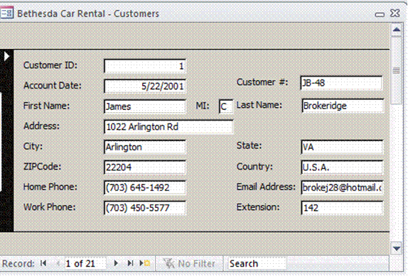

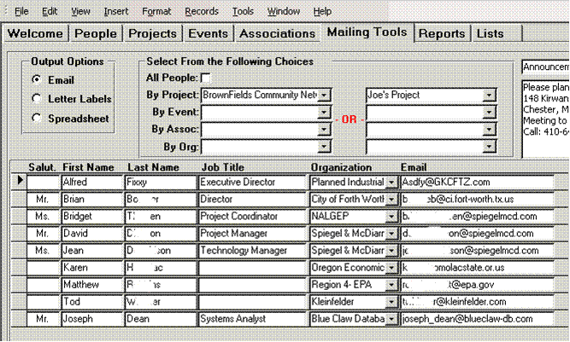This example shows a list of clients and their e-mail addresses.

### Identify and input correct information

You have to be able to input the information from the client correctly and accurately – in other words, the information must be entered into the correct filed of the computer software programme. If you enter the fax number where the telephone number should be, it will be difficult to contact the client telephonically in the future. It is also important to spell names correctly and to enter PO Box numbers, street numbers, etc., accurately. If you, for example, enter the postal code incorrectly, any mail will go to the incorrect town or suburb and will never be delivered.

Information has to be captured consistently according to the formats and requirements laid down by your company. Use the correct form and enter the data immediately to ensure that the records are always up to date.

All this is done while you have the client on the line, so you really have to pay attention.

In order to be valuable to the organisation, information has to be accurate, timely, complete and relevant.

* **Accurate**. For information to be of real value to a manager, it must be accurate. Accuracy means that the information must provide a valid and reliable reflection of reality.
* **Timely**. Information needs to be within company specific timeframes. Managers need information on time – if they want this week’s sales figures, giving them the figures for 3 months back is of no value to them. An address of a client that is 5 years old also has no value, he could have moved around many times during this time.
* **Complete**. Information must tell a complete story to be useful to a manager. For example, if the sales manager needs sales figures for 3 products for the past 3 months, giving him sales figures for 2 products for the past 2 months is not good enough – the information is not complete
* **Relevant**. Information must be relevant if it is to be of use to a manager. If a manager wants sales figures for toothpaste and you give him a report of the sales of coffee, it has no value to him.

The specific format described for use by your company must be used to record this data. This will allow your company to easily analyse the information if and when required.

Typical information required by many such systems are:

* Customer specific information such as personal or business details.
* Product specific information relating to the customer’s needs such as an order.
* Queries or problems experienced by the customer.
* Operational information gathered during the call specific to the contact centre’s requirements.

### Repeat information

#### Check Understanding

Extract the main idea from client’s verbal communication

Description: pe01683_It is essential to have a clear understanding of what the client’s needs are so that you can address those specific needs and not waste time on irrelevant issues as this can further aggravate your client. Do the following:

* Repeat the main issues to show the client that you are taking notice of what is said and that you are committed to finding a solution to his problems.
* Focus on these issues and make notes to help you remember them.

Use summarising techniques and ask for clarification on areas of uncertainty.

* When you summarise what the client said in your own words it will show the client that you are paying attention. It will also help clarify any misinterpretation of what the client said and assist you to concentrate by actively involving yourself in the process.

*Example: As I understand, you are requesting details regarding your last payment, as well as information on service charges for the coming year. Is that correct?*

In the same way you have to check that the details you have for the customer are still correct and, once information has been updated, you HAVE to repeat the new information to the client to confirm that you now have all the correct details.

When you repeat information, you are checking that you understand what the client needs and at the same time the client can confirm that you have the facts right.

#### Steps to ensure proper recordings

Take these steps to ensure that all details will be captured if your telephone calls are recorded.

1. Greet the customer and identify the company and yourself
2. Explain to the customer that the conversation will be recorded for quality purposes
3. Enquire from the customer what you can assist him/her with, and make notes
4. Repeat to the customer what he/she requested, and tick your notes for your own understanding (it’s a good idea to have a highlighter pen handy in order to highlight the main points of a customer’s request, query or complaint)
5. Ask the customer if it is correct what he/she wants you to do (test understanding)
6. Assist the customer immediately, if possible
7. If it is not possible to assist the customer immediately, explain to the customer that you will get back to him/her, with relevant answers and/or solutions.

### Relevant and Consistent Information

Data can be entered into a database as follows:

* Typed in using the keyboard, directly during a conversation, during wrap-up time or from an e-mail, letter of fax send to the contact centre.
* Options that you can select, with the click of a mouse.
* Faxes from customers, which you can scan into the system, using a digital scanner or optical reader, or receive on-line.
* Customers choose that you scan in and automatically match against payments that are due, producing any mismatches quickly and speeding up the ‘collect money, reconcile and bank’ process.

The best way to learn any computer application is to use it. Basic numeracy, English language proficiency and computer operating skills are requirements for working in a contact centre.

You should also seriously consider taking a touch-typing course. Or, you could obtain a self-tutoring software package from a software vendor or download one from the internet.

Being able to type fast and accurately is essential when you have to enter data in a database while listening to a caller.

Contact centres sometimes have an interface application to gain access to the necessary application on the mainframe. This is known as a GUI (graphical user interface), which acts as a doorway to applications on the mainframe. It is usually made up of icons that represent different applications, tasks or links.

The agent enters relevant key words and the GUI interface links to the relevant application. The agent will often provide the customer within a reference number so that the customer can refer to this specific call by quoting the number to the agent on duty in the future.

### What to capture?

The data that you need to capture / input will include:

* requests
* queries
* questions
* sales
* personal information
* emergency information
* medical information
* account details
* customer requirements

***Personal Information***

| **Item** | **Remember** |
| --- | --- |
| Name, surname, title | Use the correct spelling. |
| Date of birth | Gives an indication of birthdays to send personalised messages. |
| Age | Indicate what they will buy. |
| Address and contact number | May provide clues about lifestyle and buying motives.  Ensure that deliveries are made correctly. |
| Education | Provide point of contact. |
| Family and marital status | Customer needs and motives can be identified. |
| Social contacts/next of kin | Provide good point of contact and information about the prospective customer. |
| Reputation | Are you dealing with a well-known person and can give an indication about buying motives. |
| Membership of organisations and societies | Can use memberships in presentations. |
| Authority to buy | Make sure the prospect has the authority to buy and does not need someone’s approval or consent. |
| Profession and position | Get to know the job, position and salary that the person earns – you will be able to determine what the person can afford. |
| Needs and ability | Identify the needs of the customer and his/her ability to purchase. |
| Convenience | Determine what time you can contact the prospective customer. |
| Interest, hobbies and recreation | Can provide clues on the kind of products/services that the customer may be interested in. |

***Company Information***

| **Item** | **Remember** |
| --- | --- |
| Company name, address and type of business | Correct spelling and correct information should be captured. |
| Information and history about company | Gives an indication of their needs. |
| Business functioning | Gives an indication of what the company consumes and uses and whether production changes throughout the year. |
| Future plans | Are they planning any expansions, new product lines and/or diversifications? |
| Competitors | From whom and when they buy? Are they happy with their current suppliers? |
| Purchasing procedures | How much and when do they purchase? |
| Stakeholders/owners | Determine the size of the business and whether they are credit worthy. Knows who make the buying decisions. |

## Methods to grade customers SO4 AC2

Customers who purchase products with high turnover rates are ones that help to reduce your financing costs. There’s also your company’s cost of money and its impact on your receivables. The longer it takes a customer to pay their invoice, the higher you receivable financing costs. Also, the types of products your customer buys also dictates their value to your business.

Your company has some product lines that create more gross profit than others. As such, you should be tracking the types of products your customers purchase. Now, some companies include other factors, but these are often viewed as the most important. These factors are summarized below, along with the first portion of the sample sheet.

1. How Much Does the Customer Spend?

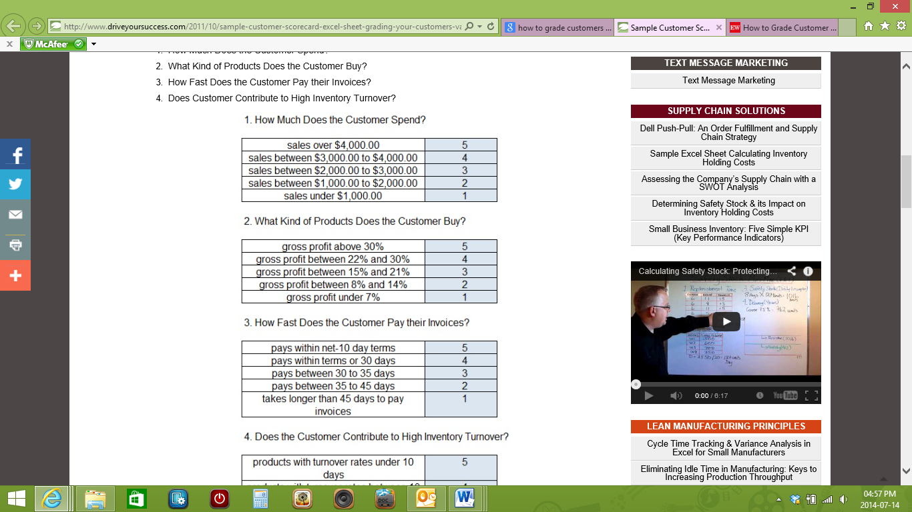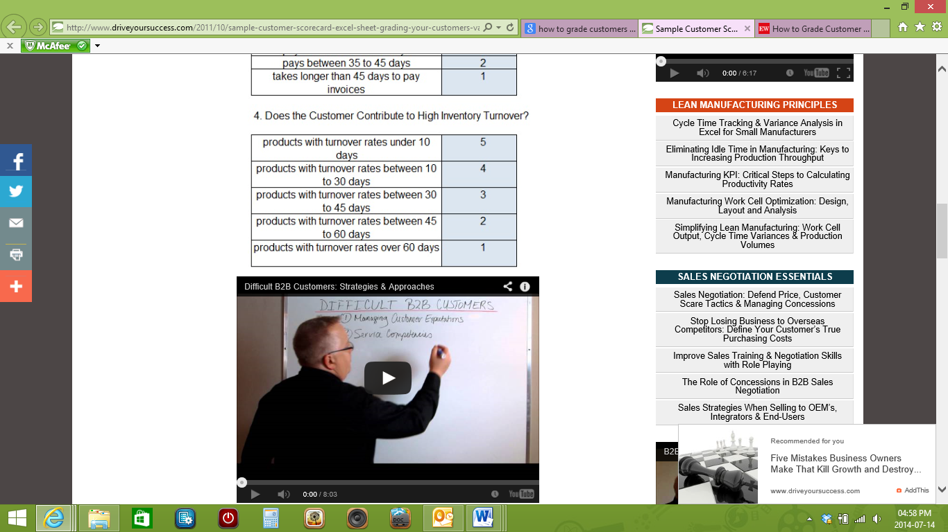

1. What Kind of Products Does the Customer Buy?
2. How Fast Does the Customer Pay their Invoices?
3. Does Customer Contribute to High Inventory Turnover?

### Why Should You Grade Your Customer’s Value?

Transparency is essential between your internal departments.

Your company must be able to distinguish between a high value customer account and a customer that is less than desirable. It’s not enough that only your sales and marketing teams know which customer is important.

To be successful means your entire organization must be aware of each customer’s value. This transparency improves efficiency between departments because it empowers internal resources to respond to situations based on the customer’s value to the business.

Regardless of whether it is the customer service, accounting, inventory or the shipping department, having an internal grading system is essential to streamlining how your company manages customers.

The sample sheet takes the grades from each of the four aforementioned criteria, and takes an average score to determine a customer’s value. This value falls between the following four grades below, until a final grade is given

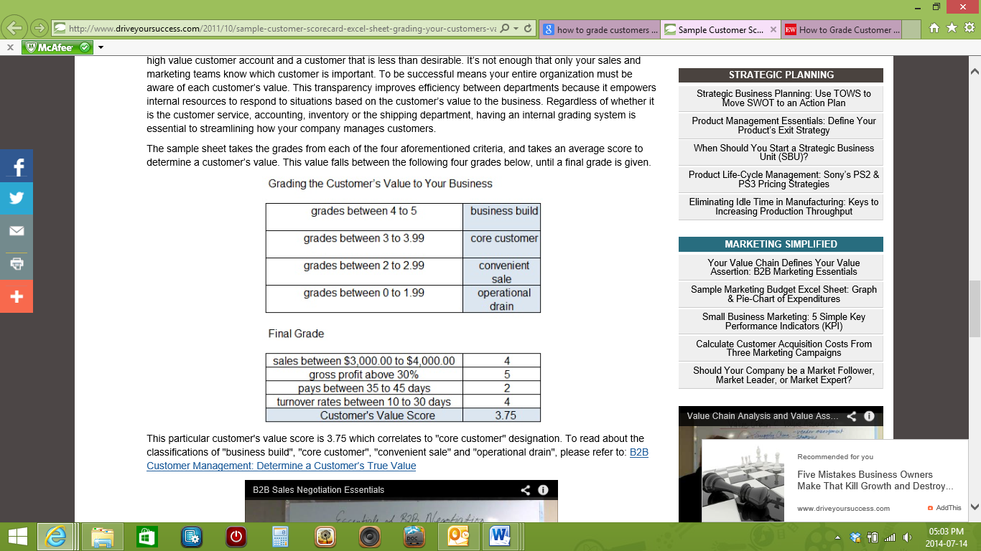

This particular customer's value score is 3.75 which correlates to "core customer" designation.

Don’t just base your customer’s value on how much they spend. Your gross profit is determined by far more than just the amount a customer spends on your business. In essence, it’s about finding those customers who help you help them.

These are the customers who pay on time, rarely leave you holding obsolete or outdated inventory, and respect your company’s inventory holding costs.

### Grade your customers

We can see that all customers are not the same. Some are more valuable than others.

* Your “A” customers contribute to the bottom line;
* “B” customers aren't particularly profitable, but they contribute to volume purchasing and help with economies of scale;
* “C” customers are ones that you might be better off without.

This method ranks customers by contribution to net profit. It's important to only look at customers who have done business with a company for at least 12 months. New customers should always be treated “special” until they prove themselves less than worthy.

Let’s discuss the C, B, and A customers of any business:

#### “C” customers

Group “C” customers are those customers who give nothing but the business needs to give everything. These customers take pride in their ability to beat a business up on price, run the business all over town and string out the business’s money. It is a harsh route to follow to either convert these customers to “B” or “A” customers, but it is necessary to at least give it a try. Some of the “C” customers will leave the business and go to the nearest competitor, but strangely, it does not matter at all due to the fact that this particular customer didn’t contribute to the success of the business at all, so they won’t contribute to the competitor’s success as well.

These are the customers who purchase for small amounts at very irregular intervals – and still demand discounts. The business should stop the discounts and give the customers the business’ price list.

Now take a look at the services the business provides. Does the business provide free deliveries to this group? Do you have minimum orders? Is the business transferring product at its own expense? If a business can answer yes to these questions it is clear that there is a definite amount of resources in the company. Don't waste them on customers who are not contributing. A good strategy is to require minimum orders for both credit purchases and delivered product. Do not order special products for “C” customers. They can buy what the business has on the shelf. Above all, do not transfer product at the expense of the business.

#### “B” customers

The middle group, let's call them “B” customers, is a different animal. They do have a negative contribution to net profit, but the business wouldn't want to lose them. They provide a business with the volume to purchase more efficiently and allow the business to enjoy certain economies of scale. Some slight adjustments to how you handle this customer group will allow many of them to rise to positive contribution.

Most of these customers have a decent gross-profit volume. The real trouble occurs in the frequency of order. A business may find itself processing several low-Rand orders in a single day. If a business could get them to consolidate orders to once a day, they would slide up the profitability scale. This type of discussion will need to come from someone senior in the business. They can speak in terms of reduction in the clerical costs of purchase-order generation and payment processing.

Another strategy is to look at how a business handles special orders and transfers for this customer group. Ask this customer to bear the cost of expedited handling. In addition, consider suggesting the customer accept a substitute rather than ordering in a special item. Make sure a business gets a high margin on special orders because the business spends company resources to bring them in. Be strict with return policies and be mindful of internal costs.

Finally, look at modest price increases. This is where a matrix-pricing guru can come in handy. Look for subtle increases to less popular items. You should be able to raise your overall margin by 1 percent to 2 percent.

#### “A” customers

Now to analyse the best customers. Let's call them “A” customers. These are the folks that make a positive contribution to net profit. A business should love them, and the business should tell them how much their business is appreciated. If a business loses one of these customers, it will often be an expensive loss. The business will throw all kinds of deals at them to woo them back. Unfortunately, the cash impact of these deals will be felt for many years to come. Don't lose them in the first place.

Get close to the “A” customers. Don't leave the relationship to the sales manager or salesperson. At least once a year, business owners should meet with the owner of each of these companies. Talk about what the business are doing for them. They need to be reminded. Incidentally, this is an excellent use of sports tickets or that golf club membership. People still do business with people they know, like and trust.

Is it easier to get new customers or sell deeper into a business’s existing customer base? The business already has them on the books; sell them more product categories. It's always a blow to the ego when a long-standing customer says, “I didn't know you carried that.” Most sales managers would love to be able to analyse each customer and figure out what the business are not selling them. The problem is that the task is just too daunting because there are too many customers to really look at.

It doesn’t make sense to sell more into companies that produce a negative contribution to net profit. Focus on selling deeper into group “A”.

## Present analysis and/or report to correct individuals SO4 AC3

When you have graded the customers, you need to report this to the correct person in the organisation, for example the marketing manager or the CEO, depending on the procedures in your organisation.

Follow the steps discussed earlier, write a report and make recommendations and suggestions.

## Identify trends and/or problems in the report SO4 AC4

**The free dictionary gives the following definition of a trend:**

1. The general direction in which something tends to move.

2. A general tendency or inclination.

3. Current style; vogue: the latest trend in fashion.

From the analysis you will also be able to identify trends, for example

* how many clients now use cell phones to watch TV or listen to the radio rather than just making telephone calls
* the type of products your competitors are offering and whether your client would like something similar
* what the expectations of your clients are
* how much your clients know about your products, etc.

In the same way you will be able to identify problems:

* What clients are complaining about
* What clients expect and where your company is failing to meet these expectations
* Which departments need improvement
* Which products are not popular
* Why these products are not popular, etc.

Make sure to note the trends and problems in the report as well



While there is a strong correlation with regards to product A and calls made, there is almost no correlation with product B. Therefore management should possibly look at a better way of marketing product B.





The table below gives information about three different custom-ers for different criteria. If “A” is best and “C” worst, how would you grade them according to each of the criteria, and what should management’s instructions be to staff as to how to treat them on the phone?

A. Mrs Lotter bought the most products, so should receive priority

B. Mrs Lotter also bought in the most product so she is category A. Mrs Khumalo is category B, while Mrs Bright is category C.

C. Time to pay account: Mrs Bright is category A, Ms Khumalo is category B and Mrs Lotter is Category C.



# REFERENCES

<http://www.driveyoursuccess.com/2011/10/sample-customer-scorecard-excel-sheet-grading-your-customers-value.html>

<http://ewweb.com/archive/how-grade-customer-profitability>