# 9016 FORMATIVE ASSESSMENTS WORKBOOK

### Formative Assessment 1

|  |
| --- |
| Estimate (guess) and then measure the lengths of the following line segments. Give your answers in cm and mm. |
|  |
|  |
|  |
|  |

1

2

3

|  |
| --- |
| A rectangular plot of land has a length of 250m and a width of 175 m. The farmer wants to fence the plot using 6 strands of wire. What length of wire will s/he need? |
|  |
|  |

### Formative Assessment 2

Every weekday, from Monday to Thursday, Thabo drives the distance of 25 km between his home and work in 30 minutes. However, Fridays it only takes him 20 minutes to cover the same distance.

|  |
| --- |
| Calculate his speed on weekdays except Fridays. |
|  |
| Calculate his speed on Fridays. |
|  |

A bicycle moves 65 meters in 15 seconds. Calculate the speed of the bicycle.

|  |
| --- |
| s = distance / time |
| = |
| = |

### Formative Assessment 3

|  |
| --- |
| Every weekday Sam drives the distance of 25 km between his home and work in 30 minutes. However, Fridays it only takes him 20 minutes to cover the same distance. |
| What information do you need to calculate the velocity of Sam’s car on these different days? |
|  |
| One day Sam drives at a speed of 20 m/s on a straight road. Suddenly a dog appears in front of him and he hits the breaks for 4s. The car decrease speed (uniformly) to a speed of 8 m/s. What was the acceleration? |
|  |
|  |
| Sam drove from his house to College. When he stopped at College he saw on the instrument panel of his car that he covered 26.5 km. Consider the figure below and answer the following questions: |
| What is the distance covered by Sam? |
|  |
| What is the displacement? |
|  |

Sam’s house

Sam’s College

20 km

|  |
| --- |
| A bird flies 50 km everyday to collect food for his offspring and 20 km to drink water. To fly this distance takes him 1 hr 40 min |
| Calculate its average speed over the whole day. |
|  |
| Calculate its average speed during flight. |
|  |
| What would the average velocity of the bird be if it returns to its nest every night. |
|  |

### Formative Assessment 4

|  |
| --- |
| Estimate and then calculate the area of: This page |
|  |
| The top of your file |
|  |
| Which units of area will be best for measuring the area of the floor of this room? |
|  |
| the area of a soccer field? |
|  |
| the area of South Africa? |
|  |
| Calculate the area of each of the following triangles |
| 1. |
|  |
| 2. |
|  |
| 3. |
|  |

3 cm

4 cm

50 mm

50 mm

60mm

40 mm

40 mm

70 mm

No 1

No 2

No 3

|  |
| --- |
| Consider a box with dimensions: length 34 cm, width 4 cm and height 3 cm. How many 1 cm3 unit cubes are needed to cover the base of the box? How many layers of cubes are needed to fill the box? |
|  |
|  |
|  |
|  |

### Formative Assessment 5

|  |
| --- |
| Estimate (guess) which object has the greater volume: a cube with sides of 6 cm or a rectangular box of 7 cm by 6 cm by 4 cm. Now calculate the volumes accurately. |
| Cube: |
| Box: |

### Formative Assessment 6

|  |
| --- |
| In each case give the greater/greatest measurement: |
| a. 250 g; 0.2 kg |
| b. 0.01 kg; 12 000 mg; 10 g |
| Give some examples of fluids that you can buy in packages that are marked in |
| a. ml |
| b. l |
| What is the mass indicated on the spring balance shown on the next page? |
| What is the volume of the fluid in the measuring cylinder shown on the next page? |
| Choose the best estimate: |
| The mass of a pen is: 0.2 kg; 5 g; 90 mg |
| Container A is filled with cookies and container B with chips. Which will have the greater mass? Explain your answer. |

30

25

20

10

5

**kg**

15

200

100

ml

### Formative Assessment 7

|  |
| --- |
| Give some examples of fluids that you can buy in packages that are marked in |
| a. ml |
| b. l |

### Formative Assessment 8

|  |
| --- |
| How many seconds are there in 2 minutes? |
|  |
| How many minutes are there in 3 h 45 min? |
|  |
| How many seconds are there in 610,2 minutes? |
|  |
| Write the following according to the international time system: |
| a. 2.16 p.m. |
|  |
| b. 12.05 p.m. |
|  |
| c. 3.12 a.m. |
|  |
| An athlete runs 1 500 m in 3 min. 42 s. How many seconds is this less than 4 min. |
|  |
| How many seconds is this more than 3 min 38 s. |
|  |

### Formative Assessment 9

|  |
| --- |
| A bucket of water has to be heated from 20 ºC to 45 ºC. The heating element can heat at 0.05 ºC/s (heating factor). How many seconds would it take this element to heat the water to the required temperature? |
| time = change in temperature / heating factor |
| = |
| = |
| The inlet of a boiler adds 6 Litres of water per second to its contents. We will call this a flow factor (ff). The volume needs to increase from 1000 Litres to 1500 Litres. How many seconds would this take? |
| First calculate the change in volume. |
| Δv (change in volume) = vf (final volume) – vi (initial volume) |
| = |
| = |
| Next use the flow factor(ff) of 6 Litres per second to calculate the time required. |
| time = Δv / ff |
| = |
| = |
| What is the difference in temperature in degree Celsius between Ice and boiling water: |
|  |
| The maximum and minimum temperatures for a day (estimate!) in June: |

### Formative assessment 10: using the SI system

The SI system uses the metric (decimal) system and uses a number of standard prefixes for units of length and mass that were covered in the previous section. Using the SI system means that we should know the most important ones. The three most important ones are:



|  |
| --- |
| Complete each of the following: |
| 150cm = ____m |
| 360mm = ____m |
| 62ml = ____litres |
| 3.6 tonnes = ____kg |

Complete the table below:

|  |  |  |
| --- | --- | --- |
| **Quantity** | **Unit** | **Symbol** |
| Mass |  |  |
|  | Meter |  |
|  |  | s |
| Temperature |  |  |
|  |  | A |
| Light |  |  |
| Chemical standard unit |  |  |

### Formative Assessment 11

Write down the names of objects you have come across in your daily life which have the shapes of the solids shown above.

|  |
| --- |
|  |
|  |
|  |
|  |
|  |
| The rectangular sheet of material below is folded to produce the open cylinder . |
| What is the height of the cylinder? |
|  |
| Calculate the surface area of the open cylinder. |
|  |
| Calculate the radius r of the cylinder. |
|  |

C

r

300 mm

200 mm

A

B

D

:

2

2

4

5

|  |
| --- |
| Calculate the area of the figures above |
|  |
|  |
|  |

|  |
| --- |
| Two rectangular boxes have the following dimensions: |
| A:10 mm X 60 mm X 20 mm |
| B: 20 mm X 30 mm X 20 mm |
| Make a rough sketch of each and calculate the capacity of each box. |
|  |
|  |
|  |
|  |
|  |

|  |
| --- |
|  |

|  |
| --- |
| Estimate and then calculate the volume of each of the following boxes with sides of: |
| a) 4 cm, 34 cm and 3 cm |
|  |
|  |
|  |
|  |
| b) 5.25 cm, 40 mm, 7 cm |
|  |
|  |
|  |
|  |
| A manufacturer of body lotion decides to market his product in a new cylindrical container which will hold 500 ml and which is 100 mm high. |
| What will the radius of this new container be? |
|  |

|  |
| --- |
| v = 500ml = 500cm^3 = 500 000mm^3 |
| l = 100mm |
| r = ? |
| a = ? |
|  |
| area of circle = v / l |
|  |
|  |
| area of circle = pi x r^2 |
| r = √(area of circle / pi) |
|  |
|  |

|  |
| --- |
| Calculate how much material (area) will be needed to make one such container. |
|  |
|  |

|  |
| --- |
| area of material = (2 x circle area) + side area |
| circumference = 2 x pi x r |
|  |
|  |
| side area = l x circumference of circle |
|  |
|  |
|  |
|  |

|  |
| --- |
| Calculate the volume of the rectangle. |
|  |
| If the outside of the rectangle is painted red, calculate the area of red paint. |
|  |
|  |

8 cm

5 cm

20 cm

### Formative Assessment 12

|  |
| --- |
| Find the value of z. |
|  |

z

5

13

|  |
| --- |
| You are involved in the planning of a team building venue. You are going to install a slide on top of a tower A which is 40m high. Anchor C has been placed 60m from the building on the ground. How long will the cable be from A to C? |
|  |
|  |
|  |
|  |
|  |
|  |

Team

Building

Venue

A

B

Tower A

Anchor

C

|  |
| --- |
| The base of this prism on the next page is a right-angled triangle. The two sides adjacent to the right angle are 5 cm and 12 cm. The height of the prism is 20 cm. |
| 1. Calculate the length of the third side of the base. |
|  |
|  |
| 1. Calculate the volume of the prism. |
|  |
|  |
|  |
| 1. Calculate the surface area of the prism. |
|  |
|  |

20 cm

5 cm

12 cm

### Formative Assessment 13

|  |
| --- |
| Construct triangle ABC with AB = 2 cm, BC = 3cm and AC = 4cm. |
| Construct triangle DEF with sides 2 cm longer than the sides of triangle ABC. |
| Construct triangle PQR with sides twice as long as the sides of ABC. |
| Which of the two triangles DEF or PQR is an enlargement of ABC? |
|  |

### Formative Assessment 14

|  |
| --- |
| A model train is made to a scale of 1:50 |
| a) If the length of the real train is 25 m, what is the length of the model |
|  |
| b) If the model is 15 cm high, what is the height of the real train? |
|  |
| On the plan of a building every 2 cm represents 1 m on the actual building. What scale is used? |
|  |

### Formative Assessment 15

|  |
| --- |
| Look at the plan of the house on the next page. The area of the lounge is 3035cm X 3850cm. |
| Calculate the area of the lounge in cm. Lounge area in cm: |
|  |
| Convert the cm into m. Lounge area in m: |
|  |

### Formative Assessment 16

|  |
| --- |
| You want to place the tumble dryer under a shelf in the laundry. The height of the shelf is 900mm. Will the tumble dryer fit under the shelf? |
|  |

Draw a front view of the tumble dryer with the door closed. Make sure that your drawing is according to scale, with a ratio of 10:1. If your drawing is not good enough or not right, do it over until you get it right. You will need it for the assessment. You do not have to draw the castors at the bottom of the tumble dryer. The dimensions of the drawing are:

Width: 60 mm

Depth: 50 mm

Height: 90 mm

Door: 40 mm wide and 40 mm high and 20 mm from the bottom

Front panel: 25 mm high and 60 mm wide

* Draw or trace the box shape on to paper (or card) and cut along straight lines and curves.
* Gently fold along all the fold lines to shape
* Erase any pencil lines as required
* Ease box into shape
* Run glue along the side flaps and press into position
* Fold in base flaps, shortest first
* Stick one large flap over the other with glue
* To close box, gently push top sections together and push flat

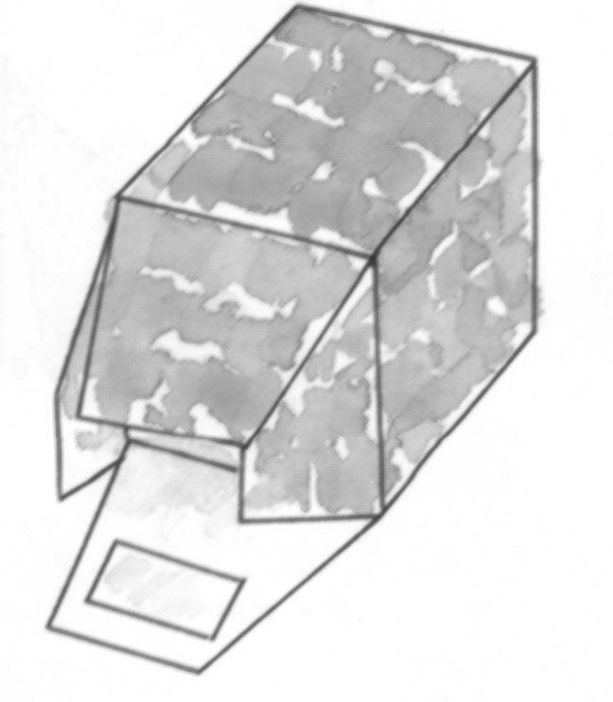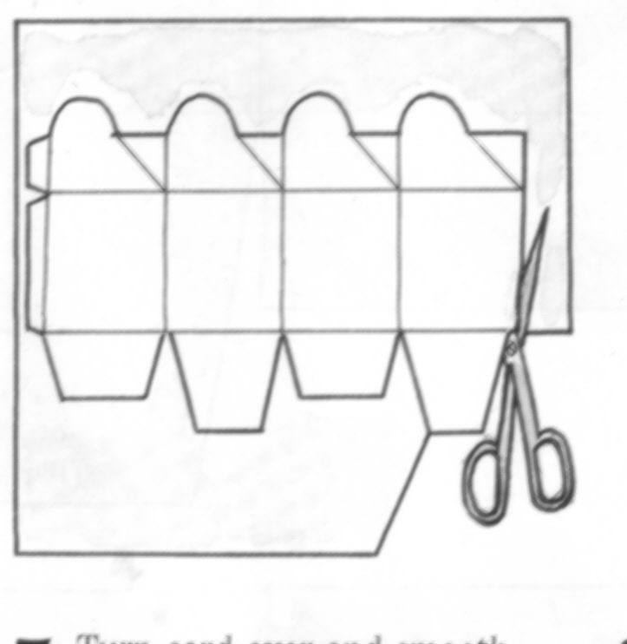

### Formative Assessment 17

**Handout 4**

* Cut out the box in handout 4, follow the instructions above and make a box.
* Measure the height, length and width of the box and write it down.
* Calculate the volume of the box.
* Made a drawing of the finished box.

### Formative Assessment 18

|  |
| --- |
| List at least three cities in South Africa: |
|  |
|  |
|  |
| Which cities have international airports?: |
|  |
|  |
|  |
| Name two countries that are located to the north of South Africa: |
|  |
|  |
| South Africa encloses two other independent countries. Name them: |
|  |
|  |
| One province is not named on the map, which province is this? |
|  |
| The names of two provinces are different to that quoted on the map. Give their old and new names. |
|  |
|  |

### Formative Assessment 19

|  |
| --- |
| Refer to page 5 of handout 1 and give the GPS coordinates of the following locations: |
| Corner of Bennit Avenue and Farrar Street: |
|  |
|  |
| Corner of Main Reef and Pretoria Roads |
|  |
|  |
| Corner of Morgan and Gayle Roads |
|  |
|  |