LEARNER
PORTFOLIO OF EVIDENCE

Numeracy level 4

Physical Quantities and Geometrical Relationships
Unit standard 9016 Level 4 Credits 4

TABLE OF CONTENTS
TABLE OF CONTENTS i
Contact Details 1
Competence 2
Appeals & Disputes 3
Assessment Process Flow 4
ASSESSMENT STRATEGY 5
Record Of Learning 6
PRE-ASSESSMENT PROCEDURES 9016 7
Unit Standard 9016 12
Formative Assessments 14
Summative Assessment Readiness Statement 15
9016 Knowledge Questionnaire 16

Contact Details
Unit Standard: | 9016
Course:

Assessor Details
Name
Branch |  |  | Registration No:
Contact Details | email:
Contact Details | Phone: |  | Fax:

Moderator Details
Name
Branch
Contact Details | email: |  | Registration No:
Contact Details | Phone: |  | Fax:

Candidate Details
Surname |  |  |  | Name
College |  |  |  | ID No
Branch
Contact Details | Email:
Contact Details | Phone: |  |  | Fax:

Competence
Congratulations on completing this program. We sincerely hope you enjoyed the programme and that the learning experience was enriching. The fact that you have attended training, however, is not sufficient evidence of your competence for us to award you a certificate and the credits attached to this programme. You are required to undergo assessment in order to prove your competence to achieve credits leading to a national qualification.

Being Declared Competent Entails:
Competence is the ability to perform whole work roles, to the standards expected in employment, in a real working environment.
There are three levels of competence:
- Foundational competence: an understanding of what you do and why
- Practical competence: the ability to perform a set of tasks in an authentic context
- Reflexive competence: the ability to adapt to changed circumstances appropriately and responsibly, and to explain the reason behind the action
To receive a certificate of competence and be awarded credits, you are required to provide evidence of your competence by compiling a portfolio of evidence, which will be assessed by a Services SETA accredited assessor.

You Have to Submit a Portfolio of Evidence
A portfolio of evidence is a structured collection of evidence that reflects your efforts, progress and achievement in a specific learning area, and demonstrates your competence.

The Assessment of Your Competence
Assessment of competence is a process of making judgments about an individual's competence through matching evidence collected to the appropriate national standards.
The evidence in your portfolio should closely reflect the outcomes and assessment criteria of the unit standards of the learning programme for which you are being assessed.
To determine a candidate’s knowledge and ability to apply the skills before and during the learning programme, formative assessments are done to determine the learner’s progress towards full competence. This normally guides the learner towards a successful summative (final) assessment to which assessor and the candidate only agree when they both feel the candidate is ready.
Should it happen that a candidate is deemed not yet competent upon a summative assessment, that candidate will be allowed to be re-assessed. The candidate can, however, only be allowed two reassessments.
When learners have to undergo re-assessment, the following conditions will apply:
- Specific feedback will be given so that candidates can concentrate on only those areas in which they were assessed as not yet competent
- Re-assessment will take place in the same situation or context and under the same conditions as the original assessment
- Only the specific outcomes that were not achieved will be re-assessed
Candidates who are repeatedly unsuccessful will be given guidance on other possible and more suitable learning avenues.
In order for your assessor to assess your competence, your portfolio should provide evidence of both your knowledge and skills, and of how you applied your knowledge and skills in a variety of contexts.
This Candidate’s Assessment Portfolio directs you in the activities that need to be completed so that your competence can be assessed and so that you can be awarded the credits attached to the programme.

Appeals & Disputes
The candidate has the right to appeal against assessment decision or practice they regard as unfair. An Appeals and Disputes procedure is in place and communicated to all assessment candidates in order for them to appeal on the basis of:
- Unfair assessment
- Invalid assessment
- Unreliable assessment
- Unethical practices
- Inadequate expertise and experience of the assessor
Appeals have to be lodged in writing (Candidate Appeal Form) & submitted to Stanford Business College internal moderator within 48 hours, following the assessment in question. The moderator will consider the appeal & make a decision regarding the granting of a re-assessment. The learner will be informed about the appeal-outcome within 3 days of lodging the appeal. Should the learner not be satisfied with the internal appeal outcome, the learner will be advised of the rights to refer the matter to the SETA ETQA.

Assessment Process Flow
Assessment Plan agreed by candidate & completed by the assessors before the actual assessment
Assessment Activities conducted per the Assessment Plan
CANDIDATE

Assessment Guide submitted to training provider as per Assessment Plan
Detailed Assessor Report compiled & forwarded for Moderation
ASSESSMENT

Feedback Report Completed by Assessor & individual feedback given to candidate
Assessment Results Moderated
Appeal form completed by the candidate in event of dispute
Record of Learning Updated

Action Plan completed by Assessor

All records & evidence filed
SETA
Completed Assessor report/Moderator report/Record of Learning forwarded to SETA
Approval and Certification obtained from SETA

SETA to register on National Learner Database

Certificate of Competencies issued to successful candidates

ASSESSMENT STRATEGY

Exit level outcome: Demonstrate an understanding of basic economics within a market economy.
These assessment exercises will cover the above exit level outcome. The following unit standards are included in this exit level outcome: 9016; 7468; 9015.
The purpose of the assessment process is to gather enough evidence to prove that the exit level outcome was achieved.
Competency will be assessed through a knowledge questionnaire and workplace activities and assignments recorded in POE. Assessment evidence should be sufficient to prove that the candidate is capable in all required tasks set by the unit standards and a competency judgement will be made regarding the exit level outcome. Principles of fairness, validity, practicability, reliability and consistency will be adhered to throughout.

Qualification |  |  | Unit Standard Codes |  | 9016
Level | Level 4 |  | Credits |  | 4
Purpose of Assessment | The purpose of this assessment is to check your understanding of the selected unit standards in order to prepare you for the workplace
Assessment Procedures | - An integrated assessment approach will be followed to allow for practical and theoretical components. The entails the assessment of a number of unit standards, outcomes and criteria together in one assessment activity  - Candidates are not only assessed against specific outcomes, but also on critical outcomes, attitudes and values  - A summative competence judgment will be made on the basis of all assessment evidence produced, that proves that the candidate can be consistently judged as competent against the outcomes of the unit standards and the qualification as a whole.  - Candidates take responsibility for their own assessment and should notify the assessor when they are ready for assessment  - Candidates will receive feedback after the summative assessment, which will be discussed after all assessments have been completed  - All assessments will be reviewed to ensure that assessment practices are valid, fair, transparent, consistent and current  - An Internal/External moderator will moderate assessment practices  - The SETA will also conduct external moderation
Context of Assessment | Assessment Method | Assessment Conditions |  | Who will conduct assessment | Assessment results and feedback
Context of Assessment | Questionnaires  Workplace assignments | Input based assessments |  | Assessor | Immediate

Record Of Learning

Candidate's Name: |  |  |  | ID No
Assessor's Name: |  |  |  | Ass. Reg. No
Moderator's Name: |  |  |  | Mod. Reg. No
Date:
UNIT STANDARD | NQF LEVEL | CREDITS | DATE OF COMPLETION | SIGNATURE OF ASSESSOR |  | SIGNATURE OF MODERATOR
9016 | 4 | 4

PRE-ASSESSMENT PROCEDURES 9016
CANDIDATE'S NAME:
ID Number
Job: Company and department
Contact details | Phone: |  |  | Fax:
Contact details | Email:
ASSESSOR'S NAME:
Organisation
Registration number
Contact details | phone |  |  | Fax
Contact details | Email
Unit Standard Title:
Pre assessment meeting
Date
Time
Venue
How to prepare the candidate |  | Document Requirements | Agree (tick) |  | Action Required
Explain to the candidate why your are meeting and the purpose of the assessment |  | NQF Framework Assessment process
Discuss the assessment plan in detail |  | Assessment strategy
Explain assessment process, show assessment instruments to candidate and describe assessment conditions |  | Assessment instruments
Identify the role-players during assessment |  | Assessors  Moderator
Describe the evidence required to be declared competent |  | Examples of evidence
Explain how evidence will be judged
Explain to the candidate how to prepare: Give candidate summative task description |  | Summative task description
Confirm with the candidate what he/she should bring to the assessment |  | Detailed briefing on exact requirements to be given to candidate
Ensure that candidate understands the procedures of all assessment practices |  | Appeals procedure  Moderation procedure  Assessment policy
Ask the candidate if he/she foresees any problems or identify any special needs |  | List needs
Check with candidate that he/she clearly understands the assessment procedure
Comments or questions:

AGREED ASSESSMENT PLAN
Special Assessment Requirements
Event | Date, time and location | Resources required | Evidence to be generated
Attend Training |  | Training material, Facilitator | Attendance Register
Complete Assessments |  | Assessments | Completed Assessments
Complete Portfolio of Evidence |  | Portfolio of Evidence guide | Completed Portfolio of Evidence
Submit Portfolio of Evidence to training provider |  |  | Acknowledgement of receipt from training provider
Assessor roles and responsibility
Roles | - Assessor  - Guide  - Feedback Agent  - Reviewer
Responsibilities | - Consult candidate re assessment, assessment process and plan  - Agree assessment process and plan with candidate  - Forward documentation to candidate: plan, guide and assessment instruments  - Assess candidate with the use of different instruments  - Provide feedback on assessment findings  - Support candidate through assessment process  - Source feedback from candidate on assessment process  - Review assessment process and outcome  - Use assessment process as opportunity to transform assessment activities and outcomes
Candidate roles and responsibility
Roles | - Candidate  - Feedback agent  - Reviewer
Responsibilities | - Be available for assessment  - Be actively involved in the consultative process  - Learn from the assessment process  - Provide feedback to the assessor in terms of the assessment as learning activity  - Provide feedback to the assessor on the efficacy of the assessment process  - Review own role and assessor role in the assessment process
Assessment instruments
- Portfolio of evidence
- Project
- Questioning
- Workplace assignments
Assessment process
Step |  |  |  |  | Date
- Evaluation of POE addressing Essential Embedded Knowledge in unit standards
- Evaluation of Research Projects and other evidence address specific unit standards
- Consultation: assessment plan and assessment activities and instruments. Pre-assessment moderation and interviews conducted at this stage
- Observation: feedback on assessment against specific outcomes, critical outcomes and constructs in unit standards
- Feedback: to candidate regarding sufficiency of evidence and possible interview to gain supplementary evidence
- Feedback to candidate regarding assessment findings as well as review process
Feedback | Written feedback to be given to all stakeholders at the end of the assessment process, as well as verbal feedback to the candidate during assessment activities
Recording Process | Process and findings to be recorded and submitted for record keeping purposes as well as moderation and verification
Review Process | The review process is the responsibility of the assessor and the candidate. Joint reviewing will take place after feedback has been given to the candidate
Right to appeal | The candidate must be advised of the right to appeal
Training environment | Step |  |  | Date
Accessibility and safety of environment | Site inspection conducted  Pre-assessment moderation conducted
Resources Required | Assignments  POE  Assessments
Candidate declaration
I confirm that:
- I have been consulted on and have agreed to the training and assessment process as detailed in the assessment guide
- I have been advised of my right to appeal against any assessment that is unfair, unreliable, invalid or impracticable
- I have read and understood the appeal procedure
- I know that assessments may be moderated or verified by an external party
- The purpose of the assessment has been clearly explained to me
- The criteria have been discussed with me, and I know I will be assessed against these criteria
- I know when and where I will be assessed, and I was given fair notice
- I know how the assessment will be done, and any other requirements related to the assessment
- I am ready to be assessed

Signed: Date:

Assessor’s declaration
I hereby declare that I have prepared the candidate for assessment, the candidate was consulted and all stakeholders have been informed and the workplace is prepared to ensure valid and fair assessment.
Overall Assessment Decision | Competent | Not yet competent
Candidate’s Signature |  | Date
Assessor’s Signature |  | Date
Moderator’s Signature |  | Date

Unit Standard 9016
Unit Standard Title: Represent analyse and calculate shape and motion in 2-and 3-dimensional space in different contexts.
NQF Level: 4
Credits: 4
Specific Outcome 1: Measure, estimate, and calculate physical quantities in practical situations relevant to the adult.
Range:
- Basic instruments to include those readily available such as rulers, measuring tapes, measuring cylinders or jugs, thermometers, spring or kitchen balances, watches and clocks.
- In situations which necessitate it such as in the workplace, the use of more accurate instruments such as vernier callipers, micrometer screws, stop watches and chemical balances.
- Quantities to estimate or measure to include length/distance, area, mass, time, speed acceleration and temperature.
- Distinctions between mass and weight, speed and acceleration.
- The quantities should range from the low or small to the high or large.
- Mass, volume temperature, distance, and speed values are used in practical situations relevant to the young adult or the workplace.
- Calculate heights and distances using Pythagoras` theorem.
- Calculate surface areas and volumes of right prisms (i.e., end faces are polygons and the remaining faces are rectangles)
- Cylinders, cones and spheres from measurements in practical situations relevant to the adult or in the workplace.
Assessment Criteria
- Scales on the measuring instruments are read correctly
- Quantities are estimated to a tolerance justified in the context of the need
- The appropriate instrument is chosen to measure a particular quantity
- Quantities are measured correctly to within the least step of the inst
- Appropriate formulae are selected and used
- Calculations are carried out correctly and the least steps of instruments used are taken into account when reporting final values
- Symbols and units are used in accordance with SI conventions and as appropriate to the situation
Specific Outcome 2: Explore, analyse & critique, describe & represent, interpret and justify geometrical relationships and conjectures to solve problems in two and three dimensional geometrical situations.
Range:
- Applications taken from different contexts such as packaging, arts, building construction, dressmaking.
- The operation of simple linkages and mechanisms such as car jacks.
- Top, front and side views of objects are represented.
- Use rough sketches to interpret, represent and describe situations.
- The use of available technology (e.g., isometric paper, drawing instruments, software) to represent objects
- Use and interpret scale drawings of plans (e.g., plans of houses or factories; technical diagrams of simple mechanical household or work related devices,
- Road maps relevant to the country.
- World maps.
- International time zones.
- The use of the Cartesian co-ordinate system in determining location and describing relationships in at least two dimensions.
Assessment Criteria
- Descriptions are based on a systematic analysis of the shapes and reflect the properties of the shapes accurately, clearly and completely
- Descriptions include quantitative information appropriate to the situation and need.
- 3-dimensional objects are represented by top, front and side view.
- Different views are correctly assimilated to describe 3-dimensional object
- Available and appropriate technology is used in producing and analysing representations.
- Relations of distance and positions between objects are analysed from different views.
- Conjectures as appropriate to the situation, are based on well-planned investigations of geometrical properties.
- Representations of the problems are consistent with and appropriate to the problem context. The problems are represented comprehensively and in mathematical terms
- Results are achieved through efficient and correct analysis and manipulation of representations.
- Problem-solving methods are presented clearly, logically and in mathematical terms.
- Reflections on the chosen problem solving strategy reveal strengths and weaknesses of the strategy
- Alternative strategies to obtain the solution are identified and compared in terms of appropriateness and effectiveness.
Essential Embedded Knowledge
The following essential embedded knowledge will be assessed through assessment of the specific outcomes in terms of the stipulated assessment criteria. Candidates are unlikely to achieve all the specific outcomes, to the standards described in the assessment criteria, without knowledge of the listed embedded knowledge. This means that the possession or lack of the knowledge can be inferred directly from the quality of the candidate’s performance against the standards.
- Properties of geometric shapes
- Surface area and volume
- Mathematical argument and evaluation based on logical deduction
- Spatial interrelationships
Critical Cross-field Outcomes (CCFO)
Unit Standard CCFO Identifying: Solve a variety of problems relevant to the adult with increasing responsibilities involving space, shape and time using geometrical techniques
Unit Standard CCFO Collecting: Gather, organise, evaluate and critique information about objects and processes
Unit Standard CCFO Communicating: Use everyday language and mathematical language to describe properties, processes and problem solving methods.
Unit Standard CCFO Science: Use mathematics to analyse, describe and represent realistic and abstract situations and to solve problems relevant to the adult with increasing responsibilities

Formative Assessments

Summative Assessment Readiness Statement
Note: R = Ready for summative assessment, NYR = Not yet Ready for summative assessment
Candidate's Name |  |  |  |  | ID No.
Assessor's Name |  |  |  |  | Reg. No.
Unit Standard Title
ASSESSMENT DECISION
Specific Outcome |  | R | NYR | Comments

Assessor’s / Facilitator declaration:
I hereby declare that I have assessed the learner’s formative assessment and find the learner ready / not yet ready for the summative assessment

Assessor / Facilitator Name | Signature

9016 Knowledge Questionnaire
You will find all the formulas at the end of the assessment.
- On a typical ruler what would be the smallest increment to be distinguished? (1)
- What type of instrument would be used to measure the length of a curtain rail? (1)
- Draw a measuring cylinder that is three quarters full. Use a line to indicate the level on the measuring cylinder. The cylinder has a maximum capacity of 2 litre. (2)
- What is the temperature shown on the thermometer? (1)
°C
38
37
36
- Draw a spring balance showing a weight of 250 grams. The full scale of the spring balance is 1 kg (2)
- Indicate 15:15 on an analogue clock (1)
- What is commonly used to measure the diameter of a rotor shaft? (1)
- What could be used to measure the diameter of a hair? (1)
- What would you use to keep the time it takes from the beginning of a football match to halftime and fulltime? (1)
- A Chemical balance needs to weigh 237 grams using weights of 50 grams, 20 grams, 10 grams and 1 gram. How many of each weight is needed? (4)
- Calculate the weight on earth of an object with a mass of 48 kg.
- Gravitational acceleration (a) = 9.81 m/s ²
- Show all steps and formulae used. (3)
- The brakes on a vehicle can slow it down at a rate of 15m/s ². Remember that slowing down is also a rate of change of speed. If this vehicle is travelling at 40 m/s how long would it take the brakes to bring the vehicle to a standstill? Show all steps and formulae used. (3)
- Travelling at a constant speed of 40 m/s, how far would the vehicle travel in 20 seconds? Show all formulas and steps used. (4)
- To heat up a undetermined volume of water from 20 °C to 50 °C takes 5 minutes. What is the heating factor of the element used to heat up the water? Show answer in °C/second. Show all steps and formulae used. (7)
- A right prism has a rectangular face with dimensions height (h) = 4 cm and width (w) = 3 cm. The depth (d) of the prism is 5 cm. Draw a front view, side view and top view of the prism, showing the prism in three dimensions. Show all values on sketch. (4)
- Calculate the outer surface area of the previous prism. Remember that there are two surfaces in each case with the same area so all surfaces are doubled. Show all formulae and calculations. (12)
- Calculate the area of the following triangle. Show all formulas and steps. (3)

b = 2000 m
h = 750 m

- For a circle with radius (r) 6 m calculate the area and circumference. Show all formulas and steps. (6)
- The previous circle is now the face surface of a cylinder with a height of 4 m. Calculate the volume and outer surface area of this cylinder. Show all formulas and steps. (7)
- A cone has a height of 10 cm. The base radius is 2.5 cm. Calculate the volume of the cone. Show all formulas and steps. (3)
- Calculate the volume and surface area of a sphere with a radius of 20 cm. Show all formulas and steps. (6)
- A right triangle has two right angled sides
x = 5 m and y = 7 m.
Calculate the hypotenuse of this triangle. Show all formulas and steps. (4)
- At the end of this assessment you will find the template of the gift box. Draw the box to scale, fold it and hand it in as part of your assessment. (2)
- Make a drawing of the front, side and top views of the box, as shown in the learner guide. (3)
- The dimensions of a tumble dryer are as follows:
- Width 559 mm
- Depth 485 mm
- Height 850 mm
The space that you want to fit the tumble dryer in is:
- Width 559mm
- Depth 500mm
- Height 845mm
- Will the tumble dryer fit into the space? (1)
- Motivate your answer(1)
- Name two drawing aids that you can use. (2)
- You will find a time zone map at the end of the assessment. Do the following: If it is 3 o’ clock in the afternoon in South Africa
- What time is it in England? (1)
- What time is it in New York, on the East coast of the USA? (1)
- What time is it on the west coast of Australia? (1)
- You will find a map of South Africa at the end of the assessment.
- Name two countries to the north of South Africa (2)
- Is the Atlantic Ocean to the west or to the east of South Africa? (1)
- Explain the following GPS coordinates in terms of latitude, longitude, degrees, minutes and seconds. (8)
- At the end of the assessment is a picture of a jack. Answer the following questions:
- Is the jack expanded or contracted? (1)
- On the picture, indicate the linkages (1)
- On the picture, indicate the handle of the jack. (1)
- Attach your drawing of the tumble dryer to the assessment. (1)
- At the end of the assessment is a plan of a house.
- Calculate the surface area of the main bedroom. (1)
- You want to use the garage as a storage area. Calculate the volume of the garage. (1)
TOTAL: 103

Formulas
- w = m x a
- Time = speed / acceleration
- speed = distance / time
- change to
- distance = speed x time
- Δt (change in temperature) = ti (initial temperature) – tf (final temperature)
- Δt (change in temperature) = hf (heating factor ºC/s) × time
Change to
hf = Δt / time
- Volume = w x h x d
- Area = ½ x b x h
- Area = π × r ²
- Circumference = 2 x π x r
- Volume = π × r ² × h
- Surface area = (2 × π × r × h) + (2 × π × r ²)
- Volume = ⅓ × π × r ² × h
- Volume = 4/3 × π × r ³
- Surface area = 4 × π × r ²
- x ² + y ² = h ²
change to
h ² = x ² + y ²
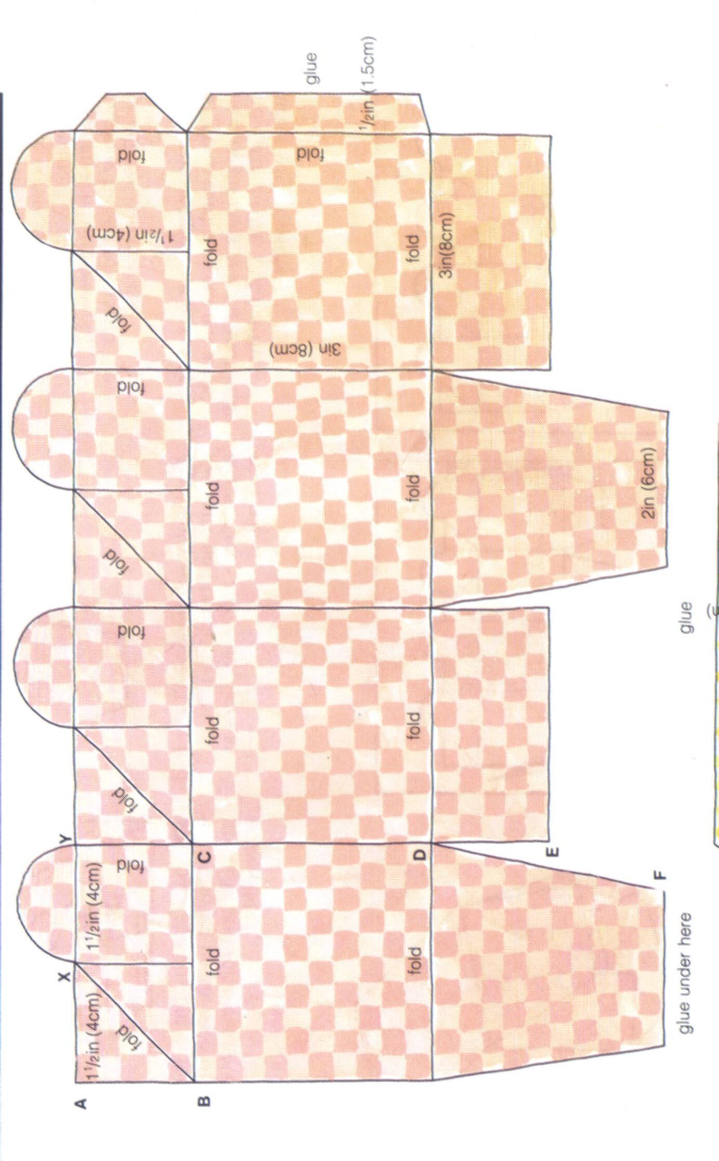

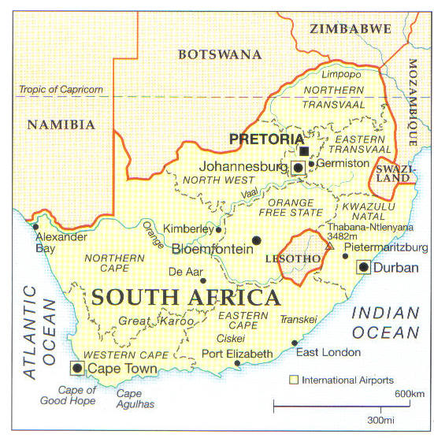

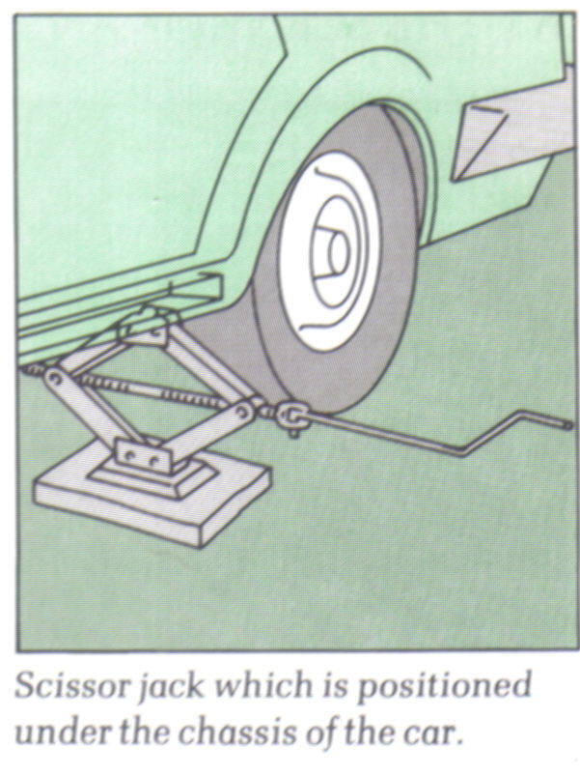
Linkages
Handle

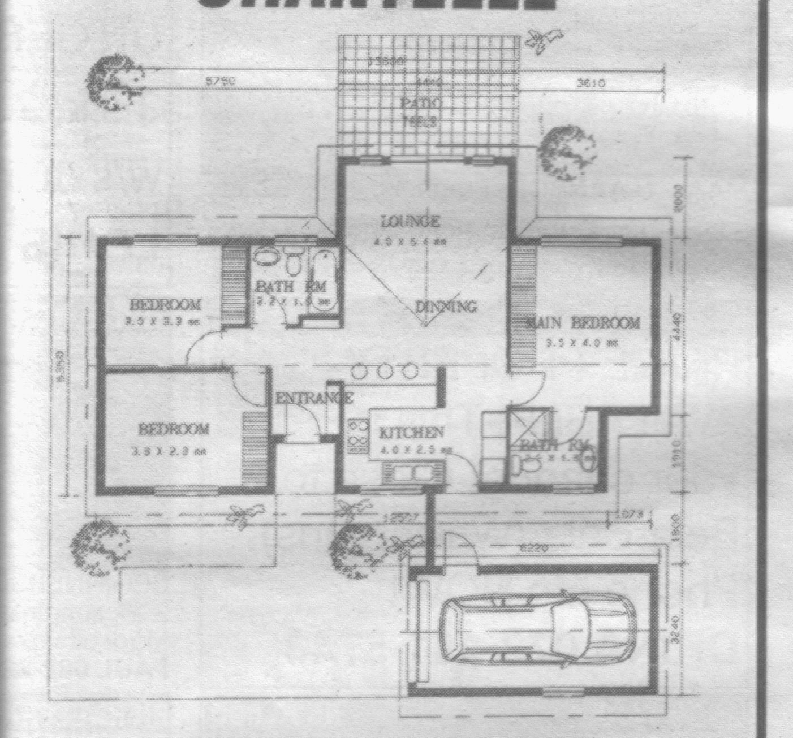
Bedroom
3.0 x 3.3m
Bedroom
3.8 x 2.3m
Lounge
4.0 x 5.4m
Main Bedroom
3.5 x 4.0m
Dining
Kitchen
Patio
The dimensions of the bathroom next to the lounge are: 2.2 x 1.8
The dimensions of the kitchen are 4.0 x 2.5
The dimensions of the garage are 6.22 (h) x 3.24 (w) x 2.4 (h)

