MAP OF SOUTH AFRICA
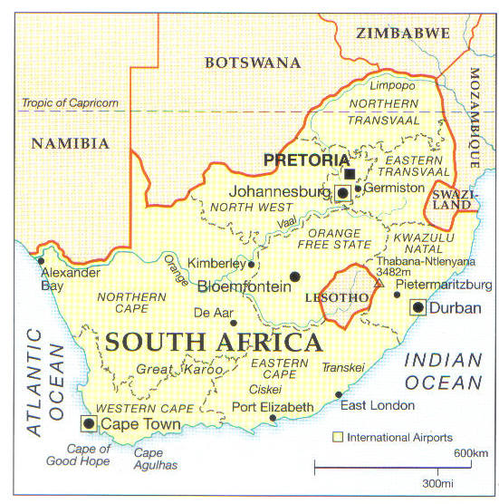
Showing details of the provinces. Northern Transvaal is, of course, now Limpopo and Eastern Transvaal is Mpumalanga.

