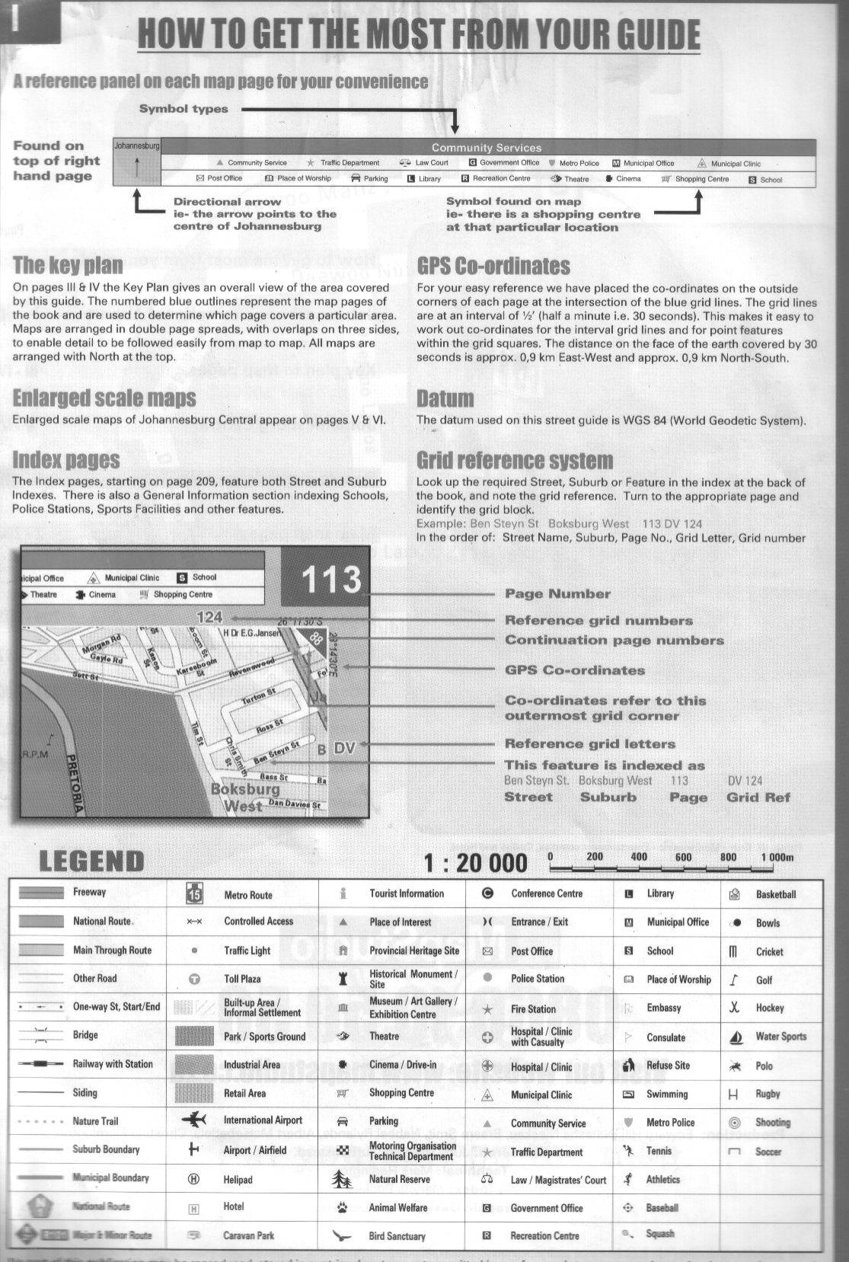

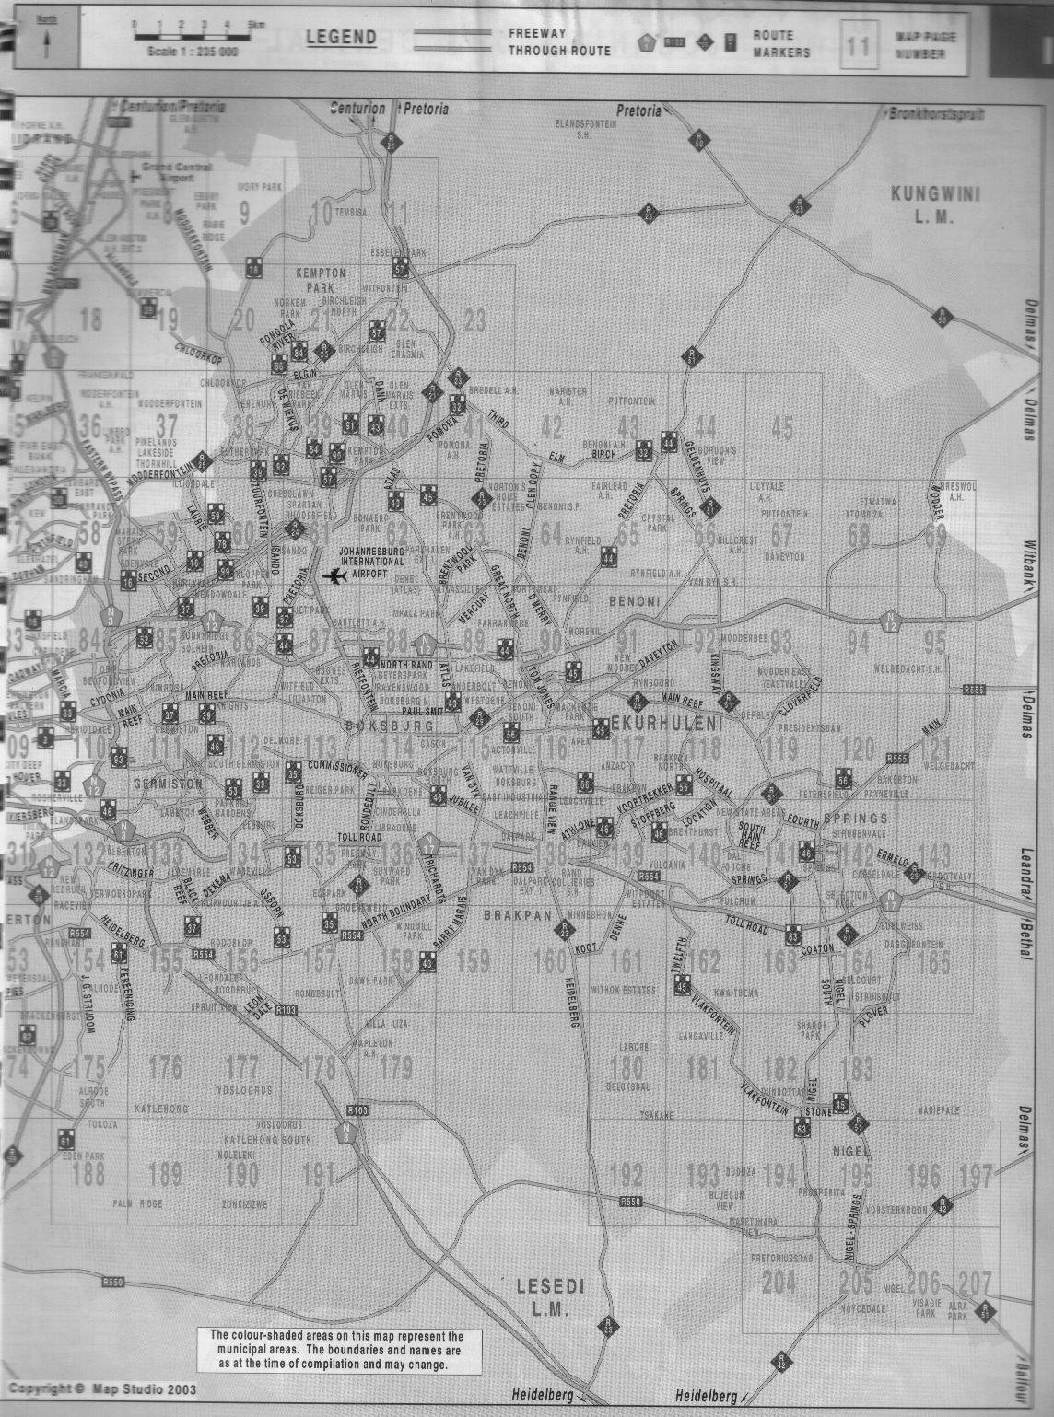
Page 113

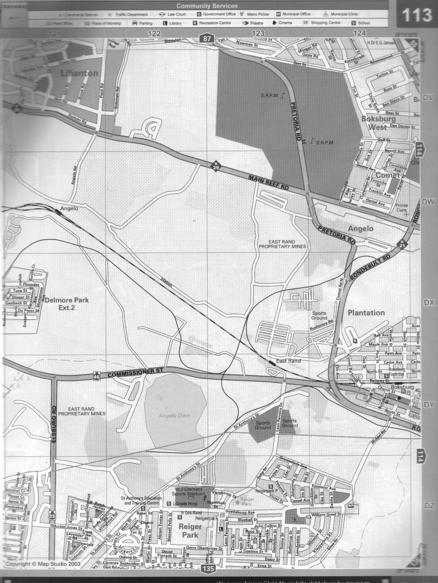
GPS Coordinates:
28º14’30”E
26º11’30”S
GPS Coordinates:
28º14’30”E
26º14;00”S



