

**DEFINE THE CORE CONCEPTS OF THE WHOLESALE & RETAIL ENVIRONMENT**

**LEARNER GUIDE**

**U/S 114895**

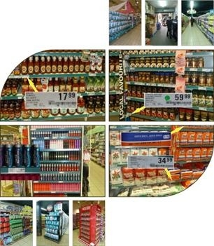





**CONTACT DETAILS**

HEAD OFFICE

Riverside Office Park Hennops Building 1303 Heuwel Avenue Centurion

Private Bag X 106 Centurion

0046

Tel: 012- 622 9500

Fax: 012 – 663 9585

NATIONAL CONTACTS

Website: [www.wrseta.org.za](http://www.wrseta.org.za/) E-mail: wrseta.org.za

Call Centre: 0860 270 027

TVET CONTACT DETAILS

Website: [www.fetcolleges.co.za](http://www.fetcolleges.co.za/)

### Click on “Public FET College” and select ‘click here’ for a list of Public TVET Colleges and their contact details

#### CONTENTS

Topic 1: SEGMENT THE WHOLESALE AND RETAIL SECTOR Page 9 - 15

* 1. Sub-sectors and categories within the wholesale and retail industry Page 10
  2. Classification of sub-sectors according to medium and micro enterprises Page 10
  3. Categories within subsectors of W&R Page 12
  4. Stakeholders in the W&R Environment Page 13
  5. Types of Retailers Page 13
  6. Functions of Retailers Page 14

Topic 2: TARGET MARKETS AND THEIR BEHAVIOUR Page 16- 20

* 1. Customer Profiles Page 17
  2. Consumer Shopping Patterns Page 17
  3. What is a target market Page 17
  4. Marketing procedures Page 19

Topic 3: STOCK- AND CASH FLOW THROUGH IN A RETAIL OUTLET Page 21 – 30

* 1. The flow of stock and sales through wholesale and retail store Page 22
  2. Operational functional departments in a wholesale and retail store Page 22 3.3The supply chain Page 23

3.4 Page 28

Topic 4: LEGISLATION AND its IMPACT ON THE RETAIL SECTOR Page 31 – 35

* 1. Legislation that impact on the industry Page 32
  2. The objectives of the different pieces of legislation Page 32
  3. General wholesale and retail terms Page 33

Topic 5: SHRINKAGES AND LOSSES IN THE RETAIL SECTOR Page 36- 39

* 1. Sales and losses within a W&R Environment Page 37
  2. Sources (methods) in which shrinkage can occur Page 37
  3. Reasons for preventative policies and procedures Page 38
  4. The impact of shrinkage and losses on an organisation Page 38

Knowledge Test Page 40

Reference List Page 41

## ICONS

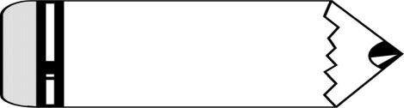

|  |  |
| --- | --- |
| **ACTIVITY 1** | **LEARNER ACTIVITIES**  **Complete these Activities in the Learner Workbook** |
| red-basket | **WORKPLACE ACTIVITY**  **Complete these Activities in the Workplace Logbook** |
| http://www.clipartbest.com/cliparts/4i9/9p8/4i99p8kiE.jpeg | **GROUP WORK ACTIVITIES**  **Complete these Activities in the Learner Guide** |
| http://tbn0.google.com/images?q=tbn:G5EiZBeQvxSQcM:http://www.mybloodfirst.com/images/exclamation.jpg | **THINK/ TIPS/REMEMBER** |
| http://tbn0.google.com/images?q=tbn:FVR2NaLwWx6bjM:http://3quarksdaily.blogs.com/3quarksdaily/images/brainstorming.gif | **BRAINSTORMING SESSIONS** |
| Poster, Art Print Of Black And White Wise Professor Owl Reading An Alphabet Book | **KNOWLEDGE QUESTIONNAIRE**  **Complete these Activities in the Learner Workbook** |
| http://tbn0.google.com/images?q=tbn:KTDpPke5q0Et9M:http://school.discoveryeducation.com/clipart/images/look---.gif | **OBSERVATION ACTIVITIES** |
|  | **LEARNING OUTCOMES** |
|  | **EXAMPLE** |

#### UNIT STANDARD 114895

**Define the core concepts of the wholesale and retail environment**

|  |  |  |  |
| --- | --- | --- | --- |
| **SAQA US ID** | **UNIT STANDARD TITLE** | | |
| 114895 | Define the core concepts of the wholesale and retail environment | | |
| **ORIGINATOR** | | **REGISTERING PROVIDER** | |
| SGB Retail and Wholesale | |  | |
| **FIELD** | | **SUBFIELD** | |
| Field 11 - Services | | Wholesale and Retail | |
| **ABET BAND** | **UNIT STANDARD TYPE** | **NQF LEVEL** | **CREDITS** |
| Undefined | Regular | Level 2 | 10 |
| **REGISTRATION STATUS** | **REGISTRATION START DATE** | **REGISTRATION END DATE** | **SAQA DECISION NUMBER** |
| Reregistered | 2008-01-22 | 2011-01-22 | SAQA 0160/05 |
| **LAST DATE FOR ENROLMENT** | | **LAST DATE FOR ACHIEVEMENT** | |
| 2012-01-22 | | 2015-01-22 | |

|  |
| --- |
| **Specific Outcomes and Assessment Criteria:** |
| **SPECIFIC OUTCOME 1** |
| Segment the wholesale and retail sector. |
| **ASSESSMENT CRITERIA** |
| **ASSESSMENT CRITERION 1** |
| Different sub-sectors and categories within wholesale/retail industry are identified as they appear in whole/retail sector, medium and micro enterprises. |
| **ASSESSMENT CRITERION 2** |
| Categories and sub-sectors within wholesale/retail are matched to given wholesale and retail stores as they appear in wholesale/retail sector. |
| **ASSESSMENT CRITERION 3** |
| Stakeholders are identified as applicable to the organisation. |

|  |
| --- |
| **SPECIFIC OUTCOME 2** |
| Identify the store`s target market. |
| **ASSESSMENT CRITERIA** |
| **ASSESSMENT CRITERION 1** |
| Types of consumer profiles are described according to wholesale/retail sector. |
| **ASSESSMENT CRITERION 2** |
| Consumer shopping patterns are described according to wholesale/retail sector. |

|  |
| --- |
| **ASSESSMENT CRITERION 3** |
| The Store`s target market is described according to the organisation`s market segment. |
| **ASSESSMENT CRITERION 4** |
| The procedures for marketing the store to its target market is described according to the organisation`s marketing strategy. |
| **SPECIFIC OUTCOME 3** |
| Explain the flow of stock and sales through a wholesale/retail operation. |
| **ASSESSMENT CRITERIA** |
| **ASSESSMENT CRITERION 1** |
| The various operational functional departments in a wholesale/retail store are identified along with their main purpose. |
| **ASSESSMENT CRITERION 2** |
| Stock flow through the store is explained as it applies to the business. |
| **ASSESSMENT CRITERION 3** |
| The flow of cash through the store is explained as it applies to the business. |
| **ASSESSMENT CRITERION 4** |
| The support functions necessary for the operation of a wholesale or retail outlet are explained as it applies to the sector. |
| **ASSESSMENT CRITERION 5** |
| The impact of the job on others in the organisation is explained in terms of systems and sub-systems. |
| **SPECIFIC OUTCOME 4** |
| Demonstrate an understanding of the wholesale & retail business environment. |
| **ASSESSMENT CRITERIA** |
| **ASSESSMENT CRITERION 1** |
| The various forms of legislation that impact on the industry are identified in terms of their titles. |
| **ASSESSMENT CRITERION 2** |
| The objectives of the different pieces of legislation are explained as it applies to each piece of legislation. |
| **ASSESSMENT CRITERION 3** |
| General wholesale and retail terms are used in context as they apply to the industry. |
| **SPECIFIC OUTCOME 5** |
| Demonstrate an understanding of the concept of shrinkage and losses within a Wholesale. |
| **OUTCOME NOTES** |
| Demonstrate an understanding of the concept of shrinkage and losses within a Wholesale and Retail environment. |
| **ASSESSMENT CRITERIA** |
| **ASSESSMENT CRITERION 1** |
| The concept of shrinkage and losses is understood and explained. |
| **ASSESSMENT CRITERION 2** |

|  |
| --- |
| Methods of shrinkage and losses are identified. |
| **ASSESSMENT CRITERION 3** |
| Reasons for preventative policies and procedures are described. |
| **ASSESSMENT CRITERION 4** |
| The impact of shrinkage and losses on the organisation is explained. |



|  |
| --- |
| **UNIT STANDARD ESSENTIAL EMBEDDED KNOWLEDGE** |
| The demonstrated understanding of:  -sectors and categories applicable to the wholesale and retail sector  ock flow through the business  -systems and how they impact on each other. nternal stakeholders of the organisation. |

#### Critical Cross-field Outcomes (CCFO):

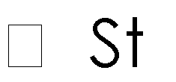

|  |
| --- |
| **UNIT STANDARD CCFO IDENTIFYING** |
| Solving problems Evident in the following: Specific outcomes:  Assessment criteria:  All |

|  |
| --- |
| **UNIT STANDARD CCFO ORGANISING** |
| Organise oneself and ones activities Evident in the following:  Specific outcomes:  k and sales through a wholesale/retail operation  Assessment criteria: All |

|  |
| --- |
| **UNIT STANDARD CCFO COLLECTING** |
| Collect, analyse, organise, and critically evaluate information  Evident in the following:  Specific outcome:  tail sector |



Assessment criteria:

All

|  |
| --- |
| **UNIT STANDARD CCFO DEMONSTRATING** |
| Understand the world as a set of related Evident in the following:  Specific outcomes:    Assessment criteria:  -sectors within wholesale/retail are matched to given wholesale and retail stores as they appear in wholesale/retail sector |

## TOPIC 1



**At the end of this topic you will know and be able to: SEGMENT THE WHOLESALE AND RETAIL SECTOR**

|  |  |
| --- | --- |
| **LEARNING OUTCOME** | **AC** |
| Explain the term ‘Sub-Sector’  Explain what is meant by Medium and Micro Enterprise with reference to size of enterprise  Identify the different Sub-Sectors within the W&R Industry’s Medium and Micro Enterprise environment | AC 1 |
| Explain the concept ‘ retail categories’  Match categories and sub-sectors to given examples of W&R stores | AC 2 |
| Explain the term ‘stakeholder’ as related in the W&R sector  Identify own store’s stakeholders | AC 3 |

#### SUB-SECTORS AND CATEGORIES WITHIN WHOLESALE/RETAIL INDUSTRY (SO 1, AC 1, 2 & 3)

Small businesses within the wholesale and retail environment cut across the formal and informal sector divide and vary in size, turnover and purpose.

Several key issues affect the performance of SMME and informal sector firms. These include access to:

* + - Financial services
    - Skills training
    - Physical infrastructure and basic services
    - Business related infrastructure and
    - The impact of regulations

***N.B.*** *The impact of regulations will be discussed later in this module.*

##### What is a medium enterprise?

* + Employs up to 200 people
  + Is owner controlled
  + Has more complex ownership and management structures
  + Has an increased division of labour

##### What is a micro enterprise?

* + Employs less than 50 workers (sometimes with no more than four regular workers)
  + Is often poorly integrated into supply chains
  + Can be classified as a survivalist or non survivalist enterprise

Survivalist enterprises do not employ anyone e.g. hawkers, spaza shop owners, vendors, whereas non survivalist enterprises usually employ not more than four regular workers.



**ACTIVITY 1**

#### (SO1 AC1)

**(5)**

**Refer to Activity 1 in your Learner Workbook**

##### Classification of sub-sectors according to medium and micro enterprises (SO1 AC1) Sub sectors within the wholesale and Retail environment

Various sub-sectors exist within the wholesale and retail sector. These are illustrated below:

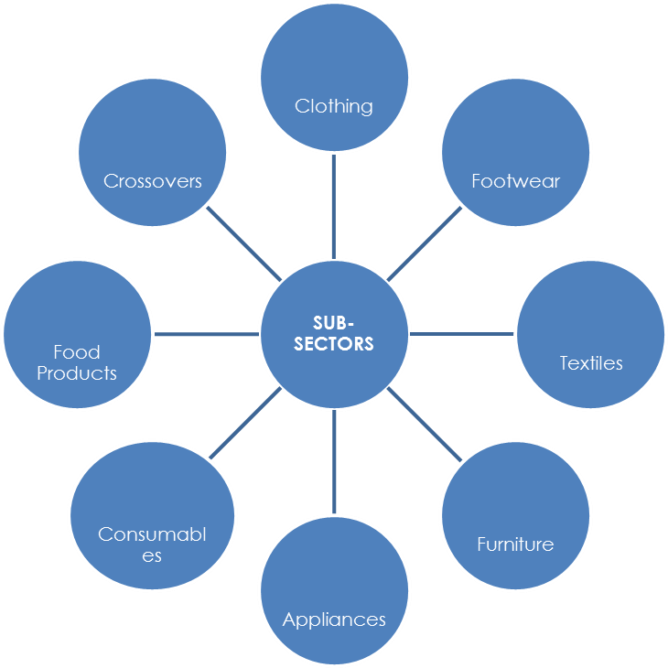

#### Figure 1: Sub-sectors within wholesale and Retail

**(SO1 AC2)**



**ACTIVITY 2**

#### (Includes Activity 3) (20)

**Refer to Activity 2 in your Learner Workbook**

2.1 List at least FOUR stores within your area. Identify the specific sub-sectors of the wholesale and retail industry within which they fall. Identify their core products. Tabulate your answer in the table provided in the Learner Workbook: (12)

2.2. Add an additional column to the table for Task 2.1. Classify the identified stores as medium or micro enterprises. (4)

##### CATEGORIES WITHIN SUB-SECTORS OF W&R

Each sub-sector mentioned above consists of a variety of categories. These are clearly outlined in the table below:

|  |  |
| --- | --- |
| **Sub-Sector** | **Category** |
| ***Crossovers*** | Many large stakeholders within the wholesale and retail industry crossover sub- sectors in the variety of products that they sell.  An example of this is Game Stores, whose core business is Appliances and Consumables.  They carry all sub-sectors of the industry, namely Footwear, Clothing, Textiles, Appliances, Consumables, Food Products  and Furniture. |
| ***Clothing*** | * Men’s: casual, sport, formal * Ladies: casual, sport, formal, evening wear * Boys * Girls * Infants |
| ***Footwear*** | * Men’s: casual, sport, formal * Ladies’: casual, fashion, classic * Children: boys, girls |
| ***Textiles*** | * Bedroom * Bathroom * Curtains * Tableware |
| ***Furniture*** | * Bedroom * Dining Room * Lounge * Patio |
| ***Appliances*** | * Large appliances: washing machine, fridge, stove, tumble drier * Small appliances: kettle, iron, toaster, kettle, snackwich * Floor care: vacuum cleaner, polisher |
| ***Consumables*** | * Household Products * Medicine * Toiletries |
| ***Food products*** | * Beverages: soft drinks, fruit juices, alcohol * Confectionery: sweets, chips, biscuits, cakes * Edible Groceries (Dry): canned foods, bottled foods * Perishable foods: frozen and fresh foods |

#### Figure 2: Categories within sub-sectors

**(Mark includes Activity 2) (4)**



**ACTIVITY 3**

(SO1 AC2)

#### Refer to Activity 3 in your Learner Workbook

* 1. **STAKEHOLDERS IN THE W&R ENVIRONMENT**

##### MCj03030410000[1]Internal and External Stakeholders

The term “no man is an island” applies to organisations as well, as each organisation depends on a number of people for its success. Those people may be internal or external to the organisation.

##### Types of Stakeholders What are stakeholders?

Stakeholders are people with direct interest, involvement, or investment in a business They may be:

* + - Shareholders
    - Staff
    - Suppliers
    - Customers

The stakeholders in any business may be internal or external to the business.

#### http://www.clipartbest.com/cliparts/4i9/9p8/4i99p8kiE.jpegGROUP ACTIVITY 1 (SO1 AC3)

Instruction: Divide into **groups of 3** and complete the instruction and table below.

Classify the list of stakeholders above, as either internal or external to an organisation. In the third column, say why you made the selection as internal or external. Tabulate your answer in the table below:



**ACTIVITY 4**

#### (SO1 AC3) Refer to Activity 4 in your Learner Workbook

##### Types of Retailers

Wholesalers and Retailers vary in terms of their size and function. They may either be classified as large or small.

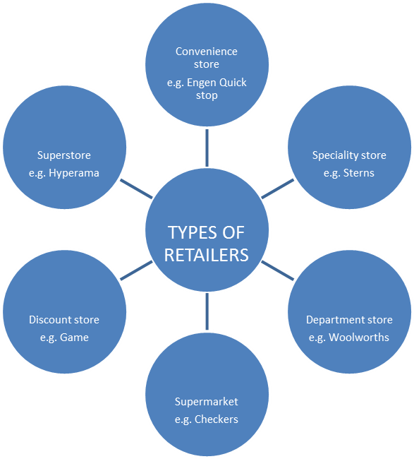

#### Figure 3: Types of Retailers

##### Functions of a Retailer

Despite the size of the various types of retailers, they all share similar functions, viz.

* + - Buy products from wholesalers
    - Store, price and display products
    - Promote products
    - Sell products to consumers

In summary, their goal is simply ……. ***Sales!***

In order to achieve that goal, retailers must identify their target market as being one of the major pillars of the retail environment.

#### http://www.clipartbest.com/cliparts/4i9/9p8/4i99p8kiE.jpegGROUP ACTIVITY 2 (SO1 AC3)

Refer to the types of retailers in Figure 2. What would you classify YOUR STORE as? Answer the question by completing the table below.

|  |  |  |
| --- | --- | --- |
| **NAME OF STORE** | **TYPE OF STORE** | **PRODUCT/S** |
|  |  |  |

# TOPIC 2

## At the end of this topic you will know and be able to: IDENTIFY TARGET MARKETS AND THEIR BEHAVIOUR



|  |  |
| --- | --- |
| **LEARNING OUTCOME** | **AC** |
| Explain what is meant by a consumer profile  List and describe the different types of consumer profiles found in the W&R Sector | AC 1 |
| Explain what is meant by a consumer pattern  Describe different consumer patterns in the W&R Sector | AC 2 |
| Explain the concepts:  ‘target market’ and ‘market segment’  Describe own store’s target market in terms of its market segment | AC 3 |
| List various marketing strategies that is applicable to the W&R industry Identify or retrieve if documented own store’s marketing Strategy  Describe the procedures that own store follows to market the store to the target market | AC 4 |

* 1. ***CUSTOMER PROFILES* (SO 2, AC 2)**

##### What is a customer profile?



A customer profile is a series of descriptive phrases that paint a picture of a selected retail consumer target.

A good customer profile is based on market segments which are defined by answers to the following questions about consumers:

* + - Age - How old are they?
    - Gender - Are they male or female?
    - Geography - Where do they live?
    - Socio-economic grouping - What work do they do?
    - Economics - How much do they earn?

The answers to these questions will ensure that the right products are sold to the right people and at the right price.

E.g. A retailer selling school bags will target customers in the education sector. Those customers may be educators, students or students’ parents. The bags will vary in size, shape, style, colour and price, to cater for the different customer profiles, and their varying needs.

* 1. ***CONSUMER SHOPPING PATTERNS* (SO 2, AC 2)**

Retailers must also be aware of the buying patterns of consumers. In other words, they must pay attention to consumer behaviour.

They do this by asking the following questions:

* + - What product brands do consumers prefer?
    - What makes them choose certain brands over others?
    - What motivates them to buy?
    - When do they buy? i.e. do they make seasonal purchases?
    - Consumers tend to buy products according to a buying process

**2.3 *WHAT IS A TARGET MARKET?* (SO 2, AC 2&3)**



A specific group of consumers or customers at which the retailer aims its products and services

Defining a target market requires market segmentation i.e. pulling apart the entire market and separating the segments in the market according to demographics. This information is important to retailers as they need to be sure that their products are suitable for particular types of customers. If they sell relevant products, their sales and their profits will increase.

To identify their target market, retailers must understand the type of customer that will buy their products. In other words, they must understand their customer profile.

This is illustrated below:

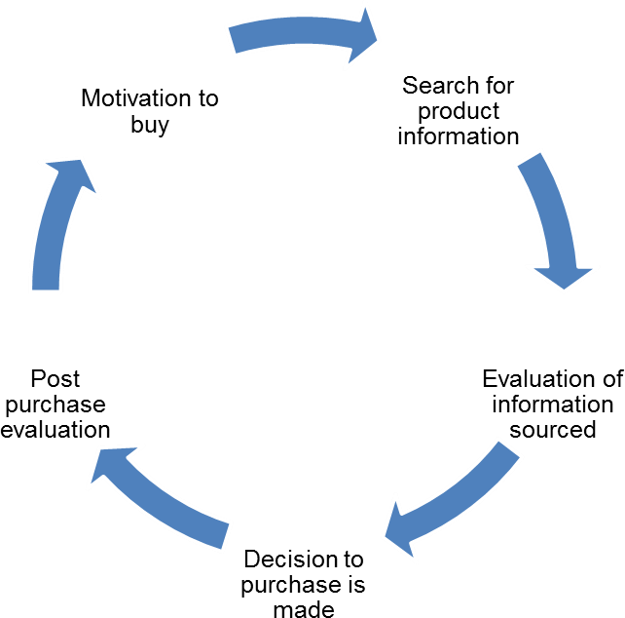

**Figure 4: The purchase process**

##### Motivation to buy

* + - An item is out of stock
    - They are dissatisfied with a current product or service
    - They need or want a particular product
    - They purchase related products or services e.g. a new camera also requires batteries
    - They are enticed by marketing
    - New products on the market

##### Search for product information using:

* + - Personal sources
    - Commercial sources
    - Public sources
    - Personal experience

##### Information evaluation

* + - Brands and products are compared

##### Decision to purchase

* + - Purchase is made

##### Post-purchase evaluation

* + - Decision is made on future purchases

***2.4. MARKETING PROCEDURES* (SO2, AC 2)**



Every retailer appreciates the importance of marketing their products. Hence each store has its own marketing strategy.

#### http://www.clipartbest.com/cliparts/4i9/9p8/4i99p8kiE.jpegGROUP ACTIVITY 3 (SO2 AC2)

Instruction: Divide into **groups of 3** and complete the instruction below.

Discuss the marketing strategies used in your stores. Place your answers in the table below

|  |  |  |  |
| --- | --- | --- | --- |
|  | **STORE 1 –** | **STORE 2 -** | **STORE 3 -** |
| Marketing Strategy 1 |  |  |  |
| Marketing Strategy 2 |  |  |  |
| Marketing Strategy 3 |  |  |  |

***The following guidelines are used in retail marketing:***

#### Customer and market potential

* + Estimate customer potential
  + Estimate market potential
  + Estimate the revenue potential of customers to determine their current, potential and life-time value
  + Consider market opportunities

#### Customer and market profiles

* + Develop more effective communication strategies through a better understanding of who the customers are
  + Learn more about the customers (their age, income, family structure, media usage, life-styles, etc.)
  + Use this information in branding, advertising and direct marketing strategies
  + Identify your market potential through a better understanding of your targets

#### Customer and market segmentation

* + Develop more effective communication strategies through a better understanding of different customer groups and market segments
  + Customize product offers by different customer and market segments
  + Identify target segments and optimize marketing spend

#### Product and service potential

* Identify products/services that best suit the customers’ needs and market offerings more effectively
* Be relevant and improve up-sell and cross-sell initiatives
* Manage products and services through a better understanding of market needs

#### Trade area analysis

* Use the information on the store performance and the socio-demographic characteristics of the trading area to estimate market potential by individual stores
* Use trade area characteristics to customize product offerings, store displays, store size, etc. to be more relevant to customers and to better penetrate the market
* Evaluate performance of stores based on their trade area characteristics
* Determine the optimum number of stores to support market needs
* Customize and optimize stores to attract more customers



**ACTIVITY 5**

#### (SO2 AC2)

**Refer to Activity 5 in your Learner Workbook (20)**

* 1. Consumer profiling is based on FIVE categories. (5) List the five categories
  2. From the list given in 5.1 identify at least TWO categories that apply to YOUR STORE. (2)
  3. Give a reason for your answer to 5.2 (2)
  4. Each store has its own marketing procedures.
     1. Identify TWO different products sold at your store. (2)
     2. Write down the target market that your store aimed those products at. (1)
     3. Identify the shopping pattern/s displayed by the consumers at your store when purchasing those products. (2)
     4. Discuss the marketing procedures used to promote those products to your store’s target market. Attach a sample of your store’s marketing material (6)

***You will answer the questions for 5.4 in a table in your Learner Workbook***

# TOPIC 3

### At the end of this topic you will know and be able to:



UNDERSTAND THE PROCESS OF STOCK- AND CASH FLOW THROUGH IN A RETAIL BUSINESS

|  |  |
| --- | --- |
| **LEARNING OUTCOME** | **AC** |
| Explain the concept of stock flow through in a retail store | AC 2 |
| Explain the concept of cash flow through in a retail store | AC 3 |
| List and explain the purpose of each support function in a retail business Range: HR, Procurement, Cleaning, IT etc. | AC 4 |
| Explain what is meant by ‘systems and sub-systems’ in a retail store Explain the impact of own job on these systems and sub-systems in own  store by making use of examples | AC 5 |

#### THE FLOW OF STOCK AND SALES THROUGH A WHOLESALE/RETAIL OPERATION (SO 3)

A wholesale or retail operation has as its main aim, the sale of stock to its consumers. This is not as simple as it seems for there are many factors that influence the sales process.

##### Operational functional departments in a wholesale/retail store (SO3 AC 3)

Each retail outlet has many departments that offer support functions to each other. These departments include:

|  |  |  |
| --- | --- | --- |
| FUNCTION | SUPPORT/OPERATIONS FUNCTION | PURPOSE |
| Finance/Accounting | Support | Provides cash flow information and releases funds for payment |
| IT (Information Technology) | Support | Ensures smooth and efficient run of electronic technology that the store  may use |
| Supply Chain (Stock) | Operational | Ensures that the store has sufficient stock and that it is ordered and paid for |
| Merchandising | Operational | Ensures that product displays, shelving  and replenishment is according to store’s standards |
| Marketing | Support | Markets the products and promotions on time and in an efficient, cost effective and effective manner to  increase sales |
| Human resources | Support | Takes care of staffing issues such as  scheduling, contracts, compensation, well- being etc. |
| Receiving | Operational Function | Receive goods and ensure reduction of losses in the receiving end. Ensures correct flow through of stock after receipt to speed up and enhance  stock supply on the floor |
| Cleaning | Operational | Assist the store in maintaining high health and housekeeping standards |

#### Figure 5: Operational functional departments in a wholesale and retail store

Support functions are necessary as each department shares a common goal – the efficient sale of stock to the consumer. Support functions **SUPPORT** the Service Departments such as receiving, bakery, butchery, point of sales etc. in a store to be able to operate.

They must therefore function as a team to ensure that the stock supply is efficiently maintained to meet the consumers’ needs.

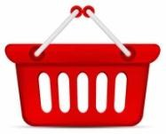**Refer to Workplace Activity 1 (Total 9 – 3 marks per department)** Identify at least 3 departments within YOUR STORE. List the functions that they carry out to support sales. Tabulate your answer in the table as provided in the Learner Workbook

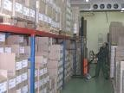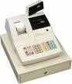

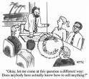

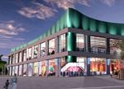

#### Figure 6: Functional operational departments

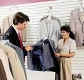

* 1. **The Supply Chain**

##### What is a supply chain?

It is the process that includes all activities related to goods moving from the raw material stage to the manufacturer, the wholesaler, the retailer and finally to the customer

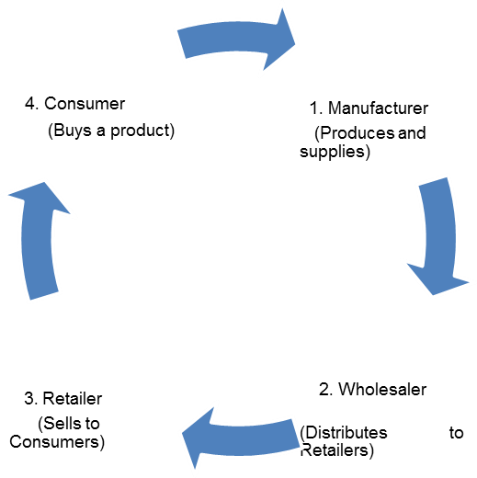

#### Figure 7: The Supply Chain

**Effective Supply Chain Management**

The purpose of the supply chain is to supply the *right goods* at the *right quality*, at the *right time* and at the *right price*.

*Oversupply* in the supply chain will result in goods/products being sold at low prices and therefore low profits. *Undersupply* will mean the store cannot meet the needs of its consumers.

***Remember: A single unhappy customer is one too many!***

#### Principles of the Supply Chain

There are 7 principles of the Supply Chain. These are:

|  |  |
| --- | --- |
| **PRINCIPLE** | **EXPLANATION** |
| 1. Segment the customers | Products stocked must suit customer needs |
| 2. Ensure a good logistics network | Required for customer feedback, data capturing |
| 3. Plan for market demand | Be aware of market changes and plan accordingly |
| 4. Match products to customer demand | Provide sufficient stock of only those products that are in definite demand |
| 5. Manage the source of supply | Work closely with suppliers to provide products and services |
| 6. Make use of technology | Technology must aid communication and supply of products |
| 7. Adopt performance measures | Monitor performance across the supply  chain |

#### Figure 8: Principles of the supply chain

**Principles of effective stock and supply (SO 2 AC 5)**

The retailer must always make sure that stock shortages never occur. It will have various impacts on the organization such as:

#### Effective stock and supply management

**Efficiency Customer Service Supply and demand**

Sufficient stock levels Meet expectations Flexibility in response to

Customer demands

#### Sufficient supply levels

The retailer must make sure that the stock levels at the store are neither too much nor too little. There must be enough stock for customer demand yet also enough money on hand when needed.

#### Maximum and minimum stock levels

Stock must be ordered when the minimum stock level is reached.

#### Excess stock

Too much stock on hand will result in:

* Stock standing and not being sold
* Increased shrinkage
* Waste of time
* Waste of space
* Loss of profit

#### red-basketRefer to Workplace Activity 2 (8)

Investigate the stock and supply principles as they are used at YOUR STORE. Discuss how YOUR STORE responds to each principle.

Put your answers in the table provided in your Learner Workbook.

|  |  |
| --- | --- |
| **Principles of effective stock & supply** | **Explanation of OWN STORE practice** |
| 1. Effective stock and supply management | (2) |
| 2. Sufficient supply levels | (2) |
| 3. Maximum and minimum stock levels | (2) |
| 4. Excess stock | (2) |

**Actual *Flow of stock***

The Flow of Goods / Stock chain will ensure that sufficient levels of stock are achieved through:

* Ordering stock
* Receiving of goods
* Pricing
* Merchandising
* Promotion

Plan

Mark price

Set price

Ordering

Finalise promotion

Promotion

Promote

Prepare for promotion

Finalise deliveries

Receiving

Receive deliveries

Prepare for deliveries

#### Figure 9: Flow of Stock

Merchandise

Merchandising

Change price

Pricing

**26** |LEARNER G U I D E : 1 1 4 8 9 5

#### The flow of stock explained

1. **Ordering**

When ordering, it is important to know which suppliers to use based on quality, service and price.

A normal order is the day-to-day stock replenishment for the store. These orders are usually placed with the store’s Distribution Centre and direct suppliers.

A promotional order is a special order for extra stock before a promotion

#### Receiving

**Prepare for deliveries:**

* + Set up the correct security measures to receive the delivery
  + Have a security checklist
  + Have a checklist for damaged goods
  + Have a delivery schedule that shows what is being delivered when and by whom

#### Receiving deliveries:

* + - Check the service level report to determine out of stock information
    - Check the address on the invoice/Delivery note to ensure that the delivery is for your store
    - Check the seal number on the truck with the seal number on the LDA and break the seal if correct
    - Contact your distribution centre if the number is incorrect
    - Unload the truck carefully to avoid damage to the goods
    - Use control measures to ensure security and quality of goods
    - Check, together with the driver, that the number of boxes specified on the LDA, correspond with the number of boxes on the truck
    - Report any shortages to the distribution centre
    - Stamp supplier invoices with the Store G.R.V. stamp to avoid fraud
    - Sign the LDA once the uploading is completed
    - Sign the Driver’s Daily routine Sheet
    - Seal the vehicle and record the seal number on the LDA
    - Lock the receiving gates

#### Finalise deliveries:

* + Use the goods received voucher to record stock received from the suppliers
  + Determine any discrepancies between the Priced Order and the G.R.V.

#### Pricing

**Market price:** the same as the general market price for competing goods

**Odd price:** this makes the customers believe that the product is cheap e.g. R299

**Penetration price:** Set below market price to gain as much of the market share as possible

#### displayMerchandising

**E**ffective merchandising will:

* maximize the returns on the selling space in the store
* prevent loss of money due to overstocking
* offers customers a personal touch by helping them to find what they are looking for quicker

#### Advertising

Various forms of media may be used to promote a store and its goods. These may include:

* + radio



* + television
  + billboards
  + pamphlets
  + magazines
  + newspapers

The type of advertising media used will depend on the budget available.

#### Promotion

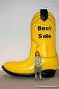Promotion boosts sales and gives the store more media coverage. Some of the tools used by wholesalers and retailers in promotion include:

* + samples
  + coupons
  + games
  + gondola ends
  + point of purchase displays

#### red-basketRefer to Workplace Activity 3 (12)

Describe the Flow of Goods Process within YOUR STORE. Use the headings provided in the table below.

#### THE FLOW OF CASH (AC 3)

Every wholesaler or retailer manages cash as an operational process in the store. This may be through:

* petty cash
* sales
* purchases
* wages
* salaries

The Cash flow cycle in a general Retail store should look as follows:

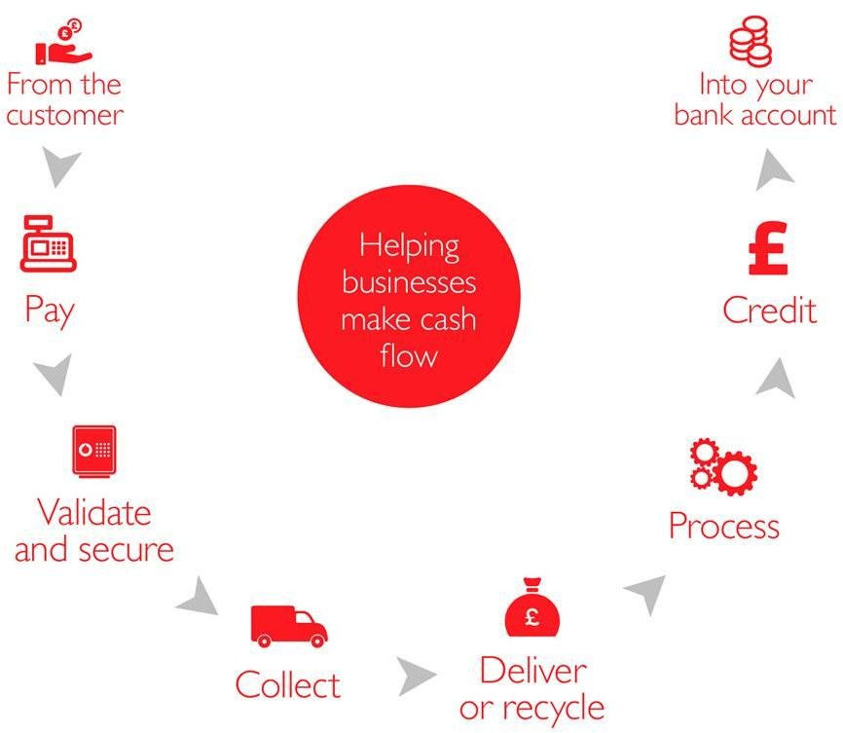

Fidelity delivers to the bank or back to the store again on a delivery note

Process the cash delivery – do the paperwork

Some store have a credit facility to enhance cash flow – if they need to request credit from their collection, they complete the paperwork

Delivery/Cash takings are paid into the business bank account

#### Figure 10: Cash flow cycle in retail

For security reasons, certain procedures are put in place to protect the employees as well as to secure the stores’ money:

#### Access to the cash office

* The office is occupied by the Chief Cashier
* No visitors are allowed in the office
* Only cashiers and managers are allowed entry

#### Security measures for the cash office

* No unauthorized staff are allowed to enter the cash office
* The office is secured behind two gates – an inner and outer gate
* Normal staff members stand between the first and second gate and address the Chief Cashier through a window
* Fidelity guards must show their identity cards to the Chief Cashier through the window, before they are allowed access through the second gate
* Fidelity guards must sign the fidelity book, including the date and time of entry
* They issue a pick up slip from their book signed by them, with the bag numbers entered on the slip

#### Security equipment in the cash office

* CCTV camera – used to check if you are allowing access to the right person
* 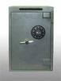Panic buttons – used during emergencies
* Access doors – controls entry
* Time delay on the safe
* Drop safe

#### Procedures when issuing change

* The front end controller gives the chief cashier a requisition slip with the amount requested in notes
* The chief cashier checks signatures on the requisition slip, issues the change, signs the requisition slip and puts it in the bag with the change

#### petty cash boxPetty cash

Cash FloatEvery store needs to have some money available within the store for emergency or small purchases. This is called a petty cash float. The petty cash float is used to make small payments to a maximum of a pre- determined amount.

Every item that was bought with the petty cash must have a receipt or invoice from the supplier of the goods or services, or a signed voucher by the receiver of the petty cash.

The receipt must be attached to the petty cash voucher

The only monies received into petty cash must be the money that replaces what was spent.

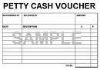All other income to the store must be directed to the Cash Office so that it can be recorded correctly and then banked.

#### Petty cash may not be used for: X Alcohol

**X** Wages

**X** Gifts to members of staff

**X** Non business use of goods/services

**X** Entertainment

#### Refer to Workplace Activity 4 (12)

Complete this activity in the Workplace Logbook

# TOPIC 4

## At the end of this topic you will know and be able to: UNDERSTAND LEGISLATION AND its IMPACT ON THE RETAIL SECTOR



|  |  |
| --- | --- |
| **LEARNING OUTCOME** | **AC** |
| List the various legislation in own country that impacts on the retail industry | AC 1 |
| State the objectives of each of the listed legislations | AC 2 |
| List and explain at least 10 general W&R Terms as used in the Retail Industry  Use each of the listed terms in context of a retail example  Range: customer, consumer, shrinkage, price, promotion, losses, profits, displays, merchandising, sales, supply chain, till slip, Pi Label, price tag etc. | AC 3 |

#### legislation4.1. LEGISLATION THAT IMPACT ON THE INDUSTRY (SO 4 AC 1)

As registered employers all wholesalers and retailers must comply with legislation that governs the manner in which they operate their business.

If they ignore or disregard legislation, they could be fined or imprisoned, depending on the severity of the situation.

All legislation with which employers must comply is designed to protect workers and the environment in which they work.

##### 4.2 The objectives of the different pieces of legislation (SO 4 AC 2)

The table below reflects the legislation that impact on the wholesale and retail industry. It explains the objectives of each piece of legislation.

|  |  |
| --- | --- |
| **LEGISLATION** | **OBJECTIVE** |
| 1. Employment Equity | Management’s commitment to ensure fair consideration of all applicants |
| 2. Wage Determination | to ensure wages are paid according to duties performed |
| 3. Skills Development Levy | A compulsory levy scheme with the purpose of funding education and training. This is payable monthly |
| 4. Unemployment Insurance Fund (UIF) | Compulsory contribution to fund unemployment benefits |
| 5. Pay as you earn (PAYE) | A monthly deduction from an employee’s salary payable to SARS |
| 6. Value Added Tax (VAT) | To provide for taxation in respect of goods and services |
| 7. Occupational Health & Safety | the protection of employees from incurring illness at work |
| 8. Basic Conditions of Employment | to ensure fair labour practice |
| 9. Labour Relations | to protect the rights of the employer and employee in the workplace |

#### Figure 11: Legislation impacting the wholesale and retail industry

**(SO4 AC2)**



**ACTIVITY 6**

#### Refer to Activity 6 in your Learner Workbook

* 1. Identify the legislation that impacts on YOUR STORE.
  2. Indicate what impact the legislation has for the employees at your store.



**LET’S TALK**

**RETAIL!**

#### General wholesale and retail terms (SO 4 AC 3)

Customer person who purchases goods or service from the retailer

s

the mer

Consumer person who actually consumes, or uses, goods or services. Also a client or custo

Profit Total income minus total expenses

Waybill Pre-printed sheet that is used when couriering documents or packages.

#### It contains the following information:

* + - The person receiving the package
    - The person sending the package
    - A short description of the goods and the quantity being sent

DC Distribution Centre

Retailing All the activities involved in selling goods and/or services directly to the final consumers or their personal, non-business use

Shrinkage This refers to the loss of stock due to shoplifting, theft, fraud, negligence of employees, and damage to goods during storage, display or handling

The Supply Chain The process that includes all activities related to goods moving from the raw material stage to the manufacturer, the wholesaler, the retailer and finally to the customer

Merchandising The display, promotion and marketing of goods to increase sales

Promotions The communication with individuals, groups or organisations to directly or indirectly facilitate exchanges by influencing audience members to accept an organisation’s products and/or services, to increase sales

Displays Methods of drawing attention to a particular range of products by making them more visible

Product Assortment A collection of a variety of products

Conflict Disagreement between parties on various issues

Direct Marketing A form of promotion in which organisations communicate with consumers through methods such as telemarketing, direct- response advertising and direct mail

Credit note it is used when dispatching stock

Acknowledgement The process of bringing the stock into a Point of Sale (POS) system

Creditors Audit Trail This lists all the GRN’s done over a particular time period

Market Share Refers to the percentage of customer loyalty belonging to a store

Scanning At the checkout counter the consumers’ products are electronically scanned. The scanning of the bar codes records the price of the item on the cash register

Till slip This is a printout of all purchases made by customers

Stock take This occurs daily, weekly and monthly depending on the product and ensures what products are in the store and what must be ordered as well as what may be lost or stolen

Picking label This is a computerized label indicating the member’s name, product description, product code, warehouse location, retail selling price and the quantity of goods that require picking

Sell by date This is the date by which a particular product has to be sold.

Vacuum system The receiving room has two inter leading doors, one which opens to the delivery truck and one which opens into the stockroom. Both doors need to be locked before the delivery truck arrives. Once delivery has been received there is a point when both doors are locked thereby creating a vacuum system. This reduces shrinkage.

Receiving The stock room is the store area where goods received are stored and packed neatly. Certain retailers place their stock room nearby their selling area for efficiency.

Receiving area Goods are received from a delivery truck in the receiving area and sent to the floor or dispatched to the stock room and then to the floor

Distributing This is the process when the wholesaler and retailer moves their stock out. This is a profit generating activity

Distribution area This is the area from where the stock leaves and enters, at a store level

G.R.V. The goods received voucher is used to record stock received from suppliers at the backdoor

#### http://www.clipartbest.com/cliparts/4i9/9p8/4i99p8kiE.jpegGROUP ACTIVITY 4 (SO4 AC3)

Instruction: Divide into **groups of 3** and complete the instruction below.

Discuss any other terms and concepts that are used at your stores. List your answers.

# TOPIC 5

## At the end of this topic you will know and be able to: UNDERSTAND SHRINKAGES AND LOSSES IN THE RETAIL SECTOR



|  |  |
| --- | --- |
| **LEARNING OUTCOME** | **AC** |
| Explain the terms ‘shrinkage’ and ‘losses’ and their interconnectivity | AC 1 |
| Identify and list ways in which shrinkage and losses can occur | AC 2 |
| Explain the reasons for preventative policies and procedures for shrinkage and losses | AC 3 |
| Explain the impact of shrinkages and losses on a retail store | AC 4 |

#### SHRINKAGE AND LOSSES WITHIN A W&R ENVIRONMENT (SO 5)

* 1. ***Concept of shrinkage and losses* (SO 5 AC 1)**

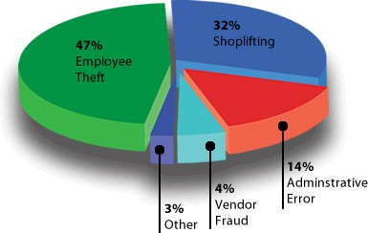Retail shrinkage is a reduction or loss of stock and therefore profits within a store.

**Shrinkage** is referred to as the percentage of ***loss of products*** between their manufacture point and point of sale.

#### Figure 12: Sources of shrinkage and losses in wholesale and retail

* 1. **SOURCES (METHODS) IN WHICH SHRINKAGE CAN OCCUR (SO 5 AC2)**
     1. Employee Theft:

Internal theft can include the abuse of staff discounts, refunds, and credit cards. Unfortunately this is one loss prevention area which does not generally receive as much monitoring as customer theft. “

* + 1. Consumer Theft (Shoplifting):

Shoplifting can occur through concealment, altering or swapping of price tags, or transferring from one package to another. This can be prevented through the use of security tags and increased security on the shop floor but is still a major problem in the retail industry.

* + 1. Administrative Error:

Paperwork errors make up a small percentage of shrinkage but the error in simple pricing mistakes due to markups or markdowns can cost the retailer quite a bit.

* + 1. Vendor Theft:

Yes, vendors the very people that supply you with merchandise have stolen from retailers. We are not saying that every vendor will do this. Most suppliers are hardworking and trying to earn and keep your business. But vendor fraud accounts for approximately 4% of a retailers losses.

However, they are a business just like you. If they have employees that are stealing this could affect you.

How?

Say you are supposed to get 24 items in a carton. But a thief in the vendor’s facility only packs 23 to a carton in your shipment.

They take the lost one out of each and put it in the trash then come back later and get them out of the trash. If you are only checking in the cartons and not piece counting you are putting money in that piggy bank of the vendor’s thief.

##### REASONS FOR PREVENTATIVE POLICIES AND PROCEDURES (SO 5 AC 3)

Store owners need to find ways to reduce the amount of theft and shrinkage in their stores. Constant shrinkage will lead to a loss of income and therefore a loss of profit.

They can do this by implementing a loss prevention plan. The plan could include:

* + - Tagging items
    - Increased security personnel
    - Installation of CCTV cameras
    - Single entry access points to the store
    - Single exit points from the store

#### GROUP ACTIVITY 5 (SO5 AC3)

Instruction: Divide into **groups of 3** and complete the instruction below. Discuss the preventative measures that are used at your stores.

#### (SO5 AC3)



**ACTIVITY 7**

**Refer to Activity 7 in your Learner Workbook**

11.1 Compare the similarities and differences between the preventative measures used at each of the stores that you discussed in Group Activity 5.

Record those similarities and differences in the table in your Learner Workbook

##### THE IMPACT OF SHRINKAGE AND LOSSES ON AN ORGANISATION (AC 4)

Shrinkage has an impact not just on the store, but on the employees also. Stock losses will result in:

* + - loss of customers if the store cannot provide them with the required goods
    - reduced profit due to write offs
    - bankruptcy due to shortage of cash flow because of losses
    - reduced working hours (short time) for staff
    - poor or no salary increases
    - retrenchment

#### (SO5 AC2)



**ACTIVITY 8**

Compare the similarities and differences between the preventative measures used at each of the stores discussed in Group Activity 4.

Record those similarities and differences in the table below

|  |  |  |  |
| --- | --- | --- | --- |
|  | **STORE 1** | **STORE 2** | **STORE3** |
| Preventative Measures Used | 1.  2.  3.  4. | 1.  2.  3.  4. | 1.  2.  3.  4. |
| Similarities | 1.  2.  3.  4. | | |
| Differences | 1.  2.  3.  4. | | |

## KNOWLEDGE TEST TOTAL: 16

Write these answers in the learner workbook

#### QUESTION 1

Name four Sub-Sectors in the Wholesale and Retail Sector

(4)

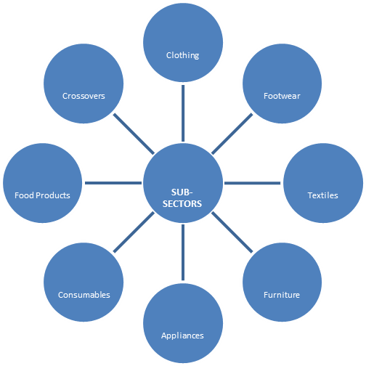

#### QUESTION 2

Explain what is meant with the term ‘Stakeholder’ and give two examples. State which stakeholder example is an internal stakeholder and which one is an external stakeholder

(5)

#### QUESTION 3

List 1 category that can be found in the furniture sub-sector (1)

#### QUESTION 4

* 1. Explain the terms ‘shrinkage’ and ‘losses’ (2)

**QUESTION 5** (4)

Explain the terms ‘customer’ and ‘supply chain’

#### Reference List:

* + 1. Unknown. Retail marketing, concepts and research model. [www.springer.com/cda/content/.../cda.../9783658046293-c1.pdf](http://www.springer.com/cda/content/.../cda.../9783658046293-c1.pdf)?. Date of access: 26 March 2013
    2. Unknown. 10 Retail Selling Tips. [*www.retaildoc.com/blog/ten-retail-selling-tips*](http://www.retaildoc.com/blog/ten-retail-selling-tips) Date of access: 26 March 2013
    3. Unknown, RMSA Retail Solutions. [www.rmsa.com.](http://www.rmsa.com/) Date of access: 26 March 2013.
    4. Technical Experience



