



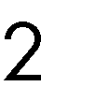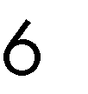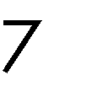

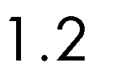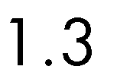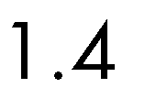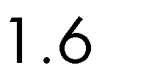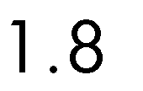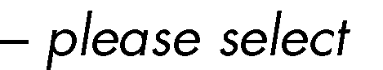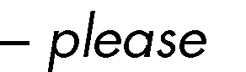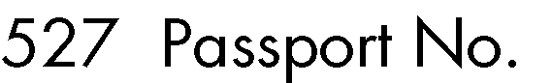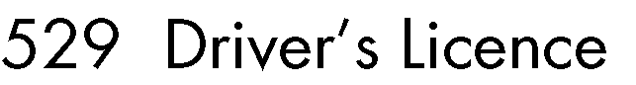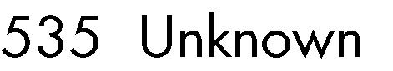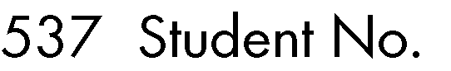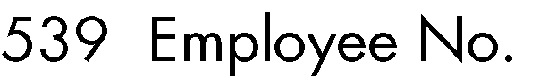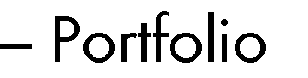

|  |  |  |  |
| --- | --- | --- | --- |
|  |  |  |  |
|  |  |  |  |
|  |  |  |  |
|  |  |  |  |

 









•







•

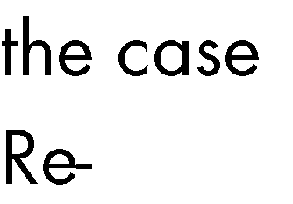

▪

▪

▪

▪

•

•

•

•

•

•

•

•

•

 





 

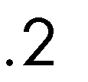

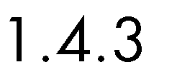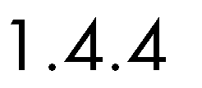

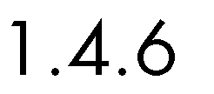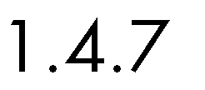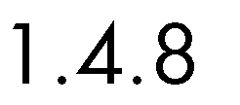



 



 

 















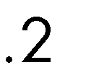



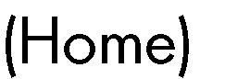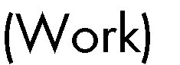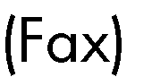

□

□

□

□



|  |  |  |  |  |
| --- | --- | --- | --- | --- |
|  | | | | |
|  | | | | |
|  | | | | |
|  | | | | |
|  | | | | |
|  | | | | |
|  | | | | |
|  |  |  | |  |
|  |  |
|  |  |  |  |  |
|  |  |  |  |  |
|  |  |  |  |  |
|  |  |  |  |  |

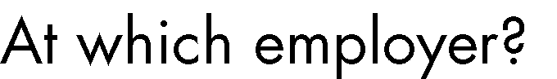

|  |  |  |  |  |
| --- | --- | --- | --- | --- |
|  |  |  |  |  |
|  |  |  |  |  |
|  |  |  |  |  |
|  |  |  |  |  |

|  |
| --- |
|  |
| •  •  •  • |

|  |  |  |  |  |  |  |  |  |
| --- | --- | --- | --- | --- | --- | --- | --- | --- |
|  | | | | | | | | |
|  | |  | | |  |  | | |
|  | |  | | |  |  | | |
|  | | | | | | | | |
|  |  | |  |  | | |  |  |













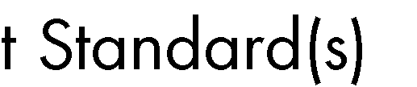





|  |
| --- |
|  |
|  |

|  |  |  |  |  |
| --- | --- | --- | --- | --- |
|  | | | | |
|  |  | | | |
|  |  | | | |
|  | |  | | |
|  | |  | | |
|  | | | | |
|  | | | | |
|  | | |  | |
|  | | |  | |
|  |  |  |  |  |
|  |  |  |  |  |
|  | |  |  |  |
|  | |  |  |  |
|  | |  | | |
|  | |  | | |



|  |
| --- |
|  |
|  |
|  |



|  |
| --- |
|  |
|  |
|  |
|  |
|  |
|  |
|  |
|  |
|  |
|  |
|  |
|  |
|  |
|  |
|  |
|  |
|  |
|  |
|  |
|  |
|  |
|  |
|  |
|  |
|  |
|  |
|  |
|  |
|  |
|  |
|  |
|  |
|  |
|  |
|  |
|  |
|  |
|  |



|  |
| --- |
|  |
|  |
|  |
|  |
|  |
|  |
|  |
|  |
|  |
|  |
|  |
|  |
|  |
|  |

|  |
| --- |
|  |
|  |
|  |
|  |



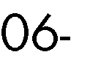





|  |  |  |  |  |  |  |  |  |  |  |  |  |  |  |
| --- | --- | --- | --- | --- | --- | --- | --- | --- | --- | --- | --- | --- | --- | --- |
|  |  |  | | | |  |  | | | | | | | |
|  |  |  |  |  |  |  |  |  |  |  |  |  |  |  |
|  |  |  |  |  |  |  |  |  |  |  |  |  |  |  |
|  |  |  |  |  |  |  |  |  |  |  |  |  |  |  |
|  |  |  |  |  |  |  |  |  |  |  |  |  |  |  |
|  |  |  |  |  |  |  |  |  |  |  |  |  |  |  |
|  |  |  |  |  |  |  |  |  |  |  |  |  |  |  |
|  |  |  |  |  |  |  |  |  |  |  |  |  |  |  |
|  |  |  |  |  |  |  |  |  |  |  |  |  |  |  |
|  |  |  |  |  |  |  |  |  |  |  |  |  |  |  |
|  |  |  |  |  |  |  |  |  |  |  |  |  |  |  |
|  | | | | | | | | | | | | | | |
|  |  |  |  |  |  |  |  |  |  |  |  |  |  |  |
|  |  |  |  |  |  |  |  |  |  |  |  |  |  |  |
|  |  |  |  |  |  |  |  |  |  |  |  |  |  |  |
|  |  |  |  |  |  |  |  |  |  |  |  |  |  |  |
|  |  |  |  |  |  |  |  |  |  |  |  |  |  |  |
|  |  |  |  |  |  |  |  |  |  |  |  |  |  |  |
|  |  |  |  |  |  |  |  |  |  |  |  |  |  |  |
|  |  |  |  |  |  |  |  |  |  |  |  |  |  |  |
|  |  |  |  |  |  |  |  |  |  |  |  |  |  |  |
|  |  |  |  |  |  |  |  |  |  |  |  |  |  |  |
|  |  |  |  |  |  |  |  |  |  |  |  |  |  |  |
|  |  |  |  |  |  |  |  |  |  |  |  |  |  |  |
|  |  |  |  |  |  |  |  |  |  |  |  |  |  |  |
|  |  |  |  |  |  |  |  |  |  |  |  |  |  |  |
|  |  |  |  |  |  |  |  |  |  |  |  |  |  |  |
|  |  |  |  |  |  |  |  |  |  |  |  |  |  |  |
|  |  |  |  |  |  |  |  |  |  |  |  |  |  |  |

|  |  |  |  |  |  |  |  |  |  |  |  |  |  |  |
| --- | --- | --- | --- | --- | --- | --- | --- | --- | --- | --- | --- | --- | --- | --- |
|  |  |  | | | |  |  | | | | | | | |
|  |  |  |  |  |  |  |  |  |  |  |  |  |  |  |
|  |  |  |  |  |  |  |  |  |  |  |  |  |  |  |
|  |  |  |  |  |  |  |  |  |  |  |  |  |  |  |
|  |  |  |  |  |  |  |  |  |  |  |  |  |  |  |
|  |  |  |  |  |  |  |  |  |  |  |  |  |  |  |
|  |  |  |  |  |  |  |  |  |  |  |  |  |  |  |
|  |  |  |  |  |  |  |  |  |  |  |  |  |  |  |
|  |  |  |  |  |  |  |  |  |  |  |  |  |  |  |
|  |  |  |  |  |  |  |  |  |  |  |  |  |  |  |
|  |  |  |  |  |  |  |  |  |  |  |  |  |  |  |
|  |  |  |  |  |  |  |  |  |  |  |  |  |  |  |
|  |  |  |  |  |  |  |  |  |  |  |  |  |  |  |
|  |  |  |  |  |  |  |  |  |  |  |  |  |  |  |

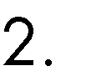

 









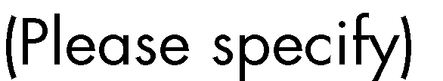

 





 

 

 

o



o 

o 

o 

 









|  |  |  |  |  |
| --- | --- | --- | --- | --- |
|  | | | | |
|  | | | | |
|  | | | | |
|  |  | |  |  |
|  |  | |  |  |
|  | | | | |
|  | |  | |  |
|  | |  | |  |
|  | |  | |  |
|  | |  | |  |
|  | |  | |  |
|  | |  | |  |
|  | |  | |  |









|  |  |  |
| --- | --- | --- |
|  |  |  |
|  |  |  |
|  |  |  |
|  |  |  |
|  |  |  |
|  |  |  |
|  |  |  |
|  |  |  |
|  | | |
|  |  |  |
|  |  |  |
|  |  |  |
|  |  |  |
|  |  |  |
|  |  |  |
|  |  |  |
|  |  |  |
|  |  |  |
|  |  |  |
|  |  |  |
|  |  |  |
|  |  |  |



 











|  |  |
| --- | --- |
|  |  |
|  |  |
|  |  |
|  |  |
|  |  |



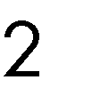



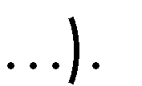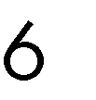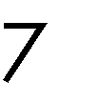





|  |  |  |  |
| --- | --- | --- | --- |
|  |  | |  |
|  | |  | |
|  | |  | |
|  | |  | |
|  | |  | |





|  |  |  |
| --- | --- | --- |
|  |  |  |

**Customers**

|  |  |  |  |
| --- | --- | --- | --- |
|  |  |  |  |
|  |  |  |  |
|  |  |  |  |
|  |  |  |  |
|  |  |  |  |



|  |  |  |
| --- | --- | --- |
|  | •  •  •  •  • |  |
|  | | |

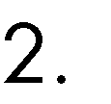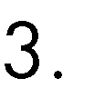



 

|  |  |  |  |
| --- | --- | --- | --- |
|  |  | | |
|  |  | | |
|  |  |  |  |
|  |  |
|  |  | | |
|  |  |  |  |
|  |  |
|  |  |  |  |
|  |  |
|  |  |





|  |  |  |  |  |  |  |  |
| --- | --- | --- | --- | --- | --- | --- | --- |
|  |  |  |  | | | | |
|  | |  | |  |
|  |  |  |  |
|  |  |  |  |  |  |  | *J Nxumalo* |
|  |  |  |  |  |  |  | *J Nxumalo* |



|  |  |  |  |  |  |  |  |
| --- | --- | --- | --- | --- | --- | --- | --- |
|  |  |  |  | | | | |
|  | |  | |  |
|  |  |  |  |
|  |  |  |  |  |  |  |  |

|  |  |  |  |  |  |  |  |
| --- | --- | --- | --- | --- | --- | --- | --- |
|  |  |  |  | | | | |
|  | |  | |  |
|  |  |  |  |
|  |  |  |  |  |  |  |  |
|  |  |  |  |  |  |  |  |
|  |  |  |  |  |  |  |  |
|  |  |  |  |  |  |  |  |
|  |  |  |  |  |  |  |  |
|  |  |  |  |  |  |  |  |
|  |  |  |  |  |  |  |  |

|  |  |  |  |  |
| --- | --- | --- | --- | --- |
|  | | | | |
|  |  | |  |  |
|  | |  | | |
|  | | | | |
|  | |  |  |  |

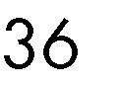





|  |  |  |  |  |
| --- | --- | --- | --- | --- |
|  | | | |  |
|  |  |  | | |
|  |  |  | | |
|  |  |  | | |
|  |  |  | | |
|  | | | | |
|  |  | |  |  |

|  |  |  |
| --- | --- | --- |
|  | |  |
|  |  | |
|  |  | |
|  |  | |
|  |  | |
|  |  | |
|  |  | |



|  |  |
| --- | --- |
|  |  |

|  |  |
| --- | --- |
|  |  |
|  | |
|  | |
|  | |
|  | |
|  | |
|  | |
|  | |
|  | |
|  | |
|  | |
|  | |
|  | |
|  | |
|  | |
|  | |
|  | |
|  | |
|  | |
|  | |
|  | |
|  | |
|  | |
|  | |
|  | |

|  |  |
| --- | --- |
|  |  |



|  |  |  |  |  |
| --- | --- | --- | --- | --- |
|  | •  •  •  •  •  • |  |  |  |
|  |  |  |  |  |
|  | |  | | |
|  | |  | | |





|  |  |  |  |
| --- | --- | --- | --- |
|  | | |  |
|  |  |  | |
|  |  |  | |
|  |  |  | |
|  |  |  | |

|  |  |  |
| --- | --- | --- |
|  |  |  |
|  |  |  |
|  |  |  |
|  |  |  |
|  |  |  |



|  |  |
| --- | --- |
|  |  |
|  | |
|  | |
|  | |
|  | |
|  | |
|  | |
|  | |
|  | |
|  | |
|  | |
|  | |
|  | |
|  | |
|  | |
|  | |
|  | |
|  | |





|  |  |  |  |
| --- | --- | --- | --- |
|  | | | |
|  |  |  |  |
|  |  |  |  |
|  |  |  |  |
|  |  |  |  |
|  |  |  |  |
|  |  |  |  |
|  |  |  |  |
|  |  |  |  |
|  |  |  |  |
|  | | | |



 

|  |  |  |  |
| --- | --- | --- | --- |
|  |  |  |  |
|  |  |  |  |
|  |  |  |  |

|  |  |  |  |
| --- | --- | --- | --- |
| **Y N** |  |  |  |



      
      
      
      
      

      
      
      
      

          
          
       
      
         
      

        
        
     
      
      
        





                
                
            
             
             
             
             
             
             
         
            
            
            



                
                
         
              
          
         
          
          
            
         
          

        
        
        
     
      
       
     
      
        