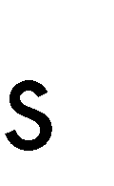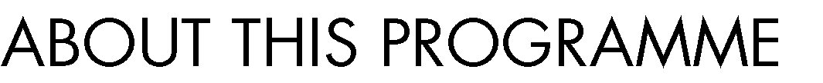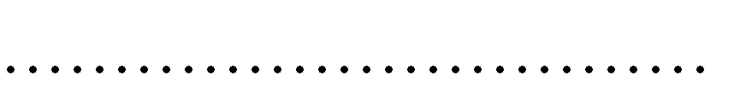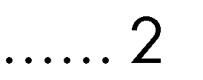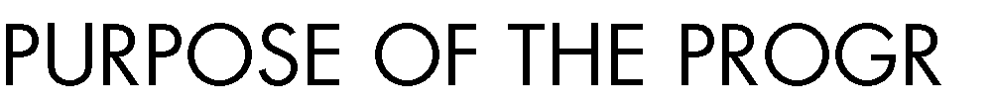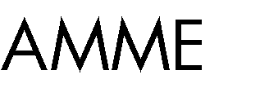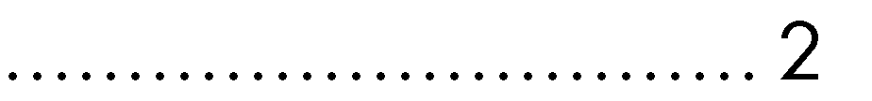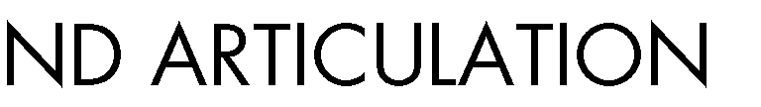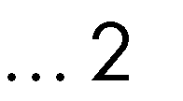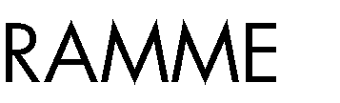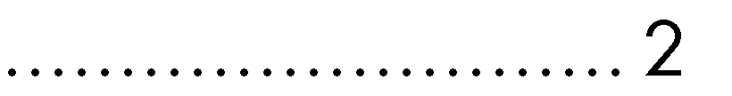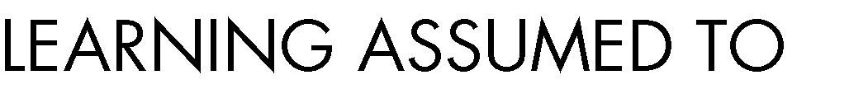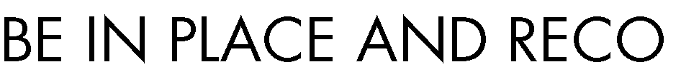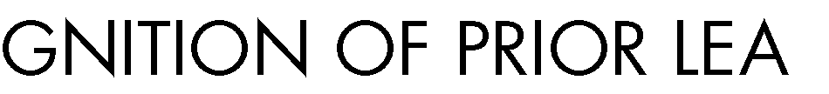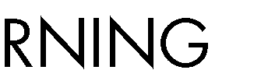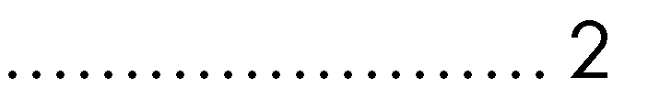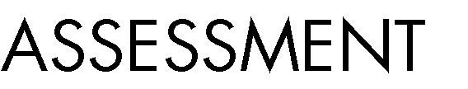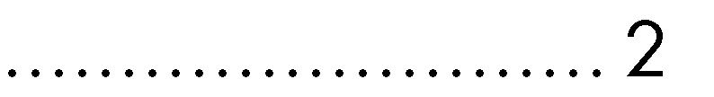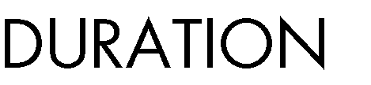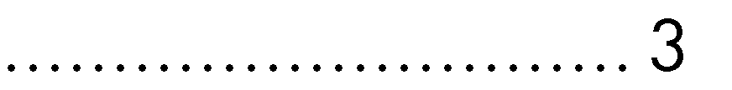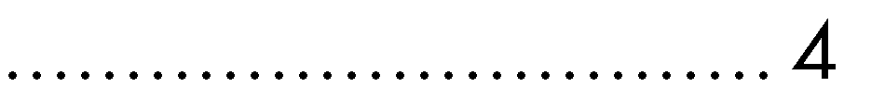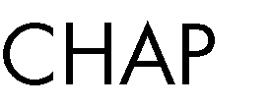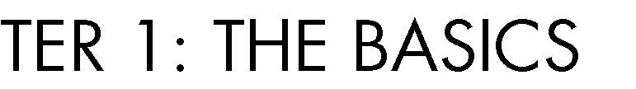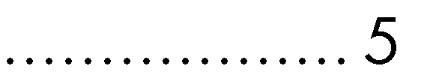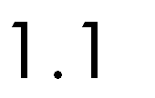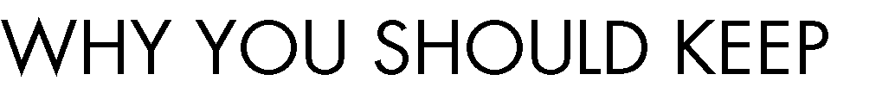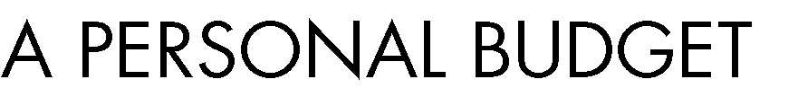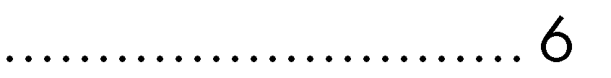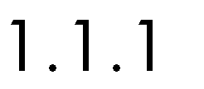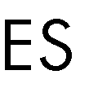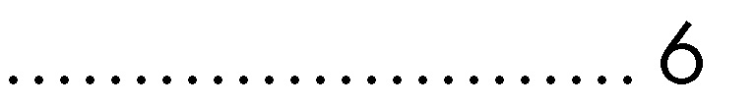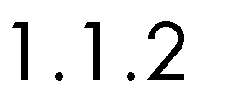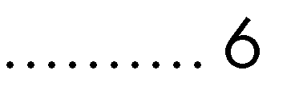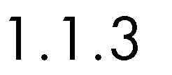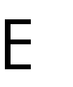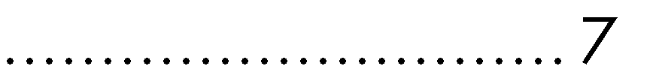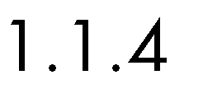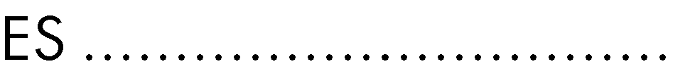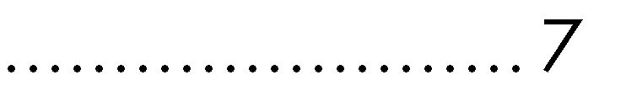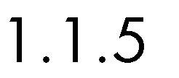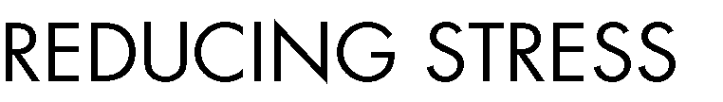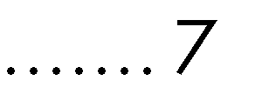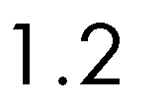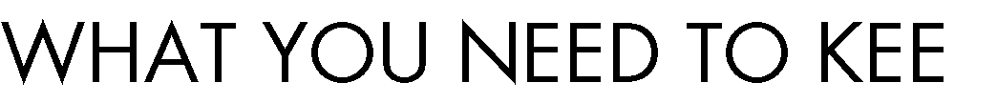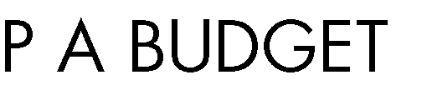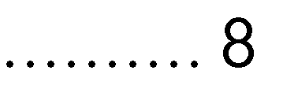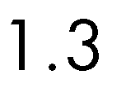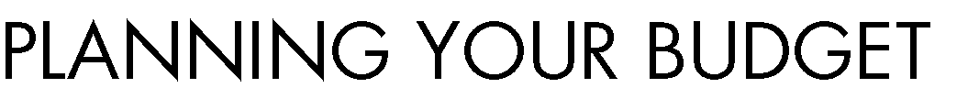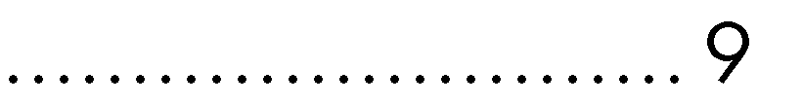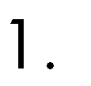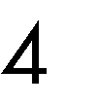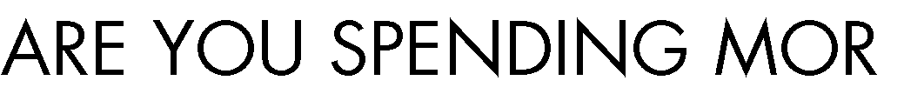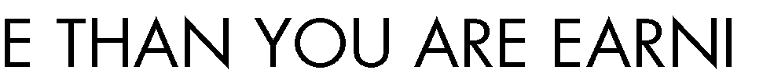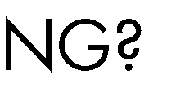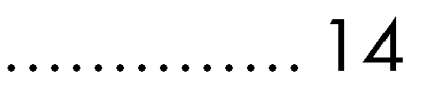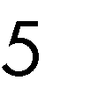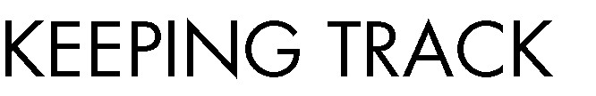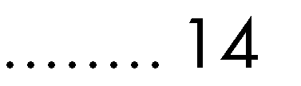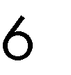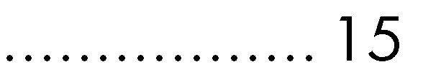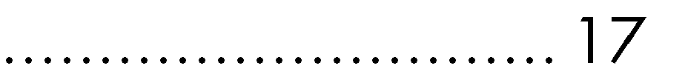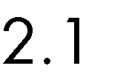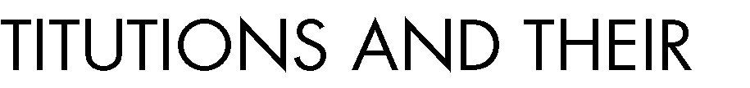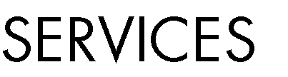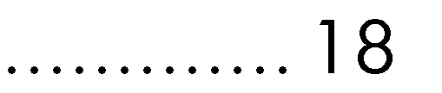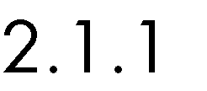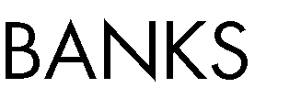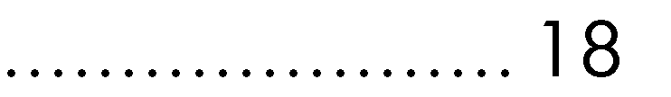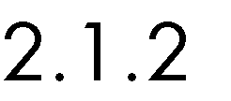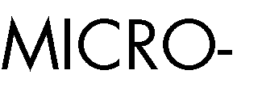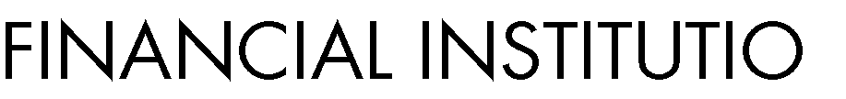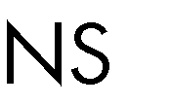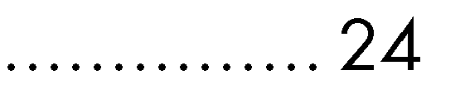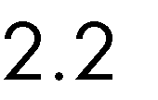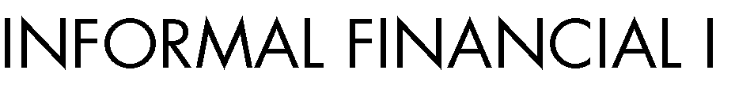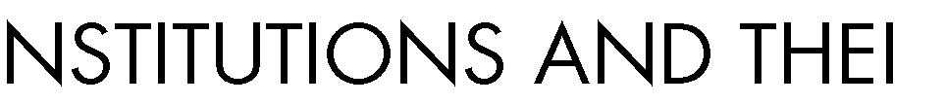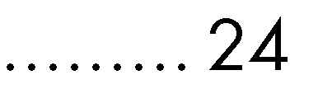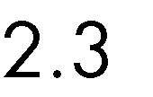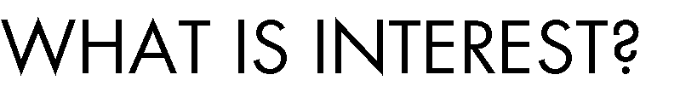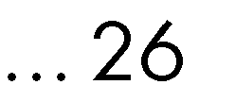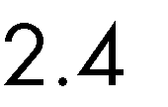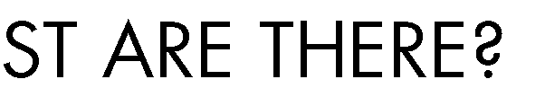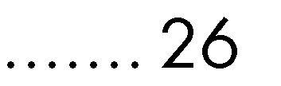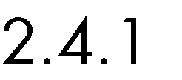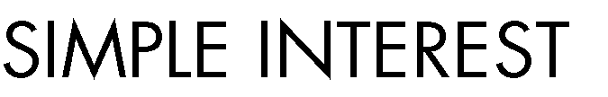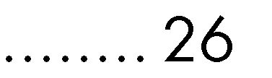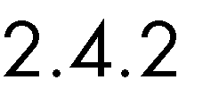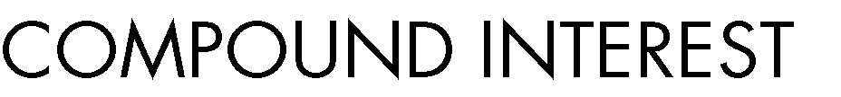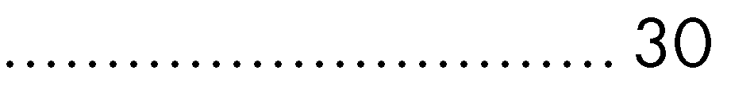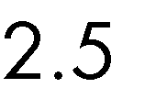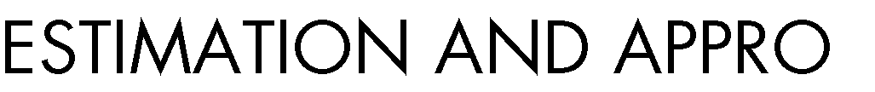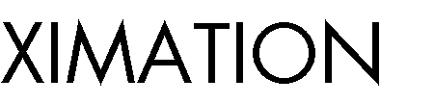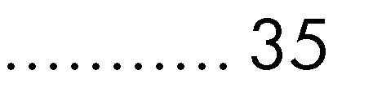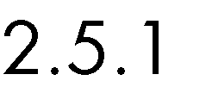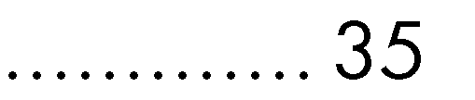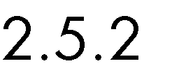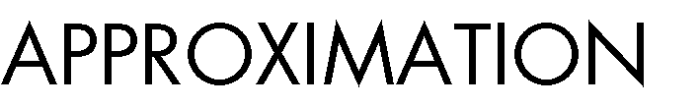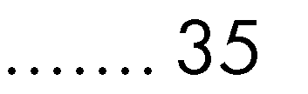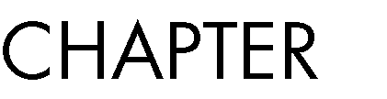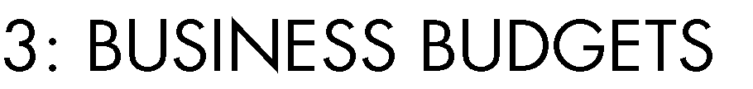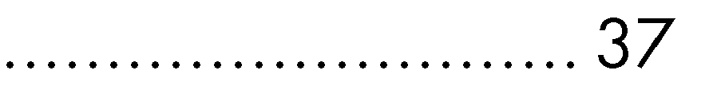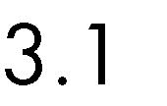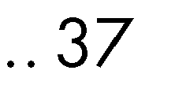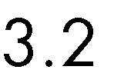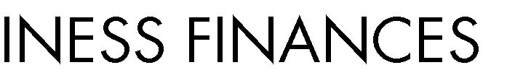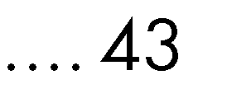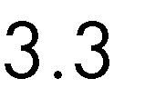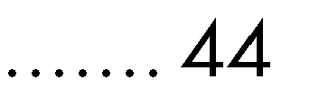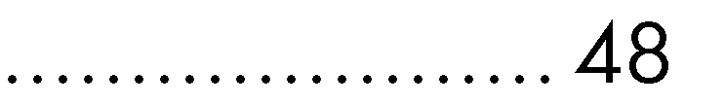



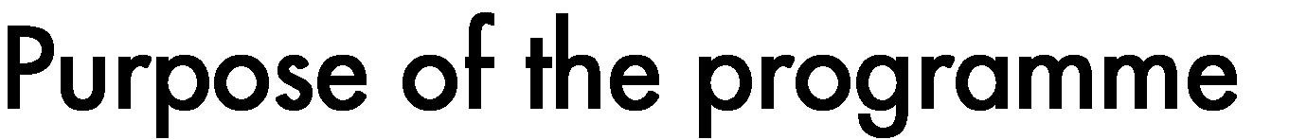





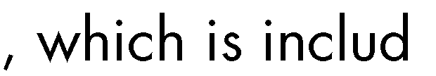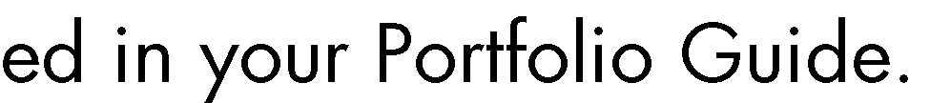



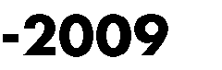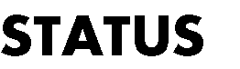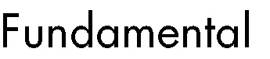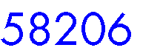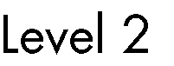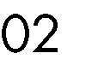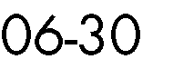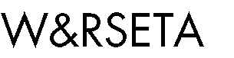



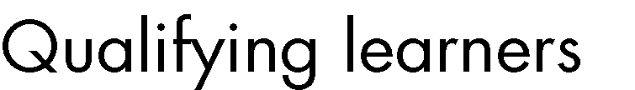

•

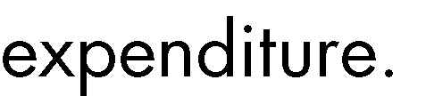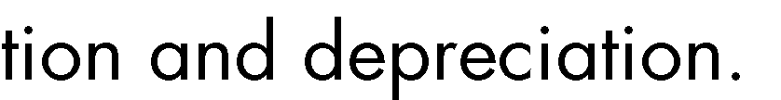

•

•

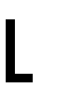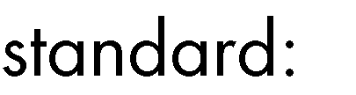

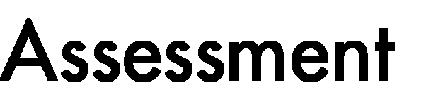

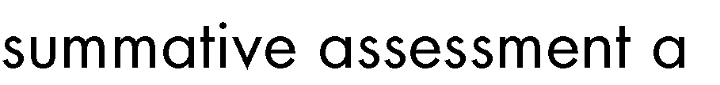







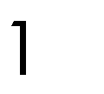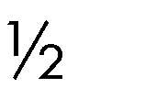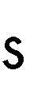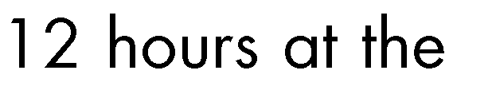











|  |  |
| --- | --- |
|  |  |
|  |  |
|  |  |
|  |  |
|  |  |





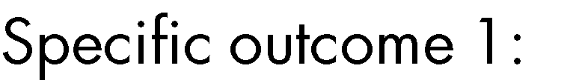

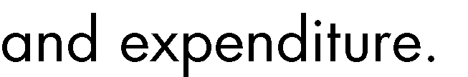

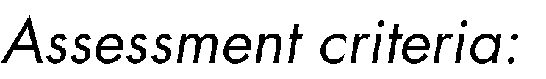

 

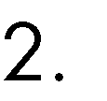 



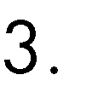



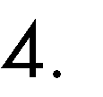 





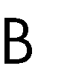



•

•

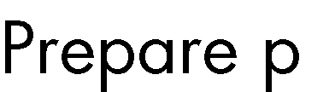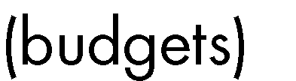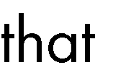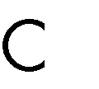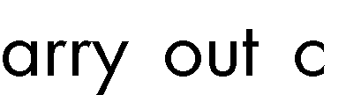

•

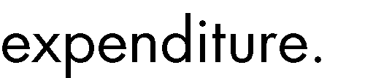•

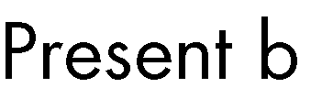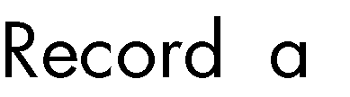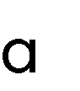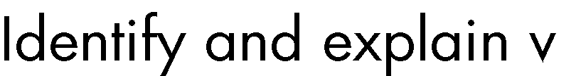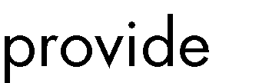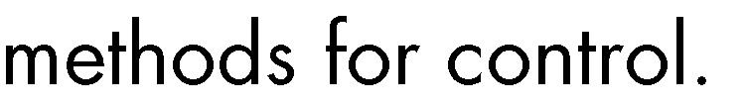

•













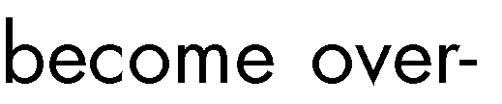









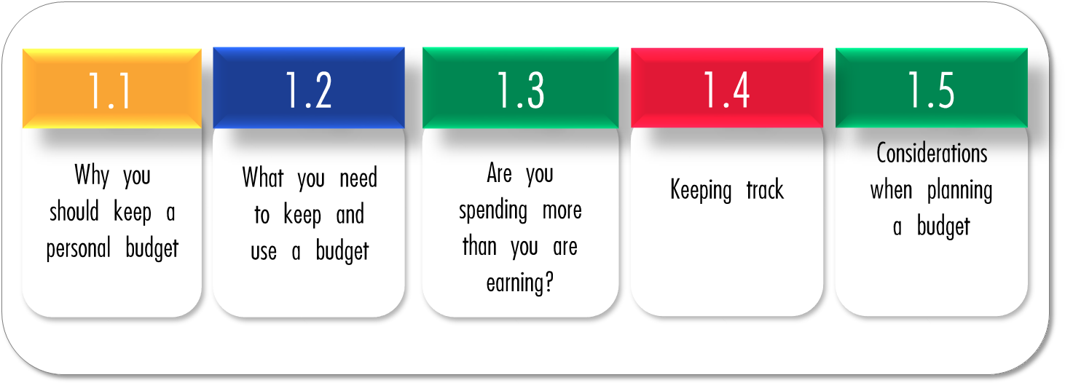

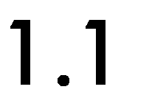

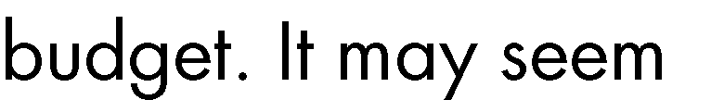

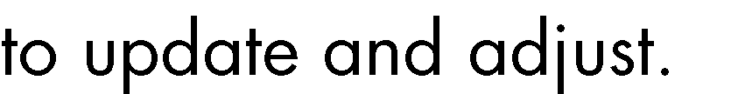

# Tracking your expenses













* + 1. Avoiding debt







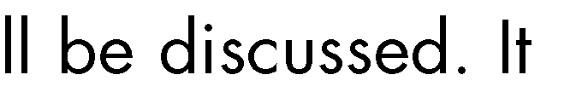







# Saving for the future





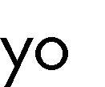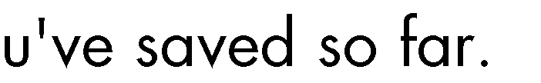













* + 1. Saving for emergencies







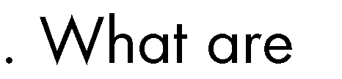





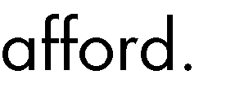

# Reducing stress











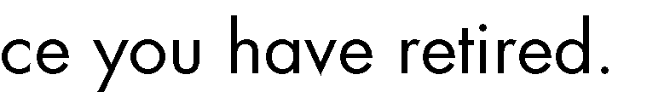

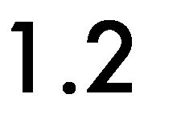 



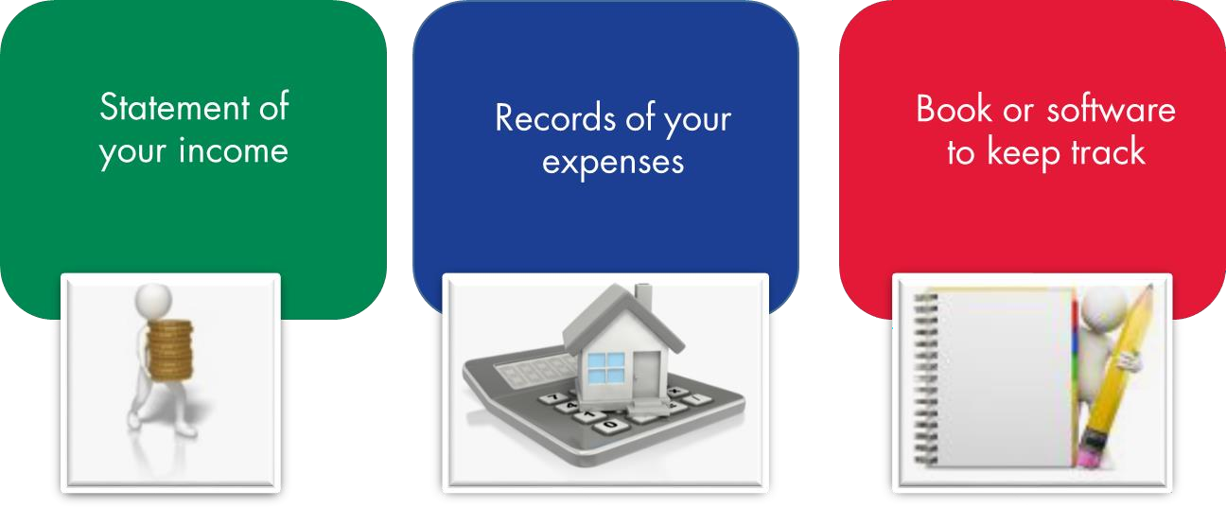

|  |  |
| --- | --- |
|  |  |
|  |  |
|  |  |

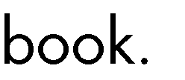

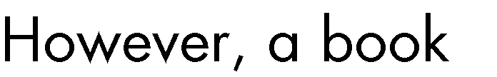

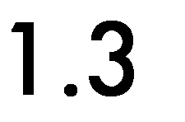

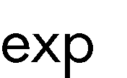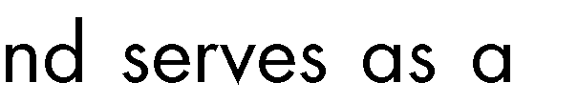



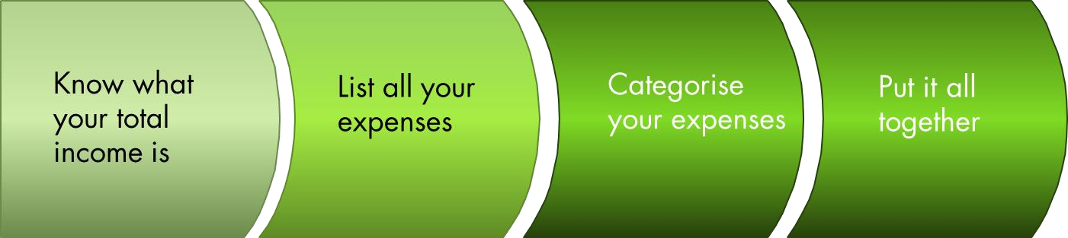

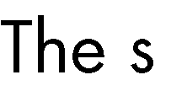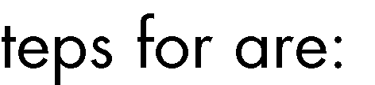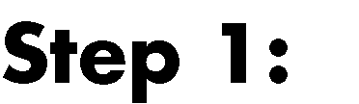



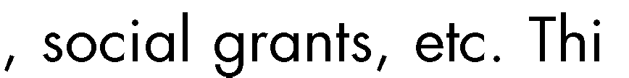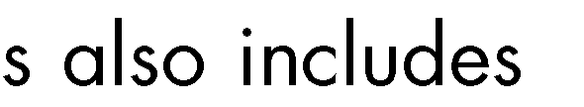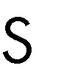



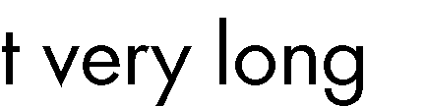











• 

•



•

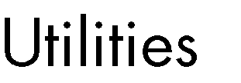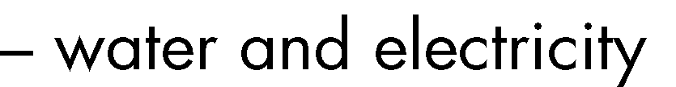

• 

• 

• 

•



• 

• 



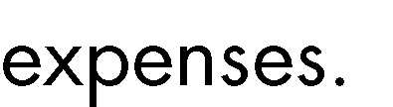

|  |  |
| --- | --- |
|  | •  •  •  •  •  •  • |
|  |  |



|  |  |
| --- | --- |
|  | •  •  •  •  •  • |





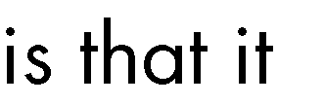





|  |  |
| --- | --- |
|  | •  •  •  •  •  •  •  • |

|  |  |
| --- | --- |
|  |  |
|  |  |





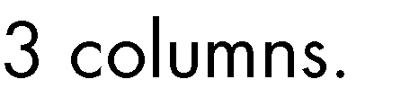



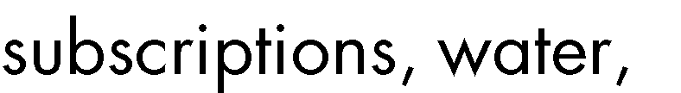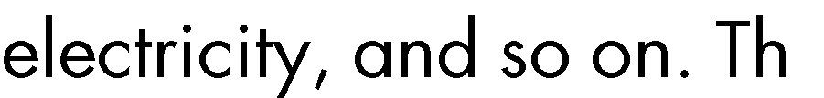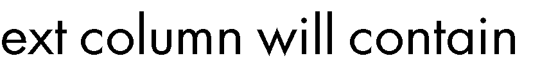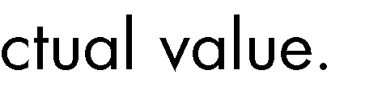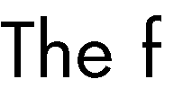



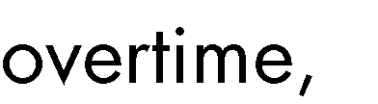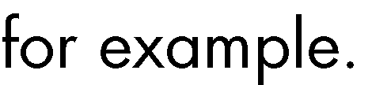



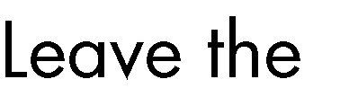

|  |  |  |
| --- | --- | --- |
|  |  |  |
|  |  |  |
|  |  |  |
|  |  |  |

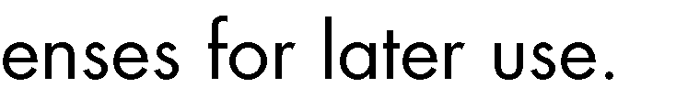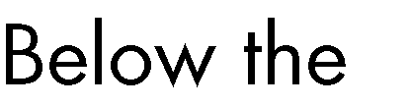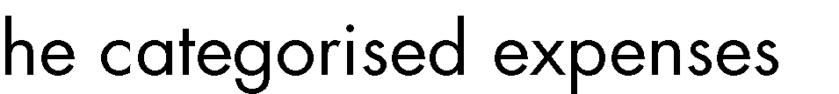

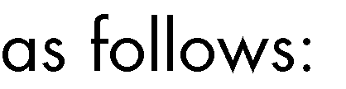

|  |  |  |
| --- | --- | --- |
|  |  |  |
|  |  |  |
|  |  |  |
|  |  |  |
|  |  |  |
|  | | |
|  | | |
|  |  |  |
|  |  |  |
|  |  |  |
|  | | |
|  |  |  |
|  |  |  |
|  |  |  |
|  |  |  |
|  | | |
|  | | |
|  |  |  |
|  | | |
|  |  |  |
|  |  |  |
|  |  |  |



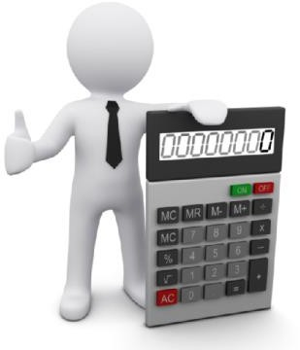

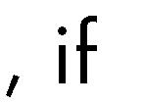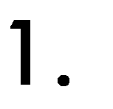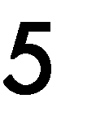



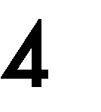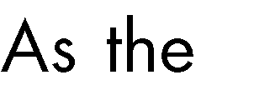

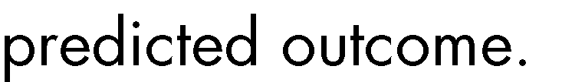

|  |  |  |
| --- | --- | --- |
|  |  |  |
|  |  |  |
|  |  |  |
|  |  |  |
|  |  |  |
|  | | |
|  | | |
|  |  |  |
|  |  |  |
|  |  |  |
|  | | |
|  |  |  |
|  |  |  |
|  |  |  |
|  |  |  |
|  | | |
|  | | |
|  |  |  |
|  | | |
|  |  |  |
|  |  |  |
|  |  |  |





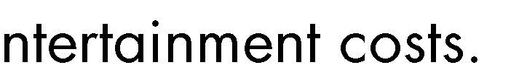





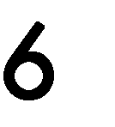

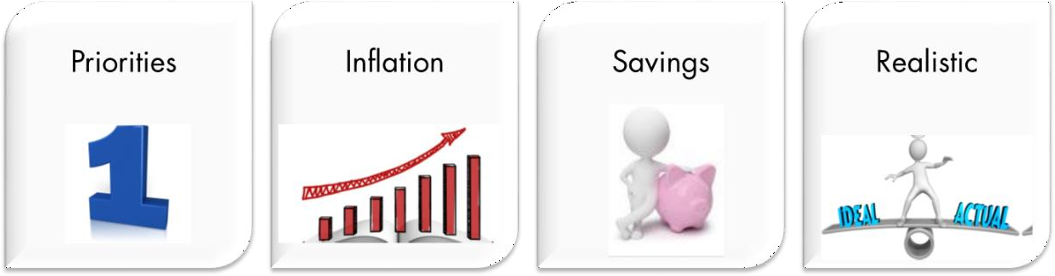

|  |  |
| --- | --- |
|  |  |
|  |  |

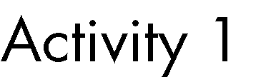

|  |  |
| --- | --- |
|  |  |
|  |  |
|  |  |













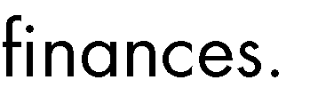

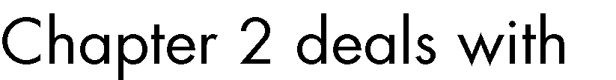



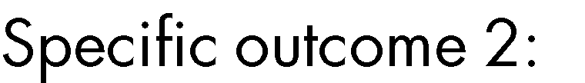





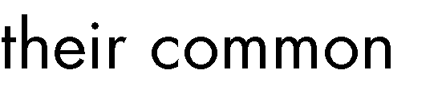



 

 

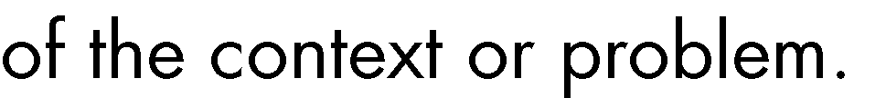











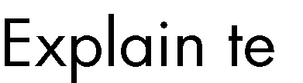



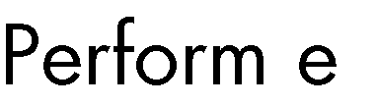



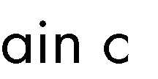



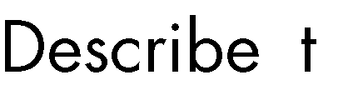



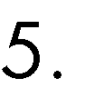

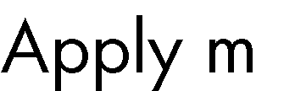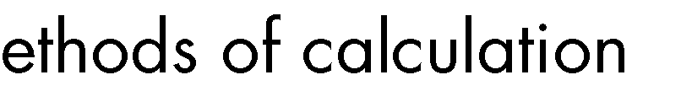

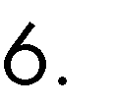

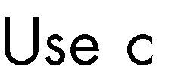

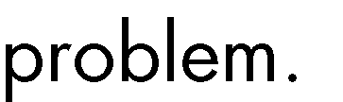

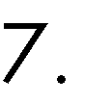

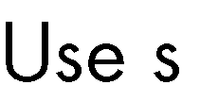





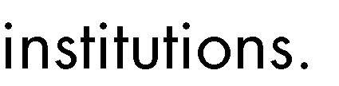





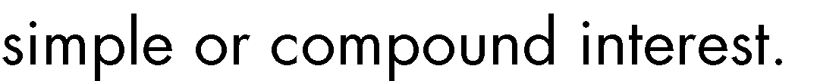



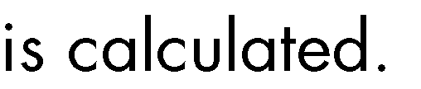

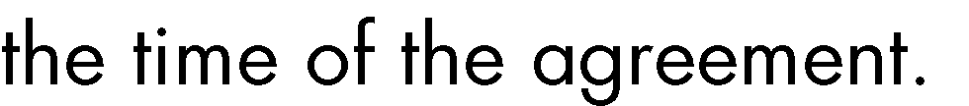

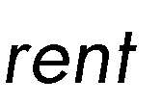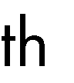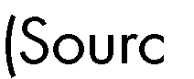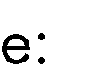



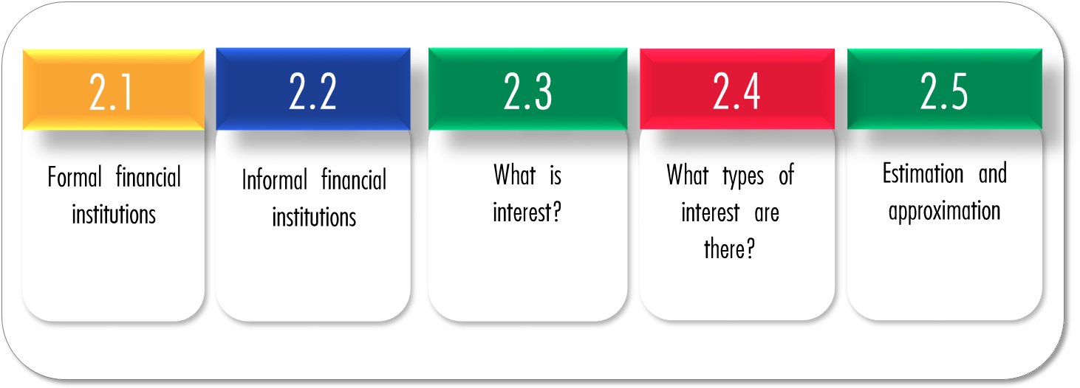

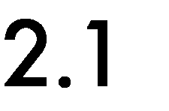



# Banks



* + - 1. Hire purchase agreements

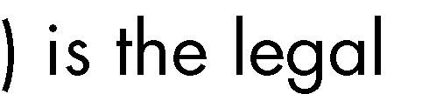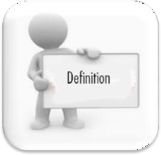



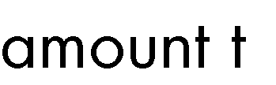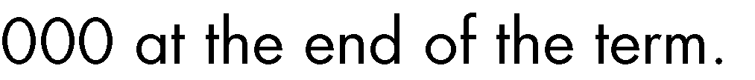



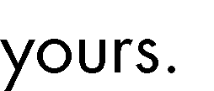

# Savings account



|  |  |
| --- | --- |
|  |  |

|  |  |
| --- | --- |
|  |  |
|  |  |



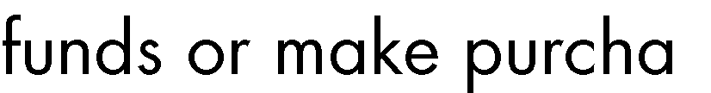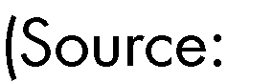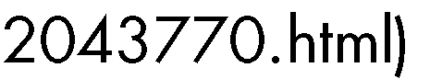

* + - 1. Cheque account

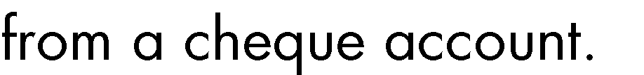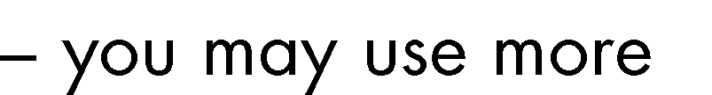



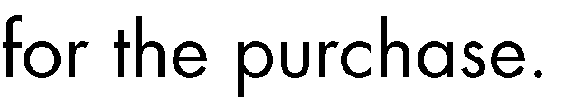



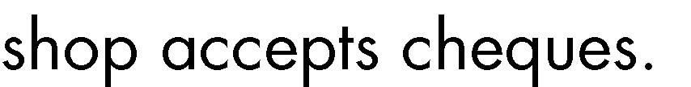



•

•

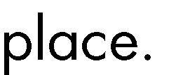



•

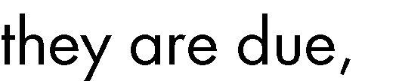



# Credit card















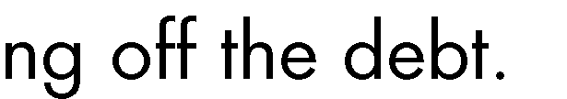



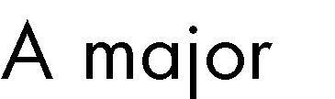



* + - 1. Transmission account

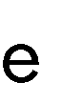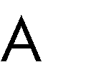

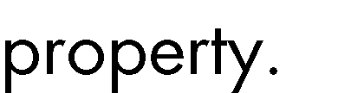

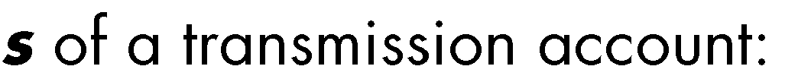

• 

• 

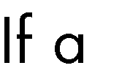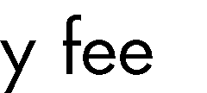

•



# Mortgage loan

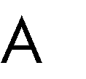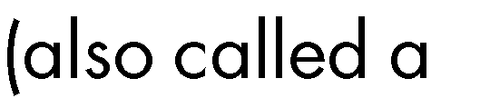









* + 1. Micro-financial institutions

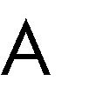

•



• 

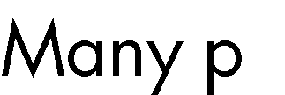

•





• 

•

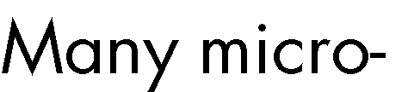



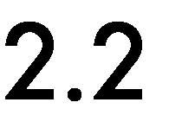



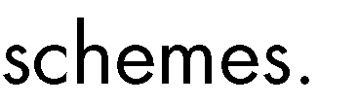

|  |  |  |
| --- | --- | --- |
|  |  |  |
|  |  |  |

|  |  |  |
| --- | --- | --- |
|  |  |  |
|  |  |  |
|  |  |  |
|  |  |  |

|  |  |  |
| --- | --- | --- |
|  |  |  |
|  |  |  |

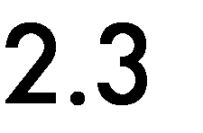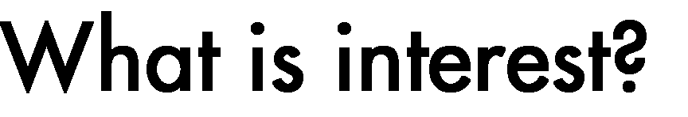

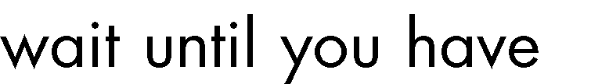













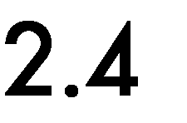

• 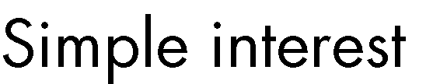

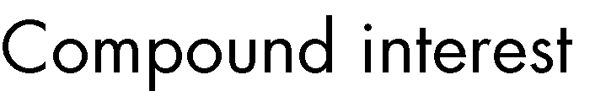•

# Simple interest

What is it?

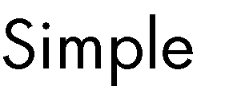







# Where is it used?



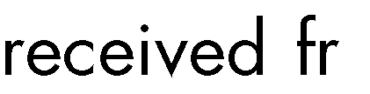





How does it work?

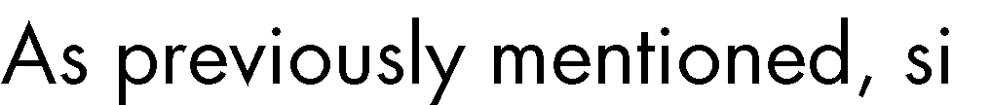



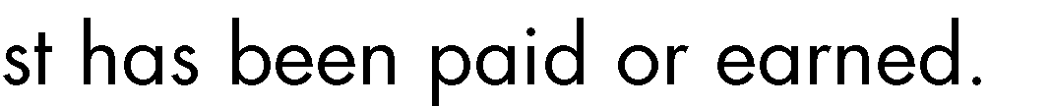



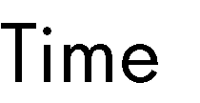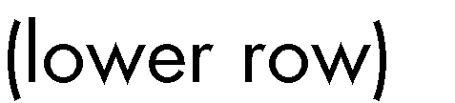



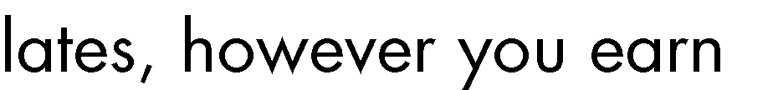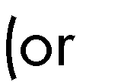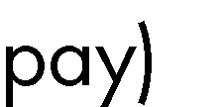





|  |  |  |  |
| --- | --- | --- | --- |
|  |  |  |  |
|  |  |  |  |
|  |  |  |  |
|  |  |  |  |
|  |  |  |  |
|  |  |  |  |
|  |  |  |  |



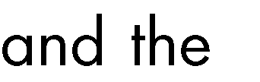



# The formula





𝐴 = 𝑃(1 + 𝑖𝑛 𝑥 𝑛)

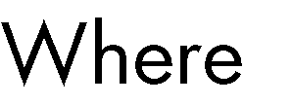

𝐴 = 𝑓𝑖𝑛𝑎𝑙 𝑎𝑚𝑜𝑢𝑛𝑡

𝑃 = 𝑝𝑟𝑖𝑛𝑐𝑖𝑝𝑎𝑙 𝑜𝑟 𝑜𝑟𝑖𝑔𝑖𝑛𝑎𝑙 𝑎𝑚𝑜𝑢𝑛𝑡

𝑖 = 𝑡ℎ𝑒 𝑖𝑛𝑡𝑒𝑟𝑒𝑠𝑡 𝑟𝑎𝑡𝑒

𝑛 = 𝑡ℎ𝑒 𝑛𝑢𝑚𝑏𝑒𝑟 𝑜𝑓 𝑦𝑒𝑎𝑟𝑠

# A few examples Example 1











𝑃 = 5 000

13

𝑖 =

100

= 0.13

𝑛 = 3

𝐴 = 𝑃(1 + 𝑖𝑛 𝑥 𝑛)

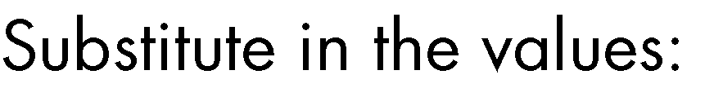

𝐴 = 5 000(1 + (0.13)(3))

𝐴 = 6 950

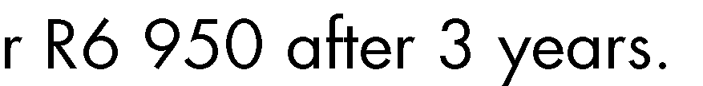

# Example 2

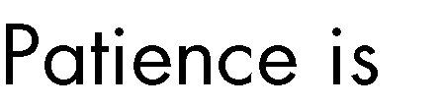









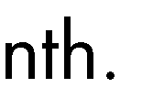







𝑃 = 5 000 − (5 000 ×

10

) = 5 000 − 500 = 4 500

100



𝑖 =

9

100

= 0.09

𝑛 = 2

𝐴 = 𝑃(1 + 𝑖𝑛)

𝐴 = 4 500(1 + 0.09(2))

𝐴 = 5 310

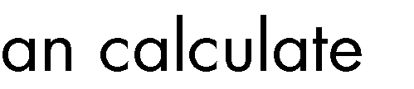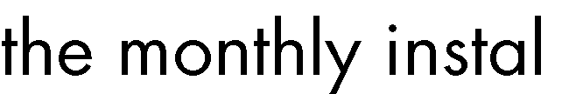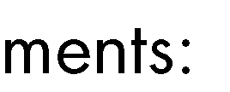

𝑀𝑜𝑛𝑡ℎ𝑙𝑦 𝑝𝑎𝑦𝑚𝑒𝑛𝑡 =

= 221.25

5 310

24









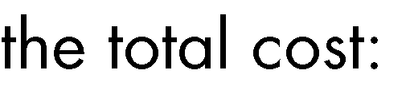

5 310 + 500 = 5 810







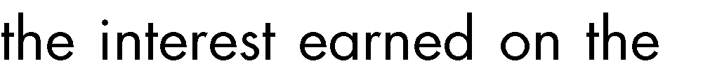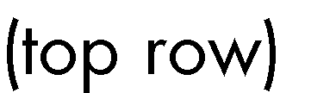

# Compound interest

What is it?













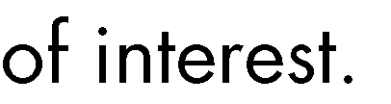

# Where is it used?



•

•

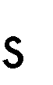

•

•

# How does it work?

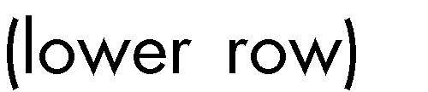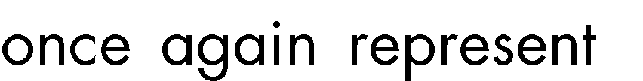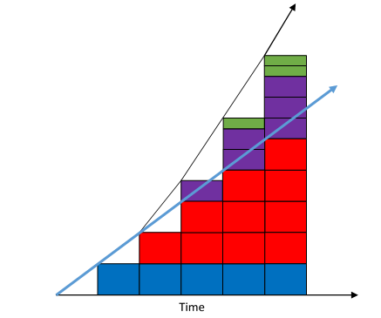



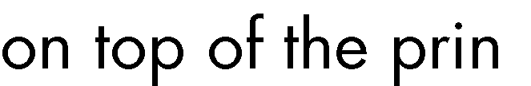







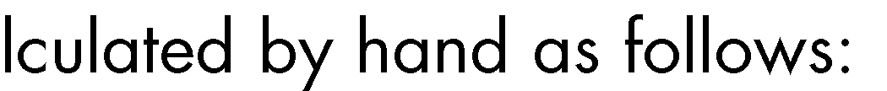



|  |  |  |  |
| --- | --- | --- | --- |
|  |  |  |  |
|  |  |  |  |
|  |  |  |  |
|  |  |  |  |
|  |  |  |  |
|  |  |  |  |
|  |  |  |  |

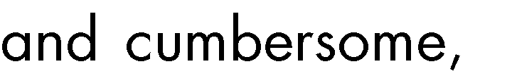



The formula



𝐴 = 𝑃(1 + 𝑖)𝑛

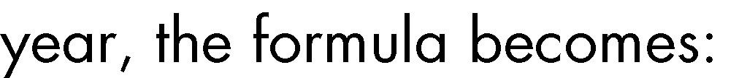

𝐴 = 𝑃(1 + 𝑖 )𝑛𝑚

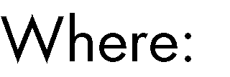𝑚

𝐴 = 𝑡ℎ𝑒 𝑓𝑖𝑛𝑎𝑙 𝑎𝑚𝑜𝑢𝑛𝑡

𝑃 = 𝑡ℎ𝑒 𝑝𝑟𝑖𝑛𝑐𝑖𝑝𝑎𝑙 𝑎𝑚𝑜𝑢𝑛𝑡

𝑖 = 𝑡ℎ𝑒 𝑖𝑛𝑡𝑒𝑟𝑒𝑠𝑡 𝑟𝑎𝑡𝑒

𝑚 = 𝑛𝑢𝑚𝑏𝑒𝑟 𝑜𝑓 𝑡𝑖𝑚𝑒𝑠 𝑡ℎ𝑒 𝑖𝑛𝑡𝑒𝑟𝑒𝑠𝑡 𝑖𝑠 𝑐𝑜𝑚𝑝𝑜𝑢𝑛𝑑𝑒𝑑 𝑝𝑒𝑟 𝑦𝑒𝑎𝑟

𝑛 = 𝑛𝑢𝑚𝑏𝑒𝑟 𝑜𝑓 𝑦𝑒𝑎𝑟𝑠



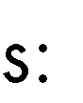

•

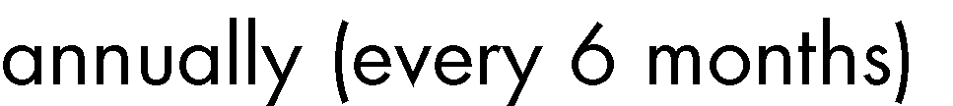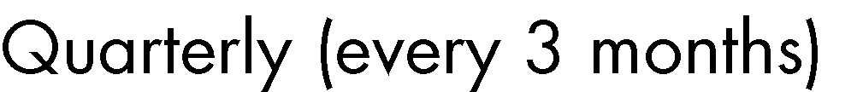

•

•

•

•



•







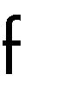





𝐴 = 𝑃𝑒𝑖𝑛

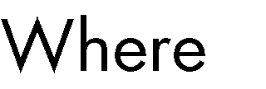

𝑒







𝐴 = 𝑃(1 + 𝑖)𝑛



𝐴 = 𝑃(1 − 𝑖)𝑛

# A few examples Example 1







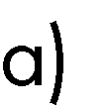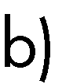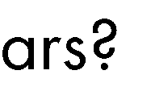



 

𝑃 = 10 000

7.5

𝑖 =

100

= 0.075

𝑛 = 10

𝐴 = 𝑃(1 + 𝑖)𝑛



𝐴 = 10 000(1 + 0.075)10

𝐴 = 20 610.31562



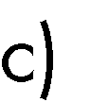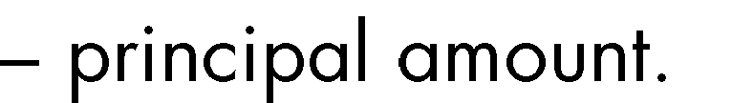

𝑅20 610.32 − 𝑅10 000 = 𝑅10 610.32

# Example 2





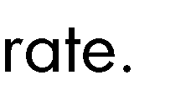

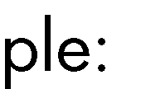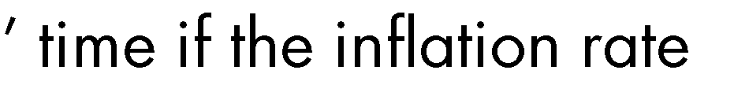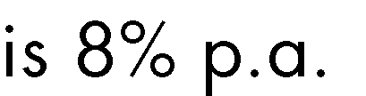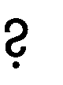





𝑃 = 12

8

𝑖 =

100

𝑛 = 4

= 0.08



𝐴 = 𝑃(1 + 𝑖)𝑛

𝐴 = 12(1 + 0.08)4

𝐴 = 16.33

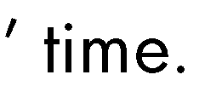

# Example 3

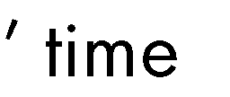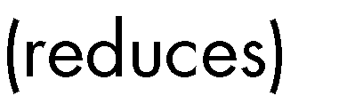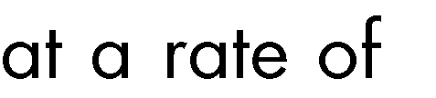







𝑃 = 300 000

2

𝑖 =

100

= 0.02

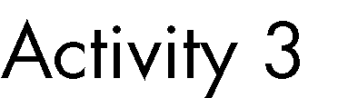𝑛 = 4



𝐴 = 𝑃(1 − 𝑖 )𝑚𝑛

𝑚

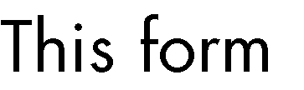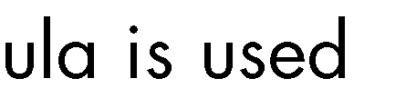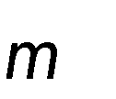

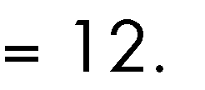

𝐴 = 300000(1 − 0.02)(12)(4)

12

𝐴 = 288227.213

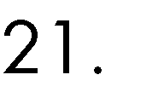

𝐴 = 𝑃(1 − 𝑖)𝑛 

𝐴 = 𝑃(1 − 𝑖)𝑛

𝐴 = 300000(1 − 0.02)4

𝐴 = 276710.448











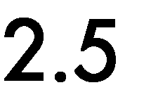 







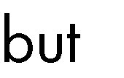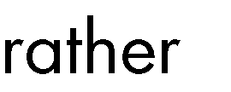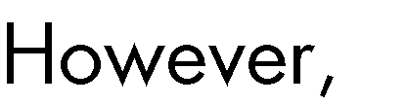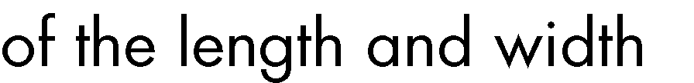



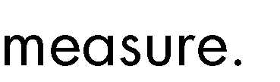

# Estimation

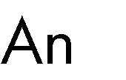





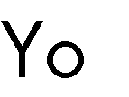





* + 1. 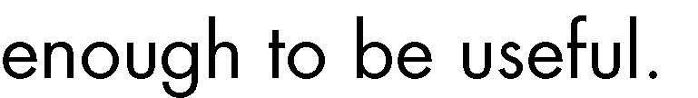Approximation



≈



















      
      
      
      



    
    
   
    
    
    
    
    
    
    
  
    
    
    
    
    
    
    
    
    
    
    
    
    
    
    
    
    
    

