

|  |  |
| --- | --- |
|  |  |

|  |  |  |  |
| --- | --- | --- | --- |
|  |  | | |
|  |  |  |  |
|  |  | | |
|  |  | | |
|  |  |  |  |

|  |  |  |
| --- | --- | --- |
|  |  |  |
|  | | |
|  | | |
|  | | |
|  | | |
|  | | |
| √5184 = | | |
| √8649 = | | |

|  |
| --- |
|  |
|  |

|  |  |  |  |  |  |
| --- | --- | --- | --- | --- | --- |
|  | |  | | |  |
|  | | | | | |
|  | | | | | |
|  |  | |  |  | |
|  | |  |
|  | |  |
|  | |  |
|  | |  |

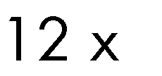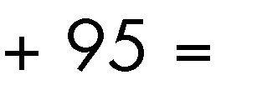

|  |  |  |
| --- | --- | --- |
|  |  |  |
|  | | |
|  | | |
|  | | |
| √36 | | |

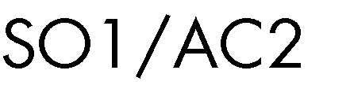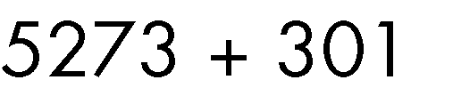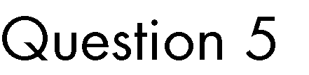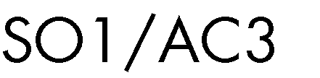

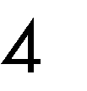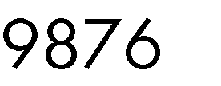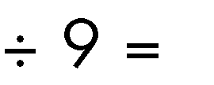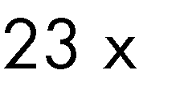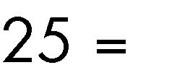

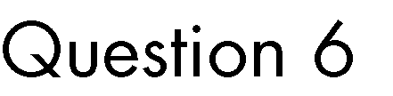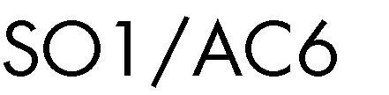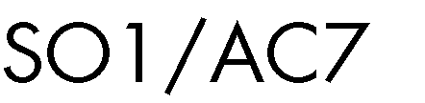

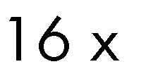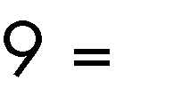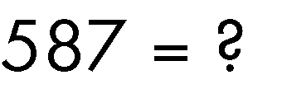

|  |  |  |
| --- | --- | --- |
|  |  |  |
| 𝑥 + 𝑎 + 𝑏 + 𝑥 + 𝑏 + 𝑐 + 𝑥 = | | |
| 5 𝑥 + 9 𝑥 + 𝑎 + 𝑏 + 𝑎 + 𝑥 = | | |
| 𝑎 × 𝑎 × 𝑎 × 𝑎 + 𝑏 = | | |
| 𝑑10 = | | |

|  |
| --- |
| Solve x where 7𝑥 − 3 = 4𝑥 + 12 |
| 12𝑏 − 2 = 𝑐 + 8 |

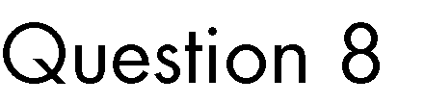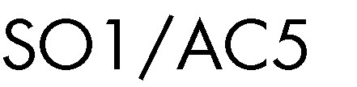

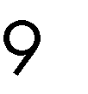

|  |  |  |  |  |
| --- | --- | --- | --- | --- |
|  |  | | |  |
|  | |  |  | |
| 1 12  + =  4 3 | | | | |

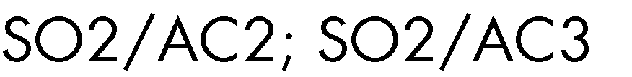

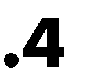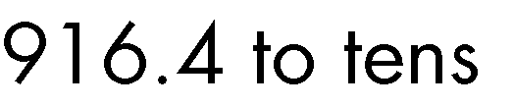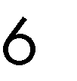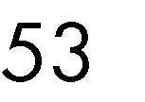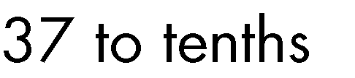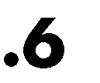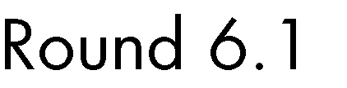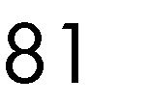

|  |  |  |
| --- | --- | --- |
|  |  |  |
| 3 1  − =  7 10 | | |

|  |  |  |
| --- | --- | --- |
|  |  |  |
| 1 3  × =  8 4 | | |

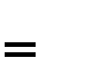

|  |  |
| --- | --- |
|  |  |
| 7  12 | |
| 8  15 | |
|  | |
|  | |

|  |  |  |
| --- | --- | --- |
|  |  |  |
|  | | |
|  | | |
|  | | |
|  | | |
|  | | |
|  | | |
|  | | |



