



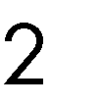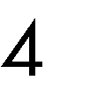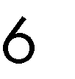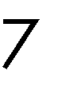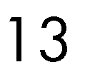

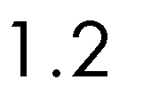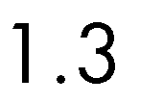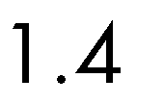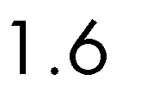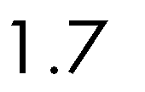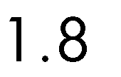



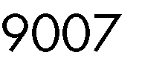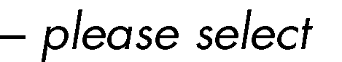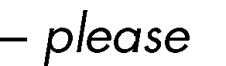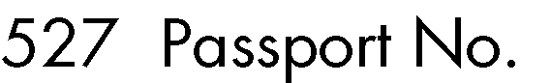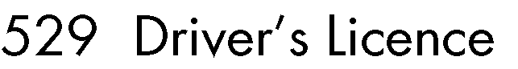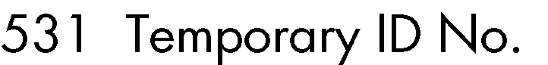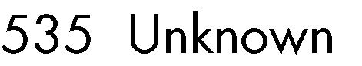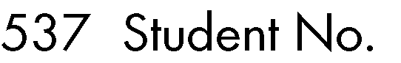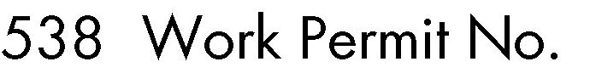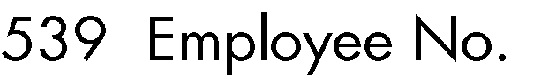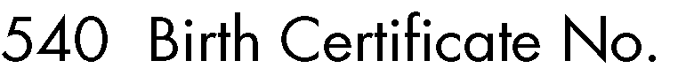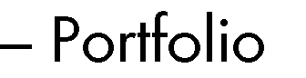

|  |  |  |  |
| --- | --- | --- | --- |
|  |  |  |  |
|  |  |  |  |
|  |  |  |  |
|  |  |  |  |

 













•

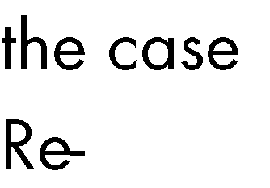

▪

▪

▪

▪

•

•

•

•

•

•

•

•

•

 





 

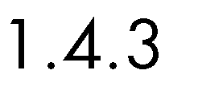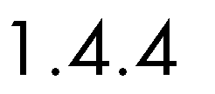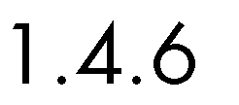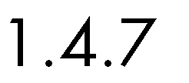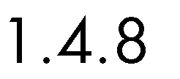

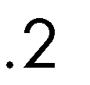

 



 

 









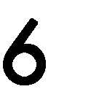







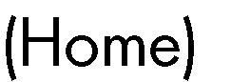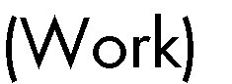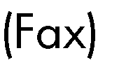

□

□

□

□



















|  |
| --- |
|  |
|  |

|  |  |  |  |  |
| --- | --- | --- | --- | --- |
|  |  | | | |
|  |  | | | |
|  | |  | | |
|  | |  | | |
|  | | | | |
|  | | | | |
|  | | |  | |
|  | | |  | |
|  |  |  |  |  |
|  |  |  |  |  |
|  | |  |  |  |
|  | |  |  |  |
|  | |  | | |
|  | |  | | |



|  |
| --- |
|  |
|  |

|  |
| --- |
| •  •  •    •  •  • |
|  |

|  |
| --- |
|  |
|  |



•



•

•

•

•

|  |
| --- |
| •  •  • |
|  |
|  |





|  |
| --- |
|  |
|  |

|  |
| --- |
|  |
|  |

|  |
| --- |
|  |
|  |

|  |
| --- |
|  |
|  |





|  |
| --- |
|  |
|  |

|  |
| --- |
|  |
|  |

|  |
| --- |
|  |
|  |

|  |
| --- |
|  |
|  |







|  |
| --- |
|  |
|  |

|  |
| --- |
|  |
|  |

|  |
| --- |
|  |
|  |

|  |
| --- |
|  |
|  |

|  |
| --- |
|  |
|  |

|  |
| --- |
|  |
|  |

|  |
| --- |
|  |
|  |





|  |
| --- |
|  |
|  |
|  |

|  |
| --- |
|  |
|  |

|  |
| --- |
|  |
|  |

|  |
| --- |
|  |
|  |











|  |  |  |  |  |  |  |  |  |  |  |  |  |  |  |
| --- | --- | --- | --- | --- | --- | --- | --- | --- | --- | --- | --- | --- | --- | --- |
|  |  |  | | | |  |  | | | | | | | |
|  |  |  |  |  |  |  |  |  |  |  |  |  |  |  |
|  |  |  |  |  |  |  |  |  |  |  |  |  |  |  |
|  |  |  |  |  |  |  |  |  |  |  |  |  |  |  |
|  |  |  |  |  |  |  |  |  |  |  |  |  |  |  |
|  |  |  |  |  |  |  |  |  |  |  |  |  |  |  |
|  |  |  |  |  |  |  |  |  |  |  |  |  |  |  |
|  |  |  |  |  |  |  |  |  |  |  |  |  |  |  |
|  |  |  |  |  |  |  |  |  |  |  |  |  |  |  |
|  |  |  |  |  |  |  |  |  |  |  |  |  |  |  |
|  |  |  |  |  |  |  |  |  |  |  |  |  |  |  |
|  | | | | | | | | | | | | | | |

|  |  |  |  |  |  |  |  |  |  |  |  |  |  |  |
| --- | --- | --- | --- | --- | --- | --- | --- | --- | --- | --- | --- | --- | --- | --- |
|  |  |  | | | |  |  | | | | | | | |
|  |  |  |  |  |  |  |  |  |  |  |  |  |  |  |
|  | | | | | | | | | | | | | | |
|  |  |  |  |  |  |  |  |  |  |  |  |  |  |  |
|  |  |  |  |  |  |  |  |  |  |  |  |  |  |  |
|  |  |  |  |  |  |  |  |  |  |  |  |  |  |  |
|  |  |  |  |  |  |  |  |  |  |  |  |  |  |  |
|  |  |  |  |  |  |  |  |  |  |  |  |  |  |  |
|  |  |  |  |  |  |  |  |  |  |  |  |  |  |  |
|  |  |  |  |  |  |  |  |  |  |  |  |  |  |  |
|  |  |  |  |  |  |  |  |  |  |  |  |  |  |  |
|  |  |  |  |  |  |  |  |  |  |  |  |  |  |  |
|  |  |  |  |  |  |  |  |  |  |  |  |  |  |  |
|  |  |  |  |  |  |  |  |  |  |  |  |  |  |  |
|  |  |  |  |  |  |  |  |  |  |  |  |  |  |  |
|  |  |  |  |  |  |  |  |  |  |  |  |  |  |  |
|  |  |  |  |  |  |  |  |  |  |  |  |  |  |  |
|  |  |  |  |  |  |  |  |  |  |  |  |  |  |  |
|  |  |  |  |  |  |  |  |  |  |  |  |  |  |  |
|  |  |  |  |  |  |  |  |  |  |  |  |  |  |  |
|  |  |  |  |  |  |  |  |  |  |  |  |  |  |  |
|  |  |  |  |  |  |  |  |  |  |  |  |  |  |  |
|  |  |  |  |  |  |  |  |  |  |  |  |  |  |  |
|  |  |  |  |  |  |  |  |  |  |  |  |  |  |  |
|  |  |  |  |  |  |  |  |  |  |  |  |  |  |  |
|  |  |  |  |  |  |  |  |  |  |  |  |  |  |  |
|  |  |  |  |  |  |  |  |  |  |  |  |  |  |  |
|  |  |  |  |  |  |  |  |  |  |  |  |  |  |  |
|  |  |  |  |  |  |  |  |  |  |  |  |  |  |  |
|  |  |  |  |  |  |  |  |  |  |  |  |  |  |  |
|  |  |  |  |  |  |  |  |  |  |  |  |  |  |  |
|  |  |  |  |  |  |  |  |  |  |  |  |  |  |  |

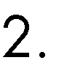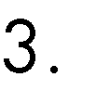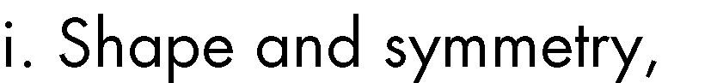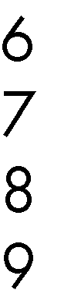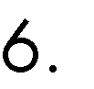



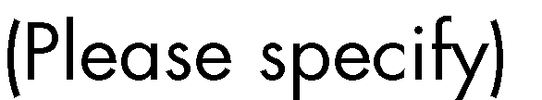

 



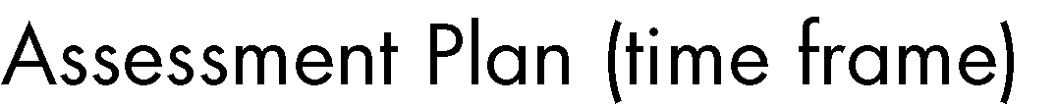

 

 

 

o



o 

o 

o 

 









|  |  |  |  |  |
| --- | --- | --- | --- | --- |
|  | | | | |
|  | | | | |
|  | | | | |
|  |  | |  |  |
|  |  | |  |  |
|  | | | | |
|  | |  | |  |
|  | |  | |  |
|  | |  | |  |
|  | |  | |  |
|  | |  | |  |
|  | |  | |  |
|  | |  | |  |
|  | |  | |  |
|  | |  | |  |









|  |  |  |
| --- | --- | --- |
|  |  |  |
|  |  |  |
|  |  |  |
|  |  |  |
|  |  |  |
|  |  |  |
|  |  |  |
|  |  |  |
|  | | |
|  |  |  |
|  |  |  |
|  |  |  |
|  |  |  |
|  |  |  |
|  |  |  |
|  |  |  |
|  |  |  |
|  |  |  |
|  |  |  |
|  |  |  |
|  |  |  |
|  |  |  |







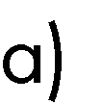 𝑦 = 3𝑥 + 5

 0 = 22𝑥 + 6 − 5𝑥2

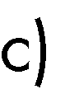3 = 5𝑥 + 7𝑥3





19𝑦3 + 28𝑥𝑦3 − 8𝑦3 + 13𝑥𝑦2 = 43𝑥3 − 15𝑦2 − 𝑦 + 5𝑥𝑦2 − 𝑥2 + 93𝑥3 + 32𝑦2 = 0



𝑦3 : 19𝑦3, −8𝑦3

𝑥2: …



 3𝑥 + 9 = 0

𝑥2 = 9

5𝑥 + 7 = 4𝑥 + 3



𝑦 = 3𝑥2 − 3𝑥 + 7



|  |  |
| --- | --- |
|  |  |
|  |  |
|  |  |
|  |  |
|  |  |
|  |  |
|  |  |
|  |  |
|  |  |
|  |  |
|  |  |







 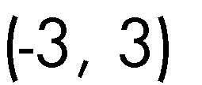

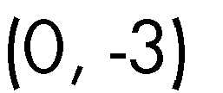

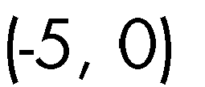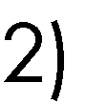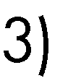





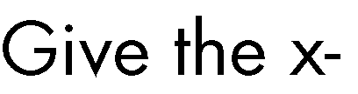

 𝑦 = 9𝑥2 + 8𝑥 − 10

𝑦 = 10

𝑦 = 5 + 2

𝑥−3





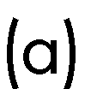

800

600

400

200

-40

-30

-20

-10

~~0~~

0

-200

10

20

30

40

-400

-600

-800



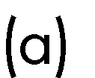

900

-100

-30

-20

-10

0

10

20

30

-1100

-2100

-3100

-4100

-5100

-6100

-7100

-8100

 

# a.

Graph of y=sin(x)

1.5

1

0.5

0

-4

-3

-2

-1

0

1

2

3

4

-0.5

-1

-1.5

b.

Graph of y=cos(x)

1.5

1

0.5

0

-4

-3

-2

-1

0

1

2

3

4

-0.5

-1

-1.5

# c.

Graph of y=x3+2x2+2x+1

1500

1000

500

0

-15

-10

-5

0

5

10

15

-500

-1000



a)

Graph of y=5/x

15

10

5

0

-60

-40

-20

0

20

40

60

-5

-10

-15

Graph of y=(x-3)2

180

160

140

120

100

80

60

40

20

0

-15

-10

-5

0

5

10

15

20





# a)

Graph of y=10/x

12

10

8

6

4

2

0

0

2

4

6

8

10

12

|  |  |  |  |  |  |
| --- | --- | --- | --- | --- | --- |
|  |  |  |  |  |  |
|  |  |  |  |  |  |
|  |  |  |  |  |  |
|  |  |  |  |  |  |
|  |  |  |  |  |  |
|  |  |  |  |  |  |

Graph of -x2+3

20

0

0

2

4

6

8

10

12

-20

-40

-60

-80

-100

-120





30

25

20

15

10

5

0

-6

-4

-2

0

2

4

6

 





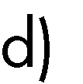

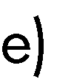



𝑦 = 𝑥2 + 2







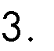

•



•

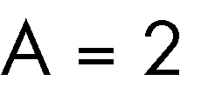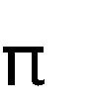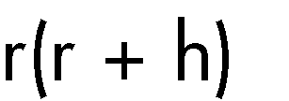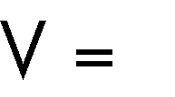

|  |  |
| --- | --- |
|  |  |
|  |  |
|  |  |
|  |  |
|  |  |









|  |  |  |  |
| --- | --- | --- | --- |
|  | | | |
|  |  |  |  |
|  |  |  |  |
|  |  |  |  |
|  |  |  |  |
|  |  |  |  |
|  |  |  |  |
|  |  |  |  |
|  |  |  |  |
|  |  |  |  |
|  |  |  |  |
|  |  |  |  |
|  | | | |



 

|  |  |  |  |
| --- | --- | --- | --- |
|  |  |  |  |
|  |  |  |  |
|  |  |  |  |

|  |  |  |  |
| --- | --- | --- | --- |
| **Y N** |  |  |  |



      
      
      
      
      
      

      
      
      

          
          
       
      
         
      

        
        
     
      
      
        







                
                
            
             
             
             
             
             
             
         
            
            
            



                
                
         
              
          
         
          
          
            
         
          

        
        
        
     
      
       
     
      
        