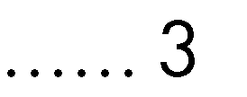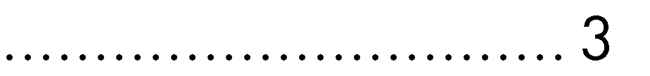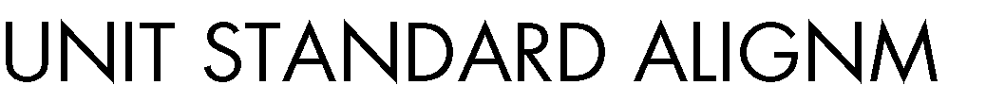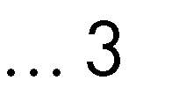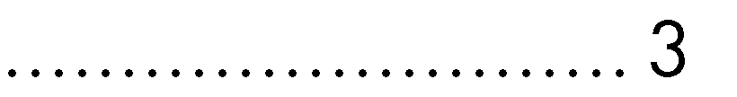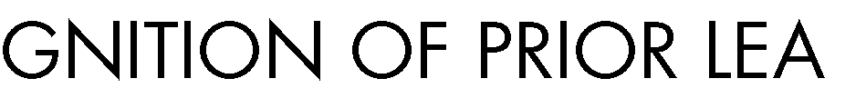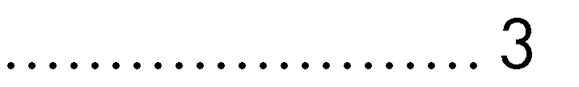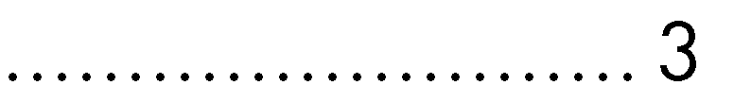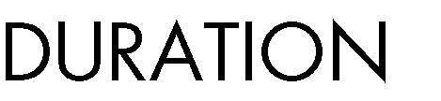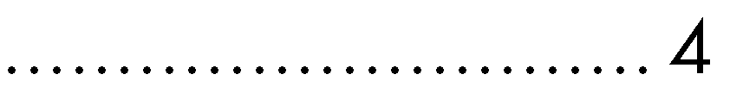

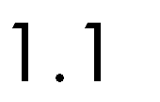

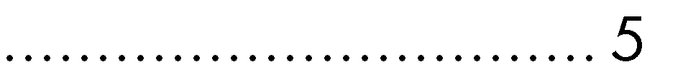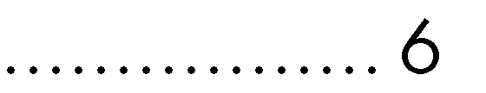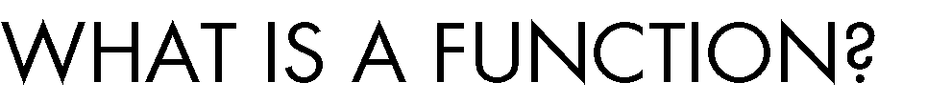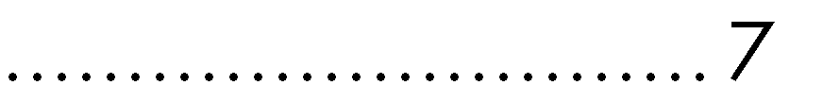

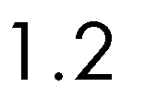

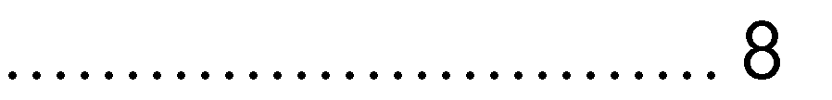

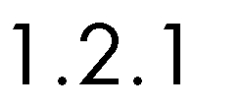

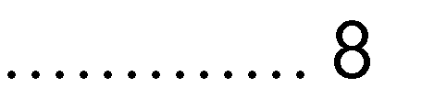

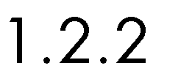

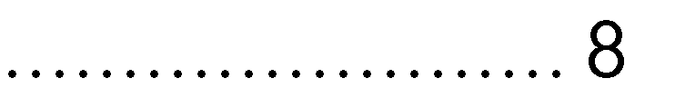

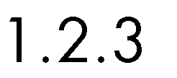

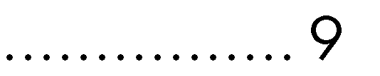

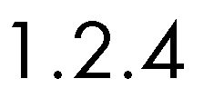

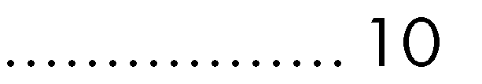

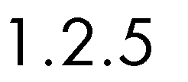

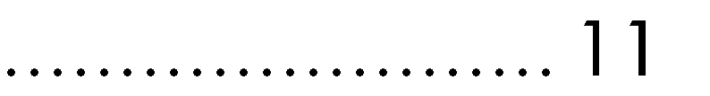

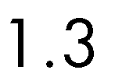

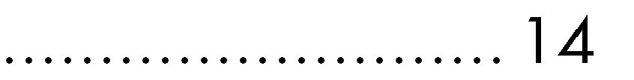

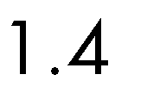

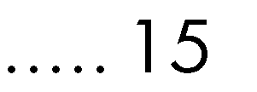

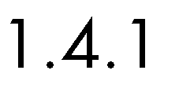

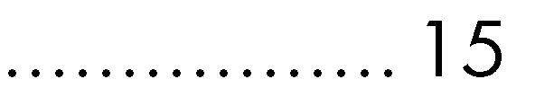

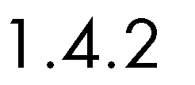

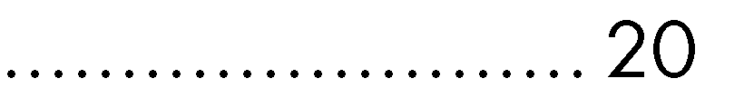

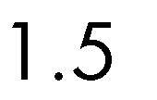

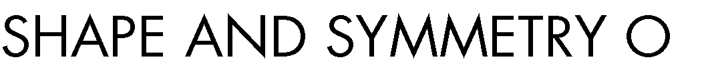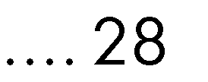

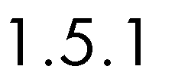

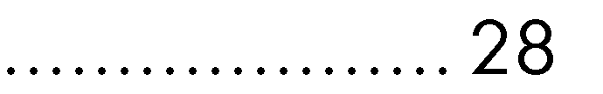

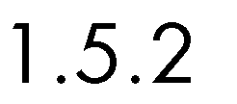

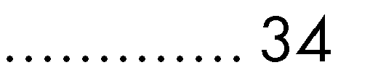

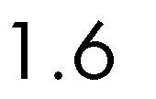

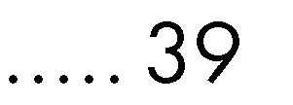

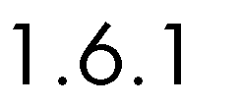

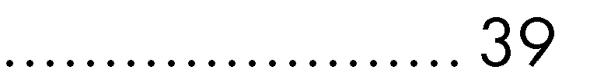

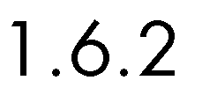

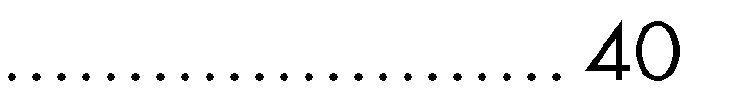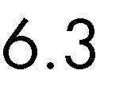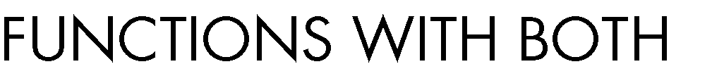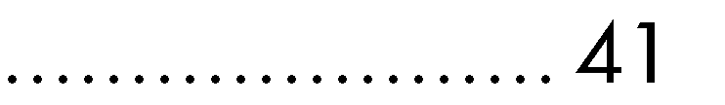

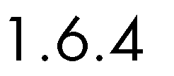

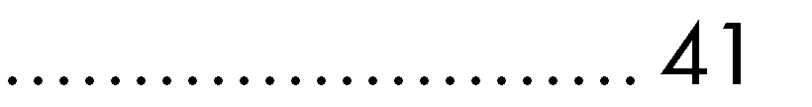

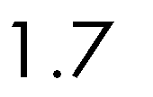

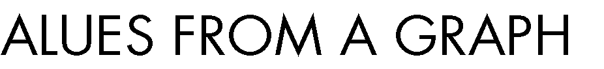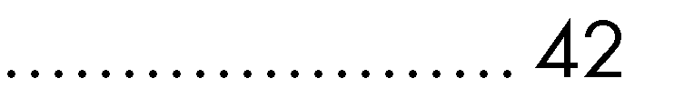

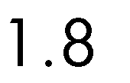

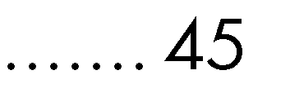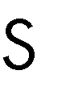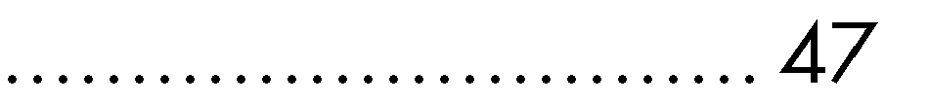

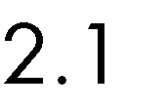

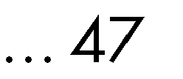

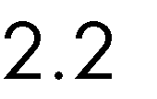

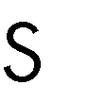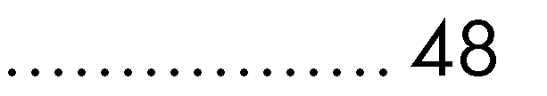

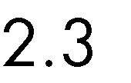

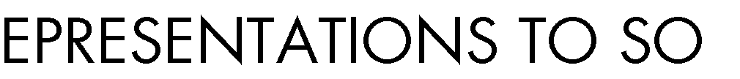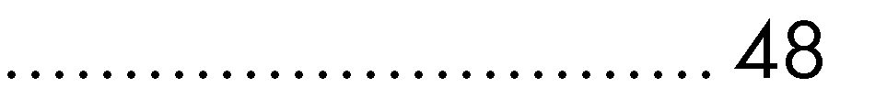

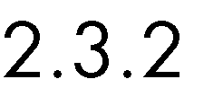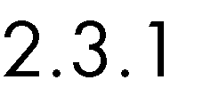

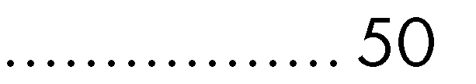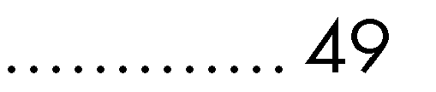

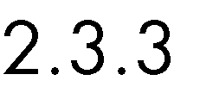

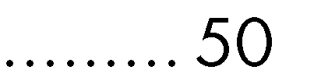

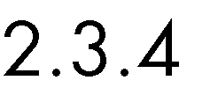

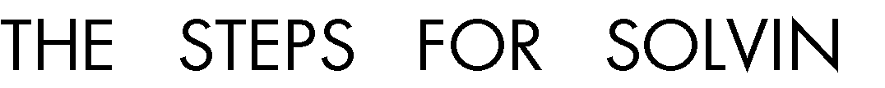



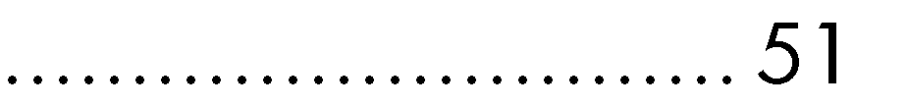

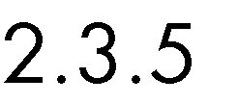

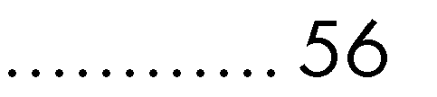

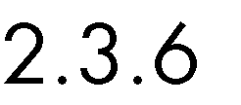

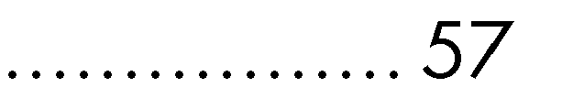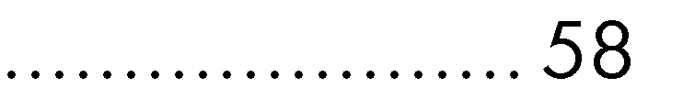









•



•

•









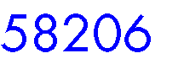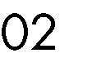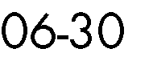

•

•



•















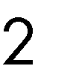





|  |  |
| --- | --- |
|  |  |
|  |  |
|  |  |
|  |  |
|  |  |





•

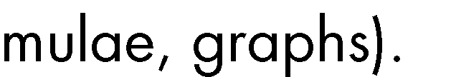

• 









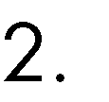 

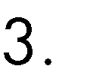 

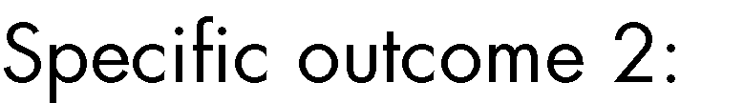



• 



•



 

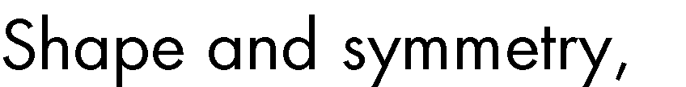



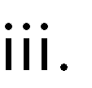



 

 





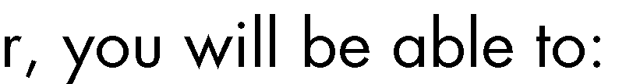

•



•

•



•

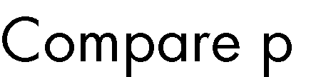





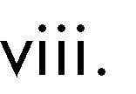



•



•

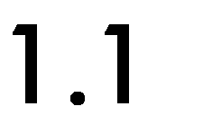











4

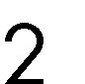

21 42

36 72













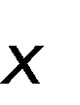



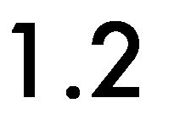

# Using variables in equations





















1. 9 + 3𝑥

2. 4𝑦

3. 5 − 7

𝑥

4.

𝑦

# Parts of an expression



7𝑦 − 53 = 4

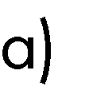









𝑦 = 𝑥2 + 3𝑥 + 2

𝑦, 𝑥2, 3𝑥 and 2.





# 𝑦

− 3 + 𝑥 = 1

# 𝑥

𝑦 , −3, 𝑥, 𝑎𝑛𝑑 1



𝑥



# 𝑦

− 4 + 𝑥 = 0

# 𝑥



3 = 5𝑥 + 7𝑥3

0 = 22𝑥 + 6 − 5𝑥2

𝑦 = 3𝑥 + 5

* + 1. 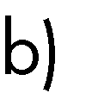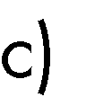Like terms







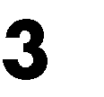



1

−2𝑥, 7𝑥, 10𝑥, 𝑥

3





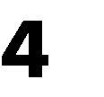

−2𝑥𝑦2, 3𝑥𝑦, 6𝑥𝑦2, −7𝑥𝑦2













# Manipulating expressions

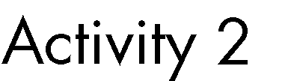



19𝑦3 + 28𝑥𝑦3 − 8𝑦3 + 13𝑥𝑦2 + 43𝑥3 − 15𝑦2 − 𝑦 + 5𝑥𝑦2 − 𝑥2 + 93𝑥3 + 32𝑦2

= 0



𝑦3: 19𝑦3, −8𝑦3

𝑥2: …







* + 1. Balancing equations













.

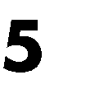

2𝑥 + 3 = 7







2𝑥 + 3 − 3 = 7 − 3

2𝑥 = 4

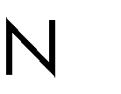

𝑥 = 2

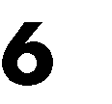

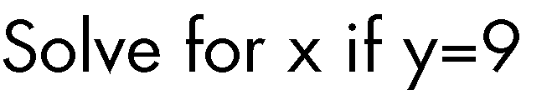

𝑦 = 𝑥2 − 12







𝑦 + 12 = 𝑥2 − 12 + 12

𝑦 + 12 = 𝑥2

𝑥2 = 𝑥 × 𝑥



𝑥2

√𝑦 + 12 = √𝑥2

√𝑦 + 12 = 𝑥





√9 + 12 = 𝑥

√21 = 𝑥







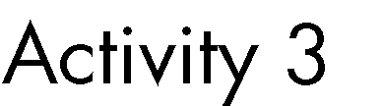

c) 5𝑥 + 7 = 4𝑥 + 3

Using basic algebra, find the value of x for the following expressions: a) 3𝑥 + 9 = 0

b) 𝑥2 = 9

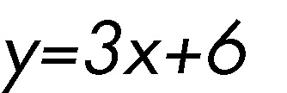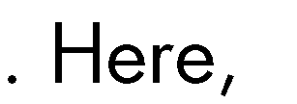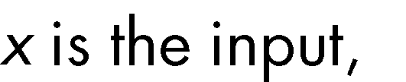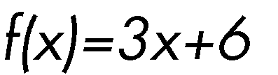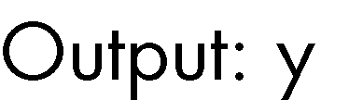



y 12



21 69

36 114



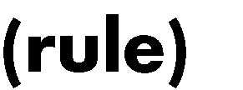





# 𝑦2 = 𝑥



𝑦 = 𝑓(𝑥),

𝑓(𝑥) =

±√𝑥,

𝑦 = ±√9

y = +3 y =-3,

x=9.

(3)2 = 𝑥 → 𝑥 = 9 (−3)2 = 𝑥 → 𝑥 = 9

𝑦2 = 𝑥 





𝑦 = 𝑥2



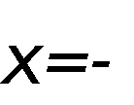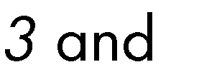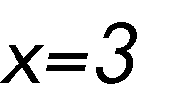



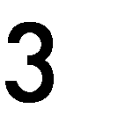

















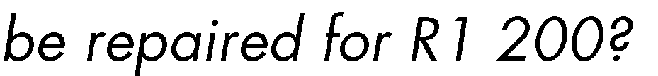







|  |  |
| --- | --- |
|  |  |
|  |  |
|  |  |
|  |  |
|  |  |





𝑦 = 153𝑥





𝑦 = 1 200



1 200 = 153𝑥

𝑥 = 7.843𝑚

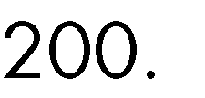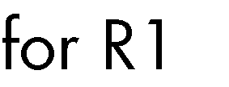







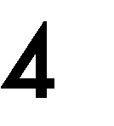

|  |  |
| --- | --- |
|  |  |
|  |  |
|  |  |
|  |  |

# Numerical representation

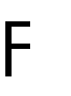

𝑦 = 3𝑥2 + 12𝑥 + 6

|  |  |  |
| --- | --- | --- |
|  |  |  |
|  | 𝑦 = 3(1)2 + 12(1) + 6 |  |
|  | 𝑦 = 3(2)2 + 12(2) + 6 |  |
|  | 𝑦 = 3(3)2 + 12(3) + 6 |  |
|  | 𝑦 = 3(4)2 + 12(4) + 6 |  |
|  | 𝑦 = 3(5)2 + 12(5) + 6 |  |
|  | 𝑦 = 3(10)2 + 12(10) + 6 |  |
|  | 𝑦 = 3(20)2 + 12(20) + 6 |  |









|  |  |
| --- | --- |
|  |  |
|  |  |
|  |  |

|  |  |
| --- | --- |
|  |  |
|  |  |
|  |  |
|  |  |
|  |  |
|  |  |
|  |  |
|  |  |





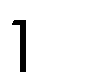

27

23

19

15

4 4 4 4



𝑦1 − 𝑦2

𝑚1 = 𝑥

1

− 𝑥2

11 − 15

=

1 − 2

= 4

𝑦3 − 𝑦4

𝑚2 = 𝑥

3

− 𝑥4

19 − 23

=

3 − 4

= 4



𝑦 =

4𝑥

𝑦 = 𝑚𝑥 + 𝑐



𝑚 = 4

𝑦 = 4𝑥 + 𝑐

𝑦 = 43, 𝑥 = 9

43 = 4(9) + 𝑐

𝑐 = 43 − 36

𝑐 = 7

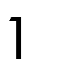

124

85

54

31

𝑦 = 4𝑥 + 7



|  |  |
| --- | --- |
|  |  |
|  |  |
|  |  |
|  |  |
|  |  |
|  |  |
|  |  |
|  |  |
|  |  |
|  |  |
|  |  |





124

85

54

31

15 23 31 39



8

8

8

39

31

23

15



𝑦 = 𝑎𝑥2 + 𝑏𝑥 + 𝑐







:

𝑦 = 𝑎𝑥2 + 𝑏𝑥 + 𝑐



16 = 𝑎 + 𝑏 + 𝑐

54 = 𝑎(9) + 𝑏(3) + 𝑐

360 = 𝑎(81) + 𝑏(9) + 𝑐

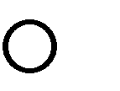





𝑎 = 16 − 𝑏 − 𝑐

# T



54 = (16 − 𝑏 − 𝑐)(9) + 𝑏(3) + 𝑐

54 = 144 − 9𝑏 − 9𝑐 + 3𝑏 + 𝑐

54 = 144 − 6𝑏 − 8𝑐

−90 + 6𝑏 = −8𝑐 90 − 6𝑏

𝑐 =



8

𝑎 = 16 − 𝑏 −

90 − 6𝑏

8

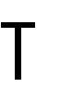

8𝑎 = 128 − 8𝑏 − 90 + 6𝑏

8𝑎 = 38 − 2𝑏

38 − 2𝑏

𝑎 =

8



38 − 2𝑏

360 = 81 (

8

) + 9𝑏 +

90 − 6𝑏

8

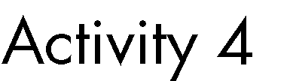

𝑦 = 3𝑥2 − 3𝑥 + 7



2880 = 81(38 − 2𝑏) + 72𝑏 + 90 − 6𝑏

2880 = 3078 − 162𝑏 + 72𝑏 + 90 − 6𝑏

2880 = 3168 − 96𝑏

−288 = −96𝑏

𝑏 = 3



𝑦 = 4𝑥2 + 3𝑥 + 9



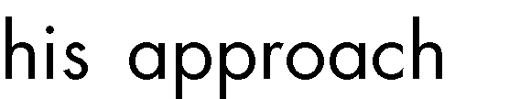



|  |  |
| --- | --- |
| x | y |
| 1 | 9 |
| 2 | 16 |
| 3 | 29 |
| 4 | 48 |
| 5 | 73 |
| 6 | 104 |
| 7 | 141 |
| 8 | 184 |
| 9 | 233 |
| 10 | 288 |



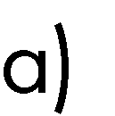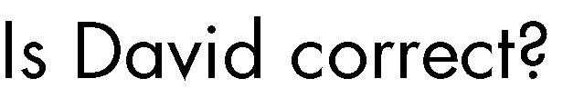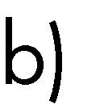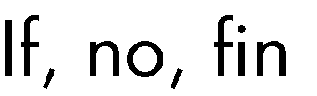

# Graphical representation of functions











* + - 1. The Cartesian plane





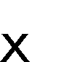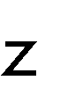

y

x





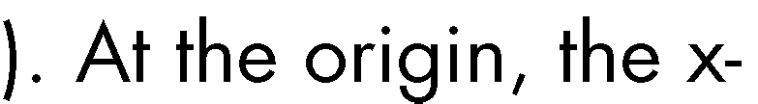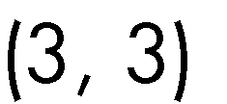

(-4, 5)

(4, -2)

(-6, -6)

















(-4, 5)





(-6, -6)



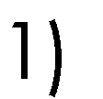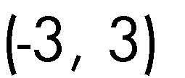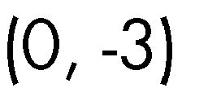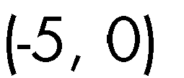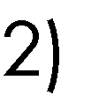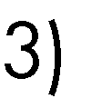

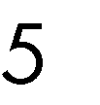

(-4, 5)

(4, -2)

(-6, -6)

# Ordered pairs



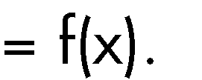





𝑦 = 2𝑥 + 1

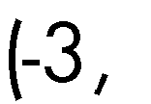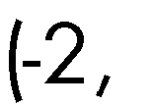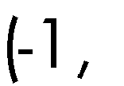

Plot of y=2x+1 with 7 points

10

9

8

7

6

5

4

3

2

1

0

-4

-3

-2

-1

0

x-axis

1

2

3

4

y-axis





|  |  |  |  |
| --- | --- | --- | --- |
|  |  |  |  |
|  | 2−3 + 1 | 9  8 | 9  8 |
|  | 2−2 + 1 | 5  4 | 5  4 |
|  | 2−1 + 1 | 3  2 | 3  2 |
|  | 20 + 1 |  |  |
|  | 21 + 1 |  |  |
|  | 22 + 1 |  |  |
|  | 23 + 1 |  |  |







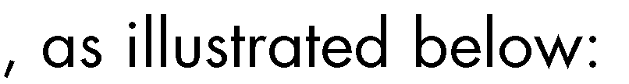





Plot of y=2x+1 with 13 points

10

9

8

7

6

5

4

3

2

1

0

-4

-3

-2

-1

0

x-axis

1

2

3

4

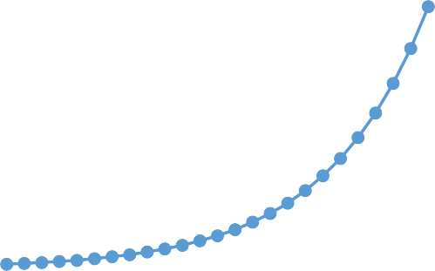

Plot of y=2x+1 with 25 points

10

9

8

7

6

5

4

3

2

1

0

-4

-3

-2

-1

0

x-axis

1

2

3

4

y-axis

y-axis







𝑦 = 3𝑥3 + 2𝑥 + 1



𝑦 =

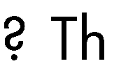

2

𝑥2−1







𝑦 = sin(𝑥)





# x- and y-intercepts

𝑦 = 3𝑥3 + 2𝑥 + 1

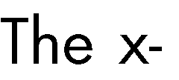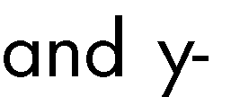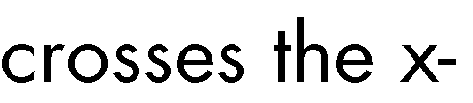











𝑦 = 3𝑥 + 7

𝑦 = 9𝑥 + 7 𝑦 = 𝑥2 + 5𝑥 + 6 𝑦 = 2 + 3

𝑥−1

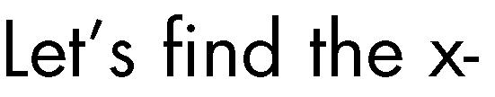





𝑦 = 9𝑥 + 7:

y=0

0 = 9𝑥 + 7



9𝑥 = −7

7

𝑥 = −

9



− 9

7



𝑦 = 𝑥2 + 5𝑥 + 6:

y=0:

0 = 𝑥2 + 5𝑥 + 6





𝑥 =

−𝑏 ± √𝑏2 − 4𝑎𝑐

2𝑎

𝑦 = 𝑎𝑥2 + 𝑏𝑥 + 𝑐.

, 0 = 𝑥2 + 5𝑥 + 6 



𝑥 = −5+√(5)2−4(1)(6) = −2 and 𝑥 = −5−√(5)2−4(1)(6) = −3.

2(1) 2(1)





For 𝑦 = 2

𝑥−1

+ 3:



2

0 = + 3

𝑥 − 1



−3 =

2

𝑥 − 1

−3(𝑥 − 1) = 2

−3𝑥 + 3 = 2

−3𝑥 = −1

1

𝑥 =

3

1.

3

𝑦 = 3𝑥 + 7:

0 = 3𝑥 + 7

−7 = 3𝑥











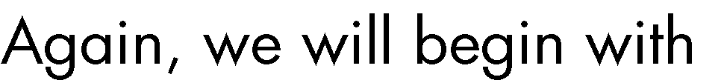𝑦 = 9𝑥 + 7.

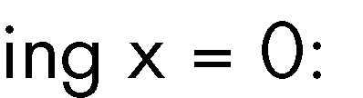

𝑦 = 9(0) + 7



# 𝑦 = 𝑥2 + 5𝑥 + 6. x=0:

𝑦 = (0)2 + 5(0) + 6

# 𝑦 = 6

𝑦 =

2



+ 3

0 − 1

𝑦 = 2

𝑥−1

# + 3 x=0:

𝑦 = −2 + 3

𝑦 = 1

# x=0:

𝑦 = 3𝑥 + 7

𝑦 = 30 + 7



𝑦 = 1 + 7

𝑦 = 8





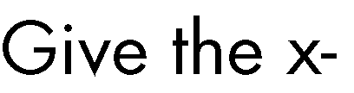



|  |  |  |  |  |
| --- | --- | --- | --- | --- |
|  |  |  |  |  |
| 𝑦 = 9𝑥 + 7 |  | 7  −  9 |  |  |
| 𝑦 = 𝑥2 + 5𝑥 + 6 |  |  |  |  |
| 2  𝑦 = + 3  𝑥 − 1 |  | 1  3 |  |  |
| 𝑦 = 3𝑥 + 7 |  |  |  |  |

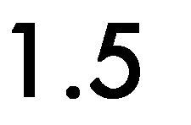

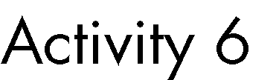

𝑥−3

𝑦 = 5 + 2

𝑦 = 10

𝑦 = 9𝑥2 + 8𝑥 − 10



# Shape



1.5.1.1 𝒚 = 𝒂𝒙 + 𝒃

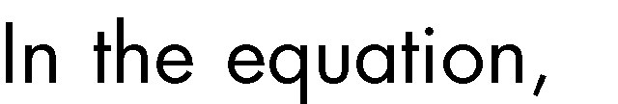𝑦 = 𝑎𝑥 + 𝑏

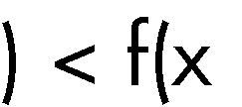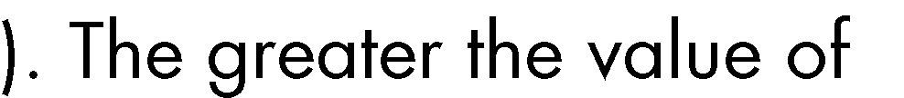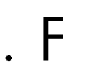



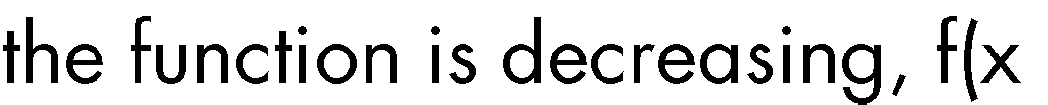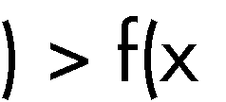

a= -5 < 0

200

150

100

50

0

-40

-30

-20

-10

0

10

20

30

40

-50

-100

-150

-200

a=-10 < 0

400

300

200

100

0

-40

-30

-20

-10

-100

0

10

20

30

40

-200

-300

-400

Series2









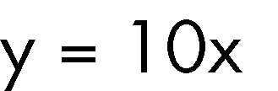

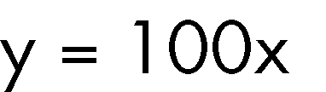

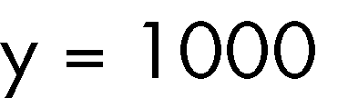

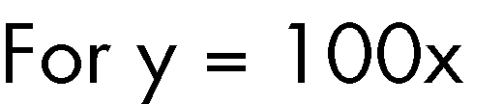

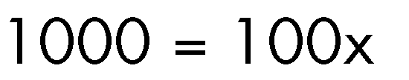

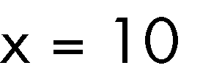

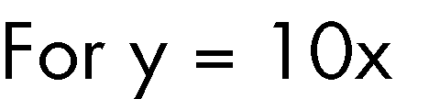

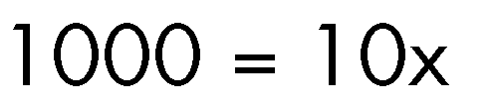

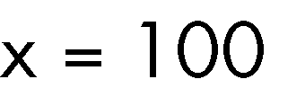





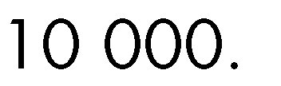

-40

-30

-20

a = 1 > 0

1000

900

800

700

600

500

400

300

200

100

0

-10 0 10

20

30

40



-40

-30

-20

-10

a = -1 < 0

0

-100 0

-200

10

20

30

40

-300

-400

-500

-600

-700

-800

-900

-1000

# 1.5.1.2 𝒚 = 𝒂𝒙𝟐 + 𝒃𝒙 + 𝒄

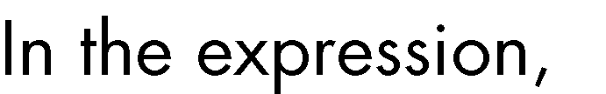𝑦 = 𝑎𝑥2 + 𝑏𝑥 + 𝑐

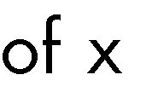







2000

1800

1600

1400

1200

1000

800

600

400

200

0

-40

-30

-20

-10

0

10

20

30

40

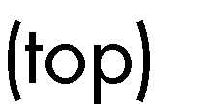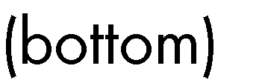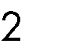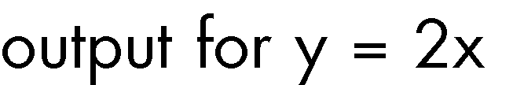





# 1.5.1.3 𝒚 = 𝒂

𝒙−𝒃

# + 𝒄







a = -5 < 0

10

8

6

4

2

0

-30

-20

-10

0

10

20

30

-2

-4

-6

-8

-10





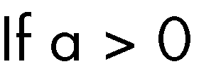

a = 5 > 0

10

8

6

4

2

-30

-20

-10

0

-2 0

-4

-6

10

20

30

-8

-10







50

40

30

20

10

0

-40

-30

-20

-10

0

10

20

30

40

-10

-20

-30

-40

-50

𝑦 = 20



𝑥



𝑦 = 5



𝑥

20

𝑥

𝑦 =

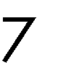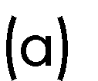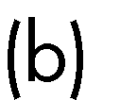

800

600

400

200

0

-

0

10

2

-200

-400

-600

-800

40

0

3

0

-10

-20

-30

40



900

-100

-30

-20

-10

0

10

20

30

-1100

-2100

-3100

-4100

-5100

-6100

-7100

-8100

# Symmetry



•



•



•

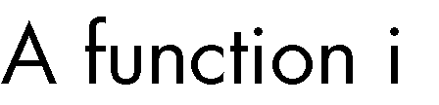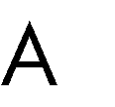





= 𝑥2 + 1



𝑓(𝑥) = 𝑥2 + 1



𝑦

𝑓(−𝑥) = (−𝑥)2 + 1

𝑓(−𝑥) = 𝑥2 + 1

∴ 𝑓(−𝑥) = 𝑓(𝑥)



|  |  |  |
| --- | --- | --- |
|  |  |  |
|  | 𝑦 = (1)2 + 1 = 2 | 𝑦 = (−1)2 + 1 = 2 |
|  | 𝑦 = (2)2 + 1 = 5 | 𝑦 = (−2)2 + 1 = 5 |
|  | 𝑦 = (3)2 + 1 = 10 | 𝑦 = (−3)2 + 1 = 10 |
|  | 𝑦 = (4)2 + 1 = 17 | 𝑦 = (−4)2 + 1 = 17 |









Graph of y=x2+1

120

100

80

60

40

20

0

-15

-10

-5

0

5

10

15

𝑦 = (𝑥 − 2)2



5

4

3

2

1

0

-1

-2

-3

-4

-5

0

0.5

1

1.5

2

2.5

3

3.5

4

4.5

5

5.5

6

6.5

7

7.5

8

8.5

9

9.5

10

10.5

11

11.5

12

12.5

13

13.5

14

Graph of y=(x-2)2

160

140

120

100

80

60

40

20

0

-15

-10

-5

0

5

10

15

20



𝑦2 = 𝑥









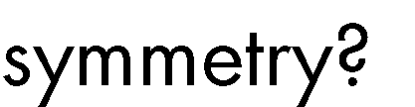

# a.

Graph of y=sin(x)

1.5

1

0.5

0

-2

-3

-1

-

4

-0.5

0 1 2 3



Graph of y=cos(x)

1.5

1

0.5

0

-4

-3

-2

-1

0

1

2

3

4

-0.5

-1

-1.5

-1

-1.5

# b.

c.

Graph of y=x3+2x2+2x+1

1500

1000

500

0

-15

-10

-5

0

5

10

15

-500

-1000

Graph of y=5/x

15

10

5

0

-60

-40

-20

0

20

40

60

-5

-10

-15



# a)

Graph of y=(x-3)2

180

160

140

120

100

80

60

40

20

0

-15

-10

-5

0

5

10

15

20

b)

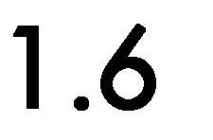



* + 1. Increasing functions



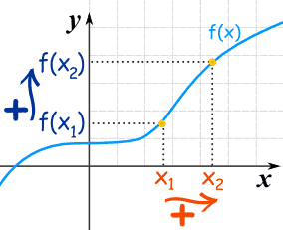

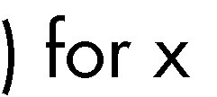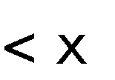

𝑦 = 𝑒𝑥

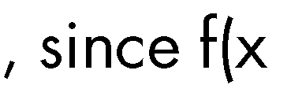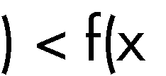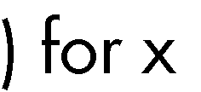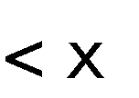

Graph of y=ex

500

400

300

200

100

0

0

1

2

3

4

5

6

7

|  |  |  |  |  |  |  |
| --- | --- | --- | --- | --- | --- | --- |
|  |  |  |  |  |  |  |
|  |  |  |  |  |  |  |
|  |  |  |  |  |  |  |
|  |  |  |  |  |  |  |
|  |  |  |  |  |  |  |

# Decreasing functions



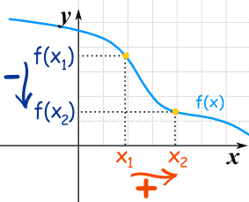

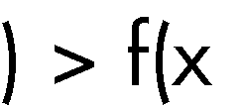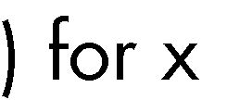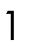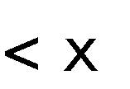

𝑦 = −9𝑥 + 9

Graph of y=-9x+9

80

60

40

20

-8

-6

-4

0

-2 0

-20

2

4

6

8

-40

-60

# Functions with both increasing and decreasing segments

𝑦 = 𝑥3 − 6𝑥2 + 5𝑥 + 3:



10 Graph of y=x3-6x2+5x+3

5

0

-2

-1

-5 0

-10

-15

-20

-25

1

2

3

4

5

6



# Constant functions



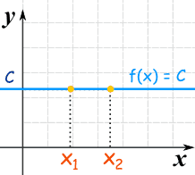



a)

Graph of y=10/x

12

10

8

6

4

2

0

0

b)

2

4

6

8

10

12

Graph of -x2+3

20

0

0

2

4

6

-20

-40

-60

-80

-100

-120

12

10

8



 

|  |  |  |  |  |  |
| --- | --- | --- | --- | --- | --- |
|  |  |  |  |  |  |
|  |  |  |  |  |  |
|  |  |  |  |  |  |
|  |  |  |  |  |  |
|  |  |  |  |  |  |
|  |  |  |  |  |  |

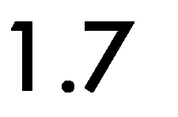





Capacitor Voltage versus Time

1.2

1

0.8

0.6

0.4

0.2

0

0

20

40

60

Time (seconds)

80

100

120

Voltage (V)

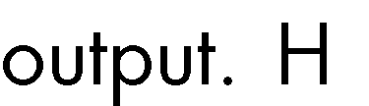





|  |  |  |  |  |  |
| --- | --- | --- | --- | --- | --- |
|  |  |  |  |  |  |
|  |  |  |  |  |  |
|  |  |  |  |  |  |
|  |  |  |  |  |  |
|  |  |  |  |  |  |
|  |  |  |  |  |  |



























Capacitor Voltage versus Time

1.2

1

0.8

0.6

0.4

0.2

0

0

20

40

60

Time (seconds)

80

100

120

Capacitor Voltage versus Time

1.2

1

0.8

0.6

0.4

0.2

0

0

20

40

60

Time (seconds)

80

100

120

Voltage (V)

Voltage (V)

|  |  |  |  |  |  |
| --- | --- | --- | --- | --- | --- |
|  |  |  |  |  |  |
|  |  |  |  |  |  |
|  |  |  |  |  |  |
|  |  |  |  |  |  |
|  |  |  |  |  |  |
|  |  |  |  |  |  |









|  |  |  |  |  |  |
| --- | --- | --- | --- | --- | --- |
|  |  |  |  |  |  |
|  |  |  |  |  |  |
|  |  |  |  |  |  |
|  |  |  |  |  |  |
|  |  |  |  |  |  |
|  |  |  |  |  |  |



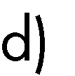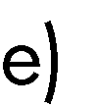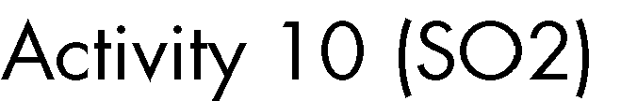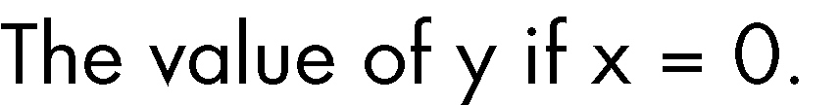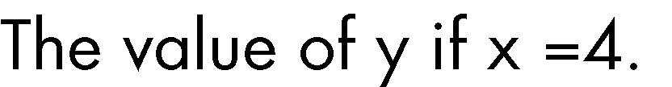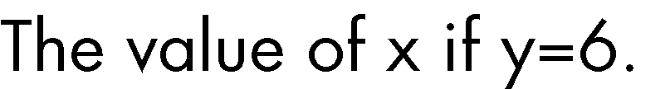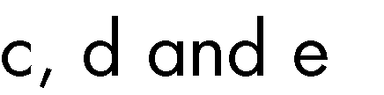

30

25

20

15

10

5

0

-6

-4

-2

0

2

4

𝑦 = 𝑥2 + 2



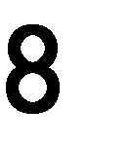













•

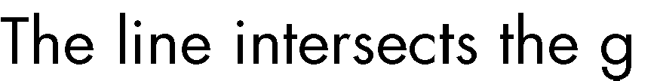

•



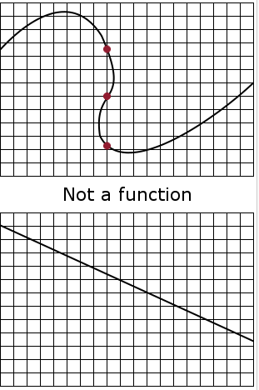



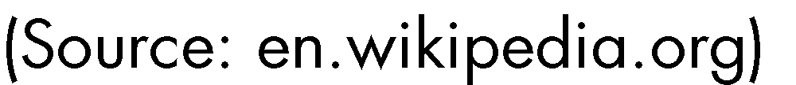









•



•







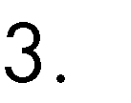





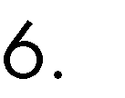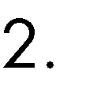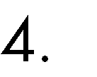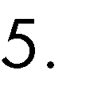



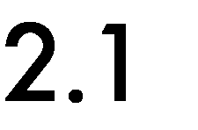

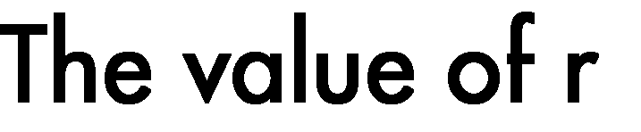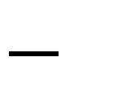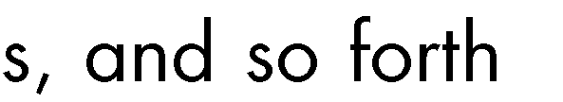







# •

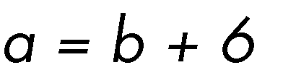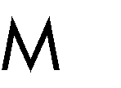

•



# ▪

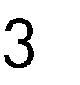

▪



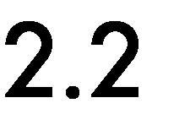



▪

▪



▪



▪

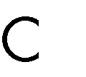

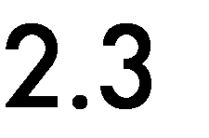









|  |  |
| --- | --- |
|  |  |
|  |  |
|  |  |



# Examples of symbolic representations and how they can be used



Entity-relationship diagrams





• 

• 

• 





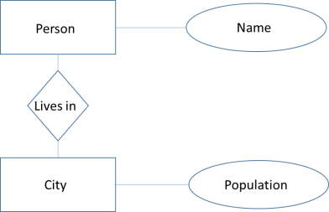

# Geometric shapes

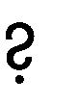



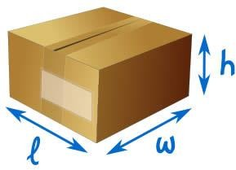•

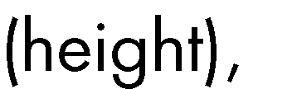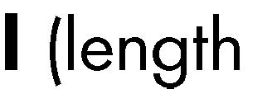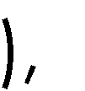

•

•

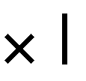



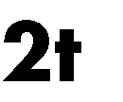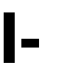

# Choice of representation













• 

• 

•

# Accuracy of answer required

















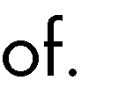





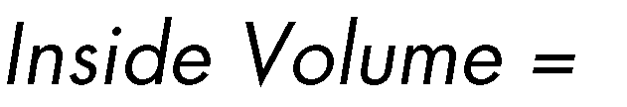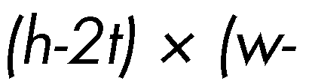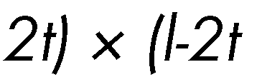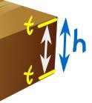

•

•

•

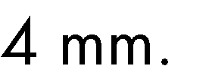





•

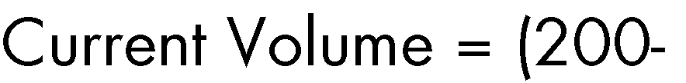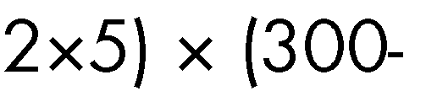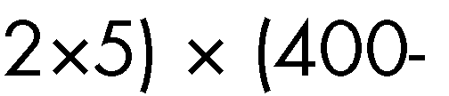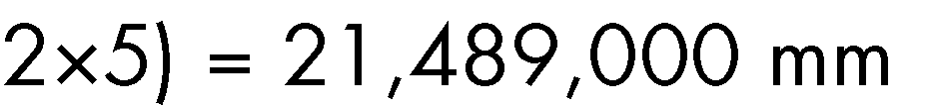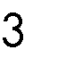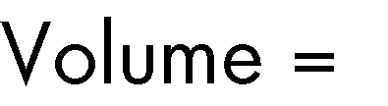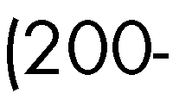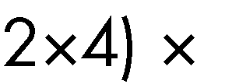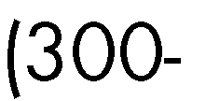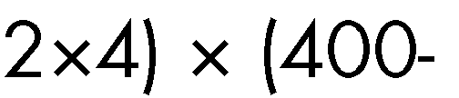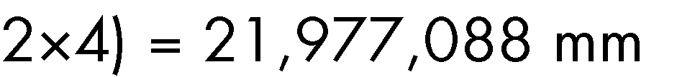

•



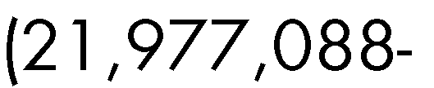

# The steps for solving more complex situations using mathematical representation, and using point-by-point plotting to make recommendations







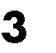









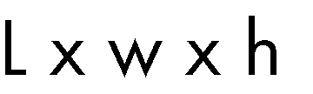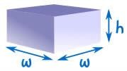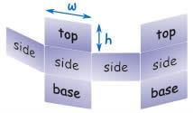



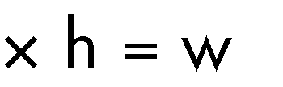



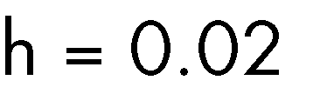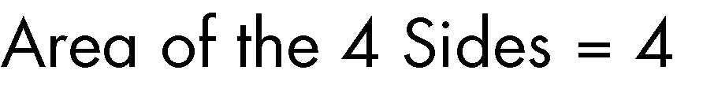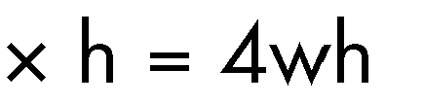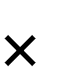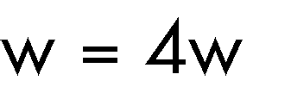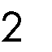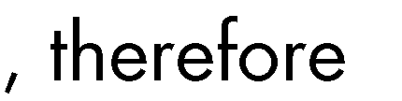



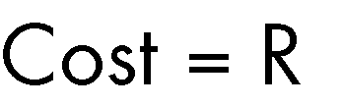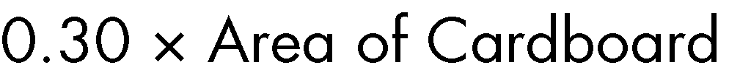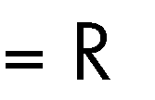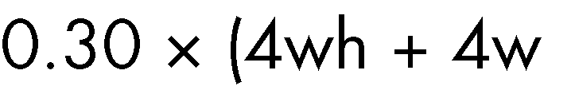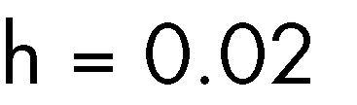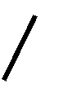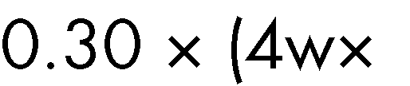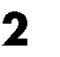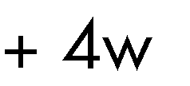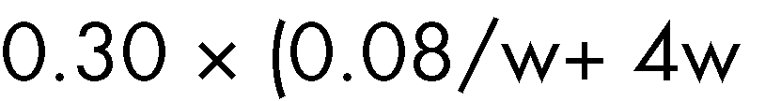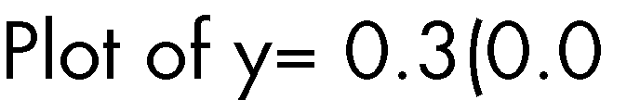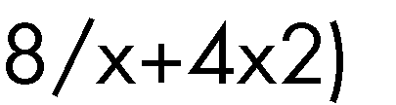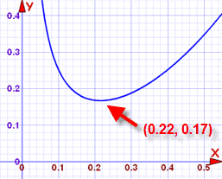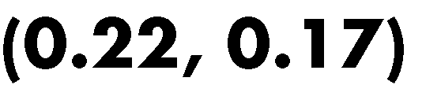

•

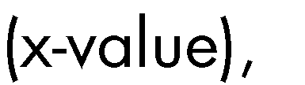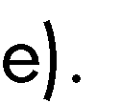

•









•

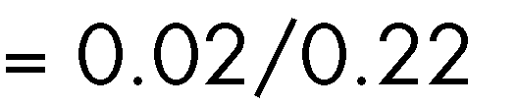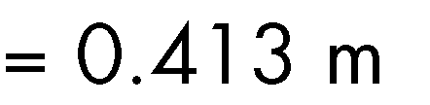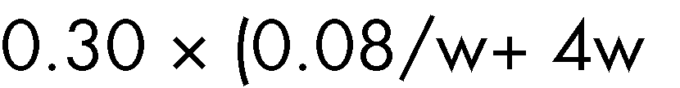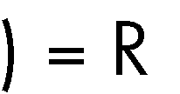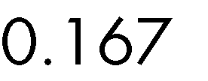

•

•















Weight versus spring elongation

180

160

140

120

100

80

60

40

20

0

0

200

400

600

800

1000

1200

Weight added in grams

Change in length in mm















|  |  |
| --- | --- |
|  |  |
|  |  |
|  |  |
|  |  |
|  |  |
|  |  |
|  |  |
|  |  |
|  |  |
|  |  |
|  |  |
|  |  |



|  |  |  |  |  |  |
| --- | --- | --- | --- | --- | --- |
|  |  |  |  |  |  |
|  |  |  |  |  |  |
|  |  |  |  |  |  |
|  |  |  |  |  |  |
|  |  |  |  |  |  |
|  |  |  |  |  |  |
|  |  |  |  |  |  |
|  |  |  |  |  |  |
|  |  |  |  |  |  |















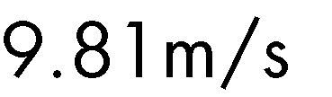

F = (0.7kg)(9.81m/s2) = 6.867N



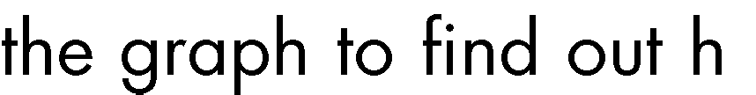

















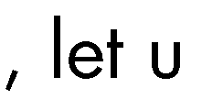

𝑚 =

𝑚 =

140 × 10−3 − 0

700 − 0

1

5000

𝑦 = 1

5000

𝑥 + 𝑐

𝑦 = 1 𝑥



5000



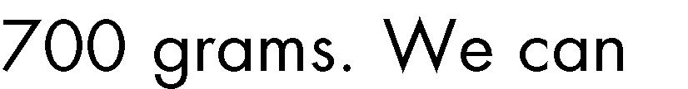



𝑦 = (

1

5000

) (200)

𝑦 = 0.04𝑚 𝑜𝑟 40𝑚𝑚



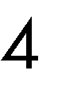



# Predicting







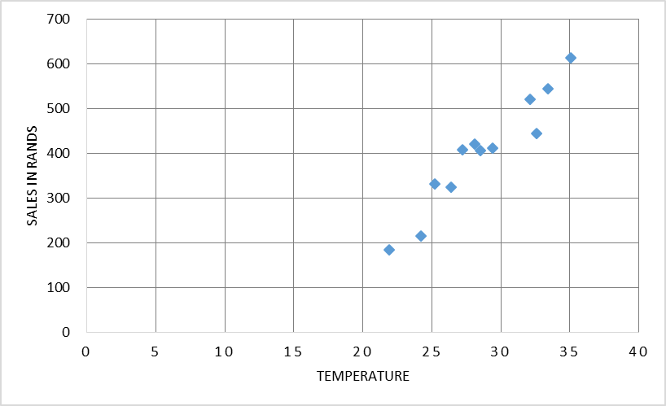

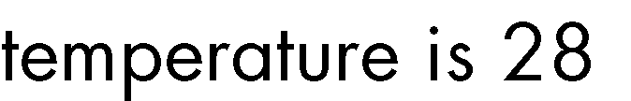





* + 1. Verifying representations

























