

|  |  |
| --- | --- |
|  |  |

|  |
| --- |
|  |

|  |  |  |  |
| --- | --- | --- | --- |
|  |  | | |
|  |  |  |  |
|  |  | | |
|  |  | | |
|  |  |  |  |



|  |
| --- |
|  |
|  |
|  |

|  |
| --- |
|  |



|  |
| --- |
|  |
|  |
|  |
|  |
|  |
|  |
|  |
|  |
|  |
|  |

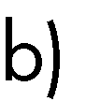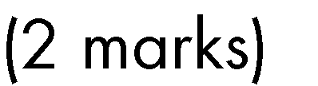



|  |
| --- |
| 𝑦 = 𝑥2 − 1 |
|  |
|  |
|  |
| 𝑦 = 9 − 3  𝑥−1 |
|  |
|  |
|  |
|  |



|  |
| --- |
| 2.5  2  1.5  1  0.5  0  -10 -9 -8 -7 -6 -5 -4 -3 -2 -1 0 1 2 3 4 5 6 7 8 9 10 |

10

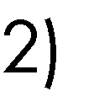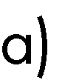

1.5

1

0.5

0

-4

-3

-2

-1

0

1

2

3

4

-0.5

-1

-1.5

5

-10 -8

-6 -4

0

-2 0 2 4 6 8 1

-5

-10



|  |
| --- |
| 200  150  100  50  0  -40 -30 -20 -10 0 10 20 30 40  -50  -100  -150  -200    450  400  350  300  250  200  150  100  50  0  -6 -4 -2 0 2 4 6 8 |

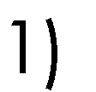

12

10

8

6

4

2

0

-4

-3

-2

-1

0

1

2

3

4

5

6

-2

-4

-6

-8

 





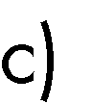

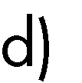

e) 

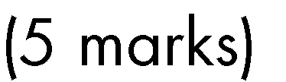

𝑦 = −𝑥2 + 2𝑥 + 9





𝑦 = 5𝑥 − 2



