LEARNER GUIDE

67465 National Certificate:
Business Administration Services
Level 3

Module 7 Numeracy and Research

Use mathematics to investigate and monitor the financial aspects of personal, business and national issues.
7456
NQF Level 3
Credits 5

TABLE OF CONTENTS

TABLE OF CONTENTS ii
INTRODUCTION 1
Programme Overview 1
Personal Objectives And Expectations 2
UNIT STANDARD 7456 3
USE MATHEMATICS TO CONTROL BUDGETS 5
Banking 6
The Role Of Bank Staff 6
Savings Account 7
Cheque Account 7
Fixed Deposits 10
Difference Between Stop Orders And Debit Orders 10
Credit Cards 11
Debit Cards 11
Finance 12
Budget 12
Fixed Expenses 13
Changing Expenses 13
Luxury Expenses 13
Drawing Up A Budget 13
Reasons For Budgeting 14
Why should you save? 14
Drawing up your own budget 14
National And Provincial Budgets 16
Tax 16
Why Do We Have to Pay Tax? 17
Employees’ Tax 17
Direct Tax vs. Indirect Tax 18
Taxes paid by companies 19
Control Of Income and Expenditure 19
Budgets 19
Profit and Loss 24
Price 24
Mark-Up Percentage and Profit Percentage 25
What does a business do with profits? 25
SIMPLE AND COMPOUND INTEREST 26
Interest 27
Simple and Compound Interest 27
Basic terminology 27
Simple interest 27
Annual compound interest 29
Define changes in interest over a period of time 31
Commission 32
What is a percentage? 32
Effective and Nominal Interest Rates 33
Depreciation And Appreciation 34
Depreciation 34
Calculate depreciation 35
Appreciation 36
Calculate appreciation 37
Inflation 37
The Rule of 72 38
THE NATIONAL ECONOMY 40
Introduction to Economics 41
Kinds of production 42
Government’s role 42
What are some of the things we can do to be competitive? 42
Tax 42
Why Do We Have to Pay Tax? 43
Direct Tax vs. Indirect Tax 43
Equitable Distribution of Resources 44
National Economic Planning 45
Energy And Resource Development 45
Water Supply, Waste Disposal and Pollution 45
Agricultural Development 45
Industrial Development 46
Welfare Benefits 46
Military and Police Facilities 46
Financial Affairs Relating to The Provinces 46
The Functions and Powers of Local Government 46
Productivity 47
Impact of HIV on Productivity 49
Prevalence of HIV/AIDS 49
Labour market 50
Productivity 50
Effect of HIV on the labour market 50

Name
Contact Address
Telephone (H) |  | Telephone (W)
Cellular
ID Number
Learner Number

INTRODUCTION
This module belongs to you. It is designed to serve as a guide for the duration of your course and as a resource for after the time. It contains readings, activities, and application aids that will assist you in developing the knowledge and skills stipulated in the specific outcomes and assessment criteria.
Follow along in the guide as the facilitator takes you through the material, and feel free to make notes and diagrams that will help you to clarify or retain information. Jot down things that work well or ideas that come from the group. Also note any points you’d like to explore further.
Participate actively in the skills practice activities as they will give you an opportunity to gain insights from other people’s experiences and to practice the skills. Remember to share your own experiences so that others can lean from you too.
Each section will be preceded by outcomes and assessment criteria taken from the South African Unit Standards, where available. These will describe what you must know and be able to do in order to successfully complete the course. If the course is aligned to Unit Standards, you will be able to receive credits towards a National Qualification upon successful assessment.

Programme Overview

Purpose
In order to achieve the credits and qualify for the this appropriate registered standard, determined by the Sector of Education Training Authority, you are expected to have demonstrated specific learning outcomes.

Specific Outcomes
Specific Outcomes describe what the learner has to be able to do successfully at the end of this learning experience.

Assessment Criteria
The only way to establish whether a learner is competent and has accomplished the specific outcomes, is through the assessment process. Assessment involves collecting and interpreting evidence about the learners’ ability to perform a task. This module includes assessments in the form of self-assessments, group tasks, quizzes, projects and a practical training programme whereby your are required to perform tasks and collect, as portfolio of evidence, proof signed by your facilitator that you have successfully performed these tasks.

To Qualify
To qualify and receive credits towards your qualification, a registered Assessor will conduct an evaluation and assessment of your portfolio of evidence and competency.

Range of Learning
This describes the situation and circumstance in which competence must be demonstrated and the parameters in which the learner operates.

Responsibility
The responsibility of learning rests with you, so be proactive and ask questions; seek assistance and help from your facilitator, if required.

How You Will Learn
The programme methodology includes facilitator presentations, readings, individual activities, group discussions and skill application exercises. Know what you want to get out of the programme from the start and start applying your new skills immediately. Participate as much as possible so that the learning will be interactive and stimulating.

How you will be assessed
This programme has been aligned to registered unit standards. You will be assessed against the outcomes of the unit standards by completing a assessments that cover the essential embedded knowledge stipulated in the unit standards, and by compiling a portfolio of evidence that provides proof of your ability to apply the learning to your work situation. When you are assessed as competent against the unit standards, you will receive 10 credits towards your National Qualification.

Personal Objectives And Expectations
You will get much more out of the programme if you take some time to think about the things you would like to achieve as a result of the training.

UNIT STANDARD 7456

Unit Standard Title
Use mathematics to investigate and monitor the financial aspects of personal, business and national issues

NQF Level
3

Credits
5

Purpose
This unit standard will be useful to people who aim to achieve recognition at some level in Further Education and Training or to meet the Fundamental requirement of a wide range of qualifications registered on the National Qualifications Framework.

People credited with this unit standard are able to:
Use mathematics to plan and control personal and/or household budgets and income and expenditure.
Use simple and compound interest to make sense of and define a variety of situations including investments, stokvels, inflation, appreciation and depreciation.
Investigate various aspects of financial transactions including costs, prices, revenue, cost price, selling price, loss and profit.

Learning Assumptions
Learners accessing this Unit Standard should be competent in Mathematical Literacy and Communications at NQF level 2.

Specific Outcomes and Assessment Criteria
Specific Outcome 1: Use mathematics to plan and control personal, regional and/or national budgets and income and expenditure: Bank accounts, provincial and key elements of national budgets and tax
Assessment Criteria
Use mathematics to plan and control personal, regional and/or national budgets and income and expenditure
Plans describe projected income and expenditure realistically
Calculations are carried out using computational tools efficiently and correctly and solutions obtained are verified in terms of the context
Budgets are presented in a manner that makes for easy monitoring and control
Actual income and expenditure is recorded accurately and in relation to planned income and expenditure. Variances are identified and explained and methods are provided for control

Specific Outcome 2: Use simple and compound interest to make sense of and define a variety of situations: Effective and nominal rates, commission, appreciation and depreciation
Assessment Criteria
Use simple and compound interest to make sense of and define a variety of situations
The differences between simple and compound interest are described in terms of their common applications and effects
Methods of calculation are appropriate to the problem types.
Computational tools are used efficiently and correctly and solutions obtained are verified in terms of the context or problem
Solutions to calculations are used effectively to define the changes over a period of time

Specific Outcome 3: Use mathematics to debate aspects of the national economy: tax, productivity and the equitable distribution of resources
Assessment Criteria
Values are calculated correctly
Mathematical tools and systems are used effectively to determine, compare and describe aspects of the national economy
Debating points are based on well-reasoned arguments and are supported by mathematical information

Unit Standard Essential Embedded Knowledge
Budgets
Terminology and definitions associated with financial situations
Estimation and approximation
Compound increase and decrease

USE MATHEMATICS TO CONTROL BUDGETS

Outcome
Use mathematics to plan and control personal, regional and/or national budgets and income and expenditure

Assessment criteria
- Plans describe projected income and expenditure realistically
- Calculations are carried out using computational tools efficiently and correctly and solutions obtained are verified in terms of the context
- Budgets are presented in a manner that makes for easy monitoring and control
- Actual income and expenditure is recorded accurately and in relation to planned income and expenditure. Variances are identified and explained and methods are provided for control

Banking

The Role Of Bank Staff
Today’s bank staff have a wide knowledge of
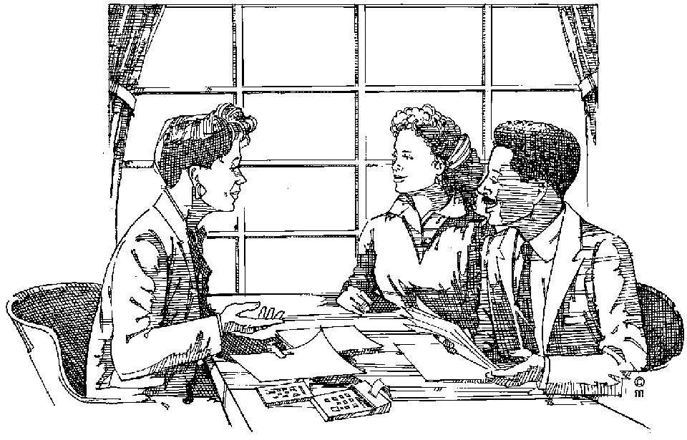
Banking,
Property finance,
Credit cards, f
Foreign exchange regulations,
Personal finance,
Small business,
Corporate finance and much, much more.
A good relationship with your bank that is based on trust and understanding can be very helpful. It can, for instance, help you to overcome a difficult time in your business or in your personal financial life.
In order to have a good relationship with your bank, you have to develop the relationship – work on it. When you decide to open a bank account, make an appointment to see a bank consultant or official. The sooner they get to know you, the better.
Inform him / her what you want from your bank, why you need the various services you have applied for, and so on. They will usually need proof of your income, such as your salary and other income, such as interest on investments. Sometimes they will ask you for a balance sheet of your assets and liabilities. It is always good if your bank has this on record. If you have to apply for an overdraft, a mortgage loan or any other kind of credit, the bank already knows what your finances look like and the process goes faster.
Try and build up and maintain a good credit rating. Your must keep your record at the bank clean. This means NOT writing out cheques when there is not enough money in your banking account, hoping that nobody will pick it up. The bank will notice it immediately.
While the bank manager might allow you once or twice, for small amounts to overdraw your account, he will start returning your cheques as unpaid if you do it too often. You should actually never do this.
If you are going to go into overdraft (in other words use money that you do not have on your account) or exceed your overdraft limit if you have one (use more money than the bank has authorized you to use), pick up the phone and ask him for an overdraft or an extension. In most cases, he is likely to provide you with one.
A bank manager needs to know what you are doing. After all, it’s not his money that he is handing out. When you find yourself in trouble, don’t try and run away. Ask to see your manager and explain the situation to him. In most cases he will try and get you out of trouble. But if you start playing games with him, promising to make payments and failing to do so, he is likely to take action against you.
Remember, a good credit record is an invaluable asset.
Long ago people used to stuff money into their mattresses or bury it in the ground. Today’s banking world very different from those primitive days. The purpose is the same– to keep the money safe from other people as well as inflation. Banks today offer a range of banking products in order to be of service to their clients.

Savings Account
This is probably the simplest of all the services offered by banks. The main purpose is to put money away for a “rainy day” or simply as a nest egg.
The bank keeps your money until you need to make withdrawals (take it out of the banking account), which can be at any time. For this reason, the interest rate usually is very low, because the money can be reclaimed at very short notice.
A savings account gives you easy access to your money while it earns some interest. Many people use the account to pay in their salary cheque every month and make withdrawals against it during the month. Most banks want you to leave a minim balance of R50 or R100 in the account, so you will find that you cannot withdraw every last cent from a savings account.
Interest that you earn on your savings account is credited (paid into the account by the bank) once a month.
There are also special savings accounts available. The minim balance that has to be left in the account is higher, usually between R1000 and R5000, but the interest rate is also higher, which means that you will earn more money from interest. Many of these special savings’ accounts also have special rules, such as that you can only withdraw money twice a month, and so on.
If you are issued with a card and you lose it, report it to your bank or financial institution immediately. Otherwise, you could suffer serious losses.

Cheque Account
With this account, you are given a cheque book. With a cheque book, you can make withdrawals without going to the bank or the ATM. You can also pay for goods you are buying by writing out a cheque.
The main advantage of a cheque account is that money is safe and can be quickly paid to other people. The interest banks pay on credit balances varies. Some pay on daily balances (in most cases daily balances over R500) while others pay on a minimum daily basis.
Understandably, when you go into overdraft, you pay interest on that money, because you are borrowing money from them.
Most banks nowadays guarantee cheques up to a certain limit. Depending on the credit rating of the client, this varies from R100 to R5000.
When you have a cheque account, the bank will send you regular statements. Bank statements are a record of all the transactions that go through your account – deposits you make, cheques you wrote out to pay for purchases or services and bank charges that were debited to your account. As soon as a cheque is taken or sent to the bank, the bank will pay the money out. The cheques which have been paid by the bank by the time the statement is sent, will also be attached to the bank statement.
This means you can check which cheques have already been paid and which cheques still have to be paid by the bank. This is called reconciling your cheque book with your statement.
It is good money management to go through your statements the day they arrive. This way you can check whether the statement is correct and see which cheques have been drawn against your account (have been presented to the bank for payment and paid by the bank).
Of course, nothing in life is free, and you pay for the service of writing cheques. The fee formulas differ from bank to bank and you should enquire about this when you open the account. The banking charges for cheque accounts are much higher than those for savings accounts.
Most banks also show the formula they use on the bank statements. Banks also charge for other services like stop orders and debit orders, post-dated and guaranteed cheques, money transfers, etc. After all, that’s why they are in business.

What is a cheque?
A cheque is a written instruction from you to your bank to pay an amount of money from your cheque account.
There are many services related to cheque accounts. For example, you can place a stop order on your cheque account in favour of your savings account, should you wish to save a fixed amount every month.
Other services include automatic teller machines (ATM), garage cards and electronic account payments. Electronic account payments are payments made through an ATM. Of course, you first have to go into the bank to arrange for these payments to happen. These days, most things can be paid electronically, such as water and lights accounts, telephone accounts,
Cash withdrawals and deposits, among many transactions, can be made after and during office hours by operating your cheque account through ATMs.
If you have a cheque account, you can buy goods and pay for them through the post.
When you have a cheque account you don’t have to carry large amounts of cash on your person. If you should lose a cheque or cheques, you can ask your bank to stop payment of the cheque or cheques.
Cheque books have counterfoils, a little piece of paper that stays in the cheque book once you have torn out the cheque. You must always complete the counterfoil as this is your record of which cheques you have written out. If you do not, you might forget about a cheque that you have written out and this can mean that your account becomes overdrawn.

How To Fill In A Cheque Correctly
Seven easy steps to make sure that your cheque is as clear as possible:
- First fill in the counterfoil, as this is the only record you will have of this transaction until you get your bank statement.
- Write the date in the space provided for the date.
- If you want to cash a cheque, write the word “cash”. Now the cheque reads “pay cash or bearer”. Do not leave cheques made out like this lying around as they could easily be cashed by anyone.
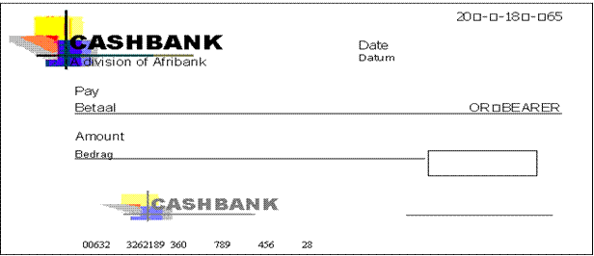
- Write the amount that the cheque must be for in words Immediately after the printed words “the sum of”. You do this so that no one can insert any word or words to make the amount of the cheque more than it is, and so commit fraud. To protect yourself again against fraudulent additions, fill in any unused space with a line.

- Then write the amount in figures starting as closely to the “R” sign as possible. Make sure that the amount in words and in figures are the same.
- You must sign the cheque only after all the other parts of the cheque (1-5 above) have been carefully completed. Blank signed cheques should never be left lying around.

Date |  | Your Bank  YOUR BANK Limited  Main Street Branch, 100 Main Road, JHB | Date
To
Balance b/f: |  | Pay or Bearer
Amount paid in: |  |  |  |  | R
Cheque number 001 |  | “.99979 :999999: 99999999999”. 99 |  |  | Joe Smith

The picture above shows a counterfoil and the cheque.
When you open a cheque account, the bank takes a specimen (example) of your signature and places it on record – they keep the example of your signature to check the signature when cheques are presented. You must make sure when you sign cheques that your signature on the cheque looks like the sample the bank has on record. You might want to give someone else the authority to sign cheques on your behalf. For this, you have to go to the bank and sign an authority at your branch.
- Always write your cheques in ink. Pencil or ink that can be erased could cause you to lose money due to fraudulent use of a cheque or cheques.
When you make a cheque out to “Cash or Bearer” the holder of the cheque will be able to withdraw money from the branch of the bank on which it is drawn (the branch of the bank where you have your account). This is called the drawee bank. The drawee bank may not cash a cheque if the cheque is crossed, which means that the holder will have to deposit it into a banking account and will have to wait for 3 to 7 days before the cheque is cleared and the money becomes available.

Crossing f Cheques
The reason for crossing a cheque is to ensure that the bank does not cash it, but pays it to a banker presenting it for payment. Crossing a cheque enables the drawer (you) via the drawee bank (your bank) to trace the history of the cheque through the banking system and normally to identify the holder. This is better than writing out cash cheques.
A cheque can be crossed as follows:
The true owner (the person or company that should get the money) gets some protection by writing “not negotiable” between the crossing lines. As stated, the cheque then has to be paid into a banking account and may not be paid out in cash. This means that the true owner can recover loss from someone who held the cheque after its loss or theft.

Safeguards Against Stolen Or Lost Cheques
If your cheque is stolen or lost, let your branch know immediately.
When you get your bank statement, file the cheques received with your statements, as they are your receipts for payments.
Deposit or cash cheques received by you without delay. Cheques will not be honoured if they are older than six months.

Fixed Deposits
This is where a sum of money is invested for a fixed period of time, between 6 and 36 months, at a fixed rate of interest. During the period of the investment, the money cannot be withdrawn except under exceptional circumstances.
For this reason, fixed deposits usually pay the highest rate of interest available.
Normally a fixed deposit may not be repaid prematurely (before the time has lapsed), but it may be redeemed in the case of insolvency or a deceased estate.
The 32-day notice or call deposit is also a very popular savings account that carries higher interest than a normal savings account

Difference Between Stop Orders And Debit Orders

Stop Order
The kind of payments that have to be made on a regular basis are the ones you tend to take for granted, like mortgage repayments, car instalments and other fixed expenses.
For this purpose, use a stop order. A stop order is when you ask your bank in writing to pay a specific amount of money to a third party on a specific date. All the bank needs from you is:
The beneficiary’s full names – the full names of the person or company you want to make the payment to
The beneficiary’s bank account number and where the account is held
The frequency and dates of the payments – how often and when payments must be made, e.g. Every month on the seventh or every second month on the fifteenth.
If you have money available in your bank account when the payment must be made, the bank will make the payment. The payments will be made every time until you order the bank to stop. This has to be done at the bank and in writing. The bank charges a fixed fee for this service, no matter what the amount.

Debit Order
Debit Orders are another way of making regular payments to a third party, without having to write out a cheque every month. Insurance companies prefer this method of payment. In this case, the beneficiary, e.g. the insurance company, will present the debit order to the bank for payment. The bank will honour any debit instruction to a client’s account, provided the client has authorized it with the organisation from whom the debit order has originated.
Debit orders are usually used for making regular payments that vary every month like electricity and water accounts, telephone accounts, rates, etc.
In the case of a debit order, the bank collects payment from a third party. A debit order has to be stopped by the organization from whom it originated, e.g. the insurance company has to stop the payment of the debit order from their side.

Credit Cards
Credit cards are most probably the easiest way to get horribly into debt. You simply present your card, sign the voucher and the goods are yours.
However, the pain does come later, at the end of the month. In fact, the term credit card is actually a misnomer; it should be called a debt card.
But seriously, used correctly, a credit card can be a wonderful tool in someone’s financial life. It enables you to pay for goods and services without needing to have any cash on hand. In today’s crime-ridden world, that is quite reassuring.
You can also withdraw cash from automatic teller machines (ATMs) and bank branches.
Once a month a cardholder receives a statement detailing all the transactions. The account must be paid by a certain date, usually 25 days from date of statement.
Used correctly, a credit card can provide you with up to 55 days worth of free credit. For instance, purchases made on the 1st day of the month only need to be repaid by the 25th of the following month. However, should you miss that cut-off date, the interest is calculated right back to the date that the purchase was made. The majority of credit card issuers offer a budget system that allows larger purchases to be made with repayment structured over a certain period of time.
Interest is charged monthly on the outstanding amount on both the revolving credit and the budget facilities.
The main benefits of credit cards are:
The ability to purchase goods and services wherever you please, even when you are travelling or on holiday.
The facility to make multiple purchases and settle them by cheque or even a monthly debit order.
You establish your credit rating once with the card issuer and not with each individual merchant.
You have the benefit of participating in a worldwide payment network.
Interest free credit of up to 55 days from date of purchase.

Debit Cards
A debit card is an ATM card which is linked to a savings or cheque account. It enables the accountholder (you) to use the card at retail outlets and merchants. It is therefore a safe alternative to carrying cash.
The good things about debit cards are:
It is easy to buy goods at most shops throughout the country
Transactions are fast and convenient
You cannot get into debt, as you can only carry out a transaction if you have funds available
You can withdraw cash at an ATM or supermarket
No need to carry cash with you
They improve money management, because you cannot overspend
Bank charges are lower than on cash withdrawals or cheque payments
You do not need to be credit-checked in order to get a debit card
Safe, as someone else has to know your PIN number before they can use your card

Finance
Finance is basically interpreted as being able to manage money. The financial world along with all other industries have a language all of their own. We need to become aware of what all this jargon means to help us manage our money successfully. Governments have to formulate economic policies which aim to benefit the whole community. Therefore, they often intervene in the commercial world to impose conditions which are necessary to achieve those objectives. These include measures to improve the balance of payments, to reduce unemployment, and to control the supply of money and credit.
Even though you may not be earning much, some of your income should be put aside and saved. It is all very well to convince yourself that starting your savings program can wait until you earn more, but by doing that you may never start. "Saving is a habit", a healthy one at that! For people who cannot start a savings habit, another option is to have money automatically deducted from your pay.
We all need some money stashed away for that rainy day, a safety net of three month’s take home pay is advisable. This money should be placed in a term savings account with a bank, provided of course you can draw on this without waiting for months. Every month you should check your income against debts and expenditure. You'll be surprised at the incredible fluctuations that can occur. Also, you are checking against running in the "red". There are three stages in your life when savings/ investing is at an optimum. They are when you cohabit a lodging with another person and share expenses, when you are living at home and are a wage earner, or when your children have finally left the nest, you are both working and your mortgage is greatly reduced.
Money governs what can be done in any situation. More careful management of money should always provide better value for the rand spent, but even more than that, an awareness of monies available, will enable the manager to make informed decisions on what can be afforded at any one time.
There are two aspects to financial management:
The BUDGET: this is a plan of what can and should be spent over a given period of time, and what things should be allocated what amount of money.
The FINANCIAL RECORDS: a system of books or computer files needs to be managed, keeping track of what is spent when and where; paying accounts, making purchases, authorizing and making payments, receiving money, sending bills to customers etc.

Budget
A budget is a plan of the amount of money coming in and the amount of money going out. In other words, it is a written plan of all the money you are earning and spending.
To work out the total amount of money that is coming in each month (your monthly income), write down all your earnings (your take-home pay), all your partner’s earnings (your partner’s take-home pay) and any other money coming in for the month.

Monthly Income
Husband
Wife
Other
Total Income

It stands to reason that you should not spend more than you earn, if you do you will get into debt. There are three basic types of expenses: fixed expenses, changing expenses, and luxury expenses.

Fixed Expenses
These are expenses that have to be paid every month, and the amounts don’t change, for example: rent.

Changing Expenses
These are expenses for things that you can’t normally do without, and the amounts change from month to month, for example: petrol.

Luxury Expenses
These are items that you can cut down on. They are usually luxury items, for example: cigarettes.

Drawing Up A Budget
To begin drawing up your budget, list all the main expenses that you have to pay every month.

These include:
Rent / Bond
Insurance
Electricity
School Fees
Hire Purchase Agreement

The next step is to list other money spent on items such as:
Food
Petrol
Electricity
Taxi or Bus Fare
Telephone Calls
Savings

Then you list all the luxury items that you spend money on. These can include:
Cigarettes
Alcohol
Entertainment
Sports
Clothes

Follow these steps when paying your monthly expenses:
Pay your fixed expenses.
Pay your changing expenses.
Put some money into a savings account.
Whatever is left over, use for luxury items

Reasons For Budgeting
The major reasons for budgeting for your expenses and savings are:
to avoid getting into money trouble
to prepare for a future where money won’t be a problem
to have “in-case” money for emergencies

Why should you save?
The money you save is used to pay for things that happen that you haven’t planned for. It is wise to always have savings for repairs to the house, the car, or any other type of emergency.
If you have savings in the bank, you will not get into money trouble. This will mean you will not have to borrow money from the bank.

Drawing up your own budget
In the estimate column, write down your expenses.
Write down your income.
Total your expenses. Subtract this from your income

Expenditure | Estimate | Actual | Date paid
Fixed Expenses
Bond/Rent
Rates
House Insurance
Car Insurance
Hire Purchases (e.g, fridge, furniture)
School Fees
Changing Expenses
Groceries
Petrol
Electricity/Water
Taxi Fare
Telephone
Retirement Annuities / Burial Society /Stokvel
Savings
Luxury Expenses
Clothes
Alcohol
Cigarettes
Entertainment
Sports/Hobbies
Donations
Sub Total
Unforeseen Costs
A. TOTAL SPENDING

Monthly income
Husband
Wife/Partner
Other
B. Total income
C. Subtract expenses from income
Shortfall / amount over

National And Provincial Budgets
Just as you should have a budget, every business and state organisation has a budget. During the National budget of the Minister of Finance it is announced what the budget for education will be. This is the amount of money available to the Minister of Education to be spent on education. Of course, all the government departments are allocated funds in order to run their departments. Examples are: Transport, Defence, Social Services, SA Police Services, and so on.
The Minister of Education will then budget (plan) to indicate which portion of her budget will go to which section of education and how much money should be allocated to each province. A portion of the money available to her will be held back by the National Department of Education for their own expenses and special projects.
The various provincial departments of education must draw up budgets to submit to the National Department of Education, showing how they spent their money during the previous year and how much money they will need during this year to pay their expenses and to use for special projects, such as subsidised bus fares, new schools or upgrading of the facilities of existing schools. The money that is available will then be allocated to the various provinces, based on the requirements of their individual budgets.
As the financial year proceeds, the National Department of Education as well as the Provincial Departments of Education must manage and control expenses to ensure that they do not spend more money than was allocated to them. They must also ensure that the money is spent on the items as shown in their budgets. They cannot ask for money to build new schools and then spend the money on higher salaries for top management, for example.

Tax
The question remains, where does the Minister of Finance get the money to allocate to the various state departments?
The Government has to pay for many projects worth millions of rands, for the benefit of all South Africans. These projects include:

Welfare
Housing
Education
Health care, including hospitals
Roads
Railways
Dams
Policing

All the monies collected through Value Added Tax, SITE and PAYE and tax paid by companies, estates and trusts is paid over to the Receiver of Revenue. This money is then used to fund the various government departments.

Why Do We Have to Pay Tax?
All over the world, people recognise the system of paying money to government in return for services which government provides. In South Africa the Minister of Finance is responsible for drawing up a budget in which the total government spending is announced.
Projects include state funded education and health care, policing, infrastructure (such as roads and dams, libraries, etc.), to name but a few. Obviously, the finance for all of these different government responsibilities must come from somewhere. Individual Taxation (Direct Tax and Indirect Tax) is responsible for the greatest portion of funding. The rest is made up by loan agreements.
From this it becomes quite clear that if people did not pay tax, the effect on the economy would be devastating. What one may want to examine, though, is the amount of income tax we pay.
In South Africa the laws surrounding income are statuted in the Income Tax Act. This is a very complicated piece of legislation which dates back to 1914. It covers a range of different types of tax.
In summary, it makes provision for tax to be collected from people who are employed, businesses.

Employees’ Tax
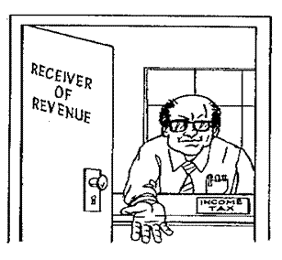
If you receive a salary, wage or what is known as remuneration for work that you do, then your employer is legally instructed to pay over a percentage of that for tax purposes to the Receiver of Revenue. The word "remuneration" would cover all of the following:
Salary
Wages
Overtime
Leave Pay
Commission
Gratuities
Pensions
Travel Allowance
Employees’ tax is paid according to either P.A.Y.E. or S.I.T.E.

Standard Income Tax on Employees (SITE)
This is an income tax levied on the first R60 000 of an employee's total annual salary. Obviously if you earn less than R60 000, you will only pay tax on the S.I.T.E. scale. This tax is "paid" by you directly from your salary to the Receiver.
S.I.T.E. as a method of employee tax collection was first introduced in March 1988. If you are taxed on this S.I.T.E. scale, then you are not required to fill in a tax return.

Pay As You Earn (P.A.Y.E.)
It is an income tax that is levied in exactly the same way as S.I.T.E. It only applies when the total annual income of an employee exceeds 60 000. This means that the first R60 000 is paid on the S.I.T.E. system and any amount over and above R60 000 is calculated on P.A.Y.E.

Assessment
The second aspect of tax collection involves assessment. Assessment is done only on those individuals who have been taxed on the P.A.Y.E. system. In short - everyone who pays P.A.Y.E. must submit a tax return at the end of the financial year (normally worked out from February of one year to February of the next). The reason for the Receiver of Revenue insisting that people do a tax return is so that they can assess taxable income in relation to taxable liability. What this means in real terms is that if you haven't paid your tax correctly, you will be required to pay the balance in to the Receiver.
The good news though, is that sometimes it works the other way - you may have been over-deducted in terms of your tax. In this instance you may receive a wonderful surprise in the form of a cheque back from the Receiver.

Note: At the end of the tax year, both P.A.Y.E. and S.I.T.E. taxpayers are given what is called an I.R.P. 5 form, to show how much tax has been paid.
The employers of P.A.Y.E. taxpayers pay tax to the receiver from your salary or wages on a regular basis. Inland Revenue provides the employer with a set of tables according to which the tax must be deducted.
During the tax year, you should keep various records for use when you complete your tax return. This includes:
Salary slips
Note of all medical expenses, e.g., doctors’ bills, prescriptions etc. You should also obtain a statement of claims paid out to you by your Medical Aid Society during the tax year
Receipts from dividend payments, or income from other investments during the year
Note of any contributions made to retirement annuities or other long-term investments, both taxable and non-taxable
IRP5 from your employer. Statement of interest earned, e.g., from your bank

Direct Tax vs. Indirect Tax

Direct tax
A direct tax is a tax which is paid by individuals or corporations calculated on the INCOME earned by those people. Because it is based on the INCOME earned by such persons, it is commonly known as Income Tax. Income Tax is paid directly from the person's employer to the Receiver of Revenue. The amount of tax that each person is liable for is based on the total amount they earned in any one-year.

Indirect tax
These are taxes which are due to any business transaction. This tax is on the "purchaser - seller" transaction rather than on the individuals concerned. At the same time, it must be seen that it is the party who funds the transaction who is responsible for paying the tax over to the party who is offering the goods or services - this kind of tax is called a consumption tax.
The most obvious example of an indirect consumption tax is Value Added Tax.
VAT is paid every time you purchase goods such as groceries, cars, furniture, pay for water and lights, etc. A flat rate of 14% is added to the price of the goods and this amount of 14% is paid over to the Receiver of Revenue.

Taxes paid by companies
All businesses pay a tax on their yearly profits, this is usually called company tax. This amount is calculated once a year, based on the net profit the business has made, and is paid to the Receiver of Revenue once a year. The amount of tax payable depends on what type of business you are running:
A sole trader and a partner pay personal income tax only
A close corporation and a company pay company tax, and members/shareholders pay personal income tax as well
Company tax is paid on taxable income, in other words on the gross profit

Every year the Minister of Finance calculates the money that was paid from various sources to the Receiver of Revenue, and on the basis of this figure works out the budget for the next year. It stands to reason that he uses the figure of the previous year and then estimates (forecasts) what amount will be paid to the Receiver of Revenue during the current year. He then uses the planned (forecast) amount to calculate his budget and to allocate money to the various government departments. This is why civil servants are called servants: their purpose is to serve the public, since the public finances all the salaries paid to employees of government departments.

Control Of Income and Expenditure

Budgets
When we talk about National and Provincial budgets, budgeting usually consists of a financial plan that shows anticipated (what you think is going to happen) or planned (what you planned to happen) costs, revenues cash balances or net income.
Costs would be costs to run the various government departments and includes salaries, rental of office space, salaries, water and lights, telephone, the cost and maintenance of government cars, building of new premises, paying social grants such as old age pension, subsidising transport, etc. The list is very long and varies from department to department and province to province.
Revenues would be the monies collected from various forms of tax.
Cash balances and net income normally refer more to privately owned businesses than government departments and would be the money that is left over after all the expenses have been paid.
As with your personal budget, a government department on both provincial and national level uses a budget to plan and control expenses (expenditure). It is crucial that persons, businesses, governments (local and national) and all business ventures budget to plan and control expenditure according to projected income. You cannot spend more money than you receive – if you or the national or provincial government departments do this, you and they will run into debt. In the case of national or provincial government departments, it means that:
pensions cannot be paid,
school bus operators cannot be paid,
the books required for schools cannot be bought and delivered to individual schools and so on and so on.
A major benefit of budgeting is that it requires managers to scrutinise and coordinate their operations very carefully, to ensure that they do not overspend. If done properly, this will help management to anticipate, many crises.
Another benefit of budgeting is that managers can and should compare actual costs (expenses) with the costs allocated in the budget – in the same way that you compare your expenses with your budget every month. If there are big differences between the budgeted costs and the actual costs, management can do what is necessary to stop this from happening.
This is why budgets are looked at each month, just like you should look at your budget every month to make sure that you do not overspend.
Managers mainly use two types of documents to control the budget: a Budget Management Report and an Income Statement.

Budget Management Report
 | Month | Year | Income |  |  |  | Purchases |  |  |  | Expenses
 | Month | Year | Budget | Actual | Over | Under | Budget | Actual | Over | Under | Budget | Actual | Over | Under
1 | March | 2003 | 4 000 | 3 600 | - | 400 | 2 000 | 2 100 | 100 | - | 1 500 | 1 800 | 300 | -
2 | April | 2003 | 5 000 | 4 200 | - | 800 | 2 500 | 2 100 | - | 400 | 1 000 | 1 100 | 100 | -
3 | May | 2003 | 6 000 | 5 100 | - | 900 | 3 000 | 3 000 | - | - | 1 000 | 1 100 | 100 | -
4 | June | 2003 | 6 000 | 6 300 | 300 | - | 3 000 | 3 000 | - | - | 1 000 | 1 100 | 100 | -
5 | July | 2003 | 6 000 | 7 000 | 1 000 | - | 3 000 | 3 000 | - | - | 1 000 | 1 200 | 200 | -
6 | August | 2003 | 6 000 | 7 000 | 1 000 | - | 3 000 | 3 400 | 400 | - | 1 000 | 1 200 | 200 | -
7 | Sept | 2003 | 7 000 | 7 500 | 500 | - | 3 500 | 4 000 | 500 | - | 1 000 | 1 200 | 200 | -
8 | October | 2003 | 7 000 | 6 500 | - | 500 | 3 500 | 4 000 | 500 | - | 1 000 | 1 300 | 300 | -
9 | Nov | 2003 | 7 000 | 8 000 | 1 000 | - | 3 500 | 4 000 | 500 | - | 1 200 | 1 500 | 300 | -
10 | Dec | 2003 | 8 000 | 8 000 | - | - | 4 000 | 4 100 | 100 | - | 1 300 | 1 600 | 300 | -
11 | Jan | 2004 | 6 000 | 4 000 | - | 2 000 | 3 000 | 3 000 | - | - | 1 000 | 1 200 | 200 | -
12 | Feb | 2004 | 7 000 | 6 000 | - | 1 000 | 3 500 | 3 000 | - | 500 | 1 000 | 1 200 | 200 | -
Total |  |  | 75000 | 73200 | - | 1 800 | 37500 | 38700 | 1 200 | - | 13000 | 15500 | 2 500 | -

The previous page contains an example of a Budget Management Report. From this report, we can see that:
The income was R1800 less for the year than anticipated
The purchases made was over budget by R1200 for the year
The expenses were R1300 over the budgeted amount for the year
The total income was R73200 for the year
The total amount spent as purchases and expenses was R54 200
There was still a balance (profit) of R19000 left after everything was paid.
In the case of a business, this is a good thing, since a business exists in order to make a profit. In the case of a government department it might not be such a good thing. The surplus money could have been used to pay for special projects such as housing, hospitals, schools, roads, etc.
Following is an example of a budget report that gives a breakdown of monthly expenses. The management budget report is compiled from various such smaller reports that give breakdowns of expenses per department, purchases per department, etc.

March 2003
 | Payments and Expenses | Budget | Actual | Over | Under
1 | Vehicle Licence | R54 | R54 | - | -
2 | Vehicle Loan | R300 | R300 | - | -
3 | Petrol | R200 | R250 | R50 | -
4 | Owner’s Salary | R600 | R600 | - | -
5 | Wages | R346 | R596 | R250 | -
6
7
8
9
10
11
Totals |  | 1 500 | 1 800 | 300 | -

The income statement can also be used to see the variance (difference) between actual expenditure and budget.
An Income and Expenditure Statement is a record of all income and expenditure with which the business conducted business in the year. This statement will tell you whether you have made a profit or a loss over a period, normally twelve months. As the name suggests, it shows you the income received and the expenses paid to operate the business.
Below is an example of an income statement.

INCOME STATEMENT – Actual vs. Budget: 01/04/2006 to 31/03/2007
 | Actual |  | Budget | Variance
 |  |  |  | Value | Percentage
SALES | 100 000.00 |  | 80 000.00 | 20 000.00 | 0.20
COST OF SALES (Purchases) | 75 000.00 |  | 60 000.00 | 15 000.00 | 0.20
OTHER INCOME | 100.00 |  | 66.00 | 34.00 | 0.34
EXPENSES | 14 300.00 |  | 16 400.00 | -2 100.00 | -0.15
Bank Charges | 1 000.00 |  | 800.00 | 200.00 | 0.20
Cleaning | 500.00 |  | 500.00 | - | -
Consumables | 200.00 |  | 300.00 | -100.00 | -0.50
Entertainment Expenses | 1 500.00 |  | 1 600.00 | -100.00 | -0.07
Interest Paid | 100.00 |  | 200.00 | -100.00 | -1.00
Printing & Stationary | 3 000.00 |  | 3 000.00 | -
Telephone & Fax | 5 000.00 |  | 6 000.00 | -1 000.00 | -0.20
Vehicle Expenses | 3 000.00 |  | 4 000.00 | -1 000.00 | -0.33
NET PROFIT/(LOSS) BEFORE TAX |  | 10 800.00 | 3 666.00 | 7 134.00 | 0.66
TAX | 3 780.00 |  | 1 283.10 | 2 496.90 | 0.66
NET PROFIT/(LOSS) | 7 020.00 |  | 2 382.90 | 4 637.10 | 0.66

From this we can see the following:
How much money came into the business
How much money was spent to purchase raw materials
How much was spent on various expense items
What the net profit before tax was
What the net profit after tax was
What the difference was between what was budgeted for and what actually happened for all the above items

Can you see how managers use these reports to ensure that the expenses of the business or the government departments do not become more than the income that was received?
You could do a similar exercise with your household budget, where profit would be money that can be saved.

Profit and Loss
A business exists with the purpose of making a profit. To be able to make profit, there will be expenses (expenditure). If the income (generated from sales or services) is more than the expenses, a profit was generated. A profit can only be generated if the expenses are managed carefully with the use of a budget.

Profit, in other words, it is the amount left over after a business has paid all its bills.

When a business makes a loss, it will go out of business.
There are many things that determine profit or loss in a business:
The price at which goods are sold
The price at which raw materials are purchased
How many goods are sold
Control of expenses
Are some of the factors that influence profit?

Price
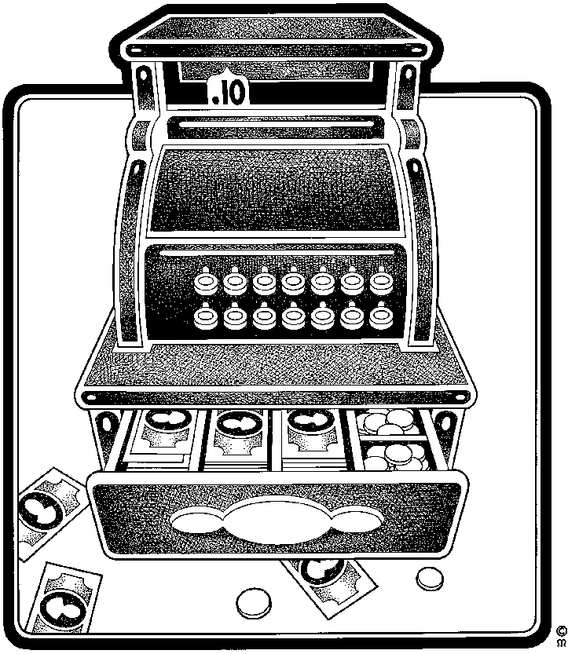
The price at which a business sells its goods or services, the selling price, should always be more than the total cost price. If not, the business will break even- there is no reward/returns to the business owners for investing their money in the business; or the business will make a loss – the business owners have to invest more money into the business to keep the business going.
The difference between cost price and selling price is called the mark up. Mark up is always calculated on the cost price. The mark up should be high enough to cover the cost price and overheads, plus allow for a profit.
Cost price
+ Expenses
+ Profit
= Selling Price

Profit is always expressed as a percentage of the selling price, because you only get the profit once the product has been sold.
Cost: R 1,00
Mark-up: R ,50
Selling Price: R 1,50

Mark-Up Percentage and Profit Percentage
Mark up is always greater (in percentage terms) than margin (profit), although the monetary figure is the same.

Mark Up = Selling Price - Cost Price
_______________________
Cost Price

Mark up % = (,50 divided by R 1,00) = 50%.

Margin = Selling Price - Cost Price
________________________
Selling Price

Margin (Profit) % = (,50 divided by R 1,50) = 33,3%.

As can be seen from the previous section, the income statement shows the profit or loss made by the business.

What does a business do with profits?
A portion of profit is used to pay the shareholders in the company, as they also have to get a reward for the money they invested in the business.
Another portion is used for investments and working capital. The biggest portion of the profit is reinvested in the business so that the business can, for example, buy new machinery, expand the range of products or services and other similar activities that are aimed at making the business bigger and more profitable.
Some companies use a portion of the profit to reward their employees by paying out bonuses

SIMPLE AND COMPOUND INTEREST

Outcome
Use simple and compound interest to make sense of and define a variety of situations

Assessment criteria
- The differences between simple and compound interest are described in terms of their common applications and effects
- Methods of calculation are appropriate to the problem types
- Computational tools are used efficiently and correctly and solutions obtained are verified in terms of the context or problem
- Solutions to calculations are used effectively to define the changes over a period of time

Interest

Simple and Compound Interest
Interest is the growth of your investment or asset, an example is that you deposit R100.00 at a bank for a period and receive in return interest on the amount deposited.
Interest can be seen in two ways:
It is money paid for the use of money lent e.g., a loan at a bank, a bond on a house, a loan for a car etc.
It is money earned for placing it in an investment, savings account, debenture etc.
Interest rates differ from bank to bank, and usually the interest you pay for a loan is higher than the interest you would earn from an investment or savings account
Interest is the cost of money; it is money which is paid for the use of money.

Basic terminology
Simple Interest | Interest earned/paid for a short period of time e.g. a month, 2 months, usually charged on overdue accounts.
Compound Interest | Interest earned/paid for long periods of time i.e. 12 months or more, usually for home loans, cars, investments, debentures, etc.
Appreciation | Increase in monetary value e.g. property investments.
Depreciation | Decrease in monetary value e.g. a car’s value is reducing every year.
Commission | Money paid to an agent in a commercial transaction e.g. a sales person earns commission on sales made.
Nominal Interest | The annual rate at which many loans and financial instruments are quoted is the nominal interest rate.
Effective Interest | The effective interest rate adjusts the nominal interest rate based on the amount of compound interest charged/earned and the number of days assumed in a year.

Simple interest
The calculation of interest may be ‘simple’ or ‘compound’. Simple interest is the application of a percentage rate to the principal sum for the period in question, as expressed in equation

Where i is the actual interest, p is the principal sum, t is the time or period of the loan in years and r is the percentage rate of interest.
Suppose that a person walks into a bank and deposits R1 000 in a savings account that earns an interest rate of ten per cent per year. How much will this depositor have in two years time if the account earns simple interest? The amount of interest is calculated by assuming that the interest does not earn interest. In other words the same base amount or principal must be used for each year. For this deposit, the value of the account after two years will be equal to the sum of the principal and the interest earned over the two years.
The interest earned in the first year is R 1000 x 0, 1 = R 100.
In the second year a similar amount of interest is earned, therefore at the end of two years the value of the account is RI 000 + R100 + RI00 = RI 200
Lindiwe has opened a Sales House clothing account. She has spent R1 080.00 on her account. Her minimum monthly payments are R200.00. Unfortunately for the past 2 months Lindiwe has been unable to pay this account, as she has had other expenses that she has had to cover. When she received her statement, she realised that Edgars have charged her 7% interest on her overdue account per month.

This is an example what her statement will look like:
SALES HOUSE (PTY) LTD |  |  |  |  |  |  |  |  |  |  | STATEMENT
P O Box 12406 |  |  |  |  |  |  |  |  |  |  | Date: 30/11/04
Johannesburg, 2000 |  |  |  |  |  |  |  |  |  |  | Page: 1
Tel: 011 123 4567 |  |  |  |  |  |  |  |  |  |  | Account Number:AC5280
Fax: 011 123 4589
MISS LINDIWE MAHLANGU
P O Box 20178
Kempton Park
2263
Account |  |  |  |  |  | Date |  |  |  |  |  | Page
AC5280 |  |  |  |  |  | 30/11/05 |  |  |  |  |  | 1
Date | Reference |  | Description |  |  |  |  |  | Debit |  |  |  | Credit |  | Amount
30/09/04 |  |  | BROUGHT FORWARD |  |  |  |  |  | 1,080.00 |  |  |  |  |  | 1,080.00D
01/10/04 | PN0904 |  | Minimum payment due |  |  |  |  |  | 200.00
30/10/04 | INT0904 |  | Interest Charged |  |  |  |  |  | 75.60 |  |  |  |  |  | 1,155.60D
01/11/04 | PN1004 |  | Minimum payment due |  |  |  |  |  | 200.00 |  |  |  |  |  | 1,155.60D
30/11/04 | INT1004 |  | Interest Charged |  |  |  |  |  | 80.89 |  |  |  |  |  | 1,236.49D
01/12/04 | PN1104 |  | Minimum payment due |  |  |  |  |  | 200.00
120+ Days |  | 90 Days |  | 60 Days | 30 Days |  |  | Current |  | Amount Due: |  |  |  | 1,236.49
0.00 |  | 0.00 |  | 280.89 | 275.60 |  |  | 200.00 |  | Amount Paid:
Payments taken into account up  to 05-12-04 |  |  |  |  |  |  |  |  |  | Comments: We noticed that your account is in arrears and need to draw your attention to regular monthly installments. This may affect your credit rating with the Credit Bureau.
  Total Due
  1,236.49

Deductions made from this statement:
- Lindiwe has been charged 7% interest for every month that she has not paid. The interest has been charged on the outstanding amount. Because Lindiwe missed the second month, interest was charged again, on the new amount, not on the balance brought forward, so due to her inability to pay, she is now paying more than she should.
- If Lindiwe had paid her account, she would be closer to having credit in her account so that she could purchase more goods, but now she does not, and only owes more money.
- After 120days (4 months) of not paying, Lindiwe is going to be handed over to their legal department, and more fees will be incurred. This has a serious impact on her credit record and may result that she will not be able to obtain other accounts or be able to purchase on credit.
What can be seen from this statement?
- The total balance owing by Lindiwe is R1 236.49
- Due to not paying, she has been charged simple interest to the value of R156.49

Amount due on 01/12/04 R1 235.49
Less opening balance R1 080.00
Simple interest charged R 156.49
- If Lindiwe had paid her minimum payment due for the past 2 months, her closing balance would have been R680.00
Amount due on 30/09/04 R1 080.00
Less payment on 01/10/04 R 200.00
R 880.00
Less payment on 01/11/04 R 200.00
Balance due on 01/12/04 R 680.00

Annual compound interest
Compound interest means interest paid on interest. If you leave your interest in your account, your money will grow at a much quicker rate. Our money becomes more valuable over time.
In most cases, in the financial world, interest is calculated as compound interest. With this method both the principal amount and the interest earn interest in later periods. In other words, the amount principal plus interest for one period, becomes the principal for the next period
Compound interest is interest on the principal sum, plus the accruing interest, as expressed in the following equation for interest compounded annually:

$i=p(1+\frac{r}{\text{100}})^{t}−p$

Interest on cheque and savings accounts at banks is usually ‘simple’ interest but is compounded in the case of investment accounts where interest is paid on interest previously credited to the account. The ‘rests’ between interest dates are critical, since the compounding effect of interest paid yearly in arrears is not as good as the compounding on interest paid quarterly.
In the case of an overdrawn current account, interest is calculated from the actual date when a customer’s cheque is paid (not from the date on the cheque), and from the actual date when money is credited to the account (usually at the computer centre).
Compound interest is earned/charged on money invested/loaned over long periods of time i.e. more than a year.
Compound interest increases the value of your money over time. If you were to invest money over 5 years, the interest earned on the money you have invested would have increased. So the value of your money after 5 years is more than the value of your money today.
When you invest money at compound interest, an amount doubles itself:

At 7 percent in | 10 years | 89 days
6 | 11 | 327
5 | 14 | 75
4.5 | 15 | 273
4 | 17 | 246

At simple interest, an amount doubles itself:
At 7 percent in | 14 years | 104 days
6 | 14 | 239
5 | 20 | -
4.5 | 22 | 81
4 | 25 | -

EXAMPLE: Compound interest
A man invests R5 000 in a company at 13% interest per year for 3 years. He decides not to use any of the interest he earns until the end of the investment period. How much will he have earned after 3 years?
Solution:
Amount at the beginning of the 1st year | R5 000
Interest (13% of R5 000) | R650
Amount at the beginning of the 2nd year | R5650
Interest (13% of R5 650) | R734.50
Amount at the beginning of the 3rd year | R6 384.50
Interest (13% of R6 384.50 | R829.99
Amount at the end of the 3rd year | R7 214.49

EXAMPLE: Calculating compound interest using the formula
calculate the compound interest on an investment of R678 which is invested for a period of 12 years at 15,6% interest per year.
Solution
$\begin{aligned}i=p(1+\frac{r}{\text{100}})^{t}−p \\ i=\text{678}(1+\frac{\text{15}\text{.}6}{\text{100}})^{\text{12}} \\ i=R\text{3891}\text{.}\text{21}\end{aligned}$

Interest = Final amount – Initial amount
Interest = R3 891.21 - R678 = R3 183,21

The following deductions can be made about compound interest:
The compound interest earned annually increased the initial value of the money.
When interest is compounded annually, it is compounded on the value of the money at the end of every year, not on the value of the money at the start.

Define changes in interest over a period of time
P = principal amount (the initial amount you borrow or deposit)
r = annual rate of interest (as a decimal)
t = number of years the amount is deposited or borrowed for.
A = amount of money accumulated after n years, including interest.
n = number of times the interest is compounded per year

Example
An amount of R1,500.00 is deposited in a bank paying an annual interest rate of 4.3%, compounded quarterly. What is the balance after 6 years?

Solution
Using the compound interest formula, we have that
P = 1500, r = 4.3/100 = 0.043, n = 4, t = 6. Therefore,
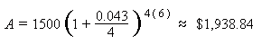
So, the balance after 6 years is approximately R1,938.84.
To calculate monthly compound interest rates, substitute 4 with 12 in the formula above.

Commission
The payment of commission as remuneration for services rendered or products sold is a common way to reward sales people. Payments often will be calculated on the basis of a percentage of the goods sold.
This is a straightforward percentage calculation. So, if a sales person earns 20% commission on sales, and the sales are R100,000, the person would earn R20,000

What is a percentage?
Percent means “for every 100” or "out of 100." The (%) symbol as a quick way to write a fraction with a denominator of 100. As an example, instead of saying "it rained 14 days out of every 100," we say "it rained 14% of the time."
Percentages can be written as decimals by moving the decimal point two places to the left:
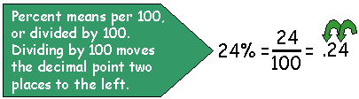
Decimals can be written as a percentage by moving the decimal point two places to the right:
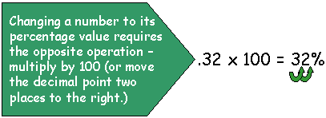
Formula for calculating percentages
The formula for calculating percentages or for converting from percentages are relatively simple.
To convert a fraction or decimal to a percentage, multiply by 100:
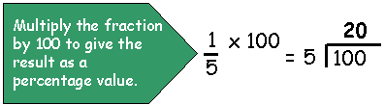
To convert a percentage to a fraction, divide by 100 and reduce the fraction (if possible):
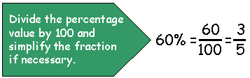
Examples of percentage calculations
The following two examples show how to calculate percentages.
1) 12 people out of a total of 25 were female. What percentage were female?
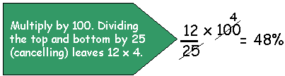
2) The price of a $1.50 candy bar was to be increased by 20%. What was the new price?
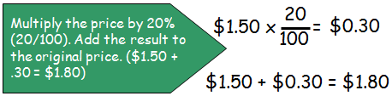
3) The tax on an item is R6.00. The tax rate is 15%. What is the price without tax?
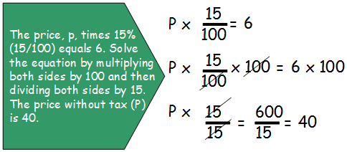

Effective and Nominal Interest Rates
The annual rate at which many loans are quoted is the nominal interest rate. One may, for an example, make an investment that pays interest at a nominal interest rate of 10% annually.
The effective interest rate adjusts the nominal interest rate based on the number of times the interest is compounded and the number of days assumed to be in a year.
Financial managers and investors must be careful when comparing different interest rates. They have to seek the cheapest financing available. Therefore the effective rate should be used when evaluating costs and returns. Often the interest rates charged by banks and other financial institutions on savings accounts are effective interest rates. Home and commercial loans state the nominal rate. If the interest charged is only compounded annually (like in the previous example), then the effective rate is equal to the nominal rate. The more regularly the interest is compounded in a year, the higher the effective interest rate will be.
Before you take out a loan from a bank for a home or a car, it is vitally important that you determine what interest rates they will be charging you, and how much additional money you will be paying for your home/car.
Example 1
A financial manager is evaluating two loans and the effective interest rate charged. Second National Bank (SNB) quotes a nominal interest rate of 16,5% compounded semi-annually. Third National Bank (TNB) quotes a nominal rate of 16,4% compounded daily.
Which of the two loans should the financial manager select in order to obtain the lowest effective interest rate cost?
SNB:
Effective interest rate = (1 + 0,165)² – 1 = 0,17181 = 17,18%
2
TNB:
Effective interest rate = (1 + 0,164)³⁶⁵ – 1 = 0,17817 = 17,81%
365

Based on the objective of obtaining the lowest effective cost of financing, the loan offered by Second National Bank should be used.
The following deductions can be made from this example:
Originally one might have thought that TNB are offering a better interest rate (16,4%), but after working it out, SNB’s 16,5% is a better rate in the long run.
It is important that we ensure that even though the rate offered by the bank may seem lower, it actually is not.
The real rate of interest is the percentage increase in purchasing power that the borrower pays to the lender for the privilege of borrowing. It indicates the increased ability to purchase goods and services that the lender earns.
The nominal rate of interest is the percentage by which the money the borrower pays back exceeds the money he borrowed, making no adjustment for any fall in the purchasing power of this money that results from inflation.

Depreciation And Appreciation

Depreciation
Depreciation is the decrease in monetary value of your assets e.g. a car.
Depreciation is a reduction in accounting earnings which are intended to reflect the reduction in value of an asset. In other words, the car, furniture, clothes, cell phones and computer equipment you buy decrease in value every year, meaning they are worth less than you paid for them. Depreciation occurs when your assets, including the buying power of your money, loses value.

Example
Solly bought a new car 5 years ago, it cost him R35 000. He has decided that he would like to buy a bigger car so that he can do deliveries. Solly took the car to the dealership, and they offered him R15 000 for his car.
Solly is angry! He knows he has lost R20 000 because he bought the car for R35 000 and now can only sell it for R15 000!

Deductions made from this example:
A car is not an asset, it depreciates in value.
A few causes of depreciation are:
High mileage
Poor maintenance
Accidents that have been repaired
Newer, better models of the same cars coming out
High demand of cars
Solly in effect has lost R20 000 and all the interest that he paid to the bank for the car.
Solly’s car depreciated with R4 000 per annum: R20 000 / 5 = R4 000

Calculate depreciation
Depreciation can be calculated in two ways. We will use a vehicle’s depreciation as an example.

Straight line method
where the amount to be depreciated is divided equally by the number of years over which the vehicle will be depreciated:

Vehicle cost price R350 000
Tyres: six tyres at R1500 each R 9 000
Anticipated life: 5 years
Anticipated vehicle resale value after 5 years R200 000

Straight line method:
Original cost less tyre costs less anticipated resale value
Anticipated life

= annual depreciation
R350 00 - R9 000 - R200 000
5 years
= R141 000
5
= R28 200 per year

In this calculation, the vehicle will have what is called a book value or R200 000. if the vehicle is sold for less than this amount, it will result in a loss on sale of asset.

Reducing balance method:
where a high level is shown in the early life of the vehicle when maintenance costs are low. The level then reduces steadily in later years when maintenance costs increase:

Vehicle cost price R350 000
Tyres: six tyres at R1500 each R 9 000
Anticipated working life: 5 years
Depreciation per year 20%
Amount to be depreciated: R350 000 - R9 000 R341 000

 | Capital | Annual depreciation | Balance carried forward
Year 1 | 341 000 X 20% | 68 200 | 272 800
Year 2 | 272 800 X 20% | 54 650 | 218 420
Year 3 | 218 400 X 20% | 43 648 | 174 592
Year 4 | 174 592 X 20% | 34 918 | 139 674
Year 5 | 139 674 X 20% | 27 935 | 111 739

According to this method, the vehicle will have a book value of R111 739 in the company’s books. If the vehicle is sold for less than this amount, it will result in a loss on sale of asset. If the vehicle is sold for more than the book value, say R120 079, there will be a profit from sale of asset of R8 340.
Both methods are acceptable accounting practice. When you start making this calculation, use the method preferred by the organisation and the accounting officers.

Appreciation
Appreciation, on the other hand is when assets, including the buying power of your money, increases in value. Property such as houses and flats are seen as assets that increase in value.
Interest is sometimes seen as a method of protecting your money against losing buying power due to inflation, provided you let the interest accumulate and don’t use it.

Example
Mpho bought a home 5 years ago, she paid R56 000 for her house. As her family has grown and she requires two more rooms, Mpho has decided to buy a new house.
Mpho contacted her bank and has requested that a property evaluator comes round to evaluate her house, before she tries to sell it. The evaluator let Mpho know that her house is now valued at R78 000.

Deductions made from this example
Mpho’s house has appreciated in value by R22 000:
R78 000 – R56 000 = R22 000
Mpho’s house has increased in monetary value by R4 400 per annum
R22 000 / 5 = R4 400
Mpho has made R22 000 after 5 years
Mpho can sell her house and use the R22 000 to put down a deposit on a bigger house.
Property usually appreciates in value.

Calculate appreciation

Case study: How does one calculate home appreciation?
Appreciation is the increase in value of a certain asset over time. Many types of assets appreciate, including stocks, commodities and real estate. When you purchase a home, you not only provide yourself with a place to live, but gain an asset that has the potential to increase in value over time. Home appreciation can be expressed several ways, such as the total rand value increase over a certain period or as an average value increase per year over a certain period.
Select the initial value you want to use for the calculation. The initial value might be the price you paid for the home or the price record of a previous sale.
Select the ending value you want to use for the calculation. The ending value might be a recent home sale price or a value estimate given by an appraiser.
Subtract the initial value from the ending value. This is the total rand appreciation over the period between the initial value and ending value. For instance, if you bought a home 10 years ago for R50,000 and you sold it for R100,000, the total appreciation was R50,000.
Divide the rand value appreciation calculated in Step 3 by the number of years between the initial value and ending value to calculate the average amount of appreciation per year. In the example, you would divide R50,000 by 10 years, which equals an average appreciation of R5,000 per year.
To calculate the future value of an asset such as a property, use the formula for compound interest.

Inflation
In its simplest form, inflation is an unhealthy and steady increase in the price of goods and services. The end result of inflation is a steady erosion in the buying power of your money. It affects all of us; it will make all of us poorer over time. It will eventually reduce our standard of living; it will destroy our confidence and peace of mind. Speak to anyone who retired on a fixed income in the last ten to fifteen years. At an inflation rate of 15%, the purchasing power of your money halves every 4,8 years.
Magnus Heystek's story of the disappearing R50 note:
He explains that R50.00 now will still be R50.00 in five years' time, but we will be able to buy much less with the same R50.00.
R50 in itself is not worth anything. It's what you can do with it in the future that is important.
So, the biggest threat to your money is something called INFLATION.
The purchasing power of money is one of the most important concepts when it comes to formulating an investment plan for yourself.
All investments must be geared towards protecting the purchasing power of your money.
The effect of inflation is that the value of the rand is dropping. Thus the value of assets rises as the purchasing power of the rands in which they are valued drops. But inflation is not bad for everybody - for every person who loses by inflation, another will gain.
The value of the average family home rises by 12% per annum due to inflation. The winners are present home-owners who see the value of their asset increase. The losers are those who have not yet bought, as it now costs them more to buy. Of course, the last couple of years has seen an increase of more than 20% per year in the value of houses and flats.
To beat inflation, one has to earn a real rate of return which means a return that beats the inflation rate after taxes. The successful investor is one who always strives to earn a rate of return equal or above the inflation rate.
Investments in the so-called "traditional" category of investments in banks have, on average, lost 5% of the purchasing power of their money per annum, over the last 20 years or more. By investing in equities and mortgage bonds, your chances of beating inflation are better.
So it is clear that in times of inflation it is sound strategy to keep the major part of your assets in a form which should increase in value, and only a small part in banks, building societies and other areas where it is losing value every day.

The Rule of 72
The Rule of 72 is a simple way to calculate the effects of inflation. If we take the number 72 and divide it by the expected inflation rate, the answer will be the number of years for money in cash form to lose HALF of its purchasing power or assets to DOUBLE in value.
If inflation was at 16% on average over the last 20 years (i.e. 72 ÷ 16 = 4,5), the following would have happened:
every four and a half years an asset such as an income-producing property ( a property that you bought and rented out) would have doubled in price,
and the money you left as interest-bearing deposits would buy half the products it would have bought four and a half years ago.
If inflation goes to 20%, this doubling or halving will occur every three and a half years, (i.e. 72 ÷ 20 = 3,6).
If inflation goes to 6%, this doubling or halving will occur every 8 years
Let's see how inflation can affect a typical married retiree who leaves work with what appears to be a large sum of money. Bill retires at 60 years of age with R200 000 which he invests in fixed deposits at 15%. The return is R30 000 per year.
Let's look at what happens if inflation runs at 16%.
After four and a half years the purchasing power of the capital is down to R100 000 and the purchasing power of the annual income is down to R12 000.
In another four and a half years the capital is only worth around R50 000 and the income will buy only R6 000 worth of goods and services.
Certainly, the face value of the fixed deposit would still be a nominal R200 000 but money is only worth what it can buy and its purchasing power has been slashed by 75% in just nine years.
Contrast this to the position of Jim who retired at the same age and used the R200 000 to buy income-producing property. The return of 10% after all costs meant that initially Jim's income was only R20 000 per year before tax, but due to inflation, grew every year. After nine years the property was worth nearly R800 000 and the income had risen to almost R80 000. By using inflation-beating techniques, Jim had managed to maintain his standard of living. On the other hand, Bill was forced to live on a decreasing (in real terms) income from his investment in fixed deposits.
Of course, currently inflation runs at rates much lower than 16%, meaning that the buying power of your money halves every 8 to 10 years, while your assets double every 8 to 10 years, but the basic lesson in the above case study is still the same:
In Bill’s case: After 8 to 10 years the purchasing power of the capital is down to R100 000 and the purchasing power of the annual income is down to R12 000.
In Jim’s case, after nine years the property will be worth nearly R400 000 and the income will have risen to R40 000 per year, giving him purchasing power of R20 000 per year. Jim will have maintained his standard of living, while Bill’s income has steadily decreased.

THE NATIONAL ECONOMY

Outcome
Use mathematics to debate aspects of the national economy: tax, productivity and the equitable distribution of resources

Assessment criteria
- Use mathematics to debate aspects of the national economy: Range: Tax, productivity and the equitable distribution of resources
- Values are calculated correctly
- Mathematical tools and systems are used effectively to determine, compare and describe aspects of the national economy
- Debating points are based on well-reasoned arguments and are supported by mathematical information

Introduction to Economics
Economics studies how man obtains and uses scarce resources to produce goods and services, and how he/she distributes these goods and services to people to satisfy their unlimited needs (wants). Economics is a social science because it studies a part of man’s behaviour.
When we deal with economics, we also have to deal with economic terminology. The table below lists and explains certain terms used.
Basic economic problem | The basic economic problem is that of scarcity as a result of unlimited wants. No country in the world has unlimited resources. As a result choices have to be made. If there were an unlimited supply of everything, we would not have to study economics. A very good example of limited resources in South Africa is water. The water that is available has to be shared between farmers who produce our food, industry who produce the things we want and need, such as iron and steel to build cars, and then water that ordinary people use daily to drink and clean.
Scarcity | Economics studies the problem of scarcity. There is not enough in the world to satisfy everyone’s needs. The individual does not have enough means to satisfy all his/her needs.
Factors of production
Collectively the resources listed below are called factors of production because they are used in the process of production.
Land | Land not only refers to agricultural land, it also includes all natural resources such as minerals, oil deposits, coal deposits, climate, etc. Land is immobile and its supply is limited.
Labour | All the physical and mental efforts provided by people are called labour. Wages are the remuneration paid to an employee for services rendered
Capital | Capital is the contribution made by the owner by putting his/her capital at the disposal of someone else who requires it to further production, and can include buildings, equipment, vehicles, etc. The remuneration for the investor is called interest
Entrepreneur | The entrepreneur is the person who organises land, labour and capital to manage the day-to-day operations and bears the risk of the business. The compensation for his/her efforts is called profit. Profit is the excess of income over expenditure in an enterprise

Kinds of production

Commodities | The things that are produced by the factors of production are called commodities. Commodities are divided into goods and services: goods are tangible, as are cars and shoes; services are intangible, as are haircuts and education. Goods are valued because of the services they yield. A car, for example, is valued because of the transportation it provides, and possibly also for the flow of satisfaction the owner gets from displaying it as a status symbol. The total output of all commodities in one country over a period of time, usually taken as a year, is called its national product.
Production and consumption | The act of making goods and services is called production, and the act of using these goods and services to satisfy wants is called consumption. Anyone who helps to make goods and services is called a producer, and anyone who consumes them to satisfy his/her wants is called a consumer.

Government’s role
Government’s role is to manage the country and to create the best environment for the economy to grow. They do this by-passing laws. Managing the country is not an easy task. South Africa is part of the world community and often what happens in one part of the world affects us.
Can you give an example of a world event which affected our economy and the value of our Rand?
Our Government has to respond to these forces and has to actively promote trade and encourage investment. We have to remember that we cannot force people to trade with us. There are other countries competing with us for markets, so we have to make sure that our goods are as competitive as possible.

What are some of the things we can do to be competitive?
Nor can we force countries or companies to invest in South Africa. Investors want a return on their investment.
How can we attract investors to South Africa so that our economy can grow
If our Government makes wrong decisions our economy will shrink and ultimately die.
Can you give examples of what is happening to the economies of some of our neighbours in Southern Africa?

Tax
This is a repeat of some of the content in section 1
The question remains, where does the Minister of Finance get the money to allocate to the various state departments?
The Government has to pay for many projects worth millions of rands, for the benefit of all South Africans. These projects include:
- Welfare
- Housing
- Education
- Health care, including hospitals
- Roads
- Railways
- Dams
- Policing
All the monies collected through Value Added Tax, SITE and PAYE and tax paid by companies, estates and trusts is paid over to the Receiver of Revenue. This money is then used to fund the various government departments.

Why Do We Have to Pay Tax?
All over the world, people recognise the system of paying money to government in return for services which government provides. In South Africa the Minister of Finance is responsible for drawing up a budget in which the total government spending is announced. Projects include state funded education and health care, policing, infrastructure (such as roads and dams, libraries, etc.), to name but a few. Obviously, the finance for all of these different government responsibilities must come from somewhere. Individual Taxation (Direct Tax and Indirect Tax) is responsible for the greatest portion of funding. The rest is made up by loan agreements.
From this it becomes quite clear that if people did not pay tax, the effect on the economy would be devastating. What one may want to examine, though, is the amount of income tax we pay.
In South Africa the laws surrounding income are statuted in the Income Tax Act. This is a very complicated piece of legislation which dates back to 1914. It covers a range of different types of tax.
In summary, it makes provision for tax to be collected from people who are employed, businesses.

Direct Tax vs. Indirect Tax

Direct tax
A direct tax is a tax which is paid by individuals or corporations calculated on the INCOME earned by those people. Because it is based on the INCOME earned by such persons, it is commonly known as Income Tax. Income Tax is paid directly from the person's employer to the Receiver of Revenue. The amount of tax that each person is liable for is based on the total amount they earned in any one-year.

Indirect tax
These are taxes which are due to any business transaction. This tax is on the "purchaser - seller" transaction rather than on the individuals concerned. At the same time, it must be seen that it is the party who funds the transaction who is responsible for paying the tax over to the party who is offering the goods or services - this kind of tax is called a consumption tax.
The most obvious example of an indirect consumption tax is Value Added Tax.
VAT is paid every time you purchase goods such as groceries, cars, furniture, pay for water and lights, etc. A flat rate of 14% is added to the price of the goods and this amount of 14% is paid over to the Receiver of Revenue.
Every year the Minister of Finance calculates the money that was paid from various sources to the Receiver of Revenue, and on the basis of this figure works out the budget for the next year. It stands to reason that he uses the figure of the previous year and then estimates (forecasts) what amount will be paid to the Receiver of Revenue during the current year. He then uses the planned (forecast) amount to calculate his budget and to allocate money to the various government departments. This is why civil servants are called servants: their purpose is to serve the public, since the public finances all the salaries paid to employees of government departments.

Equitable Distribution of Resources
The equitable distribution of resources is to make sure that everyone who needs resources, such as water, has access to these resources. This means that government must make sure that
Farmers have water in order to provide us with the food we need
Industry and businesses have water to produce goods that we can use and export
General public have water to use on a day-to-day basis to drink and clean with
The country’s new system of government is based on the Constitution of the Republic of South Africa Act, Act No. 108 of 1996. This Act also governs the entire public administration section, from parliament to local government.
Government Institutions are enterprises which are controlled exclusively by the state, and for which budgets are submitted to parliament. Government Institutions are represented by government departments such as Education and Justice.
Government Institutions have the Following Characteristics:
They are controlled exclusively by the state.
They are financed by means of budgets which are tabled in parliament. Once these budgets have been approved, the funds are made available to the departments concerned, via the Treasury.
Expenditure must be accounted for to the state, in the person of the Auditor-General.
Economy and productivity serve as measures of efficiency. This is because there is no endeavour to break even.
The breakeven point is reached when costs are equal to revenue.
One of the most important developments in modern public administration has been the development of the budgeting system of government. The use of the financial resources of a society by government has become very important.
All government programs must be planned in advance and financial and other resources must be allocated to various activities in the system. Public administrators play a very significant role in the allocation and development of programs and as such they control important decision-making roles. All public monies have to be accounted for and this has placed a vast responsibility on the public administrative sector.
The budgeting system, as it is known in modern times, began in Britain during the 19th century. The system works as follows:
The executive arm of government recommends how much should be allocated to various departments
The legislative arm of the government is responsible for the suitable distribution of those amounts to the various departments, and
The public administrative executive supervises those expenditures.

National Economic Planning
Any national economy in the modern world requires highly trained specialists to ensure that scarce resources are distributed and utilised equitably – where they are needed most, without ignoring the needs of other departments and provinces.
As mentioned previously, most of government’s monies come from taxes that are paid by individuals, companies, estates and trusts. The various provincial and local governments have to compile budgets every year, giving details of how much money they need and what they will spend it on.
Some of the areas that are the responsibility of national, provincial and local governments will be discussed.

Energy And Resource Development
Government must provide sufficient energy and other resources that are required for the efficient running of the country, use by private businesses and industries, as well as use by individuals living in the country.
Government must plan for present and future use of these resources by stockpiling raw materials such as crude oil and other strategic materials relevant to the needs of a modern society, as well as ensuring that new plants are built to accommodate future needs.
Then government must ensure that the energy resources are distributed equally amongst the users so that everyone has enough to meet their needs.

Water Supply, Waste Disposal and Pollution
Similarly, government has the responsibility to provide the following services:
Water
Waste disposal
Control of pollution
Once again, the present and future needs of the country must be planned for and government must ensure that these resources and services are distributed equally amongst the users: industries, businesses, private users.

Agricultural Development
In any society or nation, the planning and implementation of agricultural policy is of vital importance to the system. The agricultural system any nation enjoys priority, particularly since the feeding of a nation is dependent upon its successful production process.
This sector of the economies of developing countries is by far one of the most important for a variety of reasons. If one looks at the food production levels of many developing countries, one finds them to be of such a low level that emergency food imports have to be undertaken in order to avoid mass starvation. To relieve this problem, much more attention must be paid to 'he informal agricultural sector in these countries and the level of agricultural production must be raised. If surpluses are achieved the national economy can also benefit through the export of foodstuff, which in turn may bring in much needed foreign currency.
One way of doing this is through land reform, which will give all sectors of the public an opportunity to own land. Then, of course, smaller farmers should be supported by government in terms of funds to get started, support during the production process by means of training and government should also ensure that the small farmer can sell his surplus products on the general market.

Industrial Development
In order for industrialization to take place, infrastructural facilities should be provided. These include transportation facilities, electricity and other energy requirements, markets and other much needed facilities such as raw products.
Once again, all these resources should be distributed equally amongst the users, so that one party does not benefit at the cost of another party.

Welfare Benefits
Government must attempt to create a public assistance scheme that meets the needs of the society concerned. These needs must be based upon the resources available to the state to meet the welfare requirements.
In many societies the state takes full responsibility for the welfare needs of the community, while in others, private organizations also take part in relieving the more urgent needs of individuals. The state can also assist private organisations on a subsidy basis so that they may give service to certain groups such as unmarried mothers, the handicapped and so on. Often the state helps private institutions dedicated to educating handicapped or otherwise underprivileged members of society.
Health services are also of prime importance and as such, government departments are faced with the serious task of providing medical care for the public. In order to do this, government must be involved in the training process of medical personnel such as doctors, nurses and other paramedical personnel to man hospitals, clinics and other facilities.

Military and Police Facilities
These services render important services to societies. The purpose of the military arm of the security services is to serve and protect the public in the event of external attacks on a nation – attacks from outside the borders of the country.
The purpose of the police is to keep the public safe from criminal acts and also to keep the peace generally in any society in the event of civil unrest.

Financial Affairs Relating to The Provinces
Section 214 of the Act states that the provinces are entitled to an equitable share of the national revenue. This includes a portion of the income tax on individuals collected in the province and a percentage of the value added or sales tax collected within the province. The allocations made for the provinces are subject to the advice of the Financial and Fiscal Commission.
A province may, in terms of Section 228 of the Act, levy taxes, surcharges or levies, but there is a provision that the approval of Parliament and the recommendations of the Financial and Fiscal Commission is essential.
No province may levy taxes that are detrimental to the national economic good or national policies. Taxes levied by the provinces may also not negatively affect inter-provincial commerce or have a negative effect on the mobility of goods, capital, services or labour.

The Functions and Powers of Local Government
In terms of Section 152(1) of the Act, a local government must:
Provide democratic and accountable government for local communities
Ensure the provision of services to communities in a sustainable manner
Promote social and economic development
Promote a safe and healthy environment
Encourage the involvement of communities and community organisations in the matters of local government.

This means that the local government must provide
Water
Sanitation
Transportation facilities
Electricity
Primary Health Services
Education
Housing and Security
Security and Safety
In an equitable manner.

Local government is entitled to charge for the services they provide – how would they get the money to provide the services otherwise
All governments in South Africa, local, provincial and national, must be transparent in everything they do. This is why their budgets are published every year and made available to the general public. In future, when you receive a copy of a government budget, read through it to find out what they are doing with your money.

Productivity
Productivity is the relationship between input and output.
Labour productivity is typically measured as output per worker or output per labour-hour.
What this means is that, if you can produce the number of items or even more per day or week than your fellow workers or than the manager budgeted for, you are productive. It costs management the same amount to produce the items, but they are getting more items, meaning they can make a profit.
Productivity is what makes the modern world go around. A company with employees that are not productive, will not survive and everyone will lose their jobs.
Companies can increase productivity in a variety of ways. The most obvious methods involve automation and computerisation which minimise the tasks that must be performed by employees.
Recently, less obvious techniques are being employed that involve ergonomic design and worker comfort. A comfortable employee, the theory maintains, can produce more than a counterpart who struggles through the day
Increases in productivity also can influence society more broadly, by improving living standards, and creating income.
When we measure productivity, we do not measure the quantity that was produced. We measure the relationship between input and output. If a business takes on more people to increase production, but the output per man hour drops to below the level when the extra people were hired, we cannot say that there was an increase in labour productivity.

The Inputs are: | The Outputs are:
Material s | Goods
Machines | Information
Energy | Services
Technology.
Labour
Facilities
In business, inputs are measured in terms of costs and the organisation will strive to keep these costs as low as possible. Or the business will try to produce an output which is as high as possible, while keeping costs constant.
Put in another way, productivity is measured by how many products were produced (outputs) and what the cost was to produce the products by making use of inputs.

Measuring productivity
The productivity of any job can be measured in terms of:
Money - costs and profits.
Time - spent.
Manpower - utilised.
Materials - utilised.
Products - quality and amount delivered.
Service - quality and efficiency.
Product (output) quantity
Productivity = _____________________
Resource (input) quantity
Productivity is a state of mind, it is when one is continuously improving, to perform better today than yesterday!

Commitment to good working practice
I perform my duties and tasks to the best of my abilities
I do everything to the best standard
I am a model employee
I set the example of how things should be done
My good work makes me a great employee
The objective of a government department is primarily to render a service as opposed to making a profit. However, this does not mean that they are free to spend their funds to satisfy any or all the needs of the community. They have the following commitments:
To determine the particular community needs which they wish to satisfy.
To satisfy them in the most efficient manner.
This implies, that government must also give attention to the input-output relationship. To put it into other words, the government department must produce the highest possible output (need satisfaction) with the lowest possible input (resources).
This means that a government organisation must also make optimal use of the resources available to it.

Impact of HIV on Productivity
In South Africa, some 40% of South African manufacturing companies surveyed reported a reduction in profits due to HIV/AIDS. More than half reported lower productivity and increased levels of absenteeism. Losses to the manufacturing sector were due mainly to the effects of increased labour costs, a decrease in productivity and increased labour turnover.

Prevalence of HIV/AIDS
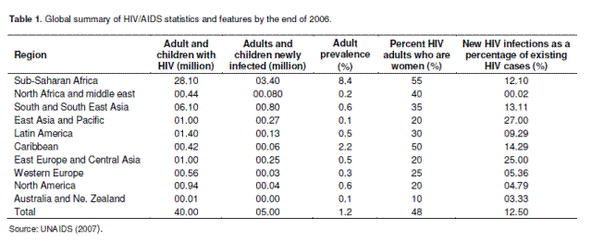
Global estimates of the human immunodeficiency virus (HIV) epidemic as of 2007 shows that about 33 million people are living with HIV, the virus that causes acquired immune deficiency syndrome (AIDS).
The international labour organization (ILO) estimates that at least 23 million workers in the prime labour force (aged15 to 49 years) are infected with HIV. More than 70% of the world’s HIV/AIDS infected population lives in Africa. Within the Africa region, the Southern Africa region has the largest HIV prevalence rate. It is estimated that more than 30% of total world HIV population lives in Southern Africa.

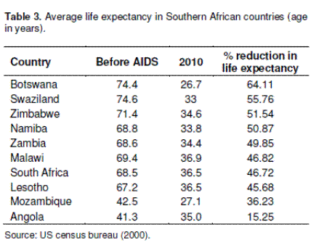

Labour market

A local labour market is a market in which most job search takes place at a local level such as farm labourers. Local labour markets exist when there are many employers and employees in specific geographical regions. Labour market definitions can be narrowed by limiting the industries, occupations, or geographical area covered.
For the purpose of this discussion, we will consider labour markets in terms of national geo-political boundaries within the region of Southern Africa. The labour force consists of all non-institutionalized individuals aged 16 or above who are either working or actively seeking work. Those who choose to be full-time students, or retire, or withdraw from the labour force for child-rearing purposes, or who give up looking for work are not counted as part of the labour force.

Productivity
We define productivity as the measure of output derived from a standard unit of input. It is an indicator of efficiency in the producer’s use of the input. Total factor productivity is the amount of output produced per unit of total factors of production. Factor productivity refers to the productivity by unit factor of production. For example, labour productivity is the quantity of output per time spent on numbers employed. It can be measured in, for example, Rand per hour.

Effect of HIV on the labour market
The concept of labour market comes into being in terms of supply and demand of labour. As a result of increased mortality rates among adults, the quality and quantity of the labour force will decline.
Since the mortality rate is higher among the productive population, it is assumed that the HIV infected population will be covering a good proportion of the highly skilled, experienced labour force.
Thus, there will be a shortage in the supply of skilled labour force. The total capacity of the system for example, private firms and public offices will be impaired in producing the expected output.
AIDS also can lower the school age population, reduce the share of the population that seeks to attend school, the capacity of the management of education system and thus it will reduce the rate of human capital accumulation. This fall in overall workforce lowers the productivity of the firm, household and nation as a whole which eventually will lead to lowering income of individual and national level.
HIV/AIDS has the greatest impact on productive members of society, such as teachers, farmers, traders and agricultural extension workers, thus increasing the number of dependents in a household.
This reduces household productivity and caring capacity, and interrupts the transfer of local knowledge and skills from one generation to the next.
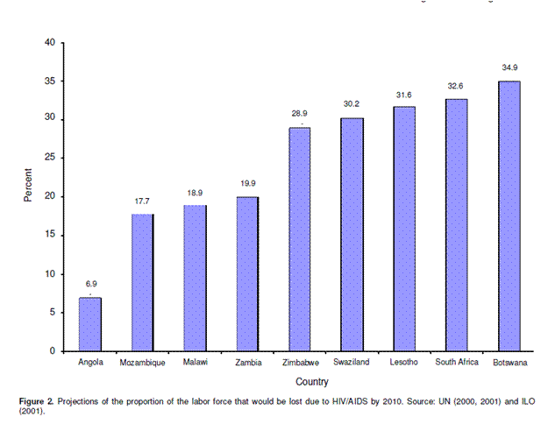
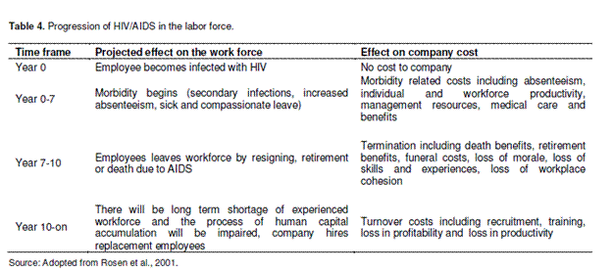

A study on several Southern African countries has estimated that the combined impact of AIDS-related absenteeism, productivity declines, health-care expenditures, and recruitment and training expenses could cut profits by at least 6 to 8%.
Nam Water, Namibia's largest water purification company has reported that HIV/AIDS was hindering its operation as absenteeism rose and productivity dropped.
A study of a sugar mill in South Africa put the cost per worker per year at R 9,500 (about £800). Of this, the cost of replacement workers, lost productivity, and absenteeism account for about a quarter each (Haaker, 2002).
Figure 4 also illustrates how these costs combine and reinforce each other to reduce revenues and profits of enterprises, and therefore their potential to survive. Available evidence suggests that productivity levels in South Africa and other countries in that sub-region could decline by up to 50% in the next five to ten years, with devastating consequences for profits.
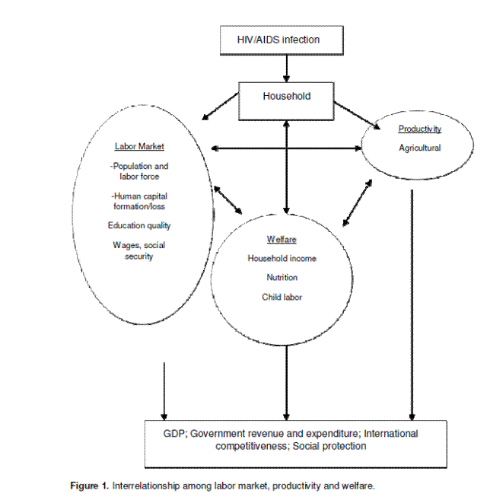
The impact of HIV/AIDS on labor markets, productivity and welfare in Southern Africa: A critical review and analysis
Franklin Simtowe1* and Kinkingninhoun-Medagbe F. M.2

