## 8970 FORMATIVE ASSESSMENTS WORKBOOK

## Unit Standard 8970

### Exercise 1

The facilitator will hand out copies of an article called Good Neighbours? From the Clicks ClubCard magazine of October 2005.

Do the following:

1. Identify the style of writing.
2. Identify the structures and features of text that was used.
3. Do the visual aids add to your understanding of the article?
4. How are sentence lengths varied to capture and hold your attention? Use any paragraph as an example.
5. Do the author’s paragraphs flow logically?
6. How does the author link paragraph? Use the first and second paragraphs as an example.
7. Do the paragraphs vary in length? Motivate your answer.
8. Where do you think the author collected information and data from?

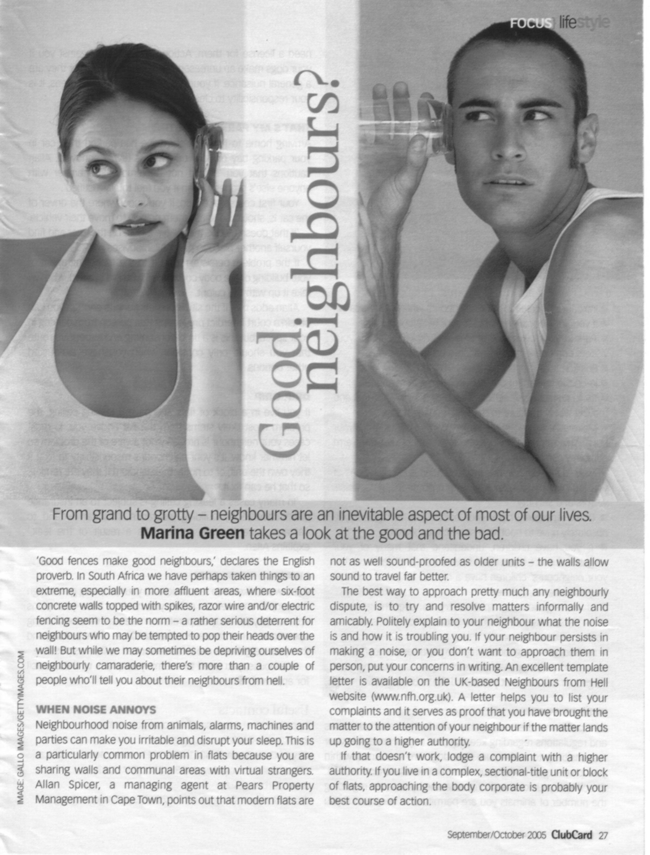

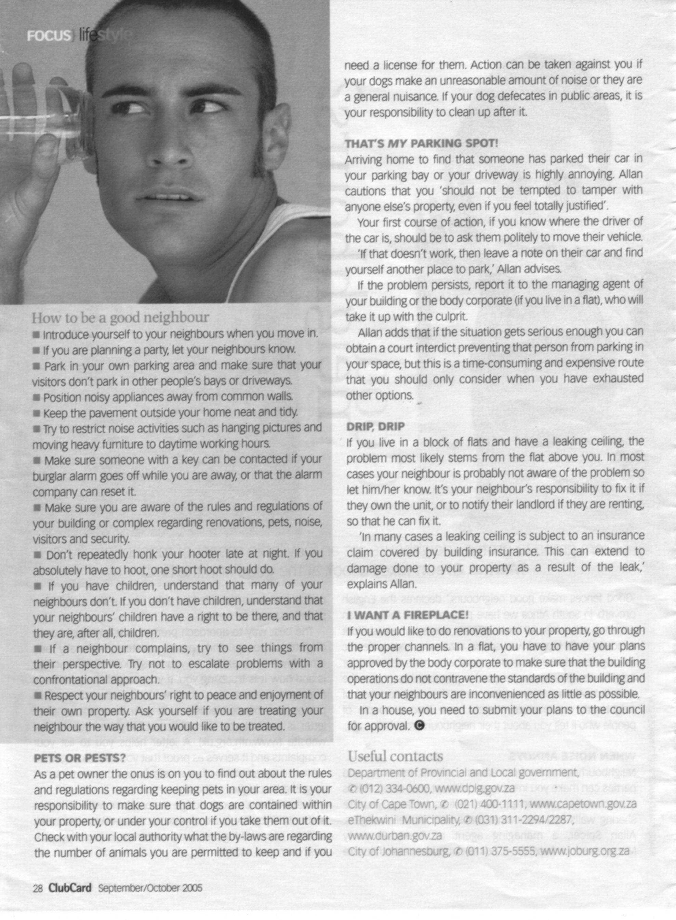

### Exercise 2

Refer back to the article called Good Neighbours? From the Clicks ClubCard magazine of October 2005. Paraphrase this article. Ensure that you use language structures and features as well as text structures and features. Vary the sentence length, vary the length of the paragraphs, pay attention to your first and last paragraph and make sure that your paragraphs follow each other logically.

### Final formative assessment

**Handout 4**

The facilitator will hand out a copy of an article from SA Computer magazine of September 2005 about a Panasonic DV Camera.

|  |  |
| --- | --- |
| **U/S 8970 Outcome 1: Use a range of reading and viewing strategies to understand the literal meaning of specific texts.**   * + **Unfamiliar words are identified.**   + **Different options for the meaning of words are tested and selected meanings are correct in relation to the context.**   + **The purpose of visual and/or graphical representations in texts are recognised and explained.** | |
| 1. List at least three examples of jargon contained in the article. | (3) |
| 1. Use at least two word-attack strategies to identify these words. Add your notes to the assessment. | (6) |
| 1. There are four examples of acronyms in the article. List two. | (2) |
| 1. What do the acronyms stand for? | (2) |
| 1. Discuss the photos included in the article with specific reference to the following:    * Do the photos enhance the article? Motivate your answer.    * Do the photos contribute towards persuading you to read the article? Motivate your answer.    * Why were photos of the product included in the article? Give at least one reason. | (2)  (2)  (1) |
| **U/S 8970 Outcome 2: Use strategies for extracting implicit messages in texts.**   * + **Source of text is identified and discussed in terms of reliability and possible bias.**   + **Author’s attitude, beliefs and intentions are explored in order to determine the point of view expressed either directly of indirectly.**   + **Author’s techniques are explored and explained in terms of purpose and audience.**   + **Promotion of or support for a particular line of thought is identified and explained with reference to selection or omission of materials.**   **U/S 8970 Outcome 4: Explore and explain how language structures and features may influence a reader.**   * + **The choice of words, language usage, symbols, pictures and tone is described in terms of how a point of view is shaped or supported.** | |
| 1. What are the purposes of the article? List at least one. | (1) |
| 1. Do you think the author of the article is reliable? Motivate your answer. | (2) |
| 1. Do you think the author is biased? Motivate your answer. | (2) |
| 1. Does the author try to persuade you to buy the camera? | (1) |
| 1. Would you buy the camera after reading this article? Why? | (2) |
| 1. How many short sentences are there in the article? | (1) |
| 1. How many longer sentences? | (1) |
| 1. Did the variation in sentence length make the article easier to read? | (1) |
| 1. Which text features are used to capture your attention? List at least three. | (3) |
| 1. Is this article written in the formal or informal register? | (1) |
| **U/S 8970 Specific Outcome 1: Write for a specified audience and purpose.**  **Specific Outcome 2: Use language structures and features to produce coherent and cohesive texts for a wide range of contexts**   * + **Meaning is clearly expressed through the use of a range of sentence lengths, types and complexities.**   + **The use of paragraph conventions, including links between paragraphs in texts, promotes coherence and cohesion in writing.**   + **The overall structure of a piece of writing and the conclusion is clearly formulated.**   **Specific Outcome 3: Draft own writing and edit to improve clarity and correctness.**   * + **Writing produced is appropriate to audience, purpose and context. Corrections are an improvement on the original.**   + **Control of grammar, diction, sentence and paragraph structure is checked and adapted for consistency.**   + **Logical sequencing of ideas and overall unity is achieved through redrafting.**   + **There is clear evidence that major grammatical and linguistic errors are edited out in redrafts.**   + **Inappropriate or potentially offensive language is identified and adapted or removed.**   + **Experimentation with different layout and options for presentation are appropriate to the nature and purpose of the task.** | |
| 1. Which style is the article written in: narrative, discursive, reflective, argumentative, reflective or expository?   . | (1) |
| 1. Summarise the article. Use a mind map to plan your summary.   . | (1) |
| 1. Vary the lengths of your sentences.   . | (1) |
| 1. Vary the types of sentence. | (1) |
| 1. Include an introductory paragraph. | (1) |
| 1. Remember the conclusion. | (1) |
| 1. Formulate your conclusion clearly. | (1) |
| 1. Ensure that your paragraphs follow each other logically.   . | (1) |
| 1. Did you redraft your rough copy? Attach evidence. | (1) |
| 1. Is your use of grammar correct? | (1) |
| 1. Did you use the correct register? | (1) |
| 1. Did you take out inappropriate or offensive language? | (1) |
| 1. Did you experiment with the layout of your summary? | (1) |
| **TOTAL** | **(28)** |

