LEARNER GUIDE

67465 National Certificate:
Business Administration Services
Level 3

Module 7 Numeracy and Research

Investigate life and work-related problems using data and probabilities.
9012
NQF Level 3
Credits 5

TABLE OF CONTENTS

TABLE OF CONTENTS ii
INTRODUCTION 5
Programme Overview 5
Personal Objectives And Expectations 6
UNIT STANDARD 9012 7
COLLECT AND ORGANISE DATA 9
The Role of Statistics when processing data 10
The Use of Statistics in Work or Every Day Life 11
Statistics in every day life 11
Statistics at work 12
Research 12
Why would you want to do research? 12
The value of research 13
Data gathering techniques 13
Work place records 13
Observation 15
Surveys 15
Personal surveys, telephone surveys, and mail surveys 16
Databases 16
Sampling 17
Sampling methods 18
Probability sample 19
Non-probability sampling 20
Using sampling methods 21
Simple Random Sampling (SRS) 21
Exercise 1 22
Exercise 2 25
Sampling distributions 30
Problems that may occur 32
Answers you need to know 33
Systematic Sampling 34
Questionnaires and Interviews 35
Designing questionnaires 35
Select questions and provide instructions 36
Questionnaire instructions 39
Formatting 41
Sampling subjects 42
Administering the questionnaire 42
Analysing and interpreting results 42
Interviews 42
Measuring instruments 42
Dichotomous 43
Discrete vs. Continuous Variables 43
Likert scales 45
Exercise 3 45
Evaluate data gathering techniques to determine reliability and validity 46
Conducting A Survey (Research) 48
Determine Your Research Aims 48
Identify The Population And Sample 49
Decide How To Collect Replies 51
Questionnaire Design 51
Run A Pilot Survey 54
Carry Out The Main Survey 54
REPRESENT, ANALYSE AND INTERPRET DATA 55
Analyse The Data 56
Exercise 4 56
Measures of centre and spread 57
Describing data 57
Measuring centre or average 57
Calculating the mean or average 58
Calculating the mode 58
Calculating the median 60
Exercise 5 60
Summarising Data 62
Exercise 6 63
Using centres and averages 63
Frequency distribution and range 65
Exercise 7 66
Quartiles 67
Calculating percentiles 68
Graphical Representation Of Data 71
Determining Trends Using Statistics 71
Displaying data 71
Frequency tables 72
Exercise 8 73
Graphing data 75
Bar graphs 77
Pie Charts 78
Scatterplots 80
Comparing (Correlation) Of Data 80
Method 1, eye judgment 83
Method 2, use the mean of each axis 86
Method 3, method of averages 86
Line Graphs 87
Fit Curves to Predict Trends 88
Linear curve 88
Standard deviation 91
The normal distribution 93
Use a variety of presentations 95
PROBABILITY CONCEPTS IN LIFE 96
Probability (Equal And Unequal Probabilities) 97
Drawing Conclusions from Data 97
Figuring out what probability means 97
Understanding the concept of chance 97
Interpreting probabilities: Thinking large and long-term 97
Playing the instant lottery 98
Seeing probability in everyday life 98
What is probability? 98
Experiment and observe 99
Definition 99
Odds on versus probability 100
Mutually Exclusive Events 100
Independent Events 100
Probability Tree Diagrams 101
Find the number of outcomes 101
Calculate probability 101
Check 104
Calcualte probability with percentages 105
Finding the Probability Using a Percent 105
How to Find the Percent Probability 105
Calculate the percentage probability from a rfaction 105

Name
Contact Address
Telephone (H) |  | Telephone (W)
Cellular
ID Number
Learner Number

INTRODUCTION
This module belongs to you. It is designed to serve as a guide for the duration of your course and as a resource for after the time. It contains readings, activities, and application aids that will assist you in developing the knowledge and skills stipulated in the specific outcomes and assessment criteria.
Follow along in the guide as the facilitator takes you through the material, and feel free to make notes and diagrams that will help you to clarify or retain information. Jot down things that work well or ideas that come from the group. Also note any points you’d like to explore further.
Participate actively in the skills practice activities as they will give you an opportunity to gain insights from other people’s experiences and to practice the skills. Remember to share your own experiences so that others can lean from you too.
Each section will be preceded by outcomes and assessment criteria taken from the South African Unit Standards, where available. These will describe what you must know and be able to do in order to successfully complete the course. If the course is aligned to Unit Standards, you will be able to receive credits towards a National Qualification upon successful assessment.

Programme Overview

Purpose
In order to achieve the credits and qualify for the this appropriate registered standard, determined by the Sector of Education Training Authority, you are expected to have demonstrated specific learning outcomes.

Specific Outcomes
Specific Outcomes describe what the learner has to be able to do successfully at the end of this learning experience.

Assessment Criteria
The only way to establish whether a learner is competent and has accomplished the specific outcomes, is through the assessment process. Assessment involves collecting and interpreting evidence about the learners’ ability to perform a task. This module includes assessments in the form of self-assessments, group tasks, quizzes, projects and a practical training programme whereby your are required to perform tasks and collect, as portfolio of evidence, proof signed by your facilitator that you have successfully performed these tasks.

To Qualify
To qualify and receive credits towards your qualification, a registered Assessor will conduct an evaluation and assessment of your portfolio of evidence and competency.

Range of Learning
This describes the situation and circumstance in which competence must be demonstrated and the parameters in which the learner operates.

Responsibility
The responsibility of learning rests with you, so be proactive and ask questions; seek assistance and help from your facilitator, if required.

How You Will Learn
The programme methodology includes facilitator presentations, readings, individual activities, group discussions and skill application exercises. Know what you want to get out of the programme from the start and start applying your new skills immediately. Participate as much as possible so that the learning will be interactive and stimulating.

How you will be assessed
This programme has been aligned to registered unit standards. You will be assessed against the outcomes of the unit standards by completing a assessments that cover the essential embedded knowledge stipulated in the unit standards, and by compiling a portfolio of evidence that provides proof of your ability to apply the learning to your work situation. When you are assessed as competent against the unit standards, you will receive 10 credits towards your National Qualification.

Personal Objectives And Expectations
You will get much more out of the programme if you take some time to think about the things you would like to achieve as a result of the training.

UNIT STANDARD 9012

Unit Standard Title
Investigate life and work-related problems using data and probabilities

NQF Level
3

Credits
5

Purpose
This Unit Standard is designed to provide credits towards the mathematical literacy requirement of the NQF at Level 3. The essential purposes of the mathematical literacy requirement are that, as the learner progresses with confidence through the levels, the learner will grow in: a confident, insightful use of mathematics in the management of the needs of everyday living to become a self-managing person
An understanding of mathematical applications that provides insight into the learner’s present and future occupational experiences and so develop into a contributing worker The ability to voice a critical sensitivity to the role of mathematics in a democratic society and so become a participating citizen
People credited with this Unit Standard are able to:
Pose questions, collect and organise data
Represent and interpret data using various techniques to investigate real life and work problems.
Use random events to explore and apply probability concepts in simple life and work related situations

Learning Assumptions
Learners accessing this Unit Standard should be competent in Mathematical Literacy and Communications at NQF level 2.

Specific Outcomes and Assessment Criteria
Specific Outcome 1: Pose questions, collect and organise data
Assessment Criteria
Situations or issues that can be dealt with through statistical methods are identified correctly
Variables contributing to a problem situation are identified and addressed in data gathering, e.g. crime is related to time of day and location
Appropriate and efficient methods are used to collect, record and organise data.
Specific Outcome 2: Represent, analyse and interpret data using various techniques to investigate real-life and work problems
Assessment Criteria
Graphical representations and numerical summaries are consistent with the data, are clear and appropriate to the situation and target audience
Different representations of aspects of the data are compared to take a position on the issue
Calculations and the use of statistics are correct and appropriate to the problem
Interpretations of statistics are justified and applied to answer questions about the problem
New questions that arise from the modelling of the data are discussed
Specific Outcome 3: Use random events to explore and apply, probability concepts in simple life and work related situations
Assessment Criteria
Data are gathered, organised, sorted and classified in a suitable manner for further processing and analysis
Probabilities are determined correctly
Distinctions are correctly made between theoretical and experimental probabilities
The outcomes of experiments and simulations are communicated clearly

Unit Standard Essential Embedded Knowledge
Methods for collecting, organising data and calculating statistics
The meaning of concepts such as centre and spread
Techniques for statistically modelling a situation
Random events, equal likelihood, probability

Critical cross-field outcomes
Upon successful completion of this course, the learner will be able to:
Solve a variety of problems or take a position on issues related to the learner based on data, statistics and probability
Collect, organise, and interpret data and statistics to make sense of adult situations
Use everyday language and mathematical language to represent data, statistics and probability and to communicate conclusions
Use mathematics to, describe and represent and interpret life or work related situations and to solve problems relevant to the learner

COLLECT AND ORGANISE DATA

Outcome 1
Pose questions, collect and organise data

Assessment criteria
Situations or issues that can be dealt with through statistical methods are identified correctly
Variables contributing to a problem situation are identified and addressed in data gathering
Appropriate and efficient methods are used to collect, record and organise data
Data samples are of adequate size and are representative of the population

The Role of Statistics when processing data
What is statistics? Most of us seem to become startled or frightened when the word ‘statistics’ is mentioned. This should not be so. We all use statistics in our daily lives. It is a natural part of ourselves that has allowed us to survive from the days of living in the dark caves of our ancestors to exploring our moon, other planets as well as the galaxy.
‘But statistics means working with numbers and I am not good with numbers’ you may say. It is true that statisticians work with numerical facts that they call data. However, these numerical facts are simply ways of
describing,
grouping and
summarizing information so that it is more easily understood.
Keep in mind that all numbers used in this module are fictitious, that is, they are numbers I invented myself. If I use numbers that are really true, I will let you know. So if I say something has risen or fallen by 20%, I made that value up just as an example.
Here are a few examples that you undoubtedly have heard and may have some idea of what they mean. (Remember to ignore the actual numbers!)
Think of our sportsmen and sportswomen. We discuss their average runs at the cricket crease, bowling rates and the athlete’s best, worst and average times on the track. We know the average number of goals a striker makes in a season. How do we obtain this information? Why do we say one player is better than another? Can we compare a gymnast with a cyclist?
We hear the weather forecaster say that there is a 20% probability of rain today. Perhaps based on this information we decide not to take an umbrella with us. If the weather forecaster said that the probability of rain today is 80%, would you leave the umbrella behind?
The government announces that the rate of crime is down by 20%, inflation is up by 10%, unemployment is down to 28% and the CPI (Consumer Price Index) has risen 3 percentage points on a year-to-year basis. What does all this mean? How do they get this information? Are these figures accurate?
You have heard that smoking is linked to lung cancer and that HIV is linked to AIDS and that the evidence for these statements is ‘statistical’. What kind of evidence is ‘statistical’ evidence?
A medical researcher claims that taking a certain tonic reduces the risk of heart attack. How can an experiment be designed to prove or disprove this statement? What is risk?
You use statistics when you cross the street or drive a vehicle. When crossing the street you look both ways, see vehicles approaching, estimate their speeds, estimate your chance of making it across the street without being run over then you move or stay. If you move you have already decided how fast you will move based on the information you have just gathered and analysed. You behave similarly when in a vehicle. Our ancestors behaved similarly when looking for food.
If you are a hunter or a sport-shooting enthusiast, you know how to aim and shoot your firearm. You also know that you rarely, if ever, hit the target in exactly the same place with every shot you take. Why is there a slight variation where the bullet hits the target? Why are the bullet holes on my target scattered, or spread, more than on another shooters target?
At this point you may have a few questions that you would like answered.
What exactly do these figures mean?
How did they (sport announcer, weather forecaster, government, researcher) obtain this information?
How accurate is the information?
What does it all mean?
We humans have survived for many thousands of years simply because we are born with the ability to take in information, organise and analyse it and then draw conclusions based on our analysis.
This is all those statistics is about:
Information
obtain information,
organize and analyse the information
and then draw conclusions from this information
The goal, however, of statistics is to provide insight by using numbers. In fact, the information usually contains some uncertainty but statistical thinking can deal with it.
Every discipline has developed its own language or terminology over time. Statistics is no different and many words and terms are used with specific meanings attached to them. Some of the same terms are also used daily by non-statisticians but in a loose, semi-defined manner. Statisticians use words to express specific ideas.
Information
For instance, statisticians use the word ‘data’ where ‘information’ has been used in this introduction. The word ‘data’ is almost always used in the plural for statistical work and this module uses ‘data’ as a result.

The Use of Statistics in Work or Every Day Life
Statistics is the collection and analysis of numerical data in large quantities. This means that you gather information about a subject and then you analyse the information or data, so that you can distinguish trends. It is a very useful and easy way to “see” the story the numbers are telling.
Every time before an election, one of the organisations, Markinor, who collect and analyse data, will tell us before the election which political party will win the election and by how big a margin, they will win the election. This is an example of gathering information and then analysing the information in order to find out what the trends are.

Statistics in every day life
We read and hear about the results of surveys and the use of statistics almost every day:
statistics are used to determine trends in society such as
the crime rate – did it increase or decrease, which types of crime increased and which types decreased, and so on.
health issues such as HIV/AIDS infections, TB, and so on
Statistics are also used to find out what the characteristics of specific target groups are, for example what kind of cell phones to the following groups prefer:
teenagers
young adults
middle aged people
older people
Businessess also use specific target groups to identify who will be interested in their product. Examples of these target groups include age, gender, socio-economic group, cultural belief.
Statistics are also used to predict the likelihood of something happening:
Bafana Bafana winning the Africa Cup of Nations
The Springboks winning the Rugby World Cup
Who will win the general election, etc.
Of course, statistics are also used to determine the opinions of people on issues such as:
new television or radion programmes
new cell phones or televisions
Bafana Bafana’s general performance
strikes in the public and private sector
service delivery, etc.

Statistics at work
In the workplace, you can gather information about absenteeism at the workplace, how much fuel your vehicles use, how many employees are off sick during winter, how much stationery is used by the administration department, etc. Once you have the information, you can analyse it to find out what the trend is.

Research
Research is defined as all activities that provide information to guide business, societal and life decisions. Research is an information gathering activity that is intended to guide strategic or operational business, societal and life decisions about target groups, competitive strategies, etc.

Why would you want to do research?
Issues/questions that are commonly addressed by research in a business:
4 C’s analysis:
customers
competitors
company
climate
Customers (Customer analysis)
Competitors (Competitive analysis)
Company (Operational analysis)
Climate (Environmental analysis)

Customer analysis
The following questions are common in customer analysis:
How big is the existing market?
How big is the potential market?
How fast is the market growing?
What are the buyer’s background characteristics?
How and why do buyers use the product?
How and where is the product bought?
How brand loyal are buyers?
What market segments exists, and how large are the various segments?

Competitive analysis
In addition to analysing customers, market research may be used to describe your organisation’s competitive position in the market. Relevant questions may include:
What market share do you and various competitors hold?
What future sales do you forecast?
What are the awareness levels?
How do buyers look at the different brands?
What are the repurchase rates for the various brands?
How satisfied are the customers with the various brands?
What are your competitors’ resources and strategies?

Operational analysis
Questions that arise under the heading of operational analysis include:
How effective is your distribution?
How effective is your advertising?
How effective are your sales promotions?
How effective are your sales people?
How effective are your pricing strategies?
How might consumers respond to product changes?
How might buyers respond to a new product?

The value of research
In order to determine the relevant statistics for just about any question, research has to be conducted – you have to gather information in a structured process to make sure that your information has value.

Data gathering techniques
Where would we get the information required for research?

Work place records

Sales and expense records
Sales and expense records take two forms. The first is the traditional accounting compilations used to prepare income statements for an organisation’s operating units. The second is sales and expense information organized by customer groups and not by operating units. The uses of traditional sales and expense data for operating units include:

Sales data for a product or business unit can be analysed to measure seasonal fluctuations and make short term sales forecasts
Sales for a product can be correlated with prices to estimate to estimate the price elasticity of demand.
It can also be correlated with advertising expenditure to estimate the advertising response function
Sales can be compared before, during and after a promotion to measure the effects of promotion.
Sales and expense data based on customers rather than operating units are less traditional but lie at the heart of database business, societal and life, which involves using purchase records and background data on individual customers to tailor what is offered to them or to develop target profiles for potential new customers. Example of using internal information in this way include:
The profitability of an individual customer or a group of customers can be calculated to determine whether price concessions or business, societal and life expenditures are justified.
Heavy purchasers can be compared with light purchasers to develop a profile of key target customers
A customer purchase records can be analysed to estimate that customers buying cycle, so that purchase reminders can be sent when a customer is due for a purchase. This also enables companies to send promotional incentives to these customers.
The problem with using sales and expense records is the difference between what has happened and what is yet to come. They provide information on what happed in the past, but future conditions may be different. The past is not always the best prediction for the future.

Sales peoples reports
Four types of reports can be useful:
Request and information reports show customer reports that can not be fulfilled and customer complaints. Documenting these, helps the company recognize problems and opportunities.
Lost sales reports provide information on lost sales opportunities. This can alert management to trends and patterns
Call reports show the date and time and dates of sales call, the company and person visited, the issues discussed, and the out come of the visit.
Activity reports summarise a sales person’s activities over some time period, how many calls were made, to whom and on what dates. The biggest limitation on using sales peoples reports is the workload they put on the sales for a. On the other hand imposing sales reports on sales people can cause resentment.

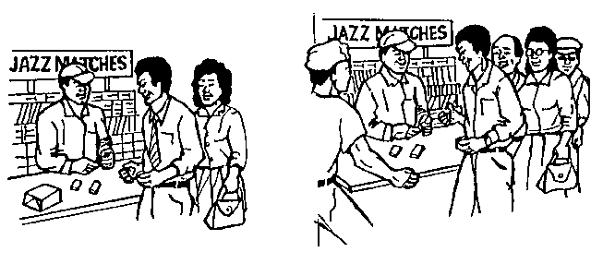

Street news
Street news about customers and competitors activities is another source of internal information. It should be made a regular part of a company’s business, societal and life information system. This can be stabled by:
Considering the types of information required
Communicating these guidelines to people in the organization and establishing a reporting system.
Regularly analysing and reporting this information

Observation
Data obtain through observation is called observational data. It involves observing people, objects, or events. Observations can be executed by human observers or mechanical devices e.g.
manufacturers invite children to play in a room containing various toys and observers record which toys are used.
Service shoppers visit stores or restaurants and record information about the service they receive
Information can also be gathered by way of self-reporting methods. One advantage of observation is that it does not suffer from respondents forgetting what happened or distorting their answers to make a good impression.
Two terms relevant to distortion is obstructive versus unobstructive and reactive versus unreactive measurement.
Obstructive means that the object being measured is aware of the measurement; reactive means that the objective reacts in changing in some way. The major problem with observation in regard to self-report measures is its limited applicability.

Surveys
When you do a survey you gather data by means of structured interviews. People who conduct surveys usually use a standardised questionnaire, which has certain advantages and disadvantages over structured interviews. The advantages of surveys are:
The use of structured questionnaires makes it easy to analyse the data since all respondents (people who complete the questionnaires) are asked the same question in the same order.
It allows the researcher to control the interview without being present
It allows structured questionnaires as well as survey interviews to be done by telephone or through mail, which means they can be cheaper than interviews which require personal interaction.
The use of telephone or mail and the lower costs per interview makes it possible to conduct a large number of interviews with a broader cross-section of the market.
The disadvantages of surveys are:
Structured interviews reduce flexibility
Deep feeling and hidden ones can not be probed very well
Question are limited to those that provide short answers.
In conclusion, surveys are good for measuring facts but less so for in-depth studies or profiles of individual respondents.

Personal surveys, telephone surveys, and mail surveys
Personal surveys offer maximum questionnaire flexibility.
Personal surveys are used where telephone surveys are not appropriate.
Intercept surveys, usually conducted in shopping malls, allow objects to be shown to respondents at a lower cost than in personal interviews.
Sample quality is low.
Save time with short questionnaire
Telephone surveys offers a good sample quality
The cost of telephone surveys is low.
Mail surveys offer the advantage of lower costs
Low response rate with mail surveys

Databases
A database is usually an external source of information, where someone else has already done the research and you can just access the information.
Examples include:

StatsSA
for information relating to the national census
www.statssa.gov.za
On this website you will find statistics relating to:
- Population of SA
- South African economics and economic factors
- Census results

Crime statistics
Information about crime in SA can be obtained from any of the following websites:
www.crimestatssa.com/
www.saps.gov.za/statistics/reports/crimestats/
www.statssa.gov.za

Stats about HIV/AIDS
www.statssa.gov.za
ww.healthalert.net/

Statistics about shopping patterns
www.statssa.gov.za
www.za.ask.com/
There are databases available for just about any topic that you need information on.

Sampling
One of the steps in gathering data is called sampling. This is where the sample of the population that you will use to gather data is determined.
Sampling is a basic concept used in statistics and is used to try to estimate what the parameters of a population are. For example, I may want to estimate how tall South African men are on the average. Perhaps, I measure a few hundred men and calculate their average. The men chosen for measurement are the sample. The parameter I am looking for is the average height of South African men.
One sip of milk is sufficient to let you know that the milk is sour. This is what sampling is all about. In order gain information about the whole you only need to examine a part. On the other hand, sipping a glass of water tells me nothing about the milk.
Here are a few definitions that statisticians use when dealing with samples:
A ‘population’ is the entire group of objects about which information is wanted.
A ‘unit’ is any individual member of the population.
A ‘sample’ is a part or subset of the population used to gain information about the whole.
A ‘sampling frame’ is the list or units from which the sample is chosen.
A ‘variable’ is a characteristic of a unit that is to be measured for those units in the sample.
The distinction between population and sample is extremely important to statistics. First, we look at a population then some examples to make the distinction clear.
A population is defined in terms of our desire for information about that population. For example, if I want information about all high school students in South Africa, then the population is all high school students in South Africa. Even if I can only choose one high school and its students, the population remains all high school students in South Africa.
It is extremely important to define clearly the population of interest.
If you want to determine how many South Africans are in favour of gun control laws, you must define the population precisely. Are all South African residents included, or only citizens? What is the minimum age you require? Are individuals imprisoned for violent crimes allowed to be included, or just those with minor offences, or none at all?
The following examples are presented to give an understanding of population, sample and variables. Data (numbers) used in most examples are completely fictitious as you have been warned.

Example 1
The national census attempts to collect basic detailed information from each household in the country.
Population: all South African households
Sample: the entire population, as far as possible.
Variables: the number of occupants, age, race, gender, family relationships, access to electricity, water and telephone services.

Example 2
You want to do market research to find out your customers’preference and usage of various products or services. Undoubtedly you have heard radio or TV announcers state that their station is listened to or watched by 80% of South African while their competitors only make up the remainder.
Population: all South Africans who have either a radio or a TV.
Sample: about 1500 residents of South Africa
Variables: gender, racial group, age, residential area, income category and the answers to the specific question or questions.
When Markinor does a survey before an election, they do not ask every person in the country for their views or opinions, they choose a number of people from the various population groups. The number of people they choose is called a sample: a sub-set of the population, while the population is the members of the group you are interested in.
When you choose the sample for a countrywide survey, you have to make sure that your sample represents the entire population. Usually the sample will then be chosen from a list that contains all the members of the population, such a list is called a sampling frame.
This is probably what Markinor does when they do surveys before elections. Luckily, for most of the research we want to do we do not have to go countrywide: we can usually choose from our community or customers or the customers of our competitors.

Sampling methods
When we sample we want to estimate the variables, or parameters, of the population. Therefore, the samples must be taken in a manner that ensures that they are representative of the population. When our sampling methods produce results that consistently and repeatedly differ from the truth about the population, we are doing something wrong.
Our sampling must consistently produce results that have high precision in estimating the parameters of the population and these estimates must have low bias. A lot of statistics-talk seems contrary to the way people talk. A statistician may use ‘high precision’ but he may also refer to lack of precision. Sometimes this practice produces some interesting double negatives.
‘Bias’ is consistent, repeated divergence (difference) of the sample statistic from the population parameter in the same direction.
‘Lack of precision’ means that in repeated sampling the values of the sample statistic are spread out or scattered. Lack of precision means that the result of sampling is not repeatable.
The easiest way to visualize bias and precision, or lack of precision, is to refer to the following targets. Of course, we want to hit the centre, the bull’s-eye! The figure on the next page shows four targets that represent
high bias and high precision,
low bias and low precision,
high bias and low precision, and
low bias and high precision.
When the bias is high the pattern is further away from the centre of the target. High precision means that the pattern is clustered close to its neighbours.
With statistics, we are aiming at low bias and high precision. This means that the values we obtain should be consistently close together and that they are good estimates of the value we are trying to estimate. Just like trying to hit the bull’s eye.
It is now time to introduce a few more terms.
A ‘probability sample’ is a sample where every element in the population has a known probability of being included in the sample.
A ‘non-probability sample’ is one where elements in the population do not have a known probability of being included in the sample.
There are times in a probability sample where certain sections of the population may have a probability of zero. That is, there are times when they are intentionally excluded. The idea of probabilities and the details of sampling are discussed in other sections.

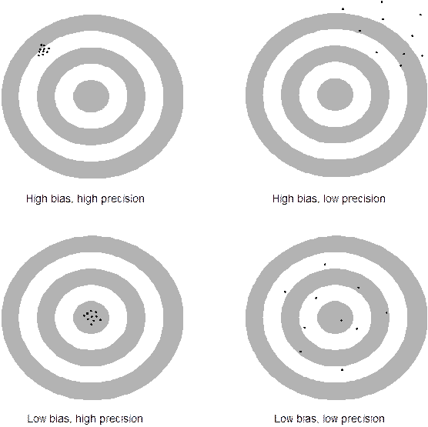

Probability sample
We will discuss 2 probability sampling techniques:

Simple random sampling (SRS)
The simple random sampling (SRS) technique is extremely simple and forms the basis for other probability sampling techniques. An SRS of size n is a sample of n units chosen in such a way that every collection of n units from the sampling frame has the same chance of being chosen. This technique ensures that all units in the population have the same probability of being chosen.
As the SRS is so important, a considerable amount of time is spent on it in this module. In addition, many of the concepts used in this module are first introduced when dealing with the SRS.
The disadvantages of an SRS are:
The numbering of all elements in the population can be time consuming, especially when the population is large.
A complete list of the population elements is often not available.
If the population is spread out over a large geographical area, contact with the elements in remote locations could be costly and time consuming.
Since all possible samples have the same chance of being selected, sampling from a heterogeneous population (one that varies considerably) could lead to large sampling errors.

Systematic Sampling
The systematic sampling technique is very easy to set up and is a simplified version of the SRS.
The advantages of systematic sampling are:
It may be more convenient and easier to administer than other sampling techniques. This is especially true if the information is kept in some filing system (electronic or manual) like the cards used in a library system or invoices.
A complete list of the population is not always necessary. In quality control only each nth (5th, 22nd) element coming from the production line is inspected.
This technique may ensure a more representative sample by covering the whole range of population elements.
If the population is homogeneous, systematic random sampling is just as reliable as an SRS. If the population is heterogeneous, systematic random sampling is more reliable than an SRS. (This means that you need to take fewer samples to obtain the same result.)
The disadvantages of systematic sampling are:
If a cycle exists in the records systematic sampling may coincide with this cycle and produce a biased result.

Non-probability sampling
Two non-probability sampling methods are discussed and some examples given. These techniques are convenience sampling and quota sampling. Convenience sampling is highly subjective and unreliable and should never be used for statistical purposes. Quota sampling is sometimes used in practice. In non-probability sampling the units are not chosen randomly.

Convenience sampling
The name gives the game away here. This technique consists of selecting the population elements with the greatest convenience.
The greengrocer who samples the top layer of apples in the first crate is performing convenience sampling. Many of us have been approached while shopping at a large shopping centre, on a Saturday morning.
It may be convenient for the one asking the questions, but who shops there? If the shopping centre is in Sandton I would expect quite a different range of clientele from those shopping in Soweto.
Convenience sampling, although used by many companies because they are cheap and quick, is usually a waste of time, cost and effort.
Results from convenience sampling usually systematically over-represent some parts of the population and under-represent other. (Who shops in Sandton on a Saturday morning for basic necessities?)
Another example of convenience sampling is when a radio or TV station ‘asks for your comment on this issue so we know what South Africans think’. This example has another element buried in it that is almost guaranteed to produce a strong bias: voluntary response.
A voluntary response sample chooses itself by responding to questions of this nature. People who feel strongly about an issue are more likely to take the time and trouble to respond.
This is especially true if the person responding has strong negative feelings about the issue being discussed. Opinions from convenience sampling, especially coupled with a voluntary response rarely represent the population as a whole.
Convenience sampling is not discussed further in this module however it is used in many places as a ‘good example of what not to do’.

Quota Sampling
A quota sample is a selection made on the basis of specific guidelines about which item should be selected. Quota sampling may be viewed as a simplified version of stratified random sampling. In quota sampling, homogenous (similar) cells are defined by the ‘researcher’ and the field worker is then expected to fill the quota from the population. For example, shopping behaviour may be required and the cells (strata) are, men, women and children. The field worker must then obtain responses from the number of people specified in each cell.
Quota sampling is more reliable than convenience sampling or judgement sampling but has no guaranteed or measurable advantages over probability sampling.
Another example of quota sampling is a real estate agent wishing to estimate the average value of houses in a population of cluster houses. The real estate agent may want to know which percentage are one-storey, two-storey, multi-storey or split-level, the percentage that has air conditioning, the percentage that has access to swimming pools and the current market value of each dwelling. The agent would use his or her subjective judgement to decide which dwelling to include in the sample. Quota sampling is not discussed further in this module.

Using sampling methods
The problem with non-probability sampling techniques is due to human choice. The human element may be removed by allowing an impersonal chance to choose the sample. The SRS (simple random sample) is the basis of probability sampling techniques so I concentrate on this method in more detail than on the other methods. In fact, I introduce a number of concepts and definitions when discussing the SRS that will be very useful in other section of this manual.

Simple Random Sampling (SRS)
A simple random sample of size n is a sample of n units chosen in such a way that every collection of n units from the sampling frame has the same chance of being chosen.
Note that this method gives every possible sample of size n the chance of being the sample actually chosen. What I mean here is that every time I take n units as my sample, every possible sample of n units has the same chance of being selected. Let’s do an SRS and see how it’s done.
There are ten of us in a room and three of us are to be chosen to represent the group for some purpose. Because we can’t decide who should go, we decide to choose the ‘volunteers’ randomly. Each name is put on a piece of paper and all pieces of paper are identical. The papers are then put in a box and thoroughly mixed. Draw one name (piece of paper) from the box and read it out or put it aside. Mix the remaining names again and draw the second one. Do the same for the third name as well. You have just performed an SRS of size 3 from a population of 10.
Physical mixing and drawing of pieces of paper certainly is simple and this is all that is behind an SRS.
Another way to accomplish the same result without the hassle of handling bits and pieces of paper is to use a table of random numbers. I created such a table for this module (handout 1). This table consists of 12,500 random digits.
Choosing a random digit is like spinning a wheel with the ten digits (0 through 9) on it. such a wheel is shown below. When you need a random digit you spin the wheel. When you need another one you spin it again and continue doing so until you have the number of digits you require.

Exercise 1
Practice the following section as the lecture proceeds
A table of random digits is simply a list of the ten digits (0 through 9) with these properties.
The digit in any position in the list has the same chance of being any of the ten digits.
Digits in different positions are independent in the sense that the value of one has no influence over the value of any other.
Any pair of digits has the same chance of being any of the 100 possible pairs (00 through 99).
Any triple of digits has the same chance of being any of the 1000 possible triples (000 through 999), and so forth for 4 digits or higher.
The table in handout 1 contains 11 columns. The first column is a sequence from 1 to 250 so that you know where you are in the table when you are using it. The random digits are in groups of five in order to make them easier to read. In addition, five rows are shaded then the next five are not, and so forth. This arrangement is for the sake of convenience because 12,500 digits strung together as one long number is difficult to read.
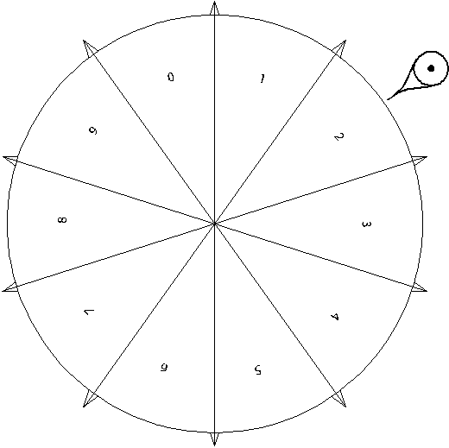
Using a random number table is actually easy when you get the hang of it. I’ll go through a few examples and you’ll be proficient in no time.

Select from 10
We now want to choose three of the ten of us as we just did by putting our names on slips of paper and drawing them randomly. This time, however, we will use the table of random digits to do it for us. Because there are ten of us we label each person 0 through 9. We then enter the table somewhere and systematically read through it. You may read left to right, right to left, upward or downward. When you run out of a row or column, continue systematically in the next one. It doesn’t matter which way you read the number, just be consistent each time you use the table.
I decided to start on line 123, the first column and read the numbers left to right. The first three digits are: 0, 9 and 5. These are the three people chosen from our group.
Let’s do this again but this time start in row 127. The first three digits are: 9, 9 and 4. We have a problem because person number 9 appears twice. Ignore duplicates and continue until you have three numbers that are all different. The fourth number is 8. In this case those labelled 9, 4 and 8 are chosen.

Select from 100
I have been asked to test 5 rounds of ammunition out of a box containing 100 cartridges. In order to randomly choose the 5 rounds, I label each cartridge 00 through 99. (Actually, I’m smarter than that. The cartridges are in a box packed 10 by 10 so I decide that the first row of cartridges is labelled 00 to 09, the next row is labelled 10 to 19 and so forth.)
I decide to start drawing my SRS from row 17 but begin with column 6: 33699, 23672 and so on. I take these numbers and group them in pairs: 33, 69, 92, 36 and 72. Notice that I read across the break in the column, no duplicates appeared so I remove and test cartridges numbered 33, 69, 92, 36 and 72 for testing.

Select any number
You are working for a hospital (hotel, restaurant, prison) that has 300 beds, (rooms, tables, cells) and need to select 7 of these randomly to check on its condition.
You label each from 000 to 299 and start in row 101, column 1 and begin to read off the following numbers, 3 digits at a time. The first three digits are 550. This number is outside the range of 000 to 299, so you ignore it and continue. The sequence you have and the actions you take follow:
550, ignore
348, ignore
121, keep
790, ignore
564, ignore
819, ignore
431, ignore.
At this point you realize that you are going to ignore about 70% of all three-digit numbers because you only have 300 items out of 1000 possibilities. So, being clever, you give each item three numbers. To make it easy for yourself, you assign number 000 to 299 to the items, as well as 300 to 599 and 600 to 899. So now the first item is labelled 000, 300 and 600. You may find duplicates, which you ignore, but you should only find about 10% that are not in the range 000 to 899. We now repeat the exercise with the following results:
550, keep (item 250)
348, keep (item 48)
121, keep
790, keep (item 190)
564, keep (item 264)
819, keep (item 219)
431, keep (item 131).
Just to make sure you are still with me and before we get involved in more interesting matters, I’m going to summarize how to select numbers from a table of random digits.
If no more than 10 units must be labelled, one-digit labels should be used.
If 11 to 100 units must be labelled, two-digit labels should be used.
If 101 to 1000 must be labelled, three-digit numbers should be used.
Always use as few digits as possible for labels.
It is also good practice to begin with zero rather than one even when not all the labels are required.
Ignore unused labels.
It is more efficient to give several labels to each unit in the same sampling frame. If you use multiple labels ensure that each unit has the same number of labels.

A worked example
The figure on the next page contains 100 circles of five different sizes: 5mm, 10mm, 15mm, 20mm and 25mm. Perhaps the circles represent something of importance to you. You will find a slightly larger copy of this figure on the next page in handout 2 although the legend is not shown. Make copies of this handout rather than working directly in your manual.
The circles may represent the size and distribution of bubbles that you may find in a vat when converting coal to petrol, brewing mampoer or making cheese. If the bubbles are too large, too small, too many or too few, the product may be damaged. For example, if your cheese has too many large bubbles it may no longer fit in the containers you have ordered. To complicate matters, if you put the cheese into the same containers, your customers will complain that the mass of cheese in the container is too low. Of course, if the bubbles are too small, you may deliver a higher mass of cheese in the same container and lose money.
The circles may represent the size of trout and their distribution on your fish farm. If you have too many large trout they may start eating your small trout. You may have too many small trout and will not be able to fill the orders you have for large trout.
The circles may represent tumours or cultures that are being studied if you are a medical or research person.
The circles may represent the size and distribution of trees in a plantation if you are a forester.
In statistics, we don’t usually know what the population parameters are so we must be able to estimate them. In this example, I am going to give you the values (answers) and then show you how statistics may be used to estimate the population parameters.
For this example the population consists of the 100 circles. I am interested in finding out the average size of the circles as well as some indication of how many circles of each size there are in the population. The true values could be calculated by taking a census and you would find the following:
There are 10 circles with a diameter of 25mm.
There are 15 circles with a diameter of 20mm.
There are 20 circles with a diameter of 15mm.
There are 25 circles with a diameter of 10mm.
There are 30 circles with a diameter of 5mm.
You could easily calculate the average diameter by adding up all the sizes (10x25 + 15x20 + 20x15 + 25x10 + 30x5 = 1250) and then divide the result by 100. The average diameter of all the circles is 12.5mm.
Because there are 100 circles, the percentage that each circle appears is 30%, 25%, 20%, 15% and 10% for the 5 millimetres, 10 millimetres, 15 millimetres, 20 millimetres and 25 millimetres, respectively.\

Exercise 2
Follow the steps below
I want you to do this example in order to convince yourself that statistics really works! This exercise involves a bit of work but it’s not difficult. Follow these steps.
Number the circles in the figure from 00 to 99, in any order that you want. I don’t care how you number the circles because the way you number them makes no difference to the outcome of the solution. You may number them vertically, horizontally, randomly or by size. You must, however, write the numbers in each circle because you will not be able to remember each circle’s number out of your head.
Once your have the circles numbered, use the table of random digits in Annexure A to select an SRS of size 4. Remember to discard all duplicates and continue until you have four unique numbers.
Find the circles that match the numbers from the table of random digits and record each diameter (check the figure as the printed version may not be exact). When you have the four diameters, calculate the ordinary average by adding the four values and dividing by four. In mathematics-talk, let d₁ be the diameter of the first circle, d₂ the diameter of the second circle, and so forth. Then calculate the ordinary average:

Start at different points in the table and repeat the same procedures three more times so that you have four averages.
Now draw an SRS of size 16 from the population ensuring that you start at a different point in the table. Record your results and calculate the ordinary average of the diameters. (Sum the 16 diameters and divide by 16).
Now comes the fun part: we are going to analyse our results. The following table displays the averages that resulted from 10 samples (results) for an SRS of size 4.
‘Not very good’, you may say, and I agree. An SRS of size 4 varies all over the place. In fact, the minimum and maximum average diameters are 6.25mm and 23.75mm, respectively.
I’m putting these results in terms we already know, and introducing a few new terms as well. The ‘range’ is simply the difference between the maximum and the minimum values obtained. In this case, the range is 17.5mm (23.75 – 6.25 = 17.5).

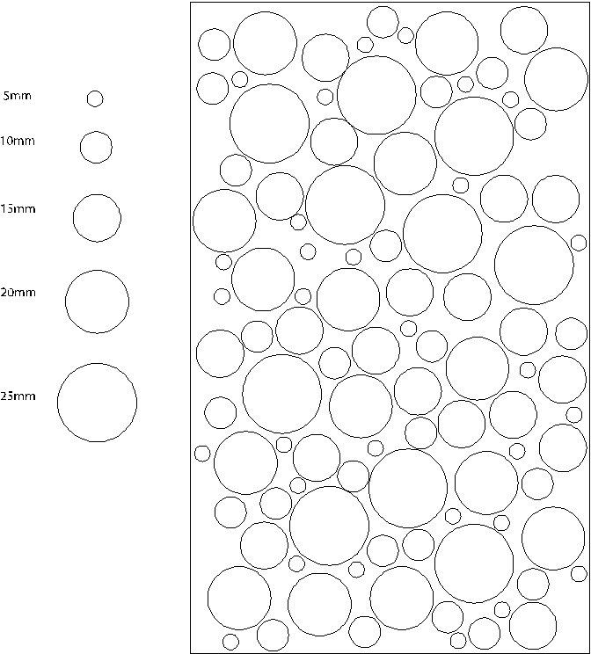

We can now say that we expect the real mean (statistics-talk for average) is likely to be between 6.25 and 23.75. This is an excellent example of low precision if you think back to the target example. This example probably has low bias but we can’t be sure of this right now.

Sample | Average 1 | Average 2 | Average 3 | Average 4
1 | 6.25 | 11.25 | 15.00 | 11.25
2 | 13.75 | 15.00 | 12.50 | 17.50
3 | 11.25 | 13.75 | 13.75 | 16.25
4 | 12.50 | 23.75 | 12.50 | 13.75
5 | 8.75 | 8.75 | 12.50 | 12.50
6 | 10.00 | 13.75 | 17.50 | 10.00
7 | 8.75 | 13.75 | 6.25 | 13.75
8 | 10.00 | 13.75 | 8.75 | 15.00
9 | 7.50 | 18.75 | 13.75 | 10.00
10 | 12.50 | 12.50 | 8.75 | 8.75

The results of using an SRS of size 16 appear in

Sample | Average
1 | 12.8125
2 | 11.5625
3 | 9.0625
4 | 11.8750
5 | 11.2500
6 | 11.8750
7 | 11.5625
8 | 11.8750
9 | 12.1875
10 | 11.8750

‘This looks better’, you will say, and I agree.
The minimum and maximum average diameters are 9.06250mm and 12.81250mm, respectively. This gives us a range of 3.7500mm. All of a sudden the range became smaller and the precision increased! We may now expect the real mean to be somewhere between 9.06mm and 12.81mm. (It’s not necessary to use so many digits after the decimal. After all, we are only approximating the real mean.)
The more samples we take, the better the estimate of the parameter we are estimating.
The average, or mean, is only one of several methods we may use to determine where the centre of the data is located. Likewise, the range is only one of the methods we may use to determine the spread, or scatter, of the data around the average, or mean.
I’m now going to average the averages to see what happens. I can do this only if I am careful to do it correctly. Because all the averages obtained from an SRS of size 4 are the same size (4), I can average all the averages. If I do this, I obtain 12.40625mm, or 12.40mm for simplicity. Averaging the averages of the SRS of size 16 produces 11.59375mm, or 11.59mm.
You might think that using more samples of size 4 is better than less of size 16, but you would be wrong. Both have the same ‘accuracy’. It just happens that in this example, the results turned out this way.
I also counted how many times a circle appeared as a result of the SRS and calculated its percentage of occurrence. The graph on the next page shows the results.
Originally we knew the percentage that each circle appeared was 30%, 25%, 20%, 15% and 10% for the 5, 10, 15, 20 and 25mm circles, respectively.
From the graph and the table we can see the frequency of the exact sizes and the estimate of the frequency of occurrence of each circle. We may estimate the occurrence of the circles as 35%, 22.8%, 17.8% 15.9% and 8.4%. The estimates are not exactly what we started with but they aren’t too bad considering I used a pretty small sample.

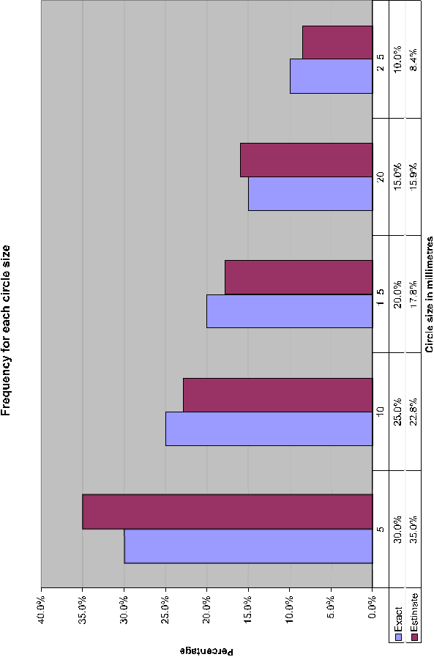

When you complete your results, I doubt you will obtain the same values as I did. Always keep in mind that we are estimating the true value of the parameter from a sample and not calculating the parameter from a census.
The lesson you should learn in this example is that an estimate of a parameter becomes more accurate as the sample size grows.

Sampling distributions
We have just learned that random sampling produces different results each time it is used. Does this mean that the results are invalid? Can I really believe them?
There is another property of random sampling that is even more important than the lack of bias. A sample statistic from an SRS has a predictable pattern with repeated sampling. This pattern is called the ‘sampling distribution’ of the statistic. Knowledge of the sampling distribution allows us to make statements about how far the sample proportion, for example, is likely to wander from the population parameter.
I’m going to make the assumption that I know the proportion of defects in a certain population as p = 0.05. In other words, I know that 5% of the items (ball bearings, sweets, computers) in the population are defective. Ask yourself a question: If I took 100 items, how many should I find defective? The answer is obviously 5.
But would I always get 5 bad items? Would there be times when I found no defective items or 10 defective items. Maybe! But I doubt that I would get exactly 5 on each sample of 100 items. And if I did, I would suspect foul play! How many defective items do you expect me to find if I take a sample of 25 items? Do you really think that I would find defective items (0.05×25 = 1.25)?
I took the output from an automated system that is designed to test for a specific defect in a product and reproduced it in the graph below. The sample size in this case is 25 and the defective items are 20% (p = 0.20). This is pretty high for a mass-produced item but fortunately the defect was a slight colour variation that did not affect the use of the product. It did, however, cause items on a shelf to appear different and this worried the manufacturer.
Let’s explain the graph in the figure before I start analysing it. The horizontal axis represents the number of defects that were found (1 to 9) in each sample. The vertical axis represents how many times that number of defects occurred. Looking at the table at the bottom of the graph, you can see the following:
1 defective item occurred 1 time (0.04%)
2 defective items occurred 12 times (0.48%)
3 defective items occurred 158 times (6.32%)
4 defective items occurred 601 times (24.04%)
5 defective items occurred 966 times (38.64%)
6 defective items occurred 594 times (23.76%)
7 defective items occurred 142 times (5.68%)
8 defective items occurred 25 times (1.00%)
9 defective items occurred 1 time (0.04%).

The percentage of occurrence is shown in parentheses. Note that about 39% of the cases had 5 defects, 86.44% had 4, 5 or 6 defects (601 + 966 + 594 = 2161), and 98.44% of the cases had 3, 4, 5, 6 or 7 defects. I think you now see that = 0.20, approximately.
If we look just at the defects, they range from 1 to 9. That is, in each sample of 25 units, the proportion of defects ranged from 4% to 36% ( = 0.04 to = 0.36). We know (actually assume) that the proportion of defects is 20% (p = 0.20). Why does one sample give us an estimate of 0.04 and another one give an estimate of 0.36? One sample on its own is not a reliable estimator of the true proportion. However, many samples taken together produce a reliable estimator of the true proportion.

I’m going to summarize the concept involved with sampling variability before we continue because it’s extremely important.
Despite the sampling variability of statistics from an SRS, the values of those statistics have a known distribution (pattern) in repeated sampling.
When the sampling frame lists the entire population, simple random sampling produces unbiased estimates. This means that the values of a statistic computed from an SRS neither consistently overestimates nor consistently underestimates the value of the population parameter.
The precision of a statistic from an SRS depends on the size of the sample and can be made as high as desired by taking a large enough sample.
To be completely honest with you, the examples with the proportions and the one with the defects were not the result of an SRS. However, the sampling methods used in these two cases are based on random selection and also share the three basic properties listed above.

Problems that may occur
Sampling is not always the solution to all data gathering methods. Things may and do go wrong. There are two separate types of errors than can affect our results. Sometimes the effects are so drastic that ‘we back the wrong horse’, so to speak. (Sampling won’t help you with horse betting, by the way!). These errors are called ‘sampling errors’ and ‘non-sampling errors’.
Sampling errors are errors caused by the act of taking a sample. These errors cause sample results to differ from the results of a census.
Non-sampling errors are errors that are not related to the act of selecting a sample and may even be present in a census.
When I’m counting defects in products, measuring the diameters of ball bearings or obtaining results from laboratory tests, sampling errors are my biggest problem.
This is easy to fix, however: use an SRS or another type of probability (statistical) sampling method.
If I am concerned with public opinion, what a consumer really wants to buy or personal matters, non-sampling errors become very serious concerns in almost every sampling technique.

Sampling errors
We know that differences in sampling will occur just as the day follows the night. In fact, the whole idea of sampling is to use the long-term effects of probability to be able to predict how precise our outcome will be. Sampling errors are different. They are the result of introducing bias into the sampling process. Here are two examples that have caused the uninitiated to have red faces.
Do you have a telephone at your place of residence? I don’t mean a cell phone I mean a telephone. If so, is the telephone in your name and is your number in the telephone directory? Or do you have an unlisted number? Telephone interviewing is very popular but if I use a telephone book to sample households my sampling frame omits a large portion of the populace.
Statistics SA, in its 2001 census reports, indicates that 10.2% of all South Africans have a telephone in their dwelling and no cell phone and 14.2% have both. Stats SA, as it is known, also state that 18.0% of South Africans have a cell phone and no telephone. (There is no indication in their data of how many telephones are unlisted.) So if I use a telephone directory to select my sample, I am excluding 75.6% of the population from my sample and only including 24.4%.
Those that I am excluding have no access to a telephone at all, or have limited access either nearby or far away. Some have access only to public telephones or through neighbours and friends.
Stats SA also state that 12.0% of black Africans, 43.2% coloureds, 74.8% Indians or Asians and 78.6% whites have telephones in their dwellings or both telephone and cell phone access.
So you have a phone in your dwelling. Who answers the phone when it rings?
Telephone surveys are often conducted with equipment that dials digits randomly. This certainly gets around the problems associated with using telephone books, but it also has its share of problems.
Usually, the survey team will speak to the first person that answers the phone. If a child, domestic servant or relative answers, the information obtained may be biased. If there is no answer at a particular number, the equipment moves on to the next number until someone answers. This, of course, biases the results towards those who are more available than others. The time of day the phone calls are made also has an impact.
Telephone surveys, although important, should not be the only way a survey is conducted. If it is, then the results will most likely be biased.

Non-sampling errors
The biggest problem to deal with when dealing with non-sampling errors is missing data. Missing data usually results in a refusal to answer a question.
Another problem concerns incorrect answers. Many people just lie when it concerns personal details like age or income. In addition, people just have bad memories. In any case, all people are inaccurate when it comes to time based events. ‘How often did you visit a doctor in the last year’ or ‘How many cigarettes did you smoke last week’ usually produce inaccurate results.
Processing errors also occur but are usually related to the human side of coding. If I must key in a ‘1’ for male and a ‘2’ for female, I just get tired and make mistakes. If I must key in ‘1’ for single, ‘2’ for married, ‘3’ for divorced and ‘4’ for widow/widower, I’ll tire quicker and will probably enter ‘5’!
Perhaps the trickiest problems to detect and fix are those that result directly from the method used to collect the data. This may include the question itself. If I am trying to obtain information on financial investments, and ask a farmer in the Free State: ‘Do you own stock?’ or ‘How much is your stock worth?’ I might just get a few surprises. He knows that sheep and cattle are stock but may have to think about including ostrich, trout or game.
The timing of a questionnaire or survey may be very important. If your survey happens just after an event, will it affect your response? If you asked a typical American on 10 September 2001 ‘Do you feel safe from terrorist attacks?’ you would probably obtain quite a different response if you asked the same question on 12 September 2001. (The World Trade Centre was destroyed on 11 September 2001.)
Questions on questionnaires must never hint at an answer or try to obtain a certain response. A few typical questions of this nature are: ‘Do you favour the banning of guns in South Africa in order to reduce the rate of violent crimes?’ or ‘Do you favour re-imposing the death penalty in order to reduce the rate of crime?’ These are loaded questions but we see them all the time.
Here are two questions on the same topic. How would you answer them?
Do you believe that there should be a law prohibiting abortions?
Do you believe there should be a law to protect the life of the unborn child?
Often the race of the interviewer affects the answer especially if dealing with racial issues. The interviewer might just take the attitude that ‘I am just doing my job’ but the person being interviewed might just think (subconsciously) ‘I am giving the answers he/she wants to hear’. Setting up a questionnaire is not an easy matter!

Answers you need to know
In order to develop critical thinking on all issues and become a participating citizen contributing toward the future of South Africa, you must ask the following questions when confronted with statistical results.
What was the population? That is, whose opinions were being sought?
How was the sample selected? Look for mention of random sampling or probability sampling.
What was the size of the sample?
How were the subjects contacted?
When was the survey conducted? Was the survey conducted just after some event that may have influenced opinion and responses?
What were the exact questions asked?

Systematic Sampling
In systematic sampling, sampling begins by randomly selecting the first element. Thereafter, subsequent observations are selected at a uniform interval. Think of systematic sampling as a circle. You choose a random place on the circle and then keep going around the circle until the desired number of elements is selected.
For example, I want to choose 6 books randomly from a selection of 20. The number of total elements in my population is 20 and I number them from 0 to 19. I want six books so I can calculate the stepping rate around the circle as . I could also choose the stepping rate from a table of random digits as well.
I then choose a random number to start. Using the table of random digits, I look at column 1 row 1 and obtain 53. If I divide 53 by 20 and keep the remainder (13) I have my starting point.
The figure on the next page shows a circle with the starting point, 13, marked by an arrow. The subsequent books are selected by counting systematically around the circle. I went in a clockwise manner but could have gone counter clockwise if I chose.
The books numbered 13, 16, 19, 2, 5 and 8 are selected from the 20 available.
This sampling scheme has resulted in some biased results when applied blindly. If you are using this technique and there is a cycle in your population, just ensure you don’t end up using the same cycle to sample.
For example, if I choose to select every third unit and my population consists of row upon row of flats that are three storeys tall, I could end up sampling the same floor in all buildings and never obtain results from tenants on other floors. (This actually happened!)
Another natural cycle consists of the days of the week. Let’s assume that I want to estimate the amount of traffic passing through an intersection. If I choose 7 as my sampling interval and my randomly chosen day is a Sunday, I will be only obtaining data from Sunday. The traffic on a Sunday will probably provide a different result than a Monday or a Friday.

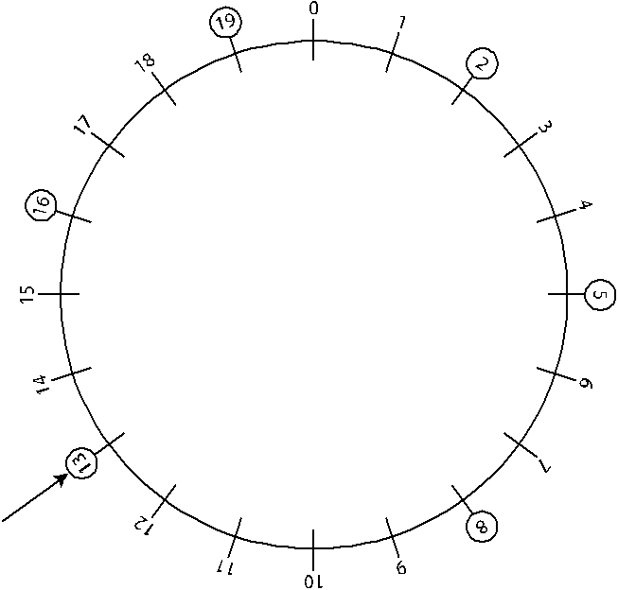

Questionnaires and Interviews
There are three general forms of surveys: questionnaires, interviews and network analysis. In ths manual, we will only discuss interviews and questionnaires.
In this section I’m going to introduce you to two types of questionnaires: questionnaires that measure your judgment or feeling about something and questionnaires that measure your achievement in something.
Questionnaires that measure your judgement are usually very difficult to prepare and use.
Questionnaires that measure your achievements are usually fairly easy to prepare.

Designing questionnaires
Completing a questionnaire involves the six steps. At each point along the way, the researcher must stop, examine, explain and justify the choices before continuing with the next point.

Select questions and provide instructions
Questionnaires are forms in which individuals respond to written items and ask respondents to report their understanding of things. Often their responses include their own behaviour.
Developing the questions is often very difficult. In general there are three ways to develop surveys and I suggest using the first two until you become more experienced in questionnaires.
Find standard forms and use them. There are hundreds of questionnaires available however most of these must be purchased from private companies. You normally must pay a fixed fee per respondent or per questionnaire purchased.
Select measurement forms that have been used in research articles you read. Researchers often provide copies of their questions in their articles. If not, they will often cite sources from which their measures were drawn.
Develop them yourself by: reading on the subject; composing a rough draft of items based on your readings; putting them into a suitable format; and, evaluating them against the standards discussed below.
Researchers face several challenges when preparing questions for a questionnaire. The respondents must cooperate in completing the questionnaire and they must report the way they honestly perceive things (their honest opinions). Sometimes respondents don’t know how they perceive things or they may feel pressured to respond in ways they believe the researcher wants. So query each of your own questions by asking yourself:
To what extent might this question influence respondents to show themselves in a good light?
To what extent might this question influence respondents to be unduly helpful by attempting to anticipate what researchers want to hear or find out?
To what extent might this question be asking for information about respondents that they are not certain, and perhaps not likely, to know about themselves?
There are many ways to use for designing questions and many ways to present the questions (format the questions). Some alternatives include the following:
You may use either direct or indirect questions. Direct questions ask for obvious facts and indirect questions ask respondents to react in ways that imply information. For example, instead of asking whether the respondents enjoy programs on television, a researcher might ask subjects to describe the quality of programs they watch on television. It usually requires more indirect questions than direct questions to obtain information you require but indirect questions often produce honest responses when topics involve sensitive matters or issues people may try to answer in ways that put them in the best light.
You may ask specific or general questions. Specific questions focus on individual activities but general questions ask about global evaluations. Employers often ask employees how satisfied they are with their physical work environment. They may ask specific questions regarding how satisfied they are with the temperature of the work environment, the cleanliness of the workplace and the ease of operating their equipment. Employers may also ask general questions about their overall view of the work environment. For example, ‘How satisfied are you with the physical work environment?’ Although specific questions are used to get precise information, in some cases individuals may become unusually ‘cautious’ or suspicious and give less-than honest answers. In these cases, general, or non-specific, questions may obtain the desired information while giving less cause for alarm to the respondent. You may just have to use a lot more general questions to get the information you want.
You may ask questions or you make statements. Some questionnaire items may ask questions while others may make statements and ask the respondents to indicate how much they agree or disagree with them. Both methods are useful in their own right but many researchers select one or the other for their questionnaire in order to minimize the number of different instructions that respondents must follow.
Phrasing items on a questionnaire is a major challenge. Through tricky phrasing, a researcher can ‘rig’ a survey to produce results that he or she wants. So you must be very careful to ensure that your questions are worded correctly.
There are generally accepted standards for wording questions that you may use to double-check questionnaires you develop or read. The table list some problems encountered when wording questions.
Problem | Example | Comment or suggestion
Double-barrelled questions | Do you favour expanded bus and fixed rail mass transit systems? | If you want only one option, you must answer ‘no’ to this question. Instead, two questions should be asked, one for each alternative.
Loaded language | Do you favour reduced military expenditures in light of the reduced threat to South Africa from other countries? | The justification for the position is advanced along with the question itself. Questions should leave out the arguments for one side or another.
Incorrect grammar | Do you know anyone who wants their taxes raised? | Some questionnaire respondents will detect the incorrect grammar and will be distracted from the content. The question should read, ‘Do you know people who want their taxes raised?’
Incompleteness | Do you believe that more money should be spent on public higher education? | More than what? Technically, this wording is a fragment, rather than a complete interrogative sentence. To you this question might mean ‘Do you want to spend more money on providing a higher education for your children’. For me the question might mean ‘Do you want the national government to spend more money on providing a higher education for your children’.
Vagueness | What do you think of your local TV service? | Such a question makes it impossible to get at specific, interpretable information. Researchers should ask questions that help them gather information they want.
Ambiguous terms | Do you believe that women get their due at your company? | The term ‘get their due’ is subject to many different interpretations. If the researcher wants specific information, unambiguous language must be used.
Lengthy items | When engaged in special project teams, do members of management rely on responsive listening techniques prior to giving reactions to suggestions made by subordinates? | Questions should be asked as briefly as possible.
Complex questions | Should serious statistics students be required to take a foreign language? | If one disagrees with requiring statistics students to take a foreign language, the answer still would be ‘yes.’ The question only asks about ‘serious’ students. ‘Serious’ is an extra ‘weasel’ word that restricts the question to a small group.
Averaging or restrictive questions | In the average week, how many hours of television news do you watch? | It may be difficult for a person to come up with an average. Instead one should ask about a limited time period, such as a week.
Leading questions | Do you agree with most South Africans who believe that the quality of public argument is poor? | Such a question creates pressure to go along with the wishes of the questioner. Such prompts as “wouldn’t you agree with me that…” are examples of leading questions.
Abbreviations | Should the CCP approve the construction of an interactive CATV system? | Abbreviations and acronyms may not be universally understood. It is best to preface this question with a brief explanation of the meaning of the abbreviated term.
Imprecise questions | Does your local TV service leave something to be desired? | Such imprecise language guarantees useless data. Whether a person is satisfied or dissatisfied with a local TV service, the answer would be ‘yes’ since there is always something more that one could desire.
Misspelling | Should children with cleft palates increase there time spent on drills? | Questionnaires are communication encounters. Misspellings show contempt for readers who notice them.
Awkward construction | How many students do you have broken down by sex? | Alcohol and drugs are probably just as big a problem as sex in breaking a person down. But maybe the question meant ‘gender’?
Items with only one logical answer | Can television programs promote acquisition of language skills among immigrants? | Anything is possible in the future. Therefore, questions that ask if something ‘can’ or ‘might’ occur have only one logical answer: ‘yes’.
Presumptive questions | How severe is your child’s stuttering? | Assuming information in a question makes it impossible to answer fairly. This example is much like the famous ‘wife beating’ question. One might ask a man, ‘Have you stopped beating your wife?’ Whether he answers yes or no, you’ve got him cornered. On the other hand, he may be like you and be a thinker and ask: ‘Beating her at what? Chess?’
Elevated vocabulary | Is the personal life of a presidential candidate germane to your choice of a candidate? | Simple words should be used where possible. Surprisingly, many people do not know that ‘germane’ means relevant. Although one should not condescend to respondents, simple language should be used whenever possible.
Imprecise agents of action | Should we adopt a guaranteed income to replace welfare? | Who is ‘we?’ Items should specify the active agency, as in the question, ‘Should the national government adopt a guaranteed income to replace welfare?’
False bipolar | Do you like coffee with or without caffeine? | Such a question misleads since it assumes that the respondent likes coffee.
Problems in wording questions

Questionnaire instructions
Questionnaire instructions should help respondents by explaining how they should answer questions. Instructions must be clear and should explain to people how they are to complete the questionnaire. As a matter of routine, many researchers find it useful to provide a category where the respondent can indicate ‘no response’ or ‘not applicable.’ This strategy is useful since researchers can separate incomplete responses from thoughtful refusals to respond. The table shows some typical methods used for questions.
Type and description | Example | Useful when
Open-ended questions  Questions to which people respond in their own words | What fringe benefits offered by this company are most important to you? | Respondents may not have information on the topic.  Respondents are motivated to communicate and spend time with the project.
Closed-ended questions  Questions to which people respond in fixed categories of answers | The fringe benefits at this company are: (check one)  [ ] superior  [ ] excellent  [ ] good  [ ] fair  [ ] poor | Possible answers are limited in number.  Respondents are known to possess information on the topic.  The respondents understand the term used.
Paired-comparison questions  Questions that ask respondents to make a judgment between alternatives taken two at a time | 1. If you had to choose between the following two options, which one would you prefer in your career?  [ ] enjoyable work  [ ] high income  2. If you had to choose between the following two options, which one would you prefer in your professional career?  [ ] good people to work with  [ ] high income | Items to be rated are very close in desirability and simple ranking is difficult.  Options are fairly limited in number.  It is practical to contrast all options against each other.
Contingency questions  Questions asked only of some respondents, determined by their responses to some other question. | Have you given a speech in the last three months?  [ ] Yes (If yes, please go to question 13)  [ ] No (If no, please go to question 20) | Situations in which responses from only certain subjects are desired.  Questions apply only to some people.
Ranking questions  Closed-ended questions that ask respondents to rank a set of options | Which sources of news do you rely on most? (rank your first choice number 1, your second choice number 2, and so forth until you have ranked all five sources)  [ ] television  [ ] newspapers  [ ] radio  [ ] magazines  [ ] friends | A small number of items are to be ranked.  All categories to be ranked are applicable to all subjects.  When priority information is desired, rather than information about degree of differences in evaluations.
Inventory Questions  Closed-ended questions that ask respondents to list all responses that apply to them | How did you hear about the health club? (check all that apply)  [ ] newspapers  [ ] school officials  [ ] health professionals  [ ] friends  [ ] radio  [ ] television  [ ] yellow pages listing | 1. Respondents differ in their backgrounds in items on the inventory  2. Categories are fairly well known  3. Categories are not mutually exclusive of others
Matrix questions  Closed-ended questions that ask respondents to use the same categories to supply information | For each of the following statements, circle ‘SA’ if you strongly agree with the statement, ‘A’ if you agree with the statement, ‘N’ if you neither agree nor disagree with the statement, ‘D’ if you disagree with the statement, and ‘DS’ if you disagree strongly with the statement.  1. Management is competent  [ SA | A | N | D | DS]  2. Management is inept  [ SA | A | N | D | DS]  3. Management is trustworthy  [ SA | A | N | D | DS] | Standard methods such as Likert scaling are used.  Many reliable statements are known to measure the domain of interest.  Items can be reasonably added together to create a logical scale.
Multiple-choice questions  Closed-ended questions that ask respondents to select a category response from a range of possible responses | How long have you been employed in your current position?  [ ] 0-1 years  [ ] 2-3 years  [ ] 3-4 years  [ ] 5-6 years  [ ] over 6 years | It is desirable to group responses into meaningful underlying units.  Exclusive categories can be found.
Types of questions

Formatting
Most survey forms begin with a brief statement of introduction to announce the survey, request participation, assure confidentiality (if appropriate), and indicate how to return the survey form. A letter of introduction is included with mailed survey forms although sometimes introductory letters are used in other settings as well.
The important part of the survey form usually includes the questions or statements to which respondents must react. In practice, most questionnaires place demographic questions (gender, age, racial group) first but some researchers argue that demographics should be placed last to avoid boring people with dull background questions at the beginning of the survey.
Next, questions that rely on the same sort of response mode (multiple choice, true and false) are grouped together. Each section should be preceded by instructions for completing the items. Some researchers recommend that questions that deal with the same issue should be grouped together. However, this ordering sometimes creates bias in response as people may try to respond in ways that are consistent with early statements on the survey. For example, suppose I ask you to evaluate the quality of teaching in statistics classes and at a later point ask you to state what you believe are the most important needs at your place of work. It is quite likely that you will mention the quality of teaching as being one of the important needs.
Although you can’t avoid the effect of question order, you should attempt to estimate what the effect will be. This will allow you to interpret results in a meaningful fashion. If the order of questions seems an especially important issue, you might prepare more than one version of the questionnaire where each contains different ordering of questions.
The correct length for a questionnaire almost always poses a problem for researchers. In general, brief questionnaires are preferred to lengthy ones but sometimes you may have to prepare long questionnaires. For example, if you use standard measures of some personality traits, you may have to include many questions. If you use several items to measure each concept, you will probably end up with a pretty long questionnaire. However, if you use only one item to measure each concept you may find yourself with insufficient information to determine your objective. Even so, you should be careful about using lengthy questionnaires and avoid the temptation to ‘throw in’ questions that are unrelated to your purpose. If you must use a lengthy questionnaire, it’s a good idea to prepare several questionnaire forms that put the scales groups in different orders to control for subject fatigue.

Sampling subjects
Researchers carefully select groups of respondents by defining the population they wish to sample. After identifying important population characteristics, researchers must define the sampling units. The researcher decides whether to sample reports, actual behaviour or examples. In each case, the researcher tries to define and obtain a sample that is representative of the population. Regardless of the methods they use, researchers are expected to describe and justify their sampling methods, their choice of a sample size and a complete list of all questions.

Administering the questionnaire
In questionnaire studies, respondents are given survey instruments along with instructions and left to provide their answers in writing. The respondents are usually left alone to answer the questionnaire so this makes it easy to send through the mail, by fax, email or be answered in classrooms and offices.
In all cases the researcher is limited by the respondent’s willingness to participate. People do not participate in survey research just because they are asked. Some people will not participate for any number of reasons and researchers face sampling biases when people choose not to respond.
For mailed questionnaires, one popular guideline is that a response rate of at least 50 per cent is adequate for analysis and reporting; a response rate of at least 60 per cent is good; and, a response rate of 70 per cent is very good.
After collecting the questionnaires, it is typical for the researcher to explain in person or in writing, what the study was about and to offer additional feedback to subjects who wish it. This ‘debriefing’ is not just a nice-to-have; it is a requirement of all ethical research.

Analysing and interpreting results
Researchers use statistical tools to analyse the data they obtain from questionnaires. In general, they use simple descriptive statistics showing averages and spread of data and may use additional statistical methods to measure associations and to identify relationships. Researchers interpret the results they receive from questionnaires in order to try to make some statement about opinions or relationships.

Interviews
Questionnaires are handy but researchers sometimes find interview methods more useful for a couple of reasons. It is easy for many people to ignore a cold questionnaire but it may be difficult for them to ignore a live person who asks questions. Of course, the interviewer may arouse some suspicions but this is part of the job to involve respondents in the task. Interviews are conducted to increase the willingness of the respondent to participate and to obtain information that may be lost with a questionnaire.
The interviewer may record information (such as a respondent’s manner and body language) that would be absent with the questionnaire method. Of course, there is some art involved in completing interview studies. So when you read studies that use the interview method, imagine the give and take involved and the pressures the researcher and respondent felt.

Measuring instruments
The Level of measurement of a variable is a critical factor in determining what kinds of tools may be used to describe the variable, and what means of analysis may be used for inference about the variable.
In short, the level of measurement determines or constrains the types of descriptive and inferential statistics that may be applied to the variable.
Questionnaires are often constructed to ask people to report their attitudes or rate some behaviour. These questionnaires are trying to estimate opinions and not obtain facts concerning achievement. A judgment is something you or I perceive, prefer, like or dislike. A fact would be something like ‘What is 2 plus 2?’
When we deal with preparing questionnaires we leave the field of statistics and enter the fields of sociology, psychology or communications. We then have to learn a whole new set of words and our terminology changes as well. When we deal with analysing questionnaires, we again enter the field of statistics and change our vocabulary back to that of a statistician.
The person who sets up the questionnaire is usually called the researcher and the ones responding to the questionnaire are usually called the respondents or subjects. Some researchers make a distinction between subject and respondent. These researchers use ‘subject’ when referring to the people used in designing the questionnaire or those approached to take part in the survey. They then use ‘respondent’ for those people who complete the questionnaire.
Usually several cycles of questions and responses are required in order to obtain the final set of questions and to determine how to rate the answers when the questionnaire is finally used. A questionnaire that is to be used to measure judgments is normally called a ‘tool’ or ‘measurement instrument’. A questionnaire that is used to measure achievement is normally called a ‘test’ or ‘assessment’.
A ‘scale’ usually refers to a question as well as the value that is used to rate the question in a questionnaire.
Judgments and opinions may be measured in many ways but the most popular ones are Thurstone scales, Likert scales, Guttman scales, and semantic differential-type scales. Don’t be frightened by their names! It’s not that difficult to understand what they do but they are difficult and time consuming to prepare properly. We will only discuss Likert scales.

Dichotomous
Dichotomous variables are variables that only have two values..
Some examples
Gender - male, female
Race - black, white
Agreement - yes, no
T/F - true, false
Value - high, low
and others less easy to name
war, no war
vote, no vote

Discrete vs. Continuous Variables
Numeric variables have values that describe a measurable quantity as a number, like 'how many' or 'how much'.
Numeric variables may be further described as either continuous or discrete:
Continuous variables can take a value based on a measurement at any point along a continuum. The value given to an observation for a continuous variable can include values as small as the instrument of measurement allows. Examples of continuous variables include height, time, age, and temperature.
Discrete variables can take a value based on a count from a set of distinct whole values. A discrete variable cannot take the value of a fraction between one value and the next closest value. Examples of discrete variables include the number of registered cars, number of business locations, and number of children in a family, all of of which measured as whole units (i.e. 1, 2, 3 cars).
Some examples will clarify the difference between discrete and continuous variables.
Suppose the fire department mandates that all fire fighters must weigh between 65 and 105 kg. The weight of a fire fighter would be an example of a continuous variable; since a fire fighter's weight could take on any value between 65 and 105 kg.
Suppose we flip a coin and count the number of heads. The number of heads could be any integer value between 0 and plus infinity. However, it could not be any number between 0 and plus infinity. We could not, for example, get 2.5 heads. Therefore, the number of heads must be a discrete variable.

Example: Semantic differential-type scales
In 1957, Charles Osgood, George Suci, and Percy Tannenbaum wrote The Measurement of Meaning in which they reported their efforts to determine how people assign meaning to words. To help them along the way they developed a scale that involved using pairs of adjectives that could be used by respondents to indicate their reactions. Since they were studying semantics (the study of the relationship between words and their meanings) they called their scale the ‘semantic differential’. This method became popular among researchers who were not studying semantics and the same technique began being applied to other subjects. As a group these scales are referred to as semantic differential-type scales.
This scale method has become the most popular measurement approach in many fields because it is very easy to set up, use and analyse. An object (physical or written) is presented to respondents who indicate their responses by checking or circling scale positions. Usually there are seven scale positions but scales using five or six are also popular. The total score is obtained by simply adding up the score of the items on either side of the middle.
This method is very convenient to use and, unlike other tools, can be employed almost everywhere regardless of the topic under evaluation. For example, the same scales can be used to assess credibility of any source and the researcher need not construct new scales to evaluate each different source.
Semantic differential-type scales do have their drawbacks. For example, suppose I received a score of 16 on four semantic differential-type scales. I may have ‘flip-flopped’ from one extreme positive position to an extreme negative position and back again or I might not have agreed nor disagreed on all the items. A simple total misses these responses, however, this method seems to have gained popularity because of its great versatility. An example follows:
Rate the concept ‘The President’ according to the way you perceive it or feel about it by placing an X on each of the seven point scales to indicate your evaluation.
The President:
reliable [__|__|__|__|__|__|__] unreliable*
uninformed [__|__|__|__|__|__|__] informed
unqualified [__|__|__|__|__|__|__] qualified
intelligent [__|__|__|__|__|__|__] unintelligent*
valuable [__|__|__|__|__|__|__] worthless*
expert [__|__|__|__|__|__|__] inexpert
honest [__|__|__|__|__|__|__] dishonest*
unfriendly [__|__|__|__|__|__|__] friendly
pleasant [__|__|__|__|__|__|__] unpleasant*
selfish [__|__|__|__|__|__|__] unselfish
awful [__|__|__|__|__|__|__] nice
virtuous [__|__|__|__|__|__|__] sinful
Items followed by asterisks (*) indicate reverse scoring and do not appear in the actual questionnaire. Scores on the first six items are added together to produce a ‘competence’ score. The remaining items are added together to produce a ‘character’ score.
The example used here is a discrete variable scale.

Likert scales
This technique consists of statements that reflect clear positions on an issue. The respondents are asked to indicate their responses on 1 to 5 point scale: Strongly Agree, Agree, Neither Agree nor Disagree, Disagree, Disagree Strongly.
A few researchers use four point scales and leave out the middle one entirely. Using an even number places stress on the respondent to either agree or disagree with the statement and not just select the middle item for all answers. Occasionally researchers add additional scale positions (Disagree Slightly and Agree Slightly) but the basic system is not defined by the number of points used.
You have probably filled out Likert scales at one time or another. These scales are very popular because they are easy to develop, use and analyse. In addition, the researcher can determine reliability at the same time the data are collected but this is not covered in this module.
Despite the ease of creating and using Likert scales the total score sometimes hides important details from the researcher. In addition, if researchers change their topics it may mean that the Likert scale will have to be created again.

Exercise 3
The following example of a Likert scale is copyright James C McCroskey and may only be used for instructional purposes.

Personal Report of Communication Apprehension (PRCA-24)
Directions: This instrument is composed of 24 statements concerning your feelings about communication with other people. Please indicate in the space provided the degree to which each statement applies to you by marking whether you (1) Strongly Agree, (2) Agree, (3) Are Undecided, (4) Disagree, or (5) Strongly Disagree with each statement. There are no right or wrong answers. Many of the statements are similar to other statements. Do not be concerned about this. Work quickly, just record your first impression.

[ ] 1. I dislike participating in group discussions.
[ ] 2. Generally, I am comfortable while participating in a group discussion.
[ ] 3. I am tense and nervous while participating in group discussions.
[ ] 4. I like to get involved in group discussions.
[ ] 5. Engaging in a group discussion with new people makes me tense and nervous.
[ ] 6. I am calm and relaxed while participating in group discussions.
[ ] 7. Generally, I am nervous when I have to participate in a meeting.
[ ] 8. Usually I am calm and relaxed while participating in meetings.
[ ] 9. I am very calm and relaxed when I am called upon to express an opinion at a meeting.
[ ] 10. I am afraid to express myself at meetings.
[ ] 11. Communicating at meetings usually makes me uncomfortable.
[ ] 12. I am very relaxed when answering questions at a meeting.
[ ] 13. While participating in a conversation with a new acquaintance, I feel very nervous.
[ ] 14. I have no fear of speaking up in conversations.
[ ] 15. Ordinarily I am very tense and nervous in conversations.
[ ] 16. Ordinarily I am very calm and relaxed in conversations.
[ ] 17. While conversing with a new acquaintance, I feel very relaxed.
[ ] 18. I’m afraid to speak up in conversations.
[ ] 19. I have no fear of giving a speech.
[ ] 20. Certain parts of my body feel very tense and rigid while giving a speech.
[ ] 21. I feel relaxed while giving a speech.
[ ] 22. My thoughts become confused and jumbled when I am giving a speech.
[ ] 23. I face the prospect of giving a speech with confidence.
[ ] 24. While giving a speech I get so nervous, I forget facts I really know.

The Likert scale is often presented with the question in one column and the scores ‘SA’, ‘A’, ‘U’ or ‘N’, ‘D’ and ‘SD’ in another column which allows the respondent to circle the answer instead of entering a number.
The items scored on this Likert scale are ‘Group’ (your score in a group), ‘Meeting’ (your score in a meeting), ‘Dyadic’ (your score in a one-on-one encounter), ‘Public’ (your score in a public meeting) and ‘Overall (your overall score). The scoring is done as follows where the numbers in parentheses represent the numbers the respondent entered.
Group = 18 - (1) + (2) - (3) + (4) - (5) + (6)
Meeting = 18 - (7) + (8) + (9) - (10) - (11) + (12)
Dyadic = 18 - (13) + (14) - (15) + (16) + (17) - (18)
Public = 18 + (19) - (20) + (21) - (22) + (23) - (24)
Overall CA = Group + Meeting + Dyadic + Public
(Dyadic means person-to-person or one-to-one.)

Evaluate data gathering techniques to determine reliability and validity
Researchers must evaluate questionnaires in order to determine whether they are valid measures of the concepts or opinions being sought. ‘Validity’ is the degree to which a measure actually measures what it claims to measure.
In addition to formal methods to establish validity, researchers often include other controls in their surveys. Sometimes they try to detect when people are not responding consistently or accurately. Three types of controls are check questions, test taking measures and alternating polarity of items. A check question involves asking the same question twice at different locations in the questionnaire, usually once positively worded and once negatively worded, such as:
The physical working conditions are good. [ SA | A | N | D | DS ]
The physical working conditions are poor. [ SA | A | N | D | DS ]
If people pay attention, they should answer the items consistently. If they answer in very different ways, then they are not really alert when completing the survey. Check questions help identify people who are not responding consistently so that they can be discarded from the final sample.
Another control method is the use of measures that test the behaviour of the respondent. Scales have been developed to reveal whether an individual is responding in unrealistic ways to questions.

The MMPI LIE (L) scale
The MMPI Lie (L) scale is a scale used to identify respondents who are attempting to avoid being honest in their responses. With these types of questions any answer of false is scored as telling a lie.
Circle T if the statement is true for you and circle F if the statement is false for you.*
[ T | F ] At times I feel like swearing.
[ T | F ] I get angry sometimes.
[ T | F ] Sometimes when I am not feeling well I am cross.
This scale consists of 15 items that are usually included in general personality tests in a random order. If a respondent scores high on these items they may be deleted from the sample. Some believe that the lie scale can be faked by testwise respondents but this hasn’t been conclusively proven.

Polarity rotation of items
Another method of control is the use of polarity rotation of items. This process means: avoid phrasing all items positively; and, avoid placing all positive adjectives on the same side of the measurement items.
Researchers often are concerned when respondents follow predictable patterns in selecting their responses. If a person gets in the habit of responding positively to items on a questionnaire, he or she may not be paying attention to the content. It is rumoured that when right-handed people get tired they tend to check positions toward the right sides of questionnaires, whereas when left-handed people get tired they tend to check positions toward the left sides of questionnaires.

Social desirability scale
The social desirability scale measures the degree to which people attempt to describe themselves in ways that they think are acceptable, desirable or approved by others. The asterisk (*) indicates a socially desirable response if the respondent answers false. This means that the person is trying to show himself or herself in a positive light.
Circle T if the statement is true for you and circle F if the statement is false for you.
[ T | F ] * It is sometimes hard for me to go on with my work if I am not encouraged.
[ T | F ] I have never intensely disliked anyone.
[ T | F ] * On occasion I have had doubts about my ability to succeed in life.
The Social Desirability scale consists of 33 items. If a person scores high on these items, that person is answering in ways to put himself or herself in the best light rather than giving a true response. Many researchers delete such respondents from their final samples but others prefer to study this effect directly. Of course some researchers use this scale to measure the general tendency of a respondent to seek approval or to avoid disapproval.

Conducting A Survey (Research)
The basic process of conducting a market survey is as follows:
Determine the aim of the survey (also called research)
Identify the population and sample: from which population group will you gather the information?
Decide how to collect replies: how will you get their replies to your questionnaire: by phone, mail, verbally, etc.?
Design your questionnaire: the questions you will ask in order to collect the information
Run a pilot survey: a test survey to check the process, the questions, the aim and the information
Carry out the main survey: the actual research
Analyse the data: now you will analyse the data in order to find out what it tells you.

It is important that the questions in your questionnaire asks questions that relate to the aim of the research in the first place.
This is why you must first determine the aim and identify the population sample and also decide
how you will collect the replies before you draw up the questionnaire.
You must also carefully think about how you will analyse the data before you start collecting the data. You should actually know before you even do the questionnaire how you will analyse the data.

Determine Your Research Aims
Start your survey by setting sown the aims for the survey. Why are you doing research and what do you want to achieve? What do you want to know? If we use Markinor as an example, they want to determine before the election who is going to win in which area, and how the other political parties will do during the elections.
In the workplace it can be that you want to find out:
How many passengers you transport per route
Why customers use your organisation rather than one of the opponents
How much fuel your vehicles use
How many man hours are lost every year during the winter due to illness of staff members
How you can improve your customer service
What other services customers require from your organisation

Doing a survey does not have to be difficult and complicated or expensive.
There is a story about a construction company that was trying to find a competitive edge. The management decided to do market research and so it asked customers about the worst habits of the competitors. Of course, the customers talked about the bad habits of constructions companies:
Being impolite
Don’t care about the dirt that workers bring into the home
Staff and equipment that looked shoddy

So, what did this construction company do to be better than their competitors? They
Bought new equipment and kept it in good condition
Trained their workers to be polite
Dressed the workers well in order to project a good image

Did the company benefit from the market research and the changes that were brought in as a result of the market research? Yes. In less than two years the company increased its yearly sales FIVE TIMES!

Identify The Population And Sample
To recap sampling:
Sampling is a basic concept used in statistics and is used to try to estimate what the parameters of a population are. For example, I may want to estimate how tall South African men are on the average. Perhaps, I measure a few hundred men and calculate their average. The men chosen for measurement are the sample. The parameter I am looking for is the average height of South African men.
One sip of milk is sufficient to let you know that the milk is sour. This is what sampling is all about. In order gain information about the whole you only need to examine a part. On the other hand, sipping a glass of water tells me nothing about the milk.
Here are a few definitions that statisticians use when dealing with samples:
A ‘population’ is the entire group of objects about which information is wanted.
A ‘unit’ is any individual member of the population.
A ‘sample’ is a part or subset of the population used to gain information about the whole.
A ‘sampling frame’ is the list or units from which the sample is chosen.
A ‘variable’ is a characteristic of a unit that is to be measured for those units in the sample.
The distinction between population and sample is extremely important to statistics. First, we look at a population then some examples to make the distinction clear.
A population is defined in terms of our desire for information about that population. For example, if I want information about all high school students in South Africa, then the population is all high school students in South Africa. Even if I can only choose one high school and its students, the population remains all high school students in South Africa.
It is extremely important to define clearly the population of interest.
If you want to determine how many South Africans are in favour of gun control laws, you must define the population precisely. Are all South African residents included, or only citizens? What is the minimum age you require? Are individuals imprisoned for violent crimes allowed to be included, or just those with minor offences, or none at all?
The following examples are presented to give an understanding of population, sample and variables. Data (numbers) used in most examples are completely fictitious as you have been warned.

Example 1
The national census attempts to collect basic detailed information from each household in the country.
Population: all South African households
Sample: the entire population, as far as possible.
Variables: the number of occupants, age, race, gender, family relationships, access to electricity, water and telephone services.

Example 2
You want to do market research to find out your customers’preference and usage of various products or services. Undoubtedly you have heard radio or TV announcers state that their station is listened to or watched by 80% of South African while their competitors only make up the remainder.
Population: all South Africans who have either a radio or a TV.
Sample: about 1500 residents of South Africa
Variables: gender, racial group, age, residential area, income category and the answers to the specific question or questions.
When Markinor does a survey before an election, they do not ask every person in the country for their views or opinions, they choose a number of people from the various population groups. The number of people they choose is called a sample: a sub-set of the population, while the population is the members of the group you are interested in.
When you choose the sample for a countrywide survey, you have to make sure that your sample represents the entire population. Usually the sample will then be chosen from a list that contains all the members of the population, such a list is called a sampling frame.
This is probably what Markinor does when they do surveys before elections. Luckily, for most of the research we want to do we do not have to go countrywide: we can usually choose from our community or customers or the customers of our competitors.

Market segmentation
When we determine the population sample, we usually want to know market segmentation as well. Market segmentation is a breakdown of your sample taking into account the following factors:
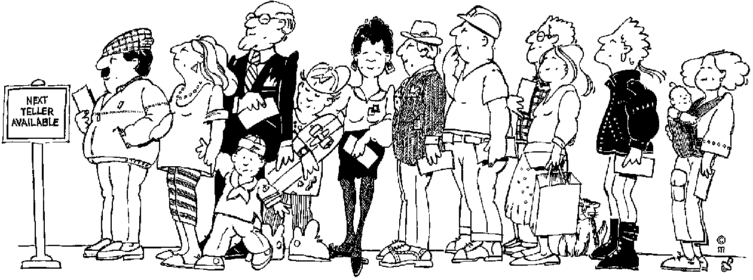
Geographic factors: where do they live? If our business is in Gauteng, getting information from people in Cape Town will not help us at all
Age: which age group should we target?
Income bracket: what should their earning be?
Gender: male or female or both?
Community and cultural beliefs: how will this influence our survey?
If you need more information about population groups and samples, you can contact
The government statistical services and
the Department of Trade and Industry who will be able to give you information regarding the population segments according to the above criteria.
In order to find out how big your sample size should be (how many people you should question) you must first determine how many responses (completed questionnaires) you will need for the analysis.
A general rule is to look for about 20-30 responses in each of the major sub-categories for the sample. For example, if a key aspect of your research is to compare male and female then you should look for about 30 females and 30 males in your responses.
Once you know how many responses you want, 60 per the above example, you have to find out how many questionnaires you have to send out. Usually, about 20% of the people will reply to the questionnaire. This means that you then have to send out about 300 questionnaires to get 60 responses (people replying to your questionnaire)
On the other hand, if you are going to interview your customers by telephone or face-to-face, you will need less questionnaires.

Decide How To Collect Replies
Now you have to decide the following:
Are you going to mail the questionnaire
Are you going to send the questionnaire by e-mail
Are you going to phone customers
Are you going to question customers face-to-face


If you are going to conduct the survey by means of telephone or face-to-face interviews, you have to decide who will do the interviews and how you will control the quality of the interviews. Remember, if you do not do this yourself, people can lie about how many interviews they conducted and what the response of the people they interviewed were.
It will also be important for the interviewer to explain to the potential respondent why they should answer the questions. They should persuade people to take part in the survey, not force them.

Questionnaire Design
Most researchers make the mistake of asking too many questions. Your greatest enemy in survey research may well be poor response rate. Clear and concise questionnaires can help get the best response.
Design of the questionnaire can be split into three elements:
Determine the questions to be asked
Select they question type for each question type and specify the wording
Design the question sequence and overall questionnaire layout

Determine the Questions to be Asked
Obviously, your questions should relate directly to the aim of the survey and to the specific information that you will require.

Decide on layout and sequence
Do not clutter up the form with unnecessary headings and numbers.
Include the contact and return information on the questionnaire, irrespective of whether addressed return envelopes are provided, these can easily become separated.
Identify individual questions for reference purposes.
Be careful not to overfill the page.
Avoid using lots of lines, borders and boxes since these can make the page look too ‘dense’.
Small fonts may put people off, especially people with bad eyesight.
Use a good legible font.
Make good use of italics and bold types, think of using italics consistently to give instructions.
Consider using bold for the questions themselves or for headings. Symbol fonts may also be useful.
Begin with questions that will raise interest.
You should try to keep the flow through the questionnaire logical and very simple, i.e. avoid any complex branching.

Question types
Open-ended Questions: E.g. Do you think football hooliganism is caused by: (tick if appropriate)
Lack of discipline at home
Players’ behaviour on pitch
Family breakdown
Youth unemployment
Poor schooling
Violence on T.V.
Other (please specify)
Single vs. Multiple Response: E.g. What is your most usual means of travelling to college?
Bus
Car
Bike

Rated Response: A popular approach in the social science is to use Likert scales such as the example below.
Please state how often you use the following: (Please circle the numbers as appropriate)
 | Very often | Often | Occasionally | Never
Newspapers | 1 | 2 | 3 | 4
Books | 1 | 2 | 3 | 4
Periodicals | 1 | 2 | 3 | 4

Wording of questions
When you compile a questionnaire, think carefully how you phrase the questions that you are going to ask the people out there. You have to phrase the questions in such a manner that the people who complete them must:
Be able to understand the question
Be able to answer the question
Be willing to give you the information you need
You also have to ensure that the questions and the way you ask them cannot be constituted as biased in any way, e.g. biased based on race, gender, age, religion, culture, etc.

Formatting
Most survey forms begin with a brief statement of introduction to announce the survey, request participation, assure confidentiality (if appropriate), and indicate how to return the survey form. A letter of introduction is included with mailed survey forms although sometimes introductory letters are used in other settings as well.
The important part of the survey form usually includes the questions or statements to which respondents must react. In practice, most questionnaires place demographic questions (gender, age, racial group) first but some researchers argue that demographics should be placed last to avoid boring people with dull background questions at the beginning of the survey.
Next, questions that rely on the same sort of response mode (multiple choice, true and false) are grouped together. Each section should be preceded by instructions for completing the items. Some researchers recommend that questions that deal with the same issue should be grouped together. However, this ordering sometimes creates bias in response as people may try to respond in ways that are consistent with early statements on the survey. For example, suppose I ask you to evaluate the quality of teaching in statistics classes and at a later point ask you to state what you believe are the most important needs at your place of work. It is quite likely that you will mention the quality of teaching as being one of the important needs.
Although you can’t avoid the effect of question order, you should attempt to estimate what the effect will be. This will allow you to interpret results in a meaningful fashion. If the order of questions seems an especially important issue, you might prepare more than one version of the questionnaire where each contains different ordering of questions.
The correct length for a questionnaire almost always poses a problem for researchers. In general, brief questionnaires are preferred to lengthy ones but sometimes you may have to prepare long questionnaires.

Run A Pilot Survey
Test the questionnaire on a small sample of your subjects first. If this is not possible at least test it on some colleagues or friends. The aim here is to detect any flaws in your questioning and correct these prior to the main survey.
Having done your pilot survey, you can make amendments that will help to maximise your response rate and minimise your error rate on answers.

Carry Out The Main Survey
The purpose of doing a pilot survey is to find out if you have to change anything in the questionnaires or in your population sample or even the aim of your survey.
If you are using fieldworkers, you have to ensure that they are well trained to minimise errors in the collecting of data.
Errors when choosing respondents
Interviewer dishonesty
Misinterpreting or misreporting of information
Non responses: where people are not at home or refuse to answer questions
For the process of actually doing the market research, you also have to
Set deadlines: start on a specific day and end on a specific day
Determine the number of questionnaires you want to complete by that day
If you employ field workers, how many questionnaires every day and how many at the end of the period
You have to put an administrative process in place: who is going to collect the completed questionnaires?
You must also have a quality and cost control system in place to prevent dishonesty and prevent fieldworkers from charging too much and wasting too much time. You could, for xample, pay per correctly completed questionnaire.

REPRESENT, ANALYSE AND INTERPRET DATA

Outcome
Represent, analyse and interpret data using various techniques to investigate real-life and work problems

Assessment criteria
- Graphical representations and numerical summaries are consistent with the data, are clear and appropriate to the situation and target audience
- Different representations of aspects of the data are compared to take a position on the issue
- Calculations and the use of statistics are correct and appropriate to the problem
- Interpretations of statistics are justified and applied to answer questions about the problem
- New questions that arise from the modelling of the data are discussed

Analyse The Data
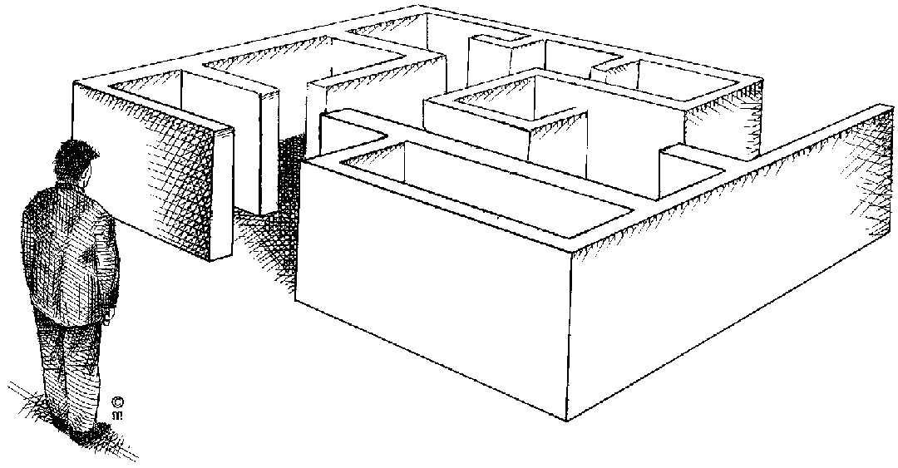
Now you have all the information, you have to do something with it: analyse the information. The only reason you went to all the trouble of conducting market research is that you want information, so that you can analyse the information and use it for the benefit of your new venture.
Once you have all the information, you have to organise it, summarise it and simplify the information so that you can make sense of it.
The easiest would be to prepare a document that lists all the questions. You then count all the answers and add the totals to the document. If we use the questions from a previous Formative Assessment:

Do you play computer games? | Yes | 1450 | No | 550
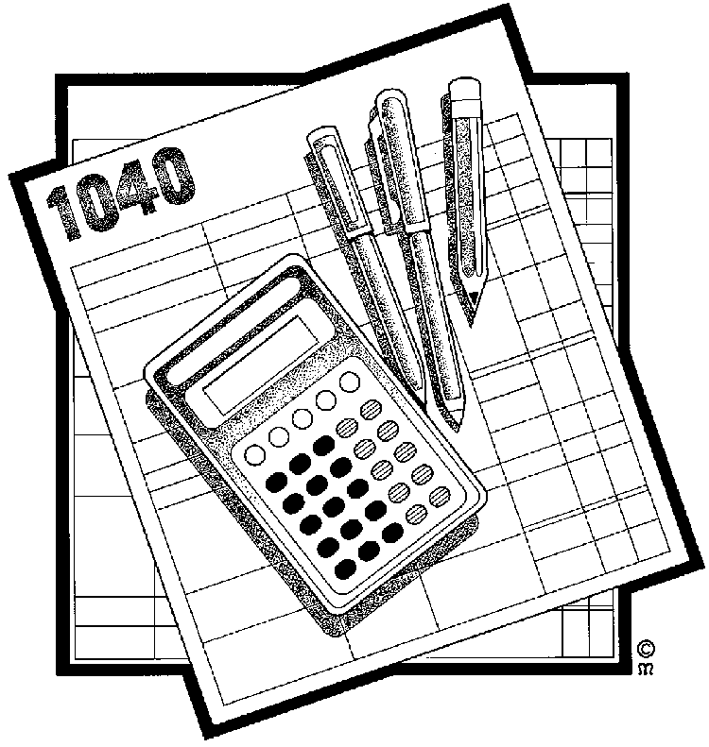
Now you can calculate a percentage of the sample: who plays computer games and therefore might be interested in buying a new game.
Total questionnaires received: 2000
Total Yes 1450 percentage of sample: 72%
Total No 550 percentage of sample 18%

This means that, of the people who took part in the market research, 72% do play computer games.

Exercise 4
Analyse the responses for the following questions:
Why do you use a taxi to and from work | Cheap | 1631
Why do you use a taxi to and from work | Fast | 1091
Why do you use a taxi to and from work | Safe | 312
Why do you use a taxi to and from work | Convenient | 1849
If you sent out 2000 questionnaires, what percentage of the sample use taxis because they are cheap, what percentage use taxis because they are fast, what percentage use taxis because they are safe and what percentage use taxis because they are convenient?
Cheap
Fast
Safe
Convenient

Which taxi route do you use every day? | Route A | 755
Which taxi route do you use every day? | Route B | 830
Which taxi route do you use every day? | Route C | 415
What percentage uses Route A, Route B and Route C?
Route A
Route B
Route C
You would do this for all the questions.
On the basis of the above information, you can now make a decision as to whether there is actually place in the market for a new taxi service, or whether your improved service will satisfy a need with the customers.

Measures of centre and spread

Describing data
Tables organize data and graphs present a clear overall picture of the distribution and spread of the data. However, I want to be able to describe the data in specific detail. I want to say that the centre of the data is ‘here’ and it has a spread ‘this large’.
This section shows us how to calculate the centre of any distribution of values and to tell how spread the values are from the centre.
In general, the set of numbers used in this section is kept to a minimum. The techniques described, however, work on any number of items. A smaller set of numbers allows the principles to be demonstrated by hand or with a calculator. A large set of numbers would just become an exercise in concentration and patience, unless of course, you are using a computer to do the work for you.

Measuring centre or average
I have a lot of data that I’ve collected and I would like to represent that data by one number: its centre. I want to know the average value of my data.
It turns out that if there isn’t just one way of measuring the centre of my data but there are many ways to do so. All are correct and all are used for different reasons. But the most commonly used methods are the mean, the median and the mode. In statistics-talk these are three ‘measurements of central tendency’.

Calculating centres and averages
When calculating centres and averages we are trying to determine where the middle of the data are. There are three main methods used for calculating the centre of data: mean or average, mode and median.

Calculating the mean or average
The arithmetic mean is the average we all know and use: add up all the numbers and divide by their count (how many there are).
The mean of the following 5 numbers: 8, 3, 12, 5 and 10 is:

The ‘5’ under the line (in the denominator) is the number of items or the count of items and has nothing to do with the value ‘5’ above the line (in the numerator).
If I had 50 numbers I would add all 50 numbers together and divide by 50.
When do we use it? Suppose, for example, that at a party there are ten people aged 14, 15, 16, 14, 15, 16, 16, 15, 60, and 65 respectively. The mean of these ages is 24.6 which are not at all typical of the people at the party. A better statistic would be a median.

Calculating the mode
The mode is simply the number that occurs most frequently.
The mode of this sequence of numbers (2, 2, 5, 7, 9, 9, 9, 10, 10, 11, 12 and 18) is 9. The number ‘9’ occurs the most number of times. This set of numbers is call ‘unimodal’ because it has one mode. (The set of numbers used to calculate the mean has no mode because all numbers occur the same number of times.)
The following sequence of numbers (2, 3, 4, 4, 4, 5, 5, 7, 7, 7 and 9) has two modes and is called ‘bimodal’.
If a set of numbers has more than two modes the set is called ‘multimodal’.
Mode is used if you have the same number occurring so frequently in a set of data that it can be regarded as the typical item. Suppose, for example that members of a group are asked to contribute to a gift for another person, and the contributions are
R1, R1, R2, R100, R100, R0.50, R2, R1, R1, R100, R100, R100.
This set of data can be described well by saying that the majority of people each contributed R100.
The mode is useful when dealing with nominal data (grouped data) like eye colour or ordinal data (ordered data) like shoe sizes. The mode is the value occurring most frequently. The shoe salesperson might have the following range of shoes with the associated number of sales during one month as shown in
The mode is the most useful measure of the centre of this data: size 10½. The salesperson now has an idea of the most common shoe size. To look at it another way: if I averaged the shoe sizes and told the salesperson the average shoe size you sold this month is 9¼, do you think this ‘statistic’ is meaningful? I don’t!
As an exercise in visualizing a table of data, imagine the previous data plotted as a distribution or histogram. Can you visualize the distribution? Frequency or relative frequency distributions are most commonly displayed in histograms. The ages that were displayed in the pyramid diagram are two histograms placed back to back.

Shoe sizes and quantity sold

Histograms look like bar charts but they are different.
Histograms may only be construction of data on an interval/ratio scale (age, length, height). Divide the range of data into classes of equal width. In the example dealing with ages, groups were formed of people with ages in five-year intervals (0-4, 5-9, 10-14). You must ensure that the classes are precisely specified and no data can fall into more than one class.
Count the number of observations in each class. These counts are the frequencies of the classes.
Draw the histogram remembering to keep the data scale horizontal and the frequency scale vertical. Each bar represents a class. The base of the bar covers the class and the bar height is the class frequency. A histogram is drawn with no horizontal space between the bars unless a class is empty (has zero height).
Bars in a histogram are vertical and the base scale is marked off in equal units. Bars in bar charts may be vertical or horizontal and there is no base scale. In other words, I may use any type of scale in a bar chart although nominal or ordinal scales are the most commonly used.
The widths of the bars in a histogram have meaning. The base of each bar covers a class (interval) of values and the height represents the class frequency. The widths of bar charts have no meaning but they should all be the same so that they do not confuse or deceive you.
The bars in a histogram touch each other unless there is a class with no entries. The bars cover an entire range of values. Even when the values of a variable have gaps between them, we extend the bases to meet halfway.
Remember that our eyes and brains respond to the area of the bars in a histogram. Therefore, all the widths must be equal, just like in a bar chart and for the same reason: so that they do not confuse or deceive you.

Calculating the median
The median is the middle value of the set of sorted values. Note that the data must be sorted before you can calculate the median by hand. A calculator or computer automatically sorts the set of numbers before calculating the mean.
When we calculate the median we are not concerned with the values of the set of data but rather the position of each number in the sorted order. This is important so pay attention.
There are two separate problems with calculating the median: an odd number of data values and an even number of data values.
For an odd number of data values (3, 4, 4, 5, 6, 8, 8, 8 and 10) select the middle value: 6. If you look at this data set you will see that there are four values below (smaller value) and four values above (larger value) 6. Therefore, 6 is the median.
For an even number of data values (5, 5, 7, 9, 11, 12, 15 and 18) take the average of the middle two values. In this case the median is 10. That is ½(9 + 11) = 10. The values 9 and 11 are the middle two values because they each have three values below and three values above them. Just average the middle two numbers.

Exercise 5
Follow the steps as detailed
mean = average
Find the mean, median, and mode for the following list of values: 13, 18, 13, 14, 13, 16, 14, 21, 13
The mean is the usual average, so:
(13 + 18 + 13 + 14 + 13 + 16 + 14 + 21 + 13) ÷ 9 = 15
Note that the mean isn't a value from the original list. This is a common result. You should not assume that your mean will be one of your original numbers.
The median is the middle value, so I'll have to rewrite the list in order:
13, 13, 13, 13, 14, 14, 16, 18, 21
There are nine numbers in the list, so the middle one will be the (9 + 1) ÷ 2 = 10 ÷ 2 = 5th number:
median = middle
13, 13, 13, 13, 14, 14, 16, 18, 21
So the median is 14.
The mode is the number that is repeated more often than any other, so 13 is the mode.
mean: 15
median: 14
mode: 13

Find the mean, median, and mode for the following list of values: 1, 2, 4, 7
The mean is the usual average: (1 + 2 + 4 + 7) ÷ 4 = 14 ÷ 4 = 3.5
The median is the middle number. In this example, the numbers are already listed in numerical order, so I don't have to rewrite the list. But there is no "middle" number, because there are an even number of numbers. In this case, the median is the mean (the usual average) of the middle two values: (2 + 4) ÷ 2 = 6 ÷ 2 = 3
The mode is the number that is repeated most often, but all the numbers appear only once. Then there is no mode.
mean: 3.5
median: 3
mode: none
The list values were whole numbers, but the mean was a decimal value. Getting a decimal value for the mean (or for the median, if you have an even number of data points) is perfectly okay; don't round your answers to try to match the format of the other numbers.
Find the mean, median, and mode for the following list of values: 8, 9, 10, 10, 10, 11, 11, 11, 12, 13
The mean is the usual average: (8 + 9 + 10 + 10 + 10 + 11 + 11 + 11 + 12 + 13) ÷ 10 = 105 ÷ 10 = 10.5
The median is the middle value. In a list of ten values, that will be the (10 + 1) ÷ 2 = 5.5th value; that is, I'll need to average the fifth and sixth numbers to find the median: (10 + 11) ÷ 2 = 21 ÷ 2 = 10.5
The mode is the number repeated most often. This list has two values that are repeated three times.
About the only hard part of finding the mean, median, and mode is keeping straight which "average" is which. Just remember the following:
mean: regular meaning
median: middle
mode: most often

Summarising Data
The purpose of this section is to revise the calculation of averages by using mean, mode and median and also to give examples of when each average is appropriate.
There are often situations in which it is useful to summarise a whole set of data by describing it with a single number. The sum of a set of numbers can be used to summarise data (e.g. the total mass of the pack of rugby forwards is an indication of the possible power of a rugby team).
The total is not always a useful summarizing number, however. Suppose we wish to compare the heights of men and women in a group. The totals cannot be used for the data given because there are different numbers of men and women.
Height of 10 year olds(m) | 1.76 | 1.77 | 1.8 | 1.66 | 1.6 | 1.79 | 1.8
Height of 9 year olds(m) | 1.69 | 1.7 | 1.5 | 1.42 | 1.42 | 1.75 | 1.67 | 1.62 | 1.6

Although the total for the 9 year olds (14.37 m) is higher than the total for the10 year olds (11.12 m), when we consider individual heights it seems that 10 year olds are typically taller than 9 year olds.
What we actually need is a single number which is typical or representative of the heights of individual 9 year and 10 year olds. One such a number is the arithmetic mean or average.

Mean
Arithmetic mean = (sum of cases)/total number of cases
- Mean height of men = 11.12/7 = 1.59
- Mean height of women = 14.37/9 = 1.6

Median
Median is the middle value in a spread of values arranged in order from the lowest to the highest.
The median of an even number of items is the mean of the two middle items when the items are arranged according to size.
The median of an odd number of items is the middle item when the items are arranged according to size.
When do we use it? Suppose, for example, that at a party there are ten people aged 14, 15, 16, 14, 15, 16, 16, 15, 60, and 65 respectively. The mean of these ages is 24.6 which are not at all typical of the people at the party. A better statistic would be a median.

Mode
When numbers occur frequently in a set of data, the number occurring most frequently is the mode. This is used if you have the same number occurring so frequently in a set of data that it can be regarded as the typical item. Suppose, for example that members of a group are asked to contribute to a gift for another person, and the contributions are
R1, R1, R2, R100, R100, R0.50, R2, R1, R1, R100, R100, R100.
This set of data can be described well by saying that the majority of people each contributed R100.
For each set of data (information) that you have collected, you will have to decide which of the three statistics (mean, mode, and median) will give you the best description of the data.

Exercise 6
In a group, do the following: In each case state which of the three statistics is not an appropriate description of the given data. Order the data and draw a histogram of the data to see how it is distributed. If it is evenly distributed, the mean is most probably the best summary. If not, consider the median. If there are many occurrences of the same value, consider using the mode.
5 7 2 3 8 1 5 2 6
6 2 9 0 3 2 0 2 1 3 1 0 2
21 30 14 5 16 24 17 3 29

Using centres and averages
For each set of data (information) that you have collected, you will have to decide which of the three statistics (mean, mode, and median) will give you the best description of the data.
The mode is useful when dealing with nominal data (grouped data) like eye colour or ordinal data (ordered data) like shoe sizes
We now know how to calculate the mean, mode and average but we must still learn how and when to use them. Although the mode is very important in many real life situations it is not used that often in statistical calculations. In many situations the mode is not useful at all because there is no mode. The median is used more frequently than the mode because it is able to describe the data set with more flexibility. The median is also easily understood. The mean, or average, is the most commonly used measure of the centre of a set of data because it is backed by statistical theory. Let’s now see these different ways of measuring the centre of data in action.
Assume that I am the owner of a sporting body and I employ twelve sportsmen (or sportswomen). The annual salaries of each sportsman (sportswoman) are as follows:
- six receive R200,000
- four receive R400,000
- one receives R800,000
- the superstar receives R2,400,000
- What is their average salary?
- If I used the mode to calculate the average salary it would be R200,000 because this value occurs with the highest frequency (6 times).
- If I use the median I must first order the salaries as shown in the table and then determine the middle value:

Order | Salary
1 | R200,000
2 | R200,000
3 | R200,000
4 | R200,000
5 | R200,000
6 | R200,000
7 | R400,000
8 | R400,000
9 | R400,000
10 | R400,000
11 | R800,000
12 | R2,400,000.

There are an even number of entries (12) so I must obtain the average of the middle two values (R200,000 and R400,000) and indicate that the median is R300,000.
If I use the average (mean) I must sum all the salaries and divide by the number of players which is R500,000 (R6,000,000 divided into 12 players).
Which is the best number to use for the average salary?
The mode indicates that the highest frequency and most players receive R200,000. This number just doesn’t seem right to me even though half the players receive this salary and the other half receive more.
The average produces R500,000. No player receives this amount but then it is an average. However, 10 players receive less that R500,000 and only two receive more. Again, this just doesn’t look right to me.
The median also produces a value that no player receives but at least half the players receive less than this amount and half receive more than this amount. This is the middle of the road average so I would agree with it. As a matter of fact, if the superstar was paid R24,000,000, this measurement of the centre (R300,000) would not change and I would still have half of the players being less and half being paid more. However, if I used the average (mean) I would find that the average salary would be R2,300,000!
The median is a good choice to use for the central value when the distributions are skewed to the right or to the left. Salaries are almost always skewed to the right (very few people obtain very high salaries while most of the workers receive salaries that are on the lower end.) Note that the median value always has half the values on one side and half the values on the other side. There is always a middle value that exists or is the average of the two centre values. The values don’t matter, only their positions when sorted matter.
When the distribution of values is more or less symmetrical and there are no outliers, then the average or mean is the best value to use for the centre of the data set.
Values that skew the distribution of values of the data affect the mean or average, sometimes dramatically. If I did pay my superstar R24,000,000 and advertised that my average salary bill is R2,300,000, the other 11 players would be at my door asking why their salary is so low!

Frequency distribution and range
When you are drawing a chart or graph, you will need the frequency distribution and range of the information in order for the graph or chart to make sense.
The range is defined as the difference between the largest and smallest values in the data set.

The range is one measure of the spread of a set of data. If the range is very large we may expect the values in the data set to be spread widely.

Definitions
Frequency distribution: where you arrange (distribute) data in some kind of order. A frequency distribution tells you how often certain numbers or values occur.
Population: The objects we are busy investigating (in the example on the next page, the learners in this class)
Range: The difference between the lowest and highest items in a set of data is called the range of the data set.

Exercise 7
Use the names of learners in your class and the number of children they have to complete the table:
Names of Learners in your class | Number of Children
Names of Learners in your class | 1 | 2 | 3 | 4 | 5 | 6
1
2
3
4
5
6
7
8
9
10
11
12
13
14
15
16
17
18
19
20
21
22

We would like to indicate how many learners (number of cases) fall within the class intervals.
The class intervals range from 0 – 1children, 2 – 3 children etc.

Class Interval | Tally (number of learners who have 0-1 children or 2 to 3 children for example) | Number of children (total number of children in this interval)
0 - 1
2 - 3
4 - 5
6 and more
TOTAL:

Calculate the range of the data set – remember, range is the largest minus the smallest

Quartiles
‘What! Five more things to learn?’ No, you already know them but you don’t know you know them!
Three of the numbers are already familiar to you: minimum value, maximum value and the median. The minimum and maximum values are used to calculate the range, so you know them. The median is the middle-most number in the data set and divides the data set into two separate but equal sizes of data: 50% of the values are above the median and 50% of the values are below the median.
Now take each half and divide it in half again (find the median of each half). What do we have? With the lower half of the data, we have the values that fall below (and above) 25% of the data and with the upper half of the data, we have the values that fall above (and below) 75% of the data.
When we calculate the median of the lower and upper half of the data set we calculate the ‘lower quartile’ and ‘upper quartile’ of the data. We also have the last two numbers of our five-number summary.

The ‘lower quartile’ (lower quarter point) is also called the ‘25th percentile’ or the ‘1st quartile’ or just Q1: 25% of the data fall below this value.
The ‘upper quartile’ (upper quarter point) is also called the ‘75th percentile’ or the ‘3rd quartile’ or just Q3: 75% of the data fall below this value.
The median is also called the ‘50th percentile’, the ‘2nd quartile’ or just Q2: 50% of the data fall below this value.The minimum and maximum values are often called Q0 and Q4, respectively
The five-number summary consists of Q0, Q1, Q2, Q3 and Q4 (minimum, 1st quartile, median, 3rd quartile and maximum values). I told you that you knew five-number summary, didn’t I?
You may also run across a few other terms in addition to quartiles. Quartiles divide your data set into 4 equal sized groups of data. ‘Deciles’ divide your data set into 10 equal sized groups of data. ‘Percentiles’ divide your data into 100 equal sized groups of data.
It’s a lot easier to work in percentiles. Just remember that the 10th percentile is the 1st decile and the 25th percentile is the 1st quartile. It also comes in handy to remember that the median is the 50th percentile and the 2nd quartile.
As an example, if you have 1000 values in a data set you must first sort the data before dividing it up into percentiles, deciles or quartiles. Create the 100 percentiles by putting 10 values into each percentile; deciles by putting 100 values into each decile and quartiles by putting 250 values into each quartile. Remember to start at the minimum value and put the number of items sequentially into each centile, decile or quartile.
I chose 1000 items in the previous paragraph for ease of grouping the data but data just does not come in easy to handle packets. So I’m going to show you how to calculate percentiles. When you can do this you can then calculate any percentile for any sized set of data.

Calculating percentiles
Remember that you are working with a sorted list of data values and must work with the position of the data as well as with the values. The i^{th} percentile, p_{i}, is defined as:
The 10th percentile may be represented as p₁₀ or d₁ to indicate the 10th percentile or the 1st decile; the 25th percentile may be represented as p₂₅, q₁ or Q1; the median is the 50th percentile and may be represented by p₅₀, d₅, q₂ or Q2.
The table has 20 values in its data set and they are numbered and sorted.
Number | Value
1 | 15
2 | 17
3 | 17
4 | 18
5 | 18
6 | 18
7 | 19
8 | 19
9 | 20
10 | 20
11 | 20
12 | 21
13 | 22
14 | 23
15 | 24
16 | 29
17 | 32
18 | 33
19 | 33
20 | 41

Example data for calculating percentiles, deciles and quartiles

Example 1: Q1, 1st quartile or 25th percentile
In order to calculate the first quartile (25th percentile) we just use the equation and insert the correct number to obtain the correct element to choose.
The value returned is not a whole number so split it into two pieces 5 and 0.25.
The 5th value in the table is 18. The value 0.25 means that Q1 is 0.25 times the distance between the 5th and the 6th entry. So we have to calculate this value:
5.25th item = 5th item + 0.25×(6th item – 5th item) or
Q1 = 18 + 0.25×(18 – 18) = 18
Therefore, the 1st quartile or Q1 is 18. This also means that 25% of the values are 18 or lower.

Example 2: Median, 2nd quartile or 50th percentile
In order to calculate the median or the 2nd quartile we just use the same formula but put in different values.
The value returned is not a whole number so split it into two pieces 10 and 0.5.
The 10th item in the table is 20. The value 0.5 means that the median is 0.5 times the distance between the 10th and 11th entry. So we have to calculate this value: 10.5th item = 10th item + 0.5×(11th item – 10th item).
Therefore the median = Q2 = 20 + 0.5×(20 – 20) = 20.
Therefore, the median is 20. This also means that 50% of the values are lower than 20.

Example 3:, 3rd quartile or 75th percentile
In order to calculate the median or the 3rd quartile we just use the same formula but put in different values.
The value returned is not a whole number so split it into two pieces 15 and 0.75.
The 15th item in the table is 24. The value 0.75 means that the median is 0.75 times the distance between the 15th and 16th entry. So we have to calculate this value: 15.75th item = 15th item + 0.75×(16th item – 15th item).
Therefore the median = Q3 = 24 + 0.75×(29 – 24) = 27.75.
Therefore, the 3rd quartile or Q3 is 27.75. This also means that 75% of the values are lower than 27.75.

Example 4: 80th percentile
In order to calculate the 80th percentile we just use the same formula but put in different values.
The value returned is not a whole number so split it into two pieces 16 and 0.8.
The 16th item in the table is 29. The value 0.8 means that the p₈₀ is 0.8 times the distance between the 16th and 17th entry. So we have to calculate this value:
16.8th item = 16th item + 0.8×(17th item – 16th item)
or
p₈₀ = 29 + 0.8×(32 – 29) = 31.4
Therefore, the 80th percentile is 31.4. This also means that 80% of the values are lower than 31.4.
In order to represent this data set with the five-number summary we may use: Q0 = 15, Q1 = 18, Q2 = 20, Q3 = 27.75 and Q4 = 41. We may also call the five-number summary by several different names that all mean the same thing.

I would like to leave this section with a small word of caution. The technique of calculating percentiles shown in this module is one of six methods in use.
If you obtain slightly different answers from a calculator or a computer remember this and don’t be shocked. If you are really curious, the six methods are:
1. Weighted average at Xnp method. (Weighted average centered at Xnp)
2. Weighted average at X(n+1)p method. (Weighted average centered at X(n+1)p)
3. Empirical distribution function method
4. Empirical distribution function with averaging method
5. Empirical Distribution Function with Interpolation with Percentile Method
6. Closest observation method.
This manual uses method 2 to calculate percentiles but Microsoft Excel and Open Office Calc use method 5. If you use either of these programs with the same data set you will obtain Q3 = 25.25 instead of 31.4.
For this data set all six methods give the same values for Q1 and the median but Q3 differs: methods 1, 3 and 6 produce 24; method 2 produces 27.75; method 4 produces 26.5; and, method 5 produces 25.25.

Graphical Representation Of Data

Determining Trends Using Statistics
We determine and identify trends in regarding issues that affect our society, such as
- crime and health;
- relevant characteristics of targets such as age, range, gender, socio-economic , cultural belief and performance;
- and the attitudes or opinions of people on issues by doing research as indicated and then by interpreting this information statistically.
Once we have the data we look at common grounds and averages to determine these trends.
The aim of statistics is to provide insight by means of numbers. In order to achieve this we must collect numbers that are valid in the sense of being both correct and relevant to the issue at hand.
Once you have analysed the information, you will want to present it in such a way that everyone understands the information.
Data are presented in tables and graphs. This section covers some simple ways to represent data in graphs and to begin seeing how these numbers are distributed. The ‘distribution’ of a variable simply describes the values the variable takes on and how often each value occurs.
We want to use our knowledge of statistics to communicate facts and to support decisions. Data, like words, need to be organized in order to tell us anything useful. Tables of data are usually very large and I believe the best place for them is in a computer storage device or in an archive somewhere. I may need to get at these data for some or other reason but I don’t want their volume to confuse me. I like simple things that I can understand.

Displaying data
I am going to start off with a table of data, taken from the 2001 census and published by Stats SA.

Language | Male | Female | Total
Afrikaans | 2,900,214 | 3,083,212 | 5,983,426
English | 1,772,483 | 1,900,720 | 3,673,203
IsiNdebele | 342,366 | 369,455 | 711,821
IsiXhosa | 3,726,376 | 4,180,777 | 7,907,153
IsiZulu | 5,045,450 | 5,631,855 | 10,677,305
Sepedi | 1,987,170 | 2,221,810 | 4,208,980
Sesotho | 1,704,071 | 1,851,115 | 3,555,186
Setswana | 1,774,785 | 1,902,231 | 3,677,016
SiSwati | 571,429 | 623,002 | 1,194,431
Tshivenda | 482,134 | 539,623 | 1,021,757
Xitsonga | 1,001,446 | 990,761 | 1,992,207
Other | 126,117 | 91,175 | 217,292
Total | 21,434,041 | 23,385,736 | 44,819,777
First home language by gender: South Africa, 2001
This table lists the languages along with the number of people, grouped by gender, who use this language as their home language. Look at the table. It contains a few very important details.
Firstly, a table is made up of rows and columns. The rows extend horizontally across the page and the columns extend vertically down the page. Secondly, the table has a caption that describes the contents of the table. In this case the caption is below the table while in other cases the caption may be above the table. This table has a total column as its last row that may or may not appear in other tables. Thirdly, each column is labelled (Language, Male, Female and Total) so that you know what is in each column of data.
A table is pretty simple. It lists data in rows and columns and you can find the information you are looking for by going to either the row or columns of interest and looking either across or down. The intersection of the row and column (where they cross) is the data you require. In this example, if I want to find out how many people reported that they speak a home language that is not one of the official nine languages, I would look in the row called ‘Other’ and read the number to its right in the ‘Total’ column: 217,292.

Frequency tables
One of the first things to do when organizing a set of data is usually to count how often each value occurs. Stats SA kindly did this for us and presented the data in the form of a table
Because rates or proportions are often more useful than totals, we calculate these and display them per the table on the next page.
The technique used to create a table of proportions or ratios is simple but can become a little tedious without a calculator or a computer program to do it for you. If you are doing this by hand, that is, actually dividing the numbers, you will probably make a few mistakes. So check your work again.

 | Male | Female | Total
Afrikaans | 0.14 | 0.13 | 0.13
English | 0.08 | 0.08 | 0.08
IsiNdebele | 0.02 | 0.02 | 0.02
IsiXhosa | 0.17 | 0.18 | 0.18
IsiZulu | 0.24 | 0.24 | 0.24
Sepedi | 0.09 | 0.10 | 0.09
Sesotho | 0.08 | 0.08 | 0.08
Setswana | 0.08 | 0.08 | 0.08
SiSwati | 0.03 | 0.03 | 0.03
Tshivenda | 0.02 | 0.02 | 0.02
Xitsonga | 0.05 | 0.04 | 0.04
Other | 0.01 | 0.00 | 0.00
Total | 1.00 | 1.00 | 1.00
The basic idea of creating a proportion of a ratio is to divide the individual value by the total value. In the case of our example, the totals are already given, so you probably won’t have to calculate them again. Or should you? Ensuring your data is correct is called ‘internal consistency’.

Exercise 8
Do the calculations that follow
I’ll show you the calculations for the first three languages for ‘Male’, ‘Female’ and ‘Total’ in order to show you how easy it is to do.
Male:

Female:

Total:
If you check the results shown in the table from Stats SA, by summing each column you will find that the sums are 1.01, 1.00 and 0.99 for the ‘Male’, ‘Female’ and ‘Total’ columns. What happened? The arithmetic is correct but when I rounded the fractions to two decimal places, a little precision was lost. These errors are called ‘round-off errors’ or ‘rounding errors’ and they will be with us any time we round numbers. You’ll get used to it!
The ‘frequency’ of any value of a variable is the number of times that value occurs in the data. A frequency is a count.
The ‘relative frequency’ of any value is the proportion or fraction or per cent of all observations that have that value.
In the example above, the total number of South Africans who use Afrikaans as a first language is 5,983,426. This is a frequency because it’s a count of something: first language Afrikaans speakers.
The relative frequency is usually expressed in decimal form and in this case is 0.13. However, we could just as well express this value as a percentage (13%). Remember that 1% is or 0.01. A number in decimal form can be changed to a percentage by moving the decimal point two places to the right. (This is the same as multiplying the decimal form by 100 and putting a per cent sign, %, behind the result. ‘Per cent’ means ‘by 100’ or ‘per 100’,)
Frequencies and relative frequencies are a very common way of summarizing data when a nominal scale is used (gender, responses on questionnaires, eye colour).
In fact, it is such a handy way of summarizing facts that it is often used with an interval/ratio scale. In this case, we artificially group items and then count how many items fall into each group.
In this example, again taken from the census figures of Stats SA, we are looking at the age of a person. Age is measured on an interval/ratio and is a continuous value.

The table below shows the actual values of the age of all South Africans grouped into five years age groups. The table also displays the percentage of each age group. Note that the column totals do not sum to 100%. I only used three decimal figures to calculate the results in order to demonstrate the potential problems with round-off errors.

Age | Male | % | Female | % | Total | %
0-4 | 2,223,731 | 10.3% | 2,226,085 | 9.5% | 4,449,816 | 9.9%
5-9 | 2,425,804 | 11.3% | 2,427,751 | 10.3% | 4,853,555 | 10.8%
10-14 | 2,518,956 | 11.7% | 2,542,961 | 10.8% | 5,061,917 | 11.2%
15-19 | 2,453,079 | 11.4% | 2,528,642 | 10.8% | 4,981,721 | 11.1%
20-24 | 2,099,293 | 9.7% | 2,195,230 | 9.3% | 4,294,523 | 9.5%
25-29 | 1,899,124 | 8.8% | 2,035,814 | 8.7% | 3,934,938 | 8.7%
30-34 | 1,594,488 | 7.4% | 1,746,412 | 7.4% | 3,340,900 | 7.4%
35-39 | 1,441,507 | 6.7% | 1,630,264 | 6.9% | 3,071,771 | 6.8%
40-44 | 1,233,632 | 5.7% | 1,385,832 | 5.9% | 2,619,464 | 5.8%
45-49 | 967,604 | 4.5% | 1,119,776 | 4.7% | 2,087,380 | 4.6%
50-54 | 769,499 | 3.5% | 868,521 | 3.7% | 1,638,020 | 3.6%
55-59 | 552,323 | 2.5% | 652,943 | 2.7% | 1,205,266 | 2.6%
60-64 | 444,510 | 2.0% | 620,784 | 2.6% | 1,065,294 | 2.3%
65-69 | 304,763 | 1.4% | 483,164 | 2.0% | 787,927 | 1.7%
70-74 | 232,547 | 1.0% | 398,922 | 1.7% | 631,469 | 1.4%
75-79 | 136,436 | 0.6% | 231,101 | 0.9% | 367,537 | 0.8%
80-84 | 90,835 | 0.4% | 180,111 | 0.7% | 270,946 | 0.6%
85+ | 45,907 | 0.2% | 111,425 | 0.4% | 157,332 | 0.3%
Total | 21,434,038 | 99.1% | 23,385,738 | 99.0% | 44,819,777 | 99.1%

Age distribution and ratio in five-year intervals by gender: South Africa 2001

Graphing data
Graphs, like tables, should be clearly labelled to show the variables that are being presented and the units being used. There are three things to remember when putting data in a graph:
Make your data stand out
Avoid clutter on the graph
Use visual perception to get the facts to others.
An excellent example of a graph is shown in one the next page. This graph is the one Stats SA distributed with the age information in the previous example.
The impact of this graph along with its clarity of presentation is striking. This type of graph is called a pyramid or butterfly graph because of its shape and it belongs in the category of bar charts.
The vertical axis displays the age categories and the horizontal axis displays the percentage of each age group according to male and female. The data for the male groups is in green and is shown on the left while that for the female groups is shown on the right. This type of graph allows you to compare two groups of items at the same time.
I’m giving a bit of interpretation of this graph so that you can get the feel of looking at a picture and still see data. The very top of the graph shows that there are very few of us in the 85+ year group. This makes sense because as the population ages its population declines. In other words, the further the green or yellow lines are from the centre the more people there are in that age group. Conversely, the closer the green or yellow lines are to the centre the fewer people there are in that age group.
In addition, the female population slightly outnumbers the male population in every category with the exception of the bottom two where they are approximately equal. This makes sense from two viewpoints. Firstly, the female population is slightly greater than the male population (52% to 48%, respectively). Secondly, females tend to live about five years longer than males. This may also be seen in the top end of the graph (above the 35-39 year group) where the male to female ration starts declining. At the 70-74 year groups and up the number of females is approximately double the number of males.
.

Age distribution of males and females in the total population, Census 2001

Bar graphs
Bar graphs compare measurements at intervals, the bars run horizontally. Column charts compare measurements at intervals and provide a view of data at a specific time. The bars run vertically
The example below shows a column chart indicating how many ice creams were sold from January to May.
If you use a bar chart, the bars will run horizontally and not vertically as with a column chart.
Number Of Ice Creams Sold

In a bar chart, the heights of the bars are important.
When you draw a bar graph, state clearly what you are representing on the two axes. This means that you have to label the axes. Also insert it on the graph above.
Draw the axes at right angles to each other
Choose a scale for the vertical axis and write in the units.
Use a ruler to help you read off the height of a bar.
The bars of the chart may be vertical or horizontal. They may touch each other as shown in the figure or they may overlap each other or be separated from each other. But be careful when creating your own bar chart! Each bar must have the same width because our eyes and mind respond to the area of the bars. When the bars have the same width and a height that varies with the variable then the area (height times width) also varies and our eyes and brains receive the correct impression.

Pie Charts
The pie chart shows how a whole is divided into parts. The home language distribution is shown on the next page.
The pie chart is a good option to choose when you want to show the relationships that parts have to the total. In this example, all the home languages are compared. They have been ordered from largest (IsiZulu) to the smallest (Other) and are displayed in this manner in the pie chart. The legend on the right as well as the labels and colouring of each section of the pie make the pie chart easy to understand.
Pie charts show us the parts that make up the whole but humans don’t see angles as clearly as we see length.
For this reason, the pie chart is not a good choice to compare sizes of various parts with the whole. In addition, the divisions used in the example of the pie chart are causing the graph to become a bit crowded.
If I tried to do a pie chart of the age groups, it would probably look pretty messy! If not messy, it certainly would look crowded. I also think the 85+year group would be hard to see. There are alternatives to the pie chart!
A pie chart shows the breakdown of a total. A pie chart is a good way to show how a fixed number is divided. The whole circle (360ْ) represents the total number (or 100%) and we express each part as a fraction or percentage of the whole. A pie chart is constructed by converting the share of each component into a percentage of 360 degrees.

Scatterplots

Comparing (Correlation) Of Data
When you do a survey, it is because you want to obtain certain information (data) and then you want to compare it to
what it should be,
what the rest of the world does,
what the ideal should be, etc.
Only once you have analysed and compared the data can you come to conclusions about the aim of your survey:
how many ice creams were sold
how many cars were sold
how many employees become ill during the winter
how many passengers do you transport on a specific route
how much fuel does your bus or taxi use, etc.
Of course, all graphs and charts serve to compare information (data) and help you to reach a conclusion, but a correlation plot is a graph that shows the relationship between two sets of scores or values. In the example below, between the number of people who are HIV/AIDS positive and the access to primary health care
This correlation plot is shown as a scatter graph (a line chart without lines)
Scatterplots consist of two sets of data that are plotted against each other. For example, you could measure temperature in °C as well as the amount of paraffin used in order to see if there is a relationship between the two. (How much paraffin do I need to keep my chickens warm at night?)
The table below contains such information.

Degrees  °C | Paraffin  (litres)
8.1 | 3.5
12.2 | 2.2
10.4 | 2.8
7.6 | 3.8
4.0 | 5.6
9.5 | 3.2
3.5 | 5.8
0.1 | 8.2
3.2 | 6.1

Temperature versus paraffin used
The figure below shows the data plotted as points.

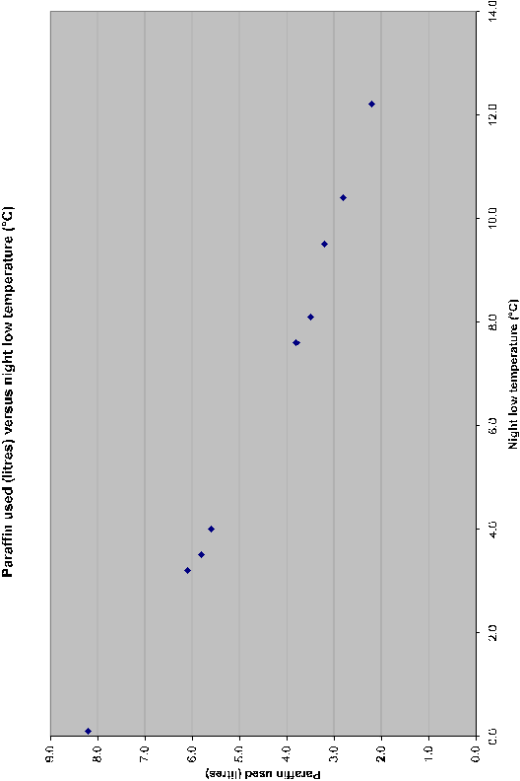

Plot of temperature versus paraffin used

Putting temperature on the x-axis (horizontal axis) and paraffin on the y-axis (vertical axis) seemed to be logical to me but there is nothing that stops me from plotting the data the other way.
Notice that the higher the temperature the less amount of paraffin is used. This makes sense. In statistics-talk these two variables are negatively correlated. That is, when one value goes up the other value goes down. If both values appear to move in the same direction they would be positively correlated. If the plot does not appear to have a pattern, the two data sets would be uncorrelated.
The plot of the two values in this case appears to be linear, therefore, the two variables may be considered to be linearly correlated. We also know that a straight line may be represented mathematically as y = a + m×x, where y represents the vertical axis and x represents the horizontal axis. There are several methods that may be used to determine a line that fits these data points.

Method 1, eye judgment
I could use a straight edge to draw a straight line through the points to be able to estimate the amount of paraffin that would be used at say 6°C. Error: Reference source not found shows a straight line that I drew by hand, guessing where the line should go.

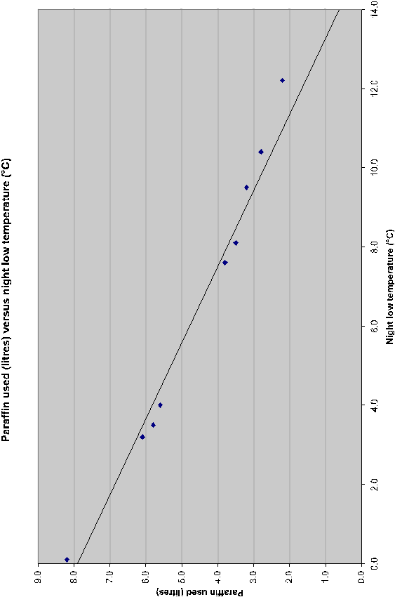

Hand drawn line to estimate the paraffin data set

From this line I can estimate the equation by reading directly from the graph but I need two points and their coordinates (x-axis and y-axis values). Choose a value on the x-axis and draw a vertical line (mentally or with a pencil) until it touches the line I drew then read the corresponding value on the y-axis (mentally or with a pencil draw a horizontal line to the y-axis. It’s a good idea to take the two readings near the ends of the graph. Write these two values down. The figure below shows the lines I drew and their coordinates in the form of (x, y).

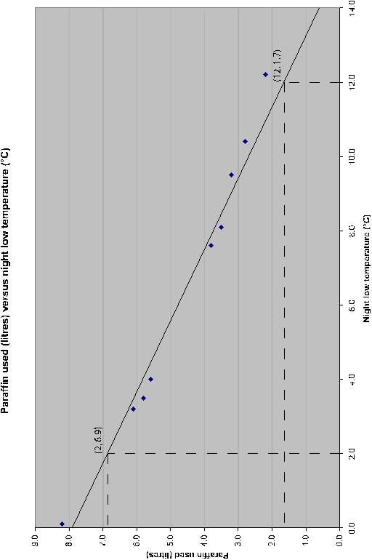

Coordinates from hand calculated line

I have two points that I am going to label (x₁, y₁) and (x₂, y₂) and assign them to (2, 6.9) and (12, 1.7) as follows: x₁ = 2; y₁ = 6.9 and x₂ = 12; y₂ = 1.7. In shorthand notation (x₁, y₁) = (2, 6.9) and (x₂, y₂) = (12, 1.7).
The equation for a line is y = a + m×x and we must figure out what a and m are. The letter m is usually used in place of b or any other letter of the alphabet and it represents the slope of the line: does the line slope up or does the line slope down. The letter a is the point where the line crosses the vertical axis. In other words, it indicates the point of the line where x = 0. There are two equations that we must use:
Remember these two equations because they are going to be used several times in this section.
In this example we have the following values (remember that m must be calculated first and then put into the second equation):
If you feel more comfortable with using names in place of x and y you could change the equation to read: Paraffin = -0.52 Degrees + 7.94. To estimate the amount of paraffin that would be used at 6°C, substitute 6 into the equation: Paraffin = -0.52(6) + 7.94 = 4.82 litres, or just 4.8 litres.

Method 2, use the mean of each axis
This method is similar to the previous method except we calculate the average (mean value) of both paraffin and temperature, put this plot in the graph and then adjust the line until it looks correct. I’ll leave this method as an example for you to do.

Method 3, method of averages
The method of averages is based on the assumption that a good fit is one in which the sum of the residuals is zero. (A residual is the difference from the true value and the estimated value.) In this case we would write each equation in the form of y_{i} = a +m×x_{i} for each data point. In our example we would have:
3.5 = a + 8.1m
2.2 = a + 12.2m
2.8 = a + 10.4m
3.8 = a + 7.6m
5.6 = a + 4.0m
3.2 = a + 9.5m
5.8 = a + 3.5m
8.2 = a + 0.1m
6.1 = a + 3.2m
We would then arbitrarily divide these equations into two groups any way we wanted to. If there were an even number of values, I would just divide them into two equal parts. In this case I will use the upper four cases and the lower five equations.
Sum the upper four equations and obtain: 12.3 = 4×a + 38.3×m.
Sum the lower five equations and obtain: 28.9 = 5×a +20.3×m.
Now solve these equations simultaneously. You don’t have to do this for this module but if you did you would obtain the following result: y = 4.78 – 0.18×m

Line Graphs
Show the changes in data or trends over a given period of time.
They are used to emphasize rather than compare. We use a dot to show the height of each bar. If we join the dots, we get a line graph.
Line graphs show the behaviour of a variable over time. Time is placed on the horizontal axis and the variable being plotted is shown on the vertical axis.
A good example of a time based line graph is the food index from Stats SA. You will find this chart on the page following the ice cream chart.
The graph makes it clear that the food index rose sharply between January 2002 and January 2003 after which its rise slowed somewhat.
As you can see in the graph, time (years and months) is displayed on the horizontal axis and the index value is displayed on the vertical axis. All time periods are of a fixed length and the length is the same for each month. I am pointing this out because I have seen graphs that try to distort facts by altering the graph in some respects.
A very handy feature with the line chart is that you may have several graphs on the same chart. This makes them a bit easier to compare. The line chart shows the Consumer Price Index for the historical metropolitan areas (CPI), the Consumer Price Index excluding interest rates on mortgage bonds (CPIX) and the Food Price Index (FPI). The FPI was shown on the last two figures.
In this graph we can see the same as before with the FPI, however, the CPI and CPIX are also shown in comparison. The interpretation of these index figures is not discussed here, however, you can see that more than one graph may be represented and comparisons may be made. The FPI represents the price of food, as you probably have already guessed. In comparison to the CPI and the CPIX note how sharply the FPI rose from about July 2002. If you remember, there was a big outcry concerning the cost of food and, in particular, basic food prices near the end of 2002. This graph shows you that rise.

Fit Curves to Predict Trends
In mathematics, the term "curve" refers to the graph of a function, regardless of whether the graph is actually curved or is instead linear.
When researchers analyse data, they identify the trend of the data points by fitting a curve, or equation, to the points. Individual points deviate from the curve because of random fluctuations (such as directional changes in the wind), variations in individual traits (such as how quickly someone metabolises a drug), and natural occurrences (such as friction).
Curve-fitting analysis identifies the trend of the data despite deviations in the individual data point.
We can therefore say that curve fitting is the process of constructing a curve, or mathematical function, that has the best fit to a series of data points, possibly subject to constraints.
Curve fitting can involve either interpolation, where an exact fit to the data is required, or smoothing, in which a "smooth" function is constructed that approximately fits the data.
Fitted curves can be used as an aid for data visualization, to infer values of a function where no data are available, and to summarize the relationships among two or more variables

Linear curve
In math, the word "curve" refers to the graph of any equation, even if the graph is linear rather than curved. If the data points approximate a straight line, linear regression is the most appropriate type of curve analysis to perform.
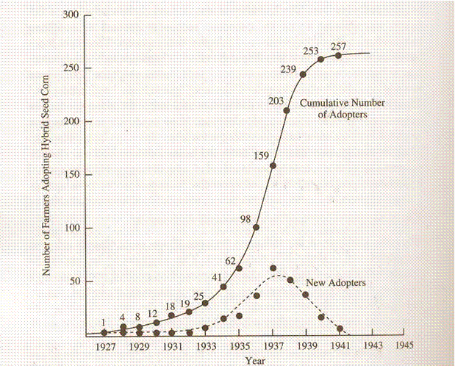

Example of a Linear Demand Curve
Note, for this example read $ as R
You operate a small produce stand at a farmers’ market. Consider that the effects of consumer income, the reputation for quality of your produce, the presence of competing produce stands and the time of year are constant.
You discover that your demand curve for apples is Q = 1,000 – 100P, where Q represents the number of bushels of apples sold in a week and P represents the price in rand.
A graph of the demand curve is shown below. What will quantity demanded be at a price of $5? At $6?

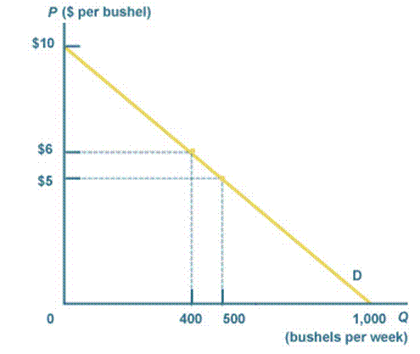
You can see from the graph that 500 bushels of apples are sold in a week at a price of $5; at a price of $6, 400 bushels of apples are sold.

Quadratic Curves
The next order of curves is the quadratic category. Whereas linear curves have a variable raised to the first power, quadratic curves have a variable raised to the second power (for instance, "x^2").
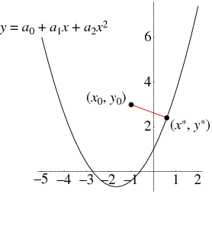

The graph of a quadratic function is a parabola. The parabola can either be in "legs up" or "legs down" orientation.
We know that a quadratic equation will be in the form:
y = ax² + bx + c
Our job is to find the values of a, b and c after first observing the graph. Sometimes it is easy to spot the points where the curve passes through, but often we need to estimate the points.
Let’s start with the simplest case. (We’ll assume the axis of the given parabola is vertical.)
Parabola cuts the graph in 2 places
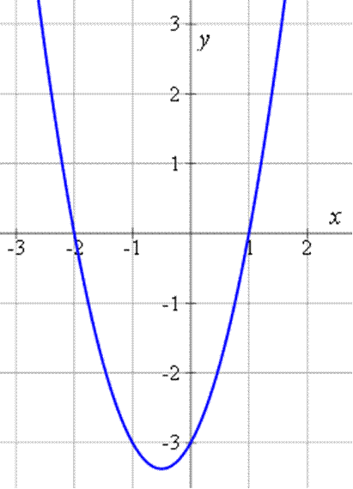
We can see on the graph that the roots of the quadratic are:
x = 2 (since the graph cuts the x-axis at x = − 2); and
x = 1 (since the graph cuts the x-axis at x = 1.)
Now, we can write our function for the quadratic as follows (since if we solve the following for 0, we’ll get our 2 intersection points):
f(x) = (x + 2)(x − 1)
We can expand this to give:
f(x) = x² + x − 2
This is a quadratic function which passes through the x-axis at the required points.

Standard deviation
The most commonly used description of a distribution is the mean and standard deviation. The mean and standard deviation are very closely related to statistical and probability theory.
By now you know what the mean is but the standard deviation is another matter.
The standard deviation is also a measure of spread of a data set just like the five-number summary. Related to the standard deviation is ‘variance’. We actually calculate variance and then calculate the standard deviation from it. Here’s a definition of variance and standard deviation:
The variance is the mean of the squares of the deviations of the observations from their means.
The standard deviation is the positive square root of the variance.
I’m going to show you what each term in the definition means with a simple example. The data set for this example is: 3, 4, 5, 6, and 7.

Step 1
First compute the mean of the data set:

Step 2
The deviation of any observation ‘x’ from the mean is the difference (x - ) and it may be either positive or negative. The table shows an arrangement that helps calculate the next set of values:
Item  x | Deviation  (x - ) | Squared deviation  (x - )²
3 | 3 – 5 = -2 | (-2)² = (-2)x(-2) = 4
4 | 4 – 5 = -1 | (-1)² = (-1)x(-1) = 1
5 | 5 – 5 = 0 | (0)² = (0)x(0) = 0
6 | 6 – 5 = 1 | (1)² = (1)x(1) = 1
7 | 7 – 5 = 2 | (2)² = (2)x(2) = 4
 | sum = 0 | sum = 10

Calculations for the standard deviation
The sum of the squares of the deviations from the mean is 10. Therefore, the variance is:

The variance is often abbreviated as var or sometimes v.

Step 3
The standard deviation s is the square root of the variance:
Most calculators have a square root key () so you don’t have to worry too much about how to create one by hand. In fact, many calculators will compute the mean and standard deviations for you. If you plan to do many statistical calculations I suggest you purchase one of these calculators as it will save you lots of arithmetic (and spare you making calculation errors).
Here are some comments and observations concerning the standard deviation:
The standard deviation s makes sense as a measure of spread or variability. It’s a kind of average deviation of the items (observations) from their mean. If the observations are spread out they will tend to be far from the mean, both above and below. Deviations are positive or negative but their square is always zero of positive. The sum of the deviations is always zero so you can use this to ensure that your arithmetic for the deviation is correct.
The standard deviation is always zero or positive. If the standard deviation is zero, its variance is also zero. This can only happen if all the observations are equal to one another. A standard deviation of zero means no spread at all. Otherwise the standard deviation is positive and increases as the spread of the data increases.
When the observations are measured in some unit (seconds, metres, kilograms) their variance is measured in the square of those units because it is an average squared deviation. The standard deviation has the same units as the original observations and this is one reason why it is used more often than the variance.
Like the mean, variances and standard deviations are influenced by outliers. An outlier can give a totally wrong impression of the spread of the data. This is why the first step in statistical analysis is to graph the data to see what it looks like.
The standard deviation is not usually a useful measure of the spread if the distribution is skewed. For skewed distributions use the five-number summary as it usually does a much better job than the mean and standard deviation. In fact, if you have a symmetrical distribution and it contains outliers, use the five-number summary. When statisticians use the word ‘symmetrical’ they don’t mean that the distribution must be perfectly symmetrical. They mean that the distribution should be more or less symmetrical and know that a bit of skewness won’t affect the results drastically.
In order to make meaningful comparisons of the variability of different distribution, statisticians often use the ‘coefficient of variation’. This is just the standard deviation expressed as a fraction of the mean and is calculated as: . If the coefficient of variation is expressed as a per cent it is called the ‘relative standard deviation’ and is usually abbreviated ‘RSD’. RSD = cv×100. Annexure B contains a graph from Stats SA showing the CV (they use capital letters) of ‘the unemployed, the unemployment rate and the economically active’.

The normal distribution
Frequency curves offer a means of quickly describing the shape of a distribution. The normal curves are particularly important in statistics because the sampling distributions of many statistics (the proportion and the mean ) are described by normal curves for moderate and large sample sizes.
All normal curves are bell-shaped and their tails drop off quickly so that they have very few outliers. Because the normal curves are symmetrical, the mean, median and mode all have the same values.
You may even locate the standard deviation of a normal curve simply by looking at it. There is a point in the normal curve where the slope seems to change from falling quickly to falling less quickly. This is the point of the standard deviation. The figure shows a normal curve and the dotted lines indicate the position of the standard deviation.

Normal curve with the standard deviation indicated

There is a rule in statistics called the ‘68-95-99.7 rule’.
In any normal distribution, 68% of the observations fall within one standard deviation of the mean. Half of these (34%) fall within one standard deviation above the mean and the other half within one standard deviation below the mean.
In addition, 95% of the observations fall within two standard deviations of the mean with half above and half below the mean. In total, 99.7% of the observations fall within three standard deviations of the mean.

The figure graphically shows the 68-95-99.7 rule.

The 68-95-99.7 rule
These facts are important because many types of data have distribution whose shapes are approximately described by the normal curve. The sample proportion of an SRS has approximately a normal distribution and is an unbiased estimate of the true proportion. Remember that no data set is exactly described by the normal curve and that this 68-95-99.7 rule is only approximately true.

Use a variety of presentations
We have seen that
The arithmetic mean is the average we all know and use: add up all the numbers and divide by their count (how many there are).
The mode is simply the number that occurs most frequently. Mode is used if you have the same number occurring so frequently in a set of data that it can be regarded as the typical item
The median is the middle value of the set of sorted values
The range of the data set is the largest minus the smallest
A table is pretty simple. It lists data in rows and columns and you can find the information you are looking for by going to either the row or columns of interest and looking either across or down. The intersection of the row and column (where they cross) is the data you require
Frequency distribution: where you arrange (distribute) data in some kind of order. A frequency distribution table tells you how often certain numbers or values occur.
Quartiles divide your data set into 4 equal sized groups of data
Bar graphs compare measurements at intervals, the bars run horizontally.
Column charts compare measurements at intervals and provide a view of data at a specific time. The bars run vertically
The pie chart shows how a whole is divided into parts
Scatterplots consist of two sets of data that are plotted against each other. For example, you could measure temperature in °C as well as the amount of paraffin used in order to see if there is a relationship between the two. (How much paraffin do I need to keep my chickens warm at night?)
Line Graphs show the changes in data or trends over a given period of time.
Curves are fit to predict trends
You would use the presenation best suited to the research that you conducted.

PROBABILITY CONCEPTS IN LIFE

Outcome
Use random events to explore and apply, probability concepts in simple life and work related situations

Assessment criteria
- Data are gathered, organised, sorted and classified in a suitable manner for further processing and analysis.
- Experiments and simulations are chosen appropriately in terms of the situation to be investigated
- Probabilities are determined correctly
- Distinctions are correctly made between theoretical and experimental probabilities
- Predictions are based on validated experimental or theoretical probabilities.
- The outcomes of experiments and simulations are communicated clearly

Probability (Equal And Unequal Probabilities)

Drawing Conclusions from Data
In order to draw conclusions from our data we have to understand it and to look at it to see what the data is telling us. In this section we are looking at simple probability theory and how to make confidence statements about our data.

Figuring out what probability means
Probabilities come in many different disguises. Some of the terms people use for probability are chance, likelihood, odds, percentage, and proportion. But the basic definition of probability is the long-term chance that a certain outcome will occur from some random process. A probability is a number between zero and one — a proportion, in other words. You can write it as a percentage, because people like to talk about probability as a percentage chance, or you can put it in the form of odds.
The term "odds," however, isn't exactly the same as probability. Odds refers to the ratio of the denominator of a probability to the numerator of a probability. For example, if the probability of a horse winning a race is 50 percent (1/2), the odds of this horse winning are 2 to 1.

Understanding the concept of chance
The term chance can take on many meanings. It can apply to an individual ("What are my chances of winning the lottery?"), or it can apply to a group ("The overall percentage of adults who get cancer is . . .").
You can signify a chance with
a percent (80 percent),
a proportion (0.80),
or a word (such as "likely").
The bottom line of all probability terms is that they revolve around the idea of a long-term chance. When you're looking at a random process (and most occurrences in the world are the results of random processes for which the outcomes are never certain), you know that certain outcomes can happen, and you often weigh those outcomes in your mind. It all comes down to long-term chance; what's the chance that this or that outcome is going to occur in the long term (or over many individuals)?
If the chance of rain tomorrow is 30 percent, does that mean it won't rain because the chance is less than 50 percent? No. If the chance of rain is 30 percent, a meteorologist has looked at many days with similar conditions as tomorrow, and it rained on 30 percent of those days (and didn't rain the other 70 percent). So, a 30 percent chance for rain means only that it's unlikely to rain.

Interpreting probabilities: Thinking large and long-term
You can interpret a probability as it applies to an individual or as it applies to a group. Because probabilities stand for long-term percentages, it may be easier to see how they apply to a group rather than to an individual. But sometimes one way makes more sense than the other, depending on the situation you face. The following sections outline ways to interpret probabilities as they apply to groups or individuals so you don't run into misinterpretation problems.

Playing the instant lottery
Probabilities are based on long-term percentages (over thousands of trials), so when you apply them to a group, the group has to be large enough (the larger the better, but at least 1,500 or so items or individuals) for the probabilities to really apply. Here's an example where long-term interpretation makes sense in place of short-term interpretation. Suppose the chance of winning a prize in an instant lottery game is 1/10, or 10 percent. This probability means that in the long term (over thousands of tickets), 10 percent of all instant lottery tickets purchased for this game will win a prize, and 90 percent won't. It doesn't mean that if you buy 10 tickets, one of them will automatically win.
If you buy many sets of 10 tickets, on average, 10 percent of your tickets will win, but sometimes a group of 10 has multiple winners, and sometimes it has no winners. The winners are mixed up amongst the total population of tickets. If you buy exactly 10 tickets, each with a 10 percent chance of winning, you might expect a high chance of winning at least one prize. But the chance of you winning at least one prize with those 10 tickets is actually only 65 percent, and the chance of winning nothing is 35 percent.

Seeing probability in everyday life
Probabilities affect the biggest and smallest decisions of people's lives.
Pregnant women look at the probabilities of their babies having certain genetic disorders.
Before you sign the papers to have surgery, doctors and nurses tell you about the chances that you'll have complications.
And before you buy a vehicle, you can find out probabilities for almost every topic regarding that vehicle, including the chance of repairs becoming necessary, of the vehicle lasting a certain number of miles, or of you surviving a front-end crash or rollover (the latter depends on whether you wear a seatbelt — another fact based on probability).

What is probability?
Even the rules of football agree that tossing a coin avoids favouritism. Probability is nothing more than tossing a coin!
We are all abley to understand and use statistics, but we do not have the innate ability to understand probability. We get confused and do silly things like gamble our money away or have another child to break the run of six boys (girls).
Because we have a memory we automatically think that chance event also have a memory. They don’t! Whether we are looking at tossing a coin, rolling a die or two dice, playing the roulette wheel, having children or observing the offspring of animals, the outcome is purely random but totally predictable in the long run.
The ‘Law of Averages’ doesn’t exist with random events and we humans have difficulty understanding this. We think that after having tossed 10 heads in a row the ‘Law of Averages’ will turn up a tail next. It might, but the next toss still has a 50-50 chance of being either a head or a tail. A coin has no memory and it doesn’t know that it turned up heads 10 times in a row.
When we gamble in games of chance, for example the roll of dice, the spinning of a coin, roulette wheel, etc. we consider the probability of winning:
in the case of dice 1 out of 6 or 2 out of 12,
flipping a coin (heads or tails) 1 out of 2
and, in the case of roulette, 1 out of 75 or higher.
These probabilities are called “a priori” probabilities.

Experiment and observe
Most probabilities cannot be estimated by deduction.
Probabilities must be estimated only after experimentation and observation.
This is also true of future possibilities of the outcome of events.
It is possible to explain the outcome of a future event by observing its frequency of occurrence in the past. This data is then projected into the future.
You know that if you toss a coin enough times you will obtain about 50% heads and 50% tails. (Usually there is a little more metal on the ‘head’ side of a coin and it turns up slightly more frequently than tails.)
But how do we work out probabilities? We observe. Only by observation can we be reasonably sure of the approximate value of the probability of an outcome.
If you have the time, try tossing a coin several hundred times and record the outcomes. You won’t get exactly 50% head and 50% tails but you will see that 50% is the value you are heading towards.
Now take the same coin but instead of tossing it, hold it on end on a hard table surface with the index finger of one hand and snap it with the index finger of the other hand. The coin will spin for a while before falling with either heads or tails showing. Do not count the spins that fall off the table or the spins that bump into anything else. What do you expect to find: 50% heads and 50% tails?
A long series of trials reveals that the probability of a spinning coin is not .
When we estimate the probability of our sport team winning on Saturday, we use deductive reasoning to make a bet on the outcome of the game. We sit down and work out what the chances are that our team will win, based on what they did in the past and which team members are playing, etc. Such probability statements are referred to as statistical or inductive statements. These estimates are based on underlying assumptions:
That enough past events have been observed.
That casual influences will be unchanged and remain as they were in the past.

Definition
$\frac{\text{number of possible outcomes to satisfy a specific condition}}{\text{total number of possible outcomes}}$
Probability =

When throwing the dice, the probability of throwing a 4 is 1/6 (one out of six). However, it could happen that the 4 is thrown more than once, let’s say it was thrown twice (2/6). This fraction is then called the success fraction.
The success fraction for an event is not necessarily equal to the probability of an event. However, if you repeat the experiment often and the results are combined, the success fraction for an event tends to draw closer to the probability of the event. The data also becomes less biased.

Odds on versus probability
Probability originated in gambling and in gambling the chance of an event is often stated in terms of odds rather than probability. You are rolling two dice and want to get a 7 but you have heard that the odds against this happening is 5 to 1.
The probability of a 7 is because there are 6 ways you may roll a 7 with two dice (1+6, 2+5, 3+4, 4+3, 5+2 and 6+1).
Odds of 5 to 1 means that failure to roll a 7 happens five times as often as success. In the long run five of every six tries will fail and one will succeed. Therefore, odds of A to B against an outcome means that the probability of that outcome is:

If the odds against the favourite in a horse race are 3 to 2 this is equivalent to the horse having a probability of of winning.
Still throwing the dice, the odds on throwing a 4 are 1 to 5, while the probability of getting a 4 is 1/6. When you place bets on a horse, or a sport game, bookies will quote you, for example 10 to 1, meaning the odds on that horse winning is 1 to 10, while the probability of the horse winning is: 1/the number of horses racing

Mutually Exclusive Events
In simple terms, two events are mutually exclusive if they cannot occur at the same time (i.e. they have no outcomes in common). In short, mutual exclusivity implies that at most one of the events may occur.
In logic, two mutually exclusive propositions are propositions that logically cannot both be true. If an event X means that another event Y does not take place, X and Y are called mutually exclusive.
These are events that cannot occur at the same time.
For example, when tossing a coin, it can only land on either head or tails, not both. The two events are mutually exclusive.
The probability of occurrence of two or more mutually exclusive events is obtained by adding the probabilities of the individual events. If the sum is equal to 1, we call them complementary events.

Independent Events
In probability theory, to say that two events are independent, intuitively means that the occurrence of one event makes it neither more nor less probable that the other occurs.
These are two or more events for which the outcome of one does not affect the other. They are events that are not dependent on what occurred previously. Each toss of a fair coin is an independent event
For example:
The event of getting a 6 the first time a die is rolled and the event of getting a 6 the second time are independent.
By contrast, the event of getting a 6 the first time a die is rolled and the event that the sum of the numbers seen on the first and second rolls is 8 are dependent.
If two cards are drawn with replacement from a deck of cards, the event of drawing a red card on the first trial and that of drawing a red card on the second trial are independent.
By contrast, if two cards are drawn without replacement from a deck of cards, the event of drawing a red card on the first trial and that of drawing a red card on the second trial are dependent.
When two coins are tossed, the probability that one will land on heads is ½ and the probability that the other one will land on heads is also ½.
These two events are not mutually exclusive. They are independent. The probability of the occurrence together of two or more independent events is obtained by multiplying the probabilities of the individual events.

Probability Tree Diagrams

Find the number of outcomes
At a roadside stall, you can order a small, medium, or large cola, with or without ice. Use a tree diagram to find the number of possible outcomes.
We have 6 possible outcomes to satisfy a specific condition

Calculate probability
Let us look at some example:
A tree diagram for the toss of a coin:
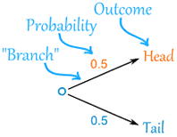 |  | There are two "branches" (Heads and Tails)  The probability of each branch is written on the branch  The outcome is written at the end of the branch
We can extend the tree diagram to two tosses of a coin:
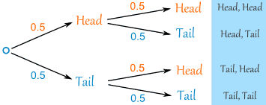
How do you calculate the overall probabilities?
You multiply probabilities along the branches
You add probabilities down columns
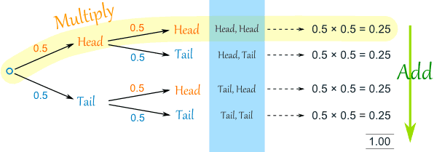

Now we can see such things as:
The probability of "Head, Head" is 0.5×0.5 = 0.25
All probabilities add to 1.0 (which is always a good check)
The probability of getting at least one Head from two tosses is 0.25+0.25+0.25 = 0.75
... and more

That was a simple example using independent events (each toss of a coin is independent of the previous toss), but tree diagrams are really wonderful for figuring out dependent events where an event depends on what happens in the previous event) like this example:

Soccer Game
You are going to play soccer, and love being the Goalkeeper, but that depends who is the Coach today:
with Coach Sam the probability of being Goalkeeper is 0.5
with Coach Alex the probability of being Goalkeeper is 0.3
Sam is Coach more often ... about 6 out of every 10 games (a probability of 0.6).
So, what is the probability you will be a Goalkeeper today?
Let's build the tree diagram. First we show the two possible coaches: Sam or Alex:
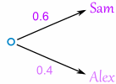
The probability of getting Sam is 0.6, so the probability of Alex must be 0.4 (together the probability is 1)
Now, if you get Sam, there is 0.5 probability of being Goalie (and 0.5 of not being Goalie):
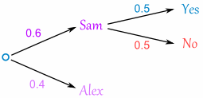
If you get Alex, there is 0.3 probability of being Goalie (and 0.7 not):
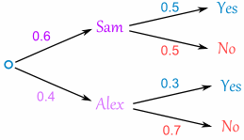
The tree diagram is complete, now let's calculate the overall probabilities. This is done by multiplying each probability along the "branches" of the tree.

Here is how to do it for the "Sam, Yes" branch:
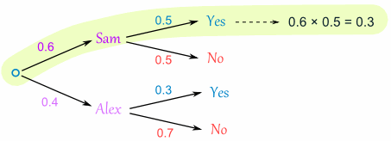
(When we take the 0.6 chance of Sam being coach and include the 0.5 chance that Sam will let you be Goalkeeper we end up with an 0.3 chance.)
But we are not done yet! We haven't included Alex as Coach:
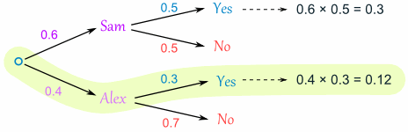
An 0.4 chance of Alex as Coach, followed by an 0.3 chance gives 0.12.
Now we add the column:
0.3 + 0.12 = 0.42 probability of being a Goalkeeper today
(That is a 42% chance)

Check
One final step: complete the calculations and make sure they add to 1:
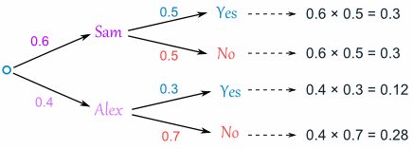
0.3 + 0.3 + 0.12 + 0.28 = 1
Yes, it all adds up.\

To calculate probabilities using a tree diagram, follow these steps:
Draw a tree diagram,
Multiply along the branches
And add the columns.
Make sure all probabilities add to 1 and you are good to go.

Calcualte probability with percentages
Calculating probability with percentages is a useful skill throughout your life. You will often hear statements like "You have a 50 percent chance of winning" or "35 percent of drivers have beverages in their hands." Understanding how to calculate these percentages with real numbers of people and things will help you understand probabilities for the rest of your life.

Finding the Probability Using a Percent
Change the percent into a decimal by moving the percent's decimal to the left two places.
Suppose you're given the following problem: Jimmy has a bag of marbles, and he has a 25 percent chance of picking a blue marble. Then he draws out one marble and returns it 12 times. You're asked how many times should he get a blue marble. In this example, 25 percent becomes 0.25.
Look at the problem to find how many attempts were made at the event. In this case, Jimmy tried to grab a marble 12 times, so 12 attempts were made.
Multiply the number of attempts by the percent probability in decimal form. The answer will be the number of times the event should occur. In the example, 12 x 0.25 = 3, so Jimmy should get a blue marble three out of the 12 times he tries to grab marbles from his bag.

How to Find the Percent Probability
Calculate the number of favorable outcomes in a common situation. For example, suppose you're given the following problem: "Jessica has a standard deck of 52 cards. What is the probability that she will pick a diamond when she draws a card at random?"
To write this probability as a percent, you first need to know the number of opportunities of the desired event occurring. In the example, there are 13 diamonds in the deck, so there are 13 chances for Jessica to draw out a diamond.
Determine the total number of events possible or total number of choices for the outcome of the event. In this case, Jessica has 52 cards total, so there are 52 possible outcomes.
Divide the number of outcomes desired by the number of events possible. In this case, 13 divided by 52 = 0.25.
Take the answer you got and move the decimal point to the right two places or multiply the decimal by 100. Your answer will be the percent probability that the desired outcome will take place. For the example: 0.25 x 100 = 25, so Jessica has a 25 percent chance of picking a diamond at random.

Calculate the percentage probability from a rfaction
Starting with a fraction, use a calculator to do the dividing indicated by the fraction.
Example
2/5 is 2 divided by 5.
The result is 0.4
The number 0.4 means 4 tenths which is 4/10
4/10 is the same as 40/100 (multiplying both top and bottom by the same number gives the same amount, in this case multiplying top and bottom by 10.
40/100 is the same as 40% because % means "per 100", so the fraction 40/100 is 40 per 100.
So 2/5 = 40%.

Another way of looking at it, starting from a fraction, is to use the idea that your goal is to change your fraction to some number over 100.
Example:2/5 is the fraction.
We need to convert it to x/100.
2/5 = x/100
multiply both sides by 100
200/5 = x
x = 40
So, your fraction 2/5 = 40/100 = 40%.

