**9013 FORMATIVE ASSESSMENT WORKBOOK**

***Unit Standard 9013***

Formative assessment SO1

1. Estimate (guess) and then measure the lengths of the following line segments. Give your answers in cm and mm.

1

2

3

1. A rectangular plot of land has a length of 250m and a width of 175 m. The farmer wants to fence the plot using 6 strands of wire. What length of wire will s/he need? Show your calculations.

|  |
| --- |
|  |
|  |
|  |

1. Calculate:

Every weekday, from Monday to Thursday, Thabo drives the distance of 25 km between his home and work in 30 minutes. However, Fridays it only takes him 20 minutes to cover the same distance.

|  |
| --- |
| Calculate his speed on weekdays except Fridays. |
|  |
| Calculate his speed on Fridays. |
|  |

1. A bicycle moves 65 meters in 15 seconds. Calculate the speed of the bicycle.

|  |
| --- |
|  |
|  |
|  |

1. Estimate and calculate the area of:

|  |
| --- |
| This page |
|  |
|  |
| The top of your file |
|  |
|  |
|  |
| Which units of area will be best for measuring |
| the area of the floor of this room? |
|  |
| the area of a soccer field? |
|  |
| the area of South Africa? |
|  |

1. Calculate the area of each of the following triangles

|  |
| --- |
|  |
|  |
|  |
|  |

3 cm

4 cm

50 mm

50 mm

60mm

40 mm

40 mm

70 mm

No 1

No 2

No 3

1. Consider a box with dimensions: length 34 cm, width 4 cm and height 3 cm. How many 1 cm3 unit cubes are needed to cover the base of the box? How many layers of cubes are needed to fill the box?

|  |
| --- |
|  |
|  |
|  |

1. Estimate (guess) which object has the greater volume: a cube with sides of 6 cm or a rectangular box of 7 cm by 6 cm by 4 cm. Now calculate the volumes accurately.

|  |
| --- |
|  |
|  |

1. Give some examples of fluids that you can buy in packages that are marked in

|  |
| --- |
| ml |
| l |

1. In each case give the greater/greatest measurement:

|  |
| --- |
| 250 g; 0.2 kg |
|  |
| 0.01 kg; 12 000 mg; 10 g |
|  |
| What is the mass indicated on the spring balance shown? |
|  |
| What is the volume of the fluid in the measuring cylinder shown age? |
|  |

30

25

20

10

5

**kg**

15

200

100

ml

1. Do the following calculations

|  |
| --- |
| A bucket of water has to be heated from 20 ºC to 45 ºC. The heating element can heat at 0.05 ºC/s (heating factor). How many seconds would it take this element to heat the water to the required temperature? |
|  |
|  |
|  |
| The inlet of a boiler adds 6 Litres of water per second to its contents. We will call this a flow factor (ff). The volume needs to increase from 1000 Litres to 1500 Litres. How many seconds would this take? |
| First calculate the change in volume. |
|  |
|  |
|  |
| Next use the flow factor(ff) of 6 Liters per second to calculate the time required. |
|  |
|  |
|  |
| What is the difference in temperature in degree Celsius between Ice and boiling water: |
|  |
| The maximum and minimum temperatures for a day (estimate!) in June: |
|  |
| How many seconds are there in 2 minutes? |
|  |
| How many minutes are there in 3 h 45 min? |
|  |
| How many seconds are there in 610,2 minutes? |
|  |
| Write the following according to the international time system: |
| 2.16 p.m. |
|  |
| 12.05 p.m. |
|  |
| 3.12 a.m. |
|  |
| An athlete runs 1 500 m in 3 min. 42 s. How many seconds is this less than 4 min. |
|  |
| How many seconds is this more than 3 min 38 s. |
|  |

1. The SI system uses the metric (decimal) system and uses a number of standard prefixes for units of length and mass that were covered in the previous section. Using the SI system means that we should know the most important ones. The three most important ones are:



1. Complete each of the following:

|  |
| --- |
| 150cm = ____m |
|  |
| 360mm = ____m |
|  |
| 62ml = ____litres |
|  |
| 3.6 tonnes = ____kg |

Complete the table:

|  |  |  |
| --- | --- | --- |
| **Quantity** | **Unit** | **Symbol** |
| Mass |  |  |
|  | Meter |  |
|  |  | s |
| Temperature |  |  |
|  |  | A |
| Light |  |  |
| Chemical standard unit |  |  |

1. Write down the names of objects you have come across in your daily life which have the shapes of the solids shown.

|  |
| --- |
| Cylinder |
| Cube |
| Rectangular prism |
| Sphere |
| Pyramid |

Cylinder

Rectangular prism

1. We can now build a prism that consists of a combination of basic shapes.

**y1 = 4 m**

**y2 = 5 m**

**at**

**h = 5** **m**

**x1 = 3** **m**

**r = 3 m**

Viewed from the front it would look like this.

This shape can now be broken up into is most basic “sub” shapes.

***1. Triangle***

Area (a1) = ½x2 × y1

**y1 = 4 m**

**a1**

= ½(6) × 4

= 3 × 4

**x2 = 6 m**

= 12 m ²

***2. Rectangle***

**y2 = 5 m**

**x2 = 6 m**

**a2**

Area (a2) = x2 × y2

= 6 × 5

= 30 m ²

***3. Half-circle***

**r = 3 m**

**a3**

Area (a3) = ½ × π × r ²

= ½ × π × (3) ²

= 14.14 m ²

To calculate the areas of the side surfaces we need a depth value. The side surfaces are all calculated as rectangular shapes. A side-on view would look like this.

**a3**

**a4**

**y1 = 4 m**

**y2 + r**

Again we start with the triangle. The two angled surfaces ***(a3)*** would have the same areas because they have the same dimensions.

Area (a3) = d × h

**d = 8 m**

Since there are two surfaces with identical measurements this value is doubled.

Area(Triangle side surfaces) = 2 × Area(a3)

Area **(a4)** consists of two parts namely the circular part and the straight rectangle part.

First we calculate the two surfaces forming the rectangle.

Area (Rectangle side Surfaces) = 2 × d × y2

Lastly we calculate the area of the side surface forming the circular part.

Start by calculating the perimeter of a full circle with a radius of ***3 m***.

Perimeter = 2 × π × r

We use half this value because there is half a circle in the prism.

The area of the side surface would then be a rectangle with measurements 9.43 m and d = 8 m.

The total outside surface area can now be calculated. Remember that there are two face ends so all face end shapes will be doubled.

Total Area = 2 × (Area (a1) + Area (a2) + Area (a3)) + Area(Triangle side surfaces) + Area (Rectangle side Surfaces) + Area (Circular side surface)

To calculate the volume of this prism we will take the face-end surface area and multiply it by the depth.

Volume = (Area (a1) + Area (a2) + Area (a3)) × d

Formative Assessment so2

1. Draw the following figure on paper and fold along the broken lines.

All sides are 3 cm long. Which solid do you make, folding the figure? This figure is called the net of a cube.

1. Complete the following activities

|  |
| --- |
| Take 1 piece of A4 paper. Calculate the area. Calculate the perimeter. What shape is the paper? |
|  |
|  |
| Fold the paper in half, so that it resembles A5 size paper. What shape is the paper now? Calculate the area. Calculate the perimeter. |
|  |
|  |

1. Draw the net of a rectangular prism.
2. Which solids do the following nets represent?

|  |
| --- |
|  |
|  |

1

2

1. Which shapes have been combined to make this drawing?



|  |
| --- |
|  |

1. Draw a square where all the sides are 6cm long. Calculate the area. Calculate the perimeter.

|  |
| --- |
|  |
|  |
|  |

1. Draw a parallelogram where two of the sides are 6cm long and two sides are 30mm long

|  |
| --- |
| . |
|  |
|  |

1. Do the following

* Construct triangle ABC with AB = 2 cm, BC = 3cm and AC = 4cm.
* Construct triangle DEF with sides 2 cm longer than the sides of triangle ABC.
* Construct triangle PQR with sides twice as long as the sides of ABC.
* Which of the two triangles DEF or PQR is an enlargement of ABC?

|  |
| --- |
|  |

1. Answer the following questions

|  |
| --- |
| A model train is made to a scale of 1:50. If the length of the real train is 25 m, what is the length of the model? |
|  |
| If the model is 15 cm high, what is the height of the real train? |
|  |
| On the plan of a building every 2 cm represents 1 m on the actual building. What scale is used? |
|  |

1. Look at the plan of the house on the next page. The area of the lounge is 3035cm X 3850cm. Calculate the area of the lounge in cm.

|  |
| --- |
|  |
|  |
| Convert the cm into m. |
|  |

1. You want to place a tumble dryer under a shelf in the laundry. The height of the shelf is 900mm. Will the tumble dryer fit under the shelf?

|  |
| --- |
|  |

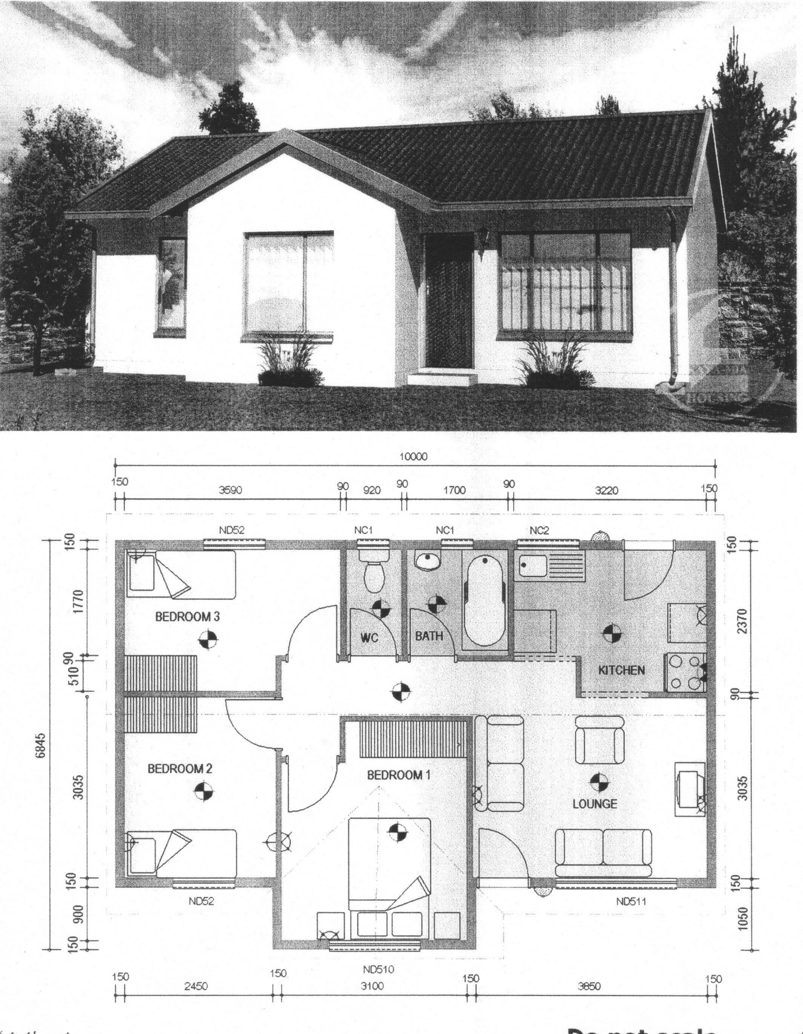

1. Draw a front view of the tumble dryer with the door closed. Make sure that your drawing is according to scale, with a ratio of 10:1. If your drawing is not good enough or not right, do it over until you get it right. You will need it for the assessment. You do not have to draw the castors at the bottom of the tumble dryer. The dimensions of the drawing are:

Width: 60 mm

Depth: 50 mm

Height: 85 mm

Door: 40 mm wide and 40 mm high and 20 mm from the bottom

Front panel: 25 mm high and 60 mm wide

1. Practical activity

***Handout 4***

* Cut out the box in handout 4, follow the instructions above and make a box.
* Measure the height, length and width of the box and write it down.
* Calculate the volume of the box.

Made a drawing of the finished box

1. Answer the following questions

|  |
| --- |
| List at least three cities in South Africa: |
|  |
| Which cities have international airports?: |
|  |
| Name two countries that are located to the north of South Africa: |
|  |
| South Africa encloses two other independent countries. Name them: |
|  |
| One province is not named on the map, which province is this? |
|  |
| The names of two provinces are different to that quoted on the map. Give their old and new names. |
|  |

1. Refer to page 5 of handout 6 and give the GPS coordinates of the following locations:

|  |
| --- |
| Corner of Bennit Avenue and Farrar Street: |
|  |
|  |
| Corner of Main Reef and Pretoria Roads |
|  |
|  |
| Corner of Morgan and Gayle Roads |
|  |
|  |

1. Finish drawing the pictures so that they are symmetrical

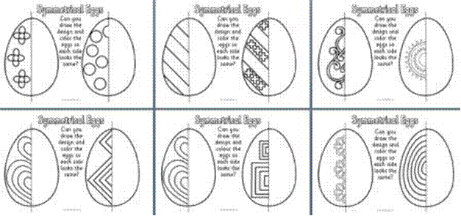



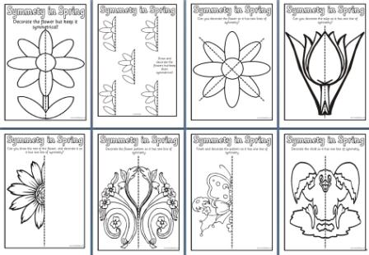



1. Draw in horizontal and vertical lines of symmetry on these shapes if they are symmetrical. Two of these shapes are not symmetrical

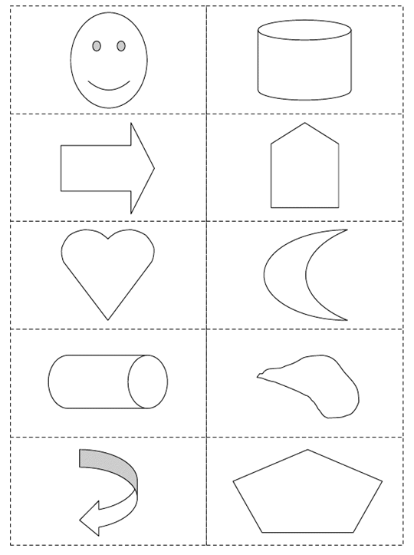

1. Think of 3 different objects in the world around you that have tessellating patterns

Item 1:

Item 2:

Item 3

Try drawing each of these patterns

1. Which types regular polygons can you use to make a tessellation

|  |
| --- |
| Item 1 polygon: |
| Item 2 polygon: |
| Item 3 polygon: |

1. Which types of symmetry does each tessellation use?

|  |
| --- |
| Item 1 uses |
| Item 2 uses |
| Item 3 uses |

1. Pentagon Tiles. Draw a tessellation that uses regular pentagons and just one other polygon and list the types of symmetry present in the tessellation.