

LEARNER

Portfolio of Evidence

MS Excel Intro

Unit Standard 116937

Level 2 Credits 4


Introduction

TABLE OF CONTENTS

TABLE OF CONTENTS ii
CONTACT DETAILS 1
Competence 1
Appeals & Disputes 2
Assessment Process Flow 4
ASSESSMENT STRATEGY 5
Assessment Preparation 7
Preparing The Candidate 7
Agreed Assessment Plan 10
Record Of Learning 13
UNIT STANDARD 116937 14
Formative Assessments 17
Formative assessment 1 17
Formative Assessment 3 17
Currency Format: Formative Assessment 6 19
Accounting Format: Formative Assessment 7 20
Formative Assessment 10 22
Formative assessment 11 22
Summative Assessment Readiness Statement 28
Assessor’s / Facilitator declaration: 28
Knowledge Questionnaire 29
Observation 30
Problem Solving Assessment 31
Workplace assignments 33
Research assignment 33
Reflexive questions 33
Work sample 33
Declaration Of Authenticity Of Evidence 34
ASSESSMENT REVIEW 35
Candidate Feedback Report 37
Candidate Appeal Form 38
Assessor's Report 40
Moderator's Report 41
PORTFOLIO BUILDING 42
Moderation 43

CONTACT DETAILS
Unit Standard: | 116937
Course:
Assessor Details
Name
Branch |  |  | Registration No:
Contact Details | email:
Contact Details | Phone: |  | Fax:
Moderator Details
Name
Branch
Contact Details | email: |  | Registration No:
Contact Details | Phone: |  | Fax:
Candidate Details
Surname |  |  |  | Name
College |  |  |  | ID No
Branch
Contact Details | Email:
Contact Details | Phone: |  |  | Fax:

Competence
Congratulations on completing the program. We sincerely hope you enjoyed the programme and that the learning experience was enriching.
The fact that you have attended training, however, is not sufficient evidence of your competence for us to award you a certificate and the credits attached to this programme. You are required to undergo assessment in order to prove your competence to achieve credits leading to a national qualification.

Being Declared Competent Entails:
Competence is the ability to perform whole work roles, to the standards expected in employment, in a real working environment.
There are three levels of competence:
- Foundational competence: an understanding of what you do and why
- Practical competence: the ability to perform a set of tasks in an authentic context
- Reflexive competence: the ability to adapt to changed circumstances appropriately and responsibly, and to explain the reason behind the action
To receive a certificate of competence and be awarded credits, you are required to provide evidence of your competence by compiling a portfolio of evidence, which will be assessed by a SETA accredited assessor.

You Have to Submit a Portfolio of Evidence
A portfolio of evidence is a structured collection of evidence that reflects your efforts, progress and achievement in a specific learning area, and demonstrates your competence.

The Assessment of Your Competence
Assessment of competence is a process of making judgments about an individual's competence through matching evidence collected to the appropriate national standards. The evidence in your portfolio should closely reflect the outcomes and assessment criteria of the unit standards of the learning programme for which you are being assessed.
To determine a candidate’s knowledge and ability to apply the skills before and during the learning programme, formative assessments are done to determine the learner’s progress towards full competence. This normally guides the learner towards a successful summative (final) assessment to which assessor and the candidate only agree when they both feel the candidate is ready.
Should it happen that a candidate is deemed not yet competent upon a summative assessment, that candidate will be allowed to be re-assessed. The candidate can, however, only be allowed two reassessments.
When learners have to undergo re-assessment, the following conditions will apply:
- Specific feedback will be given so that candidates can concentrate on only those areas in which they were assessed as not yet competent
- Re-assessment will take place in the same situation or context and under the same conditions as the original assessment
- Only the specific outcomes that were not achieved will be re-assessed
Candidates who are repeatedly unsuccessful will be given guidance on other possible and more suitable learning avenues.
In order for your assessor to assess your competence, your portfolio should provide evidence of both your knowledge and skills, and of how you applied your knowledge and skills in a variety of contexts.
This Candidate’s Assessment Portfolio directs you in the activities that need to be completed so that your competence can be assessed and so that you can be awarded the credits attached to the programme.

Appeals & Disputes
The candidate has the right to appeal against assessment decision or practice they regard as unfair. An Appeals and Disputes procedure is in place and communicated to all assessment candidates in order for them to appeal on the basis of:
- Unfair assessment
- Invalid assessment
- Unreliable assessment
- Unethical practices
- Inadequate expertise and experience of the assessor
Appeals have to be lodged in writing (Candidate Appeal Form) & submitted to The training provider internal moderator within 48 hours, following the assessment in question. The moderator will consider the appeal & make a decision regarding the granting of a re-assessment. The learner will be informed about the appeal-outcome within 3 days of lodging the appeal. Should the learner not be satisfied with the internal appeal outcome, the learner will be advised of the rights to refer the matter to the SETA ETQA.

Assessment Process Flow
Assessment Plan agreed by candidate & completed by the assessors before the actual assessment
Assessment Activities conducted per the Assessment Plan
CANDIDATE

Assessment Guide submitted to training provider as per Assessment Plan
Detailed Assessor Report compiled & forwarded for Moderation
ASSESSMENT

Feedback Report Completed by Assessor & individual feedback given to candidate

Assessment Results Moderated
Appeal form completed by the candidate in event of dispute
Record of Learning Updated

Action Plan completed by Assessor

All records & evidence filed
SETA
Completed Assessor report/Moderator report/Record of Learning forwarded to SETA
Approval and Certification obtained from SETA

SETA to register on National Learner Database

Certificate of Competencies issued to successful candidates

ASSESSMENT STRATEGY
This assessment exercise will cover the outcomes of the unit standard in order to achieve a competency certificate. The purpose of the assessment process is to gather enough evidence to prove all unit standard outcomes were achieved.
Competency will be assessed through class hands on tasks, input and performance based assessment, recorded in POE. Assessment evidence should be sufficient to prove that the candidate is competent in all require tasks set by the unit standards.
A summative assessment will be conducted at end of course to confirm assessment judgments. Principles of fairness, validity, practicability, reliability and consistency will be adhered to throughout.

Skills program | MS Excel Intro |  | Unit Standard Codes |  | 116937
Level | Level 2 |  | Credits |  | 4
Purpose of Assessment | The purpose of this assessment is to achieve the first step into entering the field of Computer Science and Information Technology covering the basic knowledge of computing.
Assessment Procedures | An integrated assessment approach will be followed to allow for practical and theoretical components. The entails the assessment of a number of unit standards, outcomes and criteria together in one assessment activity  Candidates are not only assessed against specific outcomes, but also on critical outcomes, attitudes and values  A summative competence judgment will be made on the basis of all assessment evidence produced, that proves that the candidate can be consistently judged as competent against the outcomes of the unit standards and the qualification as a whole.  Candidates take responsibility for their own assessment and should notify the assessor when they are ready for assessment  Candidates will receive feedback after the summative assessment, which will be discussed after all assessments have been completed  All assessments will be reviewed to ensure that assessment practices are valid, fair, transparent, consistent and current  An Internal/External moderator will moderate assessment practices  The SETA will also conduct external moderation
Context of Assessment | Assessment Method | Assessment Conditions |  | Who will conduct assessment | Assessment results and feedback
Context of Assessment | Questionnaire  Observation  Problem solving assessment  Workplace: research, work sample, reflexive questions | Input based assessments |  | Assessor | Immediate

Assessment Preparation

Preparing The Candidate
Name of Candidate |  |  | Date
Name of Candidate |  |  | Time
Name of Assessor |  |  | Venue
How to prepare the candidate |  | Document Requirements | Agree (tick) | Action Required
Explain to the candidate why your are meeting and the purpose of the assessment. |  | NQF Framework Assessment process
Discuss the assessment plan in detail. |  | Assessment strategy
Explain assessment process, show assessment instruments to candidate and describe assessment conditions. |  | Assessment instruments
Identify the role-players during assessment. |  | Assessors  Moderator
Describe the evidence required to be declared competent. |  | Examples of evidence
Explain how evidence will be judged.
Explain to the candidate how to prepare: Give candidate summative task description. |  | Summative task description
Confirm with the candidate what he/she should bring to the assessment. |  | Detailed briefing on exact requirements to be given to candidate
Ensure that candidate understands the procedures of all assessment practices. |  | Appeals procedure  Moderation procedure  Assessment policy
Ask the candidate if he/she foresees any problems or identify any special needs. |  | List needs
Check with candidate that he/she clearly understands the assessment procedure.
Comments or questions:

Assessor’s Declaration:
I hereby declare that I have prepared the candidate for assessment, the candidate was consulted and all stakeholders have been informed and the workplace is prepared to ensure valid and fair assessment.
Assessor Name | Signature
Interview (RPL Purposes)
The purpose of the interview is two-fold:
- A type of self-assessment for the candidate. It should assist the assessor in deciding the approach towards assessment in terms of making competence decisions where candidates are successful in proving their prior learning.
- To determine candidate’s preparedness for prior learning conducted and sensitize candidates to re-assessment.

Questions
Have you attended any short courses/courses that amount to prior learning before the start of the learnership/qualification? (Note that it should be relevant tot the qualification against which RPL is being conducted)
Did you attend all modules of the learnership/qualification training?
How were you prepared for assessments?
How were assessments conducted?

Did an accredited training provider conduct the course/s?
Did you attend classroom training during the course?
What work experience do you have to prove competence against a unit standard/s for RPL purposes? (State number of year’s experience)
Do you have a relevant certificate from an approved institution?
Do you have samples of work or other forms of evidence that can prove your competence?
Do you have a Grade 12 (Matric) with English and Maths, or English only?
Any evidence of competence provided during the course of the above interview must be considered during the planning phase of re-assessment and when making a judgement on candidate competence.

Agreed Assessment Plan
Candidate's Name:
Assessor's Name:
Unit Standard Title:
Special Assessment Requirements
Event | Date, time and location |  | Resources required |  | Evidence to be generated
Attend Training. |  |  | Training material, Facilitator |  | Attendance Register
Complete assessments |  |  | Assessment instruments |  | Completed documentation
Complete Portfolio of Evidence. |  |  | Portfolio of Evidence guide |  | Completed Portfolio of Evidence
Submit Portfolio of Evidence to Training Provider |  |  |  |  | Acknowledgement of receipt from Training Provider
Assessor roles and responsibility
Roles | - Assessor  - Guide  - Feedback Agent  - Reviewer
Responsibilities | - Consult candidate re assessment, assessment process and plan.  - Agree assessment process and plan with candidate.  - Forward documentation to candidate: plan, guide and assessment instruments.  - Assess candidate with the use of different instruments.  - Provide feedback on assessment findings.  - Support candidate through assessment process.  - Source feedback from candidate on assessment process.  - Review assessment process and outcome.  - Use assessment process as opportunity to transform assessment activities and outcomes.
Candidate roles and responsibility
Roles | - Candidate  - Feedback agent  - Reviewer
Responsibilities | - Be available for assessment.  - Be actively involved in the consultative process.  - Learn from the assessment process.  - Provide feedback to the assessor in terms of the assessment as learning activity.  - Provide feedback to the assessor on the efficacy of the assessment process.  - Review own role and assessor role in the assessment process.
Assessment Instruments | - Portfolio of evidence  - Observation  - Questionnaires  - Problem solving exercise  - Work sample  - Reflexive questions  - Work sample
Assessment Process
Step |  |  |  |  |  |  |  | Date
- Evaluation of POE addressing Essential Embedded Knowledge in unit standards.
- Evaluation of Research Projects and other evidence addressing specific unit standards.
- Consultation: assessment plan and assessment activities and instruments. Pre-assessment moderation and interviews conducted at this stage.
- Observation: feedback on assessment against specific outcomes, critical outcomes in unit standards.
- Feedback: to candidate regarding sufficiency of evidence and possible interview to gain supplementary evidence.
- Feedback to candidate regarding assessment findings as well as review process.
Feedback | Written feedback to be given to all stakeholders at the end of the assessment process, as well as verbal feedback to the candidate during assessment activities.
Recording Process | Process and findings to be recorded and submitted for record keeping purposes as well as moderation and verification.
Review Process | The review process is the responsibility of the assessor and the candidate. Joint reviewing will take place after feedback has been given to the candidate.
Right to appeal | The candidate must be advised of the right to appeal.
Accessibility and safety of environment | Step |  |  |  |  | Date
Accessibility and safety of environment | Site inspection conducted.  Pre-assessment moderation conducted.
Resources Required | - Assignments  - PoE  - Assessments  - Personal computers with correct software  - Tables and chairs
I confirm that:
I have been consulted on and have agreed to the training and assessment process as detailed in the assessment guide.
I have been advised of my right to appeal against any assessment that is unfair, unreliable, invalid or impracticable.
I have read and understood the appeal procedure.
I know that assessments may be moderated or verified by an external party.
The purpose of the assessment has been clearly explained to me.
The criteria have been discussed with me, and I know I will be assessed against these criteria.
I know when and where I will be assessed, and I was given fair notice.
I know how the assessment will be done, and any other requirements related to the assessment.

Signed: Date:
Overall Assessment Decision |  | Competent |  | Not yet competent
Candidate’s Signature |  |  |  | Date
Assessor’s Signature |  |  |  | Date
Moderator’s Signature |  |  |  | Date

Record Of Learning

Candidate's Name: |  |  |  | ID No
Assessor's Name: |  |  |  | Ass. Reg. No
Moderator's Name: |  |  |  | Mod. Reg. No
Date:
UNIT STANDARD | NQF LEVEL | CREDITS | DATE OF COMPLETION | SIGNATURE OF ASSESSOR |  | SIGNATURE OF MODERATOR
116937 | 2 | 4

UNIT STANDARD 116937

Unit Standard Title
Use a Graphical User Interface (GUI)-based spreadsheet application to create and edit spreadsheets

NQF Level
2

Credits
4

Specific Outcomes
Upon successful completion of this course, you have to demonstrate knowledge and understanding of the following specific outcomes:
Specific Outcome 1: Demonstrate an understanding of the principles of spreadsheets
Assessment Criteria
- Spreadsheet is defined in terms of its purpose and use: Cell, range of cells
- Examples of spreadsheets that can be produced using a spreadsheet application are provided: At least three examples
- The benefits of using a spreadsheet application for producing and working with spreadsheets are explained At least three benefits
- Examples of spreadsheet programs are named
Specific Outcome 2 Create, open and save spreadsheets
Assessment Criteria
- When creating new spreadsheets, the name of the new spreadsheet must allow the spreadsheet to be easily identified in terms of its purpose and content.
- The spreadsheet application program is opened
- A new spreadsheet is created: At least 4 columns and 4 rows of data are entered, no calculations.
- Methods of moving the cell cursor are demonstrated in order to move about the spreadsheet: At least 2 methods are demonstrated
- The Application Help facilities are used: Help facilities to be used at least twice in different situations
- Saving spreadsheets is explained in terms of its purpose and the destination of the saved filed
- The spreadsheet is saved with a specific name in a specific folder: At least two different methods of saving a spreadsheet
- An existing spreadsheet is opened and closed
- The spreadsheet application program is closed
Specific Outcome 3: Produce a spreadsheet from a given specification: At least 8 rows and 5 columns, first row to be column headings, first column to be row headings, the last row to be column totals, the last column to be row totals. E.g. Row1 * Row2 = Row3 + Row4 - Row5 = Row6 / Row7 = Row8. Format limited to the assessment criteria of specific outcome 5.
Assessment Criteria
- A spreadsheet is produced with the required data from given specification: Text, numbers, dates
- Formula are entered to achieve the given specification: Formulae: addition, subtraction, division, multiplication, sum
- The differences between data cells, label cells, and formula cells are explained.
- The spreadsheet is in accordance with the given specifications
- The spreadsheet is saved regularly to avoid loss of data.
- Practices are demonstrated to ensure the integrity of the data: Check against data source, check-totals, audit formulae
- The benefits of saving a file in different formats is explained: Formats: Text, CSV, HTML, other software versions, other software types
- A spreadsheet is saved in a different format: At least two of: Text, CSV, HTML, other software versions, other software types
Specific Outcome 4: Edit a spreadsheet
Assessment Criteria
- An existing spreadsheet is opened
- Cells are selected for manipulation and de-selected: Cell, cell range, entire column, entire row, entire spreadsheet
- Cells are manipulated: Move, copy, delete
- Use the automatic fill feature to automatically enter data in cells: At least two of: Year, Quarter, Month, Week, Day
- Text is located in a spreadsheet: Text is located and replaced in a spreadsheet
Specific Outcome 5: Format a spreadsheet
Assessment Criteria
- Cells are formatted: At least one out of each group below: Style (Text, number, date, currency, percentage), Alignment (left, center, right, justified, text direction), Font (type, size, style - italic, bold, underlined, colour, strike-through, superscript, subscript), Background colour
- Rows are formatted: Height, automatic fit
- Columns are formatted: Width, automatic fit
Specific Outcome 6: Check spelling in a spreadsheet
Assessment Criteria
- The dictionary to be used for spelling and word usage is set up
- Text is entered and corrected automatically while entering
- Text is checked for spelling and grammar and corrections made based on judgement: Cell, range of cells
- Words are added to the custom dictionary
Specific Outcome 7: Print a spreadsheet
Assessment Criteria
- A spreadsheet is previewed in print format
- The printing of gridlines is altered: Printing of gridlines on or off
- A row is selected to print on each page of the printed spreadsheet
- Print options are selected to print a spreadsheet: Number of copies, collate sequence
- A spreadsheet is printed to the connected printer

Critical Cross-Field Outcomes
- Identify and solve problems in which responses display that decisions using critical and creative thinking have been made
- Organise and manage oneself and one’s activities responsibly and effectively
- Collect, analyse, organise, and critically evaluate information
- Communicate effectively using visual, mathematical and/or language skills in the modes of oral and/or written persuasion when engaging with the subject
- Use science and technology effectively and critically, showing responsibility towards the environment and health of others

Formative Assessments

Formative assessment 1
There are so many things you can do with a spreadsheet. Think about how you will use a spreadsheet, how companies use spreadsheets and then make a list of uses for spreadsheets.
Make a lsit of at least 3 benefits that spreadsheets could have for you and your company.
Discuss your lists in your groups and add any new suggestions to your list.

Formative Assessment 2
Practice the selecting of cells by means of various methods for about 5 minutes, or until you are familiar with the procedure. .I.e Zooming, panning etc

Formative Assessment 3
Enter the following data into a blank worksheet:
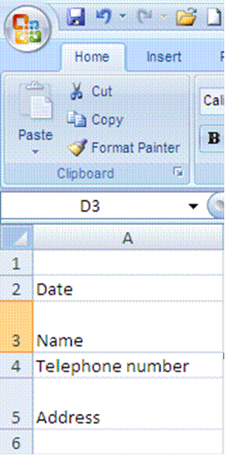

Then add:
Today’s date
Your name
Telephone number
Address
Widen column A so that the text for telephone number fits into the cell
Change the alignment of the date cell to left aligned
Change the formatting of the telephone number to text
Wrap the text of your address so that everything fits
Your worksheet should look like this:

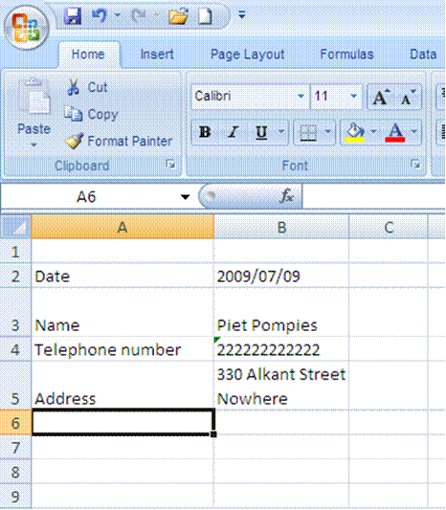
Formative Assessment 4
Ensure that you are saving your workbook in My Documents as an Excel file, name the workbook Practice and then click Save.
You workbook has now been saved as Practice. Note how the name in the Title Bar has changed.

Save a copy of a file
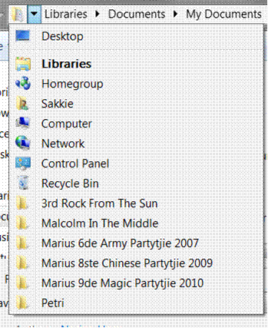
Go to the File tab and select Save As
Select the folder or drive to which you want to save from the Save In list
To save the copy in a different folder, click a different drive or a different folder in the folder list.

Formative Assessment 5
Save your workbook as Practice and add your name.
Close your Practice workbook

Currency Format: Formative Assessment 6
In your practice file enter the following amounts in cells D1 to D5:
D1: 28443;
D2: 31296;
D3: 8543;
D4: 12;
D5: 96.

Then select these cells,
On the Home tab, click the Dialogue Box Launcher next to Number.
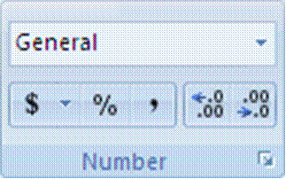
In the Category box, click Currency.
In the Symbol box, click the currency symbol that you want.
In the Decimal places box, enter the number of decimal places that you want to display.
In the Negative numbers box, select the display style for negative numbers.

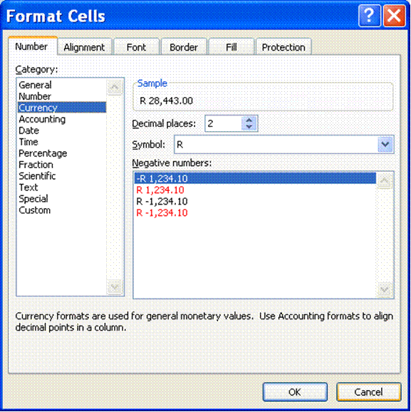

Tip If you want to display a monetary value without a currency symbol, you can click None.

Accounting Format: Formative Assessment 7
Tip Accounting formats line up the currency symbols and decimal points in a column
In Cells E1 to E5, enter the following numbers: E1: 86236; E2: 789654; E3: 789; E4: 86; E5: 98746.
Once again, select Cells E1 to E5
On the Home tab, click the Dialogue Box Launcher next to Number.
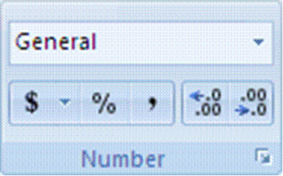
In the Category box, click Accounting.
In the Symbol box, click the currency symbol that you want.
In the Decimal places box, enter the number of decimal places that you want to display.

Note The Negative numbers box is not available for the Accounting number format.
Change the decimal places option to two; click on OK.
All the R signs will be aligned underneath each other.
Formative Assessment 8: budget
Tip Put simply, a budget is a statement of your income and expenses, showing you how much money you have left once you have paid all your debts.
Income is of course all your earnings: salary, commission, interest, maintenance, etc. Expenses are everything you have to pay: house rent, water and lights, telephone, school fees, transport, accounts, etc.
Complete your monthly budget or an imaginary one on a new sheet in your Practice document. and save it to the hard drive.
Formative Assessment 9
Click on a new sheet in your Practice workbook.
In cell A1 type 250; in cell A2 type 320; in cell A3 type 125.
Start your calculation (your sum) by entering an = in cell A4
Click cell A1 and press + .See how the formula shows in cell A4
Click cell A2 and press+ .See how the formula shows in cell A4 as well as the Formula Bar
Click cell A3 and press Enter - DO NOT PRESS + IN CELL A3!!! Press Enter!!!
The answer will display in cell A4.
If you press + and then Enter in cell A3, an error message will display. You can click on Yes and Excel will make the corrections as proposed, or you can click No and make the corrections yourself.

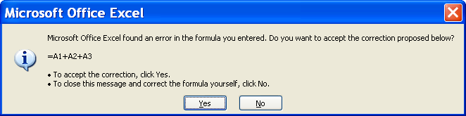

Formative Assessment 10
Enter the following amounts in column C:
C1:1230; C2: 4387; C3:2598; C4: 1121; C5: 7683; C6: 5576
Add the numbers using Autosum

Formative assessment 11
Insert the following information in a new worksheet:
A | B
Salesperson | Invoice
Buchanan | 15,000
Buchanan | 9,000
Suyama | 8,000
Suyama | 20,000
Buchanan | 5,000
Dodsworth | 22,500

In the following blank cell, enter the following formula: =SUM(B2:B3, B5) Adds two invoices from Buchanan, and one from Suyama (44,000)
In the following blank cell, enter the following formula: =SUM(B2,B5,B7) Adds individual invoices from Buchanan, Suyama, and Dodsworth (57,500)
The SUM function can include up to 30 cell or range references
You can also access the SUM function from the Insert function on the formula bar:

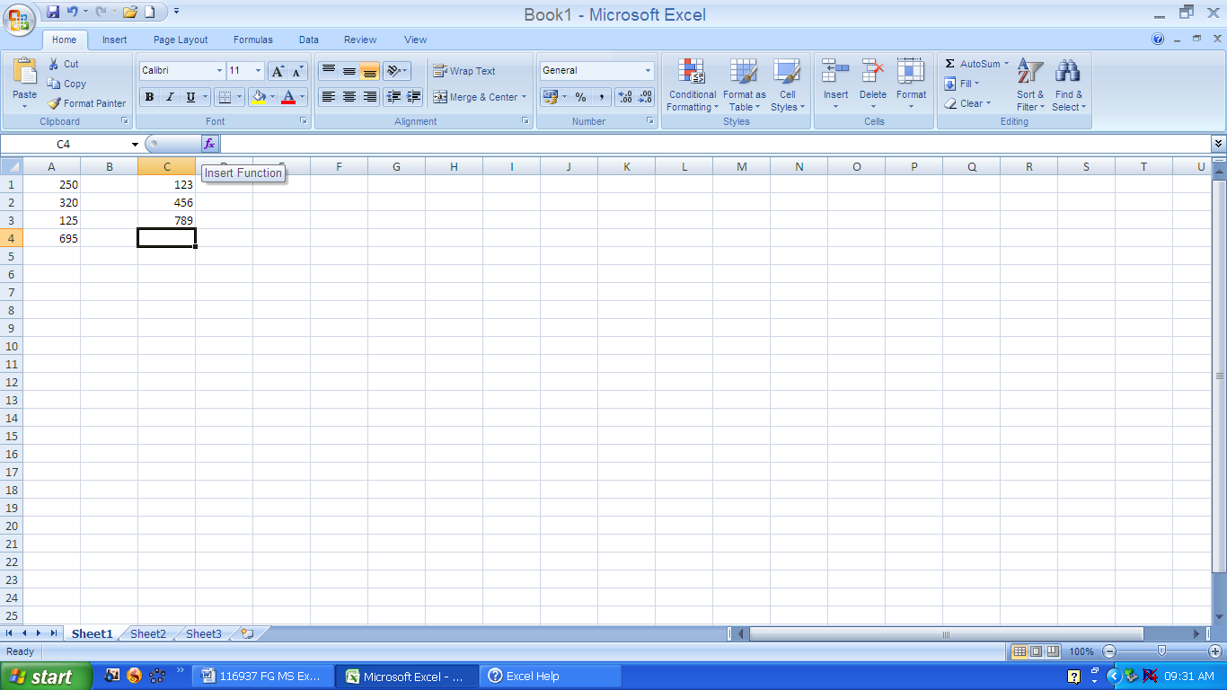

Note: You can also use the Sum Function to do calculations in rows rather than in columns.
In any two cells, type the following:
15000
-9000
Use the SUM function to subtract 9000 from 15000:

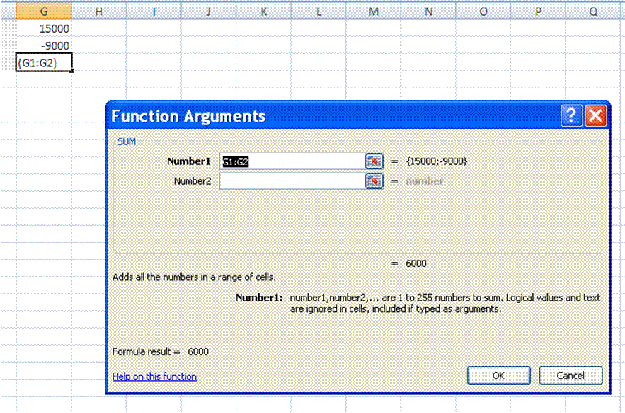

To save the copy in a new folder, click New Folder.
In the File name box, enter a new name for the file.
Click Save.

Formative Assessment 12
Enter the following amounts: cell A20: 8585; cell B20: 123.
Click on cell C20, enter = .
Click cell A7 and enter /, click cell B7 and press enter.
The answer will be displayed in cell C20
Formative Assessment 13
Open the workbook Sales Projections
In cell B7 (Overheads Growth) create a validation entry
Set these validation settings: Whole Number, Less than 1; and switch off Ignore blank
Set the Input Message title to "Input Overheads" and the message to "Enter a fraction such as .15, or a percentage such as 15%"
Set the Error Alert to Stop; title to "High Overheads", and the message as "Unrealistic figure, please re-enter."
In cell B7 enter the number 2
Reset the validation Error Alert to Warning
In cell B7 enter the number 2, and accept the number
Display the Data Tool group
Use the Circle Invalid Data button to highlight the number 2 in cell B7
Close the file without saving it
Tip To distribute data to people who do not have access to the Microsoft Excel application (or are using a different version of it), you can save a workbook in a different file format to allow them to open and edit it in whatever spreadsheet software they have.
Formative Assessment 14
Click on sheet two. In cell A1, type January. Place the mouse on the fill handle, (This is the little black handle in the lower right corner of the active cell) click and holding down the mouse button, drag the mouse to cell A12. Notice how Excel automatically enters the months for you.
In cell B1 type Monday. Place the mouse on the fill handle, click and drag down to cell B7. Excel will enter the days automatically.
In cell C1 type 1 and in cell C2 type 2. select both cells and drag the fill handle down to cell C10. Autofill will fill the cells.
In cell D1 type Jan-2009. Right click the fill handle and drag down to cell D12. Select Fill Months and Excel will autofill the months for the year 2009.

Do one of the following:
To change the row height of one row, drag the boundary below the row heading until the row is the height that you want.
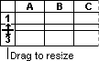
To change the row height of multiple rows, select the rows that you want to change, and then drag the boundary below one of the selected row headings.
To change the row height for all rows on the worksheet, click the Select All button, and then drag the boundary below any row heading.
To change the row height to fit the contents, double-click the boundary below the row heading.
Formative Assessment 15
Practice changing the column widths and row heights using all the above methods for about 5 minutes
Formative Assessment 16
Open the workbook Bathini Expense Form
If necessary, adjust the Zoom control so that you can see all the data
Select column A and column N
From the Format menu, select Column then Width and set it to 1
Resize rows 1, 8, and 26 to 10
Change the height of row 7 to 27 and change the vertical alignment to Top
Draw a dark blue border around B8:N26
Draw a thin dashed line border on the bottom of cells D10:M10
Select D22:D25 and change the colour to pale orange and 25% Gray pattern with Pale Yellow colouring
Click OK
Click in cell M24 then change the colour and pattern as follows: Select the Indigo colour chip. Click the arrow on the Pattern box and select the 50% Gray pattern with Pale Blue colouring
Select the Black colour chip and a thick line weight then click the Outline button
Click OK
Change the Font Colour of M24 to White and apply Bold
Save and close the workbook

Open your Practice workbook and go to your budget
Improve the presentation - add borders, shading, change number format, font styles and so on
Save and the Practice workbook
Below is an example of how the worksheet could be formatted.

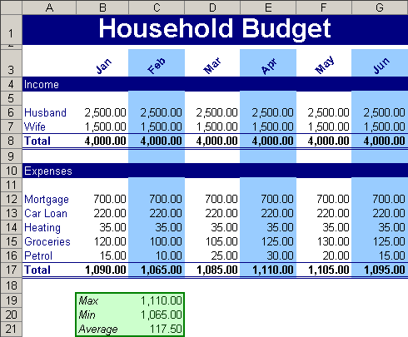

Formative Assessment 17
Select column A and then select the Format, Cells menu. Click the alignment tab. Select the Centre option and click OK. See how your cell contents are arranged in the centre of the cells. Now select the Right option and click OK. The contents of the cells will be aligned to the right. While your column is still selected, click the Left option and OK. The contents of the cell will be aligned to the left.
Select Column A and click the left align button on the formatting toolbar. See how the text automatically aligns to the left. Now click the centre button and the right align button to see the text centre and then align to the right.
In cell A7 type My Journal. Select cells A7 to D7 and click on the Merge and Centre button of the formatting toolbar. See how the text is centred in the row.
In cell A9 type My Year 2000 Journal. Select cells A9 to E9 and click on format, cells. Click on the alignment tab and then select Centre across selection. The text will be centred in the row.
Select cells A3 to D3, choose the Edit menu and select the delete command in the dialogue box. Choose the shift cells up option and click OK. Watch how the cells shift up. Now select cells A1 to D1 and press the delete key on the keyboard.
Your last two actions were to delete the entire row 1 and to delete row 3. Click the Undo command on the toolbar and watch Excel undo the very last action. Click on the arrow box next to the Undo button to see a list of your last actions that can still be undone. Click on clear and Excel will undo the clear action.
Click on the Redo button once and row 1 will be cleared again. Click on the arrow next to the Redo button to see a list of actions you can redo. Click on the first one, delete and Excel will delete row 3 again.
Undo the last two actions again.
Click in cell A3 and type 1250. Notice how the old numbers are replaced by the new numbers.
In cell A1 type 158, then press the backspace key once and type a 9. The figure now reads 159.
Double click cell B1 now. Use the arrows to move back in the cell and then delete the s of Mrs, so that the name now reads Mr B. Otto.
Formative Assessment 18
Open the workbook List Of Products and run a spell check
Find and replace all uses of "Beverage" with "Drinks"
Find and replace all uses of "pieces" to "pcs"
Add a line total column with a formula to calculate it
Save and close the workbook
Formative Assessment 19
Print your Practice workbook

Summative Assessment Readiness Statement
Note: R = Ready for summative assessment, NYR = Not yet Ready for summative assessment
Candidate's Name |  |  |  |  | ID No.
Assessor's Name |  |  |  |  | Reg. No.
Unit Standard Title
ASSESSMENT DECISION
Specific Outcome |  | R | NYR | Comments

Assessor’s / Facilitator declaration:
I hereby declare that I have assessed the learner’s formative assessment and find the learner ready / not yet ready for the summative assessment

Assessor / Facilitator Name | Signature

Knowledge Questionnaire
Specific Outcome 1: Demonstrate an understanding of the principles of spreadsheets
- Spreadsheet is defined in terms of its purpose and use: Uses include but are not limited to: Automation of repetitive calculation tasks, organisation of data into rows and columns
- Examples of spreadsheets that can be produced using a spreadsheet application are provided: At least three examples
- The benefits of using a spreadsheet application for producing and working with spreadsheets are explained At least three benefits
- Examples of spreadsheet programs are named

Specific Outcome 3: Produce a spreadsheet from a given specification: At least 8 rows and 5 columns, first row to be column headings, first column to be row headings, the last row to be column totals, the last column to be row totals. E.g. Row1 * Row2 = Row3 + Row4 - Row5 = Row6 / Row7 = Row8. Format limited to the assessment criteria of specific outcome 5.
- The benefits of saving a file in different formats is explained: Formats: Text, CSV, HTML, other software versions, other software types
Specific Outcome 7: Print a spreadsheet
- A spreadsheet is previewed in print format
- The printing of gridlines is altered: Printing of gridlines on or off
- Print options are selected to print a spreadsheet: Number of copies, collate sequence
- A spreadsheet is printed to the connected printer

- What is the purpose of a spreadsheet? (1)
- Give three examples of what spreadsheets can be used for in the office or at home (3)
- Give three benefits of using spreadsheets in the office (3)
- Name two examples of spreadsheet applications other than Excel (2)
- Explain the benefits of saving a file in an HTML format. (1)
- Write down the steps you would follow to view a spreadsheet in print preview. (2)
- What steps would you follow to change between landscape and portrait page setup in print preview. (4)
- What steps would you follow to add or remove gridlines in print preview when printing a spreadsheet. (5)
- Name the steps you would take to print 5 pages of the second page of a spreadsheet. (5)
- Name the steps taken before printing a spreadsheet and then to print the spreadsheet (3)

- Complete the following table in terms of the auto correct and spelling check functions: (7)

Click | To
Ignore Once
Ignore All
Change
Change All
Add to Dictionary
AutoCorrect
Undo Last

Observation
The following questions will be performed by you, while being observed by the trainer
Specific Outcome 2 Create, open and save spreadsheets
- When creating new spreadsheets, the name of the new spreadsheet must allow the spreadsheet to be easily identified in terms of its purpose and content.
- The spreadsheet application program is opened
- A new spreadsheet is created: At least 4 columns and 4 rows of data are entered, no calculations.
- Methods of moving the cell cursor are demonstrated in order to move about the spreadsheet: At least 2 methods are demonstrated
- The Application Help facilities are used: Help facilities to be used at least twice in different situations
- Saving spreadsheets is explained in terms of its purpose and the destination of the saved filed
- The spreadsheet is saved with a specific name in a specific folder: At least two different methods of saving a spreadsheet
- An existing spreadsheet is opened and closed
- The spreadsheet application program is closed

Action to be performed | Yes/No
- Highlight from Cell A1:G5 and keep the screen that way till the trainer has seen your computer screen or call the trainer to view your screen. (2)
- Open an Excel workbook (2)
- From A1 to D1, enter the following information: A1: Car; B1: House; C1: School; D1: Groceries. Once you have completed this task, enter an amount (only an estimate) from A2 to D2 for each of the payments that need to be made in an average budget each month. (8)
- Once the above tasks have been completed, use Save As to save your spreadsheet to My Documents with the name, Budget July, followed by your name and close Excel (3)
- Open Excel and use the Help feature to look up AutoSum. Once you have the required results from Help, copy the result and paste it in a Word document. Save the Word document in My Documents as Help feature followed by your name. (Help feature Raymond) (3)

Problem Solving Assessment
Specific Outcome 3: Produce a spreadsheet from a given specification: At least 8 rows and 5 columns, first row to be column headings, first column to be row headings, the last row to be column totals, the last column to be row totals. E.g. Row1 * Row2 = Row3 + Row4 - Row5 = Row6 / Row7 = Row8. Format limited to the assessment criteria of specific outcome 5.
Assessment Criteria
- A spreadsheet is produced with the required data from given specification: Text, numbers, dates
- Formula are entered to achieve the given specification: Formulae: addition, subtraction, division, multiplication, sum
- The differences between data cells, label cells, and formula cells are explained.
- The spreadsheet is in accordance with the given specifications
- The spreadsheet is saved regularly to avoid loss of data.
- Practices are demonstrated to ensure the integrity of the data: Check against data source, check-totals, audit formulae
- The benefits of saving a file in different formats is explained: Formats: Text, CSV, HTML, other software versions, other software types
- A spreadsheet is saved in a different format: At least two of: Text, CSV, HTML, other software versions, other software types
Specific Outcome 4: Edit a spreadsheet
- An existing spreadsheet is opened
- Cells are selected for manipulation and de-selected: Cell, cell range, entire column, entire row, entire spreadsheet
- Cells are manipulated: Move, copy, delete
- Use the automatic fill feature to automatically enter data in cells: At least two of: Year, Quarter, Month, Week, Day
- Text is located in a spreadsheet: Text is located and replaced in a spreadsheet
Specific Outcome 6: Check spelling in a spreadsheet
- The dictionary to be used for spelling and word usage is set up
- Text is entered and corrected automatically while entering
- Text is checked for spelling and grammar and corrections made based on judgement: Cell, range of cells
- Words are added to the custom dictionary
Specific Outcome 7: Print a spreadsheet
- A row is selected to print on each page of the printed spreadsheet

- Open a new spreadsheet and complete the following instructions: enter the following amounts in cells C1 to C5: C1: 28443; C2: 31296; C3: 8543; C4: 12; C5: 96. Set the number of decimal places to zero and the currency to R English. (3)
- Type the following names in cells A1:A5: Thabo, Lebohang, Jack, Raymond and Sally. Select all the names and change the font to Bookman Old Style and the font size to 12. Once you have completed these steps, select cell A2 (Lebohang) and use the Shrink to Fit feature to fit the name into the cell. (5)
- In cells D1:D5 enter the following values: 150; 286; 94; 1268; 732. Use the AutoSum function to add these values so that the answer displays in D6. Save the workbook in an HTML format with the name Outcome 3 116937 followed by your name and close it. (2)
- Open the car Sales workbook. Make the headings bold and italics Save the workbook in My Documents as Car Sales followed by your name and close the workbook. (5)
- Open the Sales Projections Workbook. Repeat Jan-Mar in cells G2:I2 by using the AutoFill function. Once you have completed this, select cells A1:F16. Cut them and Paste them in cells B1:G16. Once you have completed the instructions, save the workbook in My Documents as Sales Projectionst, followed by your name. (5)
- Use the find and replace function to find O’heads and replace it with Overheads. (2)
- Run a spell check and correct all the spelling mistakes. (3)
- Freeze the first column of the sales projections worksheet (View – Freeze panes) Save the workbook in My Documents as Sales Projections, followed by your name. (5)
TOTAL: 87

Workplace assignments

Research assignment
- Find out what spreadsheets are used for at work.
  - Explain at least 3 different uses of spreadsheets at work.

Reflexive questions
- What benefits do spreadsheets have for the people who use them?

Work sample
- Produce a spreadsheet for your department. This could be to show sales figures, hours of attendance or absenteeism, fuel usage of vehicles, etc.
  - Your spreadsheet must contain at least two formulas
  - Use text, numbers and dates in your spreadsheet
  - Format your spreadsheet
  - Mail the spreadsheet to your facilitator

Declaration Of Authenticity Of Evidence
I (Initials and Surname)
ID No:
declare/certify that the learning activities completed in the learner activity workbook in its entirety is my own original and authentic work (interpreter declaration to be completed where necessary) I acknowledge that should it come to the attention/reported to the training provider/ SETA or relevant authorities, and there is sufficient evidence to prove that there is an irregularity regarding the authenticity of this submission the necessary steps will be taken against me which can result in the one or more of following decisions being taken:
- A criminal case being opened,
- Learner achievement certificate cancelled, withdrawn
- Non processing of learner achievement submissions to the SETA pending the outcome of an investigation
- De-registration as an assessor/moderator (where unauthorised assistance is provided by the assessor/facilitator)
- Investigation into the accreditation status of the training provider if there is an irregularity on the part of the training provider
I know and understand the contents of this declaration: I have no objection to signing the prescribed declaration, The declaration was also explained to me by the training provider/facilitator
Signature of Learner: | Date
Signature of facilitator/assessor: | Date

ASSESSMENT REVIEW
NAME of LEARNER |  |  | NAME of ASSESSOR
VENUE |  |  | DATE of REVIEW
UNIT STANDARD | 116937
Review Dimension |  | ASSESSOR |  | LEARNER/  CANDIDATE | ACTION
The principles/criteria for good assessment were achieved? |  | Agree  Disagree |  | Agree  Disagree
The assessment related to the registered unit standard? |  | Agree  Disagree |  | Agree  Disagree
The assessment was practical? |  | Agree  Disagree |  | Agree  Disagree
It was time efficient and cost-effective and did not interfere with my normal responsibilities? |  | Agree  Disagree |  | Agree  Disagree
The assessment instruments were fair, clear and understandable |  | Agree  Disagree |  | Agree  Disagree
The assessment judgements was made against set requirements |  | Agree  Disagree |  | Agree  Disagree
The venue and equipment was functional? |  | Agree  Disagree |  | Agree  Disagree
Special needs were identified and the assessment plan was adjusted |  | Agree  Disagree |  | Agree  Disagree
Feedback was constructive against the evidence required |  | Agree  Disagree |  | Agree  Disagree
An opportunity to appeal was given |  | Agree  Disagree |  | Agree  Disagree
The evidence was recorded |  | Agree  Disagree |  | Agree  Disagree

LEARNER’S DECLARATION OF UNDERSTANDING
I am aware of the moderation process and understand that the moderator could declare the assessment decision invalid
Learner | Date | Assessor | Date | Moderator | Date

Candidate Feedback Report
Candidate's Name |  |  |  |  | ID No.
Assessor's Name |  |  |  |  | Reg. No.
Unit Standard Title | 116937
ASSESSMENT DECISION
Source of Evidence |  | C | NYC | Comments
Assessments
Product
Indirect Evidence
Overall Assessment Decision
Additional Notes

Date
Signature of Assessor |  |  |  | Signature of Candidate

Candidate Appeal Form
Candidate's Name: |  | ID No.
Assessor's Name: |  | Reg. No.
Unit Standard Title: | 116937
Date:
SECTION 1
Candidate's reason for disagreeing with the assessment decision
Assessor's rationale for the assessment decision
Candidate's signature
Assessor's signature
SECTION 2
Internal Moderator’s reconsidered decision and rationale
Internal Moderator's Signature
Advising Assessor’s Signature
Decision and rationale of the investigatory panel
Learner Declaration | The above decisions have been explained to me and I accept the assessment decision
Learner’s Signature
Date

Please send this form to: The Training Provider

Assessor's Report
Candidate's Name |  |  |  |  |  | ID No.
Assessor's Name |  |  |  |  |  | Reg. No.
Unit Standard Title | 116937
ASSESSMENT DECISION
Specific Outcome |  | C |  | NYC | Comments
Demonstrate an understanding of the principles of spreadsheets
Create, open and save spreadsheets
Produce a spreadsheet from a given specification
Edit a spreadsheet
Format a spreadsheet
Check spelling in a spreadsheet
Print a spreadsheet
Overall Assessment Decision
Comments
Date
Signature of Assessor |  |  | Signature of Candidate

Moderator's Report
Moderator's Name |  |  |  | Reg. No.
Assessor's Name |  |  |  | Reg. No.
Candidate's Name |  |  |  | ID No.
Unit Standard Title | 116937
MODERATION DECISION
Specific Outcome |  | C | NYC |  | Comments
Demonstrate an understanding of the principles of spreadsheets
Create, open and save spreadsheets
Produce a spreadsheet from a given specification
Edit a spreadsheet
Format a spreadsheet
Check spelling in a spreadsheet
Print a spreadsheet
Overall Moderation Decision
Feedback to Assessor
Action Required
Date of Moderation
Signature of Moderator
Signature of Assessor
Signature of Candidate

PORTFOLIO BUILDING
Your Portfolio of Evidence (PoE) contains the evidence needed to declare you competent and to award credits towards the award of this qualification to you. Evidence should be authentic and reflect both your knowledge of the subject and your ability to apply this knowledge in the workplace. Thus, evidence day to day activities supporting the specific outcomes addressed by this learning programme should complement the theoretical learning you attended and were assessed on.
There are FIVE key steps in creating a portfolio that will reflect your competence.

Plan Your Portfolio
Plan and document the sequence, graphics and layout of your portfolio. This will assist you in following a logical sequence, which makes the Portfolio also much more user friendly and understandable for the assessor. It will also reflect your professional approach and attitude towards the subject matter, your work and your life. Impact and appearance always contribute to or affect your chances of being taken seriously and declared competent!

Gather The Evidence
An evidence checklist has been provided (Section 4) to tell you what evidence needs to be gathered for assessment purposes. However, there are four broad categories of evidence that you should include:
- Knowledge evidence (your knowledge questionnaire)
- Direct performance evidence (actual samples of your work or records of activities captured on audio or video tape)
- Indirect performance evidence (documentary records of your performance e.g. appraisals, photographs, testimonials, self-assessments, customer ratings etc.)
- Supplementary evidence (to confirm the authenticity of your evidence)

Evaluate Your Evidence
Once you have collected your evidence, evaluate each piece by ensuring that it is:
- Valid (relevant to the unit standard/s being assessed)
- Authentic (clearly your own work)
- Current (not more than 2 years old)
- Sufficient (adequate to prove your competence against all of the assessment criteria and range statements in the unit standard/s)

Cross-Reference Your Evidence To The Unit Standards
Evidence for assessment against unit standards must be linked to the outcomes of the unit standard in question. An evidence locator grid is useful for this.

Organise Your Information
How you structure your portfolio is critical. Your design and layout must look professional and clearly articulate your achievements, and it should make sense to someone seeing it for the first time. Use the following structure as a guide:

- A title page indicating:
  - The title of the programme
  - The unit standard titles to which the programme is aligned
  - The assessment centre (The training provider)
  - Your name, position and organisation
  - Your contact details
  - The name of your assessor
  - The name of your moderator
  - The date
- An index
- Background information
  - Curriculum Vitae
  - Organisation profile
  - Job profile
  - Organisation/department structure
- A copy of the unit standard/s
- Your assessment plan
- Your completed Knowledge Questionnaire
- An evidence locator grid
- The evidence itself
- Supporting evidence e.g. witness testimonies, reflections and witness status list
- Assessment records

Moderation

Moderation Of Assessments Must Be Planned In Order To:
- Identify the outcomes as per unit standards
- Identify the evidence to be collected
- Identify steps of a logical process
- Design an appropriate assessment (criteria and tool)
- Review success or adjustments to be made to the assessments
- Provide appropriate feedback and set targets and action plans

Pre-Assessment Moderation
This occurs prior to assessment taking place and includes moderation of:
- Assessor suitability/qualifications
- Assessment guidelines which are explained to all assessors in bi-weekly meetings
- Standardised assessment tools which are reviewed in assessor meetings
- Guidelines for organising evidence (see Portfolio of Evidence guidelines)
- Assessor/candidate appeals process
- The assessor must consult with the moderator to ensure that the assessment instrument is valid, reliable and practicable. The moderation model will be the assessor moderator comparison, so as to ensure that the assessment instrument is fit for purpose and that the assessment plan is adequate in order to achieve the outcomes of the assessment process.

Post Assessment Moderation
Post-assessment moderation must take place at the end of the assessment process, once feedback has been given to the candidate.

Post-assessment moderation must check specifically that the evidence on which the decision of competence is based is valid, authentic, current and sufficient. Until post-assessment moderation has taken place, the assessment process is incomplete, as there is a chance that the moderator may disagree with the assessor regarding the decision reached in terms of competence.

Even so, the candidate needs to be cautioned that external moderation/verification needs to take place prior to candidate achievement being confirmed and recorded on the National Candidate Record Database.

The focus in post-assessment moderation is also to address continuous improvement of assessment activities and tools. The moderator needs to critically evaluate the review process and ensure that candidate consultation in the review process was both meaningful and constructive i.e. avoid simplistic yes/no questions which give little qualitative data.
15% of all assessment sampling across the board is moderated. The samples are representative of assessments conducted by each assessor and for each project

