

LEARNER

Portfolio of Evidence

MS Excel Advanced

Unit Standard 116943

Level 4 Credits 3


Advanced

PERSONAL INFORMATION
NAME
CONTACT ADDRESS
Code
Telephone (H)
Telephone (W)
Cellular
Learner Number
Identity Number
EMPLOYER
EMPLOYER CONTACT ADDRESS
Code
Supervisor Name
Supervisor Contact Address
Code
Telephone (H)
Telephone (W)
Cellular

TABLE OF CONTENTS

i
PERSONAL INFORMATION ii
TABLE OF CONTENTS iii
Contact Details 1
Record Of Learning 1
UNIT STANDARD 116943 3
Formative Assessments 5
Formative assessment 1 5
Formative assessment 2 5
Formative assessment 3 7
Formative assessment 4 7
Exercise 1 8
Formative assessment 5 8
Formative Assessment 7 10
Questionnaire 12
Case Study 13
Workplace Project 17
Declaration Of Authenticity Of Evidence 18
Assessor's Report 19
Moderator's Report 20

Contact Details
Unit Standard:
Course:
Assessor Details
Name
Branch |  |  | Registration No:
Contact Details | email:
Contact Details | Phone: |  | Fax:
Moderator Details
Name
Branch
Contact Details | email: |  | Registration No:
Contact Details | Phone: |  | Fax:
Candidate Details
Surname |  |  |  | Name
College |  |  |  | ID No
Branch
Contact Details | Email:
Contact Details | Phone: |  |  | Fax:

Record Of Learning

Candidate's Name: |  |  |  | ID No
Assessor's Name: |  |  |  | Ass. Reg. No
Moderator's Name: |  |  |  | Mod. Reg. No
Date:
UNIT STANDARD | NQF LEVEL | CREDITS | DATE OF COMPLETION | SIGNATURE OF ASSESSOR |  | SIGNATURE OF MODERATOR
116943 | 4 | 6

UNIT STANDARD 116943

Unit Standard Title

Using a Graphical User Interface (GUI)-based spreadsheet application, enhance the functionality and apply graph /charts to a spreadsheet

NQF Level
4

Credits
3

Specific Outcomes
Specific Outcome 1: Create and edit a graph/chart
Assessment Criteria
- The major graph/chart types are defined in terms of their purpose: At least 3 of: Pie, Bar, Column, Line, Scatter, Area
- A graph/chart is created from a given data source: At least 2 of: Pie, Bar, Column, Line, Scatter, Area
- A graph/chart is edited: At least 3 of: Graph/chart title, axis titles, data labels, background colour, line or bar colour
- The graph/chart type is changed
- A graph/chart is copied: Within a worksheet, to a different worksheet, to a different spreadsheet file.
- A chart is moved: Within a worksheet, to a different worksheet, to a different spreadsheet file.
- A chart is resized
- A chart is deleted
Specific Outcome 2 Load data from an external data source to produce a given spreadsheet result.
Assessment Criteria
- The external data file is checked to ensure that the input into a spreadsheet will achieve the required results
- The format of the input file is determined to ensure correct input into a spreadsheet: Tables from another source
- The data is copied into the spreadsheet
- The resulting spreadsheet is in accordance with the given spreadsheet result
Specific Outcome 3: Insert and edit objects in a spreadsheet: Any 2 of the following objects: pictures, images, charts, autoshapes
Assessment Criteria
- A graphic is inserted into a spreadsheet: At least 2 of the following: picture, image, chart, autoshape
- A selected graphic is manipulated in a spreadsheet: At least 2 of the following: move, copy, resize
- Use a drawing tool to draw an object in the spreadsheet

Critical Cross-field Outcomes (CCFO)
- Identify and solve problems in which responses display that decisions using critical and creative thinking have been made
- Organise and manage oneself and one’s activities responsibly and effectively
- Collect, analyse, organise, and critically evaluate information
- Communicate effectively using visual, mathematical and/or language skills in the modes of oral and/or written persuasion when engaging with the subject
- Use science and technology effectively and critically, showing responsibility towards the environment and health of others

Formative Assessments

Formative assessment 1
To get a good idea of what you can add to or change in your chart, click the Design, Layout, and Format tabs, and then explore the groups and options that are provided on each tab.

Formative assessment 2
Enter the following data into a worksheet
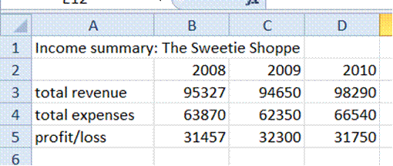
Done

Select the range of cells from A2 to D5, which includes the column titles and the row headings
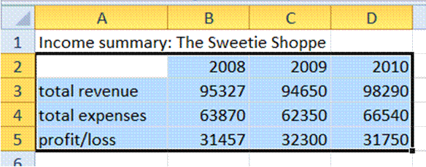
Done
Select a chart type as follows: Go to Insert, Column and select the 2-D clustered column
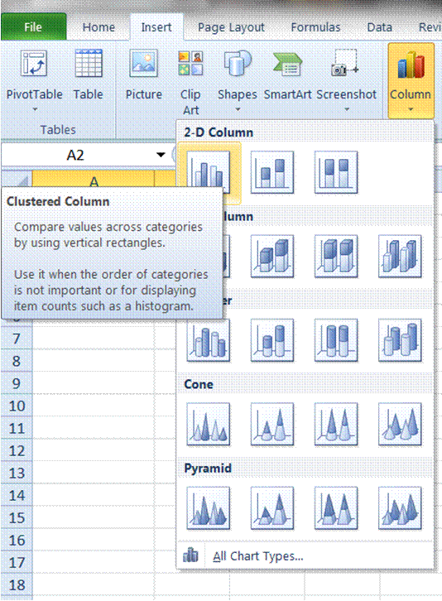

A basic column chart will be created and placed on your worksheet
Done

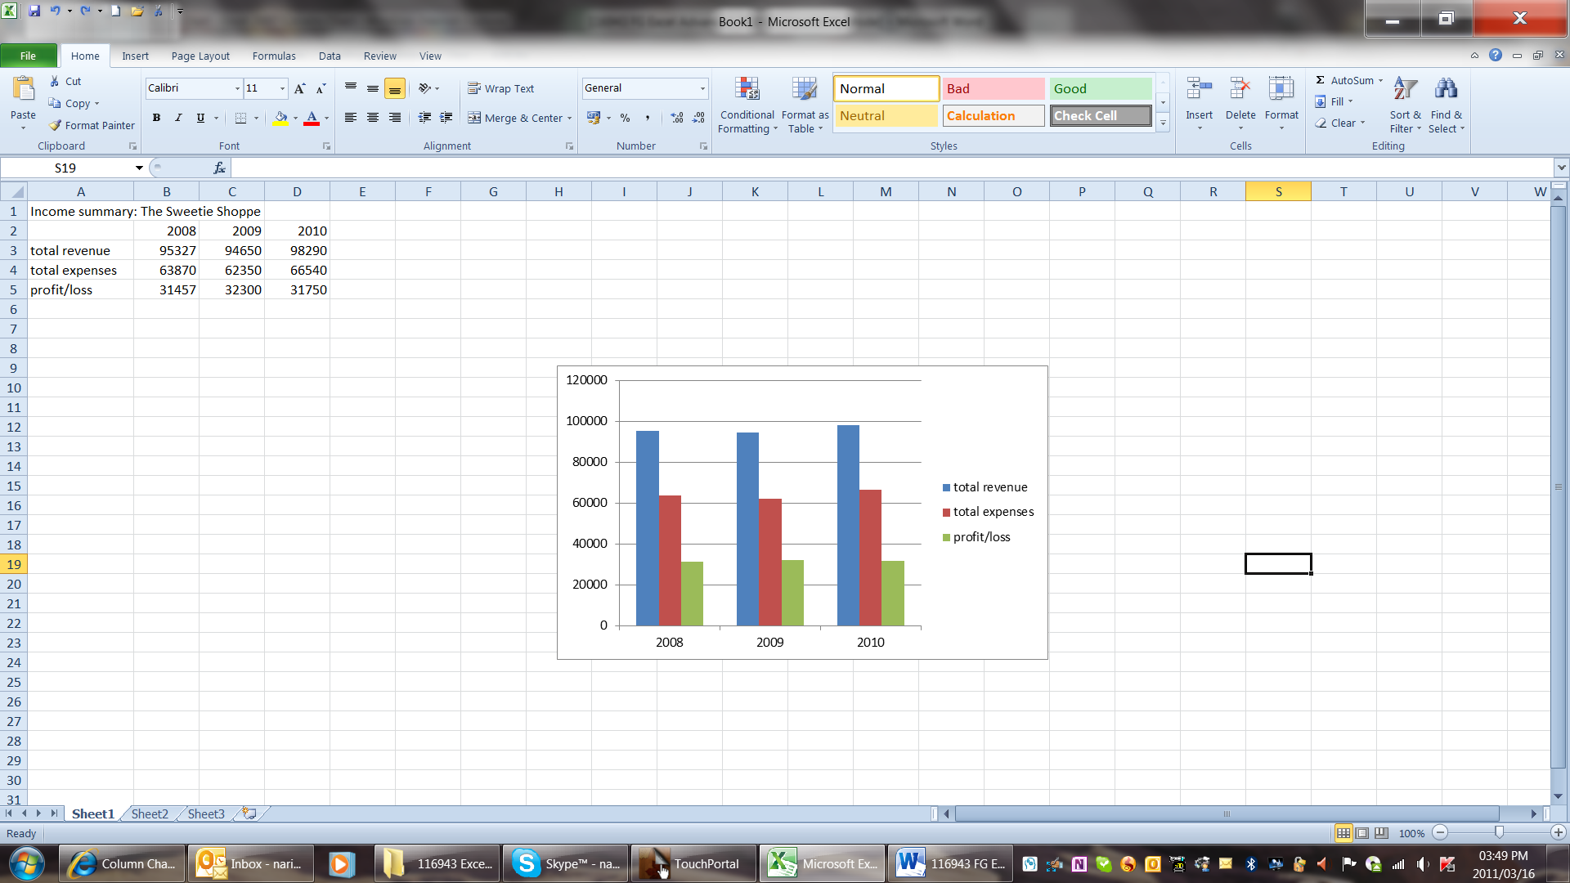

Formative assessment 3
Enter the data below in the cells indicated to create the pie chart as we go along.
Cell - Data
A1 - The Cookie Shop 2011 Revenue from Sales
A2 - Peanut Butter
A3 - Chocolate Chip
A4 - Oatmeal Raisin
A5 - Lemon
B2 - R15,500
B3 - R27,589
B4 - R24,980
B5 - R14,768
- Highlight the block of cells from A2 to B5, which includes the row headings.
Done

Formative assessment 4
Enter the data below in the cells indicated to create the line graph covered in this tutorial.
Cell - Data
A1 - Average Precipitation (mm)
A3 - January
A4 - April
A5 - July
A6 - October Done
B2 - Acapulco
B3 - 10
B4 - 5
B5 - 208
B6 - 145
C2 - Amsterdam
C3 - 69
C4 - 53
C5 - 76
C6 - 74
Done

Exercise 1
Enter the following data into cells A1 to F2 in a worksheet. Substitute the $ sign for R
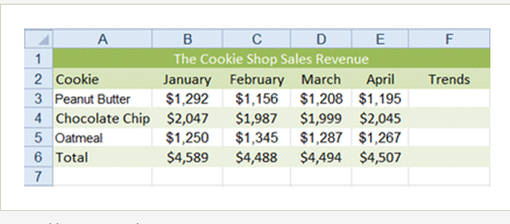

Formative assessment 5
Enter the data below in the cells indicated to create the line graph covered in this tutorial.
Cell - Data
A1 - Average Precipitation (mm)
A3 - January
A4 - April
A5 - July
A6 - October
B2 - Acapulco
B3 - 10
B4 - 5
B5 - 208
B6 - 145
C2 - Amsterdam
C3 - 69
C4 - 53
C5 - 76
C6 - 74
Done

Formative Assessment 6
If you are learning to use Excel, try creating Excel charts that look the same as the ones in this exercise.
- Create a new file (PowerPoint presentation or Word document)
- Insert a new chart object
- In the datasheet, enter the data as shown below
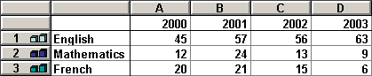
- Change the Chart Type to a 2-D column chart
- Change the colours of each of the data series
- Re-position the Legend to the bottom of the chart, use a smaller font size for the legend text, and change the font colours to match the series colour (also, move the plot area if the legend is not shown clearly)
- Add the following Title - "Exam Passes" - and format with underline
- Add the following Value Y Axis - "Grades A - C"
- Use a smaller font size for the axes
- Add Data Labels to show the value of each column
- Format the axes and gridlines as grey and change the font colours of the axes labels to grey too
- If there is one, remove the border from the Plot Area
The chart should look similar to the one shown below.
Done

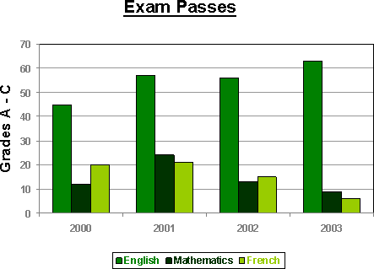

- In the same file, add a new chart on a new slide/page
- Change the datasheet as shown below

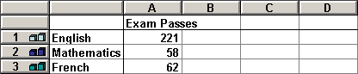

- Format the chart so that it resembles the example shown

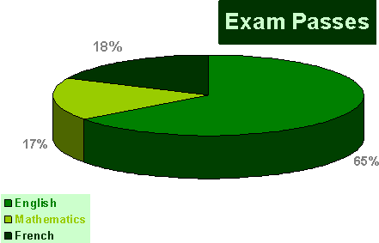

- Save the file as Exam Passes and close it
Done

Formative Assessment 7
Create a new file and save it as Pictures followed by your name. This exercise will be easiest to complete using PowerPoint, but you can use Word or Excel if you prefer
Start with a blank page, slide, or worksheet
Select Clip Art from the Insert tab, Illustrations group
Select an image to insert
Repeat the process until you have 3 images
Crop to remove part of one picture
Modify the other two images, e.g. by changing the brightness and contrast or the style of the picture
Insert a screen image in your worksheet
Save and close the file
Done

Questionnaire

- Explain the uses of the following charts: (5)
  - Bar Chart.
  - Column Chart
  - Line Charts
  - Pie Charts

- Name three different sources where you can find pictures to insert in Excel (3)

TOTAL: 8

Case Study
- In a new worksheet, enter the information as described below. (2)
ABC computer store has the following income and expenditure amounts for the period January to March:
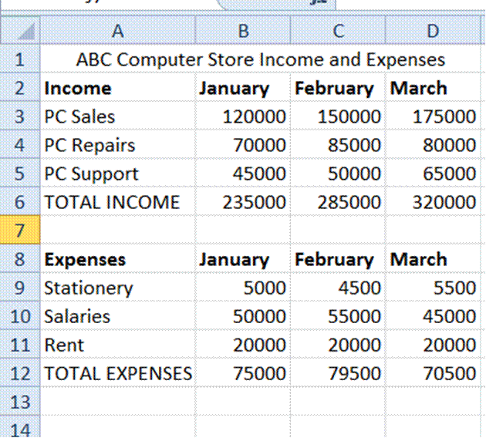
- Save this workbook as Income and Expenses followed by your name .Done
- Insert an appropriate chart of the income on the same sheet. The purpose of the chart is to compare the income of the different months. (2) Done
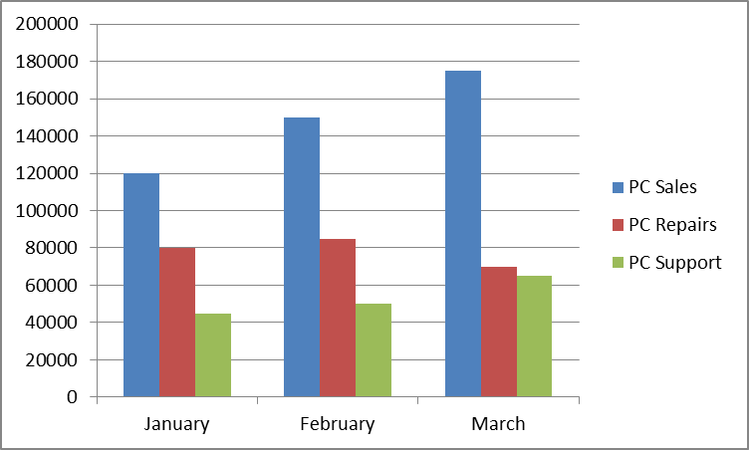

Insert an appropriate chart for the expenses on the same sheet. The purpose of the chart is to compare the expenses of the different months (2) Done
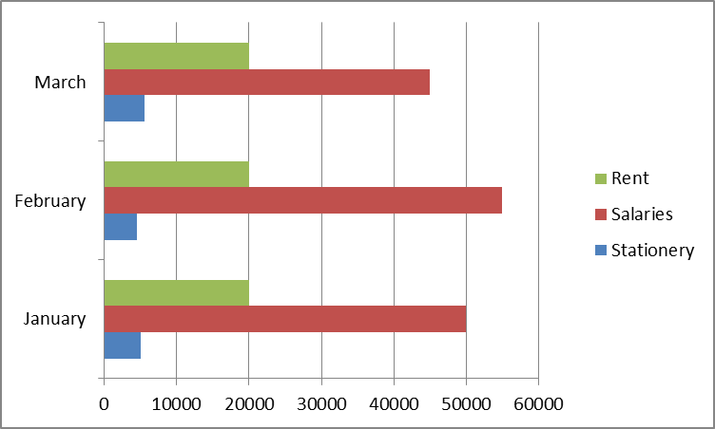
Insert an appropriate chart in a separate sheet to show the changes in the expenses from January to March (2) Done
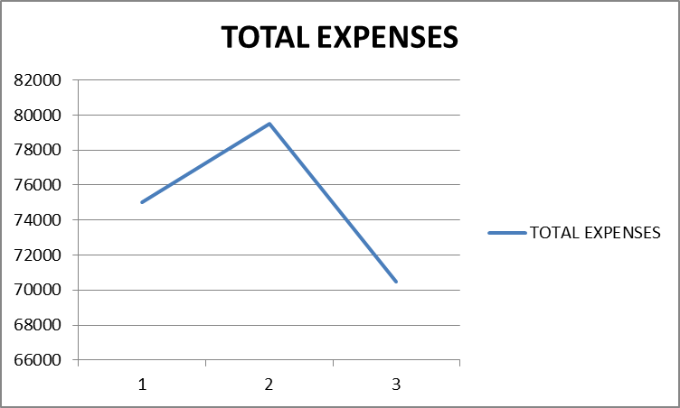
Insert an appropriate chart to show the contributions of each department to the total income (2) Done
- Change this chart to a 3-D chart (1) Done
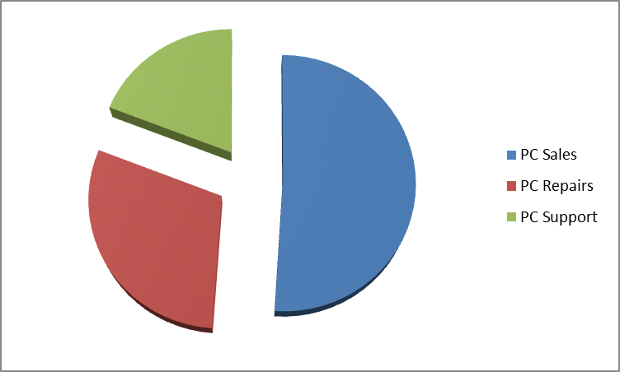
- Insert a line sparkline into column E3 (1)
- Insert a column sparkline into column E10 (1)
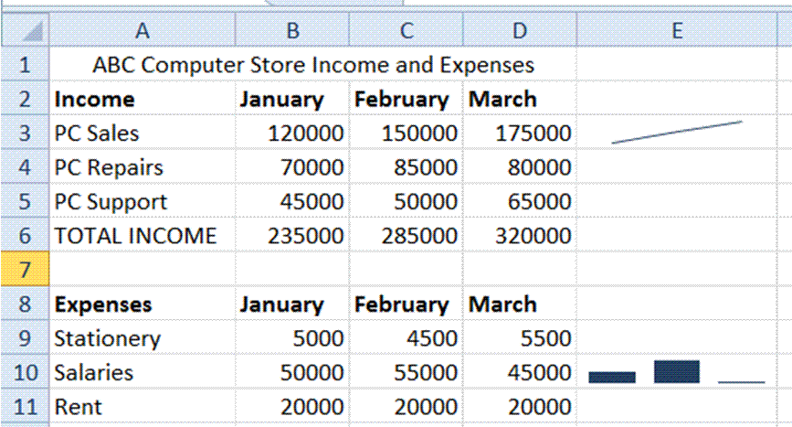

- Change the colours of one chart to orange, yellow and grey. (3)
Done
- Change the font of one legend to a different font size and colour (2)
Done

- Insert a screen image of your desktop (with all the open applications minimised) in a new worksheet of your workbook, resize the insert so the whole picture can be viewed on the screen (approximately from A1:L32). (3) Done
- Insert the data from the following workbook in a separate sheet in your workbook: Provisional Budget. (2) Done
- Rename the sheet Provisional Budget (1) Done
- Close the Provisional Budget workbook (1) Done

- Look for an applicable clipart image and insert this into the Provisional Budget sheet (1)

- Modify the clipart as follows:
  - Change the colour to washout (1)
  - Change the style to bevelled oval, black (1)
  - Insert the picture called chart from your PC (or a CD) into a blank worksheet (1)
  - Resize the picture (1)
  - Draw a box around the picture (1)
  - Change the line colour to blue or green. (1)
- Save and close your workbook. (2)

TOTAL 32

Workplace Project
- Prepare worksheet that is needed at your place of work, for example a comparison of sales figures, expenditure reports, kilometres travelled by vehicles, fuel and oil usage, overtime worked over a period.
- Populate the worksheet with the data that is needed.
- Insert at least two sparklines.
- Insert at least two charts to visually display the data.
- Change the colour scheme of the chart and the legend to that of your organisation.
- Change the font size and colour of the legends of your charts.
- Insert your organisation’s logo in one worksheet
- Resize the logo.
- Draw a line around it.
- Save your workbook and e-mail it to your facilitator. You may also save the workbook to a flash drive or CD-ROM and deliver to your facilitator.

Declaration Of Authenticity Of Evidence
I (Initials and Surname)
ID No:
declare/certify that the learning activities completed in the learner activity workbook in its entirety is my own original and authentic work (interpreter declaration to be completed where necessary) I acknowledge that should it come to the attention/reported to the training provider/ SETA or relevant authorities, and there is sufficient evidence to prove that there is an irregularity regarding the authenticity of this submission the necessary steps will be taken against me which can result in the one or more of following decisions being taken:
- A criminal case being opened,
- Learner achievement certificate cancelled, withdrawn
- Non-processing of learner achievement submissions to the SETA pending the outcome of an investigation
- De-registration as an assessor/moderator (where unauthorised assistance is provided by the assessor/facilitator)
- Investigation into the accreditation status of the training provider if there is an irregularity on the part of the training provider
I know and understand the contents of this declaration: I have no objection to signing the prescribed declaration, the declaration was also explained to me by the training provider/facilitator
Signature of Learner: | Date
Signature of facilitator/assessor: | Date

Assessor's Report
Candidate's Name |  |  |  |  |  |  | ID No.
Assessor's Name |  |  |  |  |  |  | Reg. No.
Unit Standard Title | 116943
ASSESSMENT DECISION
Specific Outcome |  | C |  |  | NYC | Comments
Create and edit a graph/chart
Load data from an external data source to produce a given spreadsheet result
Insert and edit objects in a spreadsheet
Overall Assessment Decision
Comments
Date
Signature of Assessor |  |  |  | Signature of Candidate

Moderator's Report
Moderator's Name |  |  |  | Reg. No.
Assessor's Name |  |  |  | Reg. No.
Candidate's Name |  |  |  | ID No.
Unit Standard Title | 116943
MODERATION DECISION
Specific Outcome |  | C | NYC |  | Comments
Create and edit a graph/chart
Load data from an external data source to produce a given spreadsheet result
Insert and edit objects in a spreadsheet
Overall Moderation Decision
Feedback to Assessor
Action Required
Date of Moderation
Signature of Moderator
Signature of Assessor
Signature of Candidate

